UNITED STATES
SECURITIES AND EXCHANGE COMMISSION
WASHINGTON, DC 20549
FORM 10-Q
(Mark One)
x |  |  | QUARTERLY REPORT PURSUANT TO SECTION 13 OR 15(d) OF THE SECURITIES EXCHANGE ACT OF 1934
For the quarterly period ended March 31, 2026
OR
☐ |  |  | TRANSITION REPORT PURSUANT TO SECTION 13 OR 15(d) OF THE SECURITIES EXCHANGE ACT OF 1934
For the transition period from to

Commission File Number: 001-36395

DARÉ BIOSCIENCE, INC.
(Exact Name of Registrant as Specified in its Charter)
Delaware  (State or Other Jurisdiction  of Incorporation) |  |  |  |  |  | 20-4139823  (IRS Employer  Identification No.)
3655 Nobel Drive, Suite 260  San Diego, CA  (Address of Principal Executive Offices) |  |  | (858) 926-7655  (Registrant’s telephone number, including area code) |  |  | 92122  (Zip Code)
(Former name, former address and former fiscal year, if changed since last report)
Securities registered pursuant to Section 12(b) of the Act:
Title of each class |  |  | Trading Symbol(s) |  |  | Name of each exchange on which registered
Common Stock |  |  | DARE |  |  | Nasdaq Capital Market
Indicate by check mark whether the registrant (1) has filed all reports required to be filed by Section 13 or 15(d) of the Securities Exchange Act of 1934 during the preceding 12 months (or for such shorter period that the registrant was required to file such reports), and (2) has been subject to such filing requirements for the past 90 days. Yes x No o
Indicate by check mark whether the registrant has submitted electronically every Interactive Data File required to be submitted pursuant to Rule 405 of Regulation S-T (§232.405 of this chapter) during the preceding 12 months (or for such shorter period that the registrant was required to submit such files). Yes x No o
Indicate by check mark whether the registrant is a large accelerated filer, an accelerated filer, a non-accelerated filer, a smaller reporting company, or an emerging growth company. See the definitions of “large accelerated filer,” “accelerated filer,” “smaller reporting company,” and “emerging growth company” in Rule 12b-2 of the Exchange Act.
Large Accelerated Filer |  |  |  |  |  | o |  |  |  |  |  | Accelerated filer |  |  | o
Non-accelerated filer |  |  |  |  |  | x |  |  |  |  |  | Smaller reporting company |  |  | x
Emerging growth company |  |  |  |  |  | o
If an emerging growth company, indicate by check mark if the registrant has elected not to use the extended transition period for complying with any new or revised financial accounting standards pursuant to Section 13(a) of the Exchange Act. o
Indicate by check mark whether the registrant is a shell company (as defined in Rule 12b-2 of the Act). Yes ☐ No x
As of May 13, 2026, 14,979,502 shares of the Registrant’s Common Stock, par value $0.0001, were issued and outstanding.

1

CAUTIONARY NOTE REGARDING FORWARD-LOOKING STATEMENTS
This Quarterly Report on Form 10-Q, in particular “Item 2. Management's Discussion and Analysis of Financial Condition and Results of Operations,” of Part I. Financial Information, and the information incorporated by reference herein contains forward-looking statements that involve substantial risks and uncertainties. All statements, other than statements of historical facts, contained in this report, including statements regarding our strategy, future operations, future financial position, projected revenue, funding and expenses, prospects, plans and objectives of management, are forward-looking statements. Forward-looking statements, in some cases, can be identified by terms such as "aim," "goal," "prepare," “believe,” “may,” “will,” “estimate,” “continue,” “anticipate,” “design,” “intend,” “expect,” “could,” "can," “plan,” “potential,” “predict,” “seek,” "pursue," “should,” “would,” "contemplate," “accelerate,” "project,” “target,” “tend to,” or the negative version of these words and similar expressions.
Forward-looking statements involve known and unknown risks, uncertainties and other factors that may cause our actual results, performance or achievements to be materially different from any future results, performance or achievements expressed or implied by the forward-looking statements, including those factors described in Part II, Item 1A, "Risk Factors", in this report, and elsewhere in this report. Given these uncertainties, you should not place undue reliance on any forward-looking statement. The following factors are among those that may cause such differences:
•Inability to raise additional capital, under favorable terms or at all, to fund our operating needs and continue as a going concern;
•Failure to maintain the listing of our common stock on the Nasdaq Capital Market or another nationally recognized exchange;
•Inability to generate significant revenue from sales of DARE to PLAY and other potential compounded drugs under Section 503B of the Federal Food, Drug, and Cosmetic Act, or FDCA;
•Inability to maintain and enter into arrangements with outsourcing facilities on commercially reasonable terms required to compound and distribute the compounded drugs that we seek to make available under Section 503B of the FDCA;
•The removal of sildenafil citrate or any other bulk drug substance needed to compound the compounded drugs that we seek to make available under Section 503B of the FDCA from the FDA’s list of bulk drug substances that can be compounded under Section 503B of the FDCA;
•The performance of third parties on which we will rely to bring to market, or assist us in bringing to market, compounded drugs;
•A change in regulatory requirements related to compounded drugs under Section 503B of the FDCA;
•Difficulties or delays in commencement or completion, or the termination or suspension, of our current or planned clinical or preclinical studies;
•Clinical trial outcomes and results of preclinical development;
•Failure to complete development of our product candidates or submit and obtain United States Food and Drug Administration, or FDA, or foreign regulatory authority approval for our product candidates on projected timelines or budgets, or at all;
•Challenges and delays in obtaining timely supplies of our product candidates, including their components as well as the finished product, in the quantities needed in accordance with current good manufacturing practices, our specifications and other applicable requirements;
•The performance of third parties on which we rely to conduct nonclinical studies and clinical trials of our product candidates;
•Our failure, or a failure of a strategic collaborator, to successfully commercialize our product candidates, if approved, or our failure to otherwise monetize our portfolio programs and assets;
•The number and scope of product development programs we pursue;

•Termination by Organon of our out-license agreement for commercialization of XACIATO® (clindamycin phosphate) vaginal gel 2%, or XACIATO;
•The timing and amount of future upside-sharing milestone payments from XOMA under our traditional and synthetic royalty purchase agreements, if any;
•The performance of third parties on which we rely to commercialize, or assist us in commercializing, XACIATO and any future product;
•Difficulties with maintaining existing collaborations relating to the development and/or commercialization of our product candidates, or establishing new ones on a timely basis or on acceptable terms, or at all;
•The terms and conditions of any future strategic collaborations relating to our product candidates;
•The degree of market acceptance that XACIATO and any future product achieves;
•Coverage and reimbursement levels for XACIATO and any future product by government health care programs, private health insurance companies and other third-party payors;
•Our loss of, or inability to attract, key personnel;
•A change in the FDA's prior determination that the Center for Devices and Radiological Health would lead the review of a premarket approval application for potential marketing approval of Ovaprene;
•A change in regulatory requirements for our product candidates, including the development pathway pursuant to Section 505(b)(2) of the FDCA, or the FDA's 505(b)(2) pathway;
•Unfavorable differences between preliminary, interim or topline clinical study data reported by us and final study results;
•Communication from the FDA or another regulatory authority, including a complete response letter, that such agency does not accept or agree with our assumptions, estimates, calculations, conclusions or analyses of clinical or nonclinical study data regarding a product candidate, or that such agency interprets or weighs the importance of study data differently than we have in a manner that negatively impacts the candidate's prospects for regulatory approval in a timely manner, or at all;
•Failure to select product candidates that capitalize on the most scientifically, clinically or commercially promising or profitable indications or therapeutic areas within women's health including due to our limited financial resources;
•Loss or impairment of our in-licensed rights to develop and commercialize XACIATO, our product candidates, and DARE to PLAY or potential other Section 503B compounded drugs;
•The timing and amount of our payment and other obligations under our in-license and acquisition agreements for XACIATO, our product candidates, and DARE to PLAY or potential other Section 503B compounded drugs;
•Developments by our competitors that make XACIATO, or any potential product we develop, less competitive or obsolete;
•Unfavorable or unanticipated macroeconomic factors, geopolitical events or conflicts, public health emergencies, or natural disasters;
•Weak interest in women's health relative to other healthcare sectors from the investment community or from pharmaceutical companies and other potential development and commercialization collaborators;
•Cyber-attacks, security breaches or similar events compromising our technology systems and data, our financial resources and other assets, or the technology systems and data of third parties on which we rely;
•Difficulty in introducing branded products in a market made up of generic products;

•Inability to adequately protect or enforce our, or our licensor’s, intellectual property rights;
•Lack of patent protection for the active ingredients in XACIATO and certain of our product candidates that expose them to competition from other formulations using the same active ingredients;
•Higher risk of failure associated with product candidates in preclinical stages of development that may lead investors to assign them little to no value and make these assets difficult to fund;
•Dependence on grants and other financial awards from governmental entities and private foundations to advance the development of several of our product candidates;
•Disputes or other developments concerning our intellectual property rights;
•Actual and anticipated fluctuations in our quarterly or annual operating results or results that differ from investors' expectations for such results;
•Price and volume fluctuations in the stock market, and in our stock in particular, which could cause investors to experience losses and subject us to securities class-action litigation;
•Development of safety, efficacy or quality concerns related to our product or product candidates (or third-party products or product candidates that share similar characteristics or drug substances), whether or not scientifically justified, leading to delays in or discontinuation of product development, product recalls or withdrawals, diminished sales, and/or other significant negative consequences;
•Product liability claims or governmental investigations;
•Changes in government laws and regulations in the United States and other jurisdictions, including laws and regulations governing the research, development, approval, clearance, manufacturing, supply, distribution, pricing and/or marketing of our products, product candidates and related intellectual property, health care information and data privacy and security laws, transparency laws and fraud and abuse laws, and the enforcement thereof affecting our business; and
•Increased costs as a result of operating as a public company, and substantial time devoted by our management to compliance initiatives and corporate governance practices.
In addition, statements that “we believe” and similar statements reflect our beliefs and opinions on the relevant subject. These statements are based upon information available to us as of the date of this report, and while we believe such information forms a reasonable basis for such statements, such information may be limited or incomplete, and our statements should not be read to indicate that we have conducted an exhaustive inquiry into, or review of, all potentially available relevant information. These statements are inherently uncertain and investors are cautioned not to unduly rely upon these statements.
All forward-looking statements in this report are current only as of the date of this report. We do not undertake any obligation to publicly update any forward-looking statement to reflect events or circumstances after the date on which any statement is made or to reflect the occurrence of unanticipated events, except as required by law.

TABLE OF CONTENTS
 |  |  |  |  |  | Page
PART I. FINANCIAL INFORMATION
Item 1. |  |  | Condensed Consolidated Financial Statements (Unaudited) |  |  | 1
Item 2. |  |  | Management's Discussion and Analysis of Financial Condition and Results of Operations |  |  | 29
Item 3. |  |  | Quantitative and Qualitative Disclosures About Market Risk |  |  | 44
Item 4. |  |  | Controls and Procedures |  |  | 44
PART II. OTHER INFORMATION
Item 1. |  |  | Legal Proceedings |  |  | 45
Item 1A. |  |  | Risk Factors |  |  | 45
Item 2. |  |  | Unregistered Sales of Equity Securities and Use of Proceeds |  |  | 45
Item 3. |  |  | Defaults Upon Senior Securities |  |  | 45
Item 4. |  |  | Mine Safety Disclosures |  |  | 45
Item 5. |  |  | Other Information |  |  | 45
Item 6. |  |  | Exhibits |  |  | 46
 |  |  | SIGNATURES |  |  | 48

PART I. FINANCIAL INFORMATION

Item 1. Condensed Consolidated Financial Statements (Unaudited)

Daré Bioscience, Inc. and Subsidiaries
Condensed Consolidated Balance Sheets
 |  |  | March 31,  2026 |  |  |  |  |  | December 31,  2025
 |  |  | (unaudited)
Assets
Current assets
Cash and cash equivalents |  |  | $ | 18,519,784 |  |  |  |  | $ | 24,711,356
Prepaid expenses |  |  | 1,770,844 |  |  |  |  |  | 1,392,371
Other receivables |  |  | 687,756 |  |  |  |  |  | 573,062
Other current assets |  |  | 680,753 |  |  |  |  |  | 387,090
Total current assets |  |  | 21,659,137 |  |  |  |  |  | 27,063,879
Property and equipment, net |  |  | 1,448,990 |  |  |  |  |  | 1,558,890
Operating lease right-of-use assets |  |  | 969,256 |  |  |  |  |  | 1,097,580
Finance lease right-of-use asset |  |  | 1,308,581 |  |  |  |  |  | 1,744,775
Other non-current assets |  |  | 2,442,450 |  |  |  |  |  | 1,009,439
Total assets |  |  | $ | 27,828,414 |  |  |  |  | $ | 32,474,563
Liabilities and stockholders’ equity
Current liabilities
Accounts payable |  |  | $ | 1,231,086 |  |  |  |  | $ | 1,200,686
Accrued expenses |  |  | 529,325 |  |  |  |  |  | 725,184
Deferred grant funding |  |  | 18,150,459 |  |  |  |  |  | 19,651,452
Current portion of liability related to the sale of future royalties |  |  | 12,035 |  |  |  |  |  | 11,711
Current portion of lease liabilities, operating |  |  | 598,556 |  |  |  |  |  | 602,552
Current portion of lease liability, finance |  |  | 597,552 |  |  |  |  |  | 1,494,102
Total current liabilities |  |  | 21,119,013 |  |  |  |  |  | 23,685,687
Liability related to the sale of future royalties, net |  |  | 5,556,697 |  |  |  |  |  | 5,386,877
Lease liabilities long-term, operating |  |  | 418,253 |  |  |  |  |  | 559,365
Total liabilities |  |  | 27,093,963 |  |  |  |  |  | 29,631,929
Commitments and contingencies (Note 9)
Stockholders' equity
Preferred stock, $0.01 par value, 5,000,000 shares authorized; 4,999,620 and 0 designated Series A Convertible Preferred Stock at March 31, 2026 and December 31, 2025, respectively; 65,640 and 0 issued and outstanding at March 31, 2026 and December 31, 2025, respectively. Liquidation preference of $328,200 and $0 at March 31, 2026 and December 31, 2025, respectively |  |  | 656 |  |  |  |  |  | —
Common stock, $0.0001 par value; 240,000,000 shares authorized; 14,559,502 and 14,499,502 shares issued and outstanding at March 31, 2026 and December 31, 2025, respectively |  |  | 1,456 |  |  |  |  |  | 1,450
Additional paid-in capital |  |  | 192,798,213 |  |  |  |  |  | 191,951,711
Accumulated other comprehensive loss |  |  | (377,081) |  |  |  |  |  | (421,623)
Accumulated deficit |  |  | (191,688,793) |  |  |  |  |  | (188,688,904)
Total stockholders' equity |  |  | 734,451 |  |  |  |  |  | 2,842,634
Total liabilities and stockholders' equity |  |  | $ | 27,828,414 |  |  |  |  | $ | 32,474,563
See accompanying notes to the condensed consolidated financial statements.

1

Daré Bioscience, Inc. and Subsidiaries
Condensed Consolidated Statements of Operations and Comprehensive Loss
(Unaudited)
 |  |  | Three months ended March 31,
 |  |  | 2026 |  |  |  |  |  | 2025
Revenue
Research and development services and royalty revenue |  |  | $ | 152,455 |  |  |  |  | $ | 25,427
Total revenue |  |  | 152,455 |  |  |  |  |  | 25,427
Cost of revenues |  |  | 242,325 |  |  |  |  |  | —
Operating expenses
Selling, general and administrative |  |  | 2,248,566 |  |  |  |  |  | 2,309,164
Research and development |  |  | 660,462 |  |  |  |  |  | 2,297,381
Total operating expenses |  |  | 2,909,028 |  |  |  |  |  | 4,606,545
Loss from operations |  |  | (2,998,898) |  |  |  |  |  | (4,581,118)
Other (expense) income |  |  | (991) |  |  |  |  |  | 202,811
Net loss |  |  | $ | (2,999,889) |  |  |  |  | $ | (4,378,307)
Foreign currency translation adjustments |  |  | 44,542 |  |  |  |  |  | 13,090
Comprehensive loss |  |  | $ | (2,955,347) |  |  |  |  | $ | (4,365,217)
Loss per common share - basic and diluted |  |  | $ | (0.21) |  |  |  |  | $ | (0.50)
Weighted average number of shares outstanding:
Basic and diluted |  |  | 14,522,835 |  |  |  |  |  | 8,759,053

See accompanying notes to the condensed consolidated financial statements.

2

Daré Bioscience, Inc. and Subsidiaries
Condensed Consolidated Statements of Stockholders’ Equity (Deficit)
(Unaudited)

Three Months Ended March 31, 2026
 |  |  | Series A |  |  |  |  |  |  |  |  |  |  |  |  |  |  |  |  |  |  |  |  |  |  |  | Additional |  |  |  |  |  | Accumulated  other |  |  |  |  |  |  |  |  |  |  |  | Total
 |  |  | Convertible Preferred Stock |  |  |  |  |  |  |  |  |  |  |  | Common stock |  |  |  |  |  |  |  |  |  |  |  | paid-in |  |  |  |  |  | comprehensive |  |  |  |  |  | Accumulated |  |  |  |  |  | stockholders'
 |  |  | Shares |  |  |  |  |  | Amount |  |  |  |  |  | Shares |  |  |  |  |  | Amount |  |  |  |  |  | capital |  |  |  |  |  | loss |  |  |  |  |  | deficit |  |  |  |  |  | equity
Balance at December 31, 2025 |  |  | — |  |  |  |  |  | $ | — |  |  |  |  | 14,499,502 |  |  |  |  |  | $ | 1,450 |  |  |  |  | $ | 191,951,711 |  |  |  |  | $ | (421,623) |  |  |  |  | $ | (188,688,904) |  |  |  |  | $ | 2,842,634
Stock-based compensation |  |  | — |  |  |  |  |  | — |  |  |  |  |  | — |  |  |  |  |  | — |  |  |  |  |  | 455,064 |  |  |  |  |  | — |  |  |  |  |  | — |  |  |  |  |  | 455,064
Issuance of Series A Convertible Preferred Stock and warrants in connection with Regulation A financing, net of issuance costs |  |  | 65,640 |  |  |  |  |  | 656 |  |  |  |  |  | — |  |  |  |  |  | — |  |  |  |  |  | 296,557 |  |  |  |  |  | — |  |  |  |  |  | — |  |  |  |  |  | 297,213
Issuance of common stock, net of issuance costs |  |  | — |  |  |  |  |  | — |  |  |  |  |  | 60,000 |  |  |  |  |  | 6 |  |  |  |  |  | 94,881 |  |  |  |  |  | — |  |  |  |  |  | — |  |  |  |  |  | 94,887
Net loss |  |  | — |  |  |  |  |  | — |  |  |  |  |  | — |  |  |  |  |  | — |  |  |  |  |  | — |  |  |  |  |  | — |  |  |  |  |  | (2,999,889) |  |  |  |  |  | (2,999,889)
Foreign currency translation adjustments |  |  | — |  |  |  |  |  | — |  |  |  |  |  | — |  |  |  |  |  | — |  |  |  |  |  | — |  |  |  |  |  | 44,542 |  |  |  |  |  | — |  |  |  |  |  | 44,542
Balance at March 31, 2026 |  |  | 65,640 |  |  |  |  |  | $ | 656 |  |  |  |  | 14,559,502 |  |  |  |  |  | $ | 1,456 |  |  |  |  | $ | 192,798,213 |  |  |  |  | $ | (377,081) |  |  |  |  | $ | (191,688,793) |  |  |  |  | $ | 734,451

Three Months Ended March 31, 2025
 |  |  | Series A |  |  |  |  |  |  |  |  |  |  |  |  |  |  |  |  |  |  |  |  |  |  |  | Additional |  |  |  |  |  | Accumulated  other |  |  |  |  |  |  |  |  |  |  |  | Total
 |  |  | Convertible Preferred Stock |  |  |  |  |  |  |  |  |  |  |  | Common stock |  |  |  |  |  |  |  |  |  |  |  | paid-in |  |  |  |  |  | comprehensive |  |  |  |  |  | Accumulated |  |  |  |  |  | stockholders'
 |  |  | Shares |  |  |  |  |  | Amount |  |  |  |  |  | Shares |  |  |  |  |  | Amount |  |  |  |  |  | capital |  |  |  |  |  | loss |  |  |  |  |  | deficit |  |  |  |  |  | deficit
Balance at December 31, 2024 |  |  | — |  |  |  |  |  | $ | — |  |  |  |  | 8,700,386 |  |  |  |  |  | $ | 870 |  |  |  |  | $ | 169,705,480 |  |  |  |  | $ | (428,809) |  |  |  |  | $ | (175,289,630) |  |  |  |  | $ | (6,012,089)
Stock-based compensation |  |  | — |  |  |  |  |  | — |  |  |  |  |  | — |  |  |  |  |  | — |  |  |  |  |  | 377,357 |  |  |  |  |  | — |  |  |  |  |  | — |  |  |  |  |  | 377,357
Issuance of common stock, net of issuance costs |  |  | — |  |  |  |  |  | — |  |  |  |  |  | 150,000 |  |  |  |  |  | 15 |  |  |  |  |  | 436,233 |  |  |  |  |  | — |  |  |  |  |  | — |  |  |  |  |  | 436,248
Net loss |  |  | — |  |  |  |  |  | — |  |  |  |  |  | — |  |  |  |  |  | — |  |  |  |  |  | — |  |  |  |  |  | — |  |  |  |  |  | (4,378,307) |  |  |  |  |  | (4,378,307)
Foreign currency translation adjustments |  |  | — |  |  |  |  |  | — |  |  |  |  |  | — |  |  |  |  |  | — |  |  |  |  |  | — |  |  |  |  |  | 13,090 |  |  |  |  |  | — |  |  |  |  |  | 13,090
Balance at March 31, 2025 |  |  | — |  |  |  |  |  | $ | — |  |  |  |  | 8,850,386 |  |  |  |  |  | $ | 885 |  |  |  |  | $ | 170,519,070 |  |  |  |  | $ | (415,719) |  |  |  |  | $ | (179,667,937) |  |  |  |  | $ | (9,563,701)
See accompanying notes to the condensed consolidated financial statements.

3

Daré Bioscience, Inc. and Subsidiaries
Condensed Consolidated Statements of Cash Flows
(Unaudited)
 |  |  | Three months ended March 31,
 |  |  | 2026 |  |  |  |  |  | 2025
Cash flows from operating activities
Net loss |  |  | $ | (2,999,889) |  |  |  |  | $ | (4,378,307)
Adjustments to reconcile net loss to net cash used in operating activities:
Depreciation and amortization |  |  | 554,643 |  |  |  |  |  | 175,642
Right-of-use assets - operating lease |  |  | 128,324 |  |  |  |  |  | 123,905
Stock-based compensation expense |  |  | 455,064 |  |  |  |  |  | 377,357
Non-cash royalty revenue related to sale of future royalties |  |  | (2,708) |  |  |  |  |  | (23,180)
Non-cash interest expense |  |  | 14,809 |  |  |  |  |  | 10,044
Changes in operating assets and liabilities:
Accounts receivable |  |  | (120,633) |  |  |  |  |  | —
Other receivables |  |  | 5,938 |  |  |  |  |  | 124,748
Prepaid expenses |  |  | (378,471) |  |  |  |  |  | 673,510
Deposits |  |  | — |  |  |  |  |  | —
Other current assets |  |  | (194,717) |  |  |  |  |  | —
Other non-current assets |  |  | (1,436,824) |  |  |  |  |  | 14,535
Operating lease liabilities |  |  | (145,108) |  |  |  |  |  | (131,429)
Accounts payable |  |  | (44,782) |  |  |  |  |  | (31,539)
Accrued expenses |  |  | (13,338) |  |  |  |  |  | (1,084,031)
Interest payable |  |  | 158,042 |  |  |  |  |  | 117,865
Deferred grant funding |  |  | (1,500,994) |  |  |  |  |  | (1,439,663)
Net cash used in operating activities |  |  | (5,520,644) |  |  |  |  |  | (5,470,543)
Cash flows from investing activities
Purchases of property and equipment |  |  | — |  |  |  |  |  | (157,331)
Net cash used in investing activities |  |  | — |  |  |  |  |  | (157,331)
Cash flows from financing activities
Net proceeds from issuance of common stock |  |  | 94,887 |  |  |  |  |  | 436,248
Net proceeds from issuance of Series A Convertible Preferred Stock and warrants in connection with Regulation A financing |  |  | 297,213 |  |  |  |  |  | —
Payments of deferred offering costs |  |  | (28,500) |  |  |  |  |  | —
Repayment of liability on sale of future royalties |  |  | — |  |  |  |  |  | (2,450)
Payments on note payable |  |  | (182,521) |  |  |  |  |  | (187,221)
Principal payments on financing lease |  |  | (896,549) |  |  |  |  |  | —
Net cash (used in) provided by financing activities |  |  | (715,470) |  |  |  |  |  | 246,577
Effect of exchange rate changes on cash and cash equivalents and restricted cash |  |  | 44,542 |  |  |  |  |  | 13,090
Net change in cash, cash equivalents and restricted cash |  |  | (6,191,572) |  |  |  |  |  | (5,368,207)
Cash, cash equivalents and restricted cash, beginning of period |  |  | 25,011,356 |  |  |  |  |  | 15,998,174
Cash, cash equivalents and restricted cash, end of period |  |  | $ | 18,819,784 |  |  |  |  | $ | 10,629,967
Reconciliation of cash, cash equivalents and restricted cash to amounts reported in the consolidated balance sheets:
Cash and cash equivalents |  |  | $ | 18,519,784 |  |  |  |  | $ | 10,329,967
Restricted cash included in other non-current assets |  |  | 300,000 |  |  |  |  |  | 300,000
Total cash, cash equivalents and restricted cash |  |  | $ | 18,819,784 |  |  |  |  | $ | 10,629,967
Supplemental disclosure of non-cash investing and financing activities:
Current asset payment included in accounts payable |  |  | $ | (75,181) |  |  |  |  | $ | —
Financing right-of-use assets obtained in exchange for new financing lease liabilities |  |  | $ | — |  |  |  |  | $ | 2,841,027
Prepaid rent reclassified to finance lease right-of-use asset |  |  | $ | — |  |  |  |  | $ | 458,850
Finance lease payment due included in accounts payable |  |  | $ | — |  |  |  |  | $ | 458,850
See accompanying notes to the condensed consolidated financial statements.

4

Daré Bioscience, Inc. and Subsidiaries
Notes to Condensed Consolidated Financial Statements (Unaudited)

1. ORGANIZATION AND DESCRIPTION OF BUSINESS
Daré Bioscience, Inc. is a purpose-driven health biotech company solely focused on closing the gap in women's health between promising science and real solutions. Daré Bioscience, Inc. and its wholly-owned subsidiaries operate in one segment. In this report, the “Company” refers collectively to Daré Bioscience, Inc. and its wholly-owned subsidiaries, unless otherwise stated or the context otherwise requires.
The Company began assembling its diverse portfolio of assets in 2017 through acquisitions, exclusive in-licenses and other collaborations. The Company's programs target unmet needs in women's health, primarily in the areas of contraception, sexual health, pelvic pain, fertility, infectious disease, vaginal health and menopause, and aim to enhance outcomes and convenience.
The Company’s operations have historically focused on research and development activities to advance its product candidates through clinical development and regulatory approval. While research and development remain an important part of the Company's strategy, the Company announced in March 2025 an expansion of its business model to include a dual-path approach to bringing new products to market. For select proprietary formulations, the Company is pursuing both traditional FDA approval and earlier market access via outsourcing facilities registered under Section 503B of the Federal Food, Drug, and Cosmetic Act (FDCA), which may compound and distribute certain drugs without patient-specific prescriptions. This dual-path approach reflects a shift in the Company’s operational priorities and resource allocation toward commercial execution, including partnerships and product distribution via Section 503B-registered outsourcing facilities and select consumer health channels. The Company uses the term "Section 503B compounding" to refer to the production and supply of compounded drugs by outsourcing facilities registered under Section 503B of the FDCA without patient-specific prescriptions in accordance with Section 503B of the FDCA. In addition to prescription-based offerings — both products approved by the U.S. Food and Drug Administration (FDA) and compounded drugs— the Company intends to bring to market select consumer health products that do not require a physician’s prescription.
The Company's portfolio of product candidates includes drug and drug/device product candidates and potential product candidates in various stages of development, from preclinical through a Phase 3 clinical study, and will require review and approval from the FDA or a comparable foreign regulatory authority, prior to being marketed and sold.
The first FDA-approved product to emerge from the Company's portfolio is XACIATO® (clindamycin phosphate) vaginal gel 2%, or XACIATO. In 2022, the Company licensed exclusive worldwide rights to develop, manufacture and commercialize XACIATO to an affiliate of Organon & Co., Organon International GmbH, or Organon. In January 2024, Organon announced that XACIATO was available nationwide in the U.S. In April 2024, the Company sold its rights to all royalty and potential milestone payments based on net sales of XACIATO under its agreement with Organon, net of its obligations to certain third parties, to XOMA (US) LLC, or XOMA, until XOMA receives a specified return on its investment, after which the Company will share equally in the royalty and milestone payments earned on net sales of XACIATO from Organon.

2. BASIS OF PRESENTATION AND SUMMARY OF SIGNIFICANT ACCOUNTING POLICIES
Basis of Presentation
The accompanying condensed consolidated financial statements have been prepared in accordance with generally accepted accounting principles in the United States, or U.S. GAAP, as defined by the Financial Accounting Standards Board, or FASB, for interim financial information and with the instructions to Form 10-Q and Article 8 of Regulation S-X. Accordingly, they do not include all of the information and footnotes required by GAAP for complete financial statements. In management’s opinion, the accompanying condensed consolidated financial statements reflect all adjustments, consisting of normal recurring adjustments, considered necessary for a fair presentation of the results of the interim periods presented.
Interim financial results are not necessarily indicative of results anticipated for any other interim period or for the full year. The accompanying condensed consolidated financial statements should be read in conjunction with the audited financial statements and notes thereto included in the Company's Annual Report on Form 10-K for the year ended December 31, 2025, or the 2025 10-K.
5

Use of Estimates
The preparation of the consolidated financial statements requires management to make estimates and assumptions that affect the reported amounts of assets and liabilities and the disclosure of contingent assets and liabilities at the date of the financial statements, and the reported amounts of revenues and expenses during the reporting period. Significant estimates and assumptions reflected in these condensed consolidated financial statements include, but are not limited to, management's judgments with respect to its revenue arrangements, liability related to the sale of future royalties, valuation of stock-based awards and the accrual of research and development expenses, and the recoverability of advances to suppliers. Estimates are periodically reviewed in light of changes in circumstances, facts and experience. Actual results could differ from those estimates and could materially affect the reported amounts of assets, liabilities and future operating results.
Reclassification of Prior Year Presentation
Certain prior year amounts have been reclassified for consistency with the current year presentation. These reclassifications had no effect on the reported results of operations.
Going Concern
At March 31, 2026, the Company had cash and cash equivalents of approximately $18.5 million and working capital of approximately $0.5 million. A substantial portion of the Company's cash and cash equivalents at March 31, 2026 represented funds received under grant agreements that may be applied solely toward direct costs for the projects funded under those grant agreements, or grant-funded projects, subject to an indirect cost allowance of approximately 5% to 22%. In accordance with GAAP, grant funds received but not yet expended on direct costs for grant-funded projects and the associated indirect cost allowance are recorded both in cash and cash equivalents and in the deferred grant funding liability in the Company's condensed consolidated balance sheets. As of March 31, 2026, the Company's deferred grant funding liability was approximately $18.2 million. As the Company incurs and expenses direct costs for grant-funded projects, the deferred grant funding liability is reduced accordingly. However, the deferred grant funding liability may not always correspond directly to the amount of grant funds and the associated indirect cost allowance remaining in cash and cash equivalents. This can occur when the Company incurs direct costs for grant-funded projects in a particular period, thereby reducing its cash, but the related expense is not recognized in the same period due to timing differences under GAAP, resulting in no corresponding reduction of the deferred grant funding liability. As a result of these timing differences, when this occurs, a portion of the Company's cash and cash equivalents that has already been disbursed for grant-funded project costs continues to be reflected in the deferred grant funding liability until the related expense is recognized under GAAP. See Note 10, Grant Awards for additional information.
The Company will require additional capital to advance the development programs in its pipeline that are not currently being supported by non-dilutive grant or other funding, to enable further investment across its entire portfolio of product candidates, and to support its operating plan. The Company is currently seeking to raise capital under its Regulation A offering (see Note 4 Stockholders' Equity) and will continue to evaluate and may pursue various other capital raising options, including sales of equity, debt financings, government or other grant funding, collaborations, structured financings, and commercial collaborations or other strategic transactions. The Company’s ability to obtain additional capital, including through its ongoing Regulation A offering, and the timing and terms thereof, depend on various factors, many aspects of which are not entirely within its control, and there can be no assurance that capital will be available when needed or, if available, on terms favorable to the Company and its stockholders. Raising additional capital may cause substantial dilution to the Company’s stockholders, restrict its operations or require it to relinquish rights in its technologies or product candidates and their future revenue streams. If the Company cannot raise capital when needed, on favorable terms or at all, the Company will need to reevaluate its planned operations and may need to delay, scale back or eliminate some or all of its product candidate programs and/or reduce expenses.
The Company has a history of losses from operations, net losses and negative cash flows from operations. At March 31, 2026, the Company had an accumulated deficit of approximately $191.7 million and the Company incurred a net loss of approximately $3.0 million and had negative cash flow from operations of approximately $5.5 million for the three months ended March 31, 2026. Because the Company is in the early stages of executing against its Section 503B compounding and consumer health products business strategies and, as an organization, the Company has no experience in and limited infrastructure for commercializing products, both the timing and amount of potential revenue the Company may generate remain uncertain. As a result, the Company may continue to incur significant losses from operations and negative cash flows from operations for the next several years, and
6

may never generate sufficient revenues to finance its operations or achieve profitability. Based on the Company’s current analysis of the conditions described above, there is substantial doubt about the Company's ability to continue as a going concern within the 12 month period from the issuance date of the accompanying condensed consolidated financial statements given that the timing and amount of potential revenue the Company may generate remain uncertain. The accompanying condensed consolidated financial statements were prepared on a going concern basis, which assumes that the Company will realize its assets and satisfy its liabilities in the normal course of business. The accompanying condensed consolidated financial statements do not include any adjustments to reflect the possible future effects on the recoverability and reclassification of assets or the amounts and classifications of liabilities that may result from the outcome of the uncertainty of our ability to remain a going concern.
Segment Information
Operating segments are defined as components of an enterprise about which discrete financial information is available for evaluation by the Chief Operating Decision Maker, or CODM, or decision-making group in making decisions on how to allocate resources and assess performance. The Company's CODM is the Chief Executive Officer, or CEO. The CEO views the Company's operations and manages its business as one reportable and operating segment, Women's Health. See Note 12, Segment Information, for additional information.
Significant Accounting Policies
The Company’s significant accounting policies are described in Note 2 to the consolidated financial statements included in the 2025 10-K. Since the date on which the 2025 10-K was filed with the U.S. Securities and Exchange Commission, or the SEC, there have been no material changes to the Company’s significant accounting policies except as described below.
Revenue Recognition
Research and Development Services Revenue. In September and October 2025, the Company entered into two separate services agreements with the Gates Foundation (the "Foundation") (collectively, "Foundation Services Agreements"): (i) a Preeclampsia Project Support and Mentorship Agreement (the "Preeclampsia Agreement"), under which the Company may receive up to approximately $499,000, and (ii) a Contraceptive Landscape Review Agreement (the "Contraceptive Landscape Review Agreement"), under which the Company may receive up to approximately $300,000. The Foundation Services Agreements are accounted for as contracts with a customer under FASB Accounting Standards Codification ("ASC") 606, as each represents an exchange transaction in which the Foundation obtains services that directly benefit the Foundation, and for which the Foundation is the sole owner of all deliverables produced in exchange for consideration. The work under both agreements commenced in November 2025.
The Company recognizes revenue from the Foundation Services Agreements when, or as, the related performance obligations are satisfied. Under the Preeclampsia Agreement, the Company provides ongoing project management, technical guidance, and mentorship services, and under the Contraceptive Landscape Review Agreement, the Company is engaged to perform an assessment of certain organizations with capabilities in contraceptives. In both cases, the transaction price is variable, based on actual hours incurred by designated personnel multiplied by agreed upon billing rates, and is recognized over time in the period in which the services are performed. Both contracts are rolling 30-day contracts and the Company invoices the Foundation in arrears on a monthly basis. To date, the Company has recognized approximately $0.2 million in research and development services revenue related to the Foundation Services Agreements.
Advances to Suppliers
From time to time, the Company makes unsecured advances to certain suppliers, specifically, the Section 503B-registered outsourcing facilities engaged to manufacture and distribute the Company's Section 503B products. These advances are generally non-interest bearing and are expected to be repaid to the Company through discounts applied to future manufacturing costs or through direct cash payments. Such advances are classified in the condensed consolidated balance sheets based on the estimated repayment period. Amounts expected to be recovered within one year are classified as other receivables, while amounts expected to be recovered beyond one year are classified within other non-current assets. Repayment periods for outstanding advances currently range from two to four years. As of March 31, 2026, total outstanding advances were approximately $1.8 million, consisting of $0.4 million classified as other receivables and $1.4 million classified within other non-current assets. As of December 31, 2025, total outstanding advances were approximately $0.4 million, all of which were classified
7

as other receivables. The Company evaluates advances for impairment each reporting period. An advance is considered impaired when, based on current information and events, it is probable that the Company will be unable to collect the amounts due. As of March 31, 2026, the Company determined that all outstanding advances are probable of full recovery and, accordingly, no impairment has been recognized.
Selected Significant Accounting Policies
Fair Value of Financial Instruments
GAAP defines fair value as the price that would be received for an asset or the exit price that would be paid to transfer a liability in the principal or most advantageous market in an orderly transaction between market participants on the measurement date, and also establishes a fair value hierarchy which requires an entity to maximize the use of observable inputs, where available. The three-level hierarchy of valuation techniques established to measure fair value is defined as follows:
•Level 1: inputs are unadjusted quoted prices in active markets for identical assets or liabilities.
•Level 2: inputs other than Level 1 that are observable, either directly or indirectly, such as quoted prices in active markets for similar assets and liabilities, quoted prices for identical or similar assets or liabilities in markets that are not active, or other inputs that are observable or can be corroborated by observable market data for substantially the full term of assets or liabilities.
•Level 3: unobservable inputs that are supported by little or no market activity and that are significant to the fair value of the assets or liabilities.
The following tables present the classification within the fair value hierarchy of financial assets and liabilities that are remeasured on a recurring basis as of March 31, 2026 and December 31, 2025. There were no financial assets or liabilities that were remeasured using other observable inputs (Level 2) or using unobservable inputs (Level 3) as of March 31, 2026 or December 31, 2025.
 |  |  | Fair Value Measurements
 |  |  | Level 1 |  |  |  |  |  | Level 2 |  |  |  |  |  | Level 3 |  |  |  |  |  | Total
Balance at March 31, 2026
Current assets:
Cash equivalents (1) |  |  | $ | 18,158,053 |  |  |  |  | $ | — |  |  |  |  | $ | — |  |  |  |  | $ | 18,158,053
Balance at December 31, 2025
Current assets:
Cash equivalents (1) |  |  | $ | 24,356,333 |  |  |  |  | $ | — |  |  |  |  | $ | — |  |  |  |  | $ | 24,356,333
(1) Represents cash held in money market funds.
The carrying amounts of all prepaid expenses and other current assets, accounts payable and accrued liabilities are considered to be representative of their respective fair values because of the short-term nature of those instruments. In addition, the carrying value of the liability related to the sale of future royalties approximates its fair value as of March 31, 2026, and is based on the Company’s current estimate of future royalties expected to be earned over the estimated life of the royalty interest financing arrangement. See Note 7 for the description of the Level 3 inputs used to estimate the carrying value of the liability.
Cash, Cash Equivalents, and Restricted Cash
The Company considers cash and all highly liquid investments with an original maturity of three months or less to be cash and cash equivalents. The Company has an aggregate of approximately $0.3 million in restricted cash as of March 31, 2026, related to (i) letters of credit established under real property leases for the Company's wholly-owned subsidiary, Dare MB Inc., that serve as security for potential future default of lease payments, and (ii) collateralized cash for the Company's credit cards. The restricted cash is unavailable for withdrawal or for general obligations and is included in other non-current assets on the Company's condensed consolidated balance sheet.
8

Recently Issued Accounting Pronouncements Not Yet Adopted
In December 2025, the FASB issued ASU 2025-11, Interim Reporting (Topic 270): Narrow-Scope Improvements, which clarifies the guidance in Topic 270 to improve the consistency of interim financial reporting. The ASU provides a comprehensive list of required interim disclosures and introduces a disclosure principle requiring entities to disclose events since the end of the last annual reporting period that have a material impact on the entity. ASU 2025-11 is effective for fiscal years beginning after December 15, 2027, including interim periods within those fiscal years, with early adoption permitted. The Company is currently evaluating the impact of adopting ASU 2025-11 on its consolidated financial statements and related disclosures.
In December 2025, the FASB issued ASU 2025-10, Government Grants (Topic 832): Accounting for Government Grants Received by Business Entities, which establishes authoritative guidance on the recognition, measurement, presentation, and disclosure of government grants. Under ASU 2025-10, government grants are recognized when it is probable that the entity will both comply with the conditions of the grant and the grant will be received. The ASU provides specific accounting models for grants related to assets and grants related to income, including options to recognize government grants as deferred income or as a reduction of the asset’s cost basis. The ASU also requires enhanced disclosures regarding the nature of government grants, significant terms and conditions, accounting policies applied, and amounts recognized in the financial statements. ASU 2025-10 is effective for fiscal years beginning after December 15, 2028, including interim periods within those fiscal years, with early adoption permitted. The Company is currently evaluating the impact of adopting ASU 2025-10 on its consolidated financial statements and related disclosures.
In September 2025, the FASB issued ASU 2025-06, Targeted Improvements to the Accounting for Internal Use Software, which modernizes the accounting guidance for costs associated with developing or obtaining internal-use software. The ASU eliminates the previous stage-based model (preliminary project stage, application development stage, and post-implementation-stage) and replaces it with a principles-based approach that better aligns with modern software development practices, including agile and iterative methodologies. Under the new guidance, companies may begin to capitalize internal-use software development costs when (1) management has authorized and committed to funding the project, and (2) it is probable that the project will be completed and the software will be used as intended. The ASU also supersedes the separate guidance on website development costs and incorporates it into the internal-use software framework. This guidance is effective for annual reporting periods beginning after December 15, 2027, and interim reporting periods within those annual reporting periods. Early adoption is permitted. The Company is evaluating the impact of adopting ASU 2025-06 on its consolidated financial statements and related disclosures.
In November 2024, the FASB issued ASU 2024-03, Disaggregation of Income Statement Expenses. ASU 2024-03 requires new financial statement disclosures in tabular format, disaggregating information about prescribed categories underlying any relevant income statement expense captions. Additionally, in January 2025, the FASB issued ASU 2025-01 to clarify the effective date of ASU 2024-03. The standard provides guidance to expand disclosures related to the disaggregation of income statement expenses. The standard requires, in the notes to the financial statements, disclosure of specified information about certain costs and expenses, which includes purchases of inventory, employee compensation, depreciation and intangible asset amortization included in each relevant expense caption. This guidance is effective for fiscal years beginning after December 15, 2026, and interim periods within annual reporting periods beginning after December 15, 2027, on a retrospective or prospective basis, with early adoption permitted. The Company is assessing the guidance, noting the adoption impacts disclosure only.
The Company does not believe other recently issued but not yet effective accounting standards, if currently adopted, would have a material effect on the consolidated financial statements.

3. STRATEGIC AGREEMENTS
Strategic Agreements for Product Commercialization
Organon Exclusive License Agreement
In 2022, the Company entered into an exclusive license agreement with Organon, whereby Organon licensed exclusive worldwide rights to develop, manufacture and commercialize XACIATO and other future intravaginal or urological products for human use formulated with clindamycin that rely on intellectual property controlled by the Company. As of March 31, 2026, the Company has received a total of $12.8 million in non-refundable payments, all of which have been recorded as license fee revenue in historical periods.
9

Under the terms of the license agreement, as amended, the Company is entitled to receive tiered double-digit royalties based on net sales and up to $180.0 million in tiered commercial sales milestones and regulatory milestones. Royalty payments will be subject to customary reductions and offsets.
At the inception of the license agreement, the Company concluded that the transaction price was $10.0 million and should not include the variable consideration related to unachieved development, regulatory, commercial milestones and future sales-based royalty payments. This consideration was determined to be constrained as it is probable that the inclusion of such variable consideration could result in a significant reversal in cumulative revenue. The Company re-evaluates the transaction price at each reporting period as uncertain events are resolved and other changes in circumstances occur. As a result of a $1.0 million payment in connection with the license agreement amendment and a $1.8 million milestone payment, both of which occurred in 2023, the transaction price was $12.8 million as of March 31, 2026.
The Company will recognize any consideration related to sales-based payments, including milestones and royalties which relate predominantly to the license granted, at the later of (i) when or as the related sales occur, or (ii) when the performance obligation to which some or all of the royalty has been allocated has been satisfied (or partially satisfied). Generally, because sales-based payments are required to be paid more than 45 days after the end of each quarter, other than with respect to the fourth quarter, the Company estimates sales-based payments it will recognize for a particular quarter based on an analysis of historical experience and the Company's estimated gross sales and customary deductions for the applicable quarter. To date, it has been challenging for the Company to accurately estimate the amount of the sales-based payments for a particular quarter due to limited historical information available to the Company to inform such estimates. Differences between actual and estimated sales-based payments will be adjusted for in the quarter in which the actual amount becomes known, which is generally expected to be the following quarter.
Refer to Note 8, Royalty Purchase Agreements, regarding the Company's sale to XOMA of all the Company's right, title and interest in and to, from and after April 1, 2024, all net royalty and potential net milestone payments from Organon based on net sales of XACIATO.
Unless terminated earlier, the agreement will expire on a product-by-product and country-by-country basis upon expiration of the applicable royalty period for each licensed product. In addition to customary termination rights for both parties, Organon may terminate the agreement in its entirety or on a country-by-country basis at any time in Organon's sole discretion on 120 days' advance written notice.
Bayer HealthCare License Agreement
In January 2020, the Company entered into a license agreement with Bayer, regarding the further development and commercialization of Ovaprene in the U.S. In November 2025, the Company received notice from Bayer that it was terminating the license agreement. The Company and Bayer mutually agreed to terminate the agreement effective as of December 2, 2025.
In connection with entering into the license agreement, the Company received a $1.0 million upfront non-refundable license fee payment from Bayer, which was recorded as license revenue when the agreement terminated. See Note 2, Basis of Presentation and Summary of Significant Accounting Policies – Revenue Recognition—Bayer License, to our consolidated financial statements contained in the 2025 10-K.
Strategic Agreements for Pipeline Development
Theramex Co-Development and Licensing Agreement
In February 2025, the Company entered into a co-development and licensing agreement with Theramex for a potential first-in-category biodegradable contraceptive implant called Casea S recently acquired by Theramex. Under the agreement, the Company received a royalty-free, exclusive, fully paid up, sublicensable license to the U.S. patents Theramex recently acquired for Casea S. The license fee paid by the Company during the first quarter of 2025 was recorded as research and development expense. Given that the product is in an ongoing Phase 1 study funded by a grant, there are no development costs for the Company or Theramex at this time. If the Company determines that the results from the study are positive, it would be responsible for conducting a Phase II study in the U.S., and funding for such study and for a future Phase III study in the U.S. will be shared by the Company and Theramex on terms to be agreed upon by the parties, taking into account the size of the opportunity for Casea S in the respective markets.
10

Douglas License Agreement / The University of Manchester Stand-by Direct License Arrangement
In August 2023, the Company entered into a license agreement with Douglas Pharmaceuticals Limited, or Douglas, under which the Company acquired the exclusive rights to develop and commercialize a lopinavir and ritonavir combination soft gel vaginal insert for the treatment of cervical intraepithelial neoplasia and other HPV-related pathologies, and an agreement with The University of Manchester, pursuant to which The University of Manchester consented to Douglas' sublicense to the Company of certain rights it previously granted to Douglas and agreed to grant the Company a direct license to such rights if its license agreement with Douglas is terminated. Under the Company's agreement with Douglas, it received an exclusive, royalty-bearing license to research, develop and commercialize the licensed intellectual property in the United States for the treatment or prevention of all indications for women in female reproductive health. As a result of this license, the Company commenced its DARE-HPV program. The Company is entitled to sublicense the rights granted to it under the agreement.
Under the terms of the Douglas agreement, the Company agreed to make potential future payments of up to $5.25 million in the aggregate upon achievement of certain development and regulatory milestones, and of up to $64.0 million in the aggregate upon achievement of certain commercial sales milestones for each product covered by the licenses granted under the agreement. The development and regulatory milestones may be paid in shares of the Company’s common stock, in the Company's sole discretion subject to specified limitations. Additionally, Douglas is eligible to receive tiered royalties in low single-digit to low double-digit percentages based on annual net sales of products and processes covered by the licenses granted under the agreement. As of March 31, 2026, no payments had been made under the Douglas agreement.
Hennepin License Agreement
In August 2022, the Company entered into a license agreement with Hennepin Life Sciences LLC, or Hennepin, under which the Company acquired the exclusive global rights to develop and commercialize treatments delivering the novel antimicrobial glycerol monolaurate (GML) intravaginally for a variety of health conditions including bacterial, fungal, and viral infections. As a result of this license, the Company commenced its DARE-GML program. Under the agreement, the Company received an exclusive, worldwide, royalty-bearing license to research, develop and commercialize the licensed technology. The Company is entitled to sublicense the rights granted to it under the agreement.
Under the terms of the license agreement, the Company agreed to make potential future payments of up to $6.25 million in the aggregate upon achievement of certain development and regulatory milestones, and up to $45.0 million in the aggregate upon achievement of certain commercial sales milestones for each product covered by the licenses granted under the agreement, which may be paid, in the Company’s sole discretion, in cash or shares of the Company’s common stock. Additionally, Hennepin is eligible to receive tiered royalties in low single-digit to low double-digit percentages based on worldwide net sales of products and processes covered by the licenses granted under the agreement. As of March 31, 2026, no payments have been made under this agreement.
MBI Acquisition
In November 2019, the Company acquired Dare MB Inc., or MBI, to secure the rights to develop a long-acting reversible contraception method, that a woman can turn on or off herself, according to her own needs. This candidate is now known as DARE-LARC1 and the drug delivery technology underlying DARE-LARC1 is now known as the Company's intelligent drug delivery system platform, DARE-IDDS.
Under the terms of the merger agreement, the Company agreed to pay former MBI stockholders: (a) up to $46.5 million contingent upon the achievement of specified funding, product development and regulatory milestones; (b) up to $55.0 million contingent upon the achievement of specified amounts of aggregate net sales of products incorporating the intellectual property the Company acquired in the merger; and (c) tiered royalty payments ranging from low single-digit to low double-digit percentages based on annual net sales of such products sold by the Company (but not by sublicensee) and a percentage of sublicense revenue related to such products.
In 2021, a total of $1.25 million of the contingent consideration became payable, $75,000 of which was paid in cash and the balance of which was paid in shares of the Company's common stock, as permitted by the terms of the merger agreement. As of March 31, 2026, no additional payments have been made under this agreement.
11

TriLogic and MilanaPharm License Agreement / Hammock Assignment Agreement
In December 2018, the Company entered into an Assignment Agreement with Hammock Pharmaceuticals, Inc., or the Assignment Agreement, and a First Amendment to License Agreement with TriLogic Pharma, LLC and MilanaPharm LLC, or the License Amendment. Both agreements relate to the Exclusive License Agreement among Hammock, TriLogic and MilanaPharm dated as of January 9, 2017, or the MilanaPharm License Agreement. Under the Assignment Agreement and the MilanaPharm License Agreement, as amended by the License Amendment, the Company acquired an exclusive, worldwide license under certain intellectual property to, among other things, develop and commercialize products for the diagnosis, treatment and prevention of human diseases or conditions in or through any intravaginal or urological applications. The licensed intellectual property relates to the hydrogel drug delivery platform of TriLogic and MilanaPharm known as TRI-726. In XACIATO, this proprietary technology is formulated with clindamycin for the treatment of bacterial vaginosis. In December 2019, the Company entered into amendments to each of the Assignment Agreement and License Amendment. In September 2021, the Company entered into a second amendment to the License Agreement. In 2022, the Company entered into a Consent, Waiver and Stand-By License Agreement with TriLogic, MilanaPharm and Organon, which further amended the License Agreement.
Under the terms of the License Agreement, the Company paid clinical and regulatory development milestones of $300,000 in the aggregate to MilanaPharm, the final payment of which was made in 2021, and $500,000 in connection with the first commercial sale in the United States of XACIATO in the fourth quarter of 2023. Additionally, the Company may pay up to $250,000 upon the first commercial sale in the United States of successive licensed products for each vaginal or urological use. In addition, upon achievement of $50.0 million in cumulative worldwide net sales of licensed products the Company must pay MilanaPharm $1.0 million. MilanaPharm is also eligible to receive (a) a low double-digit percentage of all income received by the Company or its affiliates in connection with any sublicense granted to a third party for use outside of the United States, subject to certain exclusions, and (b) high single-digit to low double-digit royalties based on annual worldwide net sales of licensed products and processes.
Hammock assigned and transferred to the Company all of its right, title and interest in and to the MilanaPharm license agreement and agreed to cooperate to transfer to the Company all of the data, materials and the licensed technology in its possession pursuant to a technology transfer plan. Hammock is eligible to receive up to $1.1 million in the aggregate upon achievement of certain clinical and regulatory development milestones, $850,000 of which had been paid as of March 31, 2026.
Pear Tree Acquisition
In May 2018, the Company acquired Pear Tree Pharmaceuticals, Inc., or Pear Tree, to secure exclusive, sublicensable, worldwide rights under certain patents and know-how to develop and commercialize a proprietary formulation of tamoxifen for vaginal administration. This acquisition led to the Company's DARE-VVA1 program.
Under the terms of the merger agreement, the Company agreed to pay the former stockholders of Pear Tree: (a) up to $15.5 million in the aggregate upon achievement of certain clinical development and regulatory milestones by licensed products, and (b) up to $47.0 million in the aggregate upon achievement of certain commercial milestones by licensed products. Additionally, the former stockholders of Pear Tree are eligible to receive tiered royalties based on single-digit to low double-digit percentages of annual net sales of licensed products by the Company or its affiliates, subject to customary reductions and offsets, and a portion of royalties the Company receives from sublicensees. Both the milestone and royalty payments may be made, in the Company's sole discretion, in cash or in shares of its common stock in accordance with the terms of the merger agreement. Under the merger agreement, in addition to customary royalty reductions and offsets, royalty payments and payments based on income received from sublicensees of licensed products made by the Company to Pear Tree's licensors are creditable against all royalty and sublicense revenue share payments payable to the former stockholders of Pear Tree.
The Company agreed to pay licensors of Pear Tree (a) up to approximately $3.2 million in the aggregate upon achievement of certain clinical development, regulatory and commercial milestones by each licensed product, and (b) semi-annual royalties based on a single-digit percentage of net sales of licensed products by the Company or its affiliates, subject to customary reductions and offsets, or a portion of any royalties the Company or its affiliates receives from sublicensees, and a low double-digit percentage of all sublicensing fees or other lump sum payments or compensation the Company receives from sublicensees, subject to customary exclusions. The milestone payments to the licensors of Pear Tree may be made, in the Company's sole discretion, in cash or in shares of its
12

common stock in accordance with the terms of the license agreements. Portions of certain milestone payments made to Pear Tree's licensors may be creditable against royalty payments due to Pear Tree's licensors. As of March 31, 2026, no payments have been made under this agreement.
Catalent JNP License Agreement
In April 2018, the Company entered into an exclusive license agreement with Catalent JNP, Inc., or Catalent, under which Catalent granted the Company (a) an exclusive, royalty-bearing worldwide license under certain patent rights, either owned by or exclusively licensed to Catalent, to make, have made, use, have used, sell, have sold, import and have imported products and processes, and (b) a non-exclusive, royalty-bearing worldwide license to use certain technological information owned by Catalent to make, have made, use, have used, sell, have sold, import and have imported products and processes. As a result of this license agreement, the Company commenced its DARE-HRT1, DARE-FRT1 and DARE-PTB1 programs. The Company is entitled to sublicense the rights granted to it under this agreement.
Under the terms of the license agreement, the Company paid a $250,000 non-creditable upfront license fee to Catalent in connection with the execution of the agreement and will pay a $100,000 annual license maintenance fee on each anniversary of the date of the agreement. The annual maintenance fee will be creditable against royalties and other payments due to Catalent in the same calendar year but may not be carried forward to any other year. Catalent is eligible to receive up to (a) $13.5 million in the aggregate in payments based on the achievement of specified development and regulatory milestones, $1.0 million of which had been paid as of March 31, 2026; and (b) up to $30.3 million in the aggregate in payments based on the achievement of specified commercial sales milestones for each product or process covered by the licenses granted under the agreement. Additionally, Catalent is eligible to receive mid single-digit to low double-digit royalties based on worldwide net sales of products and processes covered by the licenses granted under the agreement. In lieu of such royalty payments, the Company will pay Catalent a low double-digit percentage of all sublicense income the Company receives for the sublicense of rights under the agreement to a third party. As of March 31, 2026, no such payments have been made under this agreement.
Adare Development and Option Agreement
In March 2018, the Company entered into an exclusive development and option agreement with Adare Pharmaceuticals USA, Inc., or Adare, for the development and potential exclusive worldwide license of injectable formulations of etonogestrel for contraceptive protection over 6-month and 12-month periods (which the Company refers to as DARE-204 and DARE-214, respectively). The agreement, as amended, provides the Company with an option to negotiate an exclusive, worldwide, royalty-bearing license, with rights to sublicense, for the programs if the Company funds the conduct of specified development work. The Company has no obligation to exercise its option.
SST License and Collaboration Agreement
In February 2018, the Company entered into a license and collaboration agreement with Strategic Science & Technologies-D LLC and Strategic Science & Technologies, LLC, referred to collectively as SST, under which the Company received an exclusive, royalty-bearing, sublicensable license to develop and commercialize, in all countries and geographic territories of the world, for all indications for women related to female sexual dysfunction and/or female reproductive health, including treatment of female sexual arousal disorder and/or female sexual interest/arousal disorder, or the Field of Use, SST’s topical formulation of Sildenafil Cream, 3.6% as it existed as of the effective date of the agreement, or any other topically applied pharmaceutical product containing sildenafil or a salt thereof as a pharmaceutically active ingredient, alone or with other active ingredients, but specifically excluding any product containing ibuprofen or any salt derivative of ibuprofen, or the Licensed Products.
SST will be eligible to receive payments of up to $18.0 million in the aggregate upon achievement of certain clinical and regulatory milestones in the U.S. and worldwide, and up to $100.0 million in the aggregate upon achievement of certain commercial sales milestones. If the Company enters into strategic development or distribution partnerships related to the Licensed Products, additional milestone payments would be due to SST. Additionally, SST is eligible to receive tiered royalties based on percentages of annual net sales of licensed products in the single-digit to mid double-digits subject to customary royalty reductions and offsets, and a percentage of
13

sublicense revenue. As of March 31, 2026, $1.0 million has been paid under this agreement, which was paid in February 2025.
ADVA-Tec License Agreement
In March 2017, the Company entered into a license agreement with ADVA-Tec, Inc., or ADVA-Tec, under which the Company was granted the exclusive right to develop and commercialize Ovaprene for human contraceptive use worldwide.
Under the terms of the license agreement, the Company will pay ADVA-Tec (a) up to $14.6 million in the aggregate based on the achievement of specified development and regulatory milestones, and (b) up to $20.0 million in the aggregate based on the achievement of certain worldwide net sales milestones. As of March 31, 2026, $1.2 million in milestone payments have been paid, all of which were made prior to the periods presented in these condensed consolidated financial statements.
Additionally, ADVA-Tec is eligible to receive royalties based on aggregate annual net sales of Ovaprene in specified regions at a royalty rate that will vary between 1% and 10% and will increase based on various net sales thresholds, subject to customary reductions and offsets.
If the Company sublicenses its rights under the agreement, in lieu of royalty payments to ADVA-Tec, ADVA-Tec is eligible to receive a double-digit percentage of sublicense revenue received by the Company during the royalty term; provided, however, that for sublicense revenue the Company receives prior to the first commercial sale of a licensed product that represents an upfront payment or license fee due on or around the effective date of the sublicense, ADVA-Tec is eligible to receive a single-digit percentage of that sublicense revenue.

4. STOCKHOLDERS’ EQUITY
Equity Line
On October 21, 2024, the Company entered into a purchase agreement and registration rights agreement with Lincoln Park Capital Fund, LLC, or Lincoln Park. Under the terms and subject to the conditions of the purchase agreement, the Company has the right, but not the obligation, to sell to Lincoln Park, and Lincoln Park is obligated to purchase, up to $15.0 million of shares of the Company’s common stock. Sales of such shares by the Company, if any, are subject to certain limitations, and may occur from time to time, at the Company’s sole discretion, over the 24-month period commencing on November 27, 2024, which is referred to as the "Commencement Date."
From time to time after the Commencement Date, at the Company’s sole discretion, on any business day selected by the Company on which the closing sale price of the Company’s common stock is not below $0.50 per share, the Company may direct Lincoln Park to purchase up to 30,000 shares of the Company’s common stock (or up to 35,000 and 40,000 shares if the closing sale price of the Company’s common stock on the day on which the Company initiates a purchase is not below $5.00 or $7.50, respectively, subject to customary adjustments for stock splits and similar transactions) at a purchase price equal to the lower of (i) the lowest sale price of the Company’s common stock on the business day on which the Company initiates the purchase and (ii) the average of the three lowest closing sale prices of the Company’s common stock during the 10-business day period immediately preceding the business day on which the Company initiates the purchase. However, Lincoln Park’s maximum commitment in any single purchase may not exceed $500,000. In addition, the Company may also direct Lincoln Park to purchase other amounts of common stock as accelerated purchases and as additional accelerated purchases, subject to limits specified in the purchase agreement, at a purchase price per share calculated as specified in the purchase agreement, but in no case lower than the minimum price per share the Company stipulates in its notice to Lincoln Park initiating these purchases.
In addition, under applicable Nasdaq rules, the Company may not issue or sell to Lincoln Park under the purchase agreement more than 1,711,172 shares of the Company’s common stock, which is referred to as the Exchange Cap, unless (i) the Company obtains stockholder approval to issue shares in excess of the Exchange Cap or (ii) the average price of all applicable sales of the Company’s common stock to Lincoln Park under the purchase agreement equals or exceeds $3.59 per share (which represents the lower of (A) the official closing price per share of the Company’s common stock on Nasdaq immediately preceding the signing of the purchase agreement and (B) the average official closing price of the Company’s common stock on Nasdaq for the five consecutive trading days ending on the trading day immediately preceding the date of the purchase agreement). At its 2026 annual meeting of stockholders, the Company will be seeking stockholder approval to issue shares in
14

excess of the Exchange Cap. The Company may also not sell shares to Lincoln Park under the purchase agreement if it would result in Lincoln Park beneficially owning more than 4.99% of the Company’s then outstanding shares of common stock, which limitation is referred to as the beneficial ownership cap. Lincoln Park, upon written notice to the Company, may increase the beneficial ownership cap to up to 9.99%. Any increase in the beneficial ownership cap will not be effective until the 61st day after such written notice is delivered to the Company.
In connection with entering into the purchase agreement, the Company issued 137,614 shares of its common stock to Lincoln Park in consideration for its commitment to purchase shares thereunder.
During the three months ended March 31, 2026 and 2025, the Company sold 60,000 and 150,000 shares of common stock, respectively, under this agreement for net proceeds of approximately $0.1 million and $0.4 million, respectively.
March 2023 ATM Sales Agreement
In March 2023, the Company entered into a sales agreement with Stifel, Nicolaus & Company, Incorporated, or Stifel, and Cantor Fitzgerald & Co., or Cantor, to sell shares of its common stock from time to time through an "at-the-market," or ATM, equity offering program under which Stifel and Cantor act as the Company's agent. The Company agreed to pay a commission equal to 3% of the gross proceeds of any common stock sold under the agreement or such lower amount as the Company and Stifel and Cantor agree, plus certain legal expenses. In April 2024, the Company and Cantor mutually agreed to terminate the sales agreement with respect to Cantor. The Company sold no shares of common stock under this agreement during either of the three months ended March 31, 2026 or 2025.
Common Stock Warrants
The warrants outstanding as of March 31, 2026, are exercisable into 1,399,851 shares of common stock which shares had a fair value of $1.82 per share, based on the closing market price of the Company's common stock on March 31, 2026. The aggregate intrinsic value of warrants outstanding as of March 31, 2026, is calculated as the difference between the exercise price of the warrants and the closing market price of the Company's common stock on that date. The intrinsic value of warrants outstanding as of March 31, 2026, was zero. The Company has performed an assessment of all warrants issued and determined that the Company's warrants are equity-classified.
A summary of common stock warrants outstanding as of March 31, 2026 and December 31, 2025 is presented below:
 |  |  | Quantity of Warrants Outstanding as of
Description |  |  | March 31, 2026 |  |  |  |  |  | December 31, 2025 |  |  |  |  |  | Exercise Price |  |  |  |  |  | Expiration Date
Initial Royalty Warrant (1)* |  |  | 422,804 |  |  |  |  |  | 422,804 |  |  |  |  |  | $ | 4.10 |  |  |  |  | 12/22/2028
September 2023 Warrants (2)* |  |  | 845,225 |  |  |  |  |  | 845,225 |  |  |  |  |  | $ | 9.11 |  |  |  |  | 3/1/2029
October 2016 Warrants (3) |  |  | 542 |  |  |  |  |  | 542 |  |  |  |  |  | $ | 120.00 |  |  |  |  | 10/4/2026
Regulation A Offering Investor Warrants (4) |  |  | 131,280 |  |  |  |  |  | — |  |  |  |  |  | $ | 4.00 |  |  |  |  | (4)
Total Warrants Outstanding |  |  | 1,399,851 |  |  |  |  |  | 1,268,571
1) Refers to a warrant issued in connection with entering into the royalty interest financing agreement with UiE.

2) Refers to the warrants issued in connection with a registered direct offering the Company completed in September 2023.

3) Refers to a warrant issued in October 2016 to a former financial advisor.

4) Refers to warrants issued to investors in the Regulation A Offering. Such warrants have expiration dates ranging from 1/27/29 to 3/16/29.

* The warrant includes certain rights in favor of the holder upon a "fundamental transaction" as described in the warrant, including the right of the holder to receive from the Company or the successor entity an amount of cash equal to the Black-Scholes value (as described in the warrants) of the unexercised portion of the warrant on the date of the consummation of such fundamental transaction.
Series A Convertible Preferred Stock
On January 23, 2026, the Company filed a certificate of designation with the Delaware Secretary of State pursuant to which 4,999,620 shares of the Company’s preferred stock, $0.01 par value per share, was designated
15

as Series A Convertible Preferred Stock (the “Series A Preferred Stock”).
The Series A Preferred Stock ranks, as to rights upon liquidation, dissolution, or winding up, senior to the Company’s common stock. Each share of the Series A Preferred Stock has a stated value and liquidation preference of $5.00, in each case, subject to customary adjustments in the event of stock dividends, stock splits, reorganizations or similar events affecting the Series A Preferred Stock. Except as required by law, the Series A Preferred Stock has no voting rights. The Series A Preferred Stock is convertible at the holder's option into shares of the Company’s common stock at a conversion price of $2.50 per share, subject to customary adjustments in the event of stock dividends, stock splits, reorganizations or similar events affecting the Series A Preferred Stock. The Company has the right to require all or any portion of the Series A Preferred Stock to convert into shares of the Company’s common stock: (a) in the event of a change in control, (b) if the closing price of the Company’s common stock is at or above $4.50 per share, subject to customary adjustments in the event of stock dividends, stock splits, reorganizations or similar events, for any 10 trading days out of any 30 consecutive trading day period, or (c) if the Company consummates a firm commitment public offering of shares of the Company’s common stock resulting in gross proceeds of at least $15.0 million at an offering price per share equal to or greater than $4.50, subject to customary adjustments in the event of stock dividends, stock splits, reorganizations or similar events. Commencing on January 27, 2029, the Company may redeem the outstanding shares of Series A Preferred Stock at the lesser of (i) the stated value per share plus a non-compounded rate of return calculated at 8% per annum, and (ii) 200% of the stated value per share. Notwithstanding the conversion rights described above, to the extent prohibited by Nasdaq listing rules, the Company will not issue shares of its common stock upon conversion of shares of Series A Preferred Stock if such issuance will result in a change of control of the Company, unless the Company obtains stockholder approval of such issuance.
The Company evaluated the terms of the Series A Preferred Stock, and in accordance with the guidance of ASC 480, Distinguishing Liabilities from Equity, the Series A Preferred Stock is classified as permanent equity in the accompanying condensed consolidated balance sheets.
Regulation A Offering
On January 27, 2026, the Company completed the initial closing of its Regulation A Offering of up to 4,854,000 units (each, an “Investor Unit” and collectively the “Investor Units”), each consisting of one share of Series A Preferred Stock and two warrants, each to purchase one share of the Company’s common stock (“Investor Warrants”), with each Investor Unit being offered at an offering price of $5.00 (the “Regulation A Offering”). The closing price of the Company’s common stock on January 26, 2026, was $1.90, and because the Initial Conversion Price exceeded the sum of that closing price plus $0.125, the limitations under Nasdaq Listing Rule 5635(d) that could have applied to the conversion of the Series A Preferred Stock and to the exercise of the Investor Warrants issued in the Regulation A Offering will not apply to any of the shares of Series A Preferred Stock or the Investor Warrants that are part of the up to 4,854,000 Investors Units that may be issued in the Regulation A offering.
The Regulation A Offering is being conducted pursuant to the Company’s offering statement on Form 1-A (File No. 024-12688), as amended (the “Offering Statement”), which was most recently qualified by the SEC on April 1, 2026, and the offering circular, dated January 6, 2026, and the offering circular supplement dated March 26, 2026, which form a part thereof (the “Offering Circular”). The Regulation A Offering is being conducted on a “best efforts” basis pursuant to a selling agency agreement, dated January 5, 2026 (the “Selling Agency Agreement”), between the Company and Digital Offering, LLC (“Digital Offering”), acting as the lead selling agent for the Regulation A Offering. Digital Offering is not required to sell any specific number or dollar amount of Investor Units. The Company will pay to Digital Offering a placement fee equal to 7.25% of the offering price per Investor Unit sold in the Regulation A Offering. The Company will also issue Agent Unit Warrants (as defined below) to purchase that number of Agent Units (as defined below) equal to 3% of the total number of Investor Units sold in the Regulation A Offering. In addition, the Company paid Digital Offering a $25,000 consulting fee and reimbursed or will reimburse Digital Offering for up to $85,000 of its reasonable, out-of-pocket, and documented fees and expenses incurred in connection with the Regulation A Offering.
The Investor Warrants are exercisable at any time after issuance through the 36-month anniversary of their date of issuance at an exercise price of $4.00 per share, subject to customary adjustments in the event of stock dividends, stock splits, reorganizations or similar events. Notwithstanding the foregoing, there are certain limitations on the exercise of the Investor Warrants to the extent a holder (together with its affiliates) would own more than 4.99% (or 9.99% if elected by the warrant holder) of the Company’s common stock outstanding immediately after exercise.
16

The Regulation A Offering will terminate at the earliest of (i) the date on which the maximum offering amount of Investor Units has been sold, (ii) January 5, 2027 (one year after the date on which the Offering Statement was initially qualified by the SEC) and (iii) the date on which the Company determines to terminate the Regulation A Offering, which the Company may do in its sole discretion at any time and for any reason or no reason.
The Offering Circular also relates to 145,620 warrants (the “Agent Unit Warrants”) to purchase up to 145,620 units (the “Agent Units”) issuable to the selling agent(s) for the Regulation A offering, each Agent Unit consisting of one share of Series A Preferred Stock and two warrants, each to purchase one share of the Company’s common stock (the "Agent Common Warrants").
The exercise price per Agent Unit Warrant is $6.25, subject to customary adjustments in the event of stock dividends, stock splits, reorganizations or similar events. The Agent Unit Warrants will expire on January 7, 2031, which is the five-year anniversary of the date of commencement of sales in the Regulation A Offering.
The exercise price per Agent Common Warrant is $4.00 per share, subject to customary adjustments in the event of stock dividends, stock splits, reorganizations or similar events. The terms of the Agent Common Warrant are substantially similar to the terms of the Investor Warrants, except that they expire on January 7, 2031.
During the three months ended March 31, 2026, the Company issued an aggregate of 65,640 Investor Units consisting of 65,640 shares of Series A Preferred Stock and Investor Warrants to purchase up to 131,280 shares of the Company’s common stock, for gross proceeds of approximately $0.3 million, and Agent Unit Warrants to purchase up to 1,968 Agent Units. The Company incurred total issuance costs of approximately $31,000 including legal fees and placement fees directly related to the issuance that are recognized as a reduction in equity, resulting in net proceeds of approximately $0.3 million. The Investor Warrants were recognized in additional paid-in-capital as they met the criteria for equity classification.
Summary of Agent Unit Warrant Activity
A summary of Agent Unit Warrants outstanding during the three months ended March 31, 2026 is presented below:
 |  |  | Agent Unit Warrants
 |  |  | Number of Shares Underlying Warrants |  |  |  |  |  | Weighted Average Exercise Price |  |  |  |  |  | Weighted Average Remaining Life in Years |  |  |  |  |  | Intrinsic Value
Outstanding December 31, 2025, |  |  | — |  |  |  |  |  | $ | — |  |  |  |  |  |  |  |  |  |  | $ | —
Agent Unit Warrants Issued in connection with Regulation A Offering |  |  | 1,968 |  |  |  |  |  | 6.25 |  |  |  |  |  | 4.77
Exercised |  |  | — |  |  |  |  |  | —
Forfeited or expired |  |  | — |  |  |  |  |  | —
Outstanding and exercisable March 31, 2026 |  |  | 1,968 |  |  |  |  |  | $ | 6.25 |  |  |  |  | 4.77 |  |  |  |  |  | $ | —

5. STOCK-BASED COMPENSATION
2014 Employee Stock Purchase Plan
The Company’s 2014 Employee Stock Purchase Plan, or the ESPP, was suspended in June 2024. There was no stock-based compensation related to the ESPP for the three months ended March 31, 2026 or 2025.
Amended and Restated 2014 Stock Incentive Plan
The Amended and Restated 2014 Stock Incentive Plan, or the Amended 2014 Plan, provided for the grant of stock-based awards to employees, directors, consultants and advisors. As a result of the approval of the 2022 Plan (as defined below) by the Company's stockholders in June 2022, no further awards have been or will be granted under the Amended 2014 Plan since such approval. Outstanding awards previously granted under the Amended 2014 Plan continue to remain outstanding in accordance with their terms.
17

2022 Stock Incentive Plan
In April 2022, the Company's board of directors approved the Daré Bioscience, Inc. 2022 Stock Incentive Plan, or the 2022 Plan, which was subsequently approved by the Company's stockholders in June 2022, and became effective as of such approval. In April 2025, the Company's board of directors approved an amendment to the 2022 Plan to increase the number of shares of common stock available for issuance thereunder by 600,000, which was subsequently approved by the Company's stockholders in July 2025.
The 2022 Plan provides for the grant of stock-based incentive awards to employees, directors, consultants, and advisors.
As of March 31, 2026, the number of shares of common stock authorized for issuance under the 2022 Plan was 1,949,085, which is the sum of:
(a)128,343 shares available for awards that may be granted under the 2022 Plan, plus
(b)1,427,483 shares underlying awards granted under the 2022 Plan, plus
(c)393,259 shares underlying awards granted under the Amended 2014 Plan, which if they expire, terminate or are otherwise forfeited will become available for issuance under the 2022 Plan.
Options granted are exercisable at various dates as determined upon grant and will expire no more than ten years from their date of grant. Stock options generally vest over a four-year term. The exercise price of each option is determined by the Company's board of directors or its compensation committee based on the estimated fair value of the Company's stock on the date of grant.
Summary of Stock Option Activity
The table below summarizes stock option activity under the Company's stock incentive plans and related information for the three months ended March 31, 2026. The exercise price of all options granted during the three months ended March 31, 2026 was equal to the market value of the Company’s common stock on the date of grant. As of March 31, 2026, unamortized stock-based compensation expense of approximately $1.9 million will be amortized over a weighted average period of 1.29 years. The number of shares of common stock available for future awards granted under the 2022 Plan as of March 31, 2026 was 128,343.
 |  |  | Number of Shares |  |  |  |  |  | Weighted Average  Exercise Price
Outstanding at December 31, 2025 |  |  | 1,409,042 |  |  |  |  |  | $ | 9.41
Granted |  |  | 411,700 |  |  |  |  |  | 1.81
Exercised |  |  | —
Cancelled/forfeited |  |  | —
Expired |  |  | —
Outstanding at March 31, 2026 |  |  | 1,820,742 |  |  |  |  |  | $ | 7.69
Exercisable at March 31, 2026 |  |  | 929,342 |  |  |  |  |  | $ | 12.14
18

The weighted average grant-date fair value of stock options granted during the three months ended March 31, 2026 and 2025 was $1.26 and $2.51, respectively. The total fair value of stock options vested during the three months ended March 31, 2026 and 2025, was approximately $0.5 million and $0.4 million, respectively.
Stock-Based Compensation Expense
Total stock-based compensation expense related to stock options granted to employees and directors recognized in the condensed consolidated statements of operations and comprehensive loss is as follows:
Three Months Ended
March 31,
 |  |  | 2026 |  |  |  |  |  | 2025
Research and development |  |  | $ | 221,813 |  |  |  |  | $ | 167,058
Selling, general and administrative |  |  | $ | 233,251 |  |  |  |  | $ | 210,299
Total |  |  | $ | 455,064 |  |  |  |  | $ | 377,357

6. LEASED PROPERTIES
Finance Lease - Clean Room Space
On July 24, 2024, the Company entered into a scope of work (the "SOW") with an unrelated third party for a controlled clean room space in Massachusetts. The SOW became effective upon the execution of an associated License and Services Agreement (the "LSA") which governs the SOW. On February 25, 2025, the parties entered into a termination agreement related to the original LSA and SOW and concurrently entered into a revised LSA and revised SOW, collectively, the Clean Room Agreement, primarily to clarify the location of the clean room subject to the arrangement. The term of the Clean Room Agreement is 22 months and commenced on March 1, 2025. Fixed payments are due at the beginning of each calendar quarter and variable amounts related to support services are due monthly based on services provided during the preceding month. Upon execution of the SOW, the Company made a prepayment of approximately $459,000. The Clean Room Agreement may be renewed each year and if renewed, the fixed payment amount may increase yearly by up to 5%.
The Company determined that the Clean Room Agreement is a finance lease. On the commencement date, the Company recorded an initial finance lease right-of-use, or ROU, asset and related lease liability of approximately $3.3 million and $2.8 million, respectively. Included in the $3.3 million finance ROU asset is the $459,000 prepayment which was reclassified to the finance lease ROU asset on the commencement date. The lease does not provide an implicit rate and therefore the Company used its incremental borrowing rate as the discount rate when measuring the finance lease liability. The incremental borrowing rate represents an estimate of the interest rate the Company would incur at lease commencement to borrow an amount equal to the lease payments on a collateralized basis over the term of the lease within a particular currency environment. The Company used an incremental borrowing rate consisting of the current prime rate plus 200 basis points for its finance lease. During 2025, the parties executed two change orders primarily to amend the total contract consideration under the lease arrangement. The Company evaluated these amendments and concluded they represented a lease modification. As such, the finance lease ROU asset and finance lease liability were remeasured using an incremental borrowing rate at the date of the modification resulting in a decrease of approximately $83,000 to both the ROU asset and corresponding finance lease liability.
Operating Leases - General Office Space
The Company's lease for its corporate headquarters (3,169 square feet of office space) commenced in July 2018 and, as a result of an extension entered into in March 2024, expires on October 31, 2027. The extension entered into in March 2024 resulted in additional operating lease liabilities and ROU assets of approximately $0.4 million in March 2024.
MBI, a wholly-owned subsidiary the Company, leases general office and laboratory space in Massachusetts. The lease commenced on November 1, 2023 for a term of three years, expiring on December 31, 2026. On December 18, 2025, the term of the lease was extended to December 31, 2027, which resulted in additional operating lease liabilities and ROU assets of approximately $0.4 million.
19

Under the terms of each lease, the lessee pays base annual rent (subject to an annual fixed percentage increase), plus property taxes, and other normal and necessary expenses, such as utilities, repairs, and maintenance. The Company evaluates renewal options at lease inception and on an ongoing basis and includes renewal options that it is reasonably certain to exercise in its expected lease terms when classifying leases and measuring lease liabilities. The leases do not require material variable lease payments, residual value guarantees or restrictive covenants.
The leases do not provide an implicit rate, and therefore the Company uses its incremental borrowing rate as the discount rate when measuring operating lease liabilities. The incremental borrowing rate represents an estimate of the interest rate the Company would incur at lease commencement to borrow an amount equal to the lease payments on a collateralized basis over the term of the lease within a particular currency environment. The Company uses an incremental borrowing rate consisting of the current prime rate plus 200 basis points for operating leases. The depreciable lives of operating leases and leasehold improvements are limited by the expected lease term.
Aggregate Lease Information
The components of lease cost recorded in the Company's condensed consolidated statements of operations and comprehensive loss were as follows:
Three Months Ended
March 31,
 |  |  | 2026 |  |  |  |  |  | 2025
Operating lease cost |  |  | $ | 196,308 |  |  |  |  | $ | 196,918
Finance lease cost
Amortization of finance lease |  |  | 436,194 |  |  |  |  |  | 149,994
Interest on finance lease liability |  |  | 21,150 |  |  |  |  |  | 18,859
Variable lease cost |  |  | 34,314 |  |  |  |  |  | 36,116
Total lease cost |  |  | $ | 687,966 |  |  |  |  | $ | 401,887
Maturities of the Company's finance and operating lease liabilities as of March 31, 2026 were as follows:
Year |  |  |  |  |  | Operating Leases |  |  |  |  |  | Finance Lease |  |  |  |  |  | Total
2026 (remaining) |  |  |  |  |  | $ | 510,505 |  |  |  |  | $ | 611,800 |  |  |  |  | $ | 1,122,305
2027 |  |  |  |  |  | 583,046 |  |  |  |  |  | — |  |  |  |  |  | 583,046
Total lease payments |  |  |  |  |  | 1,093,551 |  |  |  |  |  | 611,800 |  |  |  |  |  | 1,705,351
Less: amount representing interest |  |  |  |  |  | (76,742) |  |  |  |  |  | (14,248) |  |  |  |  |  | (90,990)
Present value of lease liabilities |  |  |  |  |  | $ | 1,016,809 |  |  |  |  | $ | 597,552 |  |  |  |  | $ | 1,614,361
The weighted-average remaining lease terms and discount rates related to the Company's leases were as follows:
 |  |  |  |  |  | As of March 31,
 |  |  |  |  |  | 2026 |  |  |  |  |  | 2025
Weighted-average remaining lease term (in years)
Operating leases |  |  |  |  |  | 1.67 |  |  |  |  |  | 2.25
Finance lease |  |  |  |  |  | 0.75 |  |  |  |  |  | 1.75
Weighted-average discount rate
Operating leases |  |  |  |  |  | 9.1 |  | % |  |  |  | 10.5 |  | %
Finance lease |  |  |  |  |  | 9.5 |  | % |  |  |  | 9.5 |  | %
20

Supplemental cash flow information related to the Company's leases was as follows:
 |  |  | Three Months Ended March 31,
 |  |  | 2026 |  |  |  |  |  | 2025
Cash paid for amounts included in the measurement of lease liabilities
Financing cash flows from finance lease |  |  | $ | 896,549 |  |  |  |  | $ | —
Operating cash flows from finance lease |  |  | $ | 21,150 |  |  |  |  | $ | 18,859
Operating cash flows from operating leases |  |  | $ | 169,576 |  |  |  |  | $ | 164,490

7. ROYALTY INTEREST FINANCING
In December 2023, the Company entered into a royalty interest financing agreement, or the Royalty Interest Agreement, with United in Endeavour, LLC, or UiE, under which UiE acquired a portion of the Company's royalty interest in XACIATO. The Company received $5.0 million from UiE when the parties entered into the Royalty Interest Agreement (the "Initial Investment"), and until December 31, 2026, the Company may, in its sole discretion, but subject to XOMA's prior written consent (see Note 8, Royalty Purchase Agreements), elect to receive three additional payments (each a "Supplemental Investment") from UiE of up to an aggregate of $7.0 million, for a total of up to $12.0 million.
Under the Royalty Interest Agreement, the Company agreed to make the following payments to UiE, until such time when UiE has received aggregate payments equaling a 12% internal rate of return (the “IRR”) on the Initial Investment and each Supplemental Investment, if any: (i) from December 21, 2023 through December 31, 2025, 50% of the amount of royalty payments remaining after all amounts that are due and payable and actually paid by the Company to any licensor or sublicensee on the royalty payments generated and received by the Company on net sales of XACIATO by Organon have been deducted (the “Net Royalty Payments”), (ii) from January 1, 2026 through December 31, 2029, 75% of the Net Royalty Payments, and (iii) from December 21, 2023 through December 31, 2029, 10% of the amount of milestone payments remaining after all amounts that are due and payable and actually paid by the Company to any licensor or sublicensee on the milestone payments generated and received by the Company on net sales of XACIATO by Organon have been deducted. After December 31, 2029, the Company will be required to make certain additional payments to UiE to the extent UiE has not received payments equaling the IRR by December 31, 2029, December 31, 2033, and December 31, 2034, respectively. In addition, if UiE has not received payments equaling the IRR by December 31, 2035 and the Company has other sources of assets or income (besides XACIATO) sufficient to complete such payments, the Company has agreed to pay UiE quarterly payments evenly divided over a two-year term ("Catch-up Payments"), such that UiE will have obtained the IRR, taking into account all other payments received by UiE from the Company under the Royalty Interest Agreement. UiE’s right to receive payments will terminate when UiE has received payments in an amount equal to the IRR (such period of time is referred to as the "Financing Term"). Under the Royalty Interest Agreement, the Company has the right, at any time and from time to time, to make voluntary prepayments to UiE, and such payments will be credited against the IRR. In addition, the Company has the right at any time to pay in full and retire all of the Company's payment obligations to UiE by paying the full amount of the IRR (the "Call Payment"), calculated as of the date of the payment.
The Company evaluated the terms of the Royalty Interest Agreement and concluded that its features were similar to those of a debt instrument. As a result, the Company applied the debt recognition guidance under ASC 470, Debt, and recorded the Initial Investment as a liability related to the sale of future royalties, which will be amortized under the effective interest method over the estimated Financing Term. If the Company elects to receive additional Supplemental Investments, such additional Supplemental Investments will also be recorded as a liability related to the sale of future royalties when they are received and amortized under the interest method over the estimated remaining Financing Term. In addition, in accordance with ASC 470, Debt, any royalties and milestone payments received by or on behalf of the Company from Organon from and after the date of the Initial Investment are recorded as non-cash royalty revenue in the consolidated statements of operations as a reduction to the liability related to the sale of future royalties.
To determine the amortization of the liability related to the sale of future royalties, the Company is required to estimate the duration of the Financing Term and the total amount of future payments to UiE during the Financing Term. These estimates involve significant estimates and assumptions regarding future Net Royalty Payments that impact both the amount of the liability related to the sale of future royalties and the interest expense that will be
21

recognized over the Financing Term. The Company will periodically reassess the estimated amounts due and payable to UiE and the duration of the Financing Term and to the extent the estimated amount or timing of such payments is materially different than the prior estimate, an adjustment will be recorded in future periods, prospectively, to increase or decrease interest expense. There are a number of factors that could materially affect XACIATO's commercial success, and therefore the amount and timing of the Company's payments to UiE, and correspondingly, the amount of interest expense and interest payable recorded by the Company, most of which are not within the Company’s control. Such factors include, but are not limited to, the capabilities of Organon and its commitment of sufficient resources to market, distribute and sell the product; timely and adequate commercial supply of XACIATO and its components; perceived superiority of XACIATO's cure rates compared to other available treatments; patient satisfaction and willingness to use XACIATO again and refer it to others; price pressure given the high level of generic treatments and changes in health care laws and regulations; adequate coverage, pricing and reimbursement from third-party payors; and approval of new entrants, including alternative, non-antibiotic treatment options. These factors could result in increases or decreases to the length of the Financing Term and the total amount owed to UiE.
As of March 31, 2026, based on Net Royalty Payments to date and other factors, the Financing Term is estimated to extend through 2037, and the effective interest rate on the liability related to the sale of future royalties is 12.8%. Under the current estimated Financing Term, the estimated total amount potentially owed to UiE would be approximately $22.0 million, substantially all of which would be paid as Catch-up Payments. However, as discussed above, the Company has the right to make voluntary prepayments to UiE that would be credited against the IRR, as well as the right to make the Call Payment, either of which actions could reduce the total amount owed to UiE, potentially materially.
Warrants
In connection with entering into the Royalty Interest Agreement, the Company issued to UiE a warrant (the “Initial Royalty Warrant”) to purchase up to 422,804 shares of the Company’s common stock (see Note 4, Stockholders' Equity). In addition, for every $1.0 million of Supplemental Investment, the Company will issue to UiE a warrant to purchase 84,561 shares of common stock. If the Company elects to receive the maximum amount of Supplemental Investments, the Company would issue to UiE warrants to purchase an aggregate of up to 591,927 shares of common stock (collectively the “Additional Royalty Warrants,” and together with the Initial Royalty Warrant, the “Royalty Interest Agreement Warrants”). As of March 31, 2026, the Company has only issued the Initial Royalty Warrant.
The Initial Royalty Warrant was deemed to be an equity classified warrant and recorded under additional paid in capital. The fair value of the Initial Royalty Warrant was determined to be $0.8 million (Note 4) and was recorded as a debt discount against the Initial Investment.
The following table shows the activity of the liability related to the sale of future royalties since the date of the Initial Investment through the period indicated:
 |  |  | March 31, 2026
Upfront payment from the sale of future royalties |  |  | $ | 5,000,000
Debt issuance cost |  |  | (276,101)
Relative fair value of Initial Royalty Warrant |  |  | (834,512)
Royalty payments |  |  | (10,964)
Non-cash interest expense and interest payable associated with the sale of future royalties |  |  | 1,690,309
Liability related to the sale of future royalties |  |  | $ | 5,568,732

8. ROYALTY PURCHASE AGREEMENTS
In April 2024, the Company entered into a traditional royalty purchase agreement (the "XACIATO RPA") and a synthetic royalty purchase agreement (the "Synthetic RPA and together with the XACIATO RPA, the “Royalty Purchase Agreements”) with XOMA pursuant to which XOMA paid $22.0 million to the Company. In addition, if XOMA receives total payments under the Royalty Purchase Agreements (as described below) equal to an amount that exceeds $88.0 million, XOMA will pay $11.0 million to the Company for each successive $22.0 million XOMA receives under the Royalty Purchase Agreements (such $11.0 million payments to the Company, the “Contingent Purchase Price Payments”).
22

Under the Royalty Purchase Agreements, the Company sold, assigned, transferred and conveyed its right, title and interest in and to the following to XOMA:
(a) 100% of the royalties and potential milestone payments the Company would otherwise have the right to receive from and after April 1, 2024 under the Company's exclusive license agreement with Organon, based on net sales of XACIATO, net of (i) all royalty and milestone payments due and payable and actually paid by or on behalf of the Company under its exclusive license agreement with third-party licensors TriLogic and MilanaPharm, and (ii) all payments due and payable and actually paid by or on behalf of the Company under the Royalty Interest Agreement between the Company and UiE (such net amount, the “Purchased Receivables”);
(b) 25% of the $20.0 million payment that the Company could have potentially received under the Company's since terminated license agreement with Bayer relating to Ovaprene; and
(c) a synthetic royalty of 4.0% of the Company's, its affiliates’ and its sublicensees’ future net sales of Ovaprene, and 2.0% of the Company's, its affiliates’ and its sublicensees’ future net sales of Sildenafil Cream and DARE to PLAYTM Sildenafil Cream; provided, however, that, if XOMA receives total payments under the Royalty Purchase Agreements, net of any Contingent Purchase Price Payments made to the Company, equal to an amount that exceeds $110.0 million, the foregoing percentages will be reduced to 2.5% and 1.25%, respectively (we refer to the amounts described in this clause (c) as the “Revenue Participation Right”).
Pursuant to the XACIATO RPA, XOMA, at its sole cost and discretion, may repay in full and retire all of the Company's payment obligations to UiE under the Royalty Interest Agreement. If XOMA does so, no further amounts in respect of the Royalty Interest Agreement will be deducted from the net royalties and net milestone payments that XOMA is entitled to receive under the XACIATO RPA. The Company cannot elect to receive any additional funding from UiE under the Royalty Interest Agreement without XOMA’s prior written consent. In connection with the synthetic royalty purchase agreement, the Company granted to XOMA a security interest in certain product assets related to Ovaprene, Sildenafil Cream and DARE to PLAY.
The $22.0 million the Company received from XOMA, less transaction costs of approximately $1.6 million, was allocated to the XACIATO RPA and recorded as other income on the Company's consolidated statement of operations and comprehensive loss in the second quarter of 2024. See Note 2, Basis of Presentation and Summary of Significant Accounting Policies – Sale of Future Payments, to our consolidated financial statements in the 2025 10-K.

9. COMMITMENTS AND CONTINGENCIES
Legal Proceedings
From time to time, the Company may be involved in various claims arising in the normal course of business. Management is not aware of any material claims, disputes or unsettled matters that would have a material adverse effect on the Company’s results of operations, liquidity or financial position that the Company has not adequately provided for in the accompanying consolidated financial statements.

10. GRANT AWARDS
October 2024 Grant Award
In October 2024, the Company entered into a subaward agreement with National Collegiate Inventors and Innovators Alliance, Inc. d/b/a VentureWell (the "CMF") under which the Company is entitled to receive funding of up to $10.0 million in milestone-based payments subject to the Company's achievement over an approximately 24-month period of specified research activities and objectives relating to the advancement of the Company's DARE-HPV development program, including commencement of a Phase 2 clinical study to evaluate the safety and preliminary efficacy of DARE-HPV for the clearance of high-risk HPV infection in women. The subaward agreement was the result of the Company's selection by Advanced Research Projects Agency for Health (ARPA-H), part of the U.S. Department of Health and Human Services. The CMF is a consortium management firm that received funding from the federal agency for the subaward agreement.
The Company receives funding in advance and tracks and reports eligible expenses incurred to the federal agency. The Company is required to apply the funds it receives solely toward direct costs for the funded project, other than an approximately 22% indirect cost allowance. An “indirect cost allowance” refers to the portion of the
23

grant funds the Company receives that it may apply toward general overhead and administrative expenses that support the entire operations of the Company and which may be applied as the direct costs for the funded project are incurred. Funds received that have not been spent are recorded both in cash and cash equivalents and in deferred grant funding liability in the Company’s condensed consolidated balance sheets. Funds that have been spent but not yet expensed in accordance with GAAP or not spent on direct costs for the funded project in excess of the indirect cost allowance are also recorded in deferred grant funding liability.

Through March 31, 2026, the Company had received payments totaling $7.5 million under this award. The Company recorded credits to research and development expense of approximately $0.6 million and $0.6 million for costs related to this award for the three months ended March 31, 2026 and March 31, 2025, respectively. As of March 31, 2026 and December 31, 2025, the Company recorded approximately $3.4 million and $2.0 million in deferred grant funding liability related to this award in the Company's condensed consolidated balance sheets, respectively.
NICHD and NIH Non-Dilutive Grant Funding

The Company has received notices of awards and grant funding from NICHD and the National Institutes of Health, or NIH, to support the development of several of its product candidates. NICHD and the NIH issue notices of awards to the Company for a specified amount, and the Company must incur and track expenses eligible for reimbursement under the award and submit a detailed accounting of such expenses to receive payment. If the Company receives payments under the award, the amounts of such payments are recognized in the statements of operations as a reduction to research and development activities as the related costs are incurred to meet those obligations over the period. The federal agency that administers funding to the NIH is the Small Business Innovation Research (SBIR). In October 2025, legislative authority for the SBIR program expired, halting new solicitations and continuation awards across federal agencies, including NIH. On April 13, 2026, the Small Business Innovation and Economic Security Act (S. 3971) was signed into law, reauthorizing the SBIR and STTR programs through September 30, 2031. While the legal barrier to funding has been lifted, NIH is working through administrative backlogs resulting from the lapse, and the Company has been informed that drawdowns on its existing awards are not yet available pending NIH's resumption of normal operations.
DARE-HPV
In December 2024, the Company received a notice of award from the National Institute of Allergy and Infectious Diseases (NIAID), a component of the NIH, that the Company was awarded a $1.0 million grant in support of non-clinical activities for the development of DARE-HPV for an initial project year of December 2024 through November 2025, and that an additional $1.0 million was recommended for the subsequent project year, subject to the availability of funds and satisfactory progress of the project, as determined by NIAID. The Company recorded credits to research and development expense of $0 and approximately $31,000 for costs related to this award during the three months ended March 31, 2026 and March 31, 2025, respectively. The Company recorded a receivable of $0 and $11,000 at March 31, 2026 and December 31, 2025, respectively.
DARE-PTB1
In December 2023, the Company received a notice of award from NICHD of approximately $2.0 million to support the development of DARE-PTB1. The award is to be used to support what is referred to as the "Phase II" segment of the project outlined in the Company's grant application through November 2026. The Company recorded credits to research and development expense for costs related to this award of $0 and approximately $0.2 million during the three months ended March 31, 2026 and March 31, 2025 respectively. At March 31, 2026 and December 31, 2025, the Company had no outstanding receivable under this award.
Other Non-Dilutive Grant Funding
As described below, the Company has received substantial funding under grant agreements it entered into with the Foundation. The Company receives funding in advance and tracks and reports eligible expenses incurred to the Foundation. The Company is required to apply the funds it receives solely toward direct costs for the funded projects, other than an approximately 5% to 15% indirect cost allowance (see “—October 2024 Grant Awards" for more information regarding the indirect cost allowance). Funds received that have not been spent are recorded both in cash and cash equivalents and in deferred grant funding liability in the Company’s consolidated balance sheets.
24

Funds spent but not yet expensed in accordance with GAAP or not spent on direct costs for the funded project in excess of the indirect cost allowance are also recorded in deferred grant funding liability.
The grant agreements include the Foundation's standard discretionary termination provisions. Any grant funds received that have not been committed to the funded project or spent in compliance with the applicable grant agreement must be returned promptly to the Foundation upon expiration or termination of the agreement.
2024 Contraceptive Product Candidate Grant Agreement
In November 2024, the Company entered into a grant agreement with the Foundation under which the Company was awarded a grant of up to approximately $10.7 million to support (i) expansion of the number of study sites in the ongoing Phase 3 clinical trial of Ovaprene, and (ii) activities that will aid in the identification and development of a novel non-hormonal intravaginal contraceptive candidate, suitable for and acceptable to women in low- and middle-income country settings who need or would prefer to use such a product to avoid an unplanned pregnancy. The term of the agreement, as amended, extends through January 2027. An initial payment of approximately $5.4 million was made to the Company in November 2024 and a second payment of approximately $3.6 million was made to the Company in November 2025. Additional payments are contingent upon the Company's achievement of specified development and reporting milestones during the term of the grant agreement. The Company will track and report eligible expenses incurred to the Foundation.
The Company recorded credits to research and development expense of approximately $1.2 million and $0.8 million for costs related to this award for the three months ended March 31, 2026 and March 31, 2025, respectively. As of March 31, 2026 and December 31, 2025, the Company had recorded approximately $3.9 million and $5.1 million of deferred grant funding liability related to this award in the Company's condensed consolidated balance sheets, respectively.
2021 DARE-LARC1 Grant Agreement
In June 2021, the Company entered into an agreement with the Foundation under which the Company was awarded up to approximately $49.0 million to support the development of DARE-LARC1. The term of the agreement, as amended, extends through December 2027. The agreement supports technology development and preclinical activities to advance DARE-LARC1 through nonclinical proof-of-principle studies and other IND-enabling work to allow for the submission of an investigational new drug, or IND, application with the FDA, approval of which will be required to commence testing in humans.
As of March 31, 2026, the Company had received a cumulative total of approximately $41.8 million under the agreement. Additional payments are contingent upon the DARE-LARC1 program’s achievement of specified development and reporting milestones. The Company recorded credits to research and development expense of approximately $1.7 million and $1.5 million for costs related to this award for the three months ended March 31, 2026 and March 31, 2025, respectively. As of March 31, 2026 and December 31, 2025, the Company had recorded approximately $10.9 million and $12.6 million of deferred grant funding liability related to this award in the Company's condensed consolidated balance sheets, respectively.

11. NET LOSS PER SHARE
The Company computes basic net loss per share, or EPS, using the weighted average number of common shares outstanding during the period, without consideration for common stock equivalents. Diluted EPS is based upon the weighted average number of common shares and potentially dilutive securities (common share equivalents) outstanding during the period. Dilutive securities include the dilutive effect of in-the-money options and warrants, which is calculated based on the average share price for each period using the treasury stock method. Under the treasury stock method, the exercise price of an option or warrant, the amount of compensation cost, if any, for future service that the Company has not yet recognized, and the amount of estimated tax benefits that would be recorded in paid-in capital, if any, when the option or warrant is exercised are assumed to be used to repurchase shares in the current period. Dilutive securities are excluded from the diluted EPS calculation if their effect is anti-dilutive.
25

The following potentially dilutive outstanding securities were excluded from diluted EPS for the period indicated because of their anti-dilutive effect:
Potentially dilutive securities |  |  |  |  |  | Three Months Ended  March 31,
 |  |  |  |  |  | 2026 |  |  |  |  |  | 2025
Stock options |  |  |  |  |  | 1,820,742 |  |  |  |  |  | 1,119,010
Common stock warrants |  |  |  |  |  | 1,399,851 |  |  |  |  |  | 1,268,571
Common stock issuable upon conversion of Series A Preferred Stock |  |  |  |  |  | 131,280 |  |  |  |  |  | —
Common stock issuable upon exercise or conversion of the securities underlying the Agent Units |  |  |  |  |  | 7,872 |  |  |  |  |  | —
Total |  |  |  |  |  | 3,359,745 |  |  |  |  |  | 2,387,582

12. SEGMENT INFORMATION
Operating segments are defined as components of an enterprise about which separate discrete information is available for evaluation by the chief operating decision maker (“CODM”), in deciding how to allocate resources and in assessing performance. The Company and the Company’s chief operating decision maker view the Company’s operations and manage its business in one operating segment, which is the business of identifying, developing and commercializing pharmaceutical products that target unmet needs in women's health. The CODM, who is the chief executive officer (“CEO”), manages and allocates resources to the operations of the Company on a consolidated basis. The Company’s measure of segment profit or loss is net loss. Managing and allocating resources on a consolidated basis enables the CEO to assess the overall level of resources available and how to best deploy these resources across functions and research and development projects that are in line with the Company’s long-term company-wide strategic goals. Consistent with this decision-making process, the CEO uses consolidated financial information for purposes of evaluating performance, forecasting future period financial results, allocating resources and setting incentive targets. Operating expenses are used to monitor budget versus actual results. The CODM does not review assets in evaluating the results of the Company, and therefore, such information is not presented. In addition, substantially all of the Company's revenue was generated in the United States and substantially all of the Company's long-lived assets reside in the United States.

The following table summarizes the segment's financial information including the Company’s significant segment expenses:
26

Three Months Ended
March 31,
 |  |  | 2026 |  |  |  |  |  | 2025
Revenue:
Research and development services and royalty revenue |  |  | $ | 152,455 |  |  |  |  | $ | 25,427
Total revenue |  |  | 152,455 |  |  |  |  |  | 25,427
Cost of revenues |  |  | 242,325 |  |  |  |  |  | —
Segment operating expenses:
Research and development:
Direct program costs:
Ovaprene (1) |  |  | 1,231,760 |  |  |  |  |  | 1,495,727
Sildenafil Cream (2) |  |  | 67,791 |  |  |  |  |  | 211,389
Other advanced clinical stage programs |  |  | 375,763 |  |  |  |  |  | 490,562
Phase 1 and Phase 1-ready clinical stage programs (1) |  |  | 96,055 |  |  |  |  |  | 496,747
Preclinical stage programs |  |  | 1,168,379 |  |  |  |  |  | 1,098,738
Contra-R&D expenses (3) |  |  | (3,069,146) |  |  |  |  |  | (2,618,373)
Total research and development direct program costs |  |  | (129,398) |  |  |  |  |  | 1,174,790
Indirect costs:
Personnel-related (including stock-based compensation) |  |  | 1,192,862 |  |  |  |  |  | 1,492,248
Other indirect costs |  |  | 28,846 |  |  |  |  |  | 78,735
Contra R&D expenses |  |  | (431,848) |  |  |  |  |  | (448,392)
Total research and development indirect costs |  |  | 789,860 |  |  |  |  |  | 1,122,591
Total research and development |  |  | 660,462 |  |  |  |  |  | 2,297,381
Selling, general and administrative |  |  | 2,248,566 |  |  |  |  |  | 2,309,164
Total segment operating expenses |  |  | 2,909,028 |  |  |  |  |  | 4,606,545
Loss from operations |  |  | (2,998,898) |  |  |  |  |  | (4,581,118)
Interest expense |  |  | 199,394 |  |  |  |  |  | 134,050
Interest income |  |  | (191,688) |  |  |  |  |  | (156,621)
Other income, net |  |  | 6,715 |  |  |  |  |  | 180,240
Net loss |  |  | $ | (2,999,889) |  |  |  |  | $ | (4,378,307)
(1)The applicable program(s) receive grant funding and/or the Tax Incentive. The amount of R&D expense for the period indicated is shown on a gross basis (i.e., without deducting the amount of contra R&D expense for the applicable program(s). See footnote (3) below.
(2)The amount of expenses includes expenses for Sildenafil Cream, 3.6% and DARE to PLAY Sildenafil Cream.
(3)These contra R&D expenses were recognized as follows for the three months ended March 31, 2026 and 2025: (a) Ovaprene, $1.0 million, and $0.5 million, respectively; (b) Other advanced clinical stage programs, $0.4 million and $0.5 million, respectively, (c) Phase 1 and Phase 1-ready clinical stage programs, $0 and $0.1 million, respectively; and (d) Preclinical stage programs, $1.7 million and $1.6 million, respectively.

13. SUBSEQUENT EVENTS
Regulation A Offering
In April and May 2026, the Company issued an aggregate of 219,680 Investor Units consisting of 219,680 shares of Series A Preferred Stock and Investor Warrants to purchase up to 439,360 shares of the Company’s common stock, for gross proceeds of approximately $1.1 million. The Company issued Agent Unit Warrants to
27

purchase up to 6,590 Agent Units in connection with the foregoing.
Subsequent to March 31, 2026, 210,000 shares of Series A Preferred Stock were converted in accordance with the certificate of designation of the Series A Preferred Stock into 420,000 shares of the Company's common stock. Taking into account these conversions, as of May 13, 2026, the Company had a total of 14,979,502 shares of common stock and 75,320 shares of Series A Preferred Stock outstanding.

Receipt of Payment Under October 2024 Grant Award
On May 8, 2026, the Company received a $1.5 million payment from CMF under the agreement the Company entered into with CMF in October 2024 to support the development of DARE-HPV. For a discussion of this agreement, see Note 10, Grant Awards. Taking into account this payment, the Company has received a cumulative total of approximately $9.0 million of the up to $10.0 million in potential funding under this award.

28

Item 2. Management's Discussion and Analysis of Financial Condition and Results of Operations
The following discussion and analysis of financial condition and results of operations should be read in conjunction with our unaudited condensed consolidated financial statements and notes thereto included in this Quarterly Report on Form 10-Q and our audited consolidated financial statements and notes thereto for the year ended December 31, 2025 included in our Annual Report on Form 10-K for the year ended December 31, 2025, or our 2025 10-K, filed with the Securities and Exchange Commission, or SEC, on March 26, 2026. Past operating results are not necessarily indicative of results that may occur in future periods.
The following discussion includes forward-looking statements. See “CAUTIONARY NOTE REGARDING FORWARD-LOOKING STATEMENTS,” above. Forward-looking statements are not guarantees of future performance and our actual results may differ materially from those currently anticipated and from historical results depending upon a variety of factors, including, but not limited to, those discussed in Part I, Item 1A. Risk Factors of our 2025 10-K, and in our subsequent filings with the SEC, including any discussed in Part II, Item 1A of this report under the heading “Risk Factors,” which are incorporated herein by reference.
In this report, “we,” “us,” “our,” “Daré” or the “Company” refer collectively to Daré Bioscience, Inc. and its wholly owned subsidiaries, unless otherwise stated or the context otherwise requires. All information presented in this report is based on our fiscal year. Unless otherwise stated, references to particular years, quarters, months or periods refer to our fiscal years ending December 31 and the associated quarters, months and periods of those fiscal years.
Daré Bioscience® is a registered trademark of Daré Bioscience, Inc. and DARE to PLAY™, DARE to RESTORE™, and DARE to RECLAIM™ are trademarks of Daré Bioscience, Inc. with registration pending. Ovaprene® is a registered trademark licensed to Daré Bioscience, Inc. XACIATO® is a registered trademark of N.V. Organon. All other trademarks, service marks or trade names appearing in this report are the property of their respective owners. Use or display by us of other parties’ trademarks, service marks or trade names is not intended to and does not imply a relationship with, or endorsements or sponsorship of, us by the trademark, service mark or trade name owners.

Business Overview
We are a purpose-driven health biotech company solely focused on closing the gap in women's health between promising science and real-world solutions. Every innovation we advance is based in advanced science and backed by rigorous, peer-reviewed research. From contraception to menopause, pelvic pain to fertility, vaginal health to infectious disease, we’re working to close critical gaps in care using science that serves her needs.
In March 2025, we announced an expansion of our business model to include a dual-path approach to bringing new products to market. For select proprietary formulations, we are pursuing both traditional FDA approval and earlier market access via Section 503B compounding. We believe this strategy allows us to respond to clinician and patient demand for timely access while continuing to generate the data necessary to seek FDA approval and support long-term value creation. In addition to prescription-based offerings — both FDA-approved products and compounded drugs— we intend to bring to market select consumer health products that do not require a physician’s prescription, where appropriate based on product profile and market opportunity.
Section 503B Compounding
Our proprietary topical cream formulation of sildenafil is our first product to market under Section 503B. The compounded drug is branded as DARE to PLAY Sildenafil Cream and became available for pre-order fulfillment by prescription in the U.S. in December 2025. We expect to begin shipping product and recording revenue from sales thereof in the third quarter of 2026, however, we do not expect the amount of such revenue, if any, to be material during 2026. Because we are in the early stages of executing against our Section 503B compounding strategy and, as an organization, we have no experience in and limited infrastructure for commercializing products, the amount of potential revenue we may generate during 2026 remains uncertain.
We are also taking action to bring our proprietary estradiol progesterone intravaginal ring (DARE-HRT1) to market under Section 503B. The compounded product will be branded as DARE to RECLAIM. We are targeting to have DARE to RECLAIM available in 2027. There are no FDA-approved products that provide estradiol and progesterone together in a non-oral monthly form.
29

Consumer Health Products - DARE to RESTORE
The first product in our DARE to RESTORE vaginal probiotic suppositories product line, Flora Sync LF5, is expected to become commercially available in the U.S. in June 2026.
Our Pipeline: Clinical Stage and Pre-Clinical Stage Programs
Our product candidates are in various stages of development, from pre-clinical through a pivotal Phase 3 clinical study, and will require review and approval from the FDA, or a comparable foreign regulatory authority, prior to being marketed and sold. The most clinically advanced product candidates we are developing are: Ovaprene®, an investigational, hormone-free, monthly intravaginal contraceptive currently being evaluated in a pivotal Phase 3 clinical study; Sildenafil Cream, 3.6%, or Sildenafil Cream, an investigational cream formulation of sildenafil, the active ingredient in Viagra®, for topical administration for the treatment of female sexual arousal disorder, or FSAD; DARE-HRT1, an intravaginal ring designed to deliver combination menopausal hormone therapy, bio-identical 17β-estradiol and progesterone together, continuously over a 28-day period for the treatment of moderate to severe vasomotor symptoms, also known as hot flashes; DARE-VVA1, an investigational formulation of tamoxifen in a soft gelatin capsule for intravaginal administration as a hormone-free alternative to estrogen-based therapies for the treatment of moderate-to-severe dyspareunia, or pain during sexual intercourse; and DARE-HPV, an investigational, proprietary fixed-dose formulation of lopinavir and ritonavir in a soft gel vaginal insert for the treatment of genital human papillomavirus (HPV) infection in women as well as treatment of cervical intraepithelial neoplasia (also known as cervical dysplasia), and other HPV-related pathologies. See ITEM 1. "BUSINESS," in Part I of our 2025 10-K and “—Recent Events—Product Candidate Updates,” below, for additional information regarding our product candidates.
XACIATO®
The first FDA-approved product to emerge from our portfolio is XACIATO® (clindamycin phosphate) vaginal gel 2%, or XACIATO, was approved by the FDA in December 2021, as a single-dose prescription medication for the treatment of bacterial vaginosis in females 12 years of age and older. In 2022, we licensed exclusive worldwide rights to develop, manufacture and commercialize XACIATO to Organon and in April 2024, we sold our rights to all royalty and potential milestone payments based on net sales of XACIATO under our agreement with Organon to XOMA. See Note 3 “Strategic Agreements” and Note 8 “Royalty Purchase Agreements” to the condensed consolidated financial statements included in this report for additional information.
Operations
Our primary operations consist of research and development activities to advance our portfolio of product candidates through late-stage clinical development and/or regulatory approval, and commercialization activities for the 503B and consumer health products we seek to bring to market. Until we secure additional capital to fund our operating needs, we will focus our research and development resources primarily on advancement of Ovaprene. In addition, we expect to incur significant research and development expenses for the DARE-LARC1 and DARE-HPV programs, but we also expect such expenses will be supported by non-dilutive funding, with respect to DARE-LARC1, through December 2027, and with respect to DARE-HPV, through October 2026. See Note 10, "Grant Awards" to the accompanying condensed consolidated financial statements for additional information.
We have limited sales, marketing and distribution infrastructure, and currently, we do not intend to build our own sales force or marketing and distribution infrastructure. However, reflecting the shift in our business model, we have been and will be allocating resources to support commercial execution activities, including entering into and maintaining relationships with 503B-registered outsourcing facilities, dispensing pharmacies, telehealth providers and other third parties to help bring our proprietary formulations to market.
As discussed below, we will need to raise substantial additional capital to continue to fund our operations and execute our current business strategy. Our business is subject to a number of risks common to biopharmaceutical companies (see Item 1A. Risk Factors in Part II of this report) and the process of developing and obtaining regulatory approvals for prescription drug and drug/device products in the United States and in foreign jurisdictions is inherently uncertain and requires the expenditure of substantial financial resources without any guarantee of success. The commercialization of a product and compliance with applicable laws and regulations requires the expenditure of further substantial financial resources without any guarantee of commercial success. The amount of post-approval financial resources required for commercialization and the potential revenue we may receive from sales of any product will vary significantly depending on many factors, including whether, and the extent to which, we establish our
30

own sales and marketing capabilities and/or enter into and maintain commercial collaborations with third parties with established commercialization infrastructure.

Recent Events
Product Candidate Updates
Ovaprene®
Enrollment is ongoing in our pivotal Phase 3 multicenter, single-arm, non-comparative clinical study of Ovaprene to evaluate its effectiveness as a contraceptive along with its safety and acceptability (ClinicalTrials.gov ID: NCT06127199). We intend to maintain active recruitment at five study sites, supported by funding received under a grant agreement we entered into in November 2024.
In May 2026, the study's data safety monitoring board (DSMB), an independent group of experts which evaluates the safety and integrity of the study, conducted a second planned interim analysis and recommended the study continue without modification. As was the case with the data presented to the DSMB in July 2025, these interim data showed that approximately 9% of the women treated in the study had experienced a pregnancy. No new types of adverse events or tolerability concerns were identified. Neither an increase in the frequency of adverse events nor the emergence of new types of adverse events was observed with prolonged Ovaprene use. Approximately 12% of participants discontinued the study due to vaginal odor, the most commonly reported product-related adverse event, which is a 5% decrease compared to data reviewed by the DSMB in July 2025. No serious adverse events related to the study device were identified. A majority of participants who had completed the study reported they would be very likely or likely to use Ovaprene if it became available.
For the interim analysis, the DSMB reviewed data from 339 study subjects, contributing 1,789 menstrual cycles of safety data. The study protocol calls for at least 2,500 cycles of exposure and at least 250 subjects completing 13 menstrual cycles of use. Based on current enrollment trends, we expect to achieve 2,500 menstrual cycles of exposure before 250 subjects complete 13 menstrual cycles of use. Interim data reviewed by the DSMB indicate that prolonged product use was not associated with the emergence of new types of adverse events or an increase in the frequency of adverse events, which we believe may support the sufficiency of fewer than 250 subjects completing 13 menstrual cycles of use to evaluate Ovaprene's safety profile. We intend to engage with FDA regarding these findings. We currently expect to complete enrollment sufficient to achieve at least 2,500 menstrual cycles of exposure in 2026.
DARE-HPV
In February 2026, we announced FDA clearance of our investigational new drug, or IND, application for a Phase 2 clinical study of DARE-HPV to evaluate the safety and antiviral activity of DARE-HPV in women with persistent high-risk HPV infection. The planned Phase 2 study is expected to be supported by ARPA-H award funding. We are preparing to advance DARE-HPV into the Phase 2 study in May 2026.
Receipt of Payments Under October 2024 Grant Award
In May and February 2026, we received payments of $1.5 million and $2.0 million, respectively, under the subaward agreement we entered into with National Collegiate Inventors and Innovators Alliance, Inc. d/b/a VentureWell in October 2024 to support the development of DARE-HPV, which was the result of our selection for an initiative award by the Advanced Research Projects Agency for Health (ARPA-H), part of the U.S. Department of Health and Human Services. For a discussion of this agreement, see Note 10, "Grant Awards" to the accompanying condensed consolidated financial statements. Taking into account these payments, we have received a cumulative total of approximately $9.0 million of the up to $10.0 million in potential funding under the subaward agreement.
Regulation A Offering
In January 2026, we commenced a Regulation A offering of up to 4,854,000 units, each consisting of one share of our Series A convertible preferred stock, which is convertible into two shares of our common stock, and two warrants, each exercisable for one share of our common stock at an exercise price of $4.00 per share, and we completed the initial closing thereunder. The offering price of each unit is $5.00.
31

The offering is being conducted on a “best efforts” basis pursuant to a selling agency agreement, dated January 5, 2026, between us and Digital Offering, LLC, acting as the lead selling agent for the offering. Digital Offering is not required to sell any specific number or dollar amount of units in the offering. The offering will terminate at the earliest of (i) the date on which the maximum offering amount of units has been sold, (ii) January 5, 2027 (one year after the date on which the offering statement on Form 1-A (File No. 024-12688), as amended, was qualified by the SEC), and (iii) the date on which we determine to terminate the offering, which we may do in our sole discretion at any time and for any reason or no reason. See Note 4, "Stockholders’ Equity—Designation of Series A Preferred Stock” and “--Regulation A Offering" and Note 13, "Subsequent Events--Regulation A Offering" to the accompanying condensed consolidated financial statements and “Liquidity and Capital Resources–Capital Resources” below for additional information about the Regulation A offering.
Nasdaq Listing
On July 24, 2025, we received a letter from the Nasdaq Office of General Counsel confirming that we had demonstrated compliance with the stockholders’ equity requirement in Nasdaq Listing Rule 5550(b)(1) that our stockholders' equity be at least $2.5 million, or the Stockholders’ Equity Rule, and that we are therefore in compliance with the Nasdaq Capital Market's continued listing requirements. We are subject to a mandatory monitoring period of one-year from July 24, 2025. The July 2025 letter stated that if, within that one-year period, the Nasdaq Listing Qualifications Staff determines that we fall out of compliance with the Stockholders' Equity Rule, the Staff will issue a delist determination letter, and we will have an opportunity to request a new hearing with Nasdaq's Hearing Panel. Notwithstanding Nasdaq Listing Rule 5810(c)(2), the July 2025 letter also stated we will not be permitted to provide a plan of compliance to the Staff with respect to such non-compliance, the Staff will not be permitted to grant us additional time to regain compliance, and we will not be afforded a cure period pursuant to Nasdaq Listing Rule 5810(c)(3). We were not in compliance with the Stockholders’ Equity Rule as of March 31, 2026. Under Nasdaq Listing Rule 5550(b), an alternative to satisfying the Stockholders' Equity Rule is that the market value of our common stock be at least $35 million (which is calculated by multiplying the consolidated closing bid price of our common stock by the total number of shares of our common stock outstanding), or the Market Value of Listed Securities Rule. While the market value of our common stock has exceeded $35 million from time to time, including in May 2026, no assurances can be given that we will satisfy the Market Value of Listed Securities Rule at the time the Staff assesses our compliance with Nasdaq Listing Rule 5550(b). Unless the Staff determines that we satisfy the Market Value of Listed Securities Rule, we expect the Staff will issue a delist determination letter. In that event, we intend to request a new hearing with Nasdaq's Hearing Panel, though there can be no assurance that any such hearing would result in a favorable outcome. See the risk factor titled, There is no assurance that we will continue satisfying the listing requirements of the Nasdaq Capital Market, in Item 1A of Part II of our 2025 10-K.

Macroeconomic, Political, and Regulatory Environment Considerations

Our business, financial condition, operating results, and our ability to raise additional capital may be adversely affected by the uncertainty in the U.S. and global macroeconomic, political, and regulatory environments, such as inflation, trade disruptions and restrictive measures, including tariffs, high interest rates, slowed economic growth or recession, uncertainty with respect to the federal budget and debt ceiling, potential or prolonged U.S. government shutdowns, volatility in financial markets, changes in the regulatory landscape in the U.S., including due to significant reductions in funding and staffing of federal agencies and changes in leadership, and geopolitical factors. Unstable and unfavorable market and economic conditions may make it more difficult, more costly, and more dilutive to our stockholders to raise additional capital to fund our operations and execute against our business strategy, as well as adversely impact market demand for the women’s health solutions we bring to market. Further, the service providers, manufacturers, vendors, and collaborators on which we rely may be adversely affected by the foregoing risks, which could directly impact our ability to achieve our operating goals within planned timelines and budgets.
There may be significant future effects on the women's health sector and the pharmaceutical and biopharmaceutical industries as a result of federal policy and regulatory changes under the current U.S. presidential administration, including in areas relating to regulatory framework and oversight, research and development funding, drug pricing reform, global trade policy and tariffs, and others. Recent initiatives have resulted in material reductions in staffing levels at the FDA and NIH, including through workforce reductions and reorganizations, and have impacted the agencies’ ability to retain remaining key personnel and hire additional personnel, disrupting their ability to perform routine activities or function in the normal course. A prolonged federal government shutdown with additional agency staff furloughed or laid off could exacerbate these risks. With respect to the FDA, this may result in delays or limitations on our ability to obtain guidance from agency staff, slow review times for applications we submit to commence clinical studies and obtain requisite regulatory approvals in the future, and consequently, negatively impact
32

the cost and timelines for developing and obtaining regulatory approval of our product candidates. Moreover, our business strategy has included seeking non-dilutive sources of funding and collaborations to support product development, and we have benefited significantly from federal government funding through grants and other agreements in support of several of our development programs, including Ovaprene and DARE-HPV. Beginning in early 2025, the U.S. presidential administration took actions to freeze or terminate billions of dollars in NIH grants. In addition, although the Small Business Innovation and Economic Security Act (S. 3971), signed into law in April 2026, reauthorized the SBIR and STTR programs through September 30, 2031 following a lapse in legislative authority in October 2025, NIH continues to work through resulting administrative backlogs, and we have been informed that drawdowns on our existing awards are not yet available. See Note 10 “Grant Awards” to the accompanying condensed consolidated financial statements. Our business, financial condition and operating results may be significantly adversely affected if existing grants or other arrangements supporting our development programs are frozen or terminated or we are unable to secure additional grants or other federal government funding in the future. Given the high level of uncertainty regarding federal policy and enforcement and regulatory changes and that circumstances are rapidly evolving, including as a result of legal challenges to recent federal government actions, we are not able to reasonably predict the full extent of the potential impact on our business at this time. For additional information, see the risk factors described in Part II, Item 1A, Risk Factors in this report and Part I, Item 1A. Risk Factors in our 2025 10-K.

Financial Overview
Revenue
To date, substantially all of our revenue for 2026 relates to two agreements we entered into with the Gates Foundation, or the Foundation, under which we provide research and development services related to preeclampsia and the contraceptive market. We commenced work under both agreements in November 2025. We may receive up to approximately $499,000 under the agreement related to preeclampsia, and up to approximately $300,000 under the agreement related to the contraceptive market.
All of our revenue for 2025 was royalties from net sales of XACIATO, which have been paid to UiE under our royalty interest financing agreement with UiE, and recognized as non-cash royalty revenue.
In the future, we may generate revenue from license fees, milestone payments, and research and development payments in connection with strategic collaborations, and from product sales, including sales of 503B compounded products, consumer health products, and FDA-approved products, if any. We expect to begin recording revenue from sales of DARE to PLAY in the third quarter of 2026 and of Flora Sync LF5 in June 2026. Our ability to generate such revenue will depend on the extent to which we are successful in executing against our Section 503B and consumer health product business models, the extent to which the clinical development of our product candidates is successful, and whether we or a strategic collaborator receive the regulatory approvals necessary to market such product candidates, as well as the eventual commercial success of any FDA-approved products. If we fail to successfully achieve any of the foregoing, our ability to generate future revenue and our results of operations would be materially adversely affected. For information regarding potential payments to upstream licensors, see Note 3 “Strategic Agreements” to the accompanying condensed consolidated financial statements. For information regarding our contractual obligations to XOMA and UiE, see Note 8 “Royalty Purchase Agreements” and Note 7 “Royalty Interest Financing,” respectively, to the accompanying condensed consolidated financial statements.
Cost of Revenues
Cost of revenues primarily represent expenses associated with medical education and consumer awareness related to the commercialization of DARE to PLAY through our 503B business model and the costs of providing research and development services to the Foundation.
Research and Development Expenses
Research and development, or R&D, represents a core operational focus. We are advancing multiple product candidates through preclinical and clinical development, supported in part by significant non-dilutive grant funding from governmental and non-governmental organizations.
Although our R&D activities remain substantial, as explained in more detail below, grant funding and other financial awards offset a significant portion of our R&D expenses. As a result, our reported operating expenses may
33

appear to be weighted more heavily toward selling, general and administrative, or SG&A, expenses. However, this reflects the reduction to R&D expenses (contra R&D expense) as a result of grant funding and other financial awards, rather than a reduction in our commitment to or investment in R&D activities.
We expect our R&D expenses will continue to represent the majority of our operating expenses, on a pre-contra R&D expenses basis, for at least the next twelve months. R&D expenses consist primarily of:
•direct program costs, including:
◦expenses incurred under agreements with clinical research organizations (CROs), investigative sites and other third parties that assist in the conduct of our clinical trials and nonclinical studies and conduct other R&D and regulatory affairs activities on our behalf,
◦contract manufacturing expenses, primarily for the production of materials for use in our clinical trials and nonclinical studies;
◦expenses related to production of select proprietary formulations by 503B-registered outsourcing facilities prior to commercial launch of the product via Section 503B compounding;
◦transaction costs related to acquisitions of companies, technologies and related intellectual property, and other assets, and
◦milestone payments due to third parties under acquisition and in-licensing arrangements based on our product candidates' achievement of R&D and regulatory milestones specified therein, and
•indirect costs, including:
◦personnel-related costs, including salaries, bonuses, benefits, payroll taxes, and stock-based compensation expenses for employees engaged in R&D functions,
◦the costs of services performed by third parties, including consulting services,
◦facilities-related costs, including rent and maintenance costs, and insurance, depreciation, supplies, and miscellaneous expenses, and
◦costs related to travel, conference participation, service contracts, information technology, dues and subscriptions.
We recognize R&D expenses as they are incurred. External expenses are recognized based on our evaluation of the progress to completion of specific tasks using information provided to us by our service providers or our estimate of the amount of services that has been performed at each reporting date. Nonrefundable payments we make prior to the receipt of goods or services to be used in R&D are recognized as an expense as the related goods are delivered or services are performed. Milestone payments to third parties under acquisition, license, and option agreements are recognized as they are incurred or when we deem their incurrence to be probable.
We generally track direct R&D costs on a specific basis and present direct costs for our key development programs on a program-by-program basis. We present direct costs for all other programs on a consolidated basis generally by stage of development. Specifically, we present consolidated direct costs for (a) such programs that are in (i) advanced clinical development (Phase 2-ready to Phase 3), (ii) Phase 1 clinical development or that we believe are Phase 1-ready, and (iii) preclinical stage, and (b) other development programs. We do not track indirect costs on a program-by-program basis because those costs generally are deployed across multiple development programs.
We recognize the Australian Research and Development Tax Incentive Program, or the Tax Incentive, as a reduction of R&D expenses (contra R&D expense). The amounts are determined based on our eligible R&D expenditures and are non-refundable, provided that in order to qualify for the Tax Incentive the filing entity must have revenue of less than AUD $20.0 million during the tax year for which a reimbursement claim is made and cannot be controlled by an income tax exempt entity. The Tax Incentive is recognized when there is reasonable assurance that the Tax Incentive will be received, the relevant expenditure has been incurred, and the amount can be reliably measured or reliably estimated.
We have received, and may in the future receive, funding through grants and other financial awards from governmental entities, private foundations and other organizations that support activities related to the development of certain of our product candidates. As we incur eligible expenses under those grants or awards, we recognize grant funding in the statements of operations as a reduction to R&D expenses (contra-R&D expense). For more information, see Note 2 "Basis of Presentation and Summary of Significant Accounting Policies–Grant Funding" to our
34

consolidated financial statements contained in our 2025 10-K and Note 10 "Grant Awards" to the accompanying condensed consolidated financial statements. We recognized contra-R&D expense of approximately $3.5 million and $3.1 million for the three months ended March 31, 2026 and 2025, respectively.
At any one time, we are working on multiple programs at various stages of development. We anticipate that we will make determinations as to which product candidates to pursue and how much funding to direct to each development program on an ongoing basis based on our cash position and capital resources and in response to the results of ongoing and future clinical trials and preclinical studies, regulatory developments, and our ongoing assessments as to the commercial potential of each product candidate.
Investment in the development of and seeking regulatory approval for our clinical-stage and Phase 1-ready product candidates and the development of any other potential product candidates we may advance into and through clinical trials in the pursuit of regulatory approvals, will increase our R&D expenses. Activities associated with the foregoing will require a significant increase in investment in regulatory support, clinical supplies, inventory build-up related costs, and the payment of success-based milestones to licensors. In addition, we continue to evaluate opportunities to acquire or in-license other product candidates and technologies, which may result in higher R&D expenses due to, among other factors, milestone payments. Conducting clinical trials necessary to obtain regulatory approval is costly and time consuming. We may not obtain regulatory approval for any product candidate on a timely or cost-effective basis, or at all. Our future R&D expenses and the probability of success of our product candidates may be affected by numerous factors, including the number, scope, rate of progress, expense, and results of our clinical trials and nonclinical R&D activities, the countries in which our clinical trials are conducted, the phase of clinical development of our product candidates, the cost and timing of manufacturing our product candidates, our ability to scale up manufacturing as needed to support later-stage clinical trials and, if approved, commercialization of our product candidates, the extent of changes in government regulation and regulatory guidance relating to development and approval of our product candidates, the timing, receipt, and terms of any clearances to conduct clinical trials and any marketing approvals from applicable regulatory authorities, competition and commercial viability of our product candidates, the extent to which we establish and maintain intellectual property rights, the extent to which we establish and maintain license, collaboration, or other arrangements. As a result, we cannot accurately determine the duration and completion costs of development projects or if, when and to what extent we will generate revenue from any products we develop.
Selling, General and Administrative Expenses
SG&A expenses consist of personnel costs, facility expenses, expenses for outside professional services, including legal, audit and accounting services, commercial-readiness expenses, including for Section 503B compounded drug products and consumer health products, and milestone expenses. Personnel costs consist of salaries, benefits and stock-based compensation. Facility expenses consist of rent and other related costs. Commercial-readiness expenses consist of consultant and advisor costs. Milestone expenses consist of amounts that become due to third parties under our in-license or other agreements under which we acquired rights to technology or other intellectual property we use in a product based on the product's achievement of commercial milestones specified therein.

Critical Accounting Policies and Estimates
Management’s discussion and analysis of financial condition and results of operations is based on our interim condensed consolidated financial statements, that we prepared in accordance with accounting principles generally accepted in the United States, or GAAP. Preparing these financial statements requires management to make estimates and judgments that affect the reported amounts of assets, liabilities and expenses, and related disclosures. On an ongoing basis, we evaluate these estimates and judgments. We base our estimates on historical experience and on various assumptions we believe to be reasonable under the circumstances. These estimates and assumptions form the basis for making judgments about the carrying values of assets and liabilities and the recording of expenses that are not readily apparent from other sources. Actual results may differ materially from these estimates. For a description of critical accounting policies that affect our significant judgments and estimates used in the preparation of our accompanying condensed consolidated financial statements, refer to Item 7 in Management’s Discussion and Analysis of Financial Condition and Results of Operations in our 2025 10-K. Since December 31, 2025, there have been no material changes to our critical accounting policies or the methodologies or assumptions we apply under them except for as described below.
35

Research and Development Services Revenue

We entered into two services agreements with the Foundation (the “Foundation Services Agreements”) pursuant to which we provide research and development support services. Revenue from these arrangements is recognized in accordance with ASC 606. Additional information is included in Note 2 to the accompanying condensed consolidated financial statements.
We consider revenue recognition under the Foundation Services Agreements to be a critical accounting policy due to the judgments required in determining the appropriate pattern of revenue recognition and in measuring variable consideration. We recognize revenue over time under both agreements. This determination requires judgment in evaluating whether the customer simultaneously receives and consumes the benefits of our performance or whether our performance creates an asset with no alternative use and an enforceable right to payment for performance completed to date. These conclusions are based on the specific contractual terms and the nature of the services provided. The transaction price under the Foundation Services Agreements is variable and is based on actual hours incurred by designated personnel at contractually specified billing rates. We recognize revenue in the period in which services are performed and apply judgment in determining the appropriate level of effort incurred and the allocation of personnel time to the contracts. Changes in estimates of hours incurred or services performed could result in variability in the timing and amount of revenue recognized. For arrangements involving delivery of a defined work product, revenue is recognized based on progress toward completion. We apply judgment in measuring progress, including estimating total expected effort. Changes in these estimates could result in adjustments to revenue in future periods.
Because we invoice the Foundation in arrears, revenue recognized may exceed amounts invoiced, resulting in contract assets. We evaluate such balances to ensure revenue recognized appropriately reflects the transfer of services. Changes in our judgments or estimates regarding performance obligations, measure of progress, or variable consideration could materially impact the amount and timing of revenue recognized.

36

Results of Operations
Comparison of Three Months Ended March 31, 2026 and 2025 (Unaudited)
The following table summarizes our condensed consolidated results of operations for the periods indicated, together with the changes in those items in terms of dollars and percentage:
 |  |  | Three Months Ended March 31, |  |  |  |  |  |  |  |  |  |  |  | Change
 |  |  | 2026 |  |  |  |  |  | 2025 |  |  |  |  |  | $ |  |  |  |  |  | %
Revenues:
Research and development services and royalty revenue |  |  | $ | 152,455 |  |  |  |  | $ | 25,427 |  |  |  |  | $ | 127,028 |  |  |  |  | 500 |  | %
Total revenue |  |  | 152,455 |  |  |  |  |  | 25,427 |  |  |  |  |  | 127,028 |  |  |  |  |  | 500 |  | %
Cost of revenues |  |  | 242,325 |  |  |  |  |  | — |  |  |  |  |  | 242,325 |  |  |  |  |  | N/A
Operating expenses:
Selling, general and administrative |  |  | 2,248,566 |  |  |  |  |  | 2,309,164 |  |  |  |  |  | (60,598) |  |  |  |  |  | (3) |  | %
Research and development |  |  | 660,462 |  |  |  |  |  | 2,297,381 |  |  |  |  |  | (1,636,919) |  |  |  |  |  | (71) |  | %
Total operating expenses |  |  | 2,909,028 |  |  |  |  |  | 4,606,545 |  |  |  |  |  | (1,697,517) |  |  |  |  |  | (37) |  | %
Loss from operations |  |  | (2,998,898) |  |  |  |  |  | (4,581,118) |  |  |  |  |  | 1,582,220 |  |  |  |  |  | (35) |  | %
Other (expense) income |  |  | (991) |  |  |  |  |  | 202,811 |  |  |  |  |  | (203,802) |  |  |  |  |  | (100) |  | %
Net loss |  |  | $ | (2,999,889) |  |  |  |  | $ | (4,378,307) |  |  |  |  | $ | 1,378,418 |  |  |  |  | (31) |  | %
Other comprehensive loss
Foreign currency translation adjustments |  |  | 44,542 |  |  |  |  |  | 13,090 |  |  |  |  |  | 31,452 |  |  |  |  |  | 240 |  | %
Comprehensive loss |  |  | $ | (2,955,347) |  |  |  |  | $ | (4,365,217) |  |  |  |  | $ | 1,409,870 |  |  |  |  | (32) |  | %
Revenues
The increase of approximately $0.1 million in revenue for the three months ended March 31, 2026 as compared to the three months ended March 31, 2025 was attributable to R&D services revenues from the agreements we entered into with the Foundation in September and October 2025, partially offset by a decrease in non-cash royalty revenues related to XACIATO. See "—Financial Overview—Revenue," above for information.
Cost of revenues
Cost of revenues increased by approximately $0.2 million compared to the prior period, which had no comparable activity. Cost of revenues relates primarily to the cost of performing research and development services under our R&D services agreements we entered into with the Foundation in September and October 2025, and to expenses associated with medical education and awareness related to the commercialization of DARE to PLAY.
Selling, general and administrative expenses
The decrease of approximately $0.1 million in SG&A expenses for the three months ended March 31, 2026 as compared to the three months ended March 31, 2025 was primarily attributable to decreases in personnel costs, offset by increases in professional services and commercial-readiness expenses driven by execution against our expanded business strategy and stock-based compensation expense.
Research and development expenses
The following table summarizes our R&D expenses for the periods indicated, together with the changes in those items in terms of dollars and percentage:
37

 |  |  |  |  |  | Three Months Ended  March 31, |  |  |  |  |  |  |  |  |  |  |  | Change
 |  |  |  |  |  | 2026 |  |  |  |  |  | 2025 |  |  |  |  |  | $ |  |  |  |  |  | %
Direct program costs:
Ovaprene (1) |  |  |  |  |  | $ | 1,231,760 |  |  |  |  | $ | 1,495,727 |  |  |  |  | $ | (263,967) |  |  |  |  | (18) |  | %
Sildenafil Cream (2) |  |  |  |  |  | 67,791 |  |  |  |  |  | 211,389 |  |  |  |  |  | (143,598) |  |  |  |  |  | (68) |  | %
Other advanced clinical stage programs (1) |  |  |  |  |  | 375,763 |  |  |  |  |  | 490,562 |  |  |  |  |  | (114,799) |  |  |  |  |  | (23) |  | %
Phase 1 and Phase 1-ready clinical stage programs (1) |  |  |  |  |  | 96,055 |  |  |  |  |  | 496,747 |  |  |  |  |  | (400,692) |  |  |  |  |  | (81) |  | %
Preclinical stage programs (1) |  |  |  |  |  | 1,168,379 |  |  |  |  |  | 1,098,738 |  |  |  |  |  | 69,641 |  |  |  |  |  | 6 |  | %
Contra R&D expenses (3) |  |  |  |  |  | (3,069,146) |  |  |  |  |  | (2,618,373) |  |  |  |  |  | (450,773) |  |  |  |  |  | 17 |  | %
Total direct program costs |  |  |  |  |  | (129,398) |  |  |  |  |  | 1,174,790 |  |  |  |  |  | (1,304,188) |  |  |  |  |  | (111) |  | %
Indirect costs:
Personnel-related (including stock-based compensation) |  |  |  |  |  | 1,192,862 |  |  |  |  |  | 1,492,248 |  |  |  |  |  | (299,386) |  |  |  |  |  | (20) |  | %
Outside services (including consulting) |  |  |  |  |  | 124 |  |  |  |  |  | 19,287 |  |  |  |  |  | (19,163) |  |  |  |  |  | (99) |  | %
Facilities-related (including depreciation) |  |  |  |  |  | 21,092 |  |  |  |  |  | 18,198 |  |  |  |  |  | 2,894 |  |  |  |  |  | 16 |  | %
Other indirect R&D costs |  |  |  |  |  | 7,630 |  |  |  |  |  | 41,250 |  |  |  |  |  | (33,620) |  |  |  |  |  | (82) |  | %
Contra R&D expenses |  |  |  |  |  | (431,848) |  |  |  |  |  | (448,392) |  |  |  |  |  | 16,544 |  |  |  |  |  | (4) |  | %
Total indirect R&D costs |  |  |  |  |  | 789,860 |  |  |  |  |  | 1,122,591 |  |  |  |  |  | (332,731) |  |  |  |  |  | (30) |  | %
Total R&D expenses |  |  |  |  |  | $ | 660,462 |  |  |  |  | $ | 2,297,381 |  |  |  |  | $ | (1,636,919) |  |  |  |  | (71) |  | %
1.The applicable program(s) receive grant funding and/or the Tax Incentive. The amount of R&D expense for the period indicated is shown on a gross basis (i.e., without deducting the amount of contra R&D expense for the applicable program(s). See footnote (3) below.
2.The amounts include expenses for Sildenafil Cream, 3.6% and DARE to PLAY Sildenafil Cream.
3.These contra R&D expenses were recognized as follows for the three months ended March 31, 2026 and 2025: (a) Ovaprene, $1.0 million, and $0.5 million, respectively; (b) other advanced clinical stage programs, $0.4 million and $0.5 million, respectively, (c) Phase 1 and Phase 1-ready clinical stage programs, $0 and $0.1 million, respectively; and (d) preclinical stage programs, $1.7 million and $1.6 million, respectively.
The decrease of approximately $1.6 million in R&D expenses for the three months ended March 31, 2026 as compared to the three months ended March 31, 2025 was primarily attributable to an increase in contra R&D expenses in direct program costs, and decreases in expenses related to (i) our Phase 1 and Phase 1-ready clinical stage programs - primarily attributable to our DARE-PTB1 program, (ii) personnel costs, (iii) the ongoing Phase 3 clinical trial of Ovaprene, (iv) Sildenafil Cream and DARE to PLAY Sildenafil Cream, and (v) our other advanced clinical stage programs - primarily attributable to our DARE-HPV program. Contra R&D expenses for the three months ended March 31, 2026 and 2025 primarily offset direct program costs for DARE-LARC1, Ovaprene and DARE-HPV.
Other (expense) income
The decrease of approximately $0.2 million in other (expense) income for the three months ended March 31, 2026 as compared to the same period in 2025 was primarily driven by the absence of employee retention credits recognized in the prior year period. In the first quarter of 2025, we recognized approximately $0.2 million of employee retention credits related to applications filed in 2023 with no comparable benefit in the current period.

Liquidity and Capital Resources
Plan of Operations and Future Funding Requirements
In the near term, we plan to focus primarily on: (a) our ongoing Ovaprene Phase 3 study; (b) executing against our Section 503B compounding and consumer health products business strategies, with a focus on DARE to PLAY, DARE to RECLAIM estradiol progesterone intravaginal ring, and DARE to RESTORE vaginal probiotics; and (c) advancing the development of product candidates for which the costs are being supported by non-dilutive grant or
38

other award funding, in particular DARE-LARC1 and DARE-HPV. We will also continue engagement with the FDA to align on the Phase 3 program for Sildenafil Cream and will continue to work on the development of our other clinical and preclinical-stage programs. For additional information, see “Business Overview" and "Recent Events” above and Note 10 "Grant Awards" to the accompanying condensed consolidated financial statements.
At March 31, 2026, our cash and cash equivalents were approximately $18.5 million, and our working capital was approximately $0.5 million. As of March 31, 2026, our deferred grant funding liability was approximately $18.2 million, substantially all of which consisted of funds intended to support the DARE-LARC1 program, the Ovaprene Phase 3 clinical study, and the DARE-HPV program. For more information about our cash and cash equivalents and our deferred grant funding liability, see Note 2 "Basis of Presentation and Summary of Significant Accounting Policies—Going Concern" to the accompanying condensed consolidated financial statements, and Note 2 "Basis of Presentation and Summary of Significant Accounting Policies—Grant Funding" to our consolidated financial statements in our 2025 10-K.
We believe that our existing cash and cash equivalents will be sufficient to fund our operating needs, including planned commercial launch activities for DARE to PLAY, into the fourth quarter of 2026. We have based this estimate on assumptions that may prove to be wrong, and we could deplete our capital resources sooner than we expect. In addition to our ongoing Regulation A offering, we will continue to evaluate and may pursue various other capital raising options, including sales of equity, debt financings, government or other grant funding, collaborations, structured financings, and commercial collaborations or other strategic transactions. Our ability to obtain additional capital, including through our ongoing Regulation A offering, and the timing and terms thereof, depend on various factors, many aspects of which are not entirely within our control, and there can be no assurance that capital will be available when needed or, if available, on terms favorable to us and our stockholders. Raising additional capital may cause substantial dilution to our stockholders, restrict our operations or require us to relinquish rights in our technologies or product candidates and their future revenue streams. If we cannot raise capital when needed, on favorable terms or at all, we will need to reevaluate our planned operations and may need to delay, scale back or eliminate some or all of our product candidate programs and/or reduce expenses.
At March 31, 2026, our accumulated deficit was approximately $191.7 million, and we had a net loss of approximately $3.0 million and negative cash flows from operations of approximately $5.5 million for the three months ended March 31, 2026. Because we are in the early stages of executing against our Section 503B compounding and consumer health products business strategies and, as an organization, we have no experience in and limited infrastructure for commercializing products, both the timing and amount of potential revenue we may generate remain uncertain. As a result, we may continue to incur significant losses from operations and negative cash flows from operations for the next several years, and may never generate sufficient revenues to finance our operations or achieve profitability. Based on our current analysis of the conditions described above, there is substantial doubt about our ability to continue as a going concern within the 12-month period from the issuance date of the accompanying condensed consolidated financial statements. The accompanying condensed consolidated financial statements were prepared on a going concern basis, which assumes that we will realize our assets and satisfy our liabilities in the normal course of business. The accompanying condensed consolidated financial statements do not include any adjustments to reflect the possible future effects on the recoverability and reclassification of assets or the amounts and classifications of liabilities that may result from the outcome of the uncertainty of our ability to remain a going concern.
We expect our operating expenses will increase substantially in the future as we continue to develop and seek FDA approval for our product candidates and expand our capabilities to support our 503B compounding and consumer health business strategies. Our future capital requirements are difficult to predict because they will depend on many factors that are highly variable and difficult to predict, including, but not limited to, those discussed in the risk factors in Part I, Item 1A of our 2025 10-K under “Risks Related to Our Financial Position and Capital Needs.”
Capital Resources
Historically, the cash used to fund our operations has come from a variety of sources and predominantly from sales of shares of our common stock. We have also received a significant amount of cash through non-dilutive grants, strategic collaborations and royalty monetization transactions.
We have an ongoing Regulation A offering in which we are offering up to 4,854,000 units, each consisting of one share of our Series A convertible preferred stock, which is convertible into two shares of our common stock, and two warrants, each exercisable for one share of our common stock at an exercise price of $4.00 per share. The offering price of each unit is $5.00. As of the date of this report, we have issued an aggregate of 285,320 units to
39

investors in the offering, consisting of 285,320] shares of Series A convertible preferred stock and warrants to purchase up to 570,640 shares of our common stock, for gross proceeds of approximately $1.4 million.
We have a sales agreement with Stifel, Nicolaus & Company, Incorporated, or Stifel, to sell shares of our common stock from time to time through an ATM offering under which Stifel acts as our agent. During 2025, we sold 4,329,116 shares of our common stock under the sales agreement for net proceeds of approximately $17.6 million. Shares of our common stock sold under the sales agreement were offered and sold under our shelf registration statement on Form S-3 (File No. 333-278380) declared effective by the SEC on May 10, 2024. Because the market value of our outstanding shares of common stock held by non-affiliates, or our public float, is less than $75.0 million, our use of a shelf registration statement is currently limited by what is known as the SEC’s “baby shelf rule” to one-third of our public float in any 12-month period. Because of the "baby shelf rule" and based on sales of shares of our common stock under our ATM sales agreement, we do not expect to sell any additional shares under our ATM sales agreement during the approximately 12-month period from July 2025, unless and until our public float exceeds approximately $54.0 million, as determined in accordance with SEC rules.
We have a purchase agreement with Lincoln Park Capital Fund, LLC, or Lincoln Park, under which, subject to the conditions thereof, we have the right, but not the obligation, to sell to Lincoln Park, and Lincoln Park is obligated to purchase, up to $15.0 million in shares of our common stock. Such sales of our common stock to Lincoln Park, if any, will be subject to certain limitations, and may occur from time to time, at our sole discretion through December 1, 2026. See Note 4 "Stockholders' Equity—Equity Line" to the accompanying condensed consolidated financial statements for additional information. During 2025, we sold 1,470,000 shares of our common stock under this purchase agreement and received net proceeds of approximately $3.1 million. As of the filing date of this report, due to the limitations in the purchase agreement on the number of shares we can sell at an average price of less than $3.59, unless we obtain stockholder approval to do so, we have effectively exhausted our ability to sell shares to Lincoln Park under the purchase agreement. We are seeking stockholder approval at our 2026 annual meeting of stockholders, but there can be no assurance that approval will be obtained.
We expect to begin recording revenue from sales of our 503B products and consumer health products when such products are commercially available for purchase and are shipped. Because we are in the early stages of executing against our Section 503B compounding and consumer health products strategy and, as an organization, we have no experience in and limited infrastructure for commercializing products, the amount of potential revenue we may generate during 2026 remains uncertain.
Cash Flows
The following table shows a summary of our cash flows for the periods indicated:
 |  |  | Three months ended March 31,
 |  |  | 2026 |  |  |  |  |  | 2025
Net cash used in operating activities |  |  | $ | (5,520,644) |  |  |  |  | $ | (5,470,543)
Net cash used in investing activities |  |  | — |  |  |  |  |  | (157,331)
Net cash (used in) provided by financing activities |  |  | (715,470) |  |  |  |  |  | 246,577
Effect of exchange rate changes on cash and cash equivalents |  |  | 44,542 |  |  |  |  |  | 13,090
Net decrease in cash and cash equivalents |  |  | $ | (6,191,572) |  |  |  |  | $ | (5,368,207)
40

Net cash used in operating activities
Net cash used in operating activities of $5.5 million for the three months ended March 31, 2026 was primarily due to our net loss of $3.0 million and changes in operating assets and liabilities, offset by non-cash items such as depreciation and amortization expense, stock-based compensation expense, and our operating lease right-of-use asset. Net cash used by changes in operating assets and liabilities resulted primarily from a decrease of $1.5 million in our deferred grant funding liability, an increase of $1.4 million in other non-current assets, an increase of $0.4 million in prepaid expenses, an increase of $0.2 million in other current assets, a decrease of $0.1 million in operating lease liability, an increase of $0.1 million in accounts receivable, and a decrease of $45,000 in accounts payable, partially offset by an increase of $0.2 million in interest payable. The $1.4 million increase in other non-current assets relates to a payment made to the third-party Section 503B-registered outsourcing facility for DARE to RECLAIM during the three months ended March 31, 2026, which will be credited against amounts otherwise owed to such third-party for future purchases of DARE to RECLAIM.
Cash used in operating activities for the three months ended March 31, 2025 included the net loss of $4.4 million, decreased by non-cash stock-based compensation expense of approximately $0.4 million. Components providing operating cash were a decrease in prepaid expenses of approximately $0.7 million and decrease in other receivables of approximately $0.1 million. Components reducing operating cash were a decrease in deferred grant funding liability of approximately $1.4 million and a decrease in accrued expenses of approximately $1.1 million.
Net cash used in investing activities
No cash was used in investing activities for the three months ended March 31, 2026. Net cash used in investing activities for the three months ended March 31, 2025 related to purchases of property and equipment.
Net cash used in or provided by financing activities
Net cash used in financing activities for the three months ended March 31, 2026 resulted primarily from (i) approximately $0.9 million in payments on our facility financing lease and (ii) approximately $0.2 million in payments on a note payable related to an insurance premium financing obtained in July 2025 related to certain director and officer and other insurance premiums, partially offset by (A) approximately $0.3 million of net proceeds from sales of units under our Regulation A offering and (B) approximately $0.1 million of net proceeds from sales of our common stock under our purchase agreement with Lincoln Park.
Net cash provided by financing activities for the three months ended March 31, 2025 consisted primarily of net proceeds from the sales of our common stock under our purchase agreement with Lincoln Park of approximately $0.4 million partially offset by payments on the insurance financing note payable of approximately $0.2 million.
Contractual Obligations and Other Commitments
License and Royalty Agreements
We have assembled our pipeline primarily through acquisitions, in-license agreements, and other collaborations. We agreed to make royalty and milestone payments, and in some cases annual license fee payments, under the license and development agreements under which we acquired rights to intellectual property from third parties. For information about these obligations see Note 3 "Strategic Agreements—Strategic Agreements for Pipeline Development" to the accompanying condensed consolidated financial statements. The amount and timing of most of these payments are difficult to predict because the timing of milestone payments for pre-commercial programs generally depends on the progress of and success in development of a particular program, which is subject to many risks and uncertainties as discussed elsewhere in this report and difficult to predict, and the timing and amount of royalty and milestone payments related to commercial products generally depends on their commercial success, which may, as it is with XACIATO, be out of our control.
41

During the remainder of 2026, based on our current expectations regarding the progress of development of our product candidates and sales of XACIATO and DARE to PLAY, we expect such payments to upstream licensors to be immaterial. With respect to our license agreement relating to XACIATO, royalties payable by us to upstream licensors will be funded by royalty payments made by our licensee, Organon. For further discussion of these potential payments, see Note 3 "Strategic Agreements—Strategic Agreements for Pipeline Development" to the accompanying condensed consolidated financial statements. With respect to DARE to PLAY, for at least the first twelve months following its market introduction, we anticipate a mid single-digit royalty payment obligation to our upstream licensor on annual net sales.
Grant Agreements
For information regarding our grant agreements with the Foundation, see Note 10 "—Grant Awards—Other Non-Dilutive Grant Funding" to the accompanying condensed consolidated financial statements, and Note 2 "Basis of Presentation and Summary of Significant Accounting Policies—Grant Funding" to our consolidated financial statements in our 2025 10-K.
Royalty Purchase Agreements with XOMA
In April 2024, we entered into a traditional royalty purchase agreement and a synthetic royalty purchase agreement with XOMA pursuant to which, among other things, we sold our right, title and interest in the following to XOMA: (a) all of the royalties and potential milestone payments we would otherwise have the right to receive from and after April 1, 2024 under our exclusive license agreement with Organon based on net sales of XACIATO, net of our obligations to upstream licensors and UiE; and (b) a portion of future net sales of Ovaprene, Sildenafil Cream and DARE to PLAY.
For more information regarding our contractual obligations to XOMA, see Note 8 “Royalty Purchase Agreements” to the accompanying condensed consolidated financial statements.
Royalty Interest Financing Agreement
In December 2023, we entered into a royalty interest financing agreement with UiE pursuant to which we sold to UiE an interest in the royalty and milestone payments we are entitled to receive in respect of net sales of XACIATO under our license agreement with Organon. In exchange for any payments to us from UiE under the agreement, we agreed to make payments to UiE out of royalty and milestone payments earned on net sales of XACIATO from Organon, net of our obligations to upstream licensors, until UiE receives a specified return on its investment, or using our other sources of assets or income to complete such payments if UiE has not received the specified return on its investment by the end of 2035. We have the right to make prepayments on or pay in full and retire all of our payment obligations to UiE.
For more information regarding our contractual obligations to UiE, see Note 7 “Royalty Interest Financing” to the accompanying condensed consolidated financial statements.
Leases
We have two operating leases for our laboratory and office spaces that each expire in 2027. As of March 31, 2026, we had future minimum lease payments under these leases of $1.1 million, $0.6 million of which is classified as current and $0.4 million of which is classified as long-term, the remainder of which represents future interest payments. We have one finance lease for our clean room space that expires in 2026. As of March 31, 2026, we had future minimum lease payments under this lease of $0.6 million, all of which is classified as current. For additional information on our lease obligations, See Note 6 "Leases" to the accompanying condensed consolidated financial statements.
Other Contractual Obligations
We enter into contracts in the normal course of business with various third parties for research studies, clinical trials, testing and other services, and with Section 503B-registered outsourcing facilities, dispensing pharmacies, telehealth providers, and other third parties to help bring our proprietary formulations to market. These contracts generally provide for termination upon notice, and we do not believe that our non-cancelable obligations under these agreements are material.
42

For descriptions of additional contractual obligations and commitments, see Note 9 "Commitments and Contingencies" to the accompanying condensed consolidated financial statements.

Off-Balance Sheet Arrangements
We did not have during the periods presented, and we do not currently have, any off-balance sheet arrangements, as defined under applicable SEC rules.

43

Item 3. Quantitative and Qualitative Disclosures About Market Risk
Under SEC rules and regulations, as a smaller reporting company we are not required to provide the information required by this item.

Item 4. Controls and Procedures
Evaluation of Disclosure Controls and Procedures
We maintain disclosure controls and procedures (as defined in Rule 13a-15(e) of the Exchange Act) designed to provide reasonable assurance that information required to be disclosed in our Exchange Act reports is recorded, processed, summarized and reported within the time periods specified in the SEC’s rules and forms, and that such information is accumulated and communicated to our management, including our principal executive and financial officer, as appropriate, to allow timely decisions regarding required disclosure. In designing and evaluating the disclosure controls and procedures, management recognized that any controls and procedures, no matter how well designed and operated, can only provide reasonable assurance of achieving the desired control objectives, and in reaching a reasonable level of assurance, management necessarily was required to apply its judgment in evaluating the cost-benefit relationship of possible controls and procedures.
Based on an evaluation performed under the supervision and with the participation of our management, including our principal executive and financial officer, of the effectiveness of our disclosure controls and procedures, our principal executive and financial officer concluded that our disclosure controls and procedures (as defined in Rule 13a-15(e) of the Exchange Act) were effective as of March 31, 2026 at the reasonable assurance level.
Changes in Internal Control Over Financial Reporting
There was no change in our internal control over financial reporting identified in connection with the evaluation required by Rules 13a-15(d) and 15d-15(d) of the Exchange Act that occurred during the fiscal quarter to which this report relates that has materially affected, or is reasonably likely to materially affect, our internal control over financial reporting.

44

PART II. OTHER INFORMATION

Item 1. Legal Proceedings
From time to time, we may become involved in various claims and legal proceedings. Regardless of outcome, litigation and other legal proceedings can have an adverse impact on us because of defense and settlement costs, diversion of management resources and other factors. As of the date of filing this report, there is no material pending legal proceeding to which we are a party or to which any of our property is subject, and management is not aware of any contemplated proceeding by any governmental authority against us.

Item 1A. Risk Factors
An investment in shares of our common stock involves a high degree of risk. You should carefully consider the risks and uncertainties described in our 2025 10-K, in addition to other information in this report, before investing in our common stock. The occurrence of any of these risks could have a material adverse effect on our business, financial condition, results of operations and growth prospects. In these circumstances, the market price of our common stock could decline, and you may lose all or part of your investment. There have been no material changes from the risk factors disclosed in Part I, Item 1A. Risk Factors in our 2025 10-K.

Item 2. Unregistered Sales of Equity Securities and Use of Proceeds
(a) On October 21, 2024, we entered into a purchase agreement with Lincoln Park Capital Fund, LLC, or Lincoln Park. From January 1, 2026 through May 13, 2026, we sold 60,000 shares of our common stock to Lincoln Park under that purchase agreement for aggregate gross proceeds of approximately $0.1 million. For additional information regarding such sales and our purchase agreement with Lincoln Park, see Note 4 “Stockholders’ Equity—Equity Line” to the accompanying condensed consolidated financial statements. Lincoln Park represented to us, among other things, that it is an “accredited investor” as such term is defined in Rule 501(a)(3) of Regulation D under the Securities Act. The shares of common stock issued to Lincoln Park under the purchase agreement were issued in reliance upon an exemption from the registration requirements of the Securities Act afforded by Section 4(a)(2) of the Securities Act and/or Rule 506 of Regulation D promulgated under the Securities Act.
From January 1, 2026 through May 13, 2026, we issued 420,000 shares of our common stock upon the conversion of 210,000 shares of our Series A convertible preferred stock. Such shares of Series A convertible preferred stock and common stock were issued in reliance upon an exemption from the registration requirements of the Securities Act afforded by Regulation A promulgated under the Securities Act. See Note 4 "Stockholders' Equity—Series A Convertible Preferred Stock" and Note 4 "Stockholders' Equity—Regulation A Offering" to the accompanying condensed consolidated financial statements for information regarding the terms of our Series A convertible preferred stock and our Regulation A offering.
(b) None.
(c) None.

Item 3. Defaults Upon Senior Securities
None.

Item 4. Mine Safety Disclosures
Not applicable.

Item 5. Other Information
(a) None.
(b) None.
(c) During the period from January 1, 2026 to March 31, 2026, none of our directors or officers (as defined in Rule 16a-1(f) under the Exchange Act) adopted or terminated any Rule 10b5-1 trading arrangement (as defined in Item 408(a)(1)(i) of Regulation S-K) or any non-Rule 10b5-1 trading arrangement (as defined in Item 408(c) of Regulation S-K).

45

Item 6. Exhibits
 |  |  |  |  |  |  |  |  |  |  |  | Incorporated by Reference
Exhibit  Number |  |  |  |  |  | Description of Exhibit |  |  |  |  |  | Form |  |  |  |  |  | File No. |  |  |  |  |  | Filing Date |  |  |  |  |  | Exhibit No. |  |  |  |  |  | Filed Herewith
3.1 |  |  |  |  |  | Certificate of Designation of Series A Convertible Preferred Stock |  |  |  |  |  | 8-K |  |  |  |  |  | 0001-36395 |  |  |  |  |  | 1/29/2026 |  |  |  |  |  | 3.1
4.1 |  |  |  |  |  | Form of Investor Warrant |  |  |  |  |  | 8-K |  |  |  |  |  | 0001-36395 |  |  |  |  |  | 1/29/2026 |  |  |  |  |  | 4.1
4.2 |  |  |  |  |  | Form of Agent Unit Warrant |  |  |  |  |  |  |  |  |  |  |  |  |  |  |  |  |  |  |  |  |  |  |  |  |  |  |  |  |  | X
4.3 |  |  |  |  |  | Form of Agent Common Warrant (included in exhibit 4.2) |  |  |  |  |  |  |  |  |  |  |  |  |  |  |  |  |  |  |  |  |  |  |  |  |  |  |  |  |  | X
10.1 |  |  |  |  |  | Form of Subscription Agreement |  |  |  |  |  | 8-K |  |  |  |  |  | 0001-36395 |  |  |  |  |  | 1/29/2026 |  |  |  |  |  | 10.1
10.2 |  |  |  |  |  | Grant Agreement between Daré Bioscience, Inc. and the Gates Foundation (f/k/a the Bill & Melinda Gates Foundation), effective as of November 11, 2024, as amended to date |  |  |  |  |  |  |  |  |  |  |  |  |  |  |  |  |  |  |  |  |  |  |  |  |  |  |  |  |  | X
31.1 |  |  |  |  |  | Certification of Principal Executive Officer and Principal Financial Officer pursuant to Rule 13a-14(a)/15d-14(a) of the Securities Exchange Act of 1934, as amended |  |  |  |  |  |  |  |  |  |  |  |  |  |  |  |  |  |  |  |  |  |  |  |  |  |  |  |  |  | X
32.1 |  |  |  |  |  | Certification of Principal Executive Officer and Principal Financial Officer pursuant to 18 U.S.C. §1350, as adopted pursuant to Section 906 of the Sarbanes-Oxley Act of 2002 |  |  |  |  |  |  |  |  |  |  |  |  |  |  |  |  |  |  |  |  |  |  |  |  |  |  |  |  |  | #
101.INS |  |  |  |  |  | Inline XBRL Instance Document - The instance document does not appear in the interactive data file because its XBRL tags are embedded within the inline XBRL document. |  |  |  |  |  |  |  |  |  |  |  |  |  |  |  |  |  |  |  |  |  |  |  |  |  |  |  |  |  | X
101.SCH |  |  |  |  |  | Inline XBRL Taxonomy Extension Schema Document |  |  |  |  |  |  |  |  |  |  |  |  |  |  |  |  |  |  |  |  |  |  |  |  |  |  |  |  |  | X
101.CAL |  |  |  |  |  | Inline XBRL Taxonomy Extension Calculation Linkbase Document |  |  |  |  |  |  |  |  |  |  |  |  |  |  |  |  |  |  |  |  |  |  |  |  |  |  |  |  |  | X
101.DEF |  |  |  |  |  | Inline XBRL Taxonomy Extension Definition Linkbase Document |  |  |  |  |  |  |  |  |  |  |  |  |  |  |  |  |  |  |  |  |  |  |  |  |  |  |  |  |  | X
101.LAB |  |  |  |  |  | Inline XBRL Taxonomy Extension Label Linkbase Document |  |  |  |  |  |  |  |  |  |  |  |  |  |  |  |  |  |  |  |  |  |  |  |  |  |  |  |  |  | X
46

101.PRE |  |  |  |  |  | Inline XBRL Taxonomy Extension Presentation Linkbase Document |  |  |  |  |  |  |  |  |  |  |  |  |  |  |  |  |  |  |  |  |  |  |  |  |  |  |  |  |  | X
104 |  |  |  |  |  | Cover Page Interactive Data File (formatted as Inline XBRL and contained in Exhibit 101) |  |  |  |  |  |  |  |  |  |  |  |  |  |  |  |  |  |  |  |  |  |  |  |  |  |  |  |  |  | X
# |  |  |  |  |  | Furnished herewith. This certification is being furnished solely to accompany this report pursuant to U.S.C. § 1350, and is not being filed for purposes of Section 18 of the Securities Exchange Act of 1934, as amended, and is not to be incorporated herein by reference into any filing of the registrant whether made before or after the date hereof, regardless of any general incorporation language in such filing.

47

Signatures
Pursuant to the requirements of the Securities Exchange Act of 1934, the registrant has duly caused this report to be signed on its behalf by the undersigned thereunto duly authorized.
 |  |  |  |  |  | Daré Bioscience, Inc.
Date: May 14, 2026 |  |  | By: |  |  | /s/ Sabrina Martucci Johnson
 |  |  |  |  |  | Sabrina Martucci Johnson
 |  |  |  |  |  | President and Chief Executive Officer
 |  |  |  |  |  | (Principal Executive Officer and Principal Financial Officer)
Date: May 14, 2026 |  |  | By: |  |  | /s/ MarDee Haring-Layton
 |  |  |  |  |  | MarDee Haring-Layton
 |  |  |  |  |  | Chief Accounting Officer
 |  |  |  |  |  | (Principal Accounting Officer)
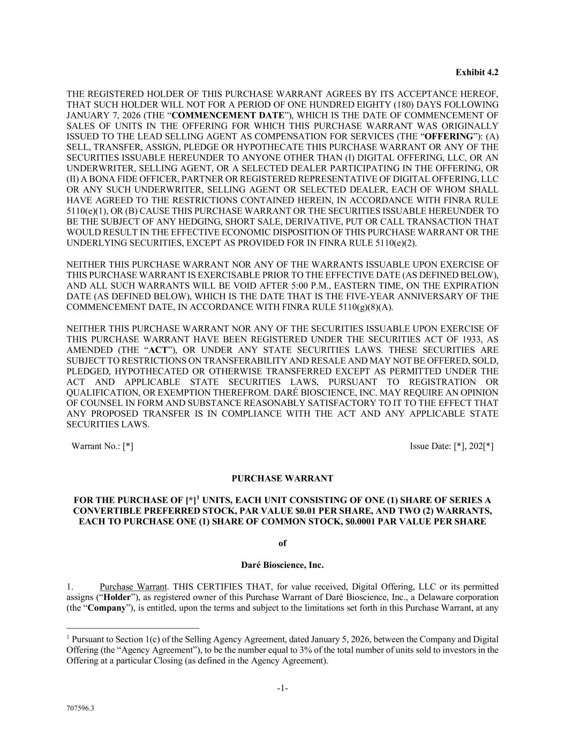
48
-1- 707596.3 Exhibit 4.2 THE REGISTERED HOLDER OF THIS PURCHASE WARRANT AGREES BY ITS ACCEPTANCE HEREOF, THAT SUCH HOLDER WILL NOT FOR A PERIOD OF ONE HUNDRED EIGHTY (180) DAYS FOLLOWING JANUARY 7, 2026 (THE “COMMENCEMENT DATE”), WHICH IS THE DATE OF COMMENCEMENT OF SALES OF UNITS IN THE OFFERING FOR WHICH THIS PURCHASE WARRANT WAS ORIGINALLY ISSUED TO THE LEAD SELLING AGENT AS COMPENSATION FOR SERVICES (THE “OFFERING”): (A) SELL, TRANSFER, ASSIGN, PLEDGE OR HYPOTHECATE THIS PURCHASE WARRANT OR ANY OF THE SECURITIES ISSUABLE HEREUNDER TO ANYONE OTHER THAN (I) DIGITAL OFFERING, LLC, OR AN UNDERWRITER, SELLING AGENT, OR A SELECTED DEALER PARTICIPATING IN THE OFFERING, OR (II) A BONA FIDE OFFICER, PARTNER OR REGISTERED REPRESENTATIVE OF DIGITAL OFFERING, LLC OR ANY SUCH UNDERWRITER, SELLING AGENT OR SELECTED DEALER, EACH OF WHOM SHALL HAVE AGREED TO THE RESTRICTIONS CONTAINED HEREIN, IN ACCORDANCE WITH FINRA RULE 5110(e)(1), OR (B) CAUSE THIS PURCHASE WARRANT OR THE SECURITIES ISSUABLE HEREUNDER TO BE THE SUBJECT OF ANY HEDGING, SHORT SALE, DERIVATIVE, PUT OR CALL TRANSACTION THAT WOULD RESULT IN THE EFFECTIVE ECONOMIC DISPOSITION OF THIS PURCHASE WARRANT OR THE UNDERLYING SECURITIES, EXCEPT AS PROVIDED FOR IN FINRA RULE 5110(e)(2). NEITHER THIS PURCHASE WARRANT NOR ANY OF THE WARRANTS ISSUABLE UPON EXERCISE OF THIS PURCHASE WARRANT IS EXERCISABLE PRIOR TO THE EFFECTIVE DATE (AS DEFINED BELOW), AND ALL SUCH WARRANTS WILL BE VOID AFTER 5:00 P.M., EASTERN TIME, ON THE EXPIRATION DATE (AS DEFINED BELOW), WHICH IS THE DATE THAT IS THE FIVE-YEAR ANNIVERSARY OF THE COMMENCEMENT DATE, IN ACCORDANCE WITH FINRA RULE 5110(g)(8)(A). NEITHER THIS PURCHASE WARRANT NOR ANY OF THE SECURITIES ISSUABLE UPON EXERCISE OF THIS PURCHASE WARRANT HAVE BEEN REGISTERED UNDER THE SECURITIES ACT OF 1933, AS AMENDED (THE “ACT”), OR UNDER ANY STATE SECURITIES LAWS. THESE SECURITIES ARE SUBJECT TO RESTRICTIONS ON TRANSFERABILITY AND RESALE AND MAY NOT BE OFFERED, SOLD, PLEDGED, HYPOTHECATED OR OTHERWISE TRANSFERRED EXCEPT AS PERMITTED UNDER THE ACT AND APPLICABLE STATE SECURITIES LAWS, PURSUANT TO REGISTRATION OR QUALIFICATION, OR EXEMPTION THEREFROM. DARÉ BIOSCIENCE, INC. MAY REQUIRE AN OPINION OF COUNSEL IN FORM AND SUBSTANCE REASONABLY SATISFACTORY TO IT TO THE EFFECT THAT ANY PROPOSED TRANSFER IS IN COMPLIANCE WITH THE ACT AND ANY APPLICABLE STATE SECURITIES LAWS. Warrant No.: [*] Issue Date: [*], 202[*] PURCHASE WARRANT FOR THE PURCHASE OF [*]1 UNITS, EACH UNIT CONSISTING OF ONE (1) SHARE OF SERIES A CONVERTIBLE PREFERRED STOCK, PAR VALUE $0.01 PER SHARE, AND TWO (2) WARRANTS, EACH TO PURCHASE ONE (1) SHARE OF COMMON STOCK, $0.0001 PAR VALUE PER SHARE of Daré Bioscience, Inc. 1. Purchase Warrant. THIS CERTIFIES THAT, for value received, Digital Offering, LLC or its permitted assigns (“Holder”), as registered owner of this Purchase Warrant of Daré Bioscience, Inc., a Delaware corporation (the “Company”), is entitled, upon the terms and subject to the limitations set forth in this Purchase Warrant, at any 1 Pursuant to Section 1(c) of the Selling Agency Agreement, dated January 5, 2026, between the Company and Digital Offering (the “Agency Agreement”), to be the number equal to 3% of the total number of units sold to investors in the Offering at a particular Closing (as defined in the Agency Agreement).

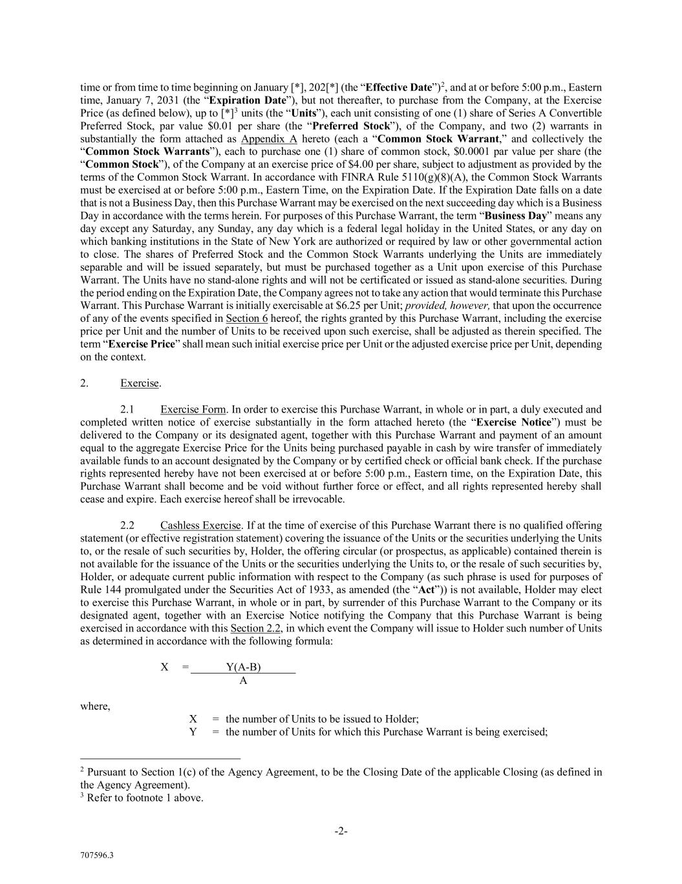
-2- 707596.3 time or from time to time beginning on January [*], 202[*] (the “Effective Date”)2, and at or before 5:00 p.m., Eastern time, January 7, 2031 (the “Expiration Date”), but not thereafter, to purchase from the Company, at the Exercise Price (as defined below), up to [*]3 units (the “Units”), each unit consisting of one (1) share of Series A Convertible Preferred Stock, par value $0.01 per share (the “Preferred Stock”), of the Company, and two (2) warrants in substantially the form attached as Appendix A hereto (each a “Common Stock Warrant,” and collectively the “Common Stock Warrants”), each to purchase one (1) share of common stock, $0.0001 par value per share (the “Common Stock”), of the Company at an exercise price of $4.00 per share, subject to adjustment as provided by the terms of the Common Stock Warrant. In accordance with FINRA Rule 5110(g)(8)(A), the Common Stock Warrants must be exercised at or before 5:00 p.m., Eastern Time, on the Expiration Date. If the Expiration Date falls on a date that is not a Business Day, then this Purchase Warrant may be exercised on the next succeeding day which is a Business Day in accordance with the terms herein. For purposes of this Purchase Warrant, the term “Business Day” means any day except any Saturday, any Sunday, any day which is a federal legal holiday in the United States, or any day on which banking institutions in the State of New York are authorized or required by law or other governmental action to close. The shares of Preferred Stock and the Common Stock Warrants underlying the Units are immediately separable and will be issued separately, but must be purchased together as a Unit upon exercise of this Purchase Warrant. The Units have no stand-alone rights and will not be certificated or issued as stand-alone securities. During the period ending on the Expiration Date, the Company agrees not to take any action that would terminate this Purchase Warrant. This Purchase Warrant is initially exercisable at $6.25 per Unit; provided, however, that upon the occurrence of any of the events specified in Section 6 hereof, the rights granted by this Purchase Warrant, including the exercise price per Unit and the number of Units to be received upon such exercise, shall be adjusted as therein specified. The term “Exercise Price” shall mean such initial exercise price per Unit or the adjusted exercise price per Unit, depending on the context. 2. Exercise. 2.1 Exercise Form. In order to exercise this Purchase Warrant, in whole or in part, a duly executed and completed written notice of exercise substantially in the form attached hereto (the “Exercise Notice”) must be delivered to the Company or its designated agent, together with this Purchase Warrant and payment of an amount equal to the aggregate Exercise Price for the Units being purchased payable in cash by wire transfer of immediately available funds to an account designated by the Company or by certified check or official bank check. If the purchase rights represented hereby have not been exercised at or before 5:00 p.m., Eastern time, on the Expiration Date, this Purchase Warrant shall become and be void without further force or effect, and all rights represented hereby shall cease and expire. Each exercise hereof shall be irrevocable. 2.2 Cashless Exercise. If at the time of exercise of this Purchase Warrant there is no qualified offering statement (or effective registration statement) covering the issuance of the Units or the securities underlying the Units to, or the resale of such securities by, Holder, the offering circular (or prospectus, as applicable) contained therein is not available for the issuance of the Units or the securities underlying the Units to, or the resale of such securities by, Holder, or adequate current public information with respect to the Company (as such phrase is used for purposes of Rule 144 promulgated under the Securities Act of 1933, as amended (the “Act”)) is not available, Holder may elect to exercise this Purchase Warrant, in whole or in part, by surrender of this Purchase Warrant to the Company or its designated agent, together with an Exercise Notice notifying the Company that this Purchase Warrant is being exercised in accordance with this Section 2.2, in which event the Company will issue to Holder such number of Units as determined in accordance with the following formula: X = Y(A-B) A where, X = the number of Units to be issued to Holder; Y = the number of Units for which this Purchase Warrant is being exercised; 2 Pursuant to Section 1(c) of the Agency Agreement, to be the Closing Date of the applicable Closing (as defined in the Agency Agreement). 3 Refer to footnote 1 above.

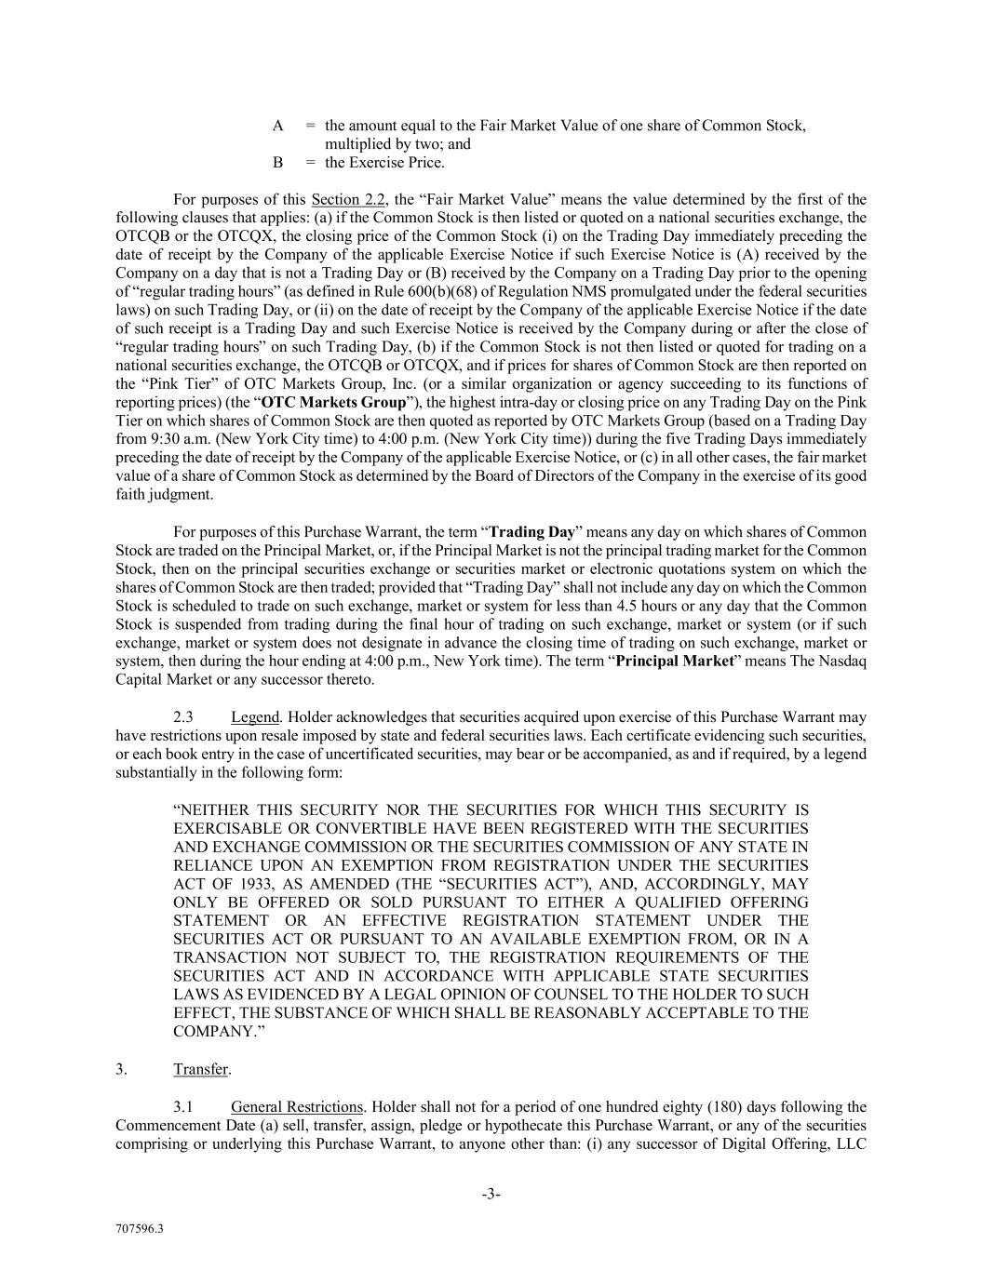
-3- 707596.3 A = the amount equal to the Fair Market Value of one share of Common Stock, multiplied by two; and B = the Exercise Price. For purposes of this Section 2.2, the “Fair Market Value” means the value determined by the first of the following clauses that applies: (a) if the Common Stock is then listed or quoted on a national securities exchange, the OTCQB or the OTCQX, the closing price of the Common Stock (i) on the Trading Day immediately preceding the date of receipt by the Company of the applicable Exercise Notice if such Exercise Notice is (A) received by the Company on a day that is not a Trading Day or (B) received by the Company on a Trading Day prior to the opening of “regular trading hours” (as defined in Rule 600(b)(68) of Regulation NMS promulgated under the federal securities laws) on such Trading Day, or (ii) on the date of receipt by the Company of the applicable Exercise Notice if the date of such receipt is a Trading Day and such Exercise Notice is received by the Company during or after the close of “regular trading hours” on such Trading Day, (b) if the Common Stock is not then listed or quoted for trading on a national securities exchange, the OTCQB or OTCQX, and if prices for shares of Common Stock are then reported on the “Pink Tier” of OTC Markets Group, Inc. (or a similar organization or agency succeeding to its functions of reporting prices) (the “OTC Markets Group”), the highest intra-day or closing price on any Trading Day on the Pink Tier on which shares of Common Stock are then quoted as reported by OTC Markets Group (based on a Trading Day from 9:30 a.m. (New York City time) to 4:00 p.m. (New York City time)) during the five Trading Days immediately preceding the date of receipt by the Company of the applicable Exercise Notice, or (c) in all other cases, the fair market value of a share of Common Stock as determined by the Board of Directors of the Company in the exercise of its good faith judgment. For purposes of this Purchase Warrant, the term “Trading Day” means any day on which shares of Common Stock are traded on the Principal Market, or, if the Principal Market is not the principal trading market for the Common Stock, then on the principal securities exchange or securities market or electronic quotations system on which the shares of Common Stock are then traded; provided that “Trading Day” shall not include any day on which the Common Stock is scheduled to trade on such exchange, market or system for less than 4.5 hours or any day that the Common Stock is suspended from trading during the final hour of trading on such exchange, market or system (or if such exchange, market or system does not designate in advance the closing time of trading on such exchange, market or system, then during the hour ending at 4:00 p.m., New York time). The term “Principal Market” means The Nasdaq Capital Market or any successor thereto. 2.3 Legend. Holder acknowledges that securities acquired upon exercise of this Purchase Warrant may have restrictions upon resale imposed by state and federal securities laws. Each certificate evidencing such securities, or each book entry in the case of uncertificated securities, may bear or be accompanied, as and if required, by a legend substantially in the following form: “NEITHER THIS SECURITY NOR THE SECURITIES FOR WHICH THIS SECURITY IS EXERCISABLE OR CONVERTIBLE HAVE BEEN REGISTERED WITH THE SECURITIES AND EXCHANGE COMMISSION OR THE SECURITIES COMMISSION OF ANY STATE IN RELIANCE UPON AN EXEMPTION FROM REGISTRATION UNDER THE SECURITIES ACT OF 1933, AS AMENDED (THE “SECURITIES ACT”), AND, ACCORDINGLY, MAY ONLY BE OFFERED OR SOLD PURSUANT TO EITHER A QUALIFIED OFFERING STATEMENT OR AN EFFECTIVE REGISTRATION STATEMENT UNDER THE SECURITIES ACT OR PURSUANT TO AN AVAILABLE EXEMPTION FROM, OR IN A TRANSACTION NOT SUBJECT TO, THE REGISTRATION REQUIREMENTS OF THE SECURITIES ACT AND IN ACCORDANCE WITH APPLICABLE STATE SECURITIES LAWS AS EVIDENCED BY A LEGAL OPINION OF COUNSEL TO THE HOLDER TO SUCH EFFECT, THE SUBSTANCE OF WHICH SHALL BE REASONABLY ACCEPTABLE TO THE COMPANY.” 3. Transfer. 3.1 General Restrictions. Holder shall not for a period of one hundred eighty (180) days following the Commencement Date (a) sell, transfer, assign, pledge or hypothecate this Purchase Warrant, or any of the securities comprising or underlying this Purchase Warrant, to anyone other than: (i) any successor of Digital Offering, LLC

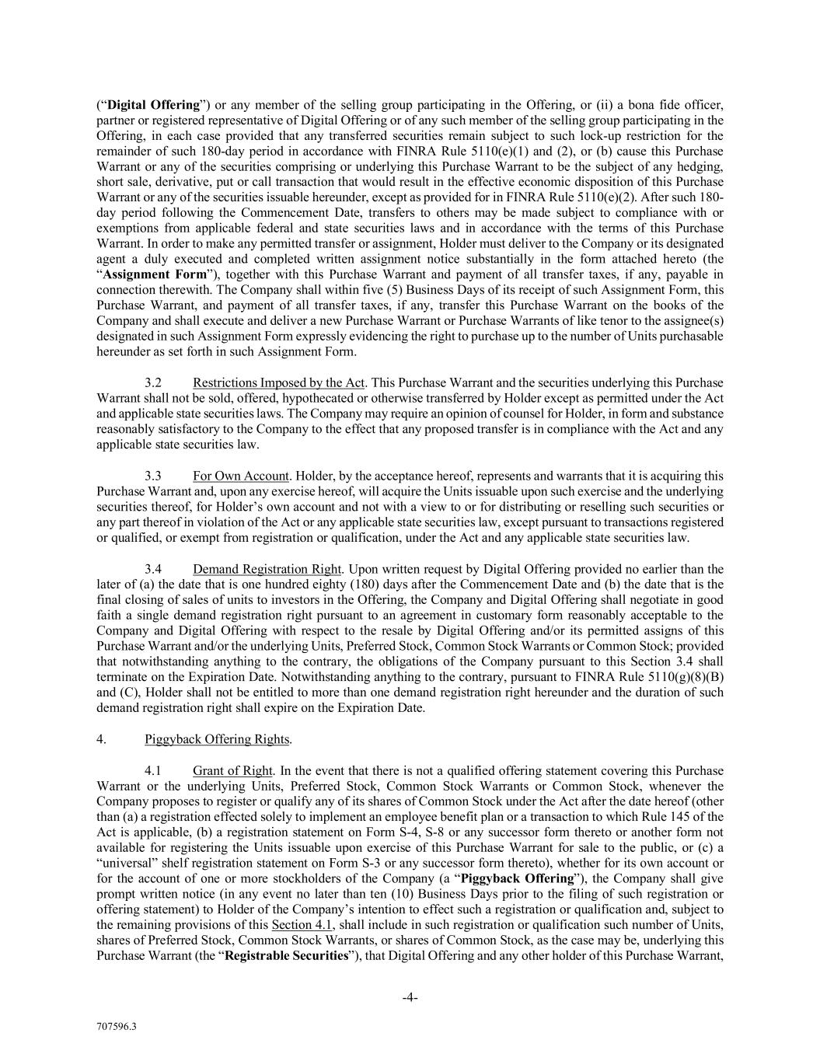
-4- 707596.3 (“Digital Offering”) or any member of the selling group participating in the Offering, or (ii) a bona fide officer, partner or registered representative of Digital Offering or of any such member of the selling group participating in the Offering, in each case provided that any transferred securities remain subject to such lock-up restriction for the remainder of such 180-day period in accordance with FINRA Rule 5110(e)(1) and (2), or (b) cause this Purchase Warrant or any of the securities comprising or underlying this Purchase Warrant to be the subject of any hedging, short sale, derivative, put or call transaction that would result in the effective economic disposition of this Purchase Warrant or any of the securities issuable hereunder, except as provided for in FINRA Rule 5110(e)(2). After such 180- day period following the Commencement Date, transfers to others may be made subject to compliance with or exemptions from applicable federal and state securities laws and in accordance with the terms of this Purchase Warrant. In order to make any permitted transfer or assignment, Holder must deliver to the Company or its designated agent a duly executed and completed written assignment notice substantially in the form attached hereto (the “Assignment Form”), together with this Purchase Warrant and payment of all transfer taxes, if any, payable in connection therewith. The Company shall within five (5) Business Days of its receipt of such Assignment Form, this Purchase Warrant, and payment of all transfer taxes, if any, transfer this Purchase Warrant on the books of the Company and shall execute and deliver a new Purchase Warrant or Purchase Warrants of like tenor to the assignee(s) designated in such Assignment Form expressly evidencing the right to purchase up to the number of Units purchasable hereunder as set forth in such Assignment Form. 3.2 Restrictions Imposed by the Act. This Purchase Warrant and the securities underlying this Purchase Warrant shall not be sold, offered, hypothecated or otherwise transferred by Holder except as permitted under the Act and applicable state securities laws. The Company may require an opinion of counsel for Holder, in form and substance reasonably satisfactory to the Company to the effect that any proposed transfer is in compliance with the Act and any applicable state securities law. 3.3 For Own Account. Holder, by the acceptance hereof, represents and warrants that it is acquiring this Purchase Warrant and, upon any exercise hereof, will acquire the Units issuable upon such exercise and the underlying securities thereof, for Holder’s own account and not with a view to or for distributing or reselling such securities or any part thereof in violation of the Act or any applicable state securities law, except pursuant to transactions registered or qualified, or exempt from registration or qualification, under the Act and any applicable state securities law. 3.4 Demand Registration Right. Upon written request by Digital Offering provided no earlier than the later of (a) the date that is one hundred eighty (180) days after the Commencement Date and (b) the date that is the final closing of sales of units to investors in the Offering, the Company and Digital Offering shall negotiate in good faith a single demand registration right pursuant to an agreement in customary form reasonably acceptable to the Company and Digital Offering with respect to the resale by Digital Offering and/or its permitted assigns of this Purchase Warrant and/or the underlying Units, Preferred Stock, Common Stock Warrants or Common Stock; provided that notwithstanding anything to the contrary, the obligations of the Company pursuant to this Section 3.4 shall terminate on the Expiration Date. Notwithstanding anything to the contrary, pursuant to FINRA Rule 5110(g)(8)(B) and (C), Holder shall not be entitled to more than one demand registration right hereunder and the duration of such demand registration right shall expire on the Expiration Date. 4. Piggyback Offering Rights. 4.1 Grant of Right. In the event that there is not a qualified offering statement covering this Purchase Warrant or the underlying Units, Preferred Stock, Common Stock Warrants or Common Stock, whenever the Company proposes to register or qualify any of its shares of Common Stock under the Act after the date hereof (other than (a) a registration effected solely to implement an employee benefit plan or a transaction to which Rule 145 of the Act is applicable, (b) a registration statement on Form S-4, S-8 or any successor form thereto or another form not available for registering the Units issuable upon exercise of this Purchase Warrant for sale to the public, or (c) a “universal” shelf registration statement on Form S-3 or any successor form thereto), whether for its own account or for the account of one or more stockholders of the Company (a “Piggyback Offering”), the Company shall give prompt written notice (in any event no later than ten (10) Business Days prior to the filing of such registration or offering statement) to Holder of the Company’s intention to effect such a registration or qualification and, subject to the remaining provisions of this Section 4.1, shall include in such registration or qualification such number of Units, shares of Preferred Stock, Common Stock Warrants, or shares of Common Stock, as the case may be, underlying this Purchase Warrant (the “Registrable Securities”), that Digital Offering and any other holder of this Purchase Warrant,

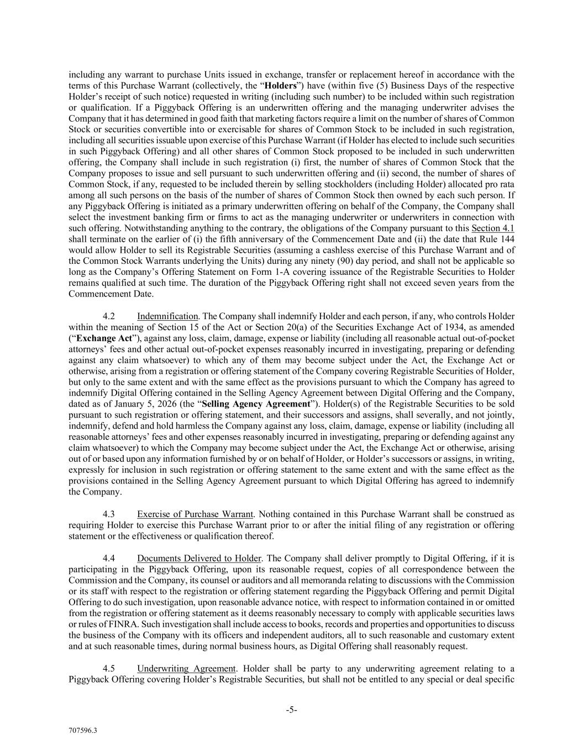
-5- 707596.3 including any warrant to purchase Units issued in exchange, transfer or replacement hereof in accordance with the terms of this Purchase Warrant (collectively, the “Holders”) have (within five (5) Business Days of the respective Holder’s receipt of such notice) requested in writing (including such number) to be included within such registration or qualification. If a Piggyback Offering is an underwritten offering and the managing underwriter advises the Company that it has determined in good faith that marketing factors require a limit on the number of shares of Common Stock or securities convertible into or exercisable for shares of Common Stock to be included in such registration, including all securities issuable upon exercise of this Purchase Warrant (if Holder has elected to include such securities in such Piggyback Offering) and all other shares of Common Stock proposed to be included in such underwritten offering, the Company shall include in such registration (i) first, the number of shares of Common Stock that the Company proposes to issue and sell pursuant to such underwritten offering and (ii) second, the number of shares of Common Stock, if any, requested to be included therein by selling stockholders (including Holder) allocated pro rata among all such persons on the basis of the number of shares of Common Stock then owned by each such person. If any Piggyback Offering is initiated as a primary underwritten offering on behalf of the Company, the Company shall select the investment banking firm or firms to act as the managing underwriter or underwriters in connection with such offering. Notwithstanding anything to the contrary, the obligations of the Company pursuant to this Section 4.1 shall terminate on the earlier of (i) the fifth anniversary of the Commencement Date and (ii) the date that Rule 144 would allow Holder to sell its Registrable Securities (assuming a cashless exercise of this Purchase Warrant and of the Common Stock Warrants underlying the Units) during any ninety (90) day period, and shall not be applicable so long as the Company’s Offering Statement on Form 1-A covering issuance of the Registrable Securities to Holder remains qualified at such time. The duration of the Piggyback Offering right shall not exceed seven years from the Commencement Date. 4.2 Indemnification. The Company shall indemnify Holder and each person, if any, who controls Holder within the meaning of Section 15 of the Act or Section 20(a) of the Securities Exchange Act of 1934, as amended (“Exchange Act”), against any loss, claim, damage, expense or liability (including all reasonable actual out-of-pocket attorneys’ fees and other actual out-of-pocket expenses reasonably incurred in investigating, preparing or defending against any claim whatsoever) to which any of them may become subject under the Act, the Exchange Act or otherwise, arising from a registration or offering statement of the Company covering Registrable Securities of Holder, but only to the same extent and with the same effect as the provisions pursuant to which the Company has agreed to indemnify Digital Offering contained in the Selling Agency Agreement between Digital Offering and the Company, dated as of January 5, 2026 (the “Selling Agency Agreement”). Holder(s) of the Registrable Securities to be sold pursuant to such registration or offering statement, and their successors and assigns, shall severally, and not jointly, indemnify, defend and hold harmless the Company against any loss, claim, damage, expense or liability (including all reasonable attorneys’ fees and other expenses reasonably incurred in investigating, preparing or defending against any claim whatsoever) to which the Company may become subject under the Act, the Exchange Act or otherwise, arising out of or based upon any information furnished by or on behalf of Holder, or Holder’s successors or assigns, in writing, expressly for inclusion in such registration or offering statement to the same extent and with the same effect as the provisions contained in the Selling Agency Agreement pursuant to which Digital Offering has agreed to indemnify the Company. 4.3 Exercise of Purchase Warrant. Nothing contained in this Purchase Warrant shall be construed as requiring Holder to exercise this Purchase Warrant prior to or after the initial filing of any registration or offering statement or the effectiveness or qualification thereof. 4.4 Documents Delivered to Holder. The Company shall deliver promptly to Digital Offering, if it is participating in the Piggyback Offering, upon its reasonable request, copies of all correspondence between the Commission and the Company, its counsel or auditors and all memoranda relating to discussions with the Commission or its staff with respect to the registration or offering statement regarding the Piggyback Offering and permit Digital Offering to do such investigation, upon reasonable advance notice, with respect to information contained in or omitted from the registration or offering statement as it deems reasonably necessary to comply with applicable securities laws or rules of FINRA. Such investigation shall include access to books, records and properties and opportunities to discuss the business of the Company with its officers and independent auditors, all to such reasonable and customary extent and at such reasonable times, during normal business hours, as Digital Offering shall reasonably request. 4.5 Underwriting Agreement. Holder shall be party to any underwriting agreement relating to a Piggyback Offering covering Holder’s Registrable Securities, but shall not be entitled to any special or deal specific

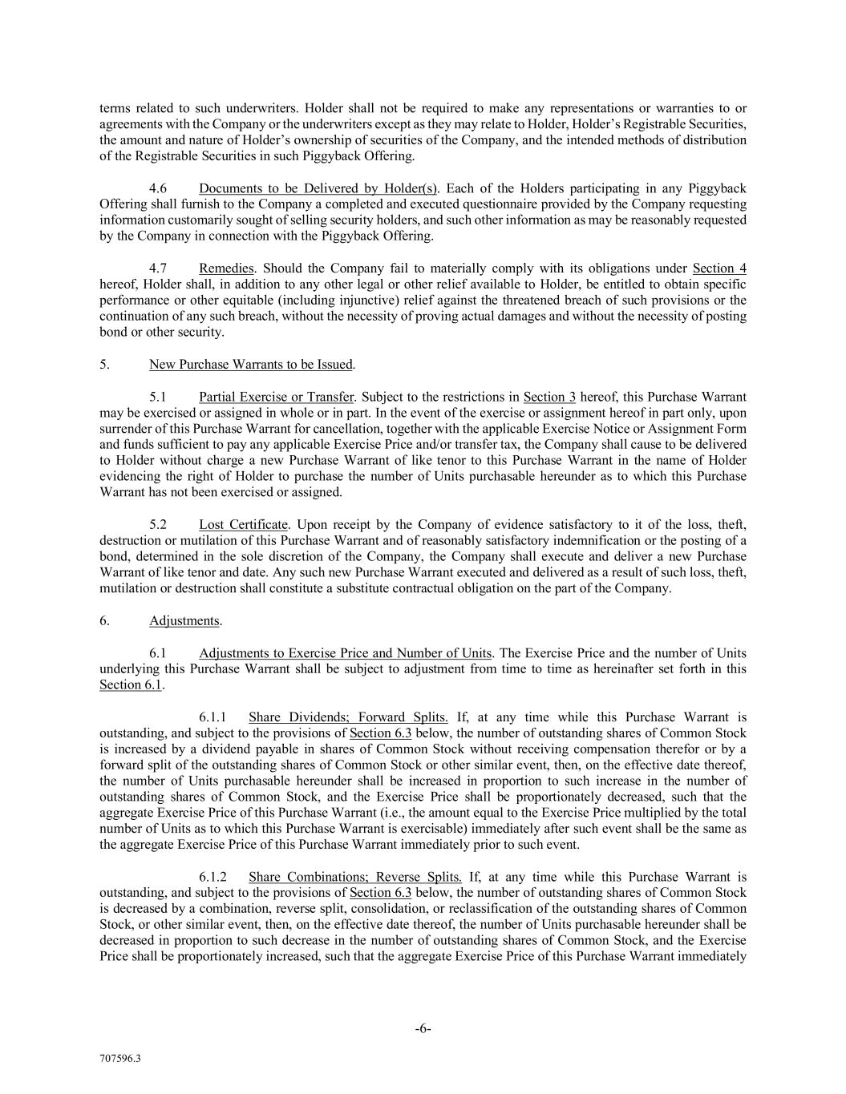
-6- 707596.3 terms related to such underwriters. Holder shall not be required to make any representations or warranties to or agreements with the Company or the underwriters except as they may relate to Holder, Holder’s Registrable Securities, the amount and nature of Holder’s ownership of securities of the Company, and the intended methods of distribution of the Registrable Securities in such Piggyback Offering. 4.6 Documents to be Delivered by Holder(s). Each of the Holders participating in any Piggyback Offering shall furnish to the Company a completed and executed questionnaire provided by the Company requesting information customarily sought of selling security holders, and such other information as may be reasonably requested by the Company in connection with the Piggyback Offering. 4.7 Remedies. Should the Company fail to materially comply with its obligations under Section 4 hereof, Holder shall, in addition to any other legal or other relief available to Holder, be entitled to obtain specific performance or other equitable (including injunctive) relief against the threatened breach of such provisions or the continuation of any such breach, without the necessity of proving actual damages and without the necessity of posting bond or other security. 5. New Purchase Warrants to be Issued. 5.1 Partial Exercise or Transfer. Subject to the restrictions in Section 3 hereof, this Purchase Warrant may be exercised or assigned in whole or in part. In the event of the exercise or assignment hereof in part only, upon surrender of this Purchase Warrant for cancellation, together with the applicable Exercise Notice or Assignment Form and funds sufficient to pay any applicable Exercise Price and/or transfer tax, the Company shall cause to be delivered to Holder without charge a new Purchase Warrant of like tenor to this Purchase Warrant in the name of Holder evidencing the right of Holder to purchase the number of Units purchasable hereunder as to which this Purchase Warrant has not been exercised or assigned. 5.2 Lost Certificate. Upon receipt by the Company of evidence satisfactory to it of the loss, theft, destruction or mutilation of this Purchase Warrant and of reasonably satisfactory indemnification or the posting of a bond, determined in the sole discretion of the Company, the Company shall execute and deliver a new Purchase Warrant of like tenor and date. Any such new Purchase Warrant executed and delivered as a result of such loss, theft, mutilation or destruction shall constitute a substitute contractual obligation on the part of the Company. 6. Adjustments. 6.1 Adjustments to Exercise Price and Number of Units. The Exercise Price and the number of Units underlying this Purchase Warrant shall be subject to adjustment from time to time as hereinafter set forth in this Section 6.1. 6.1.1 Share Dividends; Forward Splits. If, at any time while this Purchase Warrant is outstanding, and subject to the provisions of Section 6.3 below, the number of outstanding shares of Common Stock is increased by a dividend payable in shares of Common Stock without receiving compensation therefor or by a forward split of the outstanding shares of Common Stock or other similar event, then, on the effective date thereof, the number of Units purchasable hereunder shall be increased in proportion to such increase in the number of outstanding shares of Common Stock, and the Exercise Price shall be proportionately decreased, such that the aggregate Exercise Price of this Purchase Warrant (i.e., the amount equal to the Exercise Price multiplied by the total number of Units as to which this Purchase Warrant is exercisable) immediately after such event shall be the same as the aggregate Exercise Price of this Purchase Warrant immediately prior to such event. 6.1.2 Share Combinations; Reverse Splits. If, at any time while this Purchase Warrant is outstanding, and subject to the provisions of Section 6.3 below, the number of outstanding shares of Common Stock is decreased by a combination, reverse split, consolidation, or reclassification of the outstanding shares of Common Stock, or other similar event, then, on the effective date thereof, the number of Units purchasable hereunder shall be decreased in proportion to such decrease in the number of outstanding shares of Common Stock, and the Exercise Price shall be proportionately increased, such that the aggregate Exercise Price of this Purchase Warrant immediately

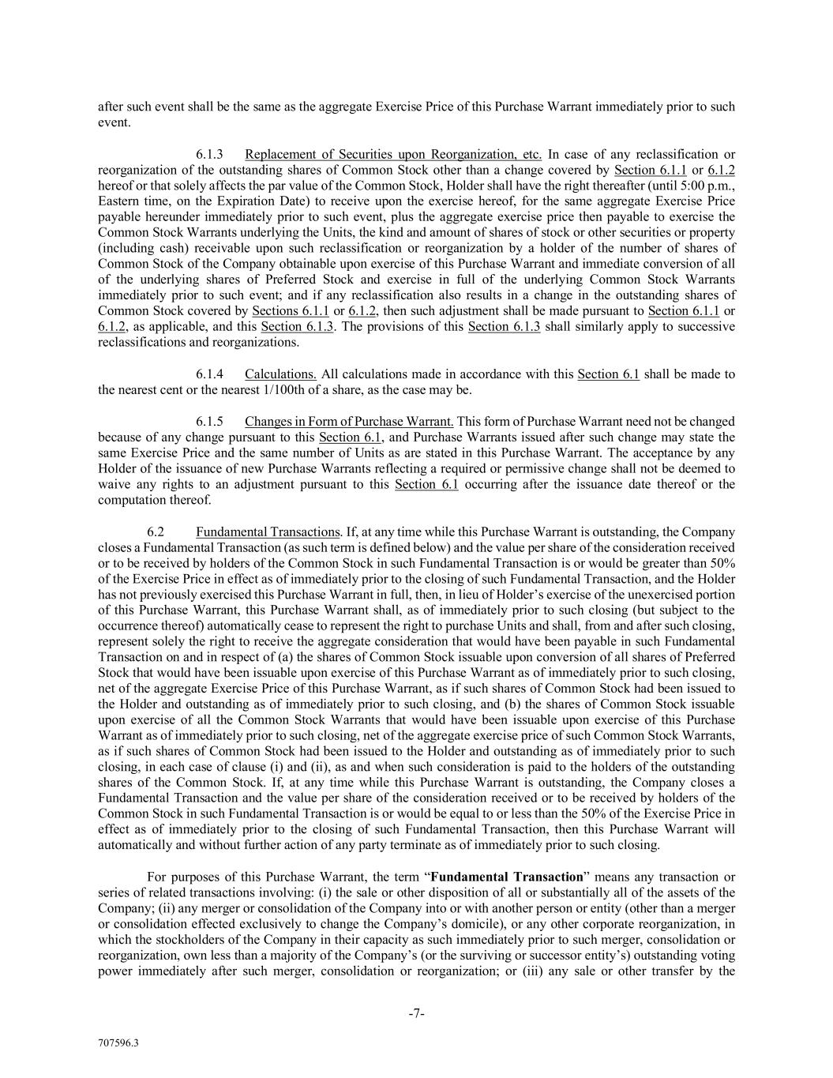
-7- 707596.3 after such event shall be the same as the aggregate Exercise Price of this Purchase Warrant immediately prior to such event. 6.1.3 Replacement of Securities upon Reorganization, etc. In case of any reclassification or reorganization of the outstanding shares of Common Stock other than a change covered by Section 6.1.1 or 6.1.2 hereof or that solely affects the par value of the Common Stock, Holder shall have the right thereafter (until 5:00 p.m., Eastern time, on the Expiration Date) to receive upon the exercise hereof, for the same aggregate Exercise Price payable hereunder immediately prior to such event, plus the aggregate exercise price then payable to exercise the Common Stock Warrants underlying the Units, the kind and amount of shares of stock or other securities or property (including cash) receivable upon such reclassification or reorganization by a holder of the number of shares of Common Stock of the Company obtainable upon exercise of this Purchase Warrant and immediate conversion of all of the underlying shares of Preferred Stock and exercise in full of the underlying Common Stock Warrants immediately prior to such event; and if any reclassification also results in a change in the outstanding shares of Common Stock covered by Sections 6.1.1 or 6.1.2, then such adjustment shall be made pursuant to Section 6.1.1 or 6.1.2, as applicable, and this Section 6.1.3. The provisions of this Section 6.1.3 shall similarly apply to successive reclassifications and reorganizations. 6.1.4 Calculations. All calculations made in accordance with this Section 6.1 shall be made to the nearest cent or the nearest 1/100th of a share, as the case may be. 6.1.5 Changes in Form of Purchase Warrant. This form of Purchase Warrant need not be changed because of any change pursuant to this Section 6.1, and Purchase Warrants issued after such change may state the same Exercise Price and the same number of Units as are stated in this Purchase Warrant. The acceptance by any Holder of the issuance of new Purchase Warrants reflecting a required or permissive change shall not be deemed to waive any rights to an adjustment pursuant to this Section 6.1 occurring after the issuance date thereof or the computation thereof. 6.2 Fundamental Transactions. If, at any time while this Purchase Warrant is outstanding, the Company closes a Fundamental Transaction (as such term is defined below) and the value per share of the consideration received or to be received by holders of the Common Stock in such Fundamental Transaction is or would be greater than 50% of the Exercise Price in effect as of immediately prior to the closing of such Fundamental Transaction, and the Holder has not previously exercised this Purchase Warrant in full, then, in lieu of Holder’s exercise of the unexercised portion of this Purchase Warrant, this Purchase Warrant shall, as of immediately prior to such closing (but subject to the occurrence thereof) automatically cease to represent the right to purchase Units and shall, from and after such closing, represent solely the right to receive the aggregate consideration that would have been payable in such Fundamental Transaction on and in respect of (a) the shares of Common Stock issuable upon conversion of all shares of Preferred Stock that would have been issuable upon exercise of this Purchase Warrant as of immediately prior to such closing, net of the aggregate Exercise Price of this Purchase Warrant, as if such shares of Common Stock had been issued to the Holder and outstanding as of immediately prior to such closing, and (b) the shares of Common Stock issuable upon exercise of all the Common Stock Warrants that would have been issuable upon exercise of this Purchase Warrant as of immediately prior to such closing, net of the aggregate exercise price of such Common Stock Warrants, as if such shares of Common Stock had been issued to the Holder and outstanding as of immediately prior to such closing, in each case of clause (i) and (ii), as and when such consideration is paid to the holders of the outstanding shares of the Common Stock. If, at any time while this Purchase Warrant is outstanding, the Company closes a Fundamental Transaction and the value per share of the consideration received or to be received by holders of the Common Stock in such Fundamental Transaction is or would be equal to or less than the 50% of the Exercise Price in effect as of immediately prior to the closing of such Fundamental Transaction, then this Purchase Warrant will automatically and without further action of any party terminate as of immediately prior to such closing. For purposes of this Purchase Warrant, the term “Fundamental Transaction” means any transaction or series of related transactions involving: (i) the sale or other disposition of all or substantially all of the assets of the Company; (ii) any merger or consolidation of the Company into or with another person or entity (other than a merger or consolidation effected exclusively to change the Company’s domicile), or any other corporate reorganization, in which the stockholders of the Company in their capacity as such immediately prior to such merger, consolidation or reorganization, own less than a majority of the Company’s (or the surviving or successor entity’s) outstanding voting power immediately after such merger, consolidation or reorganization; or (iii) any sale or other transfer by the

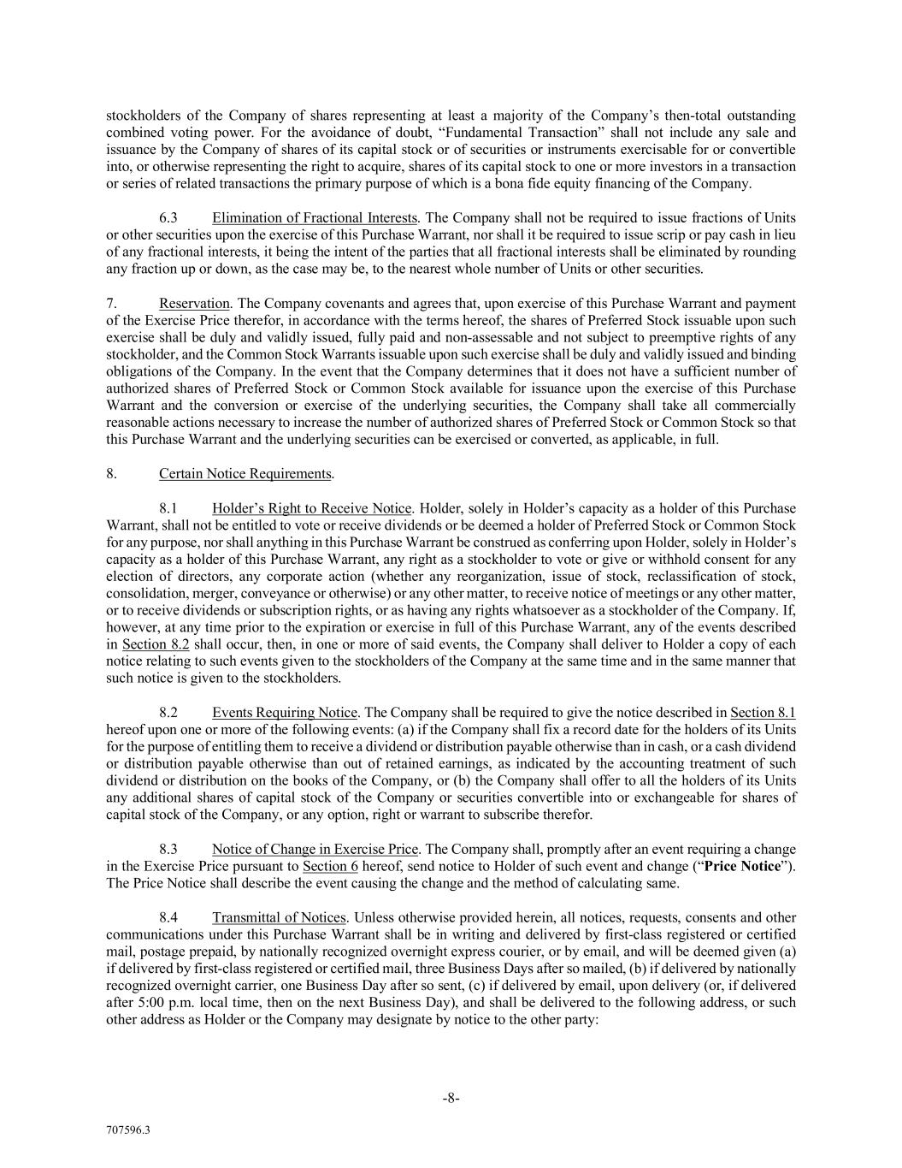
-8- 707596.3 stockholders of the Company of shares representing at least a majority of the Company’s then-total outstanding combined voting power. For the avoidance of doubt, “Fundamental Transaction” shall not include any sale and issuance by the Company of shares of its capital stock or of securities or instruments exercisable for or convertible into, or otherwise representing the right to acquire, shares of its capital stock to one or more investors in a transaction or series of related transactions the primary purpose of which is a bona fide equity financing of the Company. 6.3 Elimination of Fractional Interests. The Company shall not be required to issue fractions of Units or other securities upon the exercise of this Purchase Warrant, nor shall it be required to issue scrip or pay cash in lieu of any fractional interests, it being the intent of the parties that all fractional interests shall be eliminated by rounding any fraction up or down, as the case may be, to the nearest whole number of Units or other securities. 7. Reservation. The Company covenants and agrees that, upon exercise of this Purchase Warrant and payment of the Exercise Price therefor, in accordance with the terms hereof, the shares of Preferred Stock issuable upon such exercise shall be duly and validly issued, fully paid and non-assessable and not subject to preemptive rights of any stockholder, and the Common Stock Warrants issuable upon such exercise shall be duly and validly issued and binding obligations of the Company. In the event that the Company determines that it does not have a sufficient number of authorized shares of Preferred Stock or Common Stock available for issuance upon the exercise of this Purchase Warrant and the conversion or exercise of the underlying securities, the Company shall take all commercially reasonable actions necessary to increase the number of authorized shares of Preferred Stock or Common Stock so that this Purchase Warrant and the underlying securities can be exercised or converted, as applicable, in full. 8. Certain Notice Requirements. 8.1 Holder’s Right to Receive Notice. Holder, solely in Holder’s capacity as a holder of this Purchase Warrant, shall not be entitled to vote or receive dividends or be deemed a holder of Preferred Stock or Common Stock for any purpose, nor shall anything in this Purchase Warrant be construed as conferring upon Holder, solely in Holder’s capacity as a holder of this Purchase Warrant, any right as a stockholder to vote or give or withhold consent for any election of directors, any corporate action (whether any reorganization, issue of stock, reclassification of stock, consolidation, merger, conveyance or otherwise) or any other matter, to receive notice of meetings or any other matter, or to receive dividends or subscription rights, or as having any rights whatsoever as a stockholder of the Company. If, however, at any time prior to the expiration or exercise in full of this Purchase Warrant, any of the events described in Section 8.2 shall occur, then, in one or more of said events, the Company shall deliver to Holder a copy of each notice relating to such events given to the stockholders of the Company at the same time and in the same manner that such notice is given to the stockholders. 8.2 Events Requiring Notice. The Company shall be required to give the notice described in Section 8.1 hereof upon one or more of the following events: (a) if the Company shall fix a record date for the holders of its Units for the purpose of entitling them to receive a dividend or distribution payable otherwise than in cash, or a cash dividend or distribution payable otherwise than out of retained earnings, as indicated by the accounting treatment of such dividend or distribution on the books of the Company, or (b) the Company shall offer to all the holders of its Units any additional shares of capital stock of the Company or securities convertible into or exchangeable for shares of capital stock of the Company, or any option, right or warrant to subscribe therefor. 8.3 Notice of Change in Exercise Price. The Company shall, promptly after an event requiring a change in the Exercise Price pursuant to Section 6 hereof, send notice to Holder of such event and change (“Price Notice”). The Price Notice shall describe the event causing the change and the method of calculating same. 8.4 Transmittal of Notices. Unless otherwise provided herein, all notices, requests, consents and other communications under this Purchase Warrant shall be in writing and delivered by first-class registered or certified mail, postage prepaid, by nationally recognized overnight express courier, or by email, and will be deemed given (a) if delivered by first-class registered or certified mail, three Business Days after so mailed, (b) if delivered by nationally recognized overnight carrier, one Business Day after so sent, (c) if delivered by email, upon delivery (or, if delivered after 5:00 p.m. local time, then on the next Business Day), and shall be delivered to the following address, or such other address as Holder or the Company may designate by notice to the other party:

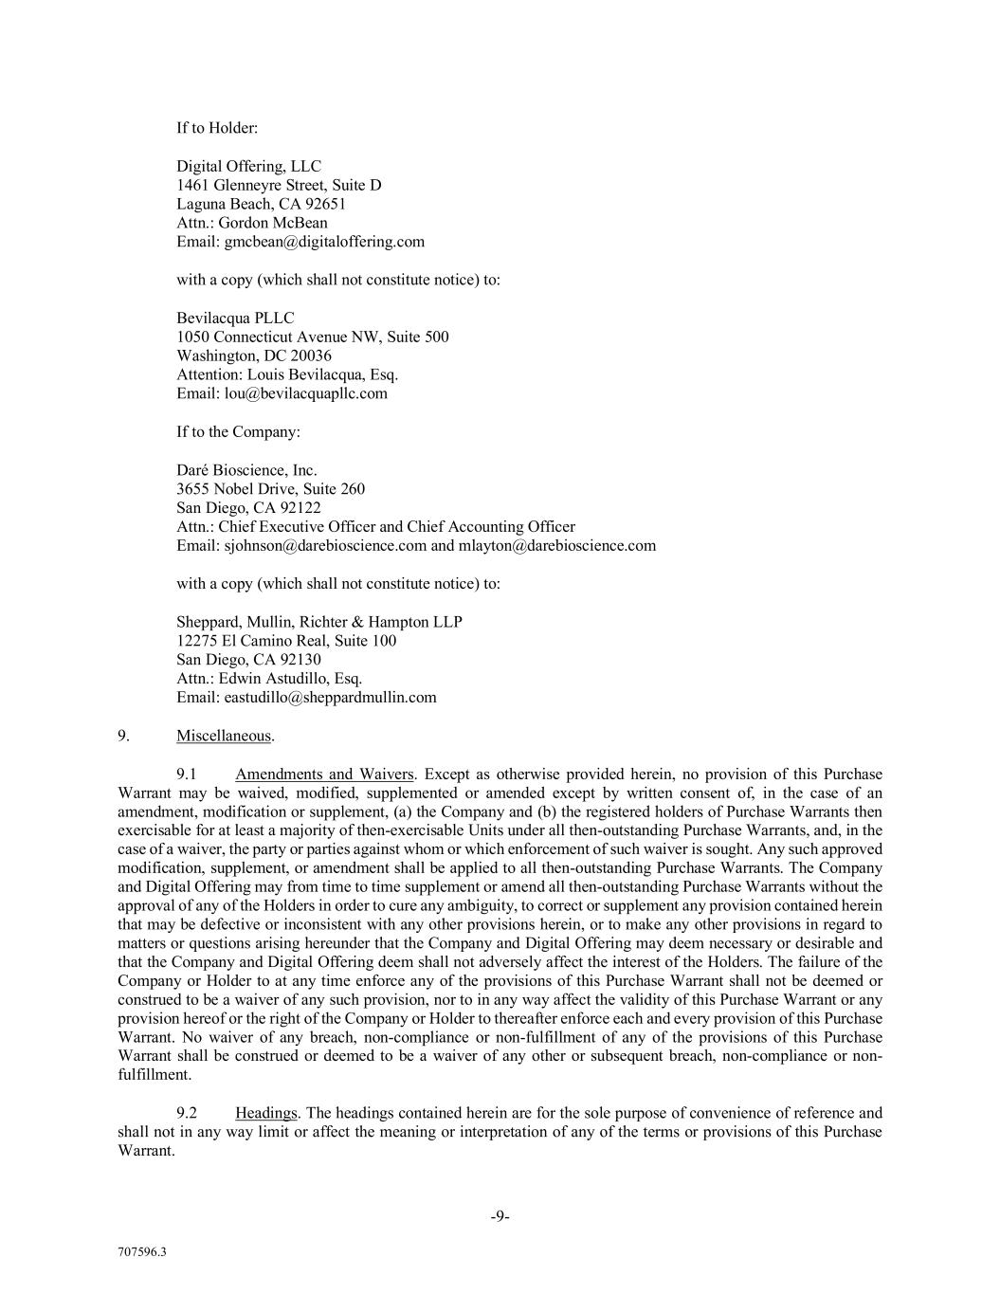
-9- 707596.3 If to Holder: Digital Offering, LLC 1461 Glenneyre Street, Suite D Laguna Beach, CA 92651 Attn.: Gordon McBean Email: gmcbean@digitaloffering.com with a copy (which shall not constitute notice) to: Bevilacqua PLLC 1050 Connecticut Avenue NW, Suite 500 Washington, DC 20036 Attention: Louis Bevilacqua, Esq. Email: lou@bevilacquapllc.com If to the Company: Daré Bioscience, Inc. 3655 Nobel Drive, Suite 260 San Diego, CA 92122 Attn.: Chief Executive Officer and Chief Accounting Officer Email: sjohnson@darebioscience.com and mlayton@darebioscience.com with a copy (which shall not constitute notice) to: Sheppard, Mullin, Richter & Hampton LLP 12275 El Camino Real, Suite 100 San Diego, CA 92130 Attn.: Edwin Astudillo, Esq. Email: eastudillo@sheppardmullin.com 9. Miscellaneous. 9.1 Amendments and Waivers. Except as otherwise provided herein, no provision of this Purchase Warrant may be waived, modified, supplemented or amended except by written consent of, in the case of an amendment, modification or supplement, (a) the Company and (b) the registered holders of Purchase Warrants then exercisable for at least a majority of then-exercisable Units under all then-outstanding Purchase Warrants, and, in the case of a waiver, the party or parties against whom or which enforcement of such waiver is sought. Any such approved modification, supplement, or amendment shall be applied to all then-outstanding Purchase Warrants. The Company and Digital Offering may from time to time supplement or amend all then-outstanding Purchase Warrants without the approval of any of the Holders in order to cure any ambiguity, to correct or supplement any provision contained herein that may be defective or inconsistent with any other provisions herein, or to make any other provisions in regard to matters or questions arising hereunder that the Company and Digital Offering may deem necessary or desirable and that the Company and Digital Offering deem shall not adversely affect the interest of the Holders. The failure of the Company or Holder to at any time enforce any of the provisions of this Purchase Warrant shall not be deemed or construed to be a waiver of any such provision, nor to in any way affect the validity of this Purchase Warrant or any provision hereof or the right of the Company or Holder to thereafter enforce each and every provision of this Purchase Warrant. No waiver of any breach, non-compliance or non-fulfillment of any of the provisions of this Purchase Warrant shall be construed or deemed to be a waiver of any other or subsequent breach, non-compliance or non- fulfillment. 9.2 Headings. The headings contained herein are for the sole purpose of convenience of reference and shall not in any way limit or affect the meaning or interpretation of any of the terms or provisions of this Purchase Warrant.

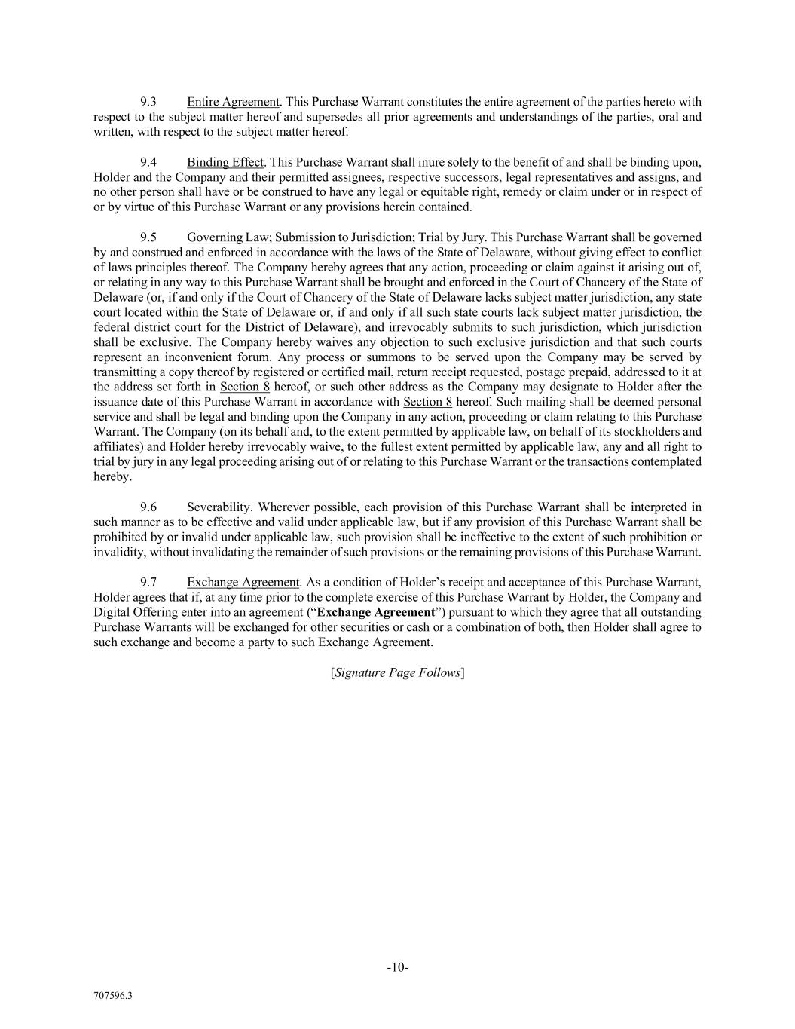
-10- 707596.3 9.3 Entire Agreement. This Purchase Warrant constitutes the entire agreement of the parties hereto with respect to the subject matter hereof and supersedes all prior agreements and understandings of the parties, oral and written, with respect to the subject matter hereof. 9.4 Binding Effect. This Purchase Warrant shall inure solely to the benefit of and shall be binding upon, Holder and the Company and their permitted assignees, respective successors, legal representatives and assigns, and no other person shall have or be construed to have any legal or equitable right, remedy or claim under or in respect of or by virtue of this Purchase Warrant or any provisions herein contained. 9.5 Governing Law; Submission to Jurisdiction; Trial by Jury. This Purchase Warrant shall be governed by and construed and enforced in accordance with the laws of the State of Delaware, without giving effect to conflict of laws principles thereof. The Company hereby agrees that any action, proceeding or claim against it arising out of, or relating in any way to this Purchase Warrant shall be brought and enforced in the Court of Chancery of the State of Delaware (or, if and only if the Court of Chancery of the State of Delaware lacks subject matter jurisdiction, any state court located within the State of Delaware or, if and only if all such state courts lack subject matter jurisdiction, the federal district court for the District of Delaware), and irrevocably submits to such jurisdiction, which jurisdiction shall be exclusive. The Company hereby waives any objection to such exclusive jurisdiction and that such courts represent an inconvenient forum. Any process or summons to be served upon the Company may be served by transmitting a copy thereof by registered or certified mail, return receipt requested, postage prepaid, addressed to it at the address set forth in Section 8 hereof, or such other address as the Company may designate to Holder after the issuance date of this Purchase Warrant in accordance with Section 8 hereof. Such mailing shall be deemed personal service and shall be legal and binding upon the Company in any action, proceeding or claim relating to this Purchase Warrant. The Company (on its behalf and, to the extent permitted by applicable law, on behalf of its stockholders and affiliates) and Holder hereby irrevocably waive, to the fullest extent permitted by applicable law, any and all right to trial by jury in any legal proceeding arising out of or relating to this Purchase Warrant or the transactions contemplated hereby. 9.6 Severability. Wherever possible, each provision of this Purchase Warrant shall be interpreted in such manner as to be effective and valid under applicable law, but if any provision of this Purchase Warrant shall be prohibited by or invalid under applicable law, such provision shall be ineffective to the extent of such prohibition or invalidity, without invalidating the remainder of such provisions or the remaining provisions of this Purchase Warrant. 9.7 Exchange Agreement. As a condition of Holder’s receipt and acceptance of this Purchase Warrant, Holder agrees that if, at any time prior to the complete exercise of this Purchase Warrant by Holder, the Company and Digital Offering enter into an agreement (“Exchange Agreement”) pursuant to which they agree that all outstanding Purchase Warrants will be exchanged for other securities or cash or a combination of both, then Holder shall agree to such exchange and become a party to such Exchange Agreement. [Signature Page Follows]


-11- 707596.3 IN WITNESS WHEREOF, the Company has caused this Purchase Warrant to be signed by its duly authorized officer as of the [*] day of [*], 202[*]. Daré Bioscience, Inc. By: Name: Title:

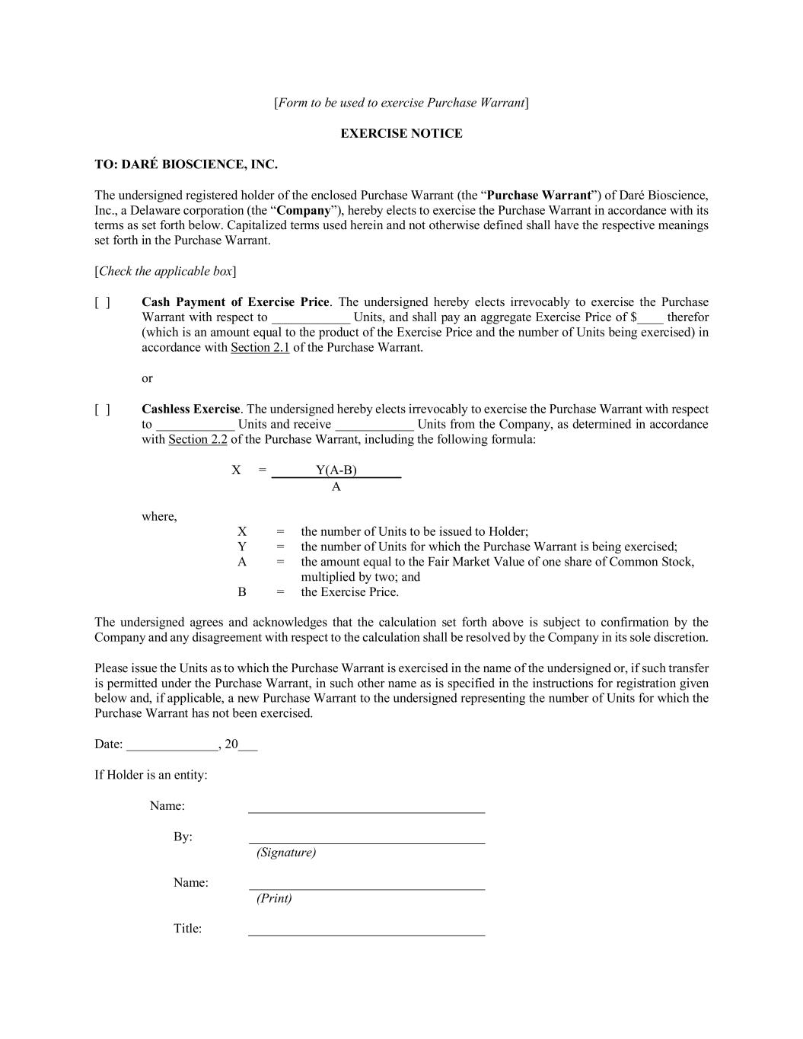
[Form to be used to exercise Purchase Warrant] EXERCISE NOTICE TO: DARÉ BIOSCIENCE, INC. The undersigned registered holder of the enclosed Purchase Warrant (the “Purchase Warrant”) of Daré Bioscience, Inc., a Delaware corporation (the “Company”), hereby elects to exercise the Purchase Warrant in accordance with its terms as set forth below. Capitalized terms used herein and not otherwise defined shall have the respective meanings set forth in the Purchase Warrant. [Check the applicable box] [ ] Cash Payment of Exercise Price. The undersigned hereby elects irrevocably to exercise the Purchase Warrant with respect to ____________ Units, and shall pay an aggregate Exercise Price of $____ therefor (which is an amount equal to the product of the Exercise Price and the number of Units being exercised) in accordance with Section 2.1 of the Purchase Warrant. or [ ] Cashless Exercise. The undersigned hereby elects irrevocably to exercise the Purchase Warrant with respect to ____________ Units and receive ____________ Units from the Company, as determined in accordance with Section 2.2 of the Purchase Warrant, including the following formula: X = Y(A-B) A where, X = the number of Units to be issued to Holder; Y = the number of Units for which the Purchase Warrant is being exercised; A = the amount equal to the Fair Market Value of one share of Common Stock, multiplied by two; and B = the Exercise Price. The undersigned agrees and acknowledges that the calculation set forth above is subject to confirmation by the Company and any disagreement with respect to the calculation shall be resolved by the Company in its sole discretion. Please issue the Units as to which the Purchase Warrant is exercised in the name of the undersigned or, if such transfer is permitted under the Purchase Warrant, in such other name as is specified in the instructions for registration given below and, if applicable, a new Purchase Warrant to the undersigned representing the number of Units for which the Purchase Warrant has not been exercised. Date: ______________, 20___ If Holder is an entity: Name: By: (Signature) Name: (Print) Title:

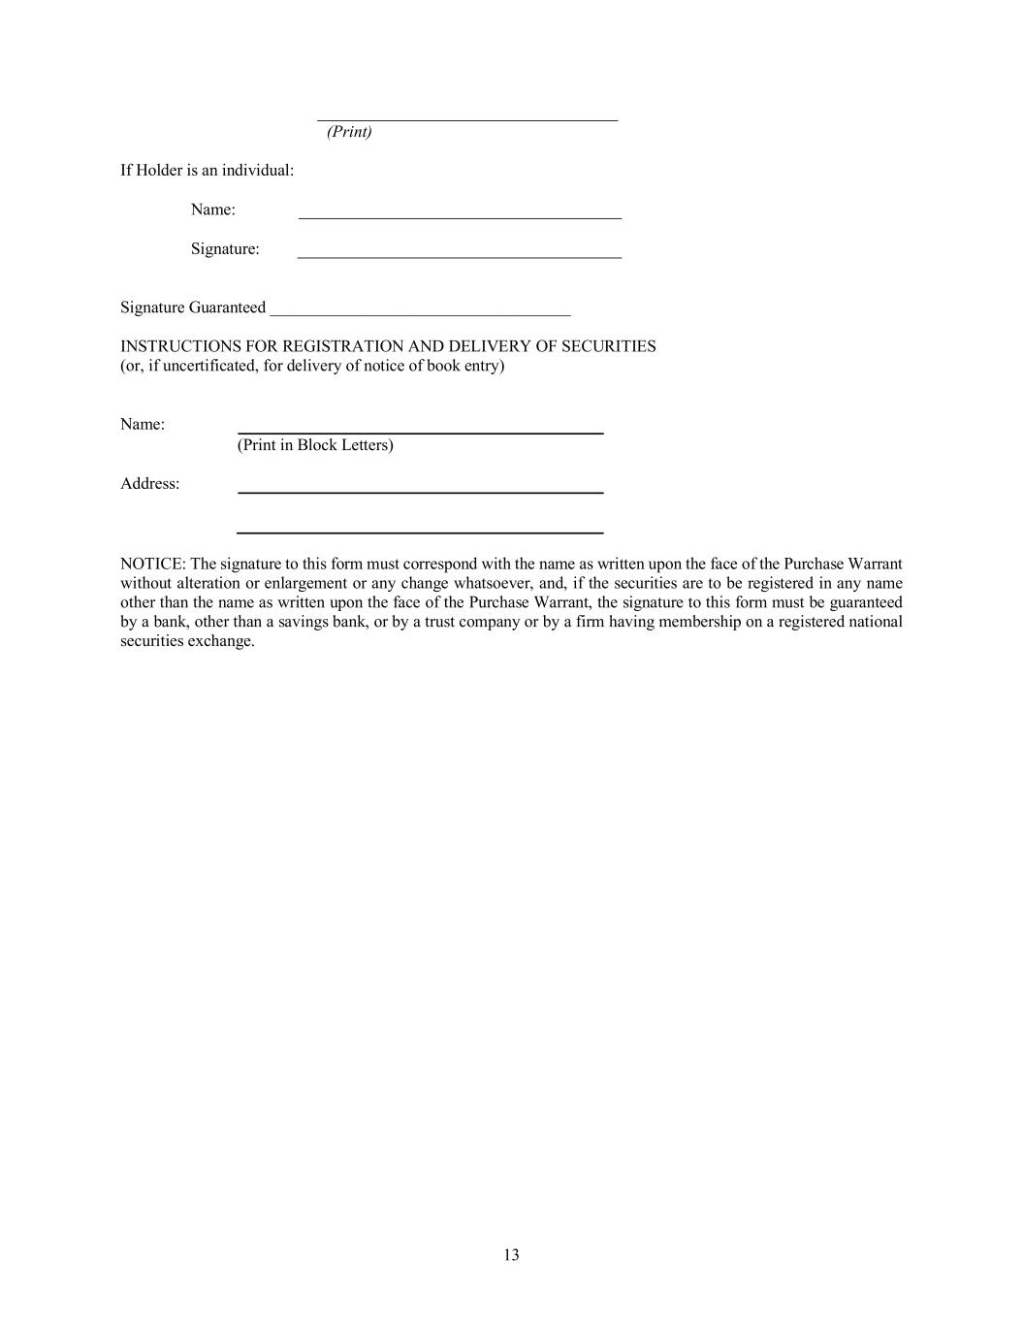
13 (Print) If Holder is an individual: Name: Signature: Signature Guaranteed ____________________________________ INSTRUCTIONS FOR REGISTRATION AND DELIVERY OF SECURITIES (or, if uncertificated, for delivery of notice of book entry) Name: (Print in Block Letters) Address: NOTICE: The signature to this form must correspond with the name as written upon the face of the Purchase Warrant without alteration or enlargement or any change whatsoever, and, if the securities are to be registered in any name other than the name as written upon the face of the Purchase Warrant, the signature to this form must be guaranteed by a bank, other than a savings bank, or by a trust company or by a firm having membership on a registered national securities exchange.

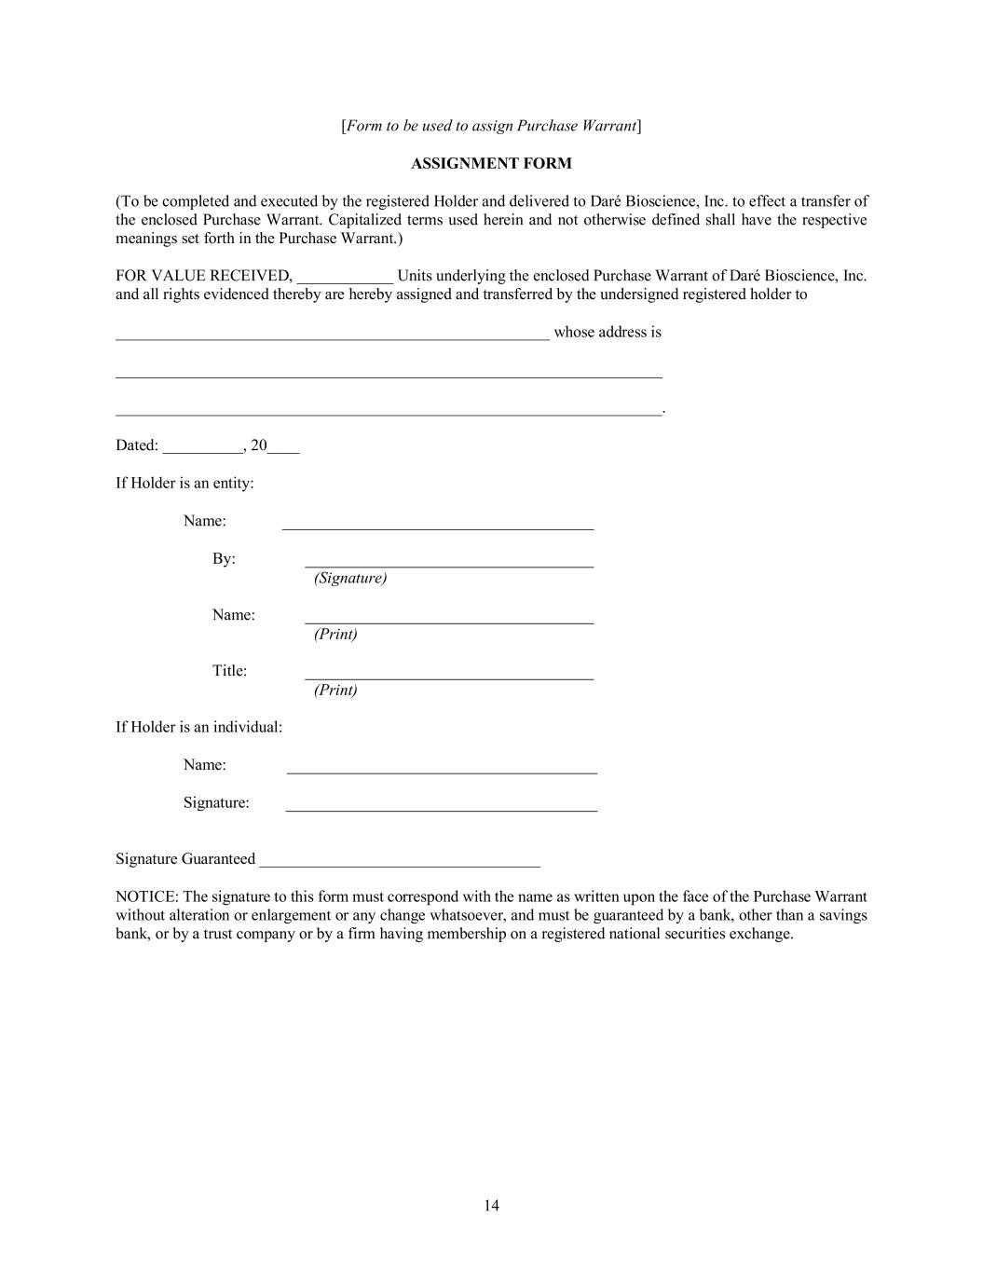
14 [Form to be used to assign Purchase Warrant] ASSIGNMENT FORM (To be completed and executed by the registered Holder and delivered to Daré Bioscience, Inc. to effect a transfer of the enclosed Purchase Warrant. Capitalized terms used herein and not otherwise defined shall have the respective meanings set forth in the Purchase Warrant.) FOR VALUE RECEIVED, ____________ Units underlying the enclosed Purchase Warrant of Daré Bioscience, Inc. and all rights evidenced thereby are hereby assigned and transferred by the undersigned registered holder to ______________________________________________________ whose address is ____________________________________________________________________ ____________________________________________________________________. Dated: __________, 20____ If Holder is an entity: Name: By: (Signature) Name: (Print) Title: (Print) If Holder is an individual: Name: Signature: Signature Guaranteed ___________________________________ NOTICE: The signature to this form must correspond with the name as written upon the face of the Purchase Warrant without alteration or enlargement or any change whatsoever, and must be guaranteed by a bank, other than a savings bank, or by a trust company or by a firm having membership on a registered national securities exchange.

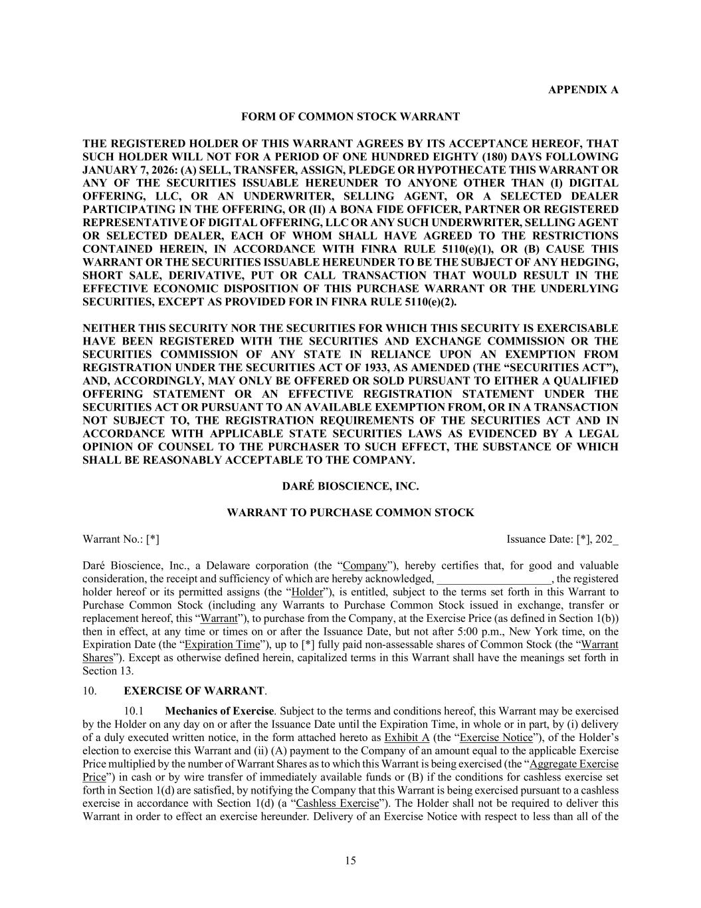
15 APPENDIX A FORM OF COMMON STOCK WARRANT THE REGISTERED HOLDER OF THIS WARRANT AGREES BY ITS ACCEPTANCE HEREOF, THAT SUCH HOLDER WILL NOT FOR A PERIOD OF ONE HUNDRED EIGHTY (180) DAYS FOLLOWING JANUARY 7, 2026: (A) SELL, TRANSFER, ASSIGN, PLEDGE OR HYPOTHECATE THIS WARRANT OR ANY OF THE SECURITIES ISSUABLE HEREUNDER TO ANYONE OTHER THAN (I) DIGITAL OFFERING, LLC, OR AN UNDERWRITER, SELLING AGENT, OR A SELECTED DEALER PARTICIPATING IN THE OFFERING, OR (II) A BONA FIDE OFFICER, PARTNER OR REGISTERED REPRESENTATIVE OF DIGITAL OFFERING, LLC OR ANY SUCH UNDERWRITER, SELLING AGENT OR SELECTED DEALER, EACH OF WHOM SHALL HAVE AGREED TO THE RESTRICTIONS CONTAINED HEREIN, IN ACCORDANCE WITH FINRA RULE 5110(e)(1), OR (B) CAUSE THIS WARRANT OR THE SECURITIES ISSUABLE HEREUNDER TO BE THE SUBJECT OF ANY HEDGING, SHORT SALE, DERIVATIVE, PUT OR CALL TRANSACTION THAT WOULD RESULT IN THE EFFECTIVE ECONOMIC DISPOSITION OF THIS PURCHASE WARRANT OR THE UNDERLYING SECURITIES, EXCEPT AS PROVIDED FOR IN FINRA RULE 5110(e)(2). NEITHER THIS SECURITY NOR THE SECURITIES FOR WHICH THIS SECURITY IS EXERCISABLE HAVE BEEN REGISTERED WITH THE SECURITIES AND EXCHANGE COMMISSION OR THE SECURITIES COMMISSION OF ANY STATE IN RELIANCE UPON AN EXEMPTION FROM REGISTRATION UNDER THE SECURITIES ACT OF 1933, AS AMENDED (THE “SECURITIES ACT”), AND, ACCORDINGLY, MAY ONLY BE OFFERED OR SOLD PURSUANT TO EITHER A QUALIFIED OFFERING STATEMENT OR AN EFFECTIVE REGISTRATION STATEMENT UNDER THE SECURITIES ACT OR PURSUANT TO AN AVAILABLE EXEMPTION FROM, OR IN A TRANSACTION NOT SUBJECT TO, THE REGISTRATION REQUIREMENTS OF THE SECURITIES ACT AND IN ACCORDANCE WITH APPLICABLE STATE SECURITIES LAWS AS EVIDENCED BY A LEGAL OPINION OF COUNSEL TO THE PURCHASER TO SUCH EFFECT, THE SUBSTANCE OF WHICH SHALL BE REASONABLY ACCEPTABLE TO THE COMPANY. DARÉ BIOSCIENCE, INC. WARRANT TO PURCHASE COMMON STOCK Warrant No.: [*] Issuance Date: [*], 202_ Daré Bioscience, Inc., a Delaware corporation (the “Company”), hereby certifies that, for good and valuable consideration, the receipt and sufficiency of which are hereby acknowledged, ____________________, the registered holder hereof or its permitted assigns (the “Holder”), is entitled, subject to the terms set forth in this Warrant to Purchase Common Stock (including any Warrants to Purchase Common Stock issued in exchange, transfer or replacement hereof, this “Warrant”), to purchase from the Company, at the Exercise Price (as defined in Section 1(b)) then in effect, at any time or times on or after the Issuance Date, but not after 5:00 p.m., New York time, on the Expiration Date (the “Expiration Time”), up to [*] fully paid non-assessable shares of Common Stock (the “Warrant Shares”). Except as otherwise defined herein, capitalized terms in this Warrant shall have the meanings set forth in Section 13. 10. EXERCISE OF WARRANT. 10.1 Mechanics of Exercise. Subject to the terms and conditions hereof, this Warrant may be exercised by the Holder on any day on or after the Issuance Date until the Expiration Time, in whole or in part, by (i) delivery of a duly executed written notice, in the form attached hereto as Exhibit A (the “Exercise Notice”), of the Holder’s election to exercise this Warrant and (ii) (A) payment to the Company of an amount equal to the applicable Exercise Price multiplied by the number of Warrant Shares as to which this Warrant is being exercised (the “Aggregate Exercise Price”) in cash or by wire transfer of immediately available funds or (B) if the conditions for cashless exercise set forth in Section 1(d) are satisfied, by notifying the Company that this Warrant is being exercised pursuant to a cashless exercise in accordance with Section 1(d) (a “Cashless Exercise”). The Holder shall not be required to deliver this Warrant in order to effect an exercise hereunder. Delivery of an Exercise Notice with respect to less than all of the

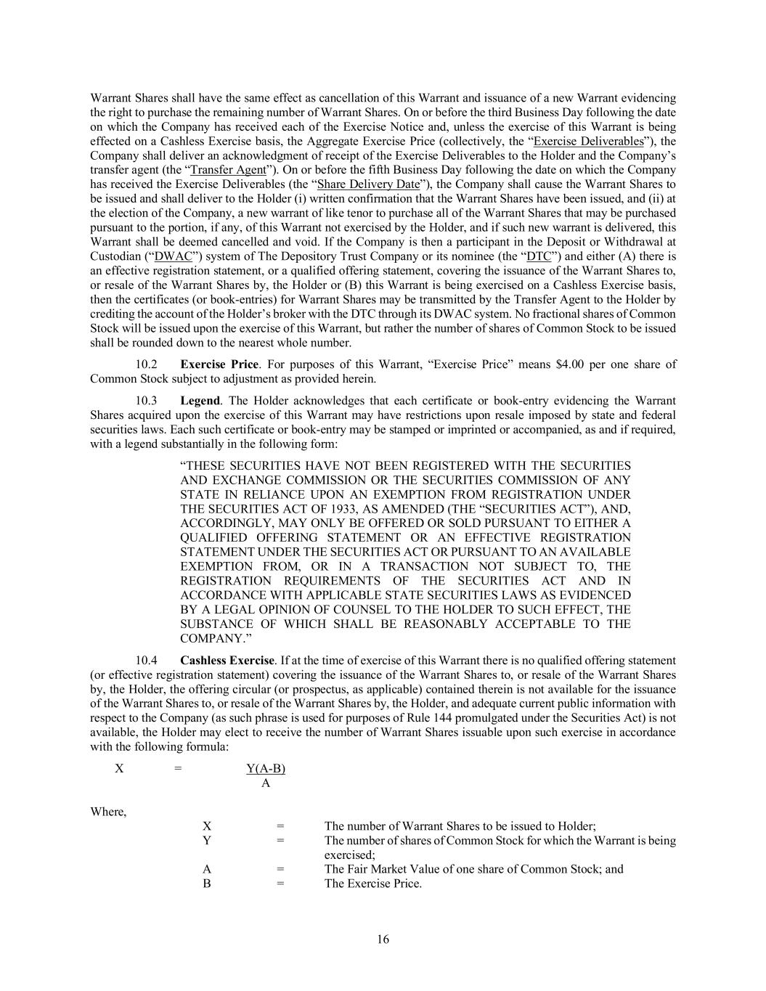
16 Warrant Shares shall have the same effect as cancellation of this Warrant and issuance of a new Warrant evidencing the right to purchase the remaining number of Warrant Shares. On or before the third Business Day following the date on which the Company has received each of the Exercise Notice and, unless the exercise of this Warrant is being effected on a Cashless Exercise basis, the Aggregate Exercise Price (collectively, the “Exercise Deliverables”), the Company shall deliver an acknowledgment of receipt of the Exercise Deliverables to the Holder and the Company’s transfer agent (the “Transfer Agent”). On or before the fifth Business Day following the date on which the Company has received the Exercise Deliverables (the “Share Delivery Date”), the Company shall cause the Warrant Shares to be issued and shall deliver to the Holder (i) written confirmation that the Warrant Shares have been issued, and (ii) at the election of the Company, a new warrant of like tenor to purchase all of the Warrant Shares that may be purchased pursuant to the portion, if any, of this Warrant not exercised by the Holder, and if such new warrant is delivered, this Warrant shall be deemed cancelled and void. If the Company is then a participant in the Deposit or Withdrawal at Custodian (“DWAC”) system of The Depository Trust Company or its nominee (the “DTC”) and either (A) there is an effective registration statement, or a qualified offering statement, covering the issuance of the Warrant Shares to, or resale of the Warrant Shares by, the Holder or (B) this Warrant is being exercised on a Cashless Exercise basis, then the certificates (or book-entries) for Warrant Shares may be transmitted by the Transfer Agent to the Holder by crediting the account of the Holder’s broker with the DTC through its DWAC system. No fractional shares of Common Stock will be issued upon the exercise of this Warrant, but rather the number of shares of Common Stock to be issued shall be rounded down to the nearest whole number. 10.2 Exercise Price. For purposes of this Warrant, “Exercise Price” means $4.00 per one share of Common Stock subject to adjustment as provided herein. 10.3 Legend. The Holder acknowledges that each certificate or book-entry evidencing the Warrant Shares acquired upon the exercise of this Warrant may have restrictions upon resale imposed by state and federal securities laws. Each such certificate or book-entry may be stamped or imprinted or accompanied, as and if required, with a legend substantially in the following form: “THESE SECURITIES HAVE NOT BEEN REGISTERED WITH THE SECURITIES AND EXCHANGE COMMISSION OR THE SECURITIES COMMISSION OF ANY STATE IN RELIANCE UPON AN EXEMPTION FROM REGISTRATION UNDER THE SECURITIES ACT OF 1933, AS AMENDED (THE “SECURITIES ACT”), AND, ACCORDINGLY, MAY ONLY BE OFFERED OR SOLD PURSUANT TO EITHER A QUALIFIED OFFERING STATEMENT OR AN EFFECTIVE REGISTRATION STATEMENT UNDER THE SECURITIES ACT OR PURSUANT TO AN AVAILABLE EXEMPTION FROM, OR IN A TRANSACTION NOT SUBJECT TO, THE REGISTRATION REQUIREMENTS OF THE SECURITIES ACT AND IN ACCORDANCE WITH APPLICABLE STATE SECURITIES LAWS AS EVIDENCED BY A LEGAL OPINION OF COUNSEL TO THE HOLDER TO SUCH EFFECT, THE SUBSTANCE OF WHICH SHALL BE REASONABLY ACCEPTABLE TO THE COMPANY.” 10.4 Cashless Exercise. If at the time of exercise of this Warrant there is no qualified offering statement (or effective registration statement) covering the issuance of the Warrant Shares to, or resale of the Warrant Shares by, the Holder, the offering circular (or prospectus, as applicable) contained therein is not available for the issuance of the Warrant Shares to, or resale of the Warrant Shares by, the Holder, and adequate current public information with respect to the Company (as such phrase is used for purposes of Rule 144 promulgated under the Securities Act) is not available, the Holder may elect to receive the number of Warrant Shares issuable upon such exercise in accordance with the following formula: X = Y(A-B) A Where, X = The number of Warrant Shares to be issued to Holder; Y = The number of shares of Common Stock for which the Warrant is being exercised; A = The Fair Market Value of one share of Common Stock; and B = The Exercise Price.

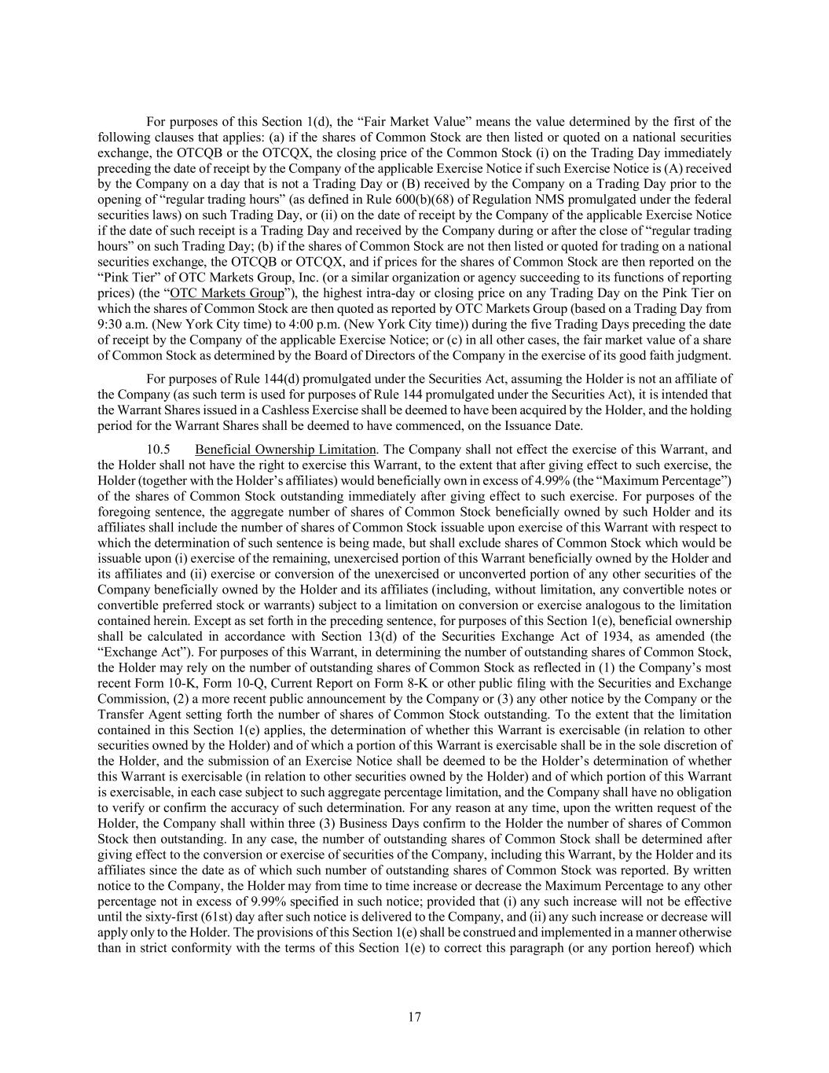
17 For purposes of this Section 1(d), the “Fair Market Value” means the value determined by the first of the following clauses that applies: (a) if the shares of Common Stock are then listed or quoted on a national securities exchange, the OTCQB or the OTCQX, the closing price of the Common Stock (i) on the Trading Day immediately preceding the date of receipt by the Company of the applicable Exercise Notice if such Exercise Notice is (A) received by the Company on a day that is not a Trading Day or (B) received by the Company on a Trading Day prior to the opening of “regular trading hours” (as defined in Rule 600(b)(68) of Regulation NMS promulgated under the federal securities laws) on such Trading Day, or (ii) on the date of receipt by the Company of the applicable Exercise Notice if the date of such receipt is a Trading Day and received by the Company during or after the close of “regular trading hours” on such Trading Day; (b) if the shares of Common Stock are not then listed or quoted for trading on a national securities exchange, the OTCQB or OTCQX, and if prices for the shares of Common Stock are then reported on the “Pink Tier” of OTC Markets Group, Inc. (or a similar organization or agency succeeding to its functions of reporting prices) (the “OTC Markets Group”), the highest intra-day or closing price on any Trading Day on the Pink Tier on which the shares of Common Stock are then quoted as reported by OTC Markets Group (based on a Trading Day from 9:30 a.m. (New York City time) to 4:00 p.m. (New York City time)) during the five Trading Days preceding the date of receipt by the Company of the applicable Exercise Notice; or (c) in all other cases, the fair market value of a share of Common Stock as determined by the Board of Directors of the Company in the exercise of its good faith judgment. For purposes of Rule 144(d) promulgated under the Securities Act, assuming the Holder is not an affiliate of the Company (as such term is used for purposes of Rule 144 promulgated under the Securities Act), it is intended that the Warrant Shares issued in a Cashless Exercise shall be deemed to have been acquired by the Holder, and the holding period for the Warrant Shares shall be deemed to have commenced, on the Issuance Date. 10.5 Beneficial Ownership Limitation. The Company shall not effect the exercise of this Warrant, and the Holder shall not have the right to exercise this Warrant, to the extent that after giving effect to such exercise, the Holder (together with the Holder’s affiliates) would beneficially own in excess of 4.99% (the “Maximum Percentage”) of the shares of Common Stock outstanding immediately after giving effect to such exercise. For purposes of the foregoing sentence, the aggregate number of shares of Common Stock beneficially owned by such Holder and its affiliates shall include the number of shares of Common Stock issuable upon exercise of this Warrant with respect to which the determination of such sentence is being made, but shall exclude shares of Common Stock which would be issuable upon (i) exercise of the remaining, unexercised portion of this Warrant beneficially owned by the Holder and its affiliates and (ii) exercise or conversion of the unexercised or unconverted portion of any other securities of the Company beneficially owned by the Holder and its affiliates (including, without limitation, any convertible notes or convertible preferred stock or warrants) subject to a limitation on conversion or exercise analogous to the limitation contained herein. Except as set forth in the preceding sentence, for purposes of this Section 1(e), beneficial ownership shall be calculated in accordance with Section 13(d) of the Securities Exchange Act of 1934, as amended (the “Exchange Act”). For purposes of this Warrant, in determining the number of outstanding shares of Common Stock, the Holder may rely on the number of outstanding shares of Common Stock as reflected in (1) the Company’s most recent Form 10-K, Form 10-Q, Current Report on Form 8-K or other public filing with the Securities and Exchange Commission, (2) a more recent public announcement by the Company or (3) any other notice by the Company or the Transfer Agent setting forth the number of shares of Common Stock outstanding. To the extent that the limitation contained in this Section 1(e) applies, the determination of whether this Warrant is exercisable (in relation to other securities owned by the Holder) and of which a portion of this Warrant is exercisable shall be in the sole discretion of the Holder, and the submission of an Exercise Notice shall be deemed to be the Holder’s determination of whether this Warrant is exercisable (in relation to other securities owned by the Holder) and of which portion of this Warrant is exercisable, in each case subject to such aggregate percentage limitation, and the Company shall have no obligation to verify or confirm the accuracy of such determination. For any reason at any time, upon the written request of the Holder, the Company shall within three (3) Business Days confirm to the Holder the number of shares of Common Stock then outstanding. In any case, the number of outstanding shares of Common Stock shall be determined after giving effect to the conversion or exercise of securities of the Company, including this Warrant, by the Holder and its affiliates since the date as of which such number of outstanding shares of Common Stock was reported. By written notice to the Company, the Holder may from time to time increase or decrease the Maximum Percentage to any other percentage not in excess of 9.99% specified in such notice; provided that (i) any such increase will not be effective until the sixty-first (61st) day after such notice is delivered to the Company, and (ii) any such increase or decrease will apply only to the Holder. The provisions of this Section 1(e) shall be construed and implemented in a manner otherwise than in strict conformity with the terms of this Section 1(e) to correct this paragraph (or any portion hereof) which

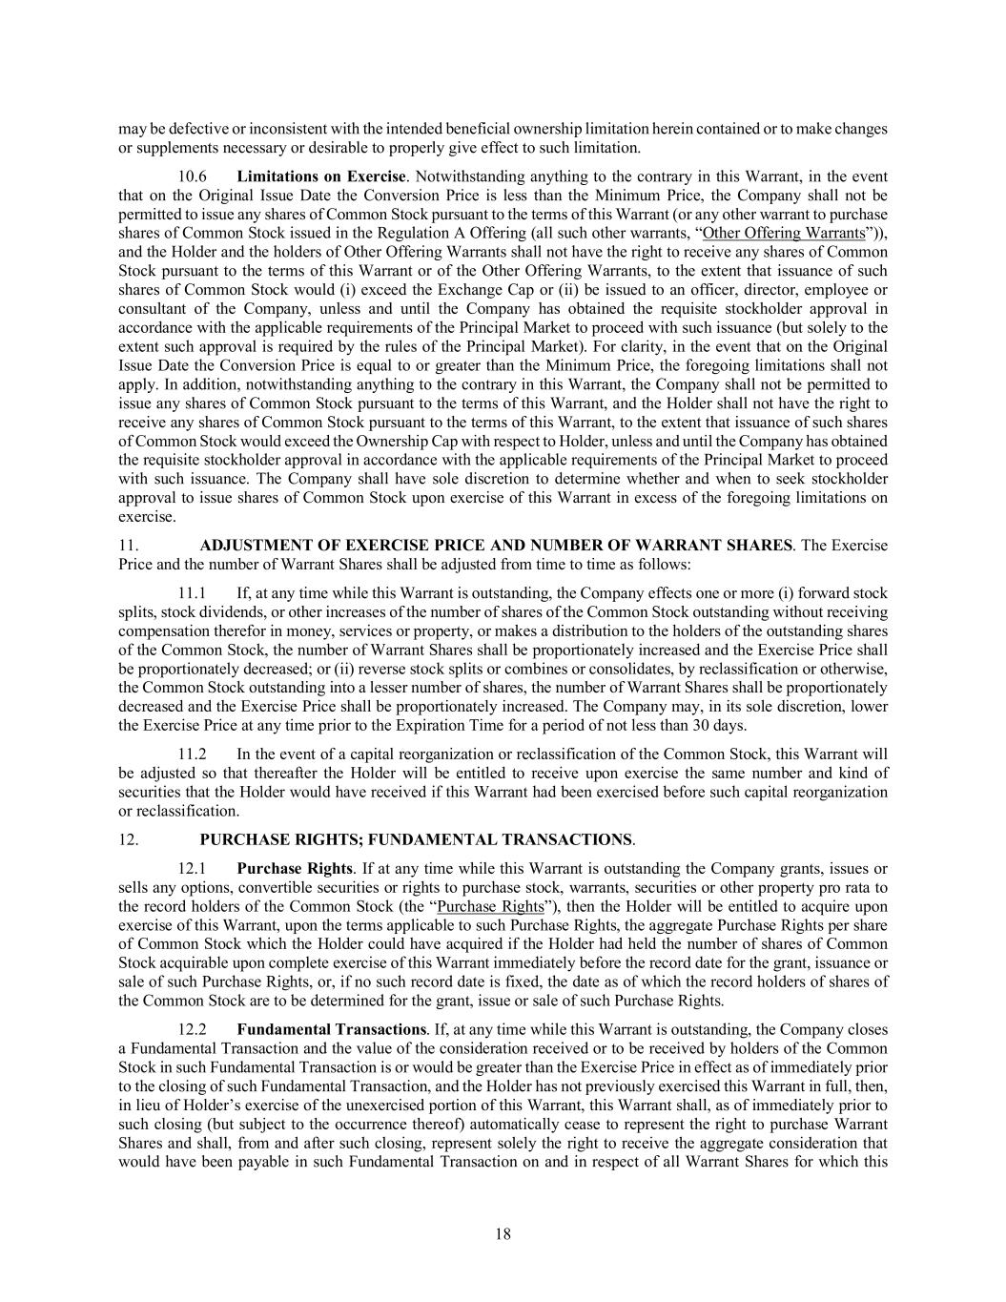
18 may be defective or inconsistent with the intended beneficial ownership limitation herein contained or to make changes or supplements necessary or desirable to properly give effect to such limitation. 10.6 Limitations on Exercise. Notwithstanding anything to the contrary in this Warrant, in the event that on the Original Issue Date the Conversion Price is less than the Minimum Price, the Company shall not be permitted to issue any shares of Common Stock pursuant to the terms of this Warrant (or any other warrant to purchase shares of Common Stock issued in the Regulation A Offering (all such other warrants, “Other Offering Warrants”)), and the Holder and the holders of Other Offering Warrants shall not have the right to receive any shares of Common Stock pursuant to the terms of this Warrant or of the Other Offering Warrants, to the extent that issuance of such shares of Common Stock would (i) exceed the Exchange Cap or (ii) be issued to an officer, director, employee or consultant of the Company, unless and until the Company has obtained the requisite stockholder approval in accordance with the applicable requirements of the Principal Market to proceed with such issuance (but solely to the extent such approval is required by the rules of the Principal Market). For clarity, in the event that on the Original Issue Date the Conversion Price is equal to or greater than the Minimum Price, the foregoing limitations shall not apply. In addition, notwithstanding anything to the contrary in this Warrant, the Company shall not be permitted to issue any shares of Common Stock pursuant to the terms of this Warrant, and the Holder shall not have the right to receive any shares of Common Stock pursuant to the terms of this Warrant, to the extent that issuance of such shares of Common Stock would exceed the Ownership Cap with respect to Holder, unless and until the Company has obtained the requisite stockholder approval in accordance with the applicable requirements of the Principal Market to proceed with such issuance. The Company shall have sole discretion to determine whether and when to seek stockholder approval to issue shares of Common Stock upon exercise of this Warrant in excess of the foregoing limitations on exercise. 11. ADJUSTMENT OF EXERCISE PRICE AND NUMBER OF WARRANT SHARES. The Exercise Price and the number of Warrant Shares shall be adjusted from time to time as follows: 11.1 If, at any time while this Warrant is outstanding, the Company effects one or more (i) forward stock splits, stock dividends, or other increases of the number of shares of the Common Stock outstanding without receiving compensation therefor in money, services or property, or makes a distribution to the holders of the outstanding shares of the Common Stock, the number of Warrant Shares shall be proportionately increased and the Exercise Price shall be proportionately decreased; or (ii) reverse stock splits or combines or consolidates, by reclassification or otherwise, the Common Stock outstanding into a lesser number of shares, the number of Warrant Shares shall be proportionately decreased and the Exercise Price shall be proportionately increased. The Company may, in its sole discretion, lower the Exercise Price at any time prior to the Expiration Time for a period of not less than 30 days. 11.2 In the event of a capital reorganization or reclassification of the Common Stock, this Warrant will be adjusted so that thereafter the Holder will be entitled to receive upon exercise the same number and kind of securities that the Holder would have received if this Warrant had been exercised before such capital reorganization or reclassification. 12. PURCHASE RIGHTS; FUNDAMENTAL TRANSACTIONS. 12.1 Purchase Rights. If at any time while this Warrant is outstanding the Company grants, issues or sells any options, convertible securities or rights to purchase stock, warrants, securities or other property pro rata to the record holders of the Common Stock (the “Purchase Rights”), then the Holder will be entitled to acquire upon exercise of this Warrant, upon the terms applicable to such Purchase Rights, the aggregate Purchase Rights per share of Common Stock which the Holder could have acquired if the Holder had held the number of shares of Common Stock acquirable upon complete exercise of this Warrant immediately before the record date for the grant, issuance or sale of such Purchase Rights, or, if no such record date is fixed, the date as of which the record holders of shares of the Common Stock are to be determined for the grant, issue or sale of such Purchase Rights. 12.2 Fundamental Transactions. If, at any time while this Warrant is outstanding, the Company closes a Fundamental Transaction and the value of the consideration received or to be received by holders of the Common Stock in such Fundamental Transaction is or would be greater than the Exercise Price in effect as of immediately prior to the closing of such Fundamental Transaction, and the Holder has not previously exercised this Warrant in full, then, in lieu of Holder’s exercise of the unexercised portion of this Warrant, this Warrant shall, as of immediately prior to such closing (but subject to the occurrence thereof) automatically cease to represent the right to purchase Warrant Shares and shall, from and after such closing, represent solely the right to receive the aggregate consideration that would have been payable in such Fundamental Transaction on and in respect of all Warrant Shares for which this

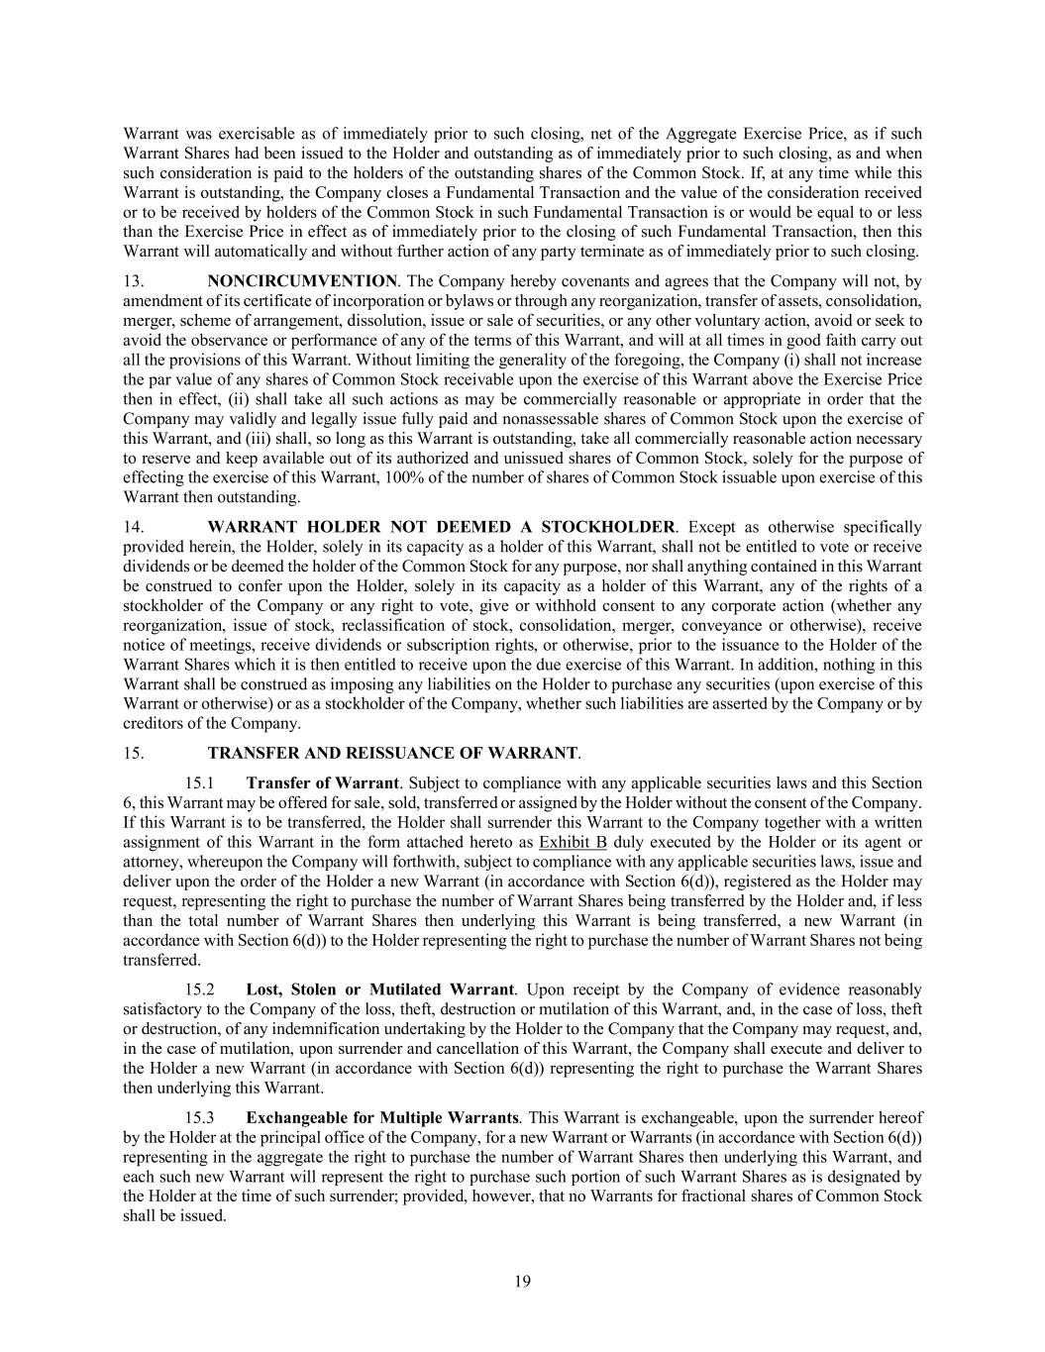
19 Warrant was exercisable as of immediately prior to such closing, net of the Aggregate Exercise Price, as if such Warrant Shares had been issued to the Holder and outstanding as of immediately prior to such closing, as and when such consideration is paid to the holders of the outstanding shares of the Common Stock. If, at any time while this Warrant is outstanding, the Company closes a Fundamental Transaction and the value of the consideration received or to be received by holders of the Common Stock in such Fundamental Transaction is or would be equal to or less than the Exercise Price in effect as of immediately prior to the closing of such Fundamental Transaction, then this Warrant will automatically and without further action of any party terminate as of immediately prior to such closing. 13. NONCIRCUMVENTION. The Company hereby covenants and agrees that the Company will not, by amendment of its certificate of incorporation or bylaws or through any reorganization, transfer of assets, consolidation, merger, scheme of arrangement, dissolution, issue or sale of securities, or any other voluntary action, avoid or seek to avoid the observance or performance of any of the terms of this Warrant, and will at all times in good faith carry out all the provisions of this Warrant. Without limiting the generality of the foregoing, the Company (i) shall not increase the par value of any shares of Common Stock receivable upon the exercise of this Warrant above the Exercise Price then in effect, (ii) shall take all such actions as may be commercially reasonable or appropriate in order that the Company may validly and legally issue fully paid and nonassessable shares of Common Stock upon the exercise of this Warrant, and (iii) shall, so long as this Warrant is outstanding, take all commercially reasonable action necessary to reserve and keep available out of its authorized and unissued shares of Common Stock, solely for the purpose of effecting the exercise of this Warrant, 100% of the number of shares of Common Stock issuable upon exercise of this Warrant then outstanding. 14. WARRANT HOLDER NOT DEEMED A STOCKHOLDER. Except as otherwise specifically provided herein, the Holder, solely in its capacity as a holder of this Warrant, shall not be entitled to vote or receive dividends or be deemed the holder of the Common Stock for any purpose, nor shall anything contained in this Warrant be construed to confer upon the Holder, solely in its capacity as a holder of this Warrant, any of the rights of a stockholder of the Company or any right to vote, give or withhold consent to any corporate action (whether any reorganization, issue of stock, reclassification of stock, consolidation, merger, conveyance or otherwise), receive notice of meetings, receive dividends or subscription rights, or otherwise, prior to the issuance to the Holder of the Warrant Shares which it is then entitled to receive upon the due exercise of this Warrant. In addition, nothing in this Warrant shall be construed as imposing any liabilities on the Holder to purchase any securities (upon exercise of this Warrant or otherwise) or as a stockholder of the Company, whether such liabilities are asserted by the Company or by creditors of the Company. 15. TRANSFER AND REISSUANCE OF WARRANT. 15.1 Transfer of Warrant. Subject to compliance with any applicable securities laws and this Section 6, this Warrant may be offered for sale, sold, transferred or assigned by the Holder without the consent of the Company. If this Warrant is to be transferred, the Holder shall surrender this Warrant to the Company together with a written assignment of this Warrant in the form attached hereto as Exhibit B duly executed by the Holder or its agent or attorney, whereupon the Company will forthwith, subject to compliance with any applicable securities laws, issue and deliver upon the order of the Holder a new Warrant (in accordance with Section 6(d)), registered as the Holder may request, representing the right to purchase the number of Warrant Shares being transferred by the Holder and, if less than the total number of Warrant Shares then underlying this Warrant is being transferred, a new Warrant (in accordance with Section 6(d)) to the Holder representing the right to purchase the number of Warrant Shares not being transferred. 15.2 Lost, Stolen or Mutilated Warrant. Upon receipt by the Company of evidence reasonably satisfactory to the Company of the loss, theft, destruction or mutilation of this Warrant, and, in the case of loss, theft or destruction, of any indemnification undertaking by the Holder to the Company that the Company may request, and, in the case of mutilation, upon surrender and cancellation of this Warrant, the Company shall execute and deliver to the Holder a new Warrant (in accordance with Section 6(d)) representing the right to purchase the Warrant Shares then underlying this Warrant. 15.3 Exchangeable for Multiple Warrants. This Warrant is exchangeable, upon the surrender hereof by the Holder at the principal office of the Company, for a new Warrant or Warrants (in accordance with Section 6(d)) representing in the aggregate the right to purchase the number of Warrant Shares then underlying this Warrant, and each such new Warrant will represent the right to purchase such portion of such Warrant Shares as is designated by the Holder at the time of such surrender; provided, however, that no Warrants for fractional shares of Common Stock shall be issued.

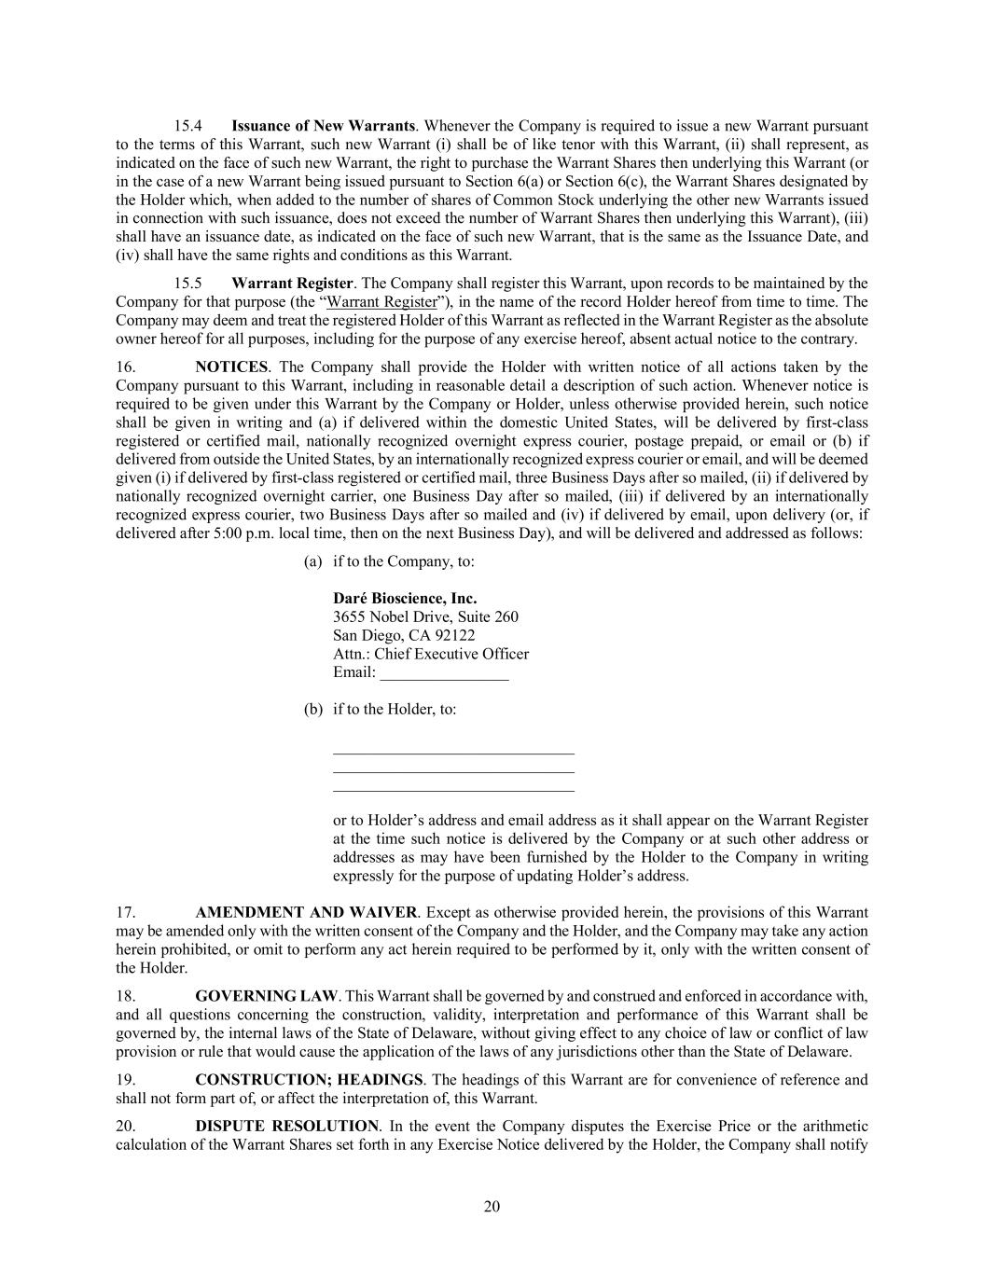
20 15.4 Issuance of New Warrants. Whenever the Company is required to issue a new Warrant pursuant to the terms of this Warrant, such new Warrant (i) shall be of like tenor with this Warrant, (ii) shall represent, as indicated on the face of such new Warrant, the right to purchase the Warrant Shares then underlying this Warrant (or in the case of a new Warrant being issued pursuant to Section 6(a) or Section 6(c), the Warrant Shares designated by the Holder which, when added to the number of shares of Common Stock underlying the other new Warrants issued in connection with such issuance, does not exceed the number of Warrant Shares then underlying this Warrant), (iii) shall have an issuance date, as indicated on the face of such new Warrant, that is the same as the Issuance Date, and (iv) shall have the same rights and conditions as this Warrant. 15.5 Warrant Register. The Company shall register this Warrant, upon records to be maintained by the Company for that purpose (the “Warrant Register”), in the name of the record Holder hereof from time to time. The Company may deem and treat the registered Holder of this Warrant as reflected in the Warrant Register as the absolute owner hereof for all purposes, including for the purpose of any exercise hereof, absent actual notice to the contrary. 16. NOTICES. The Company shall provide the Holder with written notice of all actions taken by the Company pursuant to this Warrant, including in reasonable detail a description of such action. Whenever notice is required to be given under this Warrant by the Company or Holder, unless otherwise provided herein, such notice shall be given in writing and (a) if delivered within the domestic United States, will be delivered by first-class registered or certified mail, nationally recognized overnight express courier, postage prepaid, or email or (b) if delivered from outside the United States, by an internationally recognized express courier or email, and will be deemed given (i) if delivered by first-class registered or certified mail, three Business Days after so mailed, (ii) if delivered by nationally recognized overnight carrier, one Business Day after so mailed, (iii) if delivered by an internationally recognized express courier, two Business Days after so mailed and (iv) if delivered by email, upon delivery (or, if delivered after 5:00 p.m. local time, then on the next Business Day), and will be delivered and addressed as follows: (a) if to the Company, to: Daré Bioscience, Inc. 3655 Nobel Drive, Suite 260 San Diego, CA 92122 Attn.: Chief Executive Officer Email: ________________ (b) if to the Holder, to: ______________________________ ______________________________ ______________________________ or to Holder’s address and email address as it shall appear on the Warrant Register at the time such notice is delivered by the Company or at such other address or addresses as may have been furnished by the Holder to the Company in writing expressly for the purpose of updating Holder’s address. 17. AMENDMENT AND WAIVER. Except as otherwise provided herein, the provisions of this Warrant may be amended only with the written consent of the Company and the Holder, and the Company may take any action herein prohibited, or omit to perform any act herein required to be performed by it, only with the written consent of the Holder. 18. GOVERNING LAW. This Warrant shall be governed by and construed and enforced in accordance with, and all questions concerning the construction, validity, interpretation and performance of this Warrant shall be governed by, the internal laws of the State of Delaware, without giving effect to any choice of law or conflict of law provision or rule that would cause the application of the laws of any jurisdictions other than the State of Delaware. 19. CONSTRUCTION; HEADINGS. The headings of this Warrant are for convenience of reference and shall not form part of, or affect the interpretation of, this Warrant. 20. DISPUTE RESOLUTION. In the event the Company disputes the Exercise Price or the arithmetic calculation of the Warrant Shares set forth in any Exercise Notice delivered by the Holder, the Company shall notify

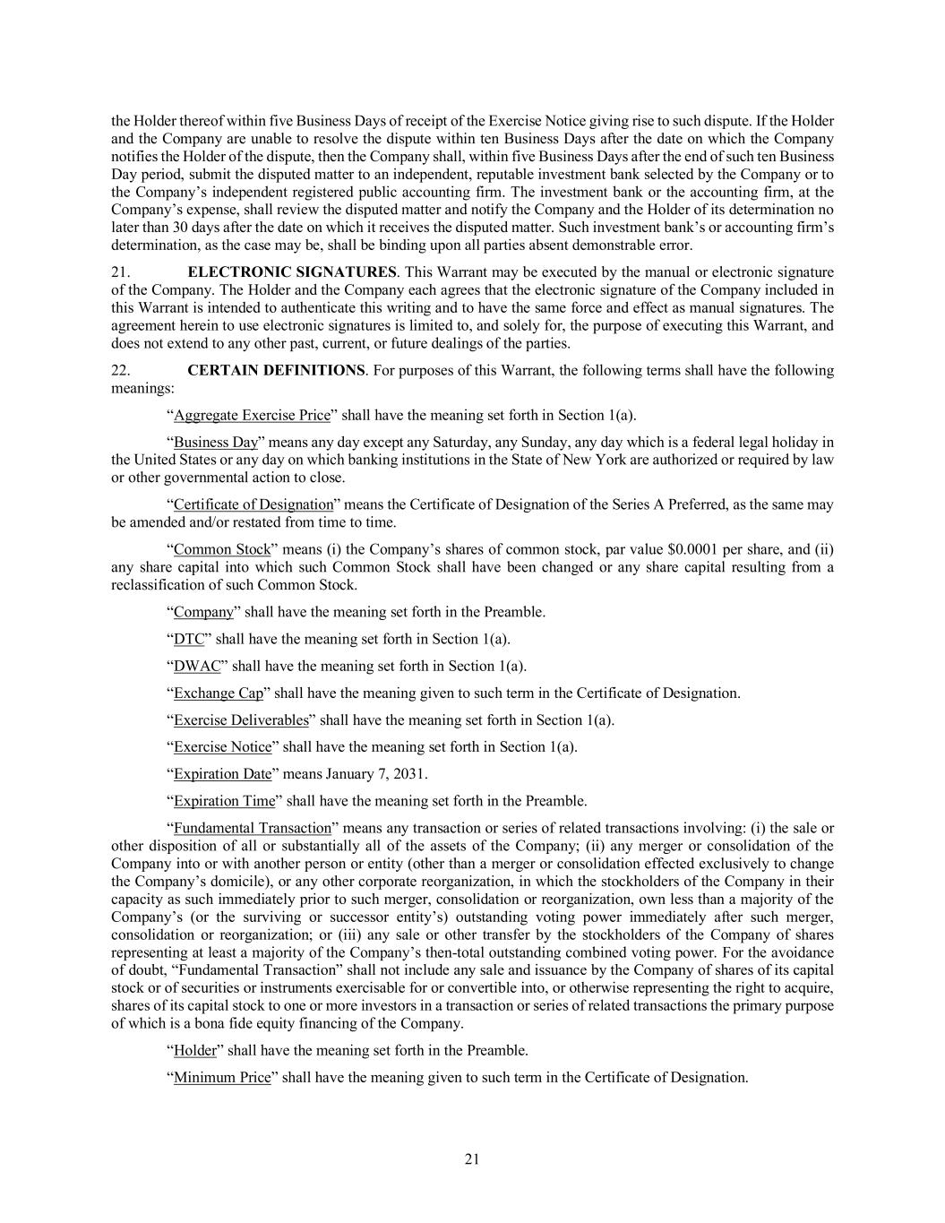
21 the Holder thereof within five Business Days of receipt of the Exercise Notice giving rise to such dispute. If the Holder and the Company are unable to resolve the dispute within ten Business Days after the date on which the Company notifies the Holder of the dispute, then the Company shall, within five Business Days after the end of such ten Business Day period, submit the disputed matter to an independent, reputable investment bank selected by the Company or to the Company’s independent registered public accounting firm. The investment bank or the accounting firm, at the Company’s expense, shall review the disputed matter and notify the Company and the Holder of its determination no later than 30 days after the date on which it receives the disputed matter. Such investment bank’s or accounting firm’s determination, as the case may be, shall be binding upon all parties absent demonstrable error. 21. ELECTRONIC SIGNATURES. This Warrant may be executed by the manual or electronic signature of the Company. The Holder and the Company each agrees that the electronic signature of the Company included in this Warrant is intended to authenticate this writing and to have the same force and effect as manual signatures. The agreement herein to use electronic signatures is limited to, and solely for, the purpose of executing this Warrant, and does not extend to any other past, current, or future dealings of the parties. 22. CERTAIN DEFINITIONS. For purposes of this Warrant, the following terms shall have the following meanings: “Aggregate Exercise Price” shall have the meaning set forth in Section 1(a). “Business Day” means any day except any Saturday, any Sunday, any day which is a federal legal holiday in the United States or any day on which banking institutions in the State of New York are authorized or required by law or other governmental action to close. “Certificate of Designation” means the Certificate of Designation of the Series A Preferred, as the same may be amended and/or restated from time to time. “Common Stock” means (i) the Company’s shares of common stock, par value $0.0001 per share, and (ii) any share capital into which such Common Stock shall have been changed or any share capital resulting from a reclassification of such Common Stock. “Company” shall have the meaning set forth in the Preamble. “DTC” shall have the meaning set forth in Section 1(a). “DWAC” shall have the meaning set forth in Section 1(a). “Exchange Cap” shall have the meaning given to such term in the Certificate of Designation. “Exercise Deliverables” shall have the meaning set forth in Section 1(a). “Exercise Notice” shall have the meaning set forth in Section 1(a). “Expiration Date” means January 7, 2031. “Expiration Time” shall have the meaning set forth in the Preamble. “Fundamental Transaction” means any transaction or series of related transactions involving: (i) the sale or other disposition of all or substantially all of the assets of the Company; (ii) any merger or consolidation of the Company into or with another person or entity (other than a merger or consolidation effected exclusively to change the Company’s domicile), or any other corporate reorganization, in which the stockholders of the Company in their capacity as such immediately prior to such merger, consolidation or reorganization, own less than a majority of the Company’s (or the surviving or successor entity’s) outstanding voting power immediately after such merger, consolidation or reorganization; or (iii) any sale or other transfer by the stockholders of the Company of shares representing at least a majority of the Company’s then-total outstanding combined voting power. For the avoidance of doubt, “Fundamental Transaction” shall not include any sale and issuance by the Company of shares of its capital stock or of securities or instruments exercisable for or convertible into, or otherwise representing the right to acquire, shares of its capital stock to one or more investors in a transaction or series of related transactions the primary purpose of which is a bona fide equity financing of the Company. “Holder” shall have the meaning set forth in the Preamble. “Minimum Price” shall have the meaning given to such term in the Certificate of Designation.

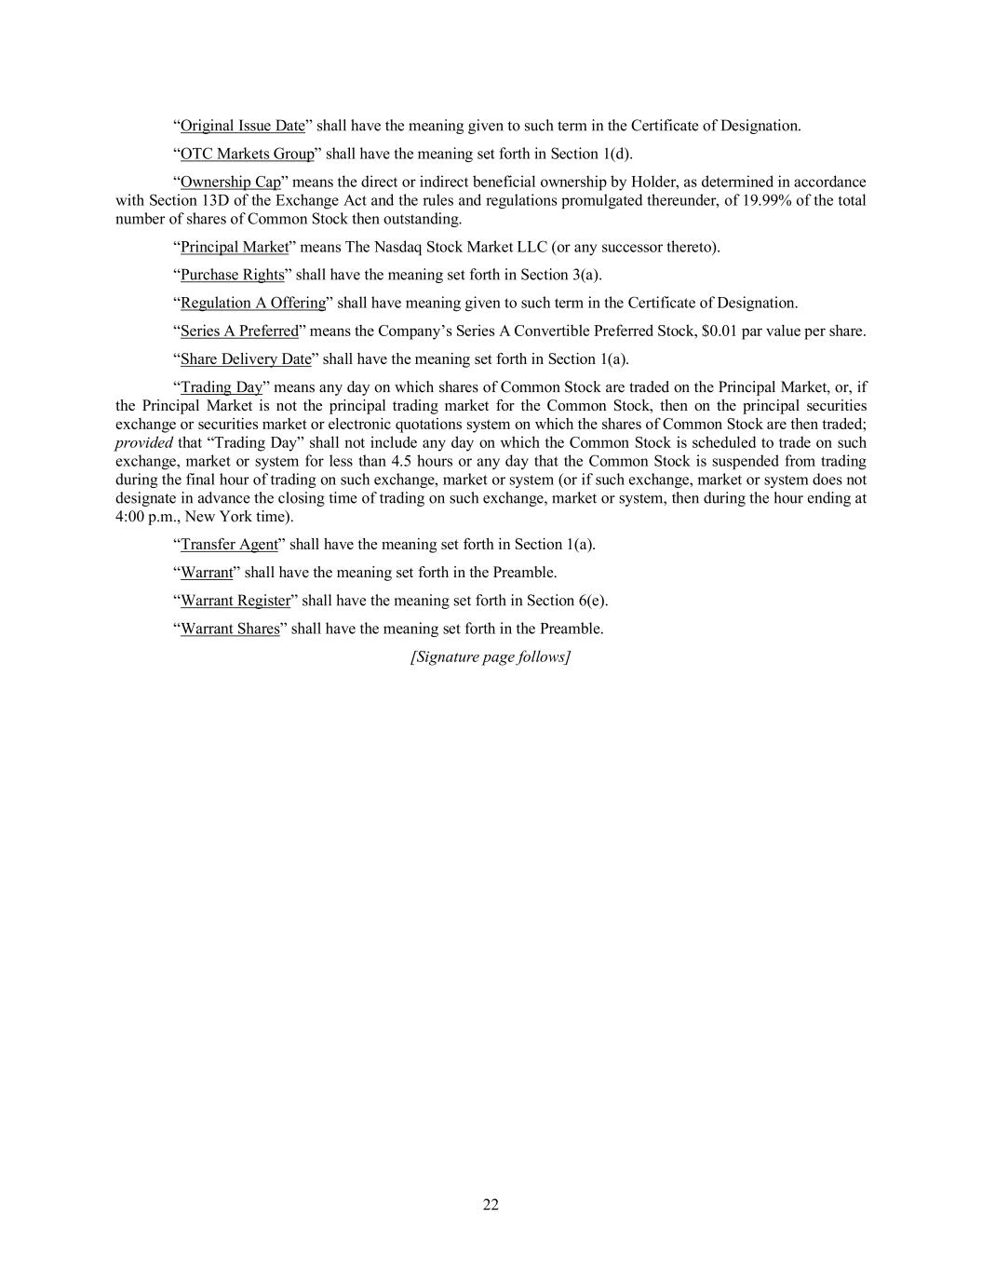
22 “Original Issue Date” shall have the meaning given to such term in the Certificate of Designation. “OTC Markets Group” shall have the meaning set forth in Section 1(d). “Ownership Cap” means the direct or indirect beneficial ownership by Holder, as determined in accordance with Section 13D of the Exchange Act and the rules and regulations promulgated thereunder, of 19.99% of the total number of shares of Common Stock then outstanding. “Principal Market” means The Nasdaq Stock Market LLC (or any successor thereto). “Purchase Rights” shall have the meaning set forth in Section 3(a). “Regulation A Offering” shall have meaning given to such term in the Certificate of Designation. “Series A Preferred” means the Company’s Series A Convertible Preferred Stock, $0.01 par value per share. “Share Delivery Date” shall have the meaning set forth in Section 1(a). “Trading Day” means any day on which shares of Common Stock are traded on the Principal Market, or, if the Principal Market is not the principal trading market for the Common Stock, then on the principal securities exchange or securities market or electronic quotations system on which the shares of Common Stock are then traded; provided that “Trading Day” shall not include any day on which the Common Stock is scheduled to trade on such exchange, market or system for less than 4.5 hours or any day that the Common Stock is suspended from trading during the final hour of trading on such exchange, market or system (or if such exchange, market or system does not designate in advance the closing time of trading on such exchange, market or system, then during the hour ending at 4:00 p.m., New York time). “Transfer Agent” shall have the meaning set forth in Section 1(a). “Warrant” shall have the meaning set forth in the Preamble. “Warrant Register” shall have the meaning set forth in Section 6(e). “Warrant Shares” shall have the meaning set forth in the Preamble. [Signature page follows]

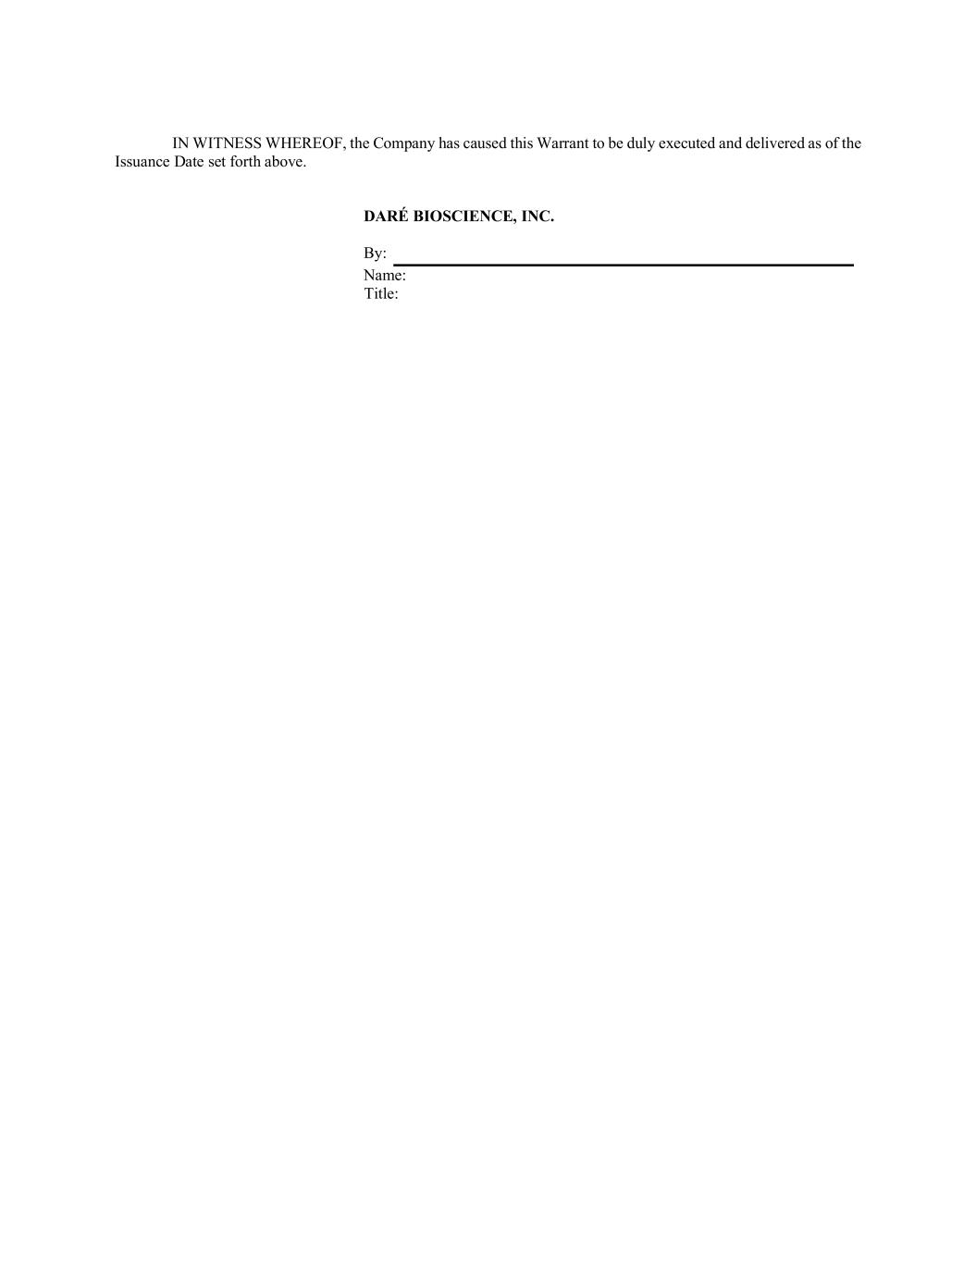
IN WITNESS WHEREOF, the Company has caused this Warrant to be duly executed and delivered as of the Issuance Date set forth above. DARÉ BIOSCIENCE, INC. By: Name: Title:

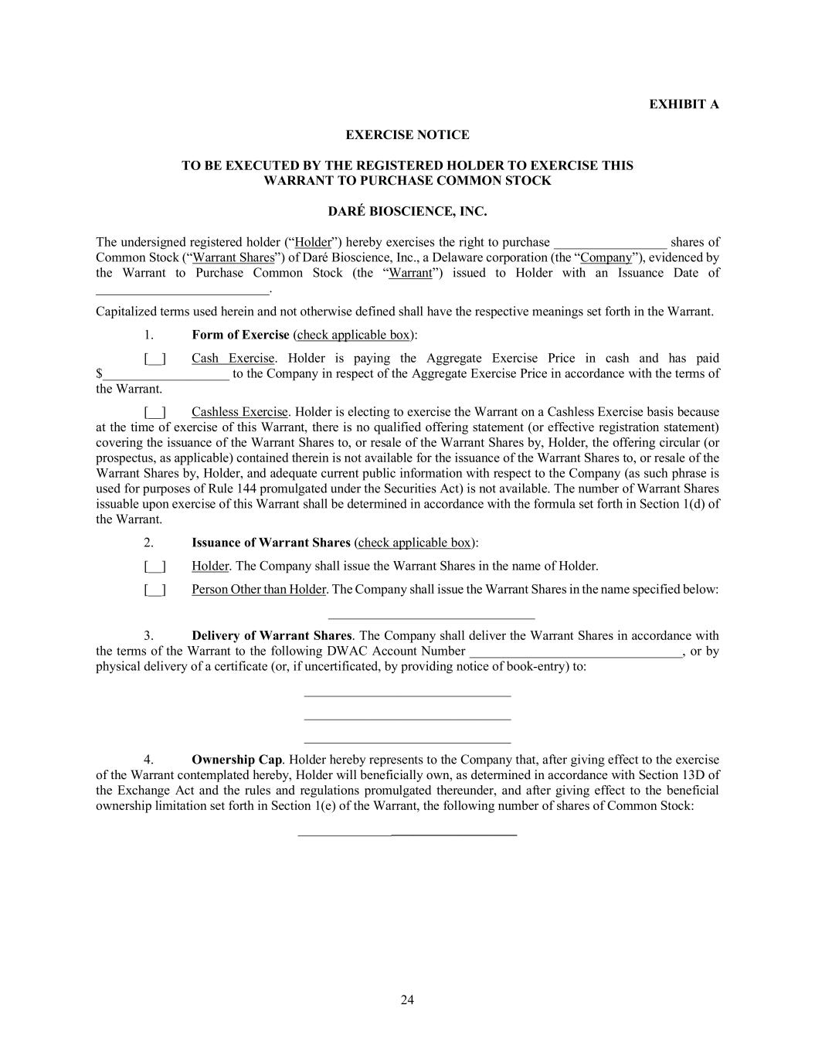
24 EXHIBIT A EXERCISE NOTICE TO BE EXECUTED BY THE REGISTERED HOLDER TO EXERCISE THIS WARRANT TO PURCHASE COMMON STOCK DARÉ BIOSCIENCE, INC. The undersigned registered holder (“Holder”) hereby exercises the right to purchase _________________ shares of Common Stock (“Warrant Shares”) of Daré Bioscience, Inc., a Delaware corporation (the “Company”), evidenced by the Warrant to Purchase Common Stock (the “Warrant”) issued to Holder with an Issuance Date of __________________________. Capitalized terms used herein and not otherwise defined shall have the respective meanings set forth in the Warrant. 1. Form of Exercise (check applicable box): [__] Cash Exercise. Holder is paying the Aggregate Exercise Price in cash and has paid $___________________ to the Company in respect of the Aggregate Exercise Price in accordance with the terms of the Warrant. [__] Cashless Exercise. Holder is electing to exercise the Warrant on a Cashless Exercise basis because at the time of exercise of this Warrant, there is no qualified offering statement (or effective registration statement) covering the issuance of the Warrant Shares to, or resale of the Warrant Shares by, Holder, the offering circular (or prospectus, as applicable) contained therein is not available for the issuance of the Warrant Shares to, or resale of the Warrant Shares by, Holder, and adequate current public information with respect to the Company (as such phrase is used for purposes of Rule 144 promulgated under the Securities Act) is not available. The number of Warrant Shares issuable upon exercise of this Warrant shall be determined in accordance with the formula set forth in Section 1(d) of the Warrant. 2. Issuance of Warrant Shares (check applicable box): [__] Holder. The Company shall issue the Warrant Shares in the name of Holder. [__] Person Other than Holder. The Company shall issue the Warrant Shares in the name specified below: _______________________________ 3. Delivery of Warrant Shares. The Company shall deliver the Warrant Shares in accordance with the terms of the Warrant to the following DWAC Account Number ________________________________, or by physical delivery of a certificate (or, if uncertificated, by providing notice of book-entry) to: _______________________________ _______________________________ _______________________________ 4. Ownership Cap. Holder hereby represents to the Company that, after giving effect to the exercise of the Warrant contemplated hereby, Holder will beneficially own, as determined in accordance with Section 13D of the Exchange Act and the rules and regulations promulgated thereunder, and after giving effect to the beneficial ownership limitation set forth in Section 1(e) of the Warrant, the following number of shares of Common Stock: _______________________________


25 Date: _______________ __, ______ Name of Registered Holder By: Name: Title:

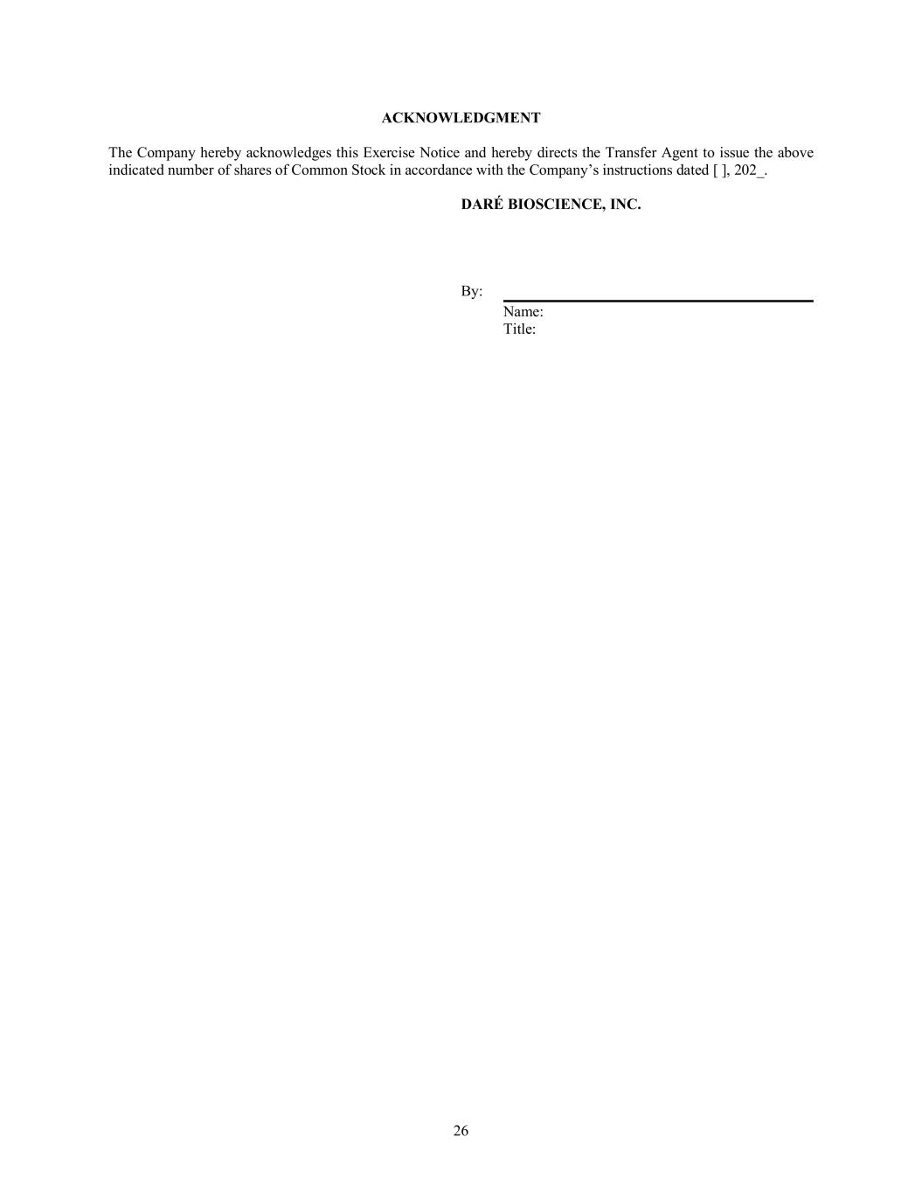
26 ACKNOWLEDGMENT The Company hereby acknowledges this Exercise Notice and hereby directs the Transfer Agent to issue the above indicated number of shares of Common Stock in accordance with the Company’s instructions dated [ ], 202_. DARÉ BIOSCIENCE, INC. By: Name: Title:

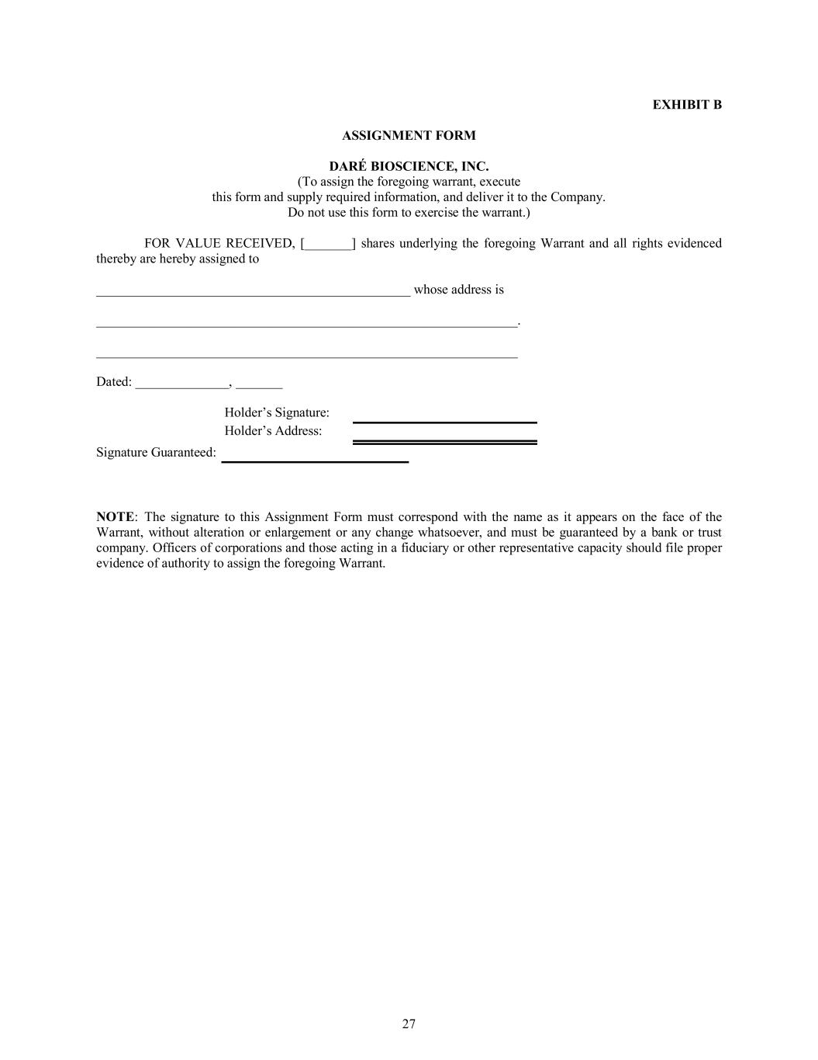
27 EXHIBIT B ASSIGNMENT FORM DARÉ BIOSCIENCE, INC. (To assign the foregoing warrant, execute this form and supply required information, and deliver it to the Company. Do not use this form to exercise the warrant.) FOR VALUE RECEIVED, [_______] shares underlying the foregoing Warrant and all rights evidenced thereby are hereby assigned to _______________________________________________ whose address is _______________________________________________________________. _______________________________________________________________ Dated: ______________, _______ Holder’s Signature: Holder’s Address: Signature Guaranteed: NOTE: The signature to this Assignment Form must correspond with the name as it appears on the face of the Warrant, without alteration or enlargement or any change whatsoever, and must be guaranteed by a bank or trust company. Officers of corporations and those acting in a fiduciary or other representative capacity should file proper evidence of authority to assign the foregoing Warrant.

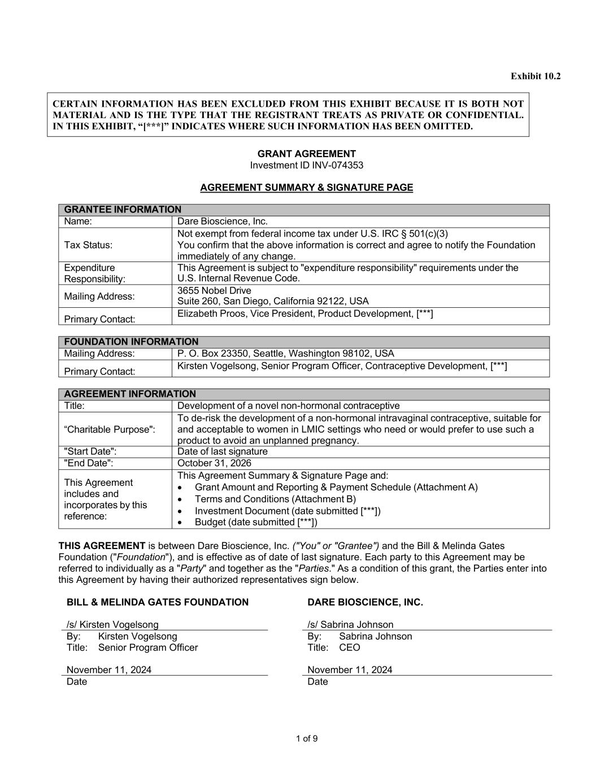
1 of 9 Exhibit 10.2 CERTAIN INFORMATION HAS BEEN EXCLUDED FROM THIS EXHIBIT BECAUSE IT IS BOTH NOT MATERIAL AND IS THE TYPE THAT THE REGISTRANT TREATS AS PRIVATE OR CONFIDENTIAL. IN THIS EXHIBIT, “[***]” INDICATES WHERE SUCH INFORMATION HAS BEEN OMITTED. GRANT AGREEMENT Investment ID INV-074353 AGREEMENT SUMMARY & SIGNATURE PAGE GRANTEE INFORMATION Name: Dare Bioscience, Inc. Tax Status: Not exempt from federal income tax under U.S. IRC § 501(c)(3) You confirm that the above information is correct and agree to notify the Foundation immediately of any change. Expenditure Responsibility: This Agreement is subject to "expenditure responsibility" requirements under the U.S. Internal Revenue Code. Mailing Address: 3655 Nobel Drive Suite 260, San Diego, California 92122, USA Primary Contact: Elizabeth Proos, Vice President, Product Development, [***] FOUNDATION INFORMATION Mailing Address: P. O. Box 23350, Seattle, Washington 98102, USA Primary Contact: Kirsten Vogelsong, Senior Program Officer, Contraceptive Development, [***] AGREEMENT INFORMATION Title: Development of a novel non-hormonal contraceptive “Charitable Purpose": To de-risk the development of a non-hormonal intravaginal contraceptive, suitable for and acceptable to women in LMIC settings who need or would prefer to use such a product to avoid an unplanned pregnancy. "Start Date": Date of last signature "End Date": October 31, 2026 This Agreement includes and incorporates by this reference: This Agreement Summary & Signature Page and: • Grant Amount and Reporting & Payment Schedule (Attachment A) • Terms and Conditions (Attachment B) • Investment Document (date submitted [***]) • Budget (date submitted [***]) THIS AGREEMENT is between Dare Bioscience, Inc. ("You" or "Grantee") and the Bill & Melinda Gates Foundation ("Foundation"), and is effective as of date of last signature. Each party to this Agreement may be referred to individually as a "Party" and together as the "Parties." As a condition of this grant, the Parties enter into this Agreement by having their authorized representatives sign below. BILL & MELINDA GATES FOUNDATION /s/ Kirsten Vogelsong DARE BIOSCIENCE, INC. /s/ Sabrina Johnson By: Kirsten Vogelsong By: Sabrina Johnson Title: Senior Program Officer Title: CEO November 11, 2024 November 11, 2024 Date Date

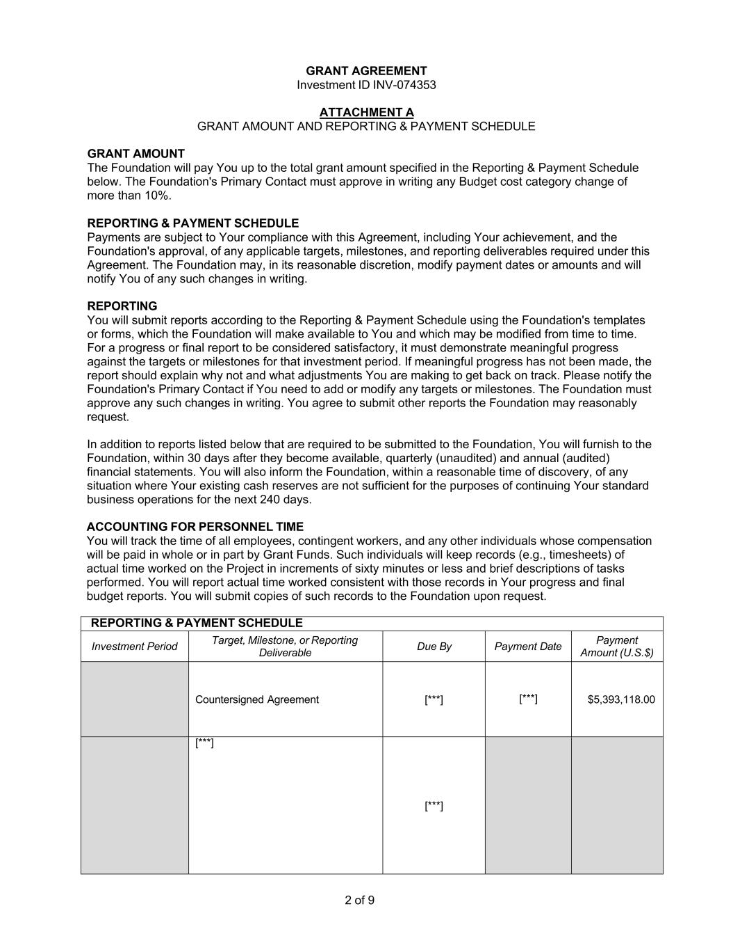
2 of 9 GRANT AGREEMENT Investment ID INV-074353 ATTACHMENT A GRANT AMOUNT AND REPORTING & PAYMENT SCHEDULE GRANT AMOUNT The Foundation will pay You up to the total grant amount specified in the Reporting & Payment Schedule below. The Foundation's Primary Contact must approve in writing any Budget cost category change of more than 10%. REPORTING & PAYMENT SCHEDULE Payments are subject to Your compliance with this Agreement, including Your achievement, and the Foundation's approval, of any applicable targets, milestones, and reporting deliverables required under this Agreement. The Foundation may, in its reasonable discretion, modify payment dates or amounts and will notify You of any such changes in writing. REPORTING You will submit reports according to the Reporting & Payment Schedule using the Foundation's templates or forms, which the Foundation will make available to You and which may be modified from time to time. For a progress or final report to be considered satisfactory, it must demonstrate meaningful progress against the targets or milestones for that investment period. If meaningful progress has not been made, the report should explain why not and what adjustments You are making to get back on track. Please notify the Foundation's Primary Contact if You need to add or modify any targets or milestones. The Foundation must approve any such changes in writing. You agree to submit other reports the Foundation may reasonably request. In addition to reports listed below that are required to be submitted to the Foundation, You will furnish to the Foundation, within 30 days after they become available, quarterly (unaudited) and annual (audited) financial statements. You will also inform the Foundation, within a reasonable time of discovery, of any situation where Your existing cash reserves are not sufficient for the purposes of continuing Your standard business operations for the next 240 days. ACCOUNTING FOR PERSONNEL TIME You will track the time of all employees, contingent workers, and any other individuals whose compensation will be paid in whole or in part by Grant Funds. Such individuals will keep records (e.g., timesheets) of actual time worked on the Project in increments of sixty minutes or less and brief descriptions of tasks performed. You will report actual time worked consistent with those records in Your progress and final budget reports. You will submit copies of such records to the Foundation upon request. REPORTING & PAYMENT SCHEDULE Investment Period Target, Milestone, or Reporting Deliverable Due By Payment Date Payment Amount (U.S.$) Countersigned Agreement [***] [***] $5,393,118.00 [***] [***]

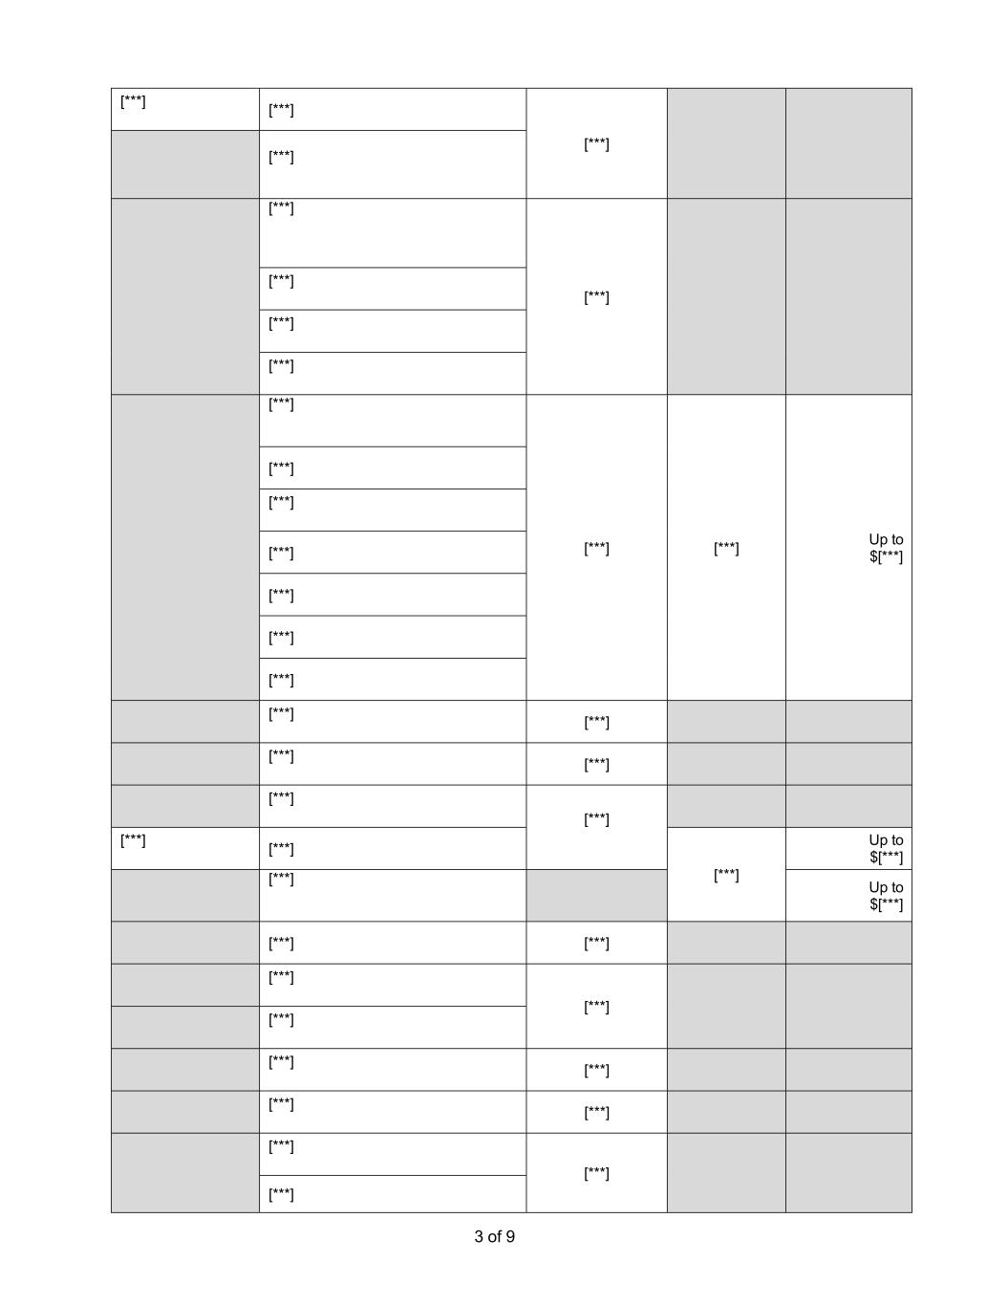
3 of 9 [***] [***] [***] [***] [***] [***] [***] [***] [***] [***] [***] [***] Up to $[***] [***] [***] [***] [***] [***] [***] [***] [***] [***] [***] [***] [***] [***] [***] [***] Up to $[***] [***] Up to $[***] [***] [***] [***] [***] [***] [***] [***] [***] [***] [***] [***] [***]


4 of 9 [***] [***] [***] [***] [***] Total Grant Amount Up to $10,683,142.00

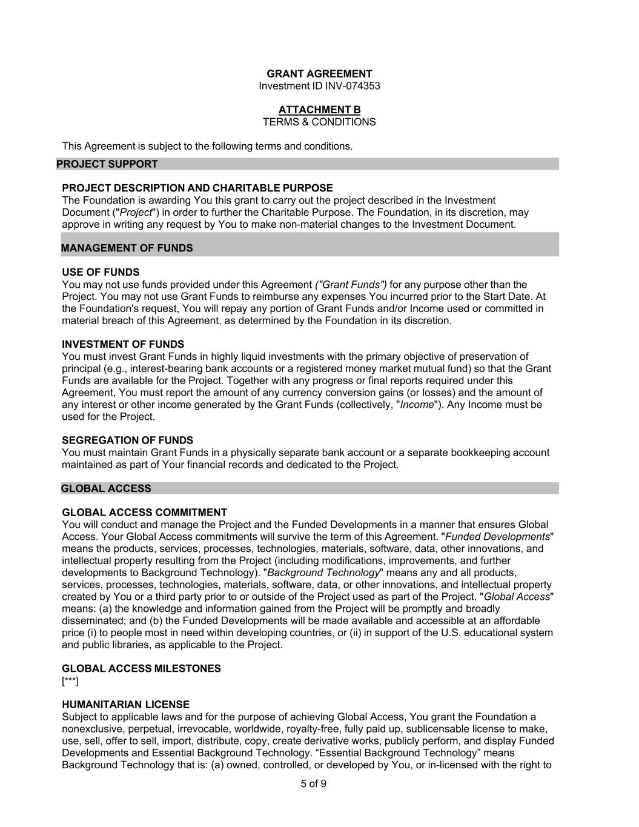
5 of 9 GRANT AGREEMENT Investment ID INV-074353 ATTACHMENT B TERMS & CONDITIONS This Agreement is subject to the following terms and conditions. PROJECT SUPPORT PROJECT DESCRIPTION AND CHARITABLE PURPOSE The Foundation is awarding You this grant to carry out the project described in the Investment Document ("Project") in order to further the Charitable Purpose. The Foundation, in its discretion, may approve in writing any request by You to make non-material changes to the Investment Document. MANAGEMENT OF FUNDS USE OF FUNDS You may not use funds provided under this Agreement ("Grant Funds") for any purpose other than the Project. You may not use Grant Funds to reimburse any expenses You incurred prior to the Start Date. At the Foundation's request, You will repay any portion of Grant Funds and/or Income used or committed in material breach of this Agreement, as determined by the Foundation in its discretion. INVESTMENT OF FUNDS You must invest Grant Funds in highly liquid investments with the primary objective of preservation of principal (e.g., interest-bearing bank accounts or a registered money market mutual fund) so that the Grant Funds are available for the Project. Together with any progress or final reports required under this Agreement, You must report the amount of any currency conversion gains (or losses) and the amount of any interest or other income generated by the Grant Funds (collectively, "Income"). Any Income must be used for the Project. SEGREGATION OF FUNDS You must maintain Grant Funds in a physically separate bank account or a separate bookkeeping account maintained as part of Your financial records and dedicated to the Project. GLOBAL ACCESS GLOBAL ACCESS COMMITMENT You will conduct and manage the Project and the Funded Developments in a manner that ensures Global Access. Your Global Access commitments will survive the term of this Agreement. "Funded Developments" means the products, services, processes, technologies, materials, software, data, other innovations, and intellectual property resulting from the Project (including modifications, improvements, and further developments to Background Technology). "Background Technology" means any and all products, services, processes, technologies, materials, software, data, or other innovations, and intellectual property created by You or a third party prior to or outside of the Project used as part of the Project. "Global Access" means: (a) the knowledge and information gained from the Project will be promptly and broadly disseminated; and (b) the Funded Developments will be made available and accessible at an affordable price (i) to people most in need within developing countries, or (ii) in support of the U.S. educational system and public libraries, as applicable to the Project. GLOBAL ACCESS MILESTONES [***] HUMANITARIAN LICENSE Subject to applicable laws and for the purpose of achieving Global Access, You grant the Foundation a nonexclusive, perpetual, irrevocable, worldwide, royalty-free, fully paid up, sublicensable license to make, use, sell, offer to sell, import, distribute, copy, create derivative works, publicly perform, and display Funded Developments and Essential Background Technology. “Essential Background Technology” means Background Technology that is: (a) owned, controlled, or developed by You, or in-licensed with the right to

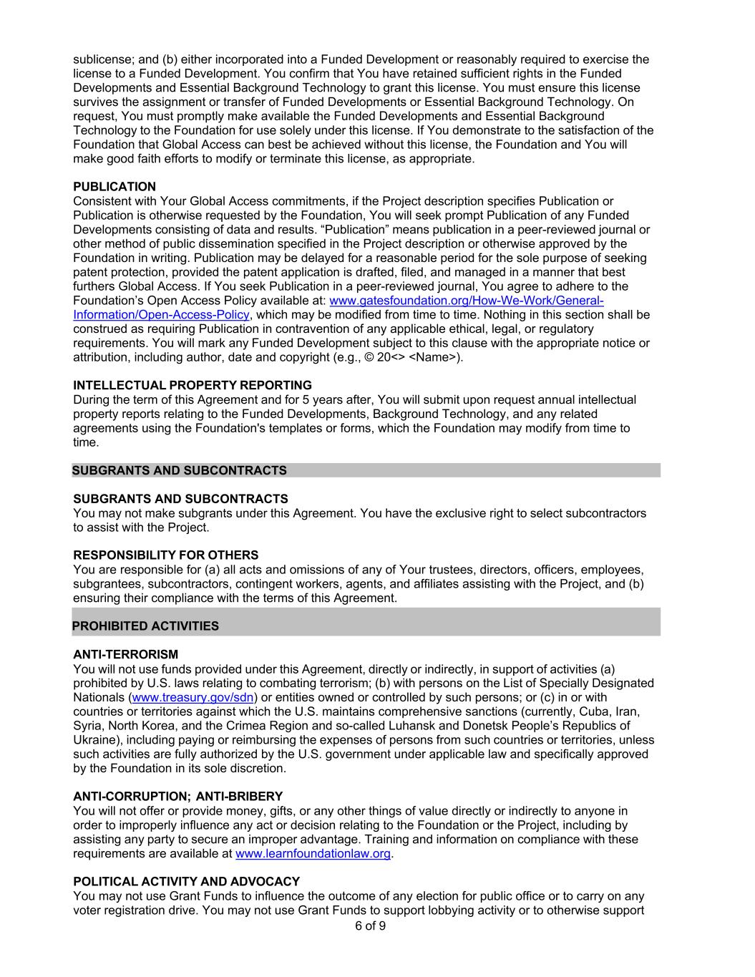
6 of 9 sublicense; and (b) either incorporated into a Funded Development or reasonably required to exercise the license to a Funded Development. You confirm that You have retained sufficient rights in the Funded Developments and Essential Background Technology to grant this license. You must ensure this license survives the assignment or transfer of Funded Developments or Essential Background Technology. On request, You must promptly make available the Funded Developments and Essential Background Technology to the Foundation for use solely under this license. If You demonstrate to the satisfaction of the Foundation that Global Access can best be achieved without this license, the Foundation and You will make good faith efforts to modify or terminate this license, as appropriate. PUBLICATION Consistent with Your Global Access commitments, if the Project description specifies Publication or Publication is otherwise requested by the Foundation, You will seek prompt Publication of any Funded Developments consisting of data and results. “Publication” means publication in a peer-reviewed journal or other method of public dissemination specified in the Project description or otherwise approved by the Foundation in writing. Publication may be delayed for a reasonable period for the sole purpose of seeking patent protection, provided the patent application is drafted, filed, and managed in a manner that best furthers Global Access. If You seek Publication in a peer-reviewed journal, You agree to adhere to the Foundation’s Open Access Policy available at: www.gatesfoundation.org/How-We-Work/General- Information/Open-Access-Policy, which may be modified from time to time. Nothing in this section shall be construed as requiring Publication in contravention of any applicable ethical, legal, or regulatory requirements. You will mark any Funded Development subject to this clause with the appropriate notice or attribution, including author, date and copyright (e.g., © 20<> <Name>). INTELLECTUAL PROPERTY REPORTING During the term of this Agreement and for 5 years after, You will submit upon request annual intellectual property reports relating to the Funded Developments, Background Technology, and any related agreements using the Foundation's templates or forms, which the Foundation may modify from time to time. SUBGRANTS AND SUBCONTRACTS SUBGRANTS AND SUBCONTRACTS You may not make subgrants under this Agreement. You have the exclusive right to select subcontractors to assist with the Project. RESPONSIBILITY FOR OTHERS You are responsible for (a) all acts and omissions of any of Your trustees, directors, officers, employees, subgrantees, subcontractors, contingent workers, agents, and affiliates assisting with the Project, and (b) ensuring their compliance with the terms of this Agreement. PROHIBITED ACTIVITIES ANTI-TERRORISM You will not use funds provided under this Agreement, directly or indirectly, in support of activities (a) prohibited by U.S. laws relating to combating terrorism; (b) with persons on the List of Specially Designated Nationals (www.treasury.gov/sdn) or entities owned or controlled by such persons; or (c) in or with countries or territories against which the U.S. maintains comprehensive sanctions (currently, Cuba, Iran, Syria, North Korea, and the Crimea Region and so-called Luhansk and Donetsk People’s Republics of Ukraine), including paying or reimbursing the expenses of persons from such countries or territories, unless such activities are fully authorized by the U.S. government under applicable law and specifically approved by the Foundation in its sole discretion. ANTI-CORRUPTION; ANTI-BRIBERY You will not offer or provide money, gifts, or any other things of value directly or indirectly to anyone in order to improperly influence any act or decision relating to the Foundation or the Project, including by assisting any party to secure an improper advantage. Training and information on compliance with these requirements are available at www.learnfoundationlaw.org. POLITICAL ACTIVITY AND ADVOCACY You may not use Grant Funds to influence the outcome of any election for public office or to carry on any voter registration drive. You may not use Grant Funds to support lobbying activity or to otherwise support

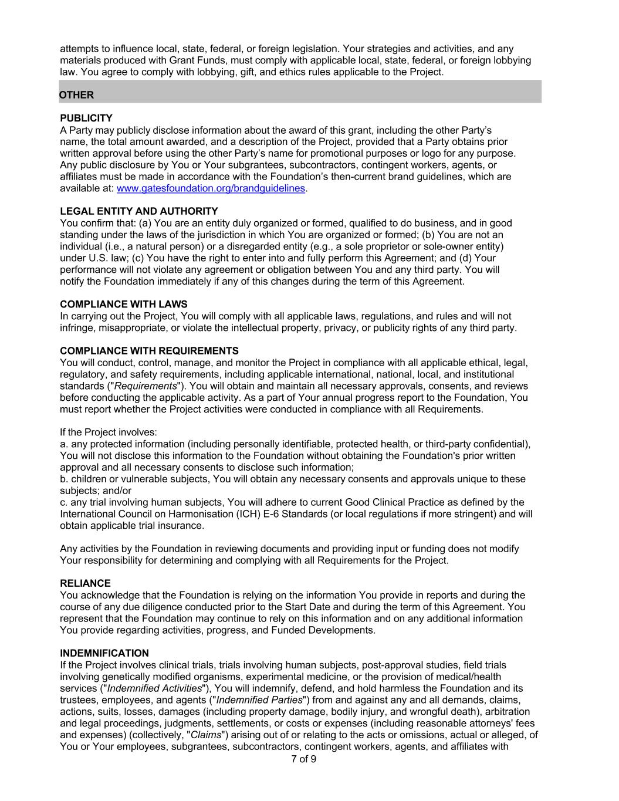
7 of 9 attempts to influence local, state, federal, or foreign legislation. Your strategies and activities, and any materials produced with Grant Funds, must comply with applicable local, state, federal, or foreign lobbying law. You agree to comply with lobbying, gift, and ethics rules applicable to the Project. OTHER PUBLICITY A Party may publicly disclose information about the award of this grant, including the other Party’s name, the total amount awarded, and a description of the Project, provided that a Party obtains prior written approval before using the other Party’s name for promotional purposes or logo for any purpose. Any public disclosure by You or Your subgrantees, subcontractors, contingent workers, agents, or affiliates must be made in accordance with the Foundation’s then-current brand guidelines, which are available at: www.gatesfoundation.org/brandguidelines. LEGAL ENTITY AND AUTHORITY You confirm that: (a) You are an entity duly organized or formed, qualified to do business, and in good standing under the laws of the jurisdiction in which You are organized or formed; (b) You are not an individual (i.e., a natural person) or a disregarded entity (e.g., a sole proprietor or sole-owner entity) under U.S. law; (c) You have the right to enter into and fully perform this Agreement; and (d) Your performance will not violate any agreement or obligation between You and any third party. You will notify the Foundation immediately if any of this changes during the term of this Agreement. COMPLIANCE WITH LAWS In carrying out the Project, You will comply with all applicable laws, regulations, and rules and will not infringe, misappropriate, or violate the intellectual property, privacy, or publicity rights of any third party. COMPLIANCE WITH REQUIREMENTS You will conduct, control, manage, and monitor the Project in compliance with all applicable ethical, legal, regulatory, and safety requirements, including applicable international, national, local, and institutional standards ("Requirements"). You will obtain and maintain all necessary approvals, consents, and reviews before conducting the applicable activity. As a part of Your annual progress report to the Foundation, You must report whether the Project activities were conducted in compliance with all Requirements. If the Project involves: a. any protected information (including personally identifiable, protected health, or third-party confidential), You will not disclose this information to the Foundation without obtaining the Foundation's prior written approval and all necessary consents to disclose such information; b. children or vulnerable subjects, You will obtain any necessary consents and approvals unique to these subjects; and/or c. any trial involving human subjects, You will adhere to current Good Clinical Practice as defined by the International Council on Harmonisation (ICH) E-6 Standards (or local regulations if more stringent) and will obtain applicable trial insurance. Any activities by the Foundation in reviewing documents and providing input or funding does not modify Your responsibility for determining and complying with all Requirements for the Project. RELIANCE You acknowledge that the Foundation is relying on the information You provide in reports and during the course of any due diligence conducted prior to the Start Date and during the term of this Agreement. You represent that the Foundation may continue to rely on this information and on any additional information You provide regarding activities, progress, and Funded Developments. INDEMNIFICATION If the Project involves clinical trials, trials involving human subjects, post-approval studies, field trials involving genetically modified organisms, experimental medicine, or the provision of medical/health services ("Indemnified Activities"), You will indemnify, defend, and hold harmless the Foundation and its trustees, employees, and agents ("Indemnified Parties") from and against any and all demands, claims, actions, suits, losses, damages (including property damage, bodily injury, and wrongful death), arbitration and legal proceedings, judgments, settlements, or costs or expenses (including reasonable attorneys' fees and expenses) (collectively, "Claims") arising out of or relating to the acts or omissions, actual or alleged, of You or Your employees, subgrantees, subcontractors, contingent workers, agents, and affiliates with

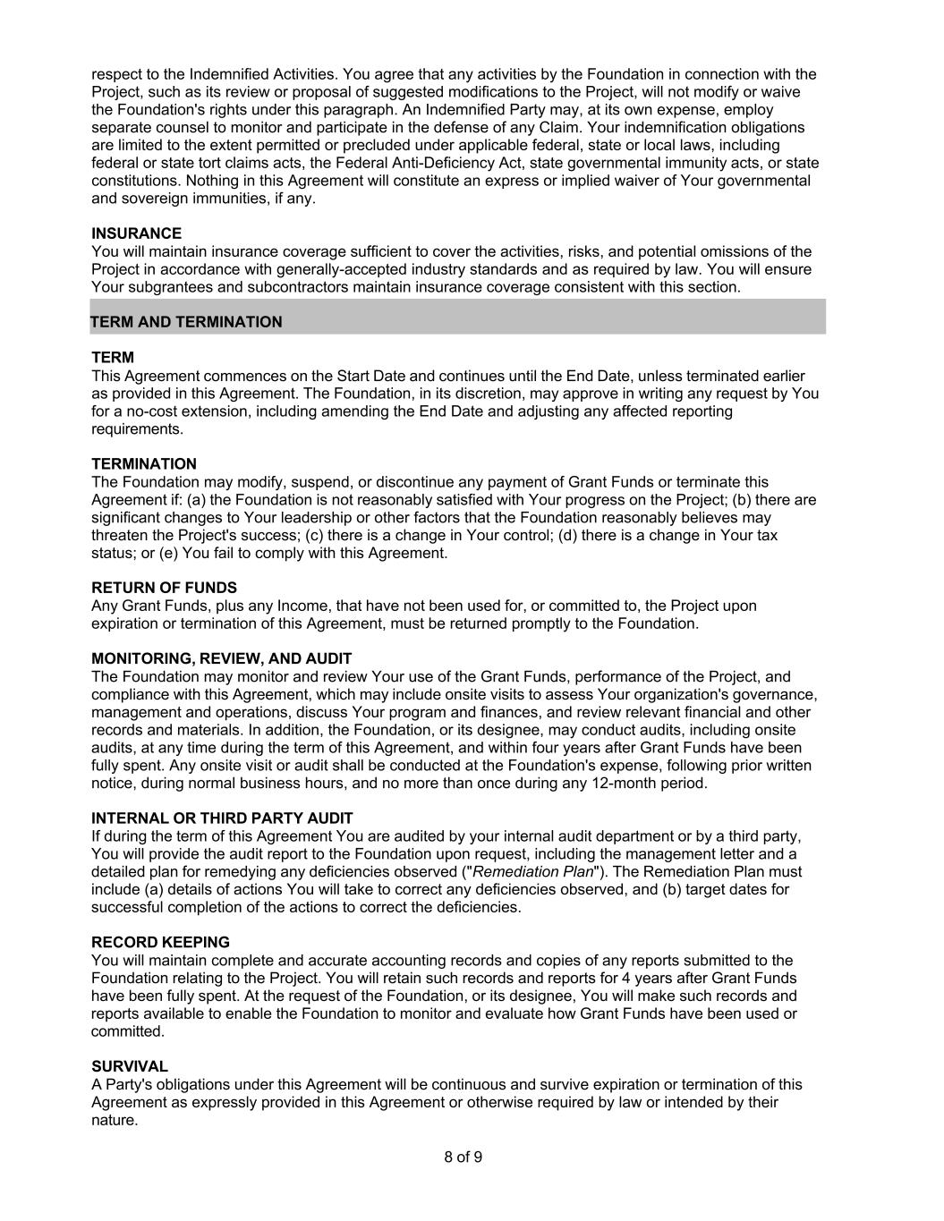
8 of 9 respect to the Indemnified Activities. You agree that any activities by the Foundation in connection with the Project, such as its review or proposal of suggested modifications to the Project, will not modify or waive the Foundation's rights under this paragraph. An Indemnified Party may, at its own expense, employ separate counsel to monitor and participate in the defense of any Claim. Your indemnification obligations are limited to the extent permitted or precluded under applicable federal, state or local laws, including federal or state tort claims acts, the Federal Anti-Deficiency Act, state governmental immunity acts, or state constitutions. Nothing in this Agreement will constitute an express or implied waiver of Your governmental and sovereign immunities, if any. INSURANCE You will maintain insurance coverage sufficient to cover the activities, risks, and potential omissions of the Project in accordance with generally-accepted industry standards and as required by law. You will ensure Your subgrantees and subcontractors maintain insurance coverage consistent with this section. TERM AND TERMINATION TERM This Agreement commences on the Start Date and continues until the End Date, unless terminated earlier as provided in this Agreement. The Foundation, in its discretion, may approve in writing any request by You for a no-cost extension, including amending the End Date and adjusting any affected reporting requirements. TERMINATION The Foundation may modify, suspend, or discontinue any payment of Grant Funds or terminate this Agreement if: (a) the Foundation is not reasonably satisfied with Your progress on the Project; (b) there are significant changes to Your leadership or other factors that the Foundation reasonably believes may threaten the Project's success; (c) there is a change in Your control; (d) there is a change in Your tax status; or (e) You fail to comply with this Agreement. RETURN OF FUNDS Any Grant Funds, plus any Income, that have not been used for, or committed to, the Project upon expiration or termination of this Agreement, must be returned promptly to the Foundation. MONITORING, REVIEW, AND AUDIT The Foundation may monitor and review Your use of the Grant Funds, performance of the Project, and compliance with this Agreement, which may include onsite visits to assess Your organization's governance, management and operations, discuss Your program and finances, and review relevant financial and other records and materials. In addition, the Foundation, or its designee, may conduct audits, including onsite audits, at any time during the term of this Agreement, and within four years after Grant Funds have been fully spent. Any onsite visit or audit shall be conducted at the Foundation's expense, following prior written notice, during normal business hours, and no more than once during any 12-month period. INTERNAL OR THIRD PARTY AUDIT If during the term of this Agreement You are audited by your internal audit department or by a third party, You will provide the audit report to the Foundation upon request, including the management letter and a detailed plan for remedying any deficiencies observed ("Remediation Plan"). The Remediation Plan must include (a) details of actions You will take to correct any deficiencies observed, and (b) target dates for successful completion of the actions to correct the deficiencies. RECORD KEEPING You will maintain complete and accurate accounting records and copies of any reports submitted to the Foundation relating to the Project. You will retain such records and reports for 4 years after Grant Funds have been fully spent. At the request of the Foundation, or its designee, You will make such records and reports available to enable the Foundation to monitor and evaluate how Grant Funds have been used or committed. SURVIVAL A Party's obligations under this Agreement will be continuous and survive expiration or termination of this Agreement as expressly provided in this Agreement or otherwise required by law or intended by their nature.

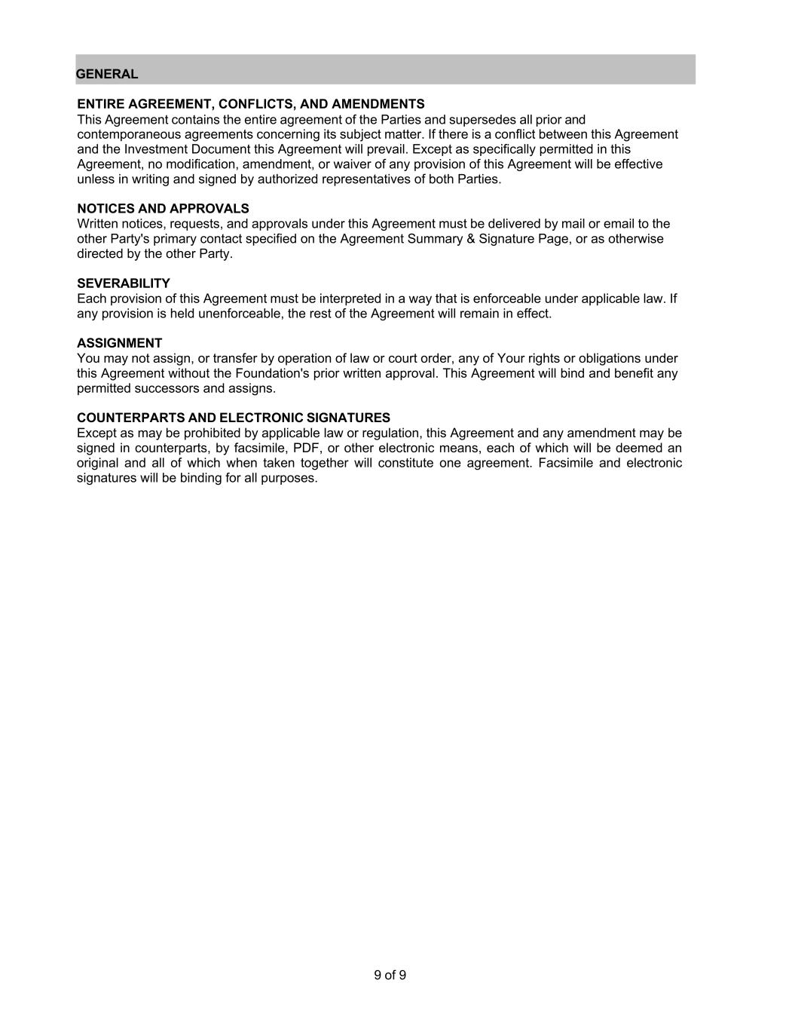
9 of 9 GENERAL ENTIRE AGREEMENT, CONFLICTS, AND AMENDMENTS This Agreement contains the entire agreement of the Parties and supersedes all prior and contemporaneous agreements concerning its subject matter. If there is a conflict between this Agreement and the Investment Document this Agreement will prevail. Except as specifically permitted in this Agreement, no modification, amendment, or waiver of any provision of this Agreement will be effective unless in writing and signed by authorized representatives of both Parties. NOTICES AND APPROVALS Written notices, requests, and approvals under this Agreement must be delivered by mail or email to the other Party's primary contact specified on the Agreement Summary & Signature Page, or as otherwise directed by the other Party. SEVERABILITY Each provision of this Agreement must be interpreted in a way that is enforceable under applicable law. If any provision is held unenforceable, the rest of the Agreement will remain in effect. ASSIGNMENT You may not assign, or transfer by operation of law or court order, any of Your rights or obligations under this Agreement without the Foundation's prior written approval. This Agreement will bind and benefit any permitted successors and assigns. COUNTERPARTS AND ELECTRONIC SIGNATURES Except as may be prohibited by applicable law or regulation, this Agreement and any amendment may be signed in counterparts, by facsimile, PDF, or other electronic means, each of which will be deemed an original and all of which when taken together will constitute one agreement. Facsimile and electronic signatures will be binding for all purposes.

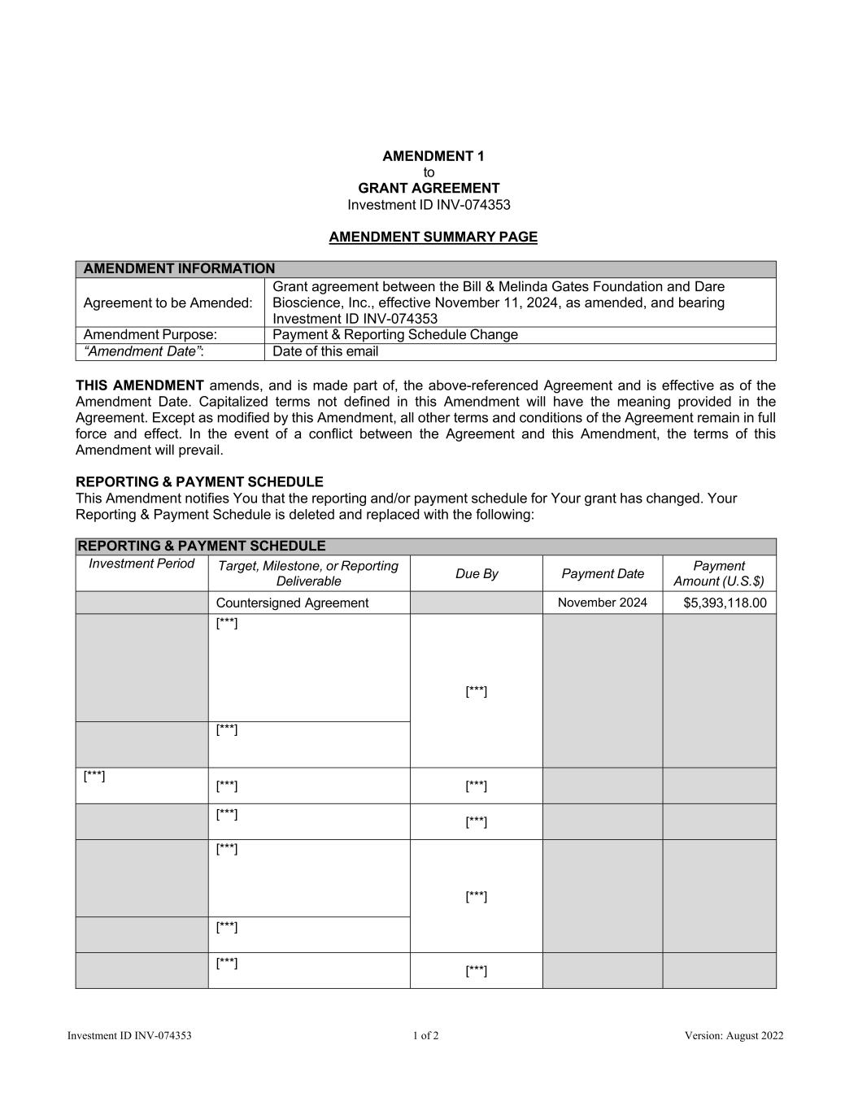
Investment ID INV-074353 1 of 2 Version: August 2022 AMENDMENT 1 to GRANT AGREEMENT Investment ID INV-074353 AMENDMENT SUMMARY PAGE AMENDMENT INFORMATION Agreement to be Amended: Grant agreement between the Bill & Melinda Gates Foundation and Dare Bioscience, Inc., effective November 11, 2024, as amended, and bearing Investment ID INV-074353 Amendment Purpose: Payment & Reporting Schedule Change “Amendment Date”: Date of this email THIS AMENDMENT amends, and is made part of, the above-referenced Agreement and is effective as of the Amendment Date. Capitalized terms not defined in this Amendment will have the meaning provided in the Agreement. Except as modified by this Amendment, all other terms and conditions of the Agreement remain in full force and effect. In the event of a conflict between the Agreement and this Amendment, the terms of this Amendment will prevail. REPORTING & PAYMENT SCHEDULE This Amendment notifies You that the reporting and/or payment schedule for Your grant has changed. Your Reporting & Payment Schedule is deleted and replaced with the following: REPORTING & PAYMENT SCHEDULE Investment Period Target, Milestone, or Reporting Deliverable Due By Payment Date Payment Amount (U.S.$) Countersigned Agreement November 2024 $5,393,118.00 [***] [***] [***] [***] [***] [***] [***] [***] [***] [***] [***] [***] [***]

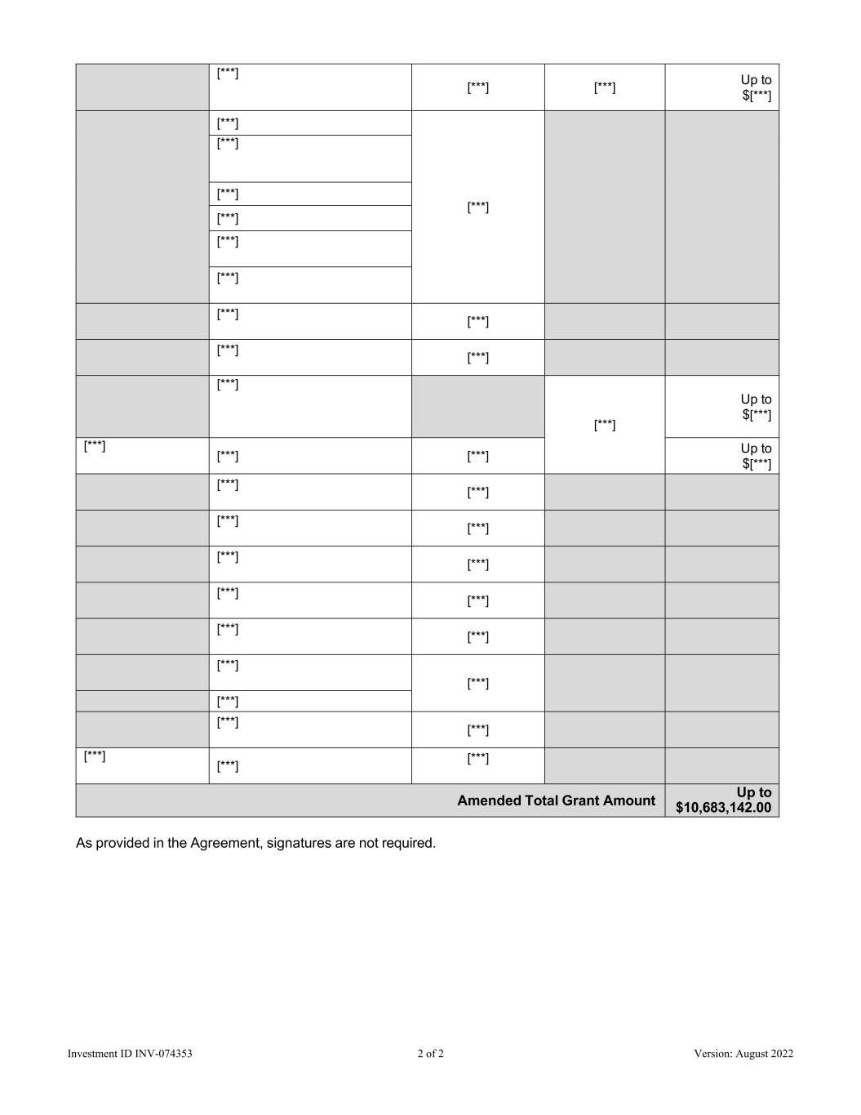
Investment ID INV-074353 2 of 2 Version: August 2022 [***] [***] [***] Up to $[***] [***] [***] [***] [***] [***] [***] [***] [***] [***] [***] [***] [***] [***] Up to $[***] [***] [***] [***] Up to $[***] [***] [***] [***] [***] [***] [***] [***] [***] [***] [***] [***] [***] [***] [***] [***] [***] [***] [***] Amended Total Grant Amount Up to $10,683,142.00 As provided in the Agreement, signatures are not required.

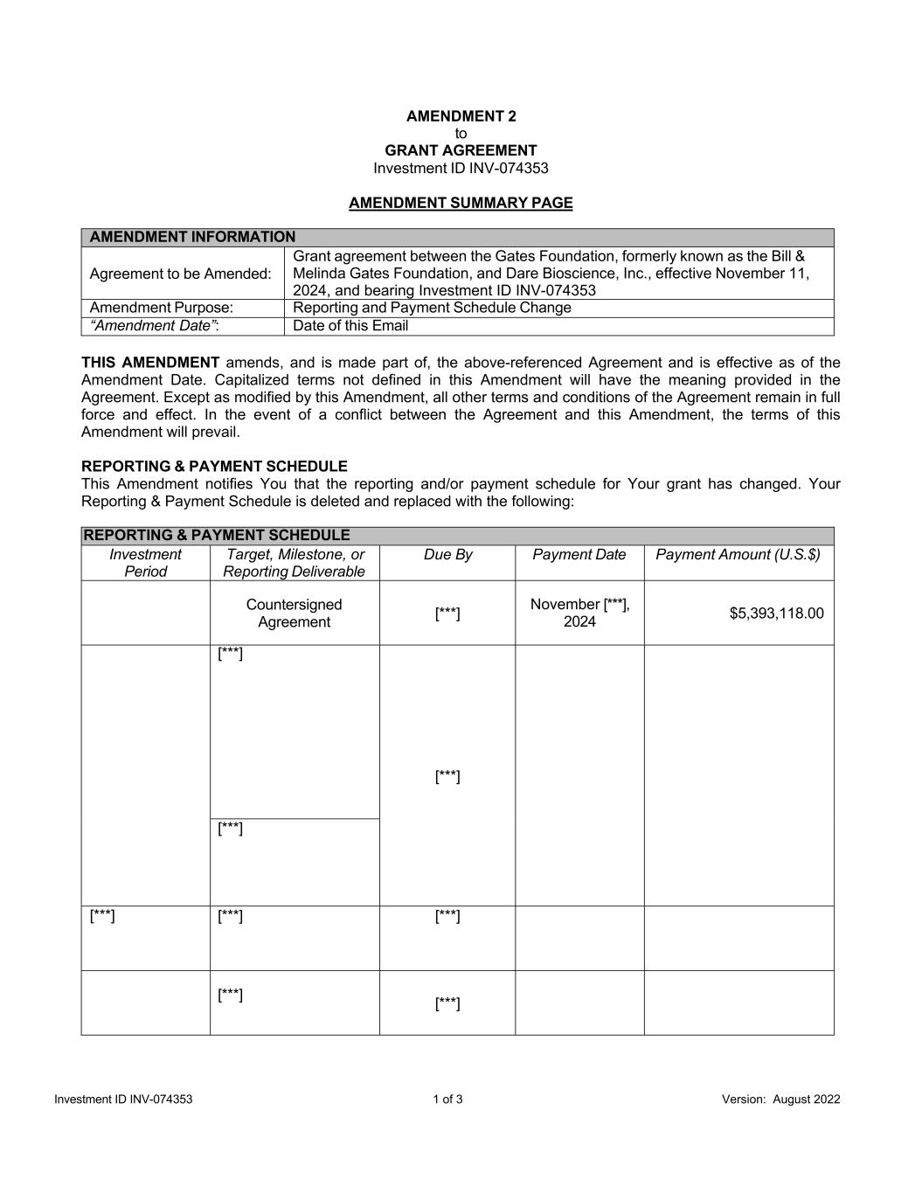
Investment ID INV-074353 1 of 3 Version: August 2022 AMENDMENT 2 to GRANT AGREEMENT Investment ID INV-074353 AMENDMENT SUMMARY PAGE AMENDMENT INFORMATION Agreement to be Amended: Grant agreement between the Gates Foundation, formerly known as the Bill & Melinda Gates Foundation, and Dare Bioscience, Inc., effective November 11, 2024, and bearing Investment ID INV-074353 Amendment Purpose: Reporting and Payment Schedule Change “Amendment Date”: Date of this Email THIS AMENDMENT amends, and is made part of, the above-referenced Agreement and is effective as of the Amendment Date. Capitalized terms not defined in this Amendment will have the meaning provided in the Agreement. Except as modified by this Amendment, all other terms and conditions of the Agreement remain in full force and effect. In the event of a conflict between the Agreement and this Amendment, the terms of this Amendment will prevail. REPORTING & PAYMENT SCHEDULE This Amendment notifies You that the reporting and/or payment schedule for Your grant has changed. Your Reporting & Payment Schedule is deleted and replaced with the following: REPORTING & PAYMENT SCHEDULE Investment Period Target, Milestone, or Reporting Deliverable Due By Payment Date Payment Amount (U.S.$) Countersigned Agreement [***] November [***], 2024 $5,393,118.00 [***] [***] [***] [***] [***] [***] [***] [***]

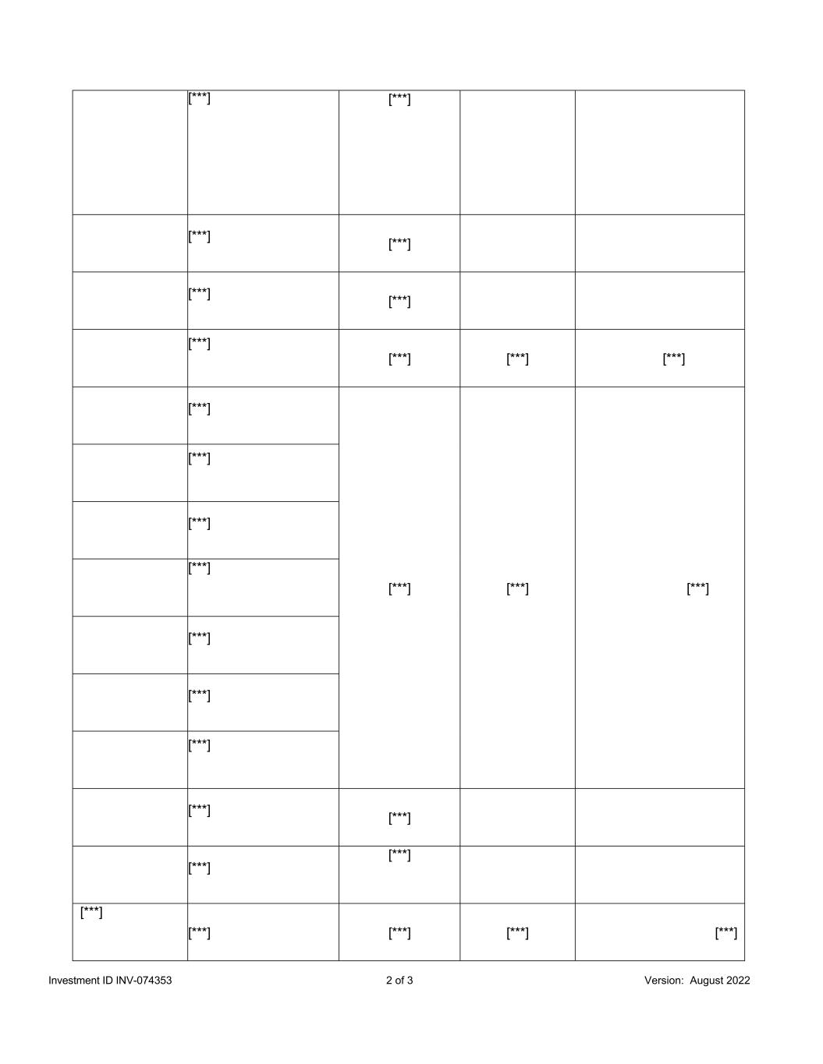
Investment ID INV-074353 2 of 3 Version: August 2022 [***] [***] [***] [***] [***] [***] [***] [***] [***] [***] [***] [***] [***] [***] [***] [***] [***] [***] [***] [***] [***] [***] [***] [***] [***] [***] [***] [***] [***]

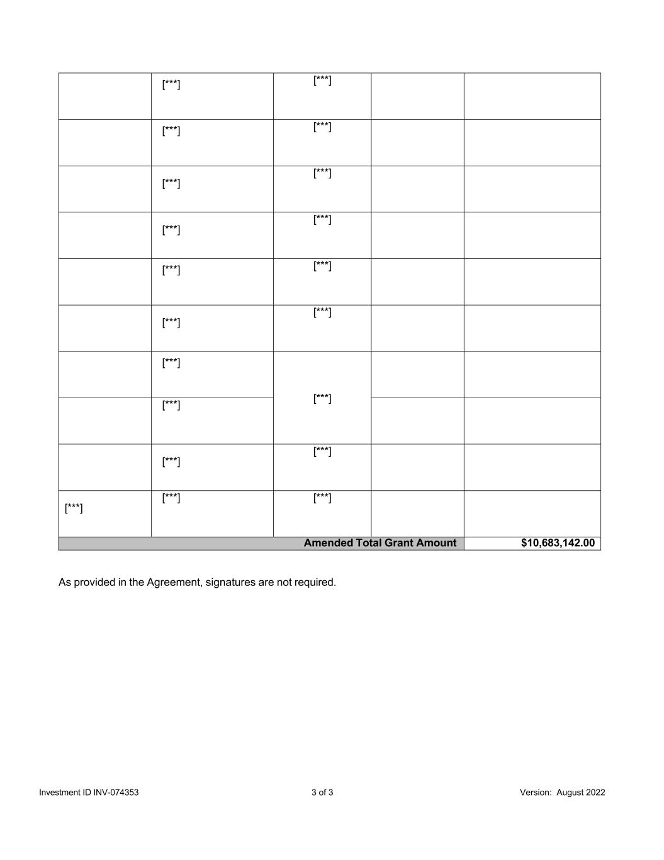
Investment ID INV-074353 3 of 3 Version: August 2022 [***] [***] [***] [***] [***] [***] [***] [***] [***] [***] [***] [***] [***] [***] [***] [***] [***] [***] [***] [***] Amended Total Grant Amount $10,683,142.00 As provided in the Agreement, signatures are not required.

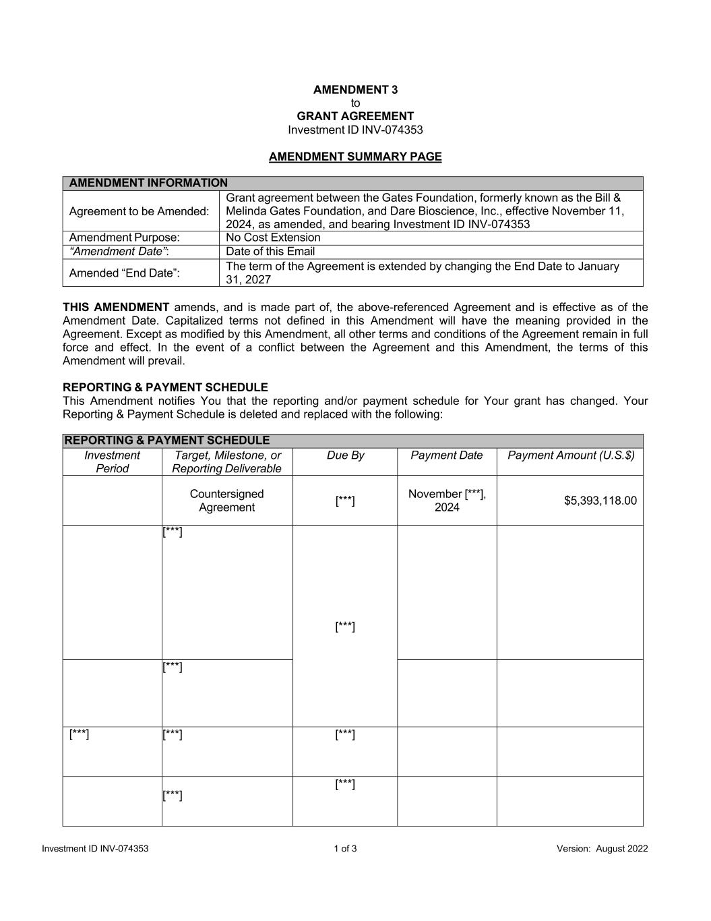
Investment ID INV-074353 1 of 3 Version: August 2022 AMENDMENT 3 to GRANT AGREEMENT Investment ID INV-074353 AMENDMENT SUMMARY PAGE AMENDMENT INFORMATION Agreement to be Amended: Grant agreement between the Gates Foundation, formerly known as the Bill & Melinda Gates Foundation, and Dare Bioscience, Inc., effective November 11, 2024, as amended, and bearing Investment ID INV-074353 Amendment Purpose: No Cost Extension “Amendment Date”: Date of this Email Amended “End Date”: The term of the Agreement is extended by changing the End Date to January 31, 2027 THIS AMENDMENT amends, and is made part of, the above-referenced Agreement and is effective as of the Amendment Date. Capitalized terms not defined in this Amendment will have the meaning provided in the Agreement. Except as modified by this Amendment, all other terms and conditions of the Agreement remain in full force and effect. In the event of a conflict between the Agreement and this Amendment, the terms of this Amendment will prevail. REPORTING & PAYMENT SCHEDULE This Amendment notifies You that the reporting and/or payment schedule for Your grant has changed. Your Reporting & Payment Schedule is deleted and replaced with the following: REPORTING & PAYMENT SCHEDULE Investment Period Target, Milestone, or Reporting Deliverable Due By Payment Date Payment Amount (U.S.$) Countersigned Agreement [***] November [***], 2024 $5,393,118.00 [***] [***] [***] [***] [***] [***] [***] [***]

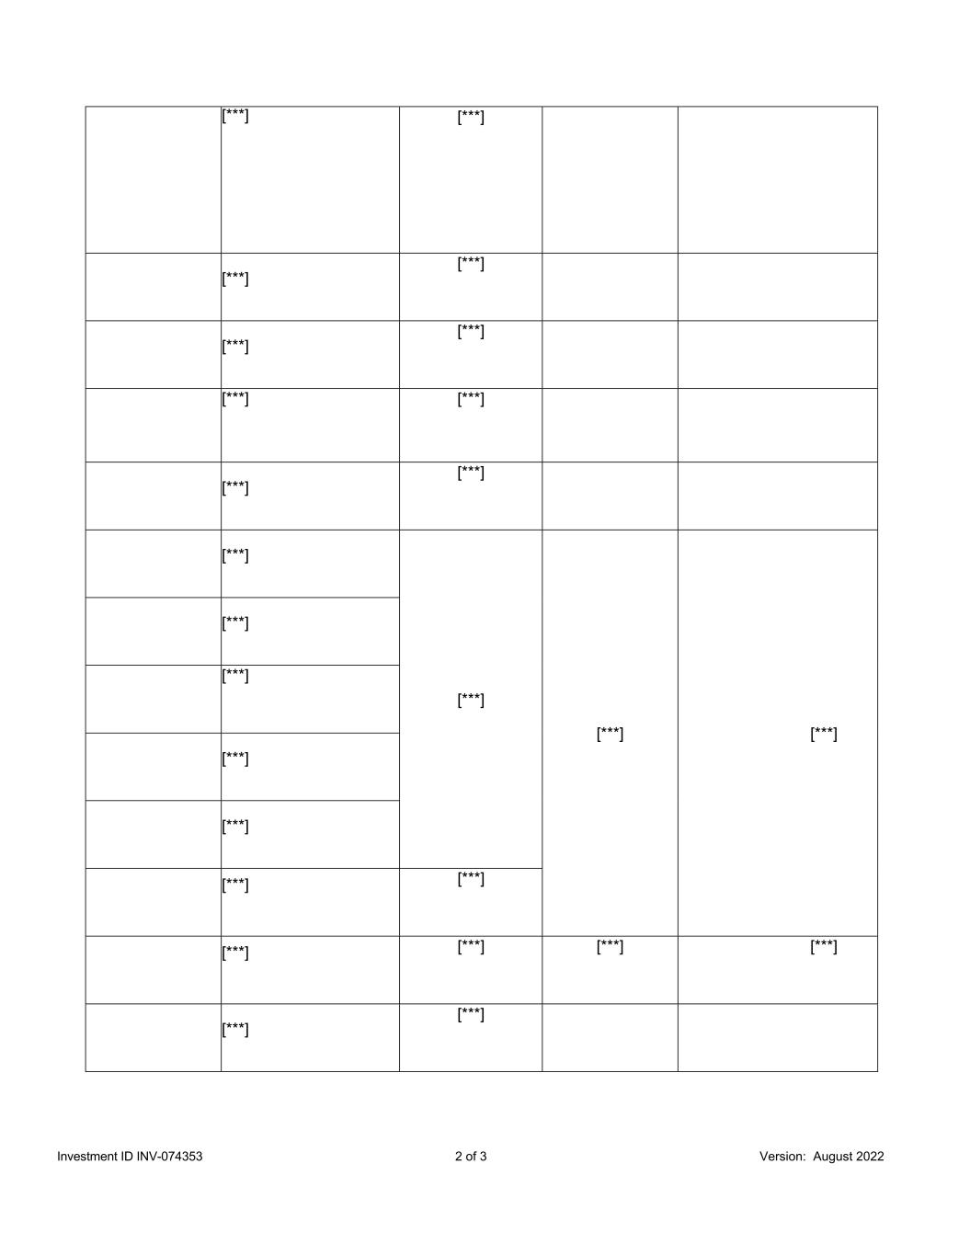
Investment ID INV-074353 2 of 3 Version: August 2022 [***] [***] [***] [***] [***] [***] [***] [***] [***] [***] [***] [***] [***] [***] [***] [***] [***] [***] [***] [***] [***] [***] [***] [***] [***] [***]

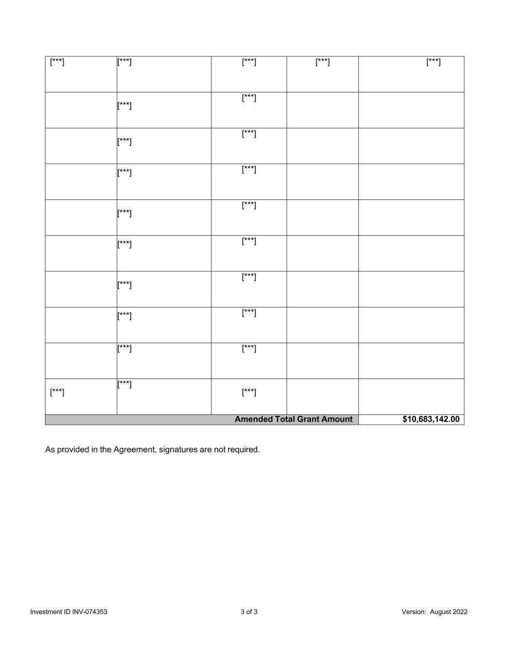
Investment ID INV-074353 3 of 3 Version: August 2022 [***] [***] [***] [***] [***] [***] [***] [***] [***] [***] [***] [***] [***] [***] [***] [***] [***] [***] [***] [***] [***] [***] [***] [***] Amended Total Grant Amount $10,683,142.00 As provided in the Agreement, signatures are not required.

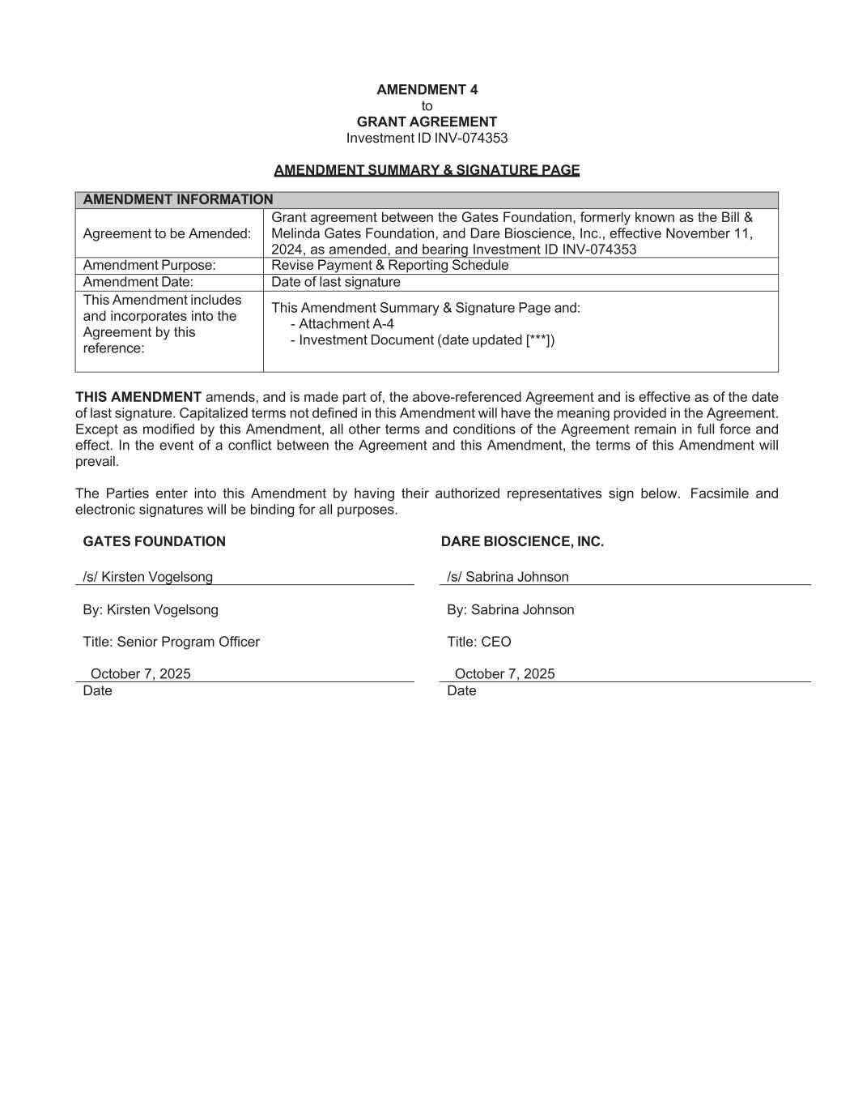
AMENDMENT 4 to GRANT AGREEMENT Investment ID INV-074353 AMENDMENT SUMMARY & SIGNATURE PAGE AMENDMENT INFORMATION Agreement to be Amended: Grant agreement between the Gates Foundation, formerly known as the Bill & Melinda Gates Foundation, and Dare Bioscience, Inc., effective November 11, 2024, as amended, and bearing Investment ID INV-074353 Amendment Purpose: Revise Payment & Reporting Schedule Amendment Date: Date of last signature This Amendment includes and incorporates into the Agreement by this reference: This Amendment Summary & Signature Page and: - Attachment A-4 - Investment Document (date updated [***]) THIS AMENDMENT amends, and is made part of, the above-referenced Agreement and is effective as of the date of last signature. Capitalized terms not defined in this Amendment will have the meaning provided in the Agreement. Except as modified by this Amendment, all other terms and conditions of the Agreement remain in full force and effect. In the event of a conflict between the Agreement and this Amendment, the terms of this Amendment will prevail. The Parties enter into this Amendment by having their authorized representatives sign below. Facsimile and electronic signatures will be binding for all purposes. GATES FOUNDATION DARE BIOSCIENCE, INC. /s/ Kirsten Vogelsong /s/ Sabrina Johnson By: Kirsten Vogelsong By: Sabrina Johnson Title: Senior Program Officer Title: CEO October 7, 2025 October 7, 2025 Date Date

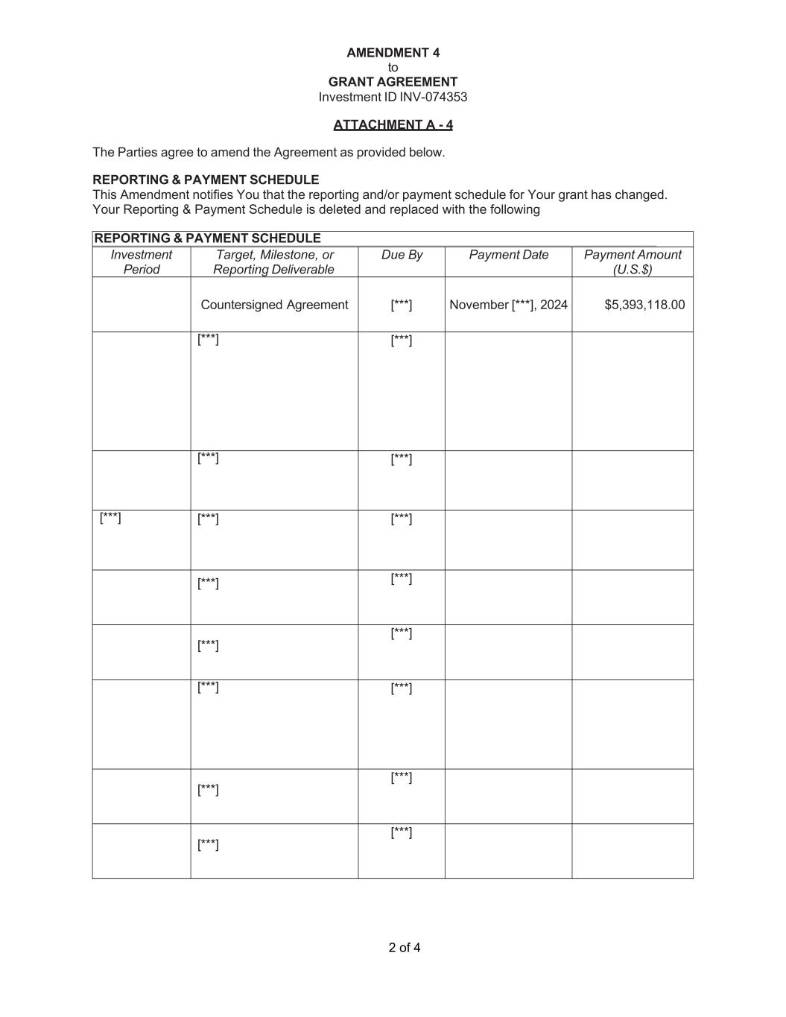
2 of 4 AMENDMENT 4 to GRANT AGREEMENT Investment ID INV-074353 ATTACHMENT A - 4 The Parties agree to amend the Agreement as provided below. REPORTING & PAYMENT SCHEDULE This Amendment notifies You that the reporting and/or payment schedule for Your grant has changed. Your Reporting & Payment Schedule is deleted and replaced with the following REPORTING & PAYMENT SCHEDULE Investment Period Target, Milestone, or Reporting Deliverable Due By Payment Date Payment Amount (U.S.$) Countersigned Agreement [***] November [***], 2024 $5,393,118.00 [***] [***] [***] [***] [***] [***] [***] [***] [***] [***] [***] [***] [***] [***] [***] [***] [***]

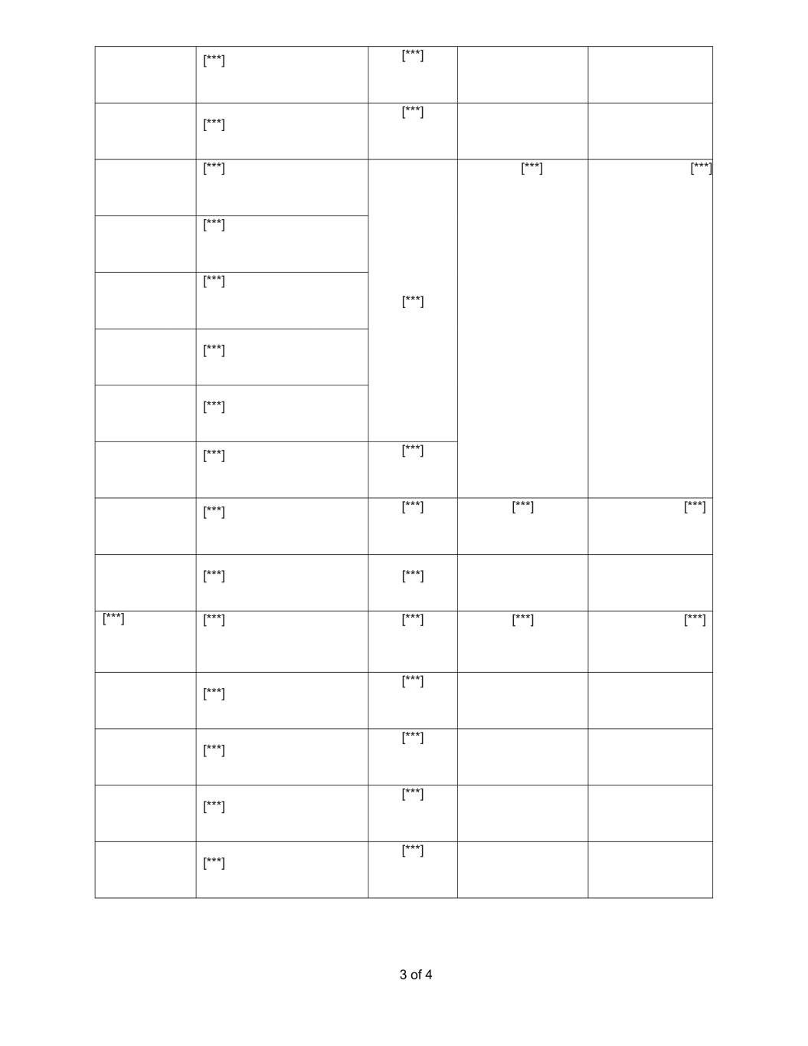
3 of 4 [***] [***] [***] [***] [***] [***] [***] [***] [***] [***] [***] [***] [***] [***] [***] [***] [***] [***] [***] [***] [***] [***] [***] [***] [***] [***] [***] [***] [***] [***] [***] [***] [***]

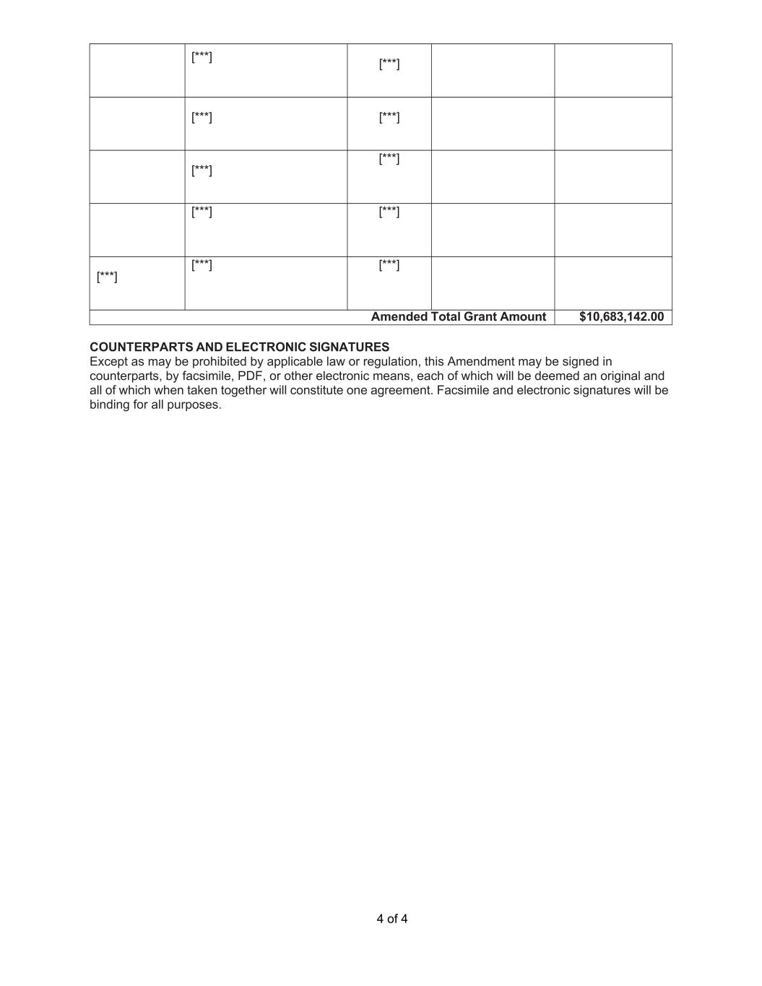
4 of 4 [***] [***] [***] [***] [***] [***] [***] [***] [***] [***] [***] Amended Total Grant Amount $10,683,142.00 COUNTERPARTS AND ELECTRONIC SIGNATURES Except as may be prohibited by applicable law or regulation, this Amendment may be signed in counterparts, by facsimile, PDF, or other electronic means, each of which will be deemed an original and all of which when taken together will constitute one agreement. Facsimile and electronic signatures will be binding for all purposes.

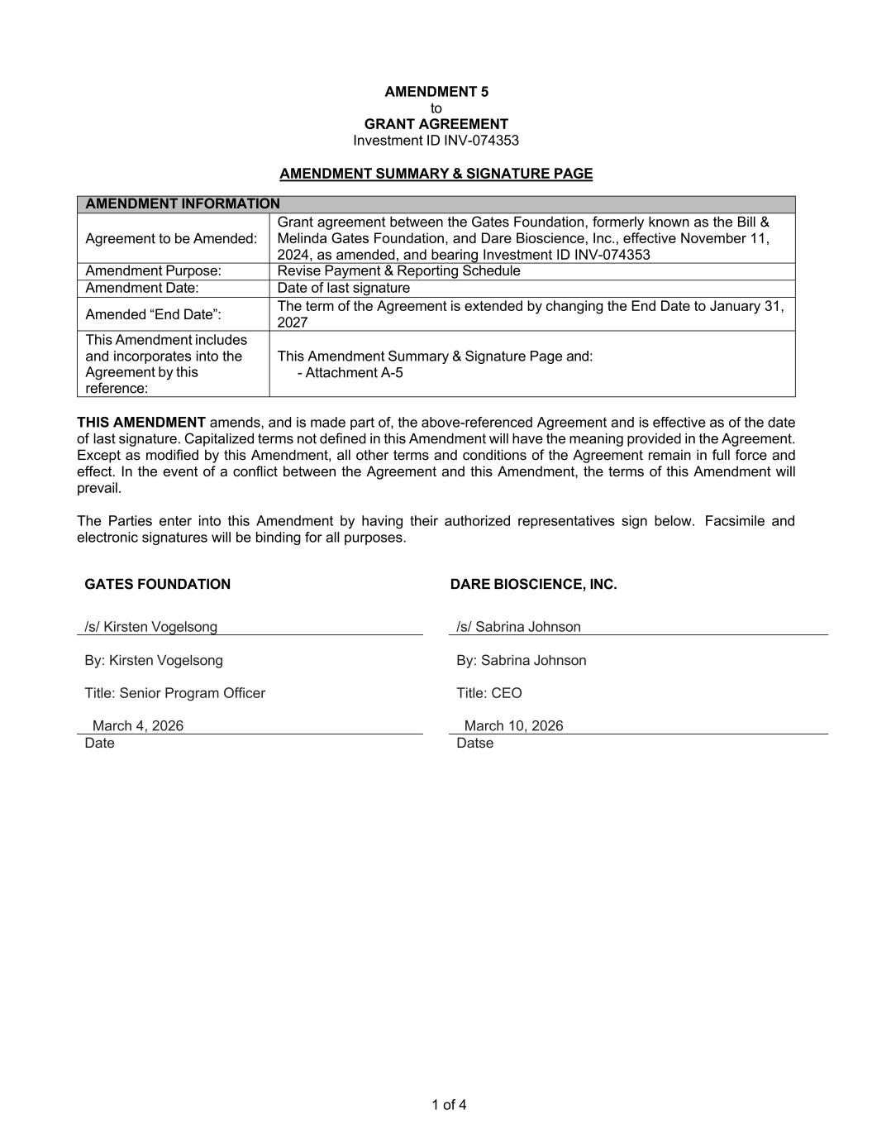
1 of 4 AMENDMENT 5 to GRANT AGREEMENT Investment ID INV-074353 AMENDMENT SUMMARY & SIGNATURE PAGE AMENDMENT INFORMATION Agreement to be Amended: Grant agreement between the Gates Foundation, formerly known as the Bill & Melinda Gates Foundation, and Dare Bioscience, Inc., effective November 11, 2024, as amended, and bearing Investment ID INV-074353 Amendment Purpose: Revise Payment & Reporting Schedule Amendment Date: Date of last signature Amended “End Date”: The term of the Agreement is extended by changing the End Date to January 31, 2027 This Amendment includes and incorporates into the Agreement by this reference: This Amendment Summary & Signature Page and: - Attachment A-5 THIS AMENDMENT amends, and is made part of, the above-referenced Agreement and is effective as of the date of last signature. Capitalized terms not defined in this Amendment will have the meaning provided in the Agreement. Except as modified by this Amendment, all other terms and conditions of the Agreement remain in full force and effect. In the event of a conflict between the Agreement and this Amendment, the terms of this Amendment will prevail. The Parties enter into this Amendment by having their authorized representatives sign below. Facsimile and electronic signatures will be binding for all purposes. GATES FOUNDATION DARE BIOSCIENCE, INC. /s/ Kirsten Vogelsong /s/ Sabrina Johnson By: Kirsten Vogelsong By: Sabrina Johnson Title: Senior Program Officer Title: CEO March 4, 2026 March 10, 2026 Date Datse

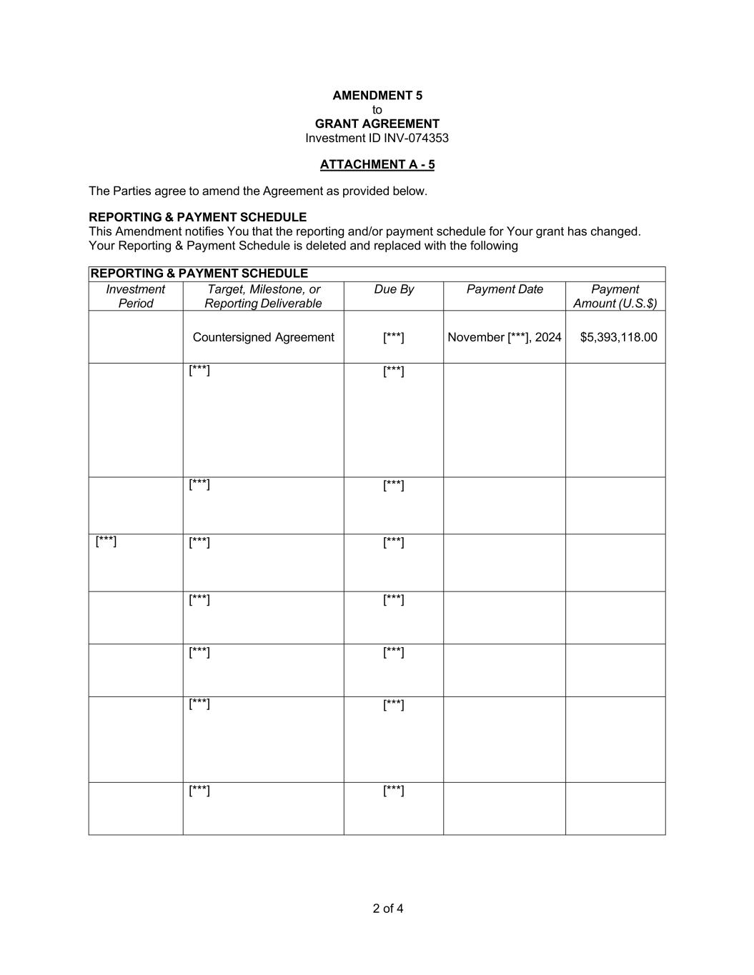
2 of 4 AMENDMENT 5 to GRANT AGREEMENT Investment ID INV-074353 ATTACHMENT A - 5 The Parties agree to amend the Agreement as provided below. REPORTING & PAYMENT SCHEDULE This Amendment notifies You that the reporting and/or payment schedule for Your grant has changed. Your Reporting & Payment Schedule is deleted and replaced with the following REPORTING & PAYMENT SCHEDULE Investment Period Target, Milestone, or Reporting Deliverable Due By Payment Date Payment Amount (U.S.$) Countersigned Agreement [***] November [***], 2024 $5,393,118.00 [***] [***] [***] [***] [***] [***] [***] [***] [***] [***] [***] [***] [***] [***] [***]

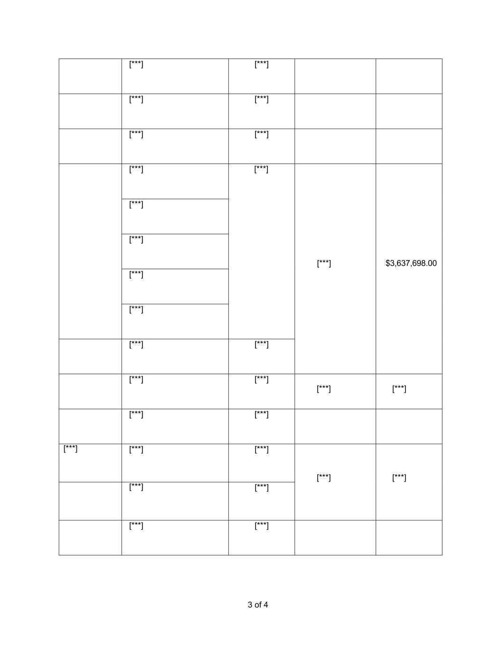
3 of 4 [***] [***] [***] [***] [***] [***] [***] [***] [***] $3,637,698.00 [***] [***] [***] [***] [***] [***] [***] [***] [***] [***] [***] [***] [***] [***] [***] [***] [***] [***] [***] [***] [***]

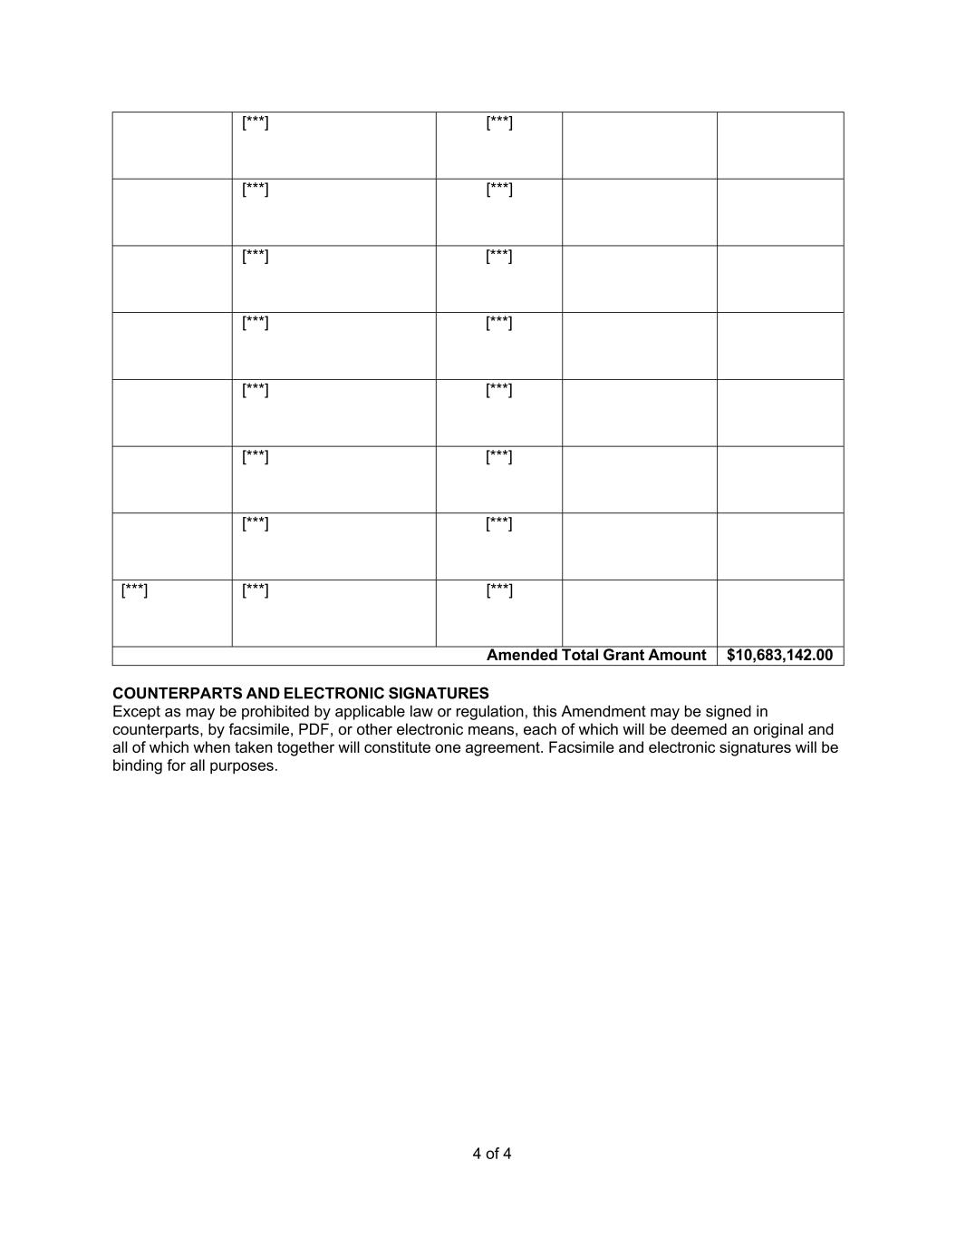
4 of 4 [***] [***] [***] [***] [***] [***] [***] [***] [***] [***] [***] [***] [***] [***] [***] [***] [***] Amended Total Grant Amount $10,683,142.00 COUNTERPARTS AND ELECTRONIC SIGNATURES Except as may be prohibited by applicable law or regulation, this Amendment may be signed in counterparts, by facsimile, PDF, or other electronic means, each of which will be deemed an original and all of which when taken together will constitute one agreement. Facsimile and electronic signatures will be binding for all purposes.

Exhibit 31.1
CERTIFICATIONS
I, Sabrina Martucci Johnson, certify that:

 |  |  | 1. |  |  | I have reviewed this Quarterly Report on Form 10-Q of Daré Bioscience, Inc.;
 |  |  | 2. |  |  | Based on my knowledge, this report does not contain any untrue statement of a material fact or omit to state a material fact necessary to make the statements made, in light of the circumstances under which such statements were made, not misleading with respect to the period covered by this report;
 |  |  | 3. |  |  | Based on my knowledge, the financial statements, and other financial information included in this report, fairly present in all material respects the financial condition, results of operations and cash flows of the registrant as of, and for, the periods presented in this report;
 |  |  | 4. |  |  | I am responsible for establishing and maintaining disclosure controls and procedures (as defined in Exchange Act Rules 13a-15(e) and 15d-15(e)) and internal control over financial reporting (as defined in Exchange Act Rules 13a-15(f) and 15d-15(f)) for the registrant and have:
 |  |  | a. |  |  | Designed such disclosure controls and procedures, or caused such disclosure controls and procedures to be designed under our supervision, to ensure that material information relating to the registrant, including its consolidated subsidiaries, is made known to us by others within those entities, particularly during the period in which this report is being prepared;
 |  |  | b. |  |  | Designed such internal control over financial reporting, or caused such internal control over financial reporting to be designed under our supervision, to provide reasonable assurance regarding the reliability of financial reporting and the preparation of financial statements for external purposes in accordance with generally accepted accounting principles;
 |  |  | c. |  |  | Evaluated the effectiveness of the registrant’s disclosure controls and procedures and presented in this report my conclusions about the effectiveness of the disclosure controls and procedures, as of the end of the period covered by this report based on such evaluation; and
 |  |  | d. |  |  | Disclosed in this report any change in the registrant’s internal control over financial reporting that occurred during the registrant’s most recent fiscal quarter (the registrant’s fourth fiscal quarter in the case of an annual report) that has materially affected, or is reasonably likely to materially affect, the registrant’s internal control over financial reporting; and
 |  |  | 5. |  |  | I have disclosed, based on my most recent evaluation of internal control over financial reporting, to the registrant’s auditors and the audit committee of the registrant’s board of directors (or persons performing the equivalent functions):
 |  |  | a. |  |  | All significant deficiencies and material weaknesses in the design or operation of internal control over financial reporting which are reasonably likely to adversely affect the registrant’s ability to record, process, summarize and report financial information; and
 |  |  | b. |  |  | Any fraud, whether or not material, that involves management or other employees who have a significant role in the registrant’s internal control over financial reporting.
Date: May 14, 2026
/s/ Sabrina Martucci Johnson
Sabrina Martucci Johnson
President and Chief Executive Officer
(Principal executive officer and principal financial officer)

Exhibit 32.1
CERTIFICATION PURSUANT TO 18 U.S.C. SECTION 1350,
AS ADOPTED PURSUANT TO
SECTION 906 OF THE SARBANES-OXLEY ACT OF 2002
In connection with the Quarterly Report on Form 10-Q of Daré Bioscience, Inc. (the “Company”) for the fiscal quarter ended March 31, 2026, as filed with the Securities and Exchange Commission on the date hereof (the “Report”), the undersigned, Sabrina Martucci Johnson, President and Chief Executive Officer of the Company, hereby certifies, pursuant to 18 U.S.C. Section 1350, that, to her knowledge on the date hereof:
(1) The Report fully complies with the requirements of Section 13(a) or 15(d) of the Securities Exchange Act of 1934; and
(2) The information contained in the Report fairly presents, in all material respects, the financial condition and results of operations of the Company.
Date: May 14, 2026

/s/ Sabrina Martucci Johnson
Sabrina Martucci Johnson
President and Chief Executive Officer
(principal executive officer and principal financial officer)

