UNITED STATES
SECURITIES AND EXCHANGE COMMISSION
WASHINGTON, DC 20549
FORM 10-Q
(Mark One)
x |  |  | QUARTERLY REPORT PURSUANT TO SECTION 13 OR 15(d) OF THE SECURITIES EXCHANGE ACT OF 1934
For the quarterly period ended September 30, 2025
OR
☐ |  |  | TRANSITION REPORT PURSUANT TO SECTION 13 OR 15(d) OF THE SECURITIES EXCHANGE ACT OF 1934
For the transition period from to

Commission File Number: 001-36395

DARÉ BIOSCIENCE, INC.
(Exact Name of Registrant as Specified in its Charter)
Delaware  (State or Other Jurisdiction  of Incorporation) |  |  |  |  |  | 20-4139823  (IRS Employer  Identification No.)
3655 Nobel Drive, Suite 260  San Diego, CA  (Address of Principal Executive Offices) |  |  | (858) 926-7655  (Registrant’s telephone number, including area code) |  |  | 92122  (Zip Code)
(Former name, former address and former fiscal year, if changed since last report)
Securities registered pursuant to Section 12(b) of the Act:
Title of each class |  |  | Trading Symbol(s) |  |  | Name of each exchange on which registered
Common Stock |  |  | DARE |  |  | Nasdaq Capital Market
Indicate by check mark whether the registrant (1) has filed all reports required to be filed by Section 13 or 15(d) of the Securities Exchange Act of 1934 during the preceding 12 months (or for such shorter period that the registrant was required to file such reports), and (2) has been subject to such filing requirements for the past 90 days. Yes x No o
Indicate by check mark whether the registrant has submitted electronically every Interactive Data File required to be submitted pursuant to Rule 405 of Regulation S-T (§232.405 of this chapter) during the preceding 12 months (or for such shorter period that the registrant was required to submit such files). Yes x No o
Indicate by check mark whether the registrant is a large accelerated filer, an accelerated filer, a non-accelerated filer, a smaller reporting company, or an emerging growth company. See the definitions of “large accelerated filer,” “accelerated filer,” “smaller reporting company,” and “emerging growth company” in Rule 12b-2 of the Exchange Act.
Large Accelerated Filer |  |  |  |  |  | o |  |  |  |  |  | Accelerated filer |  |  | o
Non-accelerated filer |  |  |  |  |  | x |  |  |  |  |  | Smaller reporting company |  |  | x
Emerging growth company |  |  |  |  |  | o
If an emerging growth company, indicate by check mark if the registrant has elected not to use the extended transition period for complying with any new or revised financial accounting standards pursuant to Section 13(a) of the Exchange Act. o
Indicate by check mark whether the registrant is a shell company (as defined in Rule 12b-2 of the Act). Yes ☐ No x
As of November 12, 2025, 14,289,229 shares of the Registrant’s Common Stock, par value $0.0001, were issued and outstanding.

1

CAUTIONARY NOTE REGARDING FORWARD-LOOKING STATEMENTS
This Quarterly Report on Form 10-Q, in particular “Item 2. Management's Discussion and Analysis of Financial Condition and Results of Operations,” of Part I. Financial Information, and the information incorporated by reference herein contains forward-looking statements that involve substantial risks and uncertainties. All statements, other than statements of historical facts, contained in this report, including statements regarding our strategy, future operations, future financial position, projected revenue, funding and expenses, prospects, plans and objectives of management, are forward-looking statements. Forward-looking statements, in some cases, can be identified by terms such as “believe,” “may,” “will,” “estimate,” “continue,” “anticipate,” “design,” “intend,” “expect,” “could,” "can," “plan,” “potential,” “predict,” “seek,” "pursue," “should,” “would,” “accelerate,” "project,” “target,” “aim,” or the negative version of these words and similar expressions.
Forward-looking statements involve known and unknown risks, uncertainties and other factors that may cause our actual results, performance or achievements to be materially different from any future results, performance or achievements expressed or implied by the forward-looking statements, including those factors described in Part II, Item 1A, "Risk Factors", in this report, and elsewhere in this report. Given these uncertainties, you should not place undue reliance on any forward-looking statement. The following factors are among those that may cause such differences:
•Inability to raise additional capital, under favorable terms or at all, or generate sufficient revenue from our Section 503B compounding and consumer health products business strategies to fund our operating needs and continue as a going concern;
•Dependence on grants and other financial awards from governmental entities and a private foundation to advance the development of several of our product candidates;
•Inexperience, as a company, in and lack of infrastructure for commercializing products;
•Reliance on third parties to execute our operating plan and business strategy, including to commercialize or assist us in commercializing products and conduct or assist us in conducting clinical and nonclinical studies of our product candidates, and delays or difficulties in establishing and maintaining agreements with third parties on a timely basis or on acceptable terms, or at all, and obtaining expected performance from third parties;
•The number and scope of product development programs we pursue;
•Difficulties or delays in commencement or completion, or the termination or suspension, of our current or planned clinical or preclinical studies;
•Clinical trial outcomes and results of preclinical development;
•Failure to complete development of our product candidates or submit and obtain United States Food and Drug Administration, or FDA, or foreign regulatory authority approval for our product candidates on projected timelines or budgets, or at all;
•Challenges and delays in obtaining timely supplies of our product candidates, including their components as well as the finished product, in the quantities needed in accordance with current good manufacturing practices, our specifications and other applicable requirements;
•The removal of sildenafil citrate or any other bulk drug substance needed to compound the compounded drugs that we seek to make available under Section 503B of the Federal Food, Drug, and Cosmetic Act, or FDCA, from the FDA’s list of bulk drug substances that can be compounded under Section 503B;
•The degree of market demand and acceptance achieved by any product we or one of our licensees or collaborators brings to market;
•A change in the laws or regulations related to compounded drugs under Section 503B of the FDCA or consumer health products;
•Termination by a collaborator of our respective out-license agreements for commercialization of XACIATO® (clindamycin phosphate) vaginal gel 2%, or XACIATO, and Ovaprene®, or, in the case of Ovaprene, a decision by the collaborator not to make the license grant fully effective following its review of the results of the ongoing pivotal clinical trial of Ovaprene;

•The timing and amount of future royalty, milestone or other payments to us, if any, under our out-license agreement for Ovaprene, and of upside-sharing milestone payments from XOMA under our traditional and synthetic royalty purchase agreements, if any;
•The terms and conditions of any future strategic collaborations relating to our product candidates;
•Coverage and reimbursement levels for XACIATO and any future product by government health care programs, private health insurance companies and other third-party payors;
•Our loss of, or inability to attract, key personnel;
•A change in the FDA's prior determination that the Center for Devices and Radiological Health would lead the review of a premarket approval application for potential marketing approval of Ovaprene;
•A change in regulatory requirements for our product candidates, including the development pathway pursuant to Section 505(b)(2) of the FDCA, or the FDA's 505(b)(2) pathway;
•Unfavorable differences between preliminary, interim or topline clinical study data reported by us and final study results;
•Communication from the FDA or another regulatory authority, including a complete response letter, that such agency does not accept or agree with our assumptions, estimates, calculations, conclusions or analyses of clinical or nonclinical study data regarding a product candidate, or that such agency interprets or weighs the importance of study data differently than we have in a manner that negatively impacts the candidate's prospects for regulatory approval in a timely manner, or at all;
•Failure to select product candidates that capitalize on the most scientifically, clinically or commercially promising or profitable indications or therapeutic areas within women's health including due to our limited financial resources;
•Loss or impairment of our in-licensed rights to develop and commercialize our products and product candidates;
•The timing and amount of our payment and other obligations under our in-license and acquisition agreements for our products and product candidates;
•Developments by our competitors that make any product or potential product we develop less competitive or obsolete;
•Unfavorable or unanticipated macroeconomic factors, geopolitical events or conflicts, public health emergencies, or natural disasters;
•Weak interest in women's health relative to other healthcare sectors from the investment community or from pharmaceutical companies and other potential development and commercialization collaborators;
•Cyber-attacks, security breaches or similar events compromising our technology systems and data, our financial resources and other assets, or the technology systems and data of third parties on which we rely;
•Difficulty in introducing branded products in a market made up of generic products;
•Inability to adequately protect or enforce our, or our licensor’s, intellectual property rights;
•Lack of patent protection for the active ingredients in XACIATO and certain of the products and potential products we develop that expose them to competition from other formulations using the same active ingredients;
•Higher risk of failure associated with product candidates in preclinical stages of development that may lead investors to assign them little to no value and make these assets difficult to fund;
•Disputes or other developments concerning our intellectual property rights;
•Actual and anticipated fluctuations in our quarterly or annual operating results or results that differ from investors' expectations for such results;
•Failure to maintain the listing of our common stock on the Nasdaq Capital Market or another nationally recognized exchange;
•Price and volume fluctuations in the stock market, and in our stock in particular, which could cause investors to experience losses and subject us to securities class-action litigation;

•Development of safety, efficacy or quality concerns related to our products or product candidates (or third-party products or product candidates that share similar characteristics or drug substances), whether or not scientifically justified, leading to delays in or discontinuation of product development, product recalls or withdrawals, diminished sales, and/or other significant negative consequences;
•Product liability claims or governmental investigations;
•Changes in government laws and regulations in the United States and other jurisdictions, including laws and regulations governing the research, development, approval, clearance, manufacturing, supply, distribution, pricing and/or marketing of our products, product candidates and related intellectual property, health care information and data privacy and security laws, transparency laws and fraud and abuse laws, and the enforcement thereof affecting our business; and
•Increased costs as a result of operating as a public company, and substantial time devoted by our management to compliance initiatives and corporate governance practices.
In addition, statements that “we believe” and similar statements reflect our beliefs and opinions on the relevant subject. These statements are based upon information available to us as of the date of this report, and while we believe such information forms a reasonable basis for such statements, such information may be limited or incomplete, and our statements should not be read to indicate that we have conducted an exhaustive inquiry into, or review of, all potentially available relevant information. These statements are inherently uncertain and investors are cautioned not to unduly rely upon these statements.
All forward-looking statements in this report are current only as of the date of this report. We do not undertake any obligation to publicly update any forward-looking statement to reflect events or circumstances after the date on which any statement is made or to reflect the occurrence of unanticipated events, except as required by law.

TABLE OF CONTENTS
 |  |  |  |  |  | Page
PART I. FINANCIAL INFORMATION
Item 1. |  |  | Condensed Consolidated Financial Statements (Unaudited) |  |  | 1
Item 2. |  |  | Management's Discussion and Analysis of Financial Condition and Results of Operations |  |  | 28
Item 3. |  |  | Quantitative and Qualitative Disclosures About Market Risk |  |  | 47
Item 4. |  |  | Controls and Procedures |  |  | 47
PART II. OTHER INFORMATION
Item 1. |  |  | Legal Proceedings |  |  | 48
Item 1A. |  |  | Risk Factors |  |  | 48
Item 2. |  |  | Unregistered Sales of Equity Securities and Use of Proceeds |  |  | 49
Item 3. |  |  | Defaults Upon Senior Securities |  |  | 49
Item 4. |  |  | Mine Safety Disclosures |  |  | 49
Item 5. |  |  | Other Information |  |  | 49
Item 6. |  |  | Exhibits |  |  | 50
 |  |  | SIGNATURES |  |  | 51

PART I. FINANCIAL INFORMATION

Item 1. Condensed Consolidated Financial Statements (Unaudited)

Daré Bioscience, Inc. and Subsidiaries
Condensed Consolidated Balance Sheets
 |  |  | September 30,  2025 |  |  |  |  |  | December 31,  2024
 |  |  | (unaudited)
Assets
Current assets
Cash and cash equivalents |  |  | $ | 23,075,261 |  |  |  |  | $ | 15,698,174
Other receivables |  |  | 369,157 |  |  |  |  |  | 229,982
Prepaid expenses |  |  | 1,506,603 |  |  |  |  |  | 2,519,707
Other current assets |  |  | 53,159 |  |  |  |  |  | —
Total current assets |  |  | 25,004,180 |  |  |  |  |  | 18,447,863
Property and equipment, net |  |  | 1,657,255 |  |  |  |  |  | 1,335,732
Operating lease right-of-use assets |  |  | 824,693 |  |  |  |  |  | 1,206,942
Finance lease right-of-use asset |  |  | 2,244,073 |  |  |  |  |  | —
Other non-current assets |  |  | 1,018,373 |  |  |  |  |  | 1,110,594
Total assets |  |  | $ | 30,748,574 |  |  |  |  | $ | 22,101,131
Liabilities and stockholders’ equity (deficit)
Current liabilities
Accounts payable |  |  | $ | 1,844,862 |  |  |  |  | $ | 1,455,832
Accrued expenses |  |  | 2,324,931 |  |  |  |  |  | 3,042,918
Deferred grant funding |  |  | 14,557,265 |  |  |  |  |  | 16,561,625
Current portion of liability related to the sale of future royalties |  |  | 10,542 |  |  |  |  |  | 4,054
Current portion of lease liabilities, operating |  |  | 609,224 |  |  |  |  |  | 548,638
Current portion of lease liability, finance |  |  | 1,869,570 |  |  |  |  |  | —
Total current liabilities |  |  | 21,216,394 |  |  |  |  |  | 21,613,067
Deferred revenue, non-current |  |  | 1,000,000 |  |  |  |  |  | 1,000,000
Liability related to the sale of future royalties, net |  |  | 5,220,525 |  |  |  |  |  | 4,745,770
Lease liabilities long-term, operating |  |  | 288,566 |  |  |  |  |  | 754,383
Lease liability long-term, finance |  |  | 165,186 |  |  |  |  |  | —
Total liabilities |  |  | 27,890,671 |  |  |  |  |  | 28,113,220
Commitments and contingencies (Note 9)
Stockholders' equity (deficit)
Preferred stock, $0.01 par value, 5,000,000 shares authorized; None issued and outstanding |  |  | — |  |  |  |  |  | —
Common stock, $0.0001 par value; 240,000,000 shares authorized; 13,929,502 and 8,700,386 shares issued and outstanding at September 30, 2025 and December 31, 2024, respectively |  |  | 1,393 |  |  |  |  |  | 870
Additional paid-in capital |  |  | 190,499,662 |  |  |  |  |  | 169,705,480
Accumulated other comprehensive loss |  |  | (395,966) |  |  |  |  |  | (428,809)
Accumulated deficit |  |  | (187,247,186) |  |  |  |  |  | (175,289,630)
Total stockholders' equity (deficit) |  |  | 2,857,903 |  |  |  |  |  | (6,012,089)
Total liabilities and stockholders' equity (deficit) |  |  | $ | 30,748,574 |  |  |  |  | $ | 22,101,131
See accompanying notes.

1

Daré Bioscience, Inc. and Subsidiaries
Condensed Consolidated Statements of Operations and Comprehensive Income (Loss)
(Unaudited)
 |  |  | Three months ended September 30, |  |  |  |  |  |  |  |  |  |  |  | Nine months ended September 30,
 |  |  | 2025 |  |  |  |  |  | 2024 |  |  |  |  |  | 2025 |  |  |  |  |  | 2024
Revenue
Royalty revenue |  |  | $ | 2,262 |  |  |  |  | $ | 41,691 |  |  |  |  | $ | 6,517 |  |  |  |  | $ | 73,431
Total revenue |  |  | 2,262 |  |  |  |  |  | 41,691 |  |  |  |  |  | 6,517 |  |  |  |  |  | 73,431
Operating expenses
General and administrative |  |  | 2,499,242 |  |  |  |  |  | 2,041,268 |  |  |  |  |  | 7,186,272 |  |  |  |  |  | 7,159,979
Research and development |  |  | 1,175,168 |  |  |  |  |  | 2,681,772 |  |  |  |  |  | 4,901,311 |  |  |  |  |  | 10,969,066
Royalty expense |  |  | — |  |  |  |  |  | — |  |  |  |  |  | — |  |  |  |  |  | 7,674
Total operating expenses |  |  | 3,674,410 |  |  |  |  |  | 4,723,040 |  |  |  |  |  | 12,087,583 |  |  |  |  |  | 18,136,719
Loss from operations |  |  | (3,672,148) |  |  |  |  |  | (4,681,349) |  |  |  |  |  | (12,081,066) |  |  |  |  |  | (18,063,288)
Other income (expense)
Sale of royalty and milestone rights, net |  |  | — |  |  |  |  |  | — |  |  |  |  |  | — |  |  |  |  |  | 20,379,376
Other income (expense), net |  |  | 109,382 |  |  |  |  |  | (21,152) |  |  |  |  |  | 123,510 |  |  |  |  |  | (863,289)
Net income (loss) |  |  | $ | (3,562,766) |  |  |  |  | $ | (4,702,501) |  |  |  |  | $ | (11,957,556) |  |  |  |  | $ | 1,452,799
Foreign currency translation adjustments |  |  | 6,860 |  |  |  |  |  | 22,935 |  |  |  |  |  | 32,843 |  |  |  |  |  | (1,729)
Comprehensive income (loss) |  |  | $ | (3,555,906) |  |  |  |  | $ | (4,679,566) |  |  |  |  | $ | (11,924,713) |  |  |  |  | $ | 1,451,070
Income (loss) per common share:
Basic |  |  | $ | (0.28) |  |  |  |  | $ | (0.55) |  |  |  |  | $ | (1.18) |  |  |  |  | $ | 0.17
Diluted |  |  | $ | (0.28) |  |  |  |  | $ | (0.55) |  |  |  |  | $ | (1.18) |  |  |  |  | $ | 0.17
Weighted average number of shares outstanding:
Basic |  |  | 12,755,112 |  |  |  |  |  | 8,534,433 |  |  |  |  |  | 10,143,078 |  |  |  |  |  | 8,656,856
Diluted |  |  | 12,755,112 |  |  |  |  |  | 8,534,433 |  |  |  |  |  | 10,143,078 |  |  |  |  |  | 8,683,610

See accompanying notes.

2

Daré Bioscience, Inc. and Subsidiaries
Condensed Consolidated Statements of Stockholders’ Equity (Deficit)
(Unaudited)

Nine Months Ended September 30, 2025
 |  |  |  |  |  |  |  |  |  |  |  |  |  |  | Additional |  |  |  |  |  | Accumulated  other |  |  |  |  |  |  |  |  |  |  |  | Total
 |  |  | Common stock |  |  |  |  |  |  |  |  |  |  |  | paid-in |  |  |  |  |  | comprehensive |  |  |  |  |  | Accumulated |  |  |  |  |  | stockholders'
 |  |  | Shares |  |  |  |  |  | Amount |  |  |  |  |  | capital |  |  |  |  |  | loss |  |  |  |  |  | deficit |  |  |  |  |  | equity
Balance at December 31, 2024 |  |  | 8,700,386 |  |  |  |  |  | $ | 870 |  |  |  |  | $ | 169,705,480 |  |  |  |  | $ | (428,809) |  |  |  |  | $ | (175,289,630) |  |  |  |  | $ | (6,012,089)
Stock-based compensation |  |  | — |  |  |  |  |  | — |  |  |  |  |  | 377,357 |  |  |  |  |  | — |  |  |  |  |  | — |  |  |  |  |  | 377,357
Issuance of common stock, net of issuance costs |  |  | 150,000 |  |  |  |  |  | 15 |  |  |  |  |  | 436,233 |  |  |  |  |  | — |  |  |  |  |  | — |  |  |  |  |  | 436,248
Net loss |  |  | — |  |  |  |  |  | — |  |  |  |  |  | — |  |  |  |  |  | — |  |  |  |  |  | (4,378,307) |  |  |  |  |  | (4,378,307)
Foreign currency translation adjustments |  |  | — |  |  |  |  |  | — |  |  |  |  |  | — |  |  |  |  |  | 13,090 |  |  |  |  |  | — |  |  |  |  |  | 13,090
Balance at March 31, 2025 |  |  | 8,850,386 |  |  |  |  |  | $ | 885 |  |  |  |  | $ | 170,519,070 |  |  |  |  | $ | (415,719) |  |  |  |  | $ | (179,667,937) |  |  |  |  | $ | (9,563,701)
Stock-based compensation |  |  | — |  |  |  |  |  | — |  |  |  |  |  | 359,018 |  |  |  |  |  | — |  |  |  |  |  | — |  |  |  |  |  | 359,018
Issuance of common stock, net of issuance costs |  |  | 180,000 |  |  |  |  |  | 18 |  |  |  |  |  | 474,995 |  |  |  |  |  | — |  |  |  |  |  | — |  |  |  |  |  | 475,013
Net loss |  |  | — |  |  |  |  |  | — |  |  |  |  |  | — |  |  |  |  |  | — |  |  |  |  |  | (4,016,483) |  |  |  |  |  | (4,016,483)
Foreign currency translation adjustments |  |  | — |  |  |  |  |  | — |  |  |  |  |  | — |  |  |  |  |  | 12,893 |  |  |  |  |  | — |  |  |  |  |  | 12,893
Balance at June 30, 2025 |  |  | 9,030,386 |  |  |  |  |  | $ | 903 |  |  |  |  | $ | 171,353,083 |  |  |  |  | $ | (402,826) |  |  |  |  | $ | (183,684,420) |  |  |  |  | $ | (12,733,260)
Stock-based compensation |  |  | — |  |  |  |  |  | — |  |  |  |  |  | 403,027 |  |  |  |  |  | — |  |  |  |  |  | — |  |  |  |  |  | 403,027
Issuance of common stock, net of issuance costs |  |  | 4,899,116 |  |  |  |  |  | 490 |  |  |  |  |  | 18,743,552 |  |  |  |  |  | — |  |  |  |  |  | — |  |  |  |  |  | 18,744,042
Net loss |  |  | — |  |  |  |  |  | — |  |  |  |  |  | — |  |  |  |  |  | — |  |  |  |  |  | (3,562,766) |  |  |  |  |  | (3,562,766)
Foreign currency translation adjustments |  |  | — |  |  |  |  |  | — |  |  |  |  |  | — |  |  |  |  |  | 6,860 |  |  |  |  |  | — |  |  |  |  |  | 6,860
Balance at September 30, 2025 |  |  | 13,929,502 |  |  |  |  |  | $ | 1,393 |  |  |  |  | $ | 190,499,662 |  |  |  |  | $ | (395,966) |  |  |  |  | $ | (187,247,186) |  |  |  |  | $ | 2,857,903

See accompanying notes.
3

Daré Bioscience, Inc. and Subsidiaries
Condensed Consolidated Statements of Stockholders’ Equity (Deficit)
(Unaudited)
Nine Months Ended September 30, 2024
 |  |  |  |  |  |  |  |  |  |  |  |  |  |  | Additional |  |  |  |  |  | Accumulated  other |  |  |  |  |  |  |  |  |  |  |  | Total
 |  |  | Common stock |  |  |  |  |  |  |  |  |  |  |  | paid-in |  |  |  |  |  | comprehensive |  |  |  |  |  | Accumulated |  |  |  |  |  | stockholders'
 |  |  | Shares |  |  |  |  |  | Amount |  |  |  |  |  | capital |  |  |  |  |  | loss |  |  |  |  |  | deficit |  |  |  |  |  | deficit
Balance at December 31, 2023 |  |  | 8,331,161 |  |  |  |  |  | $ | 833 |  |  |  |  | $ | 166,548,454 |  |  |  |  | $ | (360,896) |  |  |  |  | $ | (171,236,031) |  |  |  |  | $ | (5,047,640)
Stock-based compensation |  |  | — |  |  |  |  |  | — |  |  |  |  |  | 627,700 |  |  |  |  |  | — |  |  |  |  |  | — |  |  |  |  |  | 627,700
Issuance of common stock, net of issuance costs |  |  | 50,664 |  |  |  |  |  | 5 |  |  |  |  |  | 215,108 |  |  |  |  |  | — |  |  |  |  |  | — |  |  |  |  |  | 215,113
Net loss |  |  | — |  |  |  |  |  | — |  |  |  |  |  | — |  |  |  |  |  | — |  |  |  |  |  | (6,755,356) |  |  |  |  |  | (6,755,356)
Foreign currency translation adjustments |  |  | — |  |  |  |  |  | — |  |  |  |  |  | — |  |  |  |  |  | (39,227) |  |  |  |  |  | — |  |  |  |  |  | (39,227)
Balance at March 31, 2024 |  |  | 8,381,825 |  |  |  |  |  | $ | 838 |  |  |  |  | $ | 167,391,262 |  |  |  |  | $ | (400,123) |  |  |  |  | $ | (177,991,387) |  |  |  |  | $ | (10,999,410)
Stock-based compensation |  |  | — |  |  |  |  |  | — |  |  |  |  |  | 562,719 |  |  |  |  |  | — |  |  |  |  |  | — |  |  |  |  |  | 562,719
Issuance of common stock, net of issuance costs |  |  | 42,583 |  |  |  |  |  | 4 |  |  |  |  |  | 182,974 |  |  |  |  |  | — |  |  |  |  |  | — |  |  |  |  |  | 182,978
Reverse stock split adjustment |  |  | 121,953 |  |  |  |  |  | 12 |  |  |  |  |  | (12) |  |  |  |  |  | — |  |  |  |  |  | — |  |  |  |  |  | —
Net income |  |  | — |  |  |  |  |  | — |  |  |  |  |  | — |  |  |  |  |  | — |  |  |  |  |  | 12,910,656 |  |  |  |  |  | 12,910,656
Foreign currency translation adjustments |  |  | — |  |  |  |  |  | — |  |  |  |  |  | — |  |  |  |  |  | 14,563 |  |  |  |  |  | — |  |  |  |  |  | 14,563
Balance at June 30, 2024 |  |  | 8,546,361 |  |  |  |  |  | $ | 854 |  |  |  |  | $ | 168,136,943 |  |  |  |  | $ | (385,560) |  |  |  |  | $ | (165,080,731) |  |  |  |  | $ | 2,671,506
Stock-based compensation |  |  | — |  |  |  |  |  | — |  |  |  |  |  | 523,577 |  |  |  |  |  | — |  |  |  |  |  | — |  |  |  |  |  | 523,577
Reverse stock split adjustment |  |  | 3 |  |  |  |  |  | — |  |  |  |  |  | — |  |  |  |  |  | — |  |  |  |  |  | — |  |  |  |  |  | —
Net income |  |  | — |  |  |  |  |  | — |  |  |  |  |  | — |  |  |  |  |  | — |  |  |  |  |  | (4,702,501) |  |  |  |  |  | (4,702,501)
Foreign currency translation adjustments |  |  | — |  |  |  |  |  | — |  |  |  |  |  | — |  |  |  |  |  | 22,935 |  |  |  |  |  | — |  |  |  |  |  | 22,935
Balance at September 30, 2024 |  |  | 8,546,364 |  |  |  |  |  | $ | 854 |  |  |  |  | $ | 168,660,520 |  |  |  |  | $ | (362,625) |  |  |  |  | $ | (169,783,232) |  |  |  |  | $ | (1,484,483)
See accompanying notes.

4

Daré Bioscience, Inc. and Subsidiaries
Condensed Consolidated Statements of Cash Flows
(Unaudited)
 |  |  | Nine months ended September 30,
 |  |  | 2025 |  |  |  |  |  | 2024
Cash flows from operating activities
Net (loss) income |  |  | $ | (11,957,556) |  |  |  |  | $ | 1,452,799
Adjustments to reconcile net (loss) income to net cash (used in) provided by operating activities:
Depreciation and amortization |  |  | 1,100,091 |  |  |  |  |  | 35,957
Deferred financing cost amortization |  |  | 135,873 |  |  |  |  |  | 21,875
Right-of-use asset - operating lease |  |  | 382,249 |  |  |  |  |  | 350,112
Stock-based compensation expense |  |  | 1,139,402 |  |  |  |  |  | 1,713,996
Loss on disposal of property and equipment |  |  | — |  |  |  |  |  | 600,000
Non-cash royalty revenue related to sale of future royalties |  |  | (4,457) |  |  |  |  |  | (63,725)
Non-cash interest expense |  |  | 187,693 |  |  |  |  |  | 256,295
Changes in operating assets and liabilities:
Other receivables |  |  | (139,175) |  |  |  |  |  | 430,325
Prepaid expenses |  |  | 554,256 |  |  |  |  |  | 2,923,497
Other current assets |  |  | (53,159) |  |  |  |  |  | —
Other non-current assets |  |  | (43,652) |  |  |  |  |  | (48,285)
Operating lease liability |  |  | (405,232) |  |  |  |  |  | (359,171)
Accounts payable |  |  | 366,126 |  |  |  |  |  | (2,336,871)
Accrued expenses |  |  | (1,006,238) |  |  |  |  |  | (1,207,805)
Interest payable |  |  | 418,007 |  |  |  |  |  | 385,432
Deferred grant funding |  |  | (2,004,362) |  |  |  |  |  | (3,986,794)
Net cash (used in) provided by operating activities |  |  | (11,330,134) |  |  |  |  |  | 167,637
Cash flows from investing activities
Purchases of property and equipment |  |  | (178,637) |  |  |  |  |  | (10,197)
Net cash used in investing activities |  |  | (178,637) |  |  |  |  |  | (10,197)
Cash flows from financing activities
Net proceeds from issuance of common stock |  |  | 19,655,303 |  |  |  |  |  | 398,091
Repayment of liability on sale of future royalties |  |  | — |  |  |  |  |  | (1,910)
Issuance of note payable |  |  | 486,720 |  |  |  |  |  | 561,663
Payments on note payable |  |  | (371,308) |  |  |  |  |  | (392,002)
Principal payments on financing lease |  |  | (917,700) |  |  |  |  |  | —
Net cash provided by financing activities |  |  | 18,853,015 |  |  |  |  |  | 565,842
Effect of exchange rate changes on cash and cash equivalents and restricted cash |  |  | 32,843 |  |  |  |  |  | (1,729)
Net change in cash, cash equivalents and restricted cash |  |  | 7,377,087 |  |  |  |  |  | 721,553
Cash and cash equivalents, beginning of period |  |  | 15,998,174 |  |  |  |  |  | 10,811,056
Cash and cash equivalents, end of period |  |  | $ | 23,375,261 |  |  |  |  | $ | 11,532,609
Reconciliation of cash, cash equivalents and restricted cash to amounts reported in the consolidated balance sheets:
Cash and cash equivalents |  |  | 23,075,261 |  |  |  |  |  | 11,232,609
Restricted cash included in other non-current assets |  |  | 300,000 |  |  |  |  |  | 300,000
Total cash, cash equivalents and restricted cash |  |  | $ | 23,375,261 |  |  |  |  | $ | 11,532,609
Supplemental disclosure of non-cash investing and financing activities:
Operating right-of-use assets obtained in exchange for new operating lease liabilities, net |  |  | $ | — |  |  |  |  | $ | 358,315
Additions to property and equipment and reduction of deposits |  |  | $ | — |  |  |  |  | $ | 676,041
Financing right-of-use assets obtained in exchange for new financing lease liabilities |  |  | $ | 2,832,457 |  |  |  |  | $ | —
Prepaid rent reclassified to finance lease right-of-use asset |  |  | $ | 458,850 |  |  |  |  | $ | —
Additions to property and equipment included in accrued expenses and accounts payable |  |  | $ | 195,743 |  |  |  |  | $ | —
See accompanying notes.

5

Daré Bioscience, Inc. and Subsidiaries
Notes to Condensed Consolidated Financial Statements (Unaudited)

1. ORGANIZATION AND DESCRIPTION OF BUSINESS
Daré Bioscience, Inc. is a purpose-driven health biotech company solely focused on closing the gap in women's health between promising science and real solutions. Daré Bioscience, Inc. and its wholly-owned subsidiaries operate in one segment. In this report, the “Company” refers collectively to Daré Bioscience, Inc. and its wholly-owned subsidiaries, unless otherwise stated or the context otherwise requires.
The Company began assembling its diverse portfolio of assets in 2017 through acquisitions, exclusive in-licenses and other collaborations. The Company's programs target unmet needs in women's health, primarily in the areas of contraception, sexual health, pelvic pain, fertility, infectious disease, vaginal health and menopause, and aim to enhance outcomes and convenience.
The Company’s operations have historically focused on research and development activities to advance its product candidates through clinical development and regulatory approval. While research and development remain an important part of the Company's strategy, the Company announced in March 2025 an expansion of its business model to include a dual-path approach to bringing new products to market. For select proprietary formulations, the Company is pursuing both traditional FDA approval and earlier market access via outsourcing facilities registered under Section 503B of the Federal Food, Drug, and Cosmetic Act (FDCA), which may compound and distribute certain drugs without patient-specific prescriptions. This dual-path approach reflects a shift in the Company’s operational priorities and resource allocation toward commercial execution, including partnerships and product distribution via Section 503B outsourcing facilities and select consumer health channels. The Company uses the term "Section 503B compounding" to refer to the production and supply of compounded drugs by outsourcing facilities registered under Section 503B of the Federal Food, Drug, and Cosmetic Act, or FDCA, without patient-specific prescriptions in accordance with Section 503B of the FDCA. In addition to prescription-based offerings — both FDA-approved products and compounded drugs— the Company intends to bring to market select consumer health products that do not require a physician’s prescription.
The Company's portfolio of product candidates includes drug and drug/device product candidates and potential product candidates in various stages of development, from preclinical through a Phase 3 clinical study, and will require review and approval from the U.S. Food and Drug Administration (FDA), or a comparable foreign regulatory authority, prior to being marketed and sold.
The first FDA-approved product to emerge from the Company's portfolio is XACIATO® (clindamycin phosphate) vaginal gel 2%, or XACIATO. In 2022, the Company licensed exclusive worldwide rights to develop, manufacture and commercialize XACIATO to an affiliate of Organon & Co., Organon International GmbH, or Organon. In January 2024, Organon announced that XACIATO was available nationwide in the U.S. In April 2024, the Company sold its rights to all royalty and potential milestone payments based on net sales of XACIATO under its agreement with Organon, net of its obligations to certain third parties, to XOMA (US) LLC, or XOMA, until XOMA receives a specified return on its investment, after which the Company will share equally in the royalty and milestone payments earned on net sales of XACIATO from Organon.

2. BASIS OF PRESENTATION AND SUMMARY OF SIGNIFICANT ACCOUNTING POLICIES
Basis of Presentation
The accompanying condensed consolidated financial statements have been prepared in accordance with generally accepted accounting principles in the United States, or U.S. GAAP, as defined by the Financial Accounting Standards Board, or FASB, for interim financial information and with the instructions to Form 10-Q and Article 8 of Regulation S-X. Accordingly, they do not include all of the information and footnotes required by GAAP for complete financial statements. In management’s opinion, the accompanying condensed consolidated financial statements reflect all adjustments, consisting of normal recurring adjustments, considered necessary for a fair presentation of the results of the interim periods presented.
6

Interim financial results are not necessarily indicative of results anticipated for any other interim period or for the full year. The accompanying condensed consolidated financial statements should be read in conjunction with the audited financial statements and notes thereto included in the Company's Annual Report on Form 10-K for the year ended December 31, 2024, or the 2024 10-K.
Going Concern
At September 30, 2025, the Company had unrestricted cash and cash equivalents of approximately $23.1 million and working capital of approximately $3.8 million. A majority of the Company's unrestricted cash and cash equivalents at September 30, 2025 represented funds received under grant agreements that may be applied solely toward direct costs for the funded projects under those grant agreements, other than an approximately 5% to 22% indirect cost allowance, and as of September 30, 2025, the Company's deferred grant funding liability was approximately $14.6 million. See Note 10, Grant Awards.
The Company will require additional capital to advance the development programs in its pipeline that are not currently being supported by non-dilutive grant or other funding, to enable further investment across its entire portfolio of product candidates, and to support its long-term operating plans. The Company will continue to evaluate and may pursue various capital raising options, including sales of equity, debt financings, government or other grant funding, collaborations, structured financings, and commercial collaborations or other strategic transactions. The Company’s ability to obtain additional capital, and the timing and terms thereof, depend on various factors, many aspects of which are not entirely within its control, and there can be no assurance that capital will be available when needed or, if available, on terms favorable to the Company and its stockholders. Raising additional capital may cause substantial dilution to the Company’s stockholders, restrict its operations or require it to relinquish rights in its technologies or product candidates and their future revenue streams. If the Company cannot raise capital when needed, on favorable terms or at all, the Company will need to reevaluate its planned operations and may need to delay, scale back or eliminate some or all of its product candidate programs and/or reduce expenses.
The Company has a history of losses from operations, net losses and negative cash flows from operations. At September 30, 2025, the Company had an accumulated deficit of approximately $187.2 million and the Company incurred a net loss of approximately $12.0 million and had negative cash flow from operations of approximately $11.3 million for the nine months ended September 30, 2025. Because the Company is in the early stages of executing against its Section 503B compounding and consumer health products business strategies and, as an organization, the Company has no experience in or infrastructure for commercializing products, both the timing and amount of potential revenue the Company may generate remain uncertain. As a result, the Company may continue to incur significant losses from operations and negative cash flows from operations for the next several years, and may never generate sufficient revenues to finance its operations or achieve profitability. Based on the Company’s current analysis of the conditions described above, there is substantial doubt about the Company's ability to continue as a going concern within the 12 month period from the issuance date of the accompanying condensed consolidated financial statements. The accompanying condensed consolidated financial statements were prepared on a going concern basis, which assumes that the Company will realize its assets and satisfy its liabilities in the normal course of business. The accompanying condensed consolidated financial statements do not include any adjustments to reflect the possible future effects on the recoverability and reclassification of assets or the amounts and classifications of liabilities that may result from the outcome of the uncertainty of our ability to remain a going concern.
Segment Information
Operating segments are defined as components of an enterprise about which discrete financial information is available for evaluation by the Chief Operating Decision Maker, or CODM, or decision-making group in making decisions on how to allocate resources and assess performance. The Company's CODM is the Chief Executive Officer, or CEO. The CEO views the Company's operations and manages its business as one reportable and operating segment, Women's Health. See Note 12, Segment Information, for additional information.
Reclassification of Prior Year Presentation
Certain prior year amounts have been reclassified for consistency with the current year presentation. These reclassifications had no effect on the reported results of operations.
7

Reverse Stock Split
The Company effected a 1-for-12 reverse split of its issued common stock on July 1, 2024. At the effective time of the reverse stock split, every 12 shares of the Company’s common stock was automatically reclassified and combined into one share of common stock. No fractional shares were issued as a result of the reverse stock split. Stockholders who would have otherwise been entitled to receive a fractional share instead automatically had their fractional interests rounded up to the next whole share. The reverse stock split did not change the number of authorized shares or the par value per share of the Company’s common stock.
All common stock share and per share data presented in the accompanying condensed consolidated financial statements have been retroactively adjusted to reflect the impact of the reverse stock split for all periods presented, without giving effect to whole shares issued in lieu of fractional shares. In addition, proportionate adjustments were made in accordance with the applicable terms of outstanding stock options and warrants, the Company’s stock incentive plans and an existing agreement to the (a) per share exercise prices of, and the number of shares underlying, the Company’s outstanding stock options, (b) number of shares available for the grant of awards under the Company’s stock incentive plans, and (c) per share exercise prices of, and the number of shares underlying, outstanding warrants to purchase shares of the Company’s common stock and warrants potentially issuable by the Company in its sole discretion pursuant to an existing agreement.
Significant Accounting Policies
The Company’s significant accounting policies are described in Note 2 to the consolidated financial statements included in the 2024 10-K. Since the date on which the 2024 10-K was filed with the U.S. Securities and Exchange Commission, or the SEC, there have been no material changes to the Company’s significant accounting policies. Selected significant account policies are discussed in further detail below:
Cash, Cash Equivalents, and Restricted Cash
The Company considers cash and all highly liquid investments with an original maturity of three months or less to be cash and cash equivalents. The Company has an aggregate of approximately $0.3 million in restricted cash as of September 30, 2025, related to (i) letters of credit established under real property leases for the Company's wholly-owned subsidiary, Dare MB Inc., that serve as security for potential future default of lease payments, and (ii) collateralized cash for the Company's credit cards. The restricted cash is unavailable for withdrawal or for general obligations and is included in other non-current assets on the Company's condensed consolidated balance sheet.
Use of Estimates
The preparation of the consolidated financial statements requires management to make estimates and assumptions that affect the reported amounts of assets and liabilities and the disclosure of contingent assets and liabilities at the date of the financial statements, and the reported amounts of revenues and expenses during the reporting period. Significant estimates and assumptions reflected in these condensed consolidated financial statements include, but are not limited to, management's judgments with respect to its revenue arrangement, liability related to the sale of future royalties, valuation of stock-based awards and the accrual of research and development expenses. Estimates are periodically reviewed in light of changes in circumstances, facts and experience. Actual results could differ from those estimates and could materially affect the reported amounts of assets, liabilities and future operating results.
Fair Value of Financial Instruments
GAAP defines fair value as the price that would be received for an asset or the exit price that would be paid to transfer a liability in the principal or most advantageous market in an orderly transaction between market participants on the measurement date, and also establishes a fair value hierarchy which requires an entity to maximize the use of observable inputs, where available. The three-level hierarchy of valuation techniques established to measure fair value is defined as follows:
•Level 1: inputs are unadjusted quoted prices in active markets for identical assets or liabilities.
•Level 2: inputs other than Level 1 that are observable, either directly or indirectly, such as quoted prices in active markets for similar assets and liabilities, quoted prices for identical or similar assets or liabilities in markets that are not active, or other inputs that are observable or can be corroborated by observable market data for substantially the full term of assets or liabilities.
8

•Level 3: unobservable inputs that are supported by little or no market activity and that are significant to the fair value of the assets or liabilities.
The following tables present the classification within the fair value hierarchy of financial assets and liabilities that are remeasured on a recurring basis as of September 30, 2025 and December 31, 2024. There were no financial assets or liabilities that were remeasured using a quoted price in active markets for identical assets (Level 2) or using unobservable inputs (Level 3) as of September 30, 2025 or December 31, 2024.
 |  |  | Fair Value Measurements
 |  |  | Level 1 |  |  |  |  |  | Level 2 |  |  |  |  |  | Level 3 |  |  |  |  |  | Total
Balance at September 30, 2025
Current assets:
Cash equivalents (1) |  |  | $ | 22,693,988 |  |  |  |  | $ | — |  |  |  |  | $ | — |  |  |  |  | $ | 22,693,988
Balance at December 31, 2024
Current assets:
Cash equivalents (1) |  |  | $ | 15,283,784 |  |  |  |  | $ | — |  |  |  |  | $ | — |  |  |  |  | $ | 15,283,784
(1) Represents cash held in money market funds.
Recently Issued Accounting Pronouncements
In November 2024, the FASB issued ASU 2024-03, Disaggregation of Income Statement Expenses. ASU 2024-03 requires new financial statement disclosures in tabular format, disaggregating information about prescribed categories underlying any relevant income statement expense captions. Additionally, in January 2025, the FASB issued ASU 2025-01 to clarify the effective date of ASU 2024-03. The standard provides guidance to expand disclosures related to the disaggregation of income statement expenses. The standard requires, in the notes to the financial statements, disclosure of specified information about certain costs and expenses, which includes purchases of inventory, employee compensation, depreciation and intangible asset amortization included in each relevant expense caption. This guidance is effective for fiscal years beginning after December 15, 2026, and interim periods within annual reporting periods beginning after December 15, 2027, on a retrospective or prospective basis, with early adoption permitted. The Company is assessing the guidance, noting the adoption impacts disclosure only.
In December 2023, the FASB issued ASU 2023-09, Income Taxes (Topic 740): Improvements to Income Tax Disclosures, which requires companies to disclose, on an annual basis, specific categories in the effective tax rate reconciliation and provide additional information for reconciling items that meet a quantitative threshold. In addition, ASU 2023-09 requires companies to disclose additional information about income taxes paid. ASU 2023-09 is effective for annual periods beginning January 1, 2025 and will be applied on a prospective basis with the option to apply the standard retrospectively. The Company is evaluating the disclosure impact of ASU 2023-09 on its consolidated financial statements.
The Company does not believe other recently issued but not yet effective accounting standards, if currently adopted, would have a material effect on the consolidated financial statements.

3. STRATEGIC AGREEMENTS
Strategic Agreements for Product Commercialization
Organon Exclusive License Agreement
In March 2022, the Company entered into an exclusive license agreement with Organon which became effective in June 2022, whereby Organon licensed exclusive worldwide rights to develop, manufacture and commercialize XACIATO and other future intravaginal or urological products for human use formulated with clindamycin that rely on intellectual property controlled by the Company. As of September 30, 2025, the Company has received a total of $12.8 million in non-refundable payments, all of which have been recorded as license fee revenue in historical periods.
9

Under the terms of the license agreement, as amended, the Company is entitled to receive tiered double-digit royalties based on net sales and up to $180.0 million in tiered commercial sales milestones and regulatory milestones. Royalty payments will be subject to customary reductions and offsets.
At the inception of the license agreement, the Company concluded that the transaction price was $10.0 million and should not include the variable consideration related to unachieved development, regulatory, commercial milestones and future sales-based royalty payments. This consideration was determined to be constrained as it is probable that the inclusion of such variable consideration could result in a significant reversal in cumulative revenue. The Company re-evaluates the transaction price at each reporting period as uncertain events are resolved and other changes in circumstances occur. As a result of a $1.0 million payment in connection with the license agreement amendment and a $1.8 million milestone payment, both of which occurred in 2023, the transaction price was $12.8 million as of September 30, 2025.
The Company will recognize any consideration related to sales-based payments, including milestones and royalties which relate predominantly to the license granted, at the later of (i) when or as the related sales occur, or (ii) when the performance obligation to which some or all of the royalty has been allocated has been satisfied (or partially satisfied). Generally, because sales-based payments are required to be paid more than 45 days after the end of each quarter, other than with respect to the fourth quarter, the Company estimates sales-based payments it will recognize for a particular quarter based on an analysis of historical experience and the Company's estimated gross sales and customary deductions for the applicable quarter. To date, it has been challenging for the Company to accurately estimate the amount of the sales-based payments for a particular quarter due to the limited historical information available to the Company to inform such estimates. Differences between actual and estimated sales-based payments will be adjusted for in the quarter in which the actual amount becomes known, which is generally expected to be the following quarter.
Refer to Note 8, Royalty Purchase Agreements, regarding the Company's sale to XOMA of all the Company's right, title and interest in and to, from and after April 1, 2024, all net royalty and potential net milestone payments from Organon based on net sales of XACIATO.
The Company was responsible for regulatory interactions and for providing product supply on an interim basis until Organon assumed such responsibilities, which occurred in December 2023. Prior to that time, Organon purchased all of its product requirements of XACIATO from the Company at a transfer price equal to the Company's manufacturing costs plus a single-digit percentage markup.
Unless terminated earlier, the agreement will expire on a product-by-product and country-by-country basis upon expiration of the applicable royalty period for each licensed product. In addition to customary termination rights for both parties, Organon may terminate the agreement in its entirety or on a country-by-country basis at any time in Organon's sole discretion on 120 days' advance written notice.
Bayer HealthCare License Agreement
In January 2020, the Company entered into a license agreement with Bayer, regarding the further development and commercialization of Ovaprene in the U.S. The Company received a $1.0 million upfront non-refundable license fee payment from Bayer and Bayer agreed to support the Company in development and regulatory activities by providing the equivalent of two experts to advise the Company in clinical, regulatory, preclinical, commercial, chemistry, manufacturing and controls, and product supply matters. The Company is responsible for the pivotal trial for Ovaprene and for its development and regulatory activities and has product supply obligations. Bayer, in its sole discretion, has the right to make the license effective by paying the Company an additional $20.0 million, referred to as the $20.0 million fee. After payment of the $20.0 million fee, Bayer will be responsible for the commercialization of Ovaprene for human contraception in the U.S. Such license would be exclusive as to the commercialization of Ovaprene for human contraception in the U.S. and co-exclusive with the Company with regard to development.
The Company concluded there was one significant performance obligation related to the $1.0 million upfront payment: a distinct license to commercialize Ovaprene effective upon the receipt of the $20.0 million fee. The $1.0 million upfront payment will be recorded as license revenue at the earlier of (i) the point in time the Company receives the $20.0 million fee, the license is transferred to Bayer and Bayer is able to use and benefit from the license and (ii) the termination of the agreement. As of September 30, 2025, neither of the foregoing had occurred. The $1.0 million payment is recorded as long-term deferred license revenue in the Company's condensed consolidated balance sheets at September 30, 2025 and December 31, 2024.
10

If Bayer elects to make the license effective, the Company will be entitled to receive (a) a milestone payment in the low double-digit millions upon the first commercial sale of Ovaprene in the U.S. and escalating milestone payments based on annual net sales of Ovaprene during a calendar year, totaling up to $310.0 million if all such milestones, including the first commercial sale, are achieved, (b) tiered royalties starting in the low double digits based on annual net sales of Ovaprene during a calendar year, subject to customary royalty reductions and offsets, and (c) a percentage of sublicense revenue.
Refer to Note 8, Royalty Purchase Agreements, regarding XOMA's rights to a portion of potential future payments from Bayer under the Company's license agreement with Bayer.
The initial term of the agreement, which is subject to automatic renewal terms, continues until the later of the expiration of any valid claim covering the manufacture, use, sale or import of Ovaprene in the U.S. or 15 years from the first commercial sale of Ovaprene in the U.S. In addition to customary termination rights for both parties, Bayer may terminate the agreement at any time on 90 days' notice and the agreement will automatically terminate if the Company does not receive the $20.0 million fee if and when due.
Strategic Agreements for Pipeline Development
Theramex Co-Development and Licensing Agreement
In February 2025, the Company entered into a co-development and licensing agreement with Theramex for a potential first-in-category biodegradable contraceptive implant called Casea S recently acquired by Theramex. Under the agreement, the Company received a royalty-free, exclusive, fully paid up, sublicensable license to the U.S. patents Theramex recently acquired for Casea S, in exchange for 50% of the purchase price Theramex paid for Casea S. The license fee paid by the Company during the first quarter of 2025 was recorded as research and development expense. Given that the product is in an ongoing Phase 1 study that is funded by a grant, there are no development costs for the Company or Theramex at this time. If the Company determines that the results from the study are positive, it would be responsible for conducting a Phase II study in the U.S., and funding for such study and for a future Phase III study in the U.S. will be shared by the Company and Theramex on terms to be agreed upon by the parties, taking into account the size of the opportunity for Casea S in the respective markets.
Douglas License Agreement / The University of Manchester Stand-by Direct License Arrangement
In August 2023, the Company entered into a license agreement with Douglas Pharmaceuticals Limited, or Douglas, under which the Company acquired the exclusive rights to develop and commercialize a lopinavir and ritonavir combination soft gel vaginal insert for the treatment of cervical intraepithelial neoplasia and other HPV-related pathologies, and an agreement with The University of Manchester, pursuant to which The University of Manchester consented to Douglas' sublicense to the Company of certain rights it previously granted to Douglas and agreed to grant the Company a direct license to such rights if its license agreement with Douglas is terminated. Under the Company's agreement with Douglas, it received an exclusive, royalty-bearing license to research, develop and commercialize the licensed intellectual property in the United States for the treatment or prevention of all indications for women in female reproductive health. As a result of this license, the Company commenced its DARE-HPV program. The Company is entitled to sublicense the rights granted to it under the agreement.
Under the terms of the Douglas agreement, the Company agreed to make potential future payments of up to $5.25 million in the aggregate upon achievement of certain development and regulatory milestones, and of up to $64.0 million in the aggregate upon achievement of certain commercial sales milestones for each product covered by the licenses granted under the agreement. The development and regulatory milestones may be paid in shares of the Company’s common stock, in the Company's sole discretion subject to specified limitations. Additionally, Douglas is eligible to receive tiered royalties in low single-digit to low double-digit percentages based on annual net sales of products and processes covered by the licenses granted under the agreement. As of September 30, 2025, no payments had been made under the Douglas agreement.
11

Hennepin License Agreement
In August 2022, the Company entered into a license agreement with Hennepin Life Sciences LLC, or Hennepin, under which the Company acquired the exclusive global rights to develop and commercialize treatments delivering the novel antimicrobial glycerol monolaurate (GML) intravaginally for a variety of health conditions including bacterial, fungal, and viral infections. As a result of this license, the Company commenced its DARE-GML program. Under the agreement, the Company received an exclusive, worldwide, royalty-bearing license to research, develop and commercialize the licensed technology. The Company is entitled to sublicense the rights granted to it under the agreement.
Under the terms of the license agreement, the Company agreed to make potential future payments of up to $6.25 million in the aggregate upon achievement of certain development and regulatory milestones, and up to $45.0 million in the aggregate upon achievement of certain commercial sales milestones for each product covered by the licenses granted under the agreement, which may be paid, in the Company’s sole discretion, in cash or shares of the Company’s common stock. Additionally, Hennepin is eligible to receive tiered royalties in low single-digit to low double-digit percentages based on worldwide net sales of products and processes covered by the licenses granted under the agreement. As of September 30, 2025, no payments have been made under this agreement.
MBI Acquisition
In November 2019, the Company acquired Dare MB Inc., or MBI, to secure the rights to develop a long-acting reversible contraception method, that a woman can turn on or off herself, according to her own needs. This candidate is now known as DARE-LARC1 and the drug delivery technology underlying DARE-LARC1 is now known as the Company's intelligent drug delivery system platform, or DARE-IDDS.
Under the terms of the merger agreement, the Company agreed to pay former MBI stockholders: (a) up to $46.5 million contingent upon the achievement of specified funding, product development and regulatory milestones; (b) up to $55.0 million contingent upon the achievement of specified amounts of aggregate net sales of products incorporating the intellectual property the Company acquired in the merger; and (c) tiered royalty payments ranging from low single-digit to low double-digit percentages based on annual net sales of such products sold by the Company (but not by sublicensee) and a percentage of sublicense revenue related to such products.
In June 2021, a total of $1.25 million of the contingent consideration became payable upon the achievement of certain of the funding and product development milestone events. In accordance with the terms of the merger agreement, the Company’s board of directors elected to pay a portion of these milestone payments in shares of the Company’s common stock, and in September 2021, the Company issued approximately 58,334 shares of its common stock to former stockholders of MBI and paid $75,000 in cash to the stockholders’ representative in satisfaction of the $1.25 million in milestone payments associated with milestones achieved in June 2021. As of September 30, 2025, no additional payments have been made under this agreement.
TriLogic and MilanaPharm License Agreement / Hammock Assignment Agreement
In December 2018, the Company entered into an Assignment Agreement with Hammock Pharmaceuticals, Inc., or the Assignment Agreement, and a First Amendment to License Agreement with TriLogic Pharma, LLC and MilanaPharm LLC, or the License Amendment. Both agreements relate to the Exclusive License Agreement among Hammock, TriLogic and MilanaPharm dated as of January 9, 2017, or the MilanaPharm License Agreement. Under the Assignment Agreement and the MilanaPharm License Agreement, as amended by the License Amendment, the Company acquired an exclusive, worldwide license under certain intellectual property to, among other things, develop and commercialize products for the diagnosis, treatment and prevention of human diseases or conditions in or through any intravaginal or urological applications. The licensed intellectual property relates to the hydrogel drug delivery platform of TriLogic and MilanaPharm known as TRI-726. In XACIATO, this proprietary technology is formulated with clindamycin for the treatment of bacterial vaginosis. In December 2019, the Company entered into amendments to each of the Assignment Agreement and License Amendment. In September 2021, the Company entered into a second amendment to the License Agreement. In March 2022, the Company entered into a Consent, Waiver and Stand-By License Agreement with TriLogic, MilanaPharm and Organon, which further amended the License Agreement.
12

Under the terms of the License Agreement, the Company paid clinical and regulatory development milestones of $300,000 in the aggregate to MilanaPharm, the final payment of which was made in 2021, and $500,000 in connection with the first commercial sale in the United States of XACIATO in the fourth quarter of 2023. Additionally, the Company may pay up to $250,000 upon the first commercial sale in the United States of successive licensed products for each vaginal or urological use. In addition, upon achievement of $50.0 million in cumulative worldwide net sales of licensed products the Company must pay MilanaPharm $1.0 million. MilanaPharm is also eligible to receive (a) a low double-digit percentage of all income received by the Company or its affiliates in connection with any sublicense granted to a third party for use outside of the United States, subject to certain exclusions, and (b) high single-digit to low double-digit royalties based on annual worldwide net sales of licensed products and processes.
Hammock assigned and transferred to the Company all of its right, title and interest in and to the MilanaPharm license agreement and agreed to cooperate to transfer to the Company all of the data, materials and the licensed technology in its possession pursuant to a technology transfer plan. Hammock is eligible to receive up to $1.1 million in the aggregate upon achievement of certain clinical and regulatory development milestones, $850,000 of which had been paid as of September 30, 2025.
Pear Tree Acquisition
In May 2018, the Company acquired Pear Tree Pharmaceuticals, Inc., or Pear Tree, to secure exclusive, sublicensable, worldwide rights under certain patents and know-how to develop and commercialize a proprietary formulation of tamoxifen for vaginal administration. This acquisition led to the Company's DARE-VVA1 program.
Under the terms of the merger agreement, the Company agreed to pay the former stockholders of Pear Tree: (a) up to $15.5 million in the aggregate upon achievement of certain clinical development and regulatory milestones by licensed products, and (b) up to $47.0 million in the aggregate upon achievement of certain commercial milestones by licensed products. Additionally, the former stockholders of Pear Tree are eligible to receive tiered royalties based on single-digit to low double-digit percentages of annual net sales of licensed products by the Company or its affiliates, subject to customary reductions and offsets, and a portion of royalties the Company receives from sublicensees. Both the milestone and royalty payments may be made, in the Company's sole discretion, in cash or in shares of its common stock in accordance with the terms of the merger agreement. Under the merger agreement, in addition to customary royalty reductions and offsets, royalty payments and payments based on income received from sublicensees of licensed products made by the Company to Pear Tree's licensors are creditable against all royalty and sublicense revenue share payments payable to the former stockholders of Pear Tree.
The Company agreed to pay licensors of Pear Tree (a) up to approximately $3.2 million in the aggregate upon achievement of certain clinical development, regulatory and commercial milestones by each licensed product, and (b) semi-annual royalties based on a single-digit percentage of net sales of licensed products by the Company or its affiliates, subject to customary reductions and offsets, or a portion of any royalties the Company or its affiliates receives from sublicensees, and a low double-digit percentage of all sublicensing fees or other lump sum payments or compensation the Company receives from sublicensees, subject to customary exclusions. The milestone payments to the licensors of Pear Tree may be made, in the Company's sole discretion, in cash or in shares of its common stock in accordance with the terms of the license agreements. Portions of certain milestone payments made to Pear Tree's licensors may be creditable against royalty payments due to Pear Tree's licensors. As of September 30, 2025, no payments have been made under this agreement.
Catalent JNP License Agreement
In April 2018, the Company entered into an exclusive license agreement with Catalent JNP, Inc., or Catalent, under which Catalent granted the Company (a) an exclusive, royalty-bearing worldwide license under certain patent rights, either owned by or exclusively licensed to Catalent, to make, have made, use, have used, sell, have sold, import and have imported products and processes, and (b) a non-exclusive, royalty-bearing worldwide license to use certain technological information owned by Catalent to make, have made, use, have used, sell, have sold, import and have imported products and processes. As a result of this license agreement, the Company commenced its DARE-HRT1, DARE-FRT1 and DARE-PTB1 programs. The Company is entitled to sublicense the rights granted to it under this agreement.
13

Under the terms of the license agreement, the Company paid a $250,000 non-creditable upfront license fee to Catalent in connection with the execution of the agreement and will pay a $100,000 annual license maintenance fee on each anniversary of the date of the agreement. The annual maintenance fee will be creditable against royalties and other payments due to Catalent in the same calendar year but may not be carried forward to any other year. Catalent is eligible to receive up to (a) $13.5 million in the aggregate in payments based on the achievement of specified development and regulatory milestones, $1.0 million of which had been paid as of September 30, 2025; and (b) up to $30.3 million in the aggregate in payments based on the achievement of specified commercial sales milestones for each product or process covered by the licenses granted under the agreement. Additionally, Catalent is eligible to receive mid single-digit to low double-digit royalties based on worldwide net sales of products and processes covered by the licenses granted under the agreement. In lieu of such royalty payments, the Company will pay Catalent a low double-digit percentage of all sublicense income the Company receives for the sublicense of rights under the agreement to a third party. As of September 30, 2025, no such payments have been made under this agreement.
Adare Development and Option Agreement
In March 2018, the Company entered into an exclusive development and option agreement with Adare Pharmaceuticals USA, Inc., or Adare, for the development and potential exclusive worldwide license of injectable formulations of etonogestrel for contraceptive protection over 6-month and 12-month periods (which the Company refers to as DARE-204 and DARE-214, respectively). The agreement, as amended, provides the Company with an option to negotiate an exclusive, worldwide, royalty-bearing license, with rights to sublicense, for the programs if the Company funds the conduct of specified development work. The Company has no obligation to exercise its option.
SST License and Collaboration Agreement
In February 2018, the Company entered into a license and collaboration agreement with Strategic Science & Technologies-D LLC and Strategic Science & Technologies, LLC, referred to collectively as SST, under which the Company received an exclusive, royalty-bearing, sublicensable license to develop and commercialize, in all countries and geographic territories of the world, for all indications for women related to female sexual dysfunction and/or female reproductive health, including treatment of female sexual arousal disorder and/or female sexual interest/arousal disorder, or the Field of Use, SST’s topical formulation of Sildenafil Cream, 3.6% as it existed as of the effective date of the agreement, or any other topically applied pharmaceutical product containing sildenafil or a salt thereof as a pharmaceutically active ingredient, alone or with other active ingredients, but specifically excluding any product containing ibuprofen or any salt derivative of ibuprofen, or the Licensed Products.
SST will be eligible to receive payments of up to $18.0 million in the aggregate upon achievement of certain clinical and regulatory milestones in the U.S. and worldwide, and up to $100.0 million in the aggregate upon achievement of certain commercial sales milestones. If the Company enters into strategic development or distribution partnerships related to the Licensed Products, additional milestone payments would be due to SST. Additionally, SST is eligible to receive tiered royalties based on percentages of annual net sales of licensed products in the single-digit to mid double-digits subject to customary royalty reductions and offsets, and a percentage of sublicense revenue. As of December 31, 2024, $1.0 million became due under this agreement and was subsequently paid in February 2025.
ADVA-Tec License Agreement
In March 2017, the Company entered into a license agreement with ADVA-Tec, Inc., or ADVA-Tec, under which the Company was granted the exclusive right to develop and commercialize Ovaprene for human contraceptive use worldwide.
Under the terms of the license agreement, the Company will pay ADVA-Tec (a) up to $14.6 million in the aggregate based on the achievement of specified development and regulatory milestones, $1.2 million of which has been paid; and (b) up to $20.0 million in the aggregate based on the achievement of certain worldwide net sales milestones.
Additionally, ADVA-Tec is eligible to receive royalties based on aggregate annual net sales of Ovaprene in specified regions at a royalty rate that will vary between 1% and 10% and will increase based on various net sales thresholds, subject to customary reductions and offsets.
14

If the Company sublicenses its rights under the agreement, in lieu of royalty payments to ADVA-Tec, ADVA-Tec is eligible to receive a double-digit percentage of sublicense revenue received by the Company during the royalty term; provided, however, that for sublicense revenue the Company receives prior to the first commercial sale of a licensed product that represents an upfront payment or license fee due on or around the effective date of the sublicense, ADVA-Tec is eligible to receive a single-digit percentage of that sublicense revenue. As of September 30, 2025, only the $1.2 million in aggregate milestone payments noted above have been made.

4. STOCKHOLDERS’ EQUITY
Equity Line
On October 21, 2024, the Company entered into a purchase agreement and registration rights agreement with Lincoln Park Capital Fund, LLC, or Lincoln Park. Under the terms and subject to the conditions of the purchase agreement, the Company has the right, but not the obligation, to sell to Lincoln Park, and Lincoln Park is obligated to purchase, up to $15.0 million of shares of the Company’s common stock. Sales of such shares by the Company, if any, are subject to certain limitations, and may occur from time to time, at the Company’s sole discretion, over the 24-month period commencing on November 27, 2024, which is referred to as the "Commencement Date."
From time to time after the Commencement Date, at the Company’s sole discretion, on any business day selected by the Company on which the closing sale price of the Company’s common stock is not below $0.50 per share, the Company may direct Lincoln Park to purchase up to 30,000 shares of the Company’s common stock (or up to 35,000 and 40,000 shares if the closing sale price of the Company’s common stock on the day on which the Company initiates a purchase is not below $5.00 or $7.50, respectively, subject to customary adjustments for stock splits and similar transactions) at a purchase price equal to the lower of (i) the lowest sale price of the Company’s common stock on the business day on which the Company initiates the purchase and (ii) the average of the three lowest closing sale prices of the Company’s common stock during the 10-business day period immediately preceding the business day on which the Company initiates the purchase. However, Lincoln Park’s maximum commitment in any single purchase may not exceed $500,000. In addition, the Company may also direct Lincoln Park to purchase other amounts of common stock as accelerated purchases and as additional accelerated purchases, subject to limits specified in the purchase agreement, at a purchase price per share calculated as specified in the purchase agreement, but in no case lower than the minimum price per share the Company stipulates in its notice to Lincoln Park initiating these purchases.
In addition, under applicable Nasdaq rules, the Company may not issue or sell to Lincoln Park under the purchase agreement more than 1,711,172 shares of the Company’s common stock, which is referred to as the Exchange Cap, unless (i) the Company obtains stockholder approval to issue shares in excess of the Exchange Cap or (ii) the average price of all applicable sales of the Company’s common stock to Lincoln Park under the purchase agreement equals or exceeds $3.59 per share (which represents the lower of (A) the official closing price per share of the Company’s common stock on Nasdaq immediately preceding the signing of the purchase agreement and (B) the average official closing price of the Company’s common stock on Nasdaq for the five consecutive trading days ending on the trading day immediately preceding the date of the purchase agreement). The Company may also not sell shares to Lincoln Park under the purchase agreement if it would result in Lincoln Park beneficially owning more than 4.99% of the Company’s then outstanding shares of common stock, which limitation is referred to as the beneficial ownership cap. Lincoln Park, upon written notice to the Company, may increase the beneficial ownership cap to up to 9.99%. Any increase in the beneficial ownership cap will not be effective until the 61st day after such written notice is delivered to the Company.
In connection with entering into the purchase agreement, the Company issued 137,614 shares of its common stock to Lincoln Park in consideration for its commitment to purchase shares thereunder. During the nine months ended September 30, 2025, the Company sold 900,000 shares of common stock under this agreement for net proceeds of approximately $2.0 million.
15

March 2023 ATM Sales Agreement
In March 2023, the Company entered into a sales agreement with Stifel, Nicolaus & Company, Incorporated, or Stifel, and Cantor Fitzgerald & Co., or Cantor, to sell shares of its common stock from time to time through an "at-the-market," or ATM, equity offering program under which Stifel and Cantor act as the Company's agent. The Company agreed to pay a commission equal to 3% of the gross proceeds of any common stock sold under this agreement or such lower amount as the Company and Stifel and Cantor agree, plus certain legal expenses. In April 2024, the Company and Cantor mutually agreed to terminate this agreement with respect to Cantor. During the nine months ended September 30, 2025, the Company sold 4,329,116 shares of common stock under this agreement for aggregate gross proceeds of approximately $18.0 million, resulting in aggregate proceeds of approximately $17.6 million, net of commissions and other offering expenses of approximately $0.4 million. During the nine months ended September 30, 2024, the Company sold 93,247 shares of common stock under this agreement for aggregate gross proceeds of approximately $0.4 million, resulting in aggregate proceeds of approximately $0.4 million, net of commissions and other offering expenses of approximately $9,000.
Common Stock Warrants
December 2023 Warrant
In connection with the royalty interest financing agreement the Company entered into in December 2023 (see Note 7, Royalty Interest Financing), the Company issued a warrant to purchase up to an aggregate of 422,805 shares of the Company's common stock. The warrant has a term of five years from the date of issuance and an exercise price of $4.10 per share, subject to customary adjustment for stock splits and similar transactions. The holder (together with its affiliates) may not exercise any portion of the warrant to the extent that the holder would own more than 4.99% (or, at the election of the holder 9.99%) of the Company's outstanding common stock immediately after exercise. The warrant includes certain rights in favor of the holder upon a “fundamental transaction” as described in the warrant, including the right of the holder to receive from the Company or the successor entity the number of shares of common stock of the Company or the successor entity that would have been issuable upon exercise of the warrant immediately prior to such transaction and any additional consideration receivable as a result of such transaction by the Company's stockholders, without regard to any limitation on the exercise of the warrant. The warrant may be exercised for cash, or if at the time of exercise there is no effective registration statement registering for resale the shares underlying the warrant, then in lieu of paying the exercise price in cash, the holder may elect to exercise on a cashless basis. The warrant was deemed to be an equity classified warrant and recorded as additional paid in capital. As of September 30, 2025, no portion of the warrant had been exercised.
September 2023 Warrants
In connection with a registered direct offering completed in September 2023, the Company issued warrants to purchase up to an aggregate of 845,225 shares of the Company's common stock. The warrants became exercisable on March 1, 2024, expire March 1, 2029 and have an exercise price of $9.11 per share, subject to customary adjustment for stock splits and similar transactions. A holder (together with its affiliates) may not exercise any portion of a warrant to the extent that the holder would own more than 4.99% (or, at the election of the holder 9.99%) of the Company's outstanding common stock immediately after exercise. The warrants include certain rights in favor of the holders upon a “fundamental transaction” as described in the warrants, including the right of the holders to receive from the Company or the successor entity an amount of cash equal to the Black-Scholes value (as described in the warrants) of the unexercised portion of the warrants on the date of the consummation of such fundamental transaction. As of September 30, 2025, none of the warrants have been exercised.
Summary of Warrant Activity
A summary of warrant activity during the nine months ended September 30, 2025 is presented below:
16

 |  |  | Common Stock
 |  |  | Number of Shares Underlying Warrants |  |  |  |  |  | Weighted Average Exercise Price |  |  |  |  |  | Weighted Average Remaining Life in Years |  |  |  |  |  | Intrinsic Value
Outstanding December 31, 2024, |  |  | 1,268,572 |  |  |  |  |  | $ | 7.49 |  |  |  |  | 4.10 |  |  |  |  |  | $ | —
Granted |  |  | — |  |  |  |  |  | —
Exercised |  |  | — |  |  |  |  |  | —
Forfeited or expired |  |  | — |  |  |  |  |  | —
Outstanding and exercisable September 30, 2025, |  |  | 1,268,572 |  |  |  |  |  | $ | 7.49 |  |  |  |  | 3.35 |  |  |  |  |  | $ | —

5. STOCK-BASED COMPENSATION
2014 Employee Stock Purchase Plan
The Company’s 2014 Employee Stock Purchase Plan, or the ESPP, became effective in April 2014, but no offering period has been initiated thereunder since January 2017. In June 2024, the Company's board of directors suspended the ESPP. There was no stock-based compensation related to the ESPP for the nine months ended September 30, 2025 or 2024.
Amended and Restated 2014 Stock Incentive Plan
The Amended and Restated 2014 Stock Incentive Plan, or the Amended 2014 Plan, provided for the grant of stock-based awards to employees, directors, consultants and advisors. As a result of the approval of the 2022 Plan (as defined below) by the Company's stockholders in June 2022, no further awards have been or will be granted under the Amended 2014 Plan since such approval. Outstanding awards previously granted under the Amended 2014 Plan continue to remain outstanding in accordance with their terms.
2022 Stock Incentive Plan
In April 2022, the Company's board of directors approved the Daré Bioscience, Inc. 2022 Stock Incentive Plan, or the 2022 Plan, which was subsequently approved by the Company's stockholders on June 23, 2022, and became effective as of that date. In April 2025, the Company's board of directors approved an amendment to the 2022 Plan to increase the number of shares of common stock available for issuance thereunder by 600,000, which was subsequently approved by the Company's stockholders on July 9, 2025. The 2022 Plan provides for the grant of stock-based incentive awards to employees, directors, consultants, and advisors.
As of September 30, 2025, the number of shares of common stock authorized for issuance under the 2022 Plan was 1,949,085, which is the sum of:
(a)540,043 shares available for awards that may be granted under the 2022 Plan, plus
(b)1,015,783 shares underlying awards granted under the 2022 Plan, plus
(c)393,259 shares underlying awards granted under the Amended 2014 Plan, which if they expire, terminate or are otherwise forfeited will become available for issuance under the 2022 Plan.
Options granted are exercisable at various dates as determined upon grant and will expire no more than ten years from their date of grant. Stock options generally vest over a four-year term. The exercise price of each option is determined by the Company's board of directors or its compensation committee based on the estimated fair value of the Company's stock on the date of grant.
Summary of Stock Option Activity
The table below summarizes stock option activity under the Company's stock incentive plans and related information for the nine months ended September 30, 2025. The exercise price of all options granted during the nine months ended September 30, 2025 was equal to the market value of the Company’s common stock on the date of grant. As of September 30, 2025, unamortized stock-based compensation expense of approximately $2.2 million will be amortized over a weighted average period of 1.15 years. The number of shares of common stock available for future awards granted under the 2022 Plan as of September 30, 2025 was 540,043.
17

 |  |  | Number of Shares |  |  |  |  |  | Weighted Average  Exercise Price
Outstanding at December 31, 2024 |  |  | 883,334 |  |  |  |  |  | $ | 14.58
Granted |  |  | 583,890
Exercised |  |  | —
Cancelled/forfeited |  |  | (765)
Expired |  |  | (57,417)
Outstanding at September 30, 2025 |  |  | 1,409,042 |  |  |  |  |  | $ | 9.41
Exercisable at September 30, 2025 |  |  | 695,529 |  |  |  |  |  | $ | 14.76
The weighted average grant-date fair value of stock options granted during the nine months ended September 30, 2025 and 2024 was $2.02 and $4.16, respectively.
Stock-Based Compensation Expense
Total stock-based compensation expense related to stock options granted to employees and directors recognized in the condensed consolidated statements of operations and comprehensive loss is as follows:
 |  |  | Three Months Ended  September 30, |  |  |  |  |  |  |  |  |  |  |  | Nine Months Ended  September 30,
 |  |  | 2025 |  |  |  |  |  | 2024 |  |  |  |  |  | 2025 |  |  |  |  |  | 2024
Research and development |  |  | $ | 167,894 |  |  |  |  | $ | 200,231 |  |  |  |  | $ | 493,136 |  |  |  |  | $ | 623,752
General and administrative |  |  | $ | 235,133 |  |  |  |  | $ | 323,346 |  |  |  |  | $ | 646,296 |  |  |  |  | $ | 1,090,244
Total |  |  | $ | 403,027 |  |  |  |  | $ | 523,577 |  |  |  |  | $ | 1,139,432 |  |  |  |  | $ | 1,713,996

6. LEASED PROPERTIES
Finance Lease - Clean Room Space
On July 24, 2024, the Company entered into a scope of work (the "SOW") with an unrelated third party for a controlled clean room space in Burlington, Massachusetts. The SOW became effective upon the execution of an associated License and Services Agreement (the "LSA") which governs the SOW. On February 25, 2025, the parties entered into a termination agreement related to the original LSA and SOW and concurrently entered into a revised LSA and revised SOW, collectively, the Clean Room Agreement, primarily to clarify the location of the clean room subject to the arrangement. The term of the Clean Room Agreement is 22 months and commenced on March 1, 2025. Fixed payments are due at the beginning of each calendar quarter and variable amounts related to support services are due monthly based on services provided during the preceding month. Upon execution of the SOW, the Company made a prepayment of approximately $459,000. The Clean Room Agreement may be renewed each year and if renewed, the fixed payment amount may increase yearly by up to 5%.
The Company determined that the Clean Room Agreement is a finance lease. On the commencement date, the Company recorded an initial finance lease right-of-use asset and related lease liability of approximately $3.3 million and $2.8 million, respectively. Included in the $3.3 million finance right-of-use asset is the $459,000 prepayment which was reclassified to the finance lease right-of-use asset on the commencement date. The lease does not provide an implicit rate and therefore the Company used its incremental borrowing rate as the discount rate when measuring the finance lease liability. The incremental borrowing rate represents an estimate of the interest rate the Company would incur at lease commencement to borrow an amount equal to the lease payments on a collateralized basis over the term of the lease within a particular currency environment. The Company used an incremental borrowing rate consisting of the current prime rate plus 200 basis points for its finance lease.
Operating Leases - General Office Space
The Company's lease for its corporate headquarters (3,169 square feet of office space) commenced on July 1, 2018. In February 2022, the Company entered into an amendment to extend the term of the lease through August 31, 2024. On March 8, 2024, the Company entered into another amendment to extend the term of the lease for three years such that the term now expires on October 31, 2027, and which resulted in additional operating lease liabilities and ROU assets of approximately $0.4 million in March 2024.
18

MBI, a wholly-owned subsidiary the Company acquired in November 2019, leases general office and laboratory space in Lexington, Massachusetts. The lease commenced on November 1, 2023 for a term of three years, expiring on December 31, 2026.
Under the terms of each lease, the lessee pays base annual rent (subject to an annual fixed percentage increase), plus property taxes, and other normal and necessary expenses, such as utilities, repairs, and maintenance. The Company evaluates renewal options at lease inception and on an ongoing basis and includes renewal options that it is reasonably certain to exercise in its expected lease terms when classifying leases and measuring lease liabilities. The leases do not require material variable lease payments, residual value guarantees or restrictive covenants.
The leases do not provide an implicit rate, and therefore the Company uses its incremental borrowing rate as the discount rate when measuring operating lease liabilities. The incremental borrowing rate represents an estimate of the interest rate the Company would incur at lease commencement to borrow an amount equal to the lease payments on a collateralized basis over the term of the lease within a particular currency environment. The Company uses an incremental borrowing rate consisting of the current prime rate plus 200 basis points for operating leases. The depreciable lives of operating leases and leasehold improvements are limited by the expected lease term.
Aggregate Lease Information
The components of lease cost recorded in the Company's condensed consolidated statements of operations were as follows:
 |  |  | Three Months Ended  September 30, |  |  |  |  |  |  |  |  |  |  |  | Nine Months Ended  September 30,
 |  |  | 2025 |  |  |  |  |  | 2024 |  |  |  |  |  | 2025 |  |  |  |  |  | 2024
Operating lease cost |  |  | $ | 202,000 |  |  |  |  | $ | 194,000 |  |  |  |  | $ | 626,000 |  |  |  |  | $ | 585,000
Finance lease cost
Amortization of finance lease |  |  | 449,000 |  |  |  |  |  | — |  |  |  |  |  | 1,047,000 |  |  |  |  |  | —
Interest on finance lease liability |  |  | 48,000 |  |  |  |  |  | — |  |  |  |  |  | 120,000 |  |  |  |  |  | —
Total lease cost |  |  | $ | 699,000 |  |  |  |  | $ | 194,000 |  |  |  |  | $ | 1,793,000 |  |  |  |  | $ | 585,000
Maturities of the Company's finance and operating lease liabilities as of September 30, 2025 were as follows:
Year |  |  |  |  |  | Operating Leases |  |  |  |  |  | Finance Lease |  |  |  |  |  | Total
2025 (remaining) |  |  |  |  |  | $ | 166,000 |  |  |  |  | $ | 459,000 |  |  |  |  | $ | 625,000
2026 |  |  |  |  |  | 680,000 |  |  |  |  |  | 1,652,000 |  |  |  |  |  | 2,332,000
2027 |  |  |  |  |  | 130,000 |  |  |  |  |  | — |  |  |  |  |  | 130,000
Total lease payments |  |  |  |  |  | 976,000 |  |  |  |  |  | 2,111,000 |  |  |  |  |  | 3,087,000
Less: amount representing interest |  |  |  |  |  | (78,000) |  |  |  |  |  | (76,000) |  |  |  |  |  | (154,000)
Present value of lease liabilities |  |  |  |  |  | $ | 898,000 |  |  |  |  | $ | 2,035,000 |  |  |  |  | $ | 2,933,000
19

The weighted-average remaining lease terms and discount rates related to the Company's leases were as follows:
 |  |  |  |  |  | As of September 30,
 |  |  |  |  |  | 2025 |  |  |  |  |  | 2024
Weighted-average remaining lease term (in years)
Operating leases |  |  |  |  |  | 1.67 |  |  |  |  |  | 2.67
Finance lease |  |  |  |  |  | 1.25 |  |  |  |  |  | —
Weighted-average discount rate
Operating leases |  |  |  |  |  | 10.5 |  | % |  |  |  | 10.5 |  | %
Finance lease |  |  |  |  |  | 9.5 |  | % |  |  |  | — |  | %
Supplemental cash flow information related to the Company's leases was as follows:
 |  |  |  |  |  | Three Months Ended September 30, |  |  |  |  |  |  |  |  |  |  |  | Nine Months Ended  September 30,
 |  |  |  |  |  | 2025 |  |  |  |  |  | 2024 |  |  |  |  |  | 2025 |  |  |  |  |  | 2024
Cash paid for amounts included in the measurement of lease liabilities
Financing cash flows from finance lease |  |  |  |  |  | $ | — |  |  |  |  | $ | — |  |  |  |  | $ | 917,700 |  |  |  |  | $ | —
Operating cash flows from finance lease |  |  |  |  |  | $ | 48,000 |  |  |  |  | $ | — |  |  |  |  | $ | 120,000 |  |  |  |  | $ | —
Operating cash flows from operating leases |  |  |  |  |  | $ | 164,900 |  |  |  |  | $ | 160,200 |  |  |  |  | $ | 493,900 |  |  |  |  | $ | 478,700

7. ROYALTY INTEREST FINANCING
In December 2023, the Company entered into a royalty interest financing agreement, or the Royalty Interest Agreement, with United in Endeavour, LLC, or UiE, under which UiE acquired a portion of the Company's royalty interest in XACIATO. The Company received $5.0 million from UiE when the parties entered into the Royalty Interest Agreement (the "Initial Investment"), and until December 31, 2026, the Company may, in its sole discretion, but subject to XOMA's prior written consent (see Note 8, Royalty Purchase Agreements), elect to receive three additional payments (each a "Supplemental Investment") from UiE of up to an aggregate of $7.0 million, for a total of up to $12.0 million.
Under the Royalty Interest Agreement, the Company agreed to make the following payments to UiE, until such time when UiE has received aggregate payments equaling a 12% internal rate of return (the “IRR”) on the Initial Investment and each Supplemental Investment, if any: (i) from December 21, 2023 through December 31, 2025, 50% of the amount of royalty payments remaining after all amounts that are due and payable and actually paid by the Company to any licensor or sublicensee on the royalty payments generated and received by the Company on net sales of XACIATO by Organon have been deducted (the “Net Royalty Payments”), (ii) from January 1, 2026 through December 31, 2029, 75% of the Net Royalty Payments, and (iii) from December 21, 2023 through December 31, 2029, 10% of the amount of milestone payments remaining after all amounts that are due and payable and actually paid by the Company to any licensor or sublicensee on the milestone payments generated and received by the Company on net sales of XACIATO by Organon have been deducted. After December 31, 2029, the Company will be required to make certain additional payments to UiE to the extent UiE has not received payments equaling the IRR by December 31, 2029, December 31, 2033, and December 31, 2034, respectively. In addition, if UiE has not received payments equaling the IRR by December 31, 2035 and the Company has other sources of assets or income (besides XACIATO) sufficient to complete such payments, the Company has agreed to pay UiE quarterly payments evenly divided over a two-year term ("Catch-up Payments"), such that UiE will have obtained the IRR, taking into account all other payments received by UiE from the Company under the Royalty Interest Agreement. UiE’s right to receive payments will terminate when UiE has received payments in an amount equal to the IRR (such period of time is referred to as the "Financing Term"). Under the Royalty Interest Agreement, the Company has the right, at any time and from time to time, to make voluntary prepayments to UiE, and such payments will be credited against the IRR. In addition, the Company has the right at any time to pay in full and retire all of the Company's payment obligations to UiE by paying the full amount of the IRR (the "Call Payment"), calculated as of the date of payment of the Call Payment.
20

The Company evaluated the terms of the Royalty Interest Agreement and concluded that its features were similar to those of a debt instrument. As a result, the Company applied the debt recognition guidance under ASC 470, Debt, and recorded the Initial Investment as a liability related to the sale of future royalties, which will be amortized under the effective interest method over the estimated Financing Term. If the Company elects to receive additional Supplemental Investments, such additional Supplemental Investments will also be recorded as a liability related to the sale of future royalties when they are received and amortized under the interest method over the estimated remaining Financing Term. In addition, in accordance with ASC 470, Debt, any royalties and milestone payments received by or on behalf of the Company from Organon from and after the date of the Initial Investment are recorded as non-cash royalty revenue in the consolidated statements of operations as a reduction to the liability related to the sale of future royalties.
To determine the amortization of the liability related to the sale of future royalties, the Company is required to estimate the duration of the Financing Term and the total amount of future payments to UiE during the Financing Term. These estimates involve significant estimates and assumptions regarding future Net Royalty Payments that impact both the amount of the liability related to the sale of future royalties and the interest expense that will be recognized over the Financing Term. The Company will periodically reassess the estimated amounts due and payable to UiE and the duration of the Financing Term and to the extent the estimated amount or timing of such payments is materially different than the prior estimate, an adjustment will be recorded in future periods, prospectively, to increase or decrease interest expense. There are a number of factors that could materially affect XACIATO's commercial success, and therefore the amount and timing of the Company's payments to UiE, and correspondingly, the amount of interest expense and interest payable recorded by the Company, most of which are not within the Company’s control. Such factors include, but are not limited to, the capabilities of Organon and its commitment of sufficient resources to market, distribute and sell the product; timely and adequate commercial supply of XACIATO and its components; perceived superiority of XACIATO's cure rates compared to other available treatments; patient satisfaction and willingness to use XACIATO again and refer it to others; price pressure given the high level of generic treatments and changes in health care laws and regulations; adequate coverage, pricing and reimbursement from third-party payors; and approval of new entrants, including alternative, non-antibiotic treatment options. These factors could result in increases or decreases to the length of the Financing Term and the total amount owed to UiE. During the three months ended September 30, 2025, based on Net Royalty Payments to date and other factors, the Company updated its forecast of Net Royalty Payments, resulting in an estimated Financing Term that is approximately 9.5 years longer than previously estimated, extending through 2037, and as of September 30, 2025, the effective interest rate on the liability related to the sale of future royalties is 12.8%. Under the current estimated Financing Term, the estimated total amount potentially owed to UiE would be approximately $22.0 million, substantially all of which would be paid as Catch-up Payments. However, as discussed above, the Company has the right to make voluntary prepayments to UiE that would be credited against the IRR, as well as the right to make the Call Payment, either of which actions could reduce the total amount owed to UiE, potentially materially.
Warrants
In connection with entering into the Royalty Interest Agreement, the Company issued to UiE a warrant (the “Initial Royalty Warrant”) to purchase up to 422,805 shares of the Company’s common stock (see Note 4, Stockholders' Equity). In addition, for every $1.0 million of Supplemental Investment, the Company will issue to UiE a warrant to purchase 84,561 shares of common stock, for an aggregate of warrants to purchase up to 591,927 shares of common stock (collectively the “Additional Royalty Warrants,” and together with the Initial Royalty Warrant, the “Royalty Interest Agreement Warrants”).
The Royalty Interest Agreement Warrants were deemed to be equity classified warrants and recorded as additional paid in capital. The fair value of the Initial Royalty Warrant was determined to be $0.8 million (Note 4) and was recorded as a debt discount against the Initial Investment.
The following table shows the activity of the liability related to the sale of future royalties since the date of the Initial Investment through the period indicated:
21

 |  |  | September 30, 2025
Upfront payment from the sale of future royalties |  |  | $ | 5,000,000
Debt issuance cost |  |  | (276,101)
Relative fair value of Initial Royalty Warrant |  |  | (834,512)
Royalty payments |  |  | (6,444)
Non-cash interest expense and interest payable associated with the sale of future royalties |  |  | 1,348,124
Liability related to the sale of future royalties |  |  | $ | 5,231,067

8. ROYALTY PURCHASE AGREEMENTS
In April 2024, the Company entered into a traditional royalty purchase agreement (the "XACIATO RPA") and a synthetic royalty purchase agreement (the "Synthetic RPA and together with the XACIATO RPA, the “Royalty Purchase Agreements”) with XOMA pursuant to which XOMA paid $22.0 million to the Company. In addition, if XOMA receives total payments under the Royalty Purchase Agreements (as described below) equal to an amount that exceeds $88.0 million, XOMA will pay $11.0 million to the Company for each successive $22.0 million XOMA receives under the Royalty Purchase Agreements (such $11.0 million payments to the Company, the “Contingent Purchase Price Payments”).
Under the Royalty Purchase Agreements, the Company sold, assigned, transferred and conveyed its right, title and interest in and to the following to XOMA:
(a) 100% of the royalties and potential milestone payments the Company would otherwise have the right to receive from and after April 1, 2024 under the Company's exclusive license agreement with Organon, based on net sales of XACIATO, net of (i) all royalty and milestone payments due and payable and actually paid by or on behalf of the Company under its exclusive license agreement with third-party licensors TriLogic and MilanaPharm, and (ii) all payments due and payable and actually paid by or on behalf of the Company under the Royalty Interest Agreement between the Company and UiE (such net amount, the “Purchased Receivables”);
(b) 25% of the potential future $20.0 million payment that the Company would otherwise have the right to receive under the Company's license agreement with Bayer, if Bayer, in its sole discretion, elects to make the license granted thereunder effective following completion of the pivotal clinical trial of Ovaprene; and
(c) a synthetic royalty of 4.0% of the Company's, its affiliates’ and its sublicensees’ future net sales of Ovaprene, and 2.0% of the Company's, its affiliates’ and its sublicensees’ future net sales of Sildenafil Cream and DARE to PLAYTM Sildenafil Cream; provided, however, that, if XOMA receives total payments under the Royalty Purchase Agreements, net of any Contingent Purchase Price Payments made to the Company, equal to an amount that exceeds $110.0 million, the foregoing percentages will be reduced to 2.5% and 1.25%, respectively (such amounts described in the foregoing clauses (b) and (c), collectively, the “Revenue Participation Right”).
Pursuant to the XACIATO RPA, XOMA, at its sole cost and discretion, may repay in full and retire all of the Company's payment obligations to UiE under the Royalty Interest Agreement. If XOMA does so, no further amounts in respect of the Royalty Interest Agreement will be deducted from the net royalties and net milestone payments that XOMA is entitled to receive under the XACIATO RPA. The Company cannot elect to receive any additional funding from UiE under the Royalty Interest Agreement without XOMA’s prior written consent. In connection with the synthetic royalty purchase agreement, the Company granted to XOMA a security interest in certain product assets related to Ovaprene, Sildenafil Cream and DARE to PLAY Sildenafil Cream.
The $22.0 million the Company received from XOMA, less transaction costs of approximately $1.6 million, was allocated to the XACIATO RPA and recorded as other income on the Company's consolidated statement of operations and comprehensive loss in the second quarter of 2024. See Note 2, Basis of Presentation and Summary of Significant Accounting Policies – Sale of Future Payments, to our consolidated financial statements contained in our 2024 10-K.

22

9. COMMITMENTS AND CONTINGENCIES
Insurance Financing
In each of July 2025 and 2024, the Company obtained financing for certain director and officer and other insurance premiums. The total premiums, taxes and fees financed each year was approximately $0.5 million and $0.6 million, respectively, with an annual interest rate of approximately 8.0%. In consideration of the premium payment by the lender to the insurance companies or the agent or broker, the Company unconditionally promised to pay the lender the amount financed plus interest and other charges permitted under the agreements and the Company assigned to the lender a first priority lien on and a security interest in the financed insurance policies. With respect to the financing obtained in July 2025, the Company will make monthly installment payments through March 20, 2026. With respect to the financing obtained in July 2024, the Company made monthly installment payments through April 20, 2025. The financed amount is recognized as an insurance financing cost included in other current assets and accrued expenses in the Company's condensed consolidated balance sheets. As of September 30, 2025, the Company's remaining obligation for the financing obtained in July 2025 was approximately $0.4 million. As of December 31, 2024, the Company's remaining obligation for the financing obtained in July 2024 was approximately $0.2 million. The Company had no remaining obligations for the financing obtained in July 2024 as of September 30, 2025.
Legal Proceedings
From time to time, the Company may be involved in various claims arising in the normal course of business. Management is not aware of any material claims, disputes or unsettled matters that would have a material adverse effect on the Company’s results of operations, liquidity or financial position that the Company has not adequately provided for in the accompanying consolidated financial statements.
Related-Party Agreement
In January 2024, the Company entered into a consulting agreement with its former Chief Financial Officer to assist in transition matters subsequent to her retirement. Pursuant to the agreement, for a nine month period commencing on January 26, 2024, the Company paid its former Chief Financial Officer $31,667 per month and reimbursed her up to $500 per month for her health insurance premiums.

10. GRANT AWARDS
October 2024 Grant Award
In October 2024, the Company entered into a subaward agreement with National Collegiate Inventors and Innovators Alliance, Inc. d/b/a VentureWell (the "CMF") under which the Company is entitled to receive funding of up to $10.0 million in milestone-based payments subject to the Company's achievement over an approximately 24-month period of specified research activities and objectives relating to the advancement of the Company's DARE-HPV development program, including commencement of a Phase 2 clinical study to evaluate the safety and preliminary efficacy of DARE-HPV for the clearance of high-risk HPV infection in women. The subaward agreement was the result of the Company's selection by an agency within the U.S. Department of Health and Human Services. The CMF is a consortium management firm that received funding from the federal agency for the subaward agreement.
The Company receives funding in advance and tracks and reports eligible expenses incurred to the federal agency. The Company is required to apply the funds it receives solely toward direct costs for the funded project, other than an approximately 22% indirect cost allowance. An “indirect cost allowance” refers to the portion of the grant funds the Company receives that it may apply toward general overhead and administrative expenses that support the entire operations of the Company and which may be applied as the direct costs for the funded project are incurred. Funds received that have not been spent are recorded both in cash and cash equivalents and in deferred grant funding liability in the Company’s condensed consolidated balance sheets. Funds that have been spent but not yet expensed in accordance with GAAP or not spent on direct costs for the funded project in excess of the indirect cost allowance are also recorded in deferred grant funding liability.

23

Through September 30, 2025, the Company had received payments totaling $4.5 million under this award. The Company recorded credits to research and development expense of approximately $0.9 million and $2.2 million for costs related to this award for the three and nine months ended September 30, 2025, respectively. As of September 30, 2025 and December 31, 2024, the Company recorded approximately $1.8 million and $0.6 million in deferred grant funding liability related to this award in the Company's condensed consolidated balance sheets, respectively.
NICHD and NIH Non-Dilutive Grant Funding

The Company has received notices of awards and non-dilutive grant funding from NICHD and the National Institutes of Health, or NIH, to support the development of several of its product candidates. NICHD and the NIH issue notices of awards to the Company for a specified amount, and the Company must incur and track expenses eligible for reimbursement under the award and submit a detailed accounting of such expenses to receive payment. If the Company receives payments under the award, the amounts of such payments are recognized in the statements of operations as a reduction to research and development activities as the related costs are incurred to meet those obligations over the period.
DARE-HPV
In December 2024, the Company received a notice of award from the National Institute of Allergy and Infectious Diseases (NIAID), a component of the NIH, that the Company was awarded a $1.0 million grant in support of non-clinical activities for the development of DARE-HPV for an initial project year of December 2024 through November 2025, and that an additional $1.0 million was recommended for the subsequent project year, subject to the availability of funds and satisfactory progress of the project, as determined by NIAID. The Company recorded credits to research and development expense of approximately $40,000 and $0.7 million for costs related to this award during the three and nine months ended September 30, 2025, respectively. The Company recorded a receivable of approximately $15,000 and $0 at September 30, 2025 and December 31, 2024, respectively, for expenses incurred through such date that it believes are eligible for reimbursement under this award.
DARE-PTB1
In December 2023, the Company received a notice of award from NICHD of approximately $2.0 million to support the development of DARE-PTB1. The award is to be used to support what is referred to as the "Phase II" segment of the project outlined in the Company's grant application. The Company recorded credits to research and development expense for costs related to this award of approximately $0.2 million and $0.5 million during the three and nine months ended September 30, 2025, respectively, and $0.3 million and $0.5 million for the three and nine months ended September 30, 2024, respectively. At September 30, 2025 and December 31, 2024, the Company recorded a receivable of approximately $64,000 and $84,000, respectively, for expenses incurred through such date that it believes are eligible for reimbursement under this award.
DARE-PTB2
In July 2023, the Company received a notice of award from NICHD of approximately $0.4 million to support preclinical development of a potential new therapeutic for the prevention of idiopathic preterm birth. The grant funds supported activities related to the conduct and completion of proof-of-concept target validation studies in collaboration with the University of South Florida. The Company received aggregate reimbursements under this award of approximately $0.4 million during the grant period, which ended in July 2024. No further funds are available under this award.
Other Non-Dilutive Grant Funding
As described below, the Company has received substantial funding under grant agreements it entered into with the Gates Foundation, or the Foundation. The Company receives funding in advance and tracks and reports eligible expenses incurred to the Foundation. The Company is required to apply the funds it receives solely toward direct costs for the funded projects, other than an approximately 5% to 15% indirect cost allowance (see “—October 2024 Grant Awards" for information regarding the indirect cost allowance). Funds received that have not been spent are recorded both in cash and cash equivalents and in deferred grant funding liability in the Company’s consolidated balance sheets. Funds spent but not yet expensed in accordance with GAAP or not spent on direct costs for the funded project in excess of the indirect cost allowance are also recorded in deferred grant funding liability.
24

The grant agreements include the Foundation's standard discretionary termination provisions. Any grant funds received that have not been committed to the funded project or spent in compliance with the applicable grant agreement must be returned promptly to the Foundation upon expiration or termination of the agreement.
2024 Contraceptive Product Candidate Grant Agreement
In November 2024, the Company entered into a grant agreement with the Foundation under which the Company was awarded a grant of up to approximately $10.7 million to support (i) expansion of the number of study sites in the ongoing Phase 3 clinical trial of Ovaprene, and (ii) activities that will aid in the identification and development of a novel non-hormonal intravaginal contraceptive candidate, suitable for and acceptable to women in low- and middle-income country settings who need or would prefer to use such a product to avoid an unplanned pregnancy. An initial payment of approximately $5.4 million was made to the Company in November 2024. Additional payments are contingent upon the Company's achievement of specified development and reporting milestones during the term of the grant agreement, which extends through October 2026. The Company will track and report eligible expenses incurred to the Foundation.
The Company recorded credits to research and development expense of approximately $1.5 million and $3.0 million for costs related to this award for the three and nine months ended September 30, 2025, respectively. As of September 30, 2025 and December 31, 2024, the Company had recorded approximately $2.2 million and $5.2 million of deferred grant funding liability related to this award in the Company's condensed consolidated balance sheets, respectively.
2024 Biotherapeutic Product Grant Agreement
In January 2024, the Company entered into an agreement with the Foundation under which the Company was awarded $750,000 to fund activities related to bacteria-based live biotherapeutic product development. The Company received the full amount of the award in January 2024. The Company recorded credits to research and development expense of approximately $0.3 million and $0.7 million for the three and nine months ended September 30, 2024, respectively. The grant period ended in November 2024. No further funds are available under this award.
2021 DARE-LARC1 Grant Agreement
In June 2021, the Company entered into an agreement with the Foundation under which the Company was awarded up to approximately $49.0 million to support the development of DARE-LARC1. The agreement supports technology development and preclinical activities over the period of June 30, 2021 to November 1, 2026, to advance DARE-LARC1 through nonclinical proof of principle studies and other IND-enabling work to allow for the submission of an IND application with the FDA, approval of which will be required to commence testing in humans.
As of September 30, 2025, the Company had received a cumulative total of approximately $37.8 million in non-dilutive funding under the agreement. Additional payments are contingent upon the DARE-LARC1 program’s achievement of specified development and reporting milestones. The Company recorded credits to research and development expense of approximately $2.4 million and $6.3 million for costs related to this award for the three and nine months ended September 30, 2025, respectively, and $0.8 million and $4.8 million for the three and nine months ended September 30, 2024, respectively. As of September 30, 2025 and December 31, 2024, the Company had recorded approximately $10.5 million and $10.8 million of deferred grant funding liability related to this award in the Company's condensed consolidated balance sheets, respectively.
See Note 13, Subsequent Events, for information regarding a payment received in October 2025 under this
grant agreement.
2022 DARE-LBT Grant Agreement
In November 2022, the Company entered into an agreement with the Foundation under which the Company was awarded $585,000 to support the development of DARE-LBT over the period of November 11, 2022 to February 29, 2024. The Company received the full amount of the award in November 2022. The Company recorded credits to research and development expense of approximately $0 and $0.2 million for costs related to this award for the three and nine months ended September 30, 2024, respectively. The Company had no remaining deferred grant funding liability related to this award as of December 31, 2024.

25

11. NET LOSS PER SHARE
The Company computes basic net loss per share, or EPS, using the weighted average number of common shares outstanding during the period, without consideration for common stock equivalents. Diluted EPS is based upon the weighted average number of common shares and potentially dilutive securities (common share equivalents) outstanding during the period. Dilutive securities include the dilutive effect of in-the-money options and warrants, which is calculated based on the average share price for each period using the treasury stock method. Under the treasury stock method, the exercise price of an option or warrant, the amount of compensation cost, if any, for future service that the Company has not yet recognized, and the amount of estimated tax benefits that would be recorded in paid-in capital, if any, when the option or warrant is exercised are assumed to be used to repurchase shares in the current period. Dilutive securities are excluded from the diluted EPS calculation if their effect is anti-dilutive.
The following potentially dilutive outstanding securities were excluded from diluted EPS for the period indicated because of their anti-dilutive effect:
Potentially dilutive securities |  |  |  |  |  | Three Months Ended  September 30, |  |  |  |  |  |  |  |  |  |  |  | Nine Months Ended  September 30,
 |  |  |  |  |  | 2025 |  |  |  |  |  | 2024 |  |  |  |  |  | 2025 |  |  |  |  |  | 2024
Stock options |  |  |  |  |  | 1,409,042 |  |  |  |  |  | 903,424 |  |  |  |  |  | 1,409,042 |  |  |  |  |  | 903,424
Warrants |  |  |  |  |  | 1,268,572 |  |  |  |  |  | 1,268,572 |  |  |  |  |  | 1,268,572 |  |  |  |  |  | 1,241,818
Total |  |  |  |  |  | 2,677,614 |  |  |  |  |  | 2,171,996 |  |  |  |  |  | 2,677,614 |  |  |  |  |  | 2,145,242

12. SEGMENT INFORMATION
Operating segments are defined as components of an enterprise about which separate discrete information is available for evaluation by the chief operating decision maker (“CODM”), in deciding how to allocate resources and in assessing performance. The Company and the Company’s chief operating decision maker view the Company’s operations and manage its business in one operating segment, which is the business of identifying, developing and commercializing pharmaceutical products that target unmet needs in women's health. The CODM, who is the chief executive officer (“CEO”), manages and allocates resources to the operations of the Company on a consolidated basis. The Company’s measure of segment profit or loss is net loss. Managing and allocating resources on a consolidated basis enables the CEO to assess the overall level of resources available and how to best deploy these resources across functions and research and development projects that are in line with the Company’s long-term company-wide strategic goals. Consistent with this decision-making process, the CEO uses consolidated financial information for purposes of evaluating performance, forecasting future period financial results, allocating resources and setting incentive targets. Operating expenses are used to monitor budget versus actual results. The CODM does not review assets in evaluating the results of the Company, and therefore, such information is not presented. In addition, substantially all of the Company's revenue was generated in the United States and substantially all of the Company's long-lived assets reside in the United States.

The following table summarizes the segment's financial information including the Company’s significant segment expenses:
26

 |  |  | Three Months Ended  September 30, |  |  |  |  |  |  |  |  |  |  |  | Nine Months Ended September 30,
 |  |  | 2025 |  |  |  |  |  | 2024 |  |  |  |  |  | 2025 |  |  |  |  |  | 2024
Revenue:
Royalty revenue |  |  | $ | 2,262 |  |  |  |  | $ | 41,691 |  |  |  |  | $ | 6,517 |  |  |  |  | $ | 73,431
Total revenue |  |  | 2,262 |  |  |  |  |  | 41,691 |  |  |  |  |  | 6,517 |  |  |  |  |  | 73,431
Segment operating expenses:
Research and development:
Direct program costs:
Ovaprene |  |  | 1,458,054 |  |  |  |  |  | 1,940,537 |  |  |  |  |  | 4,270,154 |  |  |  |  |  | 7,103,894
Sildenafil Cream (1) |  |  | 417,543 |  |  |  |  |  | (60,905) |  |  |  |  |  | 678,813 |  |  |  |  |  | 1,105,605
Other advanced clinical stage programs |  |  | 699,866 |  |  |  |  |  | 164,351 |  |  |  |  |  | 2,165,918 |  |  |  |  |  | 1,009,655
Phase 1 and Phase 1-ready clinical stage programs |  |  | 269,641 |  |  |  |  |  | 91,847 |  |  |  |  |  | 1,394,982 |  |  |  |  |  | 526,291
Preclinical stage programs |  |  | 2,111,045 |  |  |  |  |  | 554,677 |  |  |  |  |  | 4,878,104 |  |  |  |  |  | 3,232,899
Other development programs |  |  | — |  |  |  |  |  | 1,206 |  |  |  |  |  | — |  |  |  |  |  | 24,132
Contra-R&D expenses |  |  | (4,314,481) |  |  |  |  |  | (1,152,437) |  |  |  |  |  | (10,713,647) |  |  |  |  |  | (5,799,795)
Total research and development direct program costs |  |  | 641,668 |  |  |  |  |  | 1,539,276 |  |  |  |  |  | 2,674,324 |  |  |  |  |  | 7,202,681
Indirect costs:
Personnel-related (including stock-based compensation) |  |  | 1,168,085 |  |  |  |  |  | 1,429,180 |  |  |  |  |  | 3,869,767 |  |  |  |  |  | 4,394,329
Other indirect costs |  |  | 38,848 |  |  |  |  |  | 58,236 |  |  |  |  |  | 238,044 |  |  |  |  |  | 218,413
Contra R&D expenses |  |  | (673,433) |  |  |  |  |  | (344,920) |  |  |  |  |  | (1,880,824) |  |  |  |  |  | (846,357)
Total research and development indirect costs |  |  | 533,500 |  |  |  |  |  | 1,142,496 |  |  |  |  |  | 2,226,987 |  |  |  |  |  | 3,766,385
General and administrative |  |  | 2,499,242 |  |  |  |  |  | 2,041,268 |  |  |  |  |  | 7,186,272 |  |  |  |  |  | 7,159,979
Other operating expenses |  |  | — |  |  |  |  |  | — |  |  |  |  |  | — |  |  |  |  |  | 7,674
Total segment operating expenses |  |  | 3,674,410 |  |  |  |  |  | 4,723,040 |  |  |  |  |  | 12,087,583 |  |  |  |  |  | 18,136,719
Loss from operations |  |  | (3,672,148) |  |  |  |  |  | (4,681,349) |  |  |  |  |  | (12,081,066) |  |  |  |  |  | (18,063,288)
Sale of royalty and milestone rights, net |  |  | — |  |  |  |  |  | — |  |  |  |  |  | — |  |  |  |  |  | 20,379,376
Interest expense |  |  | 213,171 |  |  |  |  |  | 227,573 |  |  |  |  |  | 615,754 |  |  |  |  |  | 654,613
Interest income |  |  | (319,147) |  |  |  |  |  | (194,354) |  |  |  |  |  | (445,804) |  |  |  |  |  | (428,120)
Other income (expense), net |  |  | 3,406 |  |  |  |  |  | 12,067 |  |  |  |  |  | (293,460) |  |  |  |  |  | 636,796
Net (loss) income |  |  | $ | (3,562,766) |  |  |  |  | $ | (4,702,501) |  |  |  |  | $ | (11,957,556) |  |  |  |  | $ | 1,452,799
(1) For the three and nine months ended September 30, 2025, amount also includes expenses related to DARE to PLAY Sildenafil Cream.

13. SUBSEQUENT EVENTS
Sales of Common Stock
Subsequent to September 30, 2025, the Company sold 360,000 shares of its common stock under its purchase agreement with Lincoln Park for aggregate gross proceeds of approximately $0.7 million, resulting in aggregate proceeds of approximately $0.7 million net of commissions and other offering expenses of approximately $29,000. For a discussion of the purchase agreement, see Note 4, Stockholder's Equity.
Receipt of Payment Under 2021 DARE-LARC1 Grant Agreement
In October 2025, the Company received a $4.0 million payment from the Foundation under the agreement the Company entered into in June 2021 to support the development of DARE-LARC1. For a discussion of this agreement, see Note 10, Grant Awards. Taking into account this payment, the Company has received a cumulative total of approximately $41.8 million of the up to $49.0 million in potential funding under this agreement.

27

Item 2. Management's Discussion and Analysis of Financial Condition and Results of Operations
The following discussion and analysis of financial condition and results of operations should be read in conjunction with our unaudited condensed consolidated financial statements and notes thereto included in this Quarterly Report on Form 10-Q and our audited financial statements and notes thereto for the year ended December 31, 2024 included in our Annual Report on Form 10-K for the year ended December 31, 2024, or our 2024 10-K, filed with the Securities and Exchange Commission, or SEC, on March 31, 2025. Past operating results are not necessarily indicative of results that may occur in future periods.
The following discussion includes forward-looking statements. See “CAUTIONARY NOTE REGARDING FORWARD-LOOKING STATEMENTS,” above. Forward-looking statements are not guarantees of future performance and our actual results may differ materially from those currently anticipated and from historical results depending upon a variety of factors, including, but not limited to, those discussed in Part I, Item 1A. Risk Factors of our 2024 10-K, and in our subsequent filings with the SEC, including any discussed in Part II, Item 1A of this report under the heading “Risk Factors,” which are incorporated herein by reference.
In this report, “we,” “us,” “our,” “Daré” or the “Company” refer collectively to Daré Bioscience, Inc. and its wholly owned subsidiaries, unless otherwise stated or the context otherwise requires. All information presented in this report is based on our fiscal year. Unless otherwise stated, references to particular years, quarters, months or periods refer to our fiscal years ending December 31 and the associated quarters, months and periods of those fiscal years.
Daré Bioscience® is a registered trademark of Daré Bioscience, Inc. and DARE to PLAY™, DARE to RESTORE™, and DARE to RECLAIM™ are trademarks of Daré Bioscience, Inc. with registration pending. Ovaprene® is a registered trademark licensed to Daré Bioscience, Inc. XACIATO® is a registered trademark of N.V. Organon. All other trademarks, service marks or trade names appearing in this report are the property of their respective owners. Use or display by us of other parties’ trademarks, service marks or trade names is not intended to and does not imply a relationship with, or endorsements or sponsorship of, us by the trademark, service mark or trade name owners.

Business Overview
We are a purpose-driven health biotech company solely focused on closing the gap in women's health between promising science and real-world solutions. Every innovation we advance is based in advanced science and backed by rigorous, peer-reviewed research. From contraception to menopause, pelvic pain to fertility, vaginal health to infectious disease, we’re closing critical gaps in care using science that serves her needs.
For decades, women have been told to “wait it out” or “live with it,” while innovations that could improve their quality of life languish in the regulatory or funding pipeline.
With growing awareness around menopause, sexual health, and vaginal health, the conversation is shifting. However, access to real, evidence-based solutions continues to lag. Daré was founded to change that. As a female-led health biotech company, we are accelerating the development of credible, science-based solutions that meet the high standards of clinical rigor – randomized, controlled trials; validated endpoints; peer-reviewed publications; and current Good Manufacturing Practice (cGMP) requirements.
We regularly hear from healthcare providers, researchers, and women themselves about the urgent need for expanded access to evidenced-based and convenient options. Our goal is to fulfill that need by bringing innovative products to market as soon as practicable, whether as FDA-approved therapies or through alternative regulatory pathways that enable earlier availability, such as Section 503B compounding. Through a pipeline of investigational products and near-commercial, alternative pathway products, we aim to close persistent gaps in care and deliver clinically meaningful advances that redefine standards in women’s health.
In March 2025, we announced an expansion of our business model to include a dual-path approach to bringing new products to market. For select proprietary formulations, we are pursuing both traditional FDA approval and earlier market access via outsourcing facilities registered under Section 503B of the Federal Food, Drug, and Cosmetic Act (FDCA), which may compound and distribute certain drugs without patient-specific prescriptions. We believe this strategy allows us to respond to clinician and patient demand for timely access while continuing to generate the data necessary to seek FDA approval and support long-term value creation. In addition to prescription-based offerings — both FDA-approved products and compounded drugs— we intend to bring to market select consumer health products that do not require a physician’s prescription, where appropriate based on product profile and market opportunity.
28

Beginning in the fourth quarter of 2025, we expect to initiate commercialization of DARE to PLAY Sildenafil Cream, which we also refer to as DARE to PLAY, a first-of-its-kind, topically applied formulation of sildenafil designed to improve female sexual arousal. The product will be made available in the United States through a Section 503B-registered outsourcing facility – a pathway that enables us to deliver clinically credible solutions directly to women through licensed prescribers and telehealth platforms. DARE to PLAY will address an area of women’s health that has been historically underserved and stigmatized, and be a first-of-its-kind product in that, to our knowledge, there are no other topical cream sildenafil products manufactured in accordance with cGMP requirements and supported by clinical data demonstrating increased genital blood flow within 10-15 minutes of application and improvements in arousal sensations using clinically validated and FDA-reviewed endpoints. We believe the product’s positioning – science-backed, evidence-driven, and female-focused – sets a new benchmark for credibility in the female sexual wellness category.
Following DARE to PLAY, we plan to expand our commercial portfolio with the introduction of our DARE to RESTORE product line, vaginal probiotic products designed to support vaginal microbiome balance. These offerings, which will not require a physician's prescription, align with our broader vision to integrate clinically credible, evidence-based products into women’s health routines, including select consumer health products.

Our near-term commercial initiatives are designed not only to drive revenue but also to create a self-reinforcing ecosystem for growth. The commercial experience, brand awareness, and provider engagement generated through these products can position us to efficiently introduce additional pipeline candidates, including potential future FDA-approved products. By pursuing a balanced strategy that integrates short-term commercial execution with long-term R&D investment, we aim to reduce reliance on dilutive capital and build a financially sustainable model for innovation in women’s health.

We are pursuing a capital-efficient path to commercialization that leverages targeted direct-to-consumer and healthcare professional marketing initiatives to build awareness of our women’s health portfolio, including digital campaigns, webinars, social media education, and advocacy programs. We do not have sales, marketing or distribution infrastructure, and currently, we do not intend to build our own sales force or marketing and distribution infrastructure. However, reflecting the shift in our business model, we have been and will be allocating resources to support commercial execution activities, including third-party manufacturing, market preparation, and strategic partnerships.
Our diverse portfolio of proprietary programs, assembled through acquisitions, exclusive in-licenses, and collaborations, targets product categories we believe represent meaningful opportunities to improve women's health and quality of life. These include contraception, sexual health, pelvic pain, fertility, infectious disease, vaginal health, and menopause.
Our business is subject to a number of risks common to biopharmaceutical companies and the process of developing, obtaining regulatory approvals for, and commercializing prescription drug and drug/device products in the United States and in foreign jurisdictions, is inherently uncertain, and requires the expenditure of substantial financial resources without any guarantee of success. See our discussion of many of these risks under the section entitled “Risk Factors” in Item 1A of Part I of our 2024 10-K and Part II of this report.
Section 503B Compounding
As discussed above, we are working to bring to market select proprietary formulations via Section 503B-registered outsourcing facilities. In assessing which of our proprietary formulations are candidates for Section 503B compounding, in addition to the drug substance(s) being on the FDA’s interim Category 1 list of bulk drug substances, we take into account whether we believe the formulation is ready for cGMP manufacturing at scale to meet potential demand and that the data from nonclinical and clinical studies of the formulation to date will be compelling to healthcare providers. We do not believe bringing those proprietary formulations to market via Section 503B compounding will negatively impact the regulatory process or commercial opportunity for an FDA-approved product utilizing the same proprietary formulation.
29

To execute our Section 503B compounding strategy, among other things, we have entered into and will need to maintain arrangements with one or more 503B-registered outsourcing facilities and other third parties with marketing, sales or distribution capabilities in the Section 503B market, and we intend to expand our collaborations, including by establishing relationships with telehealth platforms. We intend to focus our resources on provider-to-provider education about disease state and our proprietary formulations, leveraging online resources, including web-based ordering platforms and collaborations with telehealth platforms and other third parties. We do not plan to establish marketing, sales or distribution capabilities in order to bring our proprietary formulations to market under Section 503B.
When we use the term “Section 503B compounding” or “Section 503B,” we refer to the production and supply of compounded drugs by Section 503B-registered outsourcing facilities without patient-specific prescriptions in accordance with Section 503B of the FDCA.
DARE to PLAY™ Sildenafil Cream
Our proprietary topical cream formulation of sildenafil will be our first product to market under Section 503B. The compounded drug will be branded as DARE to PLAY Sildenafil Cream. We expect to have DARE to PLAY Sildenafil Cream to become available by prescription in the U.S. in December 2025 and to begin recording revenue from sales thereof in the fourth quarter of 2025, however, we do not expect the amount of such revenue, if any, to be material during 2025. Because we are in the early stages of executing against our Section 503B compounding strategy and, as an organization, we have no experience in or infrastructure for commercializing products, the amount of potential revenue we may generate during 2026 remains uncertain. We anticipate needing to invest no more than $1.0 million to launch DARE to PLAY Sildenafil Cream in 2025, which has been and will be utilized to support a 503B-registered outsourcing facility with technology-transfer activities specific to DARE to PLAY Sildenafil Cream, activate an awareness campaign, and facilitate access to DARE to PLAY Sildenafil Cream as an option for providers and women.

DARE to RECLAIM™ estradiol progesterone intravaginal ring

We are also taking action to bring our estradiol progesterone intravaginal ring to market under Section 503B. The compounded product will be branded as DARE to RECLAIM estradiol progesterone intravaginal ring. We are targeting to have DARE to RECLAIM estradiol progesterone intravaginal ring available, and to begin recording revenue from sales thereof, in early 2027. Because we are in the early stages of executing against our Section 503B compounding strategy and, as an organization, we have no experience in or infrastructure for commercializing products, the amount of potential revenue we may generate during 2027 remains uncertain. There are no FDA-approved products that provide estradiol and progesterone together in a non-oral monthly form.

Consumer Health Products - DARE to RESTORE™

We are also working to bring to market a line of consumer health products branded as the DARE to RESTORE family of products, designed to support vaginal microbiome balance. We have sourced vaginal probiotics from Europe that we are targeting to make available in the U.S. in the first quarter of 2026.

When we use the term “consumer health products,” we refer to consumer health products that can be obtained without a physician's prescription, unless the context otherwise requires.

Similar to our plans with respect to our Section 503B business strategy, we do not plan to establish marketing, sales or distribution capabilities in order to commercialize consumer health products, but rather we plan to pursue a capital-efficient path to market that leverages targeted direct-to-consumer and healthcare professional marketing initiatives to build awareness, including digital campaigns, webinars, social media education, and advocacy programs, as well as identify and enter into strategic agreements and collaborations with third parties with marketing, sales or distribution capabilities in the consumer health products market.
30

Product Candidates
Our product candidates are in various stages of development, from pre-clinical through a pivotal Phase 3 clinical study, and will require review and approval from the FDA, or a comparable foreign regulatory authority, prior to being marketed and sold. The most clinically advanced product candidates we are developing are: Ovaprene®, an investigational, hormone-free, monthly intravaginal contraceptive currently being evaluated in a pivotal Phase 3 clinical study, whose U.S. commercial rights are under a license agreement with Bayer HealthCare LLC, or Bayer; Sildenafil Cream, 3.6%, or Sildenafil Cream, an investigational cream formulation of sildenafil, the active ingredient in Viagra®, for topical administration for the treatment of female sexual arousal disorder, or FSAD; DARE-HRT1, an intravaginal ring designed to deliver combination menopausal hormone therapy, bio-identical 17β-estradiol and progesterone together, continuously over a 28-day period for the treatment of moderate to severe vasomotor symptoms, also known as hot flashes; DARE-VVA1, an investigational formulation of tamoxifen in a soft gelatin capsule for intravaginal administration as a hormone-free alternative to estrogen-based therapies for the treatment of moderate-to-severe dyspareunia, or pain during sexual intercourse; and DARE-HPV, an investigational, proprietary fixed-dose formulation of lopinavir and ritonavir in a soft gel vaginal insert for the treatment of genital human papillomavirus (HPV) infection in women as well as treatment of cervical intraepithelial neoplasia (also known as cervical dysplasia), and other HPV-related pathologies. See ITEM 1. BUSINESS in Part I of our 2024 10-K and “—Recent Events—Product Candidate Updates,” below, for additional information regarding our product candidates.
XACIATO®
The first FDA-approved product to emerge from our portfolio is XACIATO® (clindamycin phosphate) vaginal gel 2%, or XACIATO (pronounced zah-she-AH-toe). We achieved FDA approval of XACIATO three years after acquiring rights to the program. XACIATO was approved by the FDA in December 2021 as a single-dose prescription medication for the treatment of bacterial vaginosis in females 12 years of age and older. In 2022, we licensed exclusive worldwide rights to develop, manufacture and commercialize XACIATO to an affiliate of Organon & Co., Organon International GmbH, or Organon. In January 2024, Organon announced that XACIATO was available nationwide in the U.S. In April 2024, we sold our rights to all royalty and potential milestone payments based on net sales of XACIATO under our agreement with Organon, net of our obligations to certain third parties, to XOMA (US) LLC, or XOMA, until XOMA receives a specified return on its investment, after which we will share equally in the royalty and milestone payments earned on net sales of XACIATO from Organon. See Note 3 “Strategic Agreements” and Note 8 “Royalty Purchase Agreements” to the condensed consolidated financial statements included in this report for information regarding our exclusive license agreement with Organon and our royalty purchase agreements with XOMA, respectively.
Recent Events
Product Candidate Updates
Ovaprene®
Enrollment is ongoing in our pivotal Phase 3 multi-center, single arm, non-comparative clinical study of Ovaprene to evaluate its effectiveness as a contraceptive along with its safety and acceptability (ClinicalTrials.gov ID: NCT06127199). We intend to maintain active recruitment at five study sites, supported by grant funding we received in November 2024. We currently anticipate enrollment will be completed in 2026, and plan to provide further updates regarding anticipated enrollment and study completion targets next year.
In July 2025, the study’s data safety monitoring board (DSMB), an independent group of experts which evaluates the safety and integrity of the study, conducted a planned interim analysis and recommended the study continue without modification. No new safety or tolerability concerns were identified. At the time of the interim analysis, approximately 9% of the women treated in the study had experienced a pregnancy. Approximately 17% of participants discontinued the study due to vaginal odor, the most commonly reported product-related adverse event. No serious safety concerns were identified, and overall tolerability was favorable. As of the interim analysis, approximately 115 participants were ongoing or had completed the study. The target enrollment is approximately 250 participants completing approximately 12 months of use. The primary objective of the study is to assess the typical use pregnancy rate over 13 menstrual cycles, or the estimated Pearl Index for Ovaprene. Secondary objectives are to assess Ovaprene's 13-cycle use cumulative pregnancy rate, safety, acceptability, product fit/ease of use, and assessments of vaginal health.
31

The Phase 3 study is being conducted, in part, under our Cooperative Research and Development Agreement, or CRADA, with the U.S. Department of Health and Human Services (HHS), as represented by the Eunice Kennedy Shriver National Institute of Child Health and Human Development's (NICHD), part of the U.S. National Institutes of Health (NIH), and within the Contraceptive Clinical Trials Network (CCTN). In the first quarter of 2025, due to uncertainty regarding the future NICHD budget for the CRADA following U.S. federal policy changes and executive orders, we and NICHD agreed to pause recruitment of new participants at all 15 of the CCTN study sites then following enrolled participants to help ensure the CCTN sites would remain active for continued follow-up with those participants. We will not resume recruitment of participants at the CCTN sites. CCTN sites with ongoing subjects are expected to remain open to complete follow-up visits with those participants.
Sildenafil Cream, 3.6%
We seek to advance Sildenafil Cream into the first of two anticipated Phase 3 clinical studies to support a new drug application to the FDA for the indication of treatment of female sexual arousal disorder (FSAD) in premenopausal women utilizing the 505(b)(2) regulatory pathway.
In April 2025, we received additional input and information requests from the FDA regarding our patient reported outcomes (PRO) psychometrics for the Phase 3 study. The PRO psychometrics analysis has bearing on efficacy endpoint selection and the statistical analysis plan for the Phase 3 study. We submitted additional requested information to the FDA in the second quarter of 2025. Pending additional feedback from the FDA, the timing of which is uncertain, and alignment with the FDA on the protocol and statistical analysis plan, we cannot determine whether our prior estimate of capital required to conduct the Phase 3 studies is appropriate. As a result, we do not anticipate initiating the first Phase 3 study in 2025 and cannot at this time reasonably predict when the study will commence.
Other Development Programs
We continue to work on the development of our other clinical and preclinical-stage programs, including conducting activities necessary to enable submission of an investigational new drug, or IND, application to the FDA for a pivotal Phase 3 clinical study of DARE-HRT1, activities in preparation for a Phase 2 randomized, double-blinded, placebo-controlled, dose-finding clinical study of DARE-VVA1 based on our FDA-cleared IND relating to DARE-VVA1 and the anticipated study, and activities necessary to enable submission of an IND application to the FDA for a Phase 2 clinical study of DARE-HPV in the United States.

Recent Events
Receipt of Payments Under 2021 DARE-LARC1 Grant Agreement
In July and October 2025, we received payments of $6.0 million and $4.0 million, respectively, from the Gates Foundation, or the Foundation, under the agreement we entered into in June 2021 to support the development of DARE-LARC1, our preclinical-stage long-acting reversible personal contraceptive system, through nonclinical proof-of-principle studies and other IND-enabling work to allow for the submission of an IND application with the FDA. For a discussion of this agreement, see Note 10 "Grant Awards" to the accompanying condensed consolidated financial statements. Taking into account these payments, we have received a cumulative total of approximately $41.8 million of the up to approximately $49.0 million in potential funding under the grant agreement.
Nasdaq Listing
On July 24, 2025, we received a letter from the Nasdaq Office of General Counsel confirming that we had demonstrated compliance with the stockholders’ equity requirement in Nasdaq Listing Rule 5550(b)(1), or the Stockholders’ Equity Rule, and that we are therefore in compliance with the Nasdaq Capital Market's continued listing requirements. We are subject to a mandatory monitoring period of one-year from July 24, 2025, and if, within that one-year period, the Nasdaq Listing Qualifications Staff determines that we are out of compliance with the Stockholders' Equity Rule, the Staff will issue a delist determination letter and we will have an opportunity to request a new hearing with Nasdaq's Hearing Panel. Notwithstanding Nasdaq Listing Rule 5810(c)(2), we will not be permitted to provide a plan of compliance to the Staff with respect to such non-compliance, the Staff will not be permitted to grant additional time for us to regain compliance, and we will not be afforded a cure period pursuant to Nasdaq Listing Rule 5810(c)(3). See the risk factor titled, There is no assurance that we will continue satisfying the listing requirements of the Nasdaq Capital Market, in Item 1A of Part II of this report. Until we regained compliance with the Stockholders Equity Rule, we had not been in compliance with Nasdaq Listing Rule 5550(b) since August 2024.
32

Macroeconomic, Political, and Regulatory Uncertainty
Our business, financial condition, operating results, and our ability to raise additional capital may be adversely affected by evolving U.S. and global economic, political, and regulatory developments and conditions, such as inflation, trade disruptions and restrictive measures, including tariffs, high interest rates, slowed economic growth or recession, uncertainty with respect to the federal budget and debt ceiling, potential or prolonged U.S. government shutdowns,volatility in financial markets, changes in the regulatory landscape in the U.S., including due to significant reductions in funding and staffing of federal agencies and changes in leadership, and geopolitical factors. Unstable and unfavorable market and economic conditions may make it more difficult, more costly, and more dilutive to our stockholders to raise additional capital to fund our operations and execute against our business strategy, as well as adversely impact market demand for the women’s health solutions we bring to market. Further, the service providers, manufacturers, vendors, and collaborators on which we rely may be adversely affected by the foregoing risks, which could directly impact our ability to achieve our operating goals within planned timelines and budgets.

There may be significant future effects on the women's health sector and the pharmaceutical and biopharmaceutical industries as a result of federal policy and regulatory changes under the current U.S. presidential administration, including in areas relating to regulatory framework and oversight, research and development funding, drug pricing reform, global trade policy and tariffs, and others. Recent initiatives have resulted in significant reductions in staffing levels at the FDA and NIH and could impact the agencies’ ability to retain remaining key personnel and hire additional personnel, which may disrupt their ability to perform routine activities or function in the normal course. A prolonged federal government shutdown with additional agency staff furloughed or laid off could exacerbate these risks. With respect to the FDA, this may result in delays or limitations on our ability to obtain guidance from agency staff, slow review times for applications we submit to commence clinical studies and obtain requisite regulatory approvals in the future, and consequently, negatively impact the cost and timelines for developing and obtaining regulatory approval of our product candidates. Moreover, our business strategy has included seeking non-dilutive sources of funding and collaborations to support product development, and we have benefited significantly from federal government funding through grants and other agreements in support of several of our development programs, including Ovaprene and DARE-HPV. See Note 10 “Grant Awards” to the accompanying condensed consolidated financial statements and our 2024 10-K for additional information. In early 2025, the U.S. presidential administration took actions to freeze or terminate more than $1.0 billion in NIH grants and the future of the NIH’s budget and research funding remains highly uncertain. Our business, financial condition and operating results may be significantly adversely affected if existing grants or other arrangements supporting our development programs are frozen or terminated or we are unable to secure additional grants or other federal government funding in the future. Given the high level of uncertainty regarding federal policy and enforcement and regulatory changes and that circumstances are rapidly evolving, including as a result of legal challenges to recent federal government actions, we are not able to reasonably predict the potential impact on our business at this time. We continue to monitor these evolving developments and conditions and their potential impacts of our business, financial condition, and results of operations, and will attempt to adjust our plans, as appropriate, to mitigate risks. For additional information, see the risk factors described in Part II, Item 1A, Risk Factors in this report and Part I, Item 1A. Risk Factors in our 2024 10-K.

33

Financial Overview
Revenue
Our revenue reflects payments earned under our license agreement with Organon to commercialize XACIATO. Pursuant to our traditional royalty purchase agreement with XOMA, from and after April 1, 2024, all of the royalties and potential milestone payments we would otherwise have the right to receive under our license agreement with Organon based on net sales of XACIATO will be paid to XOMA, net of payments made under our exclusive license agreement with third-party licensors TriLogic Pharma, LLC and MilanaPharm LLC and under our royalty interest financing agreement with United in Endeavour, LLC, or UiE. Accordingly, from and after April 1, 2024, any revenue we recognize under our license agreement with Organon based on net sales of XACIATO will be payable to UiE and recognized as non-cash royalty revenue. Generally, because the royalties are required to be paid more than 45 days after the end of each quarter other than with respect to the fourth quarter, we estimate the non-cash royalty revenue we will recognize for a particular quarter based on our analysis of historical experience and interim data provided by Organon including its publicly announced sales. Differences between actual and estimated royalty revenue will be adjusted for in the quarter in which the actual amount becomes known, which is generally expected to be the following quarter. For information regarding potential payments to upstream licensors, see Note 3 “Strategic Agreements” to the accompanying condensed consolidated financial statements. For information regarding our contractual obligations to XOMA and UiE, see Note 8 “Royalty Purchase Agreements” and Note 7 “Royalty Interest Financing,” respectively, to the accompanying condensed consolidated financial statements.
Research and Development Expenses
Research and development, or R&D, represents a core operational focus. We are actively advancing multiple product candidates through preclinical and clinical development, supported in part by significant non-dilutive grant funding from governmental and non-governmental organizations.
Although our R&D activities remain substantial, as explained in more detail below, grant funding and other financial awards offset a significant portion of our R&D expenses. As a result, our reported operating expenses may appear to be weighted more heavily toward general and administrative, or G&A, expenses. However, this reflects the reduction to R&D expenses (contra R&D expense) as a result of grant funding and other financial awards, rather than a reduction in our commitment to or investment in R&D activities.
We expect our R&D expenses will continue to represent the majority of our operating expenses, on a pre-contra R&D expenses basis, for at least the next twelve months. R&D expenses consist primarily of:
•direct program costs, including:
◦expenses incurred under agreements with clinical research organizations (CROs), investigative sites and other third parties that assist in the conduct of our clinical trials and nonclinical studies and conduct other R&D and regulatory affairs activities on our behalf,
◦contract manufacturing expenses, primarily for the production of materials for use in our clinical trials and nonclinical studies;
◦expenses related to production of select proprietary formulations by 503B-registered outsourcing facilities prior to commercial launch of the product via Section 503B compounding;
◦transaction costs related to acquisitions of companies, technologies and related intellectual property, and other assets, and
◦milestone payments due to third parties under acquisition and in-licensing arrangements based on our product candidates' achievement of R&D and regulatory milestones specified therein, and
•indirect costs, including:
◦personnel-related costs, including salaries, bonuses, benefits, payroll taxes, and stock-based compensation expenses for employees engaged in R&D functions,
◦the costs of services performed by third parties, including consulting services,
◦facilities-related costs, including rent and maintenance costs, and insurance, depreciation, supplies, and miscellaneous expenses, and
34

◦costs related to travel, conference participation, service contracts, information technology, dues and subscriptions.
We recognize R&D expenses as they are incurred. External expenses are recognized based on our evaluation of the progress to completion of specific tasks using information provided to us by our service providers or our estimate of the amount of services that has been performed at each reporting date. Nonrefundable payments we make prior to the receipt of goods or services to be used in R&D are recognized as an expense as the related goods are delivered or services are performed. Milestone payments to third parties under acquisition, license, and option agreements are recognized as they are incurred or when we deem their incurrence to be probable.
We generally track direct R&D costs on a specific basis and present direct costs for our key development programs on a program-by-program basis. We present direct costs for all other programs on a consolidated basis generally by stage of development. Specifically, we present consolidated direct costs for (a) such programs that are in (i) advanced clinical development (Phase 2-ready to Phase 3), (ii) Phase 1 clinical development or that we believe are Phase 1-ready, and (iii) preclinical stage, and (b) other development programs. We do not track indirect costs on a program-by-program basis because those costs generally are deployed across multiple development programs.
Until the first commercial sale of XACIATO, we recognized contract manufacturing expenses associated with producing commercial supplies of XACIATO and costs of regulatory affairs activities related to XACIATO as R&D expenses. Following the first commercial sale of XACIATO, and during the interim period when we were the NDA holder of XACIATO and provided commercial supplies of XACIATO to Organon, those expenses were recognized as general and administrative expenses.
We recognize the Australian Research and Development Tax Incentive Program, or the Tax Incentive, as a reduction of R&D expenses (contra R&D expense). The amounts are determined based on our eligible R&D expenditures and are non-refundable, provided that in order to qualify for the Tax Incentive the filing entity must have revenue of less than AUD $20.0 million during the tax year for which a reimbursement claim is made and cannot be controlled by an income tax exempt entity. The Tax Incentive is recognized when there is reasonable assurance that the Tax Incentive will be received, the relevant expenditure has been incurred, and the amount can be reliably measured or reliably estimated.
We have received, and may in the future receive, funding through grants and other financial awards from governmental entities, private foundations and other organizations that support activities related to the development of certain of our product candidates. As we incur eligible expenses under those grants or awards, we recognize grant funding in the statements of operations as a reduction to R&D expenses (contra R&D expense). For more information, see Note 2 "Basis of Presentation and Summary of Significant Accounting Policies–Grant Funding" to our consolidated financial statements contained in our 2024 10-K and Note 10 "Grant Awards" to the accompanying condensed consolidated financial statements. We recognized contra R&D expense of approximately $5.0 million and $12.6 million for the three and nine months ended September 30, 2025, respectively, and $1.5 million and $6.6 million for the three and nine months ended September 30, 2024, respectively.
At any one time, we are working on multiple programs at various stages of development. We anticipate that we will make determinations as to which product candidates to pursue and how much funding to direct to each development program on an ongoing basis based on our cash position and capital resources and in response to the results of ongoing and future clinical trials and preclinical studies, regulatory developments, and our ongoing assessments as to the commercial potential of each product candidate.
35

Investment in the development of and seeking regulatory approval for our clinical-stage and Phase 1-ready product candidates and the development of any other potential product candidates we may advance into and through clinical trials in the pursuit of regulatory approvals, will increase our R&D expenses. Activities associated with the foregoing will require a significant increase in investment in regulatory support, clinical supplies, inventory build-up related costs, and the payment of success-based milestones to licensors. In addition, we continue to evaluate opportunities to acquire or in-license other product candidates and technologies, which may result in higher R&D expenses due to, among other factors, milestone payments. Conducting clinical trials necessary to obtain regulatory approval is costly and time consuming. We may not obtain regulatory approval for any product candidate on a timely or cost-effective basis, or at all. Our future R&D expenses and the probability of success of our product candidates may be affected by numerous factors, including the number, scope, rate of progress, expense, and results of our clinical trials and nonclinical R&D activities, the countries in which our clinical trials are conducted, the phase of clinical development of our product candidates, the cost and timing of manufacturing our product candidates, our ability to scale up manufacturing as needed to support later-stage clinical trials and, if approved, commercialization of our product candidates, the extent of changes in government regulation and regulatory guidance relating to development and approval of our product candidates, the timing, receipt, and terms of any clearances to conduct clinical trials and any marketing approvals from applicable regulatory authorities, competition and commercial viability of our product candidates, the extent to which we establish and maintain intellectual property rights, the extent to which we establish and maintain license, collaboration, or other arrangements. As a result, we cannot accurately determine the duration and completion costs of development projects or if, when and to what extent we will generate revenue from any products we develop.
License Fee Expenses
License fee expenses consist of up-front license fees and annual license fees due under our in-licensing arrangements.
Royalty Expenses
Royalty expenses consist of product sales-based payments we owe to upstream licensors. For information regarding potential payments to upstream licensors, see Note 3 "Strategic Agreements" to the accompanying condensed consolidated financial statements.
General and Administrative Expenses
General and administrative expenses consist of personnel costs, facility expenses, expenses for outside professional services, including legal, audit and accounting services, commercial-readiness expenses, including for Section 503B compounded drug products and consumer health products, and milestone expenses. Personnel costs consist of salaries, benefits and stock-based compensation. Facility expenses consist of rent and other related costs. Commercial-readiness expenses consist of consultant and advisor costs. Milestone expenses consist of amounts that become due to third parties under our in-license or other agreements under which we acquired rights to technology or other intellectual property we use in a product based on the product's achievement of commercial milestones specified therein.

Critical Accounting Policies and Estimates
Management’s discussion and analysis of financial condition and results of operations is based on our interim condensed consolidated financial statements, that we prepared in accordance with accounting principles generally accepted in the United States, or GAAP. Preparing these financial statements requires management to make estimates and judgments that affect the reported amounts of assets, liabilities and expenses, and related disclosures. On an ongoing basis, we evaluate these estimates and judgments. We base our estimates on historical experience and on various assumptions we believe to be reasonable under the circumstances. These estimates and assumptions form the basis for making judgments about the carrying values of assets and liabilities and the recording of expenses that are not readily apparent from other sources. Actual results may differ materially from these estimates. For a description of critical accounting policies that affect our significant judgments and estimates used in the preparation of our accompanying condensed consolidated financial statements, refer to Item 7 in Management’s Discussion and Analysis of Financial Condition and Results of Operations in our 2024 10-K. Since December 31, 2024, there have been no material changes to our critical accounting policies or the methodologies or assumptions we apply under them.

36

Results of Operations
Comparison of Three Months Ended September 30, 2025 and 2024 (Unaudited)
The following table summarizes our condensed consolidated results of operations for the periods indicated, together with the changes in those items in terms of dollars and percentage:
 |  |  | Three Months Ended September 30, |  |  |  |  |  |  |  |  |  |  |  | Change
 |  |  | 2025 |  |  |  |  |  | 2024 |  |  |  |  |  | $ |  |  |  |  |  | %
Revenues:
Royalty revenue |  |  | $ | 2,262 |  |  |  |  | $ | 41,691 |  |  |  |  | $ | (39,429) |  |  |  |  | (95) |  | %
Total revenue |  |  | 2,262 |  |  |  |  |  | 41,691 |  |  |  |  |  | (39,429) |  |  |  |  |  | (95) |  | %
Operating expenses:
General and administrative |  |  | 2,499,242 |  |  |  |  |  | 2,041,268 |  |  |  |  |  | 457,974 |  |  |  |  |  | 22 |  | %
Research and development |  |  | 1,175,168 |  |  |  |  |  | 2,681,772 |  |  |  |  |  | (1,506,604) |  |  |  |  |  | (56) |  | %
Total operating expenses |  |  | 3,674,410 |  |  |  |  |  | 4,723,040 |  |  |  |  |  | (1,048,630) |  |  |  |  |  | (22) |  | %
Loss from operations |  |  | (3,672,148) |  |  |  |  |  | (4,681,349) |  |  |  |  |  | 1,009,201 |  |  |  |  |  | (22) |  | %
Other income (expense) |  |  | 109,382 |  |  |  |  |  | (21,152) |  |  |  |  |  | 130,534 |  |  |  |  |  | (617) |  | %
Net loss |  |  | $ | (3,562,766) |  |  |  |  | $ | (4,702,501) |  |  |  |  | $ | 1,139,735 |  |  |  |  | (24) |  | %
Other comprehensive loss
Foreign currency translation adjustments |  |  | 6,860 |  |  |  |  |  | 22,935 |  |  |  |  |  | (16,075) |  |  |  |  |  | (70) |  | %
Comprehensive loss |  |  | $ | (3,555,906) |  |  |  |  | $ | (4,679,566) |  |  |  |  | $ | 1,123,660 |  |  |  |  | (24) |  | %
Revenues
Revenues for the three months ended September 30, 2025 and September 30, 2024 are non-cash royalty revenues related to our license agreement with Organon to commercialize XACIATO. From and after April 1, 2024, any revenue we recognize under such license agreement will be recognized as non-cash royalty revenue. See "—Financial Overview—Revenue," above for information.
General and administrative expenses
The increase of approximately $0.5 million in G&A expenses for the three months ended September 30, 2025 as compared to the three months ended September 30, 2024 was primarily attributable to increases in professional services and commercial-readiness expenses driven by execution against our expanded business strategy.
Research and development expenses
The following table summarizes our R&D expenses for the periods indicated, together with the changes in those items in terms of dollars and percentage:
37

 |  |  |  |  |  | Three Months Ended  September 30, |  |  |  |  |  |  |  |  |  |  |  | Change
 |  |  |  |  |  | 2025 |  |  |  |  |  | 2024 |  |  |  |  |  | $ |  |  |  |  |  | %
Direct program costs:
Ovaprene (1) |  |  |  |  |  | $ | 1,458,054 |  |  |  |  | $ | 1,940,537 |  |  |  |  | $ | (482,483) |  |  |  |  | (25) |  | %
Sildenafil Cream (2) |  |  |  |  |  | 417,543 |  |  |  |  |  | (60,905) |  |  |  |  |  | 478,448 |  |  |  |  |  | (786) |  | %
Other advanced clinical stage programs (1) |  |  |  |  |  | 699,866 |  |  |  |  |  | 164,351 |  |  |  |  |  | 535,515 |  |  |  |  |  | 326 |  | %
Phase 1 and Phase 1-ready clinical stage programs (1) |  |  |  |  |  | 269,641 |  |  |  |  |  | 91,847 |  |  |  |  |  | 177,794 |  |  |  |  |  | 194 |  | %
Preclinical stage programs (1) |  |  |  |  |  | 2,111,045 |  |  |  |  |  | 554,677 |  |  |  |  |  | 1,556,368 |  |  |  |  |  | 281 |  | %
Other development programs |  |  |  |  |  | — |  |  |  |  |  | 1,206 |  |  |  |  |  | (1,206) |  |  |  |  |  | (100) |  | %
Contra R&D expenses (3) |  |  |  |  |  | (4,314,481) |  |  |  |  |  | (1,152,437) |  |  |  |  |  | (3,162,044) |  |  |  |  |  | 274 |  | %
Total direct program costs |  |  |  |  |  | 641,668 |  |  |  |  |  | 1,539,276 |  |  |  |  |  | (897,608) |  |  |  |  |  | (58) |  | %
Indirect costs:
Personnel-related (including stock-based compensation) |  |  |  |  |  | 1,168,085 |  |  |  |  |  | 1,429,180 |  |  |  |  |  | (261,095) |  |  |  |  |  | (18) |  | %
Outside services (including consulting) |  |  |  |  |  | 10,682 |  |  |  |  |  | (4,022) |  |  |  |  |  | 14,704 |  |  |  |  |  | (366) |  | %
Facilities-related (including depreciation) |  |  |  |  |  | 18,677 |  |  |  |  |  | 16,711 |  |  |  |  |  | 1,966 |  |  |  |  |  | 12 |  | %
Other indirect R&D costs |  |  |  |  |  | 9,489 |  |  |  |  |  | 45,547 |  |  |  |  |  | (36,058) |  |  |  |  |  | (79) |  | %
Contra R&D expenses |  |  |  |  |  | (673,433) |  |  |  |  |  | (344,920) |  |  |  |  |  | (328,513) |  |  |  |  |  | 95 |  | %
Total indirect R&D costs |  |  |  |  |  | 533,500 |  |  |  |  |  | 1,142,496 |  |  |  |  |  | (608,996) |  |  |  |  |  | (53) |  | %
Total R&D expenses |  |  |  |  |  | $ | 1,175,168 |  |  |  |  | $ | 2,681,772 |  |  |  |  | $ | (1,506,604) |  |  |  |  | (56) |  | %
1.The applicable program(s) receive grant funding and/or the Tax Incentive. The amount of R&D expense for the period indicated is shown on a gross basis (i.e., without deducting the amount of contra R&D expense for the applicable program(s). See footnote (3) below.
2.For the three months ended September 30, 2025, amount also includes expenses for DARE to PLAY Sildenafil Cream.
3.These contra R&D expenses were recognized as follows for the three months ended September 30, 2025 and 2024: (a) Ovaprene, $1.0 million, and $0, respectively; (b) other advanced clinical stage programs, $0.7 million and $0 respectively, (c) Phase 1 and Phase 1-ready clinical stage programs, $0.1 million and $0.1 million, respectively; and (d) preclinical stage programs, $2.6 million and $1.0 million, respectively.
The decrease of approximately $1.5 million in R&D expenses for the three months ended September 30, 2025 as compared to the three months ended September 30, 2024 was primarily attributable to (i) an increase in contra R&D expenses in both direct program costs and indirect costs, (ii) a decrease in manufacturing costs related to Ovaprene, and (iii) a decrease in personnel costs, partially offset by increases in costs related to development activities for (A) our preclinical stage programs - primarily attributable to our DARE-LARC1 program, (B) our other advanced clinical stage programs - primarily attributable to our DARE-HPV program, (C) Sildenafil Cream and DARE to PLAY Sildenafil Cream, and (D) our Phase 1 and Phase 1-ready clinical stage programs - primarily attributable to our DARE-PTB1 program. Contra R&D expenses for the three months ended September 30, 2025 primarily offset direct program costs for DARE-LARC1, Ovaprene and DARE-HPV. Contra R&D expenses for the three months ended September 30, 2024 primarily offset direct program costs for DARE-LARC1.
38

Other income (expense)
The increase of $0.1 million in other income (expense) for the three months ended September 30, 2025 as compared to the three months ended September 30, 2024 was primarily due to an increase on interest earned on cash balances in the current period.
Comparison of Nine Months Ended September 30, 2025 and 2024 (Unaudited)
The following table summarizes our condensed consolidated results of operations for the periods indicated, together with the changes in those items in terms of dollars and percentage:
 |  |  | Nine Months Ended September 30, |  |  |  |  |  |  |  |  |  |  |  | Change
 |  |  | 2025 |  |  |  |  |  | 2024 |  |  |  |  |  | $ |  |  |  |  |  | %
Revenues:
Royalty revenue |  |  | $ | 6,517 |  |  |  |  | $ | 73,431 |  |  |  |  | $ | (66,914) |  |  |  |  | (91) |  | %
Total revenue |  |  | 6,517 |  |  |  |  |  | 73,431 |  |  |  |  |  | (66,914) |  |  |  |  |  | (91) |  | %
Operating expenses:
General and administrative |  |  | 7,186,272 |  |  |  |  |  | 7,159,979 |  |  |  |  |  | 26,293 |  |  |  |  |  | — |  | %
Research and development |  |  | 4,901,311 |  |  |  |  |  | 10,969,066 |  |  |  |  |  | (6,067,755) |  |  |  |  |  | (55) |  | %
Royalty expense |  |  | — |  |  |  |  |  | 7,674 |  |  |  |  |  | (7,674) |  |  |  |  |  | (100) |  | %
Total operating expenses |  |  | 12,087,583 |  |  |  |  |  | 18,136,719 |  |  |  |  |  | (6,049,136) |  |  |  |  |  | (33) |  | %
Loss from operations |  |  | (12,081,066) |  |  |  |  |  | (18,063,288) |  |  |  |  |  | 5,982,222 |  |  |  |  |  | (33) |  | %
Other income (expense)
Sale of royalty and milestone rights, net |  |  | — |  |  |  |  |  | 20,379,376 |  |  |  |  |  | (20,379,376) |  |  |  |  |  | (100) |  | %
Other income (expense), net |  |  | 123,510 |  |  |  |  |  | (863,289) |  |  |  |  |  | 986,799 |  |  |  |  |  | (114) |  | %
Net (loss) income |  |  | $ | (11,957,556) |  |  |  |  | $ | 1,452,799 |  |  |  |  | $ | (13,410,355) |  |  |  |  | (923) |  | %
Other comprehensive (loss) income:
Foreign currency translation adjustments |  |  | 32,843 |  |  |  |  |  | (1,729) |  |  |  |  |  | 34,572 |  |  |  |  |  | (2000) |  | %
Comprehensive (loss) income |  |  | $ | (11,924,713) |  |  |  |  | $ | 1,451,070 |  |  |  |  | $ | (13,375,783) |  |  |  |  | (922) |  | %
Revenues
Revenues for the nine months ended September 30, 2025 and September 30, 2024 are related to our license agreement with Organon to commercialize XACIATO. From and after April 1, 2024, any revenue we recognize under such license agreement will be recognized as non-cash royalty revenue. See "—Financial Overview—Revenue," above for information.
General and administrative expenses
For each of the nine months ended September 30, 2025 and 2024, G&A expenses were approximately $7.2 million. The current period's G&A expenses include decreases in stock-based compensation expense and personnel costs, offset by increases in professional services, general corporate overhead, and commercial-readiness expenses driven by execution against our expanded business strategy.
Research and development expenses
The following table summarizes our R&D expenses for the periods indicated, together with the changes in those items in terms of dollars and percentage:

39

 |  |  |  |  |  | Nine Months Ended  September 30, |  |  |  |  |  |  |  |  |  |  |  | Change
 |  |  |  |  |  | 2025 |  |  |  |  |  | 2024 |  |  |  |  |  | $ |  |  |  |  |  | %
Direct program costs:
Ovaprene (1) |  |  |  |  |  | $ | 4,270,154 |  |  |  |  | $ | 7,103,894 |  |  |  |  | $ | (2,833,740) |  |  |  |  | (40) |  | %
Sildenafil Cream (2) |  |  |  |  |  | 678,813 |  |  |  |  |  | 1,105,605 |  |  |  |  |  | (426,792) |  |  |  |  |  | (39) |  | %
Other advanced clinical stage programs (1) |  |  |  |  |  | 2,165,918 |  |  |  |  |  | 1,009,655 |  |  |  |  |  | 1,156,263 |  |  |  |  |  | 115 |  | %
Phase 1 and Phase 1-ready clinical stage programs (1) |  |  |  |  |  | 1,394,982 |  |  |  |  |  | 526,291 |  |  |  |  |  | 868,691 |  |  |  |  |  | 165 |  | %
Preclinical stage programs (1) |  |  |  |  |  | 4,878,104 |  |  |  |  |  | 3,232,899 |  |  |  |  |  | 1,645,205 |  |  |  |  |  | 51 |  | %
Other development programs |  |  |  |  |  | — |  |  |  |  |  | 24,132 |  |  |  |  |  | (24,132) |  |  |  |  |  | (100) |  | %
Contra R&D expenses (3) |  |  |  |  |  | (10,713,647) |  |  |  |  |  | (5,799,795) |  |  |  |  |  | (4,913,852) |  |  |  |  |  | 85 |  | %
Total direct program costs |  |  |  |  |  | 2,674,324 |  |  |  |  |  | 7,202,681 |  |  |  |  |  | (4,528,357) |  |  |  |  |  | (63) |  | %
Indirect costs:
Personnel-related (including stock-based compensation) |  |  |  |  |  | 3,869,767 |  |  |  |  |  | 4,394,329 |  |  |  |  |  | (524,562) |  |  |  |  |  | (12) |  | %
Outside services (including consulting) |  |  |  |  |  | 21,130 |  |  |  |  |  | 543 |  |  |  |  |  | 20,587 |  |  |  |  |  | 3791 |  | %
Facilities-related (including depreciation) |  |  |  |  |  | 55,391 |  |  |  |  |  | 60,344 |  |  |  |  |  | (4,953) |  |  |  |  |  | (8) |  | %
Other indirect R&D costs |  |  |  |  |  | 161,523 |  |  |  |  |  | 157,526 |  |  |  |  |  | 3,997 |  |  |  |  |  | 3 |  | %
Contra R&D expenses |  |  |  |  |  | (1,880,824) |  |  |  |  |  | (846,357) |  |  |  |  |  | (1,034,467) |  |  |  |  |  | 122 |  | %
Total indirect R&D costs |  |  |  |  |  | 2,226,987 |  |  |  |  |  | 3,766,385 |  |  |  |  |  | (1,539,398) |  |  |  |  |  | (41) |  | %
Total R&D expenses |  |  |  |  |  | $ | 4,901,311 |  |  |  |  | $ | 10,969,066 |  |  |  |  | $ | (6,067,755) |  |  |  |  | (55) |  | %
1.The applicable program(s) receive grant funding and/or the Tax Incentive. The amount of R&D expense for the period indicated is shown on a gross basis (i.e., without deducting the amount of contra R&D expense for the applicable program(s). See footnote (3) below.
2. For the nine months ended September 30, 2025, amount also includes expenses for DARE to PLAY Sildenafil Cream.
3.These contra R&D expenses were recognized as follows for the nine months ended September 30, 2025 and 2024: (a) Ovaprene, $1.9 million, and $0, respectively; (b) other advanced clinical stage programs, $2.2 million and $0 respectively, (c) Phase 1 and Phase 1-ready clinical stage programs, $0.3 million and $0.7 million, respectively; and (d) preclinical stage programs, $6.4 million and $5.1 million, respectively.
The decrease of approximately $6.1 million in R&D expenses for the nine months ended September 30, 2025 as compared to the nine months ended September 30, 2024 was primarily attributable to (i) an increase in contra R&D expenses, (ii) a decrease in manufacturing costs related to Ovaprene, (iii) a decrease in costs related to development activities for Sildenafil Cream, (iv) a decrease in costs related to development activities for DARE-HRT1, and (v) a decrease in personnel costs, partially offset by increases in costs related to development activities for (A) our other advanced clinical stage programs —primarily attributable to our DARE-HPV program, (B) our pre-clinical and other development programs - primarily attributable to DARE-LARC1, and (C) our Phase 1 and Phase 1-ready clinical stage programs —primarily attributable to our DARE-PTB1 program. Contra R&D expenses for the nine months ended September 30, 2025 and 2024 primarily offset direct program costs for DARE-LARC1.
40

Royalty expenses
Royalty expenses for the nine months ended September 30, 2024 related to our license agreement with MilanaPharm and our royalty interest financing agreement with UiE.
Other income (expense)
Sale of royalty and milestone rights, net
The decrease of $20.4 million in other income for the nine months ended September 30, 2025 as compared to the nine months ended September 30, 2024 was due to the proceeds we received in April 2024 under the Royalty Purchase Agreements we entered into with XOMA, $22.0 million of which was recorded as income, net of approximately $1.6 million in transaction costs. See Note 8 “Royalty Purchase Agreements” to the accompanying condensed consolidated financial statements.
Other income (expense), net
The increase of $1.0 million in other income for the nine months ended September 30, 2025 as compared to the nine months ended September 30, 2024 was primarily due to a loss on the disposal of a fixed asset of $0.6 million recorded in the prior year period, the receipt in the current year of approximately $0.3 million of employee retention credits for applications filed during 2023, and an increase on interest earned on cash balances in the current period.

Liquidity and Capital Resources
Plan of Operations and Future Funding Requirements
In the near term, we plan to focus primarily on: (a) our ongoing Ovaprene Phase 3 study; (b) executing against our Section 503B compounding and consumer health products business strategies, with a focus on DARE to PLAY Sildenafil Cream, DARE to RECLAIM estradiol progesterone intravaginal ring and DARE to RESTORE vaginal probiotics; and (c) advancing the development of product candidates for which the costs are being supported by non-dilutive grant or other award funding, in particular DARE-LARC1 and DARE-HPV. We will also continue engagement with the FDA to align on the Phase 3 program for Sildenafil Cream and will continue to work on the development of our other clinical and preclinical-stage programs. For additional information, see “Business Overview" and "Recent Events” above and Note 10 "Grant Awards" to the accompanying condensed consolidated financial statements.
At September 30, 2025, our cash and cash equivalents were approximately $23.1 million, and our working capital was approximately $3.8 million. A majority of our cash and cash equivalents at September 30, 2025 represented funds received under grant agreements that may be applied solely toward direct costs for the funded project under those grant agreements, other than an approximately 5% to 22% indirect cost allowance, and as of September 30, 2025, our deferred grant funding liability was approximately $14.6 million, substantially all of which consisted of funds intended to support the DARE-LARC1 program, the Ovaprene Phase 3 clinical study, and the DARE-HPV program. For more information about these grant agreements, see "—Contractual Obligations and Other Commitments—Grant Agreements" below, Note 2 "Basis of Presentation and Summary of Significant Accounting Policies—Grant Funding" to our consolidated financial statements in our 2024 10-K, and Note 10 "Grant Awards—Other Non-Dilutive Grant Funding" to the accompanying condensed consolidated financial statements.
We will require additional capital to advance the development programs in our pipeline that are not currently being supported by non-dilutive grant or other award funding, to enable further investment across our entire portfolio of product candidates, and to support our long-term operating plans. We will continue to evaluate and may pursue various capital raising options, including sales of equity, debt financings, government or other grant funding, collaborations, structured financings, and commercial collaborations or other strategic transactions. Our ability to obtain additional capital, and the timing and terms thereof, depend on various factors, many aspects of which are not entirely within our control, and there can be no assurance that capital will be available when needed or, if available, on terms favorable to us and our stockholders. Raising additional capital may cause substantial dilution to our stockholders, restrict our operations or require us to relinquish rights in our technologies or product candidates and their future revenue streams. If we cannot raise capital when needed, on favorable terms or at all, we will need to reevaluate our planned operations and may need to delay, scale back or eliminate some or all of our product candidate programs and/or reduce expenses.
41

At September 30, 2025, our accumulated deficit was approximately $187.2 million, and we had a net loss of approximately $12.0 million and negative cash flows from operations of approximately $11.3 million for the nine months ended September 30, 2025. Because we are in the early stages of executing against our Section 503B compounding and consumer health products business strategies and, as an organization, we have no experience in or infrastructure for commercializing products, both the timing and amount of potential revenue we may generate remain uncertain. As a result, we may continue to incur significant losses from operations and negative cash flows from operations for the next several years, and may never generate sufficient revenues to finance our operations or achieve profitability. Based on our current analysis of the conditions described above, there is substantial doubt about our ability to continue as a going concern within the 12-month period from the issuance date of the accompanying condensed consolidated financial statements. The accompanying condensed consolidated financial statements were prepared on a going concern basis, which assumes that we will realize our assets and satisfy our liabilities in the normal course of business. The accompanying condensed consolidated financial statements do not include any adjustments to reflect the possible future effects on the recoverability and reclassification of assets or the amounts and classifications of liabilities that may result from the outcome of the uncertainty of our ability to remain a going concern.
We expect our operating expenses will increase substantially in the future as we continue to develop and seek FDA approval for our product candidates and expand our capabilities to support our 503B compounding and consumer health business strategies. Our future capital requirements are difficult to predict because they will depend on many factors that are highly variable and difficult to predict, including, but not limited to, those discussed in the risk factors in Part I, Item 1A of our 2024 10-K under “Risks Related to Our Financial Position and Capital Needs.”
Capital Resources
Historically, the cash used to fund our operations has come from a variety of sources and predominantly from sales of shares of our common stock. We have also received a significant amount of cash through non-dilutive grants, strategic collaborations and royalty monetization transactions.
We have a sales agreement with Stifel, Nicolaus & Company, Incorporated, or Stifel, to sell shares of our common stock from time to time through an ATM offering under which Stifel acts as our agent. We sold 4,329,116 shares of our common stock under this agreement during the nine months ended September 30, 2025 and received net proceeds of approximately $17.6 million. Shares of our common stock sold under the sales agreement were offered and sold under a shelf registration statement on Form S-3. Because the market value of our outstanding shares of common stock held by non-affiliates, or our public float, is less than $75.0 million, our use of a shelf registration statement is currently limited by what is known as the SEC’s “baby shelf rule” to one-third of our public float in any 12-month period. Because of the "baby shelf rule" and based on sales of shares of our common stock under our ATM sales agreement, we do not expect to sell any additional shares under our ATM sales agreement during the approximately 12-month period from July 2025, unless and until our public float exceeds approximately $54.0 million, as determined in accordance with SEC rules.
We have a purchase agreement with Lincoln Park under which, subject to the conditions thereof, we have the right, but not the obligation, to sell to Lincoln Park, and Lincoln Park is obligated to purchase, up to $15.0 million in shares of our common stock. Such sales of our common stock to Lincoln Park, if any, will be subject to certain limitations, and may occur from time to time, at our sole discretion, over the 24-month period commencing on November 27, 2024. See Note 5 "Stockholders' Equity—Equity Line" to the accompanying condensed consolidated financial statements for additional information. We sold 900,000 shares of our common stock under this purchase agreement during the nine months ended September 30, 2025 and received net proceeds of approximately $2.0 million. We sold 360,000 shares of our common stock under this agreement subsequent to September 30, 2025 and received net proceeds of approximately $0.7 million.
As previously announced and discussed above, we are pursuing new business strategies to bring our proprietary formulations and consumer health products to market. We expect to begin recording revenue from sales thereof in the fourth quarter of 2025, however, we do not expect the amount of such revenue, if any, to be material during 2025, and because we are in the early stages of executing against these expanded business strategies and, as an organization, we have no experience in or infrastructure for commercializing products, the amount of potential revenue we may generate during 2026 remains uncertain.
42

Our royalty purchase agreements with XOMA may be a source of future capital; however, whether we receive any future payments from XOMA will depend on whether XOMA first receives total payments under those agreements equal to an amount that exceeds $88.0 million, which may not occur and will depend, in part, on the commercial success of XACIATO, which is outside of our control.
Our license agreement with Bayer regarding the further development and commercialization of Ovaprene in the U.S., if approved, may be a future source of capital; however, whether we receive any future payments from Bayer will depend on whether Bayer, in its sole discretion, exercises its right to make the license effective by paying us $20.0 million after we complete the ongoing pivotal Phase 3 clinical study of Ovaprene. For an update regarding the Phase 3 study of Ovaprene, see above under “—Recent Events—Product Candidate Updates—Ovaprene.” In addition, a portion of that potential $20.0 million payment from Bayer would be payable to XOMA as discussed under “—Contractual Obligations and Other Commitments—Royalty Purchase Agreements with XOMA,” below.
Cash Flows
The following table shows a summary of our cash flows for the periods indicated:
 |  |  | Nine months ended September 30,
 |  |  | 2025 |  |  |  |  |  | 2024
Net cash (used in) provided by operating activities |  |  | $ | (11,330,134) |  |  |  |  | $ | 167,637
Net cash used in investing activities |  |  | (178,637) |  |  |  |  |  | (10,197)
Net cash provided by financing activities |  |  | 18,853,015 |  |  |  |  |  | 565,842
Effect of exchange rate changes on cash and cash equivalents |  |  | 32,843 |  |  |  |  |  | (1,729)
Net increase in cash and cash equivalents |  |  | $ | 7,377,087 |  |  |  |  | $ | 721,553
Net cash (used in) provided by operating activities
Net cash used in operating activities of $11.3 million for the nine months ended September 30, 2025 was primarily due to our net loss of $12.0 million and changes in operating assets and liabilities, offset by non-cash items such as depreciation and amortization expense, stock-based compensation expense, and our operating lease right-of-use asset. Net cash used by changes in operating assets and liabilities resulted primarily from decreases of $2.0 million in our deferred grant funding liability, $1.0 million in accrued expenses, and $0.4 million in operating lease liability, offset by increases of $0.6 million in prepaid expenses, $0.4 million in accounts payable, and $0.4 million in interest payable.
Net cash provided by operating activities of $0.2 million for the nine months ended September 30, 2024 was primarily due to our net income of $1.5 million and non-cash items such as stock-based compensation expense and loss on disposal of property and equipment, offset by changes in operating assets and liabilities. Our net income for the nine months ended September 30, 2024 was positively impacted by the approximately $20.4 million of net proceeds we received from the sale in April 2024 of our rights to future royalty and milestone payments and revenue to XOMA. See Note 8 "Royalty Purchase Agreements" to the accompanying condensed consolidated financial statements. Net cash used by changes in operating assets and liabilities resulted primarily from decreases of $4.0 million in our deferred grant funding liability, $2.3 million in accounts payable, $1.2 million in accrued expenses, and $0.4 million operating lease liability, offset by increases of $2.9 million in prepaid expenses, $0.4 million in other receivables, and $0.4 million in interest payable.
Net cash used in investing activities
Net cash used in investing activities for the nine months ended September 30, 2025 and 2024 related to purchases of property and equipment.
43

Net cash provided by financing activities
Net cash provided by financing activities for the nine months ended September 30, 2025 resulted primarily from (i) approximately $17.6 million in net proceeds from sales of our common stock under our ATM sales agreement, (ii) approximately $2.0 million of net proceeds from sales of our common stock under our purchase agreement with Lincoln Park, and (iii) approximately $0.5 million in proceeds from the financing of certain director and officer and other liability insurance premiums, partially offset by (A) approximately $0.9 million in payments on our facility financing lease and (B) approximately $0.4 million in payments on the insurance premium financing note payable.
Net cash provided by financing activities for the nine months ended September 30, 2024 resulted primarily from (i) approximately $0.6 million in proceeds from the financing of certain director and officer and other liability insurance premiums and (ii) approximately $0.4 million in net proceeds from the sales of our common stock under our ATM sales agreement, partially offset by approximately $0.4 million in payments on the insurance premium financing note payable.
Contractual Obligations and Other Commitments
License and Royalty Agreements
We have assembled our pipeline primarily through acquisitions, in-license agreements, and other collaborations. We agreed to make royalty and milestone payments, and in some cases annual license fee payments, under the license and development agreements under which we acquired rights to intellectual property from third parties. For information about these obligations see Note 3 "Strategic Agreements—Strategic Agreements for Pipeline Development" to the accompanying condensed consolidated financial statements. The amount and timing of most of these payments are difficult to predict because the timing of milestone payments for pre-commercial programs generally depends on the progress of and success in development of a particular program, which is subject to many risks and uncertainties as discussed elsewhere in this report and difficult to predict, and the timing and amount of royalty and milestone payments related to commercial products generally depends on their commercial success, which may, as it is with XACIATO, be out of our control.
During the remainder of 2025, based on our current expectations regarding the progress of development of our product candidates and sales of XACIATO and DARE to PLAY Sildenafil Cream, we expect such payments to upstream licensors to be immaterial. With respect to our license agreement relating to XACIATO, royalties payable by us to upstream licensors will be funded by royalty payments made by our licensee, Organon. For further discussion of these potential payments, see Note 3 "Strategic Agreements—Strategic Agreements for Pipeline Development" to the accompanying condensed consolidated financial statements. With respect to DARE to PLAY Sildenafil Cream, for at least the first twelve months following its market introduction, we anticipate a mid single-digit royalty payment obligation to our upstream licensor on annual net sales.
Grant Agreements
For information regarding our grant agreements with the Foundation, see "—Deferred Grant Funding," above, Note 2 "Basis of Presentation and Summary of Significant Accounting Policies—Grant Funding" to our consolidated financial statements in our 2024 10-K, and Note 10 "Grant Awards—Other Non-Dilutive Grant Funding" to the accompanying condensed consolidated financial statements.
44

Royalty Purchase Agreements with XOMA
In April 2024, we entered into a traditional royalty purchase agreement and a synthetic royalty purchase agreement with XOMA (which, together, we refer to as the Royalty Purchase Agreements) pursuant to which we sold our right, title and interest in the following to XOMA: (a) all of the royalties and potential milestone payments we would otherwise have the right to receive from and after April 1, 2024 under our exclusive license agreement with Organon based on net sales of XACIATO, net of our obligations to upstream licensors and UiE (such net amount we refer to as the Purchased Receivables); (b) a portion of a potential future $20.0 million payment from Bayer under our license agreement relating to Ovaprene and a portion of future net sales of Ovaprene; and (c) a portion of future net sales of Sildenafil Cream and DARE to PLAY Sildenafil Cream (such amounts described in the foregoing clauses (b) and (c) we collectively refer to as the Revenue Participation Right). We received $22.0 million from XOMA in connection with entering into the Royalty Purchase Agreements. If XOMA receives total payments equal to an amount that exceeds $88.0 million, XOMA will pay $11.0 million to us for each successive $22.0 million XOMA receives under the Royalty Purchase Agreements.
Pursuant to the traditional royalty purchase agreement, XOMA, at its sole cost and discretion, may repay in full and retire all of our payment obligations to UiE under our royalty interest financing agreement with UiE. If XOMA does so, no further amounts in respect of that agreement will be deducted from the net royalties and net milestone payments that XOMA is entitled to receive. We cannot elect to receive any additional funding from UiE under our royalty interest financing agreement with UiE without XOMA’s prior written consent.
In connection with the synthetic royalty purchase agreement, we granted to XOMA a security interest in certain product assets related to the Revenue Participation Right. The Royalty Purchase Agreements include covenants that limit or restrict our ability to incur indebtedness or liens related to the Purchased Receivables, the Revenue Participation Right, and certain product assets related to the Revenue Participation Right (except pursuant to a suitable intercreditor agreement).
For more information regarding our contractual obligations to XOMA, see Note 8 “Royalty Purchase Agreements” to the accompanying condensed consolidated financial statements.
Royalty Interest Financing Agreement
In December 2023, we entered into a royalty interest financing agreement with UiE pursuant to which we sold an interest in the royalty and milestone payments we are entitled to receive in respect of net sales of XACIATO under our license agreement with Organon and received a payment of $5.0 million from UiE. We have not elected to receive any of the up to $7.0 million in potential additional payments from UiE under the agreement, and we cannot do so without XOMA’s prior written consent. In exchange for any payments to us from UiE under the agreement, we agreed to make payments to UiE out of royalty and milestone payments earned on net sales of XACIATO from Organon, net of our obligations to upstream licensors, until UiE receives a specified return on its investment, or using our other sources of assets or income to complete such payments if UiE has not received the specified return on its investment by the end of 2035. As described above, XOMA, at its sole cost and discretion, may pay in full and retire all of our payment obligations to UiE under the royalty interest financing agreement, and, in addition, we have the right to make prepayments on or pay in full and retire all of our payment obligations to UiE.
For more information regarding our contractual obligations to UiE, see Note 7 “Royalty Interest Financing” to the accompanying condensed consolidated financial statements.
45

Leases
We have two operating leases for our laboratory and office spaces that expire in 2026 and 2027, respectively. As of September 30, 2025, we had future minimum lease payments under these leases of $1.0 million, $0.6 million of which is classified as current and $0.3 million of which is classified as long-term, the remainder of which represents future interest payments. We have one finance lease for our clean room space that expires in 2026. As of September 30, 2025, we had future minimum lease payments under this lease of $2.1 million, $1.9 million of which is classified as current and $0.2 million of which is classified as long-term, the remainder of which represents future interest payments. For additional information on our lease obligations, See Note 6 "Leases" to the accompanying condensed consolidated financial statements.
Other Contractual Obligations
We enter into contracts in the normal course of business with various third parties for research studies, clinical trials, testing and other services. These contracts generally provide for termination upon notice, and we do not believe that our non-cancelable obligations under these agreements are material.
For descriptions of additional contractual obligations and commitments, see Note 9 "Commitments and Contingencies" to the accompanying condensed consolidated financial statements.

Off-Balance Sheet Arrangements
We did not have during the periods presented, and we do not currently have, any off-balance sheet arrangements, as defined under applicable SEC rules.

46

Item 3. Quantitative and Qualitative Disclosures About Market Risk
Under SEC rules and regulations, as a smaller reporting company we are not required to provide the information required by this item.

Item 4. Controls and Procedures
Evaluation of Disclosure Controls and Procedures
We maintain disclosure controls and procedures (as defined in Rule 13a-15(e) of the Exchange Act) designed to provide reasonable assurance that information required to be disclosed in our Exchange Act reports is recorded, processed, summarized and reported within the time periods specified in the SEC’s rules and forms, and that such information is accumulated and communicated to our management, including our principal executive and financial officer, as appropriate, to allow timely decisions regarding required disclosure. In designing and evaluating the disclosure controls and procedures, management recognized that any controls and procedures, no matter how well designed and operated, can only provide reasonable assurance of achieving the desired control objectives, and in reaching a reasonable level of assurance, management necessarily was required to apply its judgment in evaluating the cost-benefit relationship of possible controls and procedures.
Based on an evaluation performed under the supervision and with the participation of our management, including our principal executive and financial officer, of the effectiveness of our disclosure controls and procedures, our principal executive and financial officer concluded that our disclosure controls and procedures (as defined in Rule 13a-15(e) of the Exchange Act) were effective as of September 30, 2025 at the reasonable assurance level.
Changes in Internal Control Over Financial Reporting
There was no change in our internal control over financial reporting identified in connection with the evaluation required by Rules 13a-15(d) and 15d-15(d) of the Exchange Act that occurred during the fiscal quarter to which this report relates that has materially affected, or is reasonably likely to materially affect, our internal control over financial reporting.

47

PART II. OTHER INFORMATION

Item 1. Legal Proceedings
From time to time, we may become involved in various claims and legal proceedings. Regardless of outcome, litigation and other legal proceedings can have an adverse impact on us because of defense and settlement costs, diversion of management resources and other factors. As of the date of filing this report, there is no material pending legal proceeding to which we are a party or to which any of our property is subject, and management is not aware of any contemplated proceeding by any governmental authority against us.

Item 1A. Risk Factors
An investment in shares of our common stock involves a high degree of risk. You should carefully consider the risks and uncertainties described in our 2024 10-K, in addition to other information in this report, before investing in our common stock. The occurrence of any of these risks could have a material adverse effect on our business, financial condition, results of operations and growth prospects. In these circumstances, the market price of our common stock could decline, and you may lose all or part of your investment. Except as discussed below, there have been no material changes from the risk factors disclosed in Part I, Item 1A. Risk Factors in our 2024 10-K.
There is no assurance that we will continue satisfying the listing requirements of the Nasdaq Capital Market.
Our common stock is listed on the Nasdaq Capital Market. To maintain our listing we are required to satisfy continued listing requirements, including the requirements commonly referred to as the minimum bid price rule and with either the stockholders’ equity rule or the market value of listed securities rule. The minimum bid price rule requires that the closing bid price of our common stock be at least $1.00 per share, and the stockholders’ equity rule requires that our stockholders' equity be at least $2.5 million, or, alternatively, that the market value of our listed securities be at least $35 million or that we have net income from continuing operations of $500,000 in the most recently completed fiscal year or in two of the three most recently completed fiscal years.
We were not in compliance with the stockholders’ equity rule or the market value of listed securities rule from August 2024 until July 24, 2025, and we were not in compliance with the minimum bid price rule from July 2023 until July 2024 and from December 2022 until January 2023. Although we regained compliance with the applicable rule in each instance, but there can be no assurance that we will continue to satisfy those or other continued listing requirements and maintain the listing of our common stock on the Nasdaq Capital Market.
When Nasdaq confirmed that we regained compliance with the stockholders’ equity rule on July 24, 2025, Nasdaq also informed us that, pursuant to Nasdaq Listing Rule 5815(d)(4)(B), we will be subject to a mandatory panel monitor for a period of one year from July 24, 2025, and that if, within that one-year period, the Nasdaq Listing Qualifications Staff, or the Staff, determines that we are out of compliance with the stockholders’ equity rule, the Staff will issue a delist determination letter and we will have an opportunity to request a new hearing with Nasdaq’s Hearings Panel. Notwithstanding Nasdaq Listing Rule 5810(c)(2), we will not be permitted to provide a plan of compliance to the Staff with respect to such non-compliance, the Staff will not be permitted to grant additional time for us to regain compliance, and we will not be afforded a cure period pursuant to Nasdaq Listing Rule 5810(c)(3). The foregoing would limit our ability to regain compliance with the stockholders’ equity rule, and increases the likelihood that our common stock may be delisted, in the event we were to become non-compliant with the stockholders’ equity rule during the one-year monitoring period.
The suspension or delisting of our common stock, or the commencement of delisting proceedings, for whatever reason, could, among other things, substantially impair our ability to raise additional capital; result in the loss of interest from institutional investors, the loss of confidence in our company by investors and employees, and in fewer financing, strategic and business development opportunities; and result in potential breaches of agreements under which we made representations or covenants relating to our compliance with applicable listing requirements. Claims related to any such breaches, with or without merit, could result in costly litigation, significant liabilities and diversion of our management’s time and attention and could have a material adverse effect on our financial condition, business and results of operations. In addition, the suspension or delisting of our common stock, or the commencement of delisting proceedings, for whatever reason, may materially impair our stockholders’ ability to buy and sell shares of our common stock and could have an adverse effect on the market price of, and the efficiency of the trading market for, our common stock.

48

Item 2. Unregistered Sales of Equity Securities and Use of Proceeds
(a) On October 21, 2024, we entered into a purchase agreement with Lincoln Park Capital Fund, LLC, or Lincoln Park. During the period from July 1, 2025 to September 30, 2025, we sold 900,000 shares of our common stock to Lincoln Park under that purchase agreement for aggregate gross proceeds of approximately $2.1 million. For additional information regarding our purchase agreement with Lincoln Park, see Note 4 “Stockholders’ Equity” to the accompanying condensed consolidated financial statements. Lincoln Park represented to us, among other things, that it is an “accredited investor” as such term is defined in Rule 501(a)(3) of Regulation D under the Securities Act of 1933, as amended (the “Securities Act”). The shares of common stock issued to Lincoln Park under the purchase agreement were issued in reliance upon an exemption from the registration requirements of the Securities Act afforded by Section 4(a)(2) of the Securities Act and/or Rule 506 of Regulation D promulgated under the Securities Act.
(b) None.
(c) None.

Item 3. Defaults Upon Senior Securities
None.

Item 4. Mine Safety Disclosures
Not applicable.

Item 5. Other Information
(a) None.
(b) None.
(c) During the period from July 1, 2025 to September 30, 2025, none of our directors or officers (as defined in Rule 16a-1(f) under the Exchange Act) adopted or terminated any Rule 10b5-1 trading arrangement (as defined in Item 408(a)(1)(i) of Regulation S-K) or any non-Rule 10b5-1 trading arrangement (as defined in Item 408(c) of Regulation S-K).

49

Item 6. Exhibits
 |  |  |  |  |  |  |  |  |  |  |  | Incorporated by Reference
Exhibit  Number |  |  |  |  |  | Description of Exhibit |  |  |  |  |  | Form |  |  |  |  |  | File No. |  |  |  |  |  | Filing Date |  |  |  |  |  | Exhibit No. |  |  |  |  |  | Filed Herewith
10.1 |  |  |  |  |  | Amendment No. 1 to Daré Bioscience, Inc. 2022 Stock Incentive Plan |  |  |  |  |  | 10-Q |  |  |  |  |  | 001-36395 |  |  |  |  |  | 8/14/2025 |  |  |  |  |  | 10.1
10.2 |  |  |  |  |  | Grant Agreement between Daré Bioscience, Inc. and the Gates Foundation (f/k/a The Bill & Melinda Gates Foundation) effective as of June 30, 2021, as amended to date |  |  |  |  |  |  |  |  |  |  |  |  |  |  |  |  |  |  |  |  |  |  |  |  |  |  |  |  |  | X
10.3 |  |  |  |  |  | Grant Agreement between Daré Bioscience, Inc. and the Gates Foundation (f/k/a the Bill & Melinda Gates Foundation) effective as of November 11, 2024, as amended to date |  |  |  |  |  |  |  |  |  |  |  |  |  |  |  |  |  |  |  |  |  |  |  |  |  |  |  |  |  | X
31.1 |  |  |  |  |  | Certification of Principal Executive Officer and Principal Financial Officer pursuant to Rule 13a-14(a)/15d-14(a) of the Securities Exchange Act of 1934, as amended |  |  |  |  |  |  |  |  |  |  |  |  |  |  |  |  |  |  |  |  |  |  |  |  |  |  |  |  |  | X
32.1 |  |  |  |  |  | Certification of Principal Executive Officer and Principal Financial Officer pursuant to 18 U.S.C. §1350, as adopted pursuant to Section 906 of the Sarbanes-Oxley Act of 2002 |  |  |  |  |  |  |  |  |  |  |  |  |  |  |  |  |  |  |  |  |  |  |  |  |  |  |  |  |  | #
101.INS |  |  |  |  |  | Inline XBRL Instance Document - The instance document does not appear in the interactive data file because its XBRL tags are embedded within the inline XBRL document. |  |  |  |  |  |  |  |  |  |  |  |  |  |  |  |  |  |  |  |  |  |  |  |  |  |  |  |  |  | X
101.SCH |  |  |  |  |  | Inline XBRL Taxonomy Extension Schema Document |  |  |  |  |  |  |  |  |  |  |  |  |  |  |  |  |  |  |  |  |  |  |  |  |  |  |  |  |  | X
101.CAL |  |  |  |  |  | Inline XBRL Taxonomy Extension Calculation Linkbase Document |  |  |  |  |  |  |  |  |  |  |  |  |  |  |  |  |  |  |  |  |  |  |  |  |  |  |  |  |  | X
101.DEF |  |  |  |  |  | Inline XBRL Taxonomy Extension Definition Linkbase Document |  |  |  |  |  |  |  |  |  |  |  |  |  |  |  |  |  |  |  |  |  |  |  |  |  |  |  |  |  | X
101.LAB |  |  |  |  |  | Inline XBRL Taxonomy Extension Label Linkbase Document |  |  |  |  |  |  |  |  |  |  |  |  |  |  |  |  |  |  |  |  |  |  |  |  |  |  |  |  |  | X
101.PRE |  |  |  |  |  | Inline XBRL Taxonomy Extension Presentation Linkbase Document |  |  |  |  |  |  |  |  |  |  |  |  |  |  |  |  |  |  |  |  |  |  |  |  |  |  |  |  |  | X
104 |  |  |  |  |  | Cover Page Interactive Data File (formatted as Inline XBRL and contained in Exhibit 101) |  |  |  |  |  |  |  |  |  |  |  |  |  |  |  |  |  |  |  |  |  |  |  |  |  |  |  |  |  | X
* |  |  |  |  |  | Management contract or compensatory plan or arrangement
# |  |  |  |  |  | Furnished herewith. This certification is being furnished solely to accompany this report pursuant to U.S.C. § 1350, and is not being filed for purposes of Section 18 of the Securities Exchange Act of 1934, as amended, and is not to be incorporated herein by reference into any filing of the registrant whether made before or after the date hereof, regardless of any general incorporation language in such filing.

50

Signatures
Pursuant to the requirements of the Securities Exchange Act of 1934, the registrant has duly caused this report to be signed on its behalf by the undersigned thereunto duly authorized.
 |  |  |  |  |  | Daré Bioscience, Inc.
Date: November 13, 2025 |  |  | By: |  |  | /s/ Sabrina Martucci Johnson
 |  |  |  |  |  | Sabrina Martucci Johnson
 |  |  |  |  |  | President and Chief Executive Officer
 |  |  |  |  |  | (Principal Executive Officer and Principal Financial Officer)
Date: November 13, 2025 |  |  | By: |  |  | /s/ MarDee Haring-Layton
 |  |  |  |  |  | MarDee Haring-Layton
 |  |  |  |  |  | Chief Accounting Officer
 |  |  |  |  |  | (Principal Accounting Officer)

51
Exhibit 10.2
CERTAIN INFORMATION HAS BEEN EXCLUDED FROM THIS EXHIBIT BECAUSE IT IS BOTH NOT MATERIAL AND IS THE TYPE THAT THE REGISTRANT TREATS AS PRIVATE OR CONFIDENTIAL. IN THIS EXHIBIT, “[***]” INDICATES WHERE SUCH INFORMATION HAS BEEN OMITTED.
GRANT AGREEMENT
Investment ID INV-026060
AGREEMENT SUMMARY & SIGNATURE PAGE
GRANTEE INFORMATION
Name: |  |  | Dare Bioscience, Inc.
Tax Status: |  |  | Not exempt from federal income tax under U.S. IRC § 501(c)(3)  You confirm that the above information is correct and agree to notify the Foundation immediately of any change.
Expenditure Responsibility: |  |  | This Agreement is subject to "expenditure responsibility" requirements under the U.S. Internal Revenue Code.
Mailing Address: |  |  | 3655 Nobel Drive  Suite 260, San Diego, California 92122, USA
Primary Contact: |  |  | Nicolas Pacelli, Vice President, Business Development,  [***]
FOUNDATION INFORMATION
Mailing Address: |  |  | P. O. Box 23350, Seattle, Washington 98102, USA
Primary Contact: |  |  | Kirsten Vogelsong, Senior Program Officer, Contraceptive Development, Integrated Development, [***]

AGREEMENT INFORMATION
Title: |  |  | Personal Contraceptive System (DARE LARC1)
"Charitable Purpose": |  |  | To advance the development of a novel long-acting, user-controlled hormonal contraceptive implant suitable for use by women in low-resource settings
"Start Date": |  |  | Date of last signature
"End Date": |  |  | November 1, 2026
This Agreement includes and incorporates by this reference: |  |  | This Agreement Summary & Signature Page and:  •Grant Amount and Reporting & Payment Schedule (Attachment A)  •Terms and Conditions (Attachment B)  •Investment Document (date submitted [***])  •Results Framework and Tracker (date submitted [***])  •Budget (date submitted [***])

THIS AGREEMENT is between Dare Bioscience, Inc. ("Dare Bioscience", "You" or "Grantee") and the Bill & Melinda Gates Foundation ("Foundation"), and is effective as of date of last signature. Each party to this Agreement may be referred to individually as a "Party" and together as the "Parties." As a condition of this grant, the Parties enter into this Agreement by having their authorized representatives sign below.

BILL & MELINDA GATES FOUNDATION  /s/ Kirsten Vogelsong |  |  |  |  |  |  |  |  | DARE BIOSCIENCE, INC.  /s/ Sabrina Johnson
By: |  |  | Kirsten Vogelsong |  |  |  |  |  | By: |  |  | Sabrina Johnson
Title: |  |  | Senior Program Officer |  |  |  |  |  | Title: |  |  | CEO
June 24, 2021 |  |  |  |  |  |  |  |  | June 30, 2021
Date |  |  |  |  |  |  |  |  | Date
1 of 8

GRANT AGREEMENT
Investment ID INV-026060
ATTACHMENT A
GRANT AMOUNT AND REPORTING & PAYMENT SCHEDULE
GRANT AMOUNT
The Foundation will pay You up to the total grant amount specified in the Reporting & Payment Schedule below. The Foundation's Primary Contact must approve in writing any Budget cost category change of more than 10%.
REPORTING & PAYMENT SCHEDULE
Payments are subject to Your compliance with this Agreement, including Your achievement, and the Foundation's approval, of any applicable targets, milestones, and reporting deliverables required under this Agreement. The Foundation may, in its reasonable discretion, modify payment dates or amounts and will notify You of any such changes in writing.
REPORTING
You will submit reports according to the Reporting & Payment Schedule using the Foundation's templates or forms, which the Foundation will make available to You and which may be modified from time to time. For a progress or final report to be considered satisfactory, it must demonstrate meaningful progress against the targets or milestones for that investment period. If meaningful progress has not been made, the report should explain why not and what adjustments You are making to get back on track. Please notify the Foundation's Primary Contact if You need to add or modify any targets or milestones. The Foundation must approve any such changes in writing. You agree to submit other reports the Foundation may reasonably request.
ACCOUNTING FOR PERSONNEL TIME
You will track the time of all employees, contingent workers, and any other individuals whose compensation will be paid in whole or in part by Grant Funds. Such individuals will keep records (e.g., timesheets) of actual time worked on the Project in increments of sixty minutes or less and brief descriptions of tasks performed. You will report actual time worked consistent with those records in Your progress and final budget reports. You will submit copies of such records to the Foundation upon request.
2 of 8
REPORTING & PAYMENT SCHEDULE
Investment Period |  |  | Target, Milestone, or Reporting Deliverable |  |  | Due By |  |  | Payment Date |  |  | Payment Amount (U.S.$)
 |  |  | Countersigned Agreement |  |  |  |  |  | [***] |  |  | $ | 11,453,099
 |  |  | [***] |  |  | [***] |  |  | [***] |  |  | Up to $[***]
 |  |  | [***] |  |  | [***]
[***] |  |  | [***] |  |  | [***]
 |  |  | [***] |  |  | [***]
[***] |  |  | [***] |  |  | [***]
 |  |  | [***] |  |  | [***] |  |  | [***] |  |  | Up to $[***]
[***] |  |  | [***] |  |  | [***] |  |  | [***] |  |  | Up to $[***]
 |  |  | [***] |  |  | [***]
[***] |  |  | [***] |  |  | [***]
 |  |  | [***] |  |  | [***]
[***] |  |  | [***] |  |  | [***] |  |  | [***] |  |  | Up to $[***]
[***] |  |  | [***] |  |  | [***]
 |  |  | [***] |  |  | [***] |  |  | [***] |  |  | Up to $[***]
[***] |  |  | [***] |  |  | [***] |  |  | [***] |  |  | Up to $[***]
[***] |  |  | [***] |  |  | [***]
[***] |  |  | [***] |  |  | [***] |  |  | [***] |  |  | Up to $[***]
[***] |  |  | [***] |  |  | [***]
 |  |  | [***] |  |  | [***]
 |  |  | [***] |  |  | [***]
[***] |  |  | [***] |  |  | [***]
Total Grant Amount |  |  |  |  |  |  |  |  |  |  |  | Up to $48,945,928

3 of 8
GRANT AGREEMENT
Investment ID INV-026060
ATTACHMENT B
TERMS & CONDITIONS
This Agreement is subject to the following terms and conditions.
PROJECT SUPPORT
PROJECT DESCRIPTION AND CHARITABLE PURPOSE
The Foundation is awarding You this grant to carry out the project described in the Investment Document ("Project") in order to further the Charitable Purpose. The Foundation, in its discretion, may approve in writing any request by You to make non-material changes to the Investment Document.
MANAGEMENT OF FUNDS
USE OF FUNDS
You may not use funds provided under this Agreement ("Grant Funds") for any purpose other than the Project. You may not use Grant Funds to reimburse any expenses You incurred prior to the Start Date. At the Foundation's request, You will repay any portion of Grant Funds and/or Income used or committed in material breach of this Agreement, as determined by the Foundation in its discretion.
INVESTMENT OF FUNDS
You must invest Grant Funds in highly liquid investments with the primary objective of preservation of principal (e.g., interest-bearing bank accounts or a registered money market mutual fund) so that the Grant Funds are available for the Project. Together with any progress or final reports required under this Agreement, You must report the amount of any currency conversion gains (or losses) and the amount of any interest or other income generated by the Grant Funds (collectively, "Income"). Any Income must be used for the Project.
SEGREGATION OF FUNDS
You must maintain Grant Funds in a physically separate bank account or a separate bookkeeping account maintained as part of Your financial records and dedicated to the Project.
GLOBAL ACCESS
GLOBAL ACCESS COMMITMENT
You will conduct and manage the Project and the Funded Developments in a manner that ensures Global Access. Your Global Access commitments will survive the term of this Agreement. "Funded Developments" means the products, services, processes, technologies, materials, software, data, other innovations, and intellectual property resulting from the Project (including modifications, improvements, and further developments to Background Technology). "Background Technology" means any and all products, services, processes, technologies, materials, software, data, or other innovations, and intellectual property created by You or a third party prior to or outside of the Project used as part of the Project. "Global Access" means: (a) the knowledge and information gained from the Project will be promptly and broadly disseminated; and (b) the Funded Developments will be made available and accessible at an affordable price (i) to people most in need within developing countries, or (ii) in support of the U.S. educational system and public libraries, as applicable to the Project.
4 of 8
HUMANITARIAN LICENSE
Subject to applicable laws and for the purpose of achieving Global Access, You grant the Foundation a nonexclusive, perpetual, irrevocable, worldwide, royalty-free, fully paid up, sublicensable license to make, use, sell, offer to sell, import, distribute, copy, create derivative works, publicly perform, and display Funded Developments and Essential Background Technology. “Essential Background Technology” means Background Technology that is: (a) owned, controlled, or developed by You, or in-licensed with the right to sublicense; and (b) either incorporated into a Funded Development or reasonably required to exercise the license to a Funded Development. You confirm that You have retained sufficient rights in the Funded Developments and Essential Background Technology to grant this license. You must ensure this license survives the assignment or transfer of Funded Developments or Essential Background Technology. On request, You must promptly make available the Funded Developments and Essential Background Technology to the Foundation for use solely under this license. If You demonstrate to the satisfaction of the Foundation that Global Access can best be achieved without this license, the Foundation and You will make good faith efforts to modify or terminate this license, as appropriate.
PUBLICATION
Consistent with Your Global Access commitments, if the Project description specifies Publication or Publication is otherwise requested by the Foundation, You will seek prompt Publication of any Funded Developments consisting of data and results. “Publication” means publication in a peer-reviewed journal or other method of public dissemination specified in the Project description or otherwise approved by the Foundation in writing. Publication may be delayed for a reasonable period for the sole purpose of seeking patent protection, provided the patent application is drafted, filed, and managed in a manner that best furthers Global Access. If You seek Publication in a peer-reviewed journal, You agree to adhere to the Foundation’s Open Access Policy available at: www.gatesfoundation.org/How-We-Work/General-Information/Open-Access-Policy, which may be modified from time to time. Nothing in this section shall be construed as requiring Publication in contravention of any applicable ethical, legal, or regulatory requirements. You will mark any Funded Development subject to this clause with the appropriate notice or attribution, including author, date and copyright (e.g., © 20<> <Name>).
INTELLECTUAL PROPERTY REPORTING
During the term of this Agreement and for 5 years after, You will submit upon request annual intellectual property reports relating to the Funded Developments, Background Technology, and any related agreements using the Foundation's templates or forms, which the Foundation may modify from time to time.
SUBGRANTS AND SUBCONTRACTS
SUBGRANTS AND SUBCONTRACTS
You may not make subgrants under this Agreement. You have the exclusive right to select subcontractors to assist with the Project.
RESPONSIBILITY FOR OTHERS
You are responsible for (a) all acts and omissions of any of Your trustees, directors, officers, employees, subgrantees, subcontractors, contingent workers, agents, and affiliates assisting with the Project, and (b) ensuring their compliance with the terms of this Agreement.
PROHIBITED ACTIVITIES
ANTI-TERRORISM
You will not use funds provided under this Agreement, directly or indirectly, in support of activities (a) prohibited by U.S. laws relating to combating terrorism; (b) with persons on the List of Specially Designated Nationals (www.treasury.gov/sdn) or entities owned or controlled by such persons; or (c) in or with countries or territories against which the U.S. maintains comprehensive sanctions (currently, Cuba, Iran, Syria, North Korea, and the Crimea Region of Ukraine), including paying or reimbursing the expenses of persons from such countries or territories, unless such activities are fully authorized by the U.S. government under applicable law and specifically approved by the Foundation in its sole discretion.
5 of 8
ANTI-CORRUPTION; ANTI-BRIBERY
You will not offer or provide money, gifts, or any other things of value directly or indirectly to anyone in order to improperly influence any act or decision relating to the Foundation or the Project, including by assisting any party to secure an improper advantage. Training and information on compliance with these requirements are available at www.learnfoundationlaw.org.
POLITICAL ACTIVITY AND ADVOCACY
You may not use Grant Funds to influence the outcome of any election for public office or to carry on any voter registration drive. You may not use Grant Funds to support lobbying activity or to otherwise support attempts to influence local, state, federal, or foreign legislation. Your strategies and activities, and any materials produced with Grant Funds, must comply with applicable local, state, federal, or foreign lobbying law. You agree to comply with lobbying, gift, and ethics rules applicable to the Project.
OTHER
PUBLICITY
A Party may publicly disclose information about the award of this grant, including the other Party’s name, the total amount awarded, and a description of the Project, provided that a Party obtains prior written approval before using the other Party’s name for promotional purposes or logo for any purpose. Any public disclosure by You or Your subgrantees, subcontractors, contingent workers, agents, or affiliates must be made in accordance with the Foundation’s then-current brand guidelines, which are available at: www.gatesfoundation.org/brandguidelines.
LEGAL ENTITY AND AUTHORITY
You confirm that: (a) You are an entity duly organized or formed, qualified to do business, and in good standing under the laws of the jurisdiction in which You are organized or formed; (b) You are not an individual (i.e., a natural person) or a disregarded entity (e.g., a sole proprietor or sole-owner entity) under U.S. law; (c) You have the right to enter into and fully perform this Agreement; and (d) Your performance will not violate any agreement or obligation between You and any third party. You will notify the Foundation immediately if any of this changes during the term of this Agreement.
COMPLIANCE WITH LAWS
In carrying out the Project, You will comply with all applicable laws, regulations, and rules and will not infringe, misappropriate, or violate the intellectual property, privacy, or publicity rights of any third party.
COMPLIANCE WITH REQUIREMENTS
You will conduct, control, manage, and monitor the Project in compliance with all applicable ethical, legal, regulatory, and safety requirements, including applicable international, national, local, and institutional standards ("Requirements"). You will obtain and maintain all necessary approvals, consents, and reviews before conducting the applicable activity. As a part of Your annual progress report to the Foundation, You must report whether the Project activities were conducted in compliance with all Requirements.
If the Project involves:
a. any protected information (including personally identifiable, protected health, or third-party confidential), You will not disclose this information to the Foundation without obtaining the Foundation's prior written approval and all necessary consents to disclose such information;
b. children or vulnerable subjects, You will obtain any necessary consents and approvals unique to these subjects; and/or
c. any trial involving human subjects, You will adhere to current Good Clinical Practice as defined by the International Council on Harmonisation (ICH) E-6 Standards (or local regulations if more stringent) and will obtain applicable trial insurance.
Any activities by the Foundation in reviewing documents and providing input or funding does not modify Your responsibility for determining and complying with all Requirements for the Project.
RELIANCE
You acknowledge that the Foundation is relying on the information You provide in reports and during the course of any due diligence conducted prior to the Start Date and during the term of this Agreement. You represent that the Foundation may continue to rely on this information and on any additional information You provide regarding activities, progress, and Funded Developments.
6 of 8
INDEMNIFICATION
If the Project involves clinical trials, trials involving human subjects, post-approval studies, field trials involving genetically modified organisms, experimental medicine, or the provision of medical/health services ("Indemnified Activities"), You will indemnify, defend, and hold harmless the Foundation and its trustees, employees, and agents ("Indemnified Parties") from and against any and all demands, claims, actions, suits, losses, damages (including property damage, bodily injury, and wrongful death), arbitration and legal proceedings, judgments, settlements, or costs or expenses (including reasonable attorneys' fees and expenses) (collectively, "Claims") arising out of or relating to the acts or omissions, actual or alleged, of You or Your employees, subgrantees, subcontractors, contingent workers, agents, and affiliates with respect to the Indemnified Activities. You agree that any activities by the Foundation in connection with the Project, such as its review or proposal of suggested modifications to the Project, will not modify or waive the Foundation's rights under this paragraph. An Indemnified Party may, at its own expense, employ separate counsel to monitor and participate in the defense of any Claim. Your indemnification obligations are limited to the extent permitted or precluded under applicable federal, state or local laws, including federal or state tort claims acts, the Federal Anti-Deficiency Act, state governmental immunity acts, or state constitutions. Nothing in this Agreement will constitute an express or implied waiver of Your governmental and sovereign immunities, if any.
INSURANCE
You will maintain insurance coverage sufficient to cover the activities, risks, and potential omissions of the Project in accordance with generally-accepted industry standards and as required by law. You will ensure Your subgrantees and subcontractors maintain insurance coverage consistent with this section.
TERM AND TERMINATION
TERM
This Agreement commences on the Start Date and continues until the End Date, unless terminated earlier as provided in this Agreement. The Foundation, in its discretion, may approve in writing any request by You for a no-cost extension, including amending the End Date and adjusting any affected reporting requirements.
TERMINATION
The Foundation may modify, suspend, or discontinue any payment of Grant Funds or terminate this Agreement if: (a) the Foundation is not reasonably satisfied with Your progress on the Project; (b) there are significant changes to Your leadership or other factors that the Foundation reasonably believes may threaten the Project's success; (c) there is a change in Your control; (d) there is a change in Your tax status; or (e) You fail to comply with this Agreement.
RETURN OF FUNDS
Any Grant Funds, plus any Income, that have not been used for, or committed to, the Project upon expiration or termination of this Agreement, must be returned promptly to the Foundation.
MONITORING, REVIEW, AND AUDIT
The Foundation may monitor and review Your use of the Grant Funds, performance of the Project, and compliance with this Agreement, which may include onsite visits to assess Your organization's governance, management and operations, discuss Your program and finances, and review relevant financial and other records and materials. In addition, the Foundation may conduct audits, including onsite audits, at any time during the term of this Agreement, and within four years after Grant Funds have been fully spent. Any onsite visit or audit shall be conducted at the Foundation's expense, following prior written notice, during normal business hours, and no more than once during any 12-month period.
INTERNAL OR THIRD PARTY AUDIT
If during the term of this Agreement You are audited by your internal audit department or by a third party, You will provide the audit report to the Foundation upon request, including the management letter and a detailed plan for remedying any deficiencies observed ("Remediation Plan"). The Remediation Plan must include (a) details of actions You will take to correct any deficiencies observed, and (b) target dates for successful completion of the actions to correct the deficiencies.
7 of 8
RECORD KEEPING
You will maintain complete and accurate accounting records and copies of any reports submitted to the Foundation relating to the Project. You will retain such records and reports for 4 years after Grant Funds have been fully spent. At the Foundation's request, You will make such records and reports available to enable the Foundation to monitor and evaluate how Grant Funds have been used or committed.
SURVIVAL
A Party's obligations under this Agreement will be continuous and survive expiration or termination of this Agreement as expressly provided in this Agreement or otherwise required by law or intended by their nature.
GENERAL
ENTIRE AGREEMENT, CONFLICTS, AND AMENDMENTS
This Agreement contains the entire agreement of the Parties and supersedes all prior and contemporaneous agreements concerning its subject matter. If there is a conflict between this Agreement and the Investment Document this Agreement will prevail. Except as specifically permitted in this Agreement, no modification, amendment, or waiver of any provision of this Agreement will be effective unless in writing and signed by authorized representatives of both Parties.
NOTICES AND APPROVALS
Written notices, requests, and approvals under this Agreement must be delivered by mail or email to the other Party's primary contact specified on the Agreement Summary & Signature Page, or as otherwise directed by the other Party.
SEVERABILITY
Each provision of this Agreement must be interpreted in a way that is enforceable under applicable law. If any provision is held unenforceable, the rest of the Agreement will remain in effect.
ASSIGNMENT
You may not assign, or transfer by operation of law or court order, any of Your rights or obligations under this Agreement without the Foundation's prior written approval. This Agreement will bind and benefit any permitted successors and assigns.
COUNTERPARTS AND ELECTRONIC SIGNATURES
Except as may be prohibited by applicable law or regulation, this Agreement and any amendment may be signed in counterparts, by facsimile, PDF, or other electronic means, each of which will be deemed an original and all of which when taken together will constitute one agreement. Facsimile and electronic signatures will be binding for all purposes.

8 of 8
AMENDMENT 1
to
GRANT AGREEMENT
Investment ID INV-026060
AMENDMENT SUMMARY PAGE
AMENDMENT INFORMATION
Agreement to be Amended: |  |  | Grant Agreement between the Bill & Melinda Gates Foundation and Daré Bioscience, Inc., effective June 30, 2021, and bearing Investment ID INV-026060
Amendment Purpose: |  |  | Reporting & Payment Schedule Change
“Amendment Date”: |  |  | November 23, 2022

THIS AMENDMENT amends, and is made part of, the above-referenced Agreement and is effective as of the Amendment Date. Capitalized terms not defined in this Amendment will have the meaning provided in the Agreement. Except as modified by this Amendment, all other terms and conditions of the Agreement remain in full force and effect. In the event of a conflict between the Agreement and this Amendment, the terms of this Amendment will prevail.

REPORTING & PAYMENT SCHEDULE
This Amendment notifies You that the reporting and/or payment schedule for Your grant has changed. Your Reporting & Payment Schedule is deleted and replaced with the following:

REPORTING & PAYMENT SCHEDULE
Investment Period |  |  | Target, Milestone*, or Reporting Deliverable |  |  | Due By |  |  | Payment Date |  |  | Payment Amount (U.S.$)
 |  |  | Countersigned Grant Agreement |  |  | [***] |  |  | July 2021 |  |  | $ | 11,453,099.00
 |  |  | [***] |  |  | [***]
 |  |  | [***] |  |  | [***]
 |  |  | [***] |  |  | [***] |  |  | July 2022 |  |  | $ | 7,960,608.00
 |  |  | [***] |  |  | [***]
 |  |  | [***] |  |  | [***]
 |  |  | [***] |  |  | [***]
[***] |  |  | [***] |  |  | [***]
 |  |  | [***] |  |  | [***]
[***] |  |  | [***] |  |  | [***]
[***] |  |  | [***] |  |  | [***]

Investment ID INV-026060 |  |  | Page 1 of 2 |  |  | Version: August 2022

[***] |  |  | [***] |  |  | [***] |  |  | November 2022 |  |  | $ | 4,436,204.00
 |  |  | [***] |  |  | [***]
 |  |  | [***] |  |  | [***]
 |  |  | [***] |  |  | [***]
[***] |  |  | [***] |  |  | [***] |  |  | [***] |  |  | Up to  $[***]
 |  |  | [***] |  |  | [***]
 |  |  | [***] |  |  | [***]
 |  |  | [***] |  |  | [***]
 |  |  | [***] |  |  | [***]
 |  |  | [***] |  |  | [***]
 |  |  | [***] |  |  | [***]
[***] |  |  | [***] |  |  | [***]
 |  |  | [***] |  |  | [***]
[***] |  |  | [***] |  |  | [***] |  |  | [***] |  |  | Up to  $[***]
 |  |  | [***] |  |  | [***]
 |  |  | [***] |  |  | [***]
 |  |  | [***] |  |  | [***]
 |  |  | [***] |  |  | [***]
[***] |  |  | [***] |  |  | [***]
 |  |  | [***] |  |  | [***] |  |  | [***] |  |  | Up to  $[***]
 |  |  | [***] |  |  | [***]
[***] |  |  | [***] |  |  | [***] |  |  | [***] |  |  | Up to  $[***]
 |  |  | [***] |  |  | [***]
 |  |  | [***] |  |  | [***]
 |  |  | [***] |  |  | [***]
 |  |  | [***] |  |  | [***]
[***] |  |  | [***] |  |  | [***]
[***] |  |  | [***] |  |  | [***] |  |  | [***] |  |  | Up to  $[***]
 |  |  | [***] |  |  | [***]
 |  |  | [***] |  |  | [***]
 |  |  | [***] |  |  | [***]
 |  |  | [***] |  |  | [***]
[***] |  |  | [***] |  |  | [***]
 |  |  | [***] |  |  | [***]
 |  |  | [***] |  |  | [***]
 |  |  | [***] |  |  | [***]
[***] |  |  | [***] |  |  | [***]
 |  |  | [***] |  |  | [***]
 |  |  | [***] |  |  | [***]
 |  |  | [***] |  |  | [***]
Amended Total Grant Amount |  |  |  |  |  |  |  |  |  |  |  | Up to $48,945,928.00

As provided in the Agreement, signatures are not required.

Investment ID INV-026060 |  |  | Page 2 of 2 |  |  | Version: August 2022

AMENDMENT 2
to
GRANT AGREEMENT
Investment ID INV-026060
AMENDMENT SUMMARY PAGE

AMENDMENT INFORMATION
Agreement to be Amended: |  |  | Grant agreement between the Bill & Melinda Gates Foundation and Dare Bioscience, Inc., effective June 30, 2021, as amended, and bearing Investment  ID INV-026060
Amendment Purpose: |  |  | Payment & Reporting Schedule Change
“Amendment Date”: |  |  | September 14, 2023
THIS AMENDMENT amends, and is made part of, the above-referenced Agreement and is effective as of the Amendment Date. Capitalized terms not defined in this Amendment will have the meaning provided in the Agreement. Except as modified by this Amendment, all other terms and conditions of the Agreement remain in full force and effect. In the event of a conflict between the Agreement and this Amendment, the terms of this Amendment will prevail.

REPORTING & PAYMENT SCHEDULE
This Amendment notifies You that the reporting and/or payment schedule for Your grant has changed. Your Reporting & Payment Schedule is deleted and replaced with the following:

REPORTING & PAYMENT SCHEDULE
Investment Period |  |  | Target, Milestone, or Reporting Deliverable |  |  | Due By |  |  | Payment Date |  |  | Payment Amount (U.S.$)
 |  |  | Countersigned Agreement |  |  | [***] |  |  | July 2021 |  |  | $11,453,099.00
 |  |  | [***] |  |  | [***] |  |  | July 2022 |  |  | $7,960,608.00
 |  |  | [***] |  |  | [***]
 |  |  | [***] |  |  | [***]
 |  |  | [***] |  |  | [***]
 |  |  | [***] |  |  | [***]
[***] |  |  | [***] |  |  | [***]

Investment ID INV-026060 |  |  | 1 of 5 |  |  | Version: August 2022

 |  |  | [***] |  |  | [***]
 |  |  | [***] |  |  | [***]
[***] |  |  | [***] |  |  | [***]
[***] |  |  | [***] |  |  | [***]
[***] |  |  | [***] |  |  | [***]
 |  |  | [***] |  |  | [***] |  |  | November 2022 |  |  | $4,436,204.00
 |  |  | [***] |  |  | [***]
 |  |  | [***] |  |  | [***]
[***] |  |  | [***] |  |  | [***] |  |  | September 2023 |  |  | $4,500,000.00
 |  |  | [***] |  |  | [***]
 |  |  | [***] |  |  | [***]
 |  |  | [***] |  |  | [***]

Investment ID INV-026060 |  |  | 2 of 5 |  |  | Version: August 2022

 |  |  | [***] |  |  | [***]
 |  |  | [***] |  |  | [***]
[***] |  |  | [***] |  |  | [***]
 |  |  | [***] |  |  | [***]
[***] |  |  | [***] |  |  | [***] |  |  | [***] |  |  | [***]
 |  |  | [***] |  |  | [***]
 |  |  | [***] |  |  | [***]
 |  |  | [***] |  |  | [***]
 |  |  | [***] |  |  | [***]
 |  |  | [***] |  |  | [***]
[***] |  |  | [***] |  |  | [***]
 |  |  | [***] |  |  | [***] |  |  | [***] |  |  | [***]
 |  |  | [***] |  |  | [***]
 |  |  | [***] |  |  | [***]

Investment ID INV-026060 |  |  | 3 of 5 |  |  | Version: August 2022

[***] |  |  | [***] |  |  | [***] |  |  | [***] |  |  | [***]
 |  |  | [***] |  |  | [***]
 |  |  | [***] |  |  | [***]
 |  |  | [***] |  |  | [***]
 |  |  | [***] |  |  | [***]
[***] |  |  | [***] |  |  | [***]
 |  |  | [***] |  |  | [***] |  |  | [***] |  |  | [***]
 |  |  | [***] |  |  | [***]
 |  |  | [***] |  |  | [***]
 |  |  | [***] |  |  | [***]
[***] |  |  | [***] |  |  | [***]
[***] |  |  | [***] |  |  | [***]
 |  |  | [***] |  |  | [***]
 |  |  | [***] |  |  | [***]

Investment ID INV-026060 |  |  | 4 of 5 |  |  | Version: August 2022

 |  |  | [***] |  |  | [***]
 |  |  | [***] |  |  | [***]
 |  |  | [***] |  |  | [***]
 |  |  | [***] |  |  | [***]
[***] |  |  | [***] |  |  | [***]
Amended Total Grant Amount |  |  |  |  |  |  |  |  |  |  |  | $48,945,928.00

As provided in the Agreement, signatures are not required.

Investment ID INV-026060 |  |  | 5 of 5 |  |  | Version: August 2022

AMENDMENT 3
to
GRANT AGREEMENT
Investment ID INV-026060
AMENDMENT SUMMARY PAGE
AMENDMENT INFORMATION
Agreement to be Amended: |  |  | Grant agreement between the Bill & Melinda Gates Foundation and Dare Bioscience, Inc., effective June 30, 2021, as amended, and bearing Investment ID INV-026060
Amendment Purpose: |  |  | Payment & Reporting Schedule Change
“Amendment Date”: |  |  | Date of this email
THIS AMENDMENT amends, and is made part of, the above-referenced Agreement and is effective as of the Amendment Date. Capitalized terms not defined in this Amendment will have the meaning provided in the Agreement. Except as modified by this Amendment, all other terms and conditions of the Agreement remain in full force and effect. In the event of a conflict between the Agreement and this Amendment, the terms of this Amendment will prevail.
REPORTING & PAYMENT SCHEDULE
This Amendment notifies You that the reporting and/or payment schedule for Your grant has changed. Your Reporting & Payment Schedule is deleted and replaced with the following:
REPORTING & PAYMENT SCHEDULE
Investment Period |  |  | Target, Milestone, or Reporting Deliverable |  |  | Due By |  |  | Payment Date |  |  | Payment Amount (U.S.$)
 |  |  | Countersigned Agreement |  |  |  |  |  | July 2021 |  |  | $11,453,099.00
 |  |  | [***]
 |  |  | [***]
 |  |  | [***] |  |  |  |  |  | July 2022 |  |  | $ | 7,960,608.00
 |  |  | [***]
 |  |  | [***]
 |  |  | [***]
[***] |  |  | [***]
 |  |  | [***]
[***] |  |  | [***]
 |  |  | [***]
 |  |  | [***]
 |  |  | [***] |  |  |  |  |  | November  2022 |  |  | $4,436,204.00

Investment ID INV-026060 |  |  | 1 of 3 |  |  | Version: August 2022

 |  |  | [***]
 |  |  | [***]
[***] |  |  | [***] |  |  |  |  |  | September  2023 |  |  | $ | 4,500,000.00
 |  |  | [***]
 |  |  | [***]
 |  |  | [***]
 |  |  | [***]
 |  |  | [***]
[***] |  |  | [***]
 |  |  | [***]
[***] |  |  | [***] |  |  | [***] |  |  | Scheduled:  April 2024 |  |  | $ | 1,000,000.00
 |  |  | [***]
 |  |  | [***]
 |  |  | [***]
 |  |  | [***]
 |  |  | [***] |  |  | [***]
[***] |  |  | [***] |  |  | [***] |  |  | [***] |  |  | [***]
 |  |  | [***] |  |  | [***]
[***] |  |  | [***] |  |  | [***] |  |  | [***] |  |  | [***]
 |  |  | [***]
 |  |  | [***]
 |  |  | [***]
 |  |  | [***]
[***] |  |  | [***] |  |  | [***]

Investment ID INV-026060 |  |  | 2 of 3 |  |  | Version: August 2022

 |  |  | [***] |  |  | [***]
 |  |  | [***] |  |  | [***] |  |  | [***] |  |  | [***]
 |  |  | [***] |  |  | [***]
 |  |  | [***]
 |  |  | [***]
 |  |  | [***]
[***] |  |  | [***]
[***] |  |  | [***] |  |  | [***]
 |  |  | [***] |  |  | [***]
 |  |  | [***]
 |  |  | [***] |  |  | [***]
 |  |  | [***] |  |  | [***]
 |  |  | [***]
 |  |  | [***]
[***] |  |  | [***]
Amended Total Grant Amount |  |  |  |  |  |  |  |  |  |  |  | Up to $48,945,928.00
As provided in the Agreement, signatures are not required.

Investment ID INV-026060 |  |  | 3 of 3 |  |  | Version: August 2022

AMENDMENT 4
to
GRANT AGREEMENT
Investment ID INV-026060
AMENDMENT SUMMARY PAGE

AMENDMENT INFORMATION
Agreement to be Amended: |  |  | Grant agreement between the Bill & Melinda Gates Foundation and Dare Bioscience, Inc., effective June 30, 2021, as amended, and bearing Investment  ID INV-026060
Amendment Purpose: |  |  | Payment & Reporting Schedule Change
“Amendment Date”: |  |  | Date of this email
THIS AMENDMENT amends, and is made part of, the above-referenced Agreement and is effective as of the Amendment Date. Capitalized terms not defined in this Amendment will have the meaning provided in the Agreement. Except as modified by this Amendment, all other terms and conditions of the Agreement remain in full force and effect. In the event of a conflict between the Agreement and this Amendment, the terms of this Amendment will prevail.

REPORTING & PAYMENT SCHEDULE
This Amendment notifies You that the reporting and/or payment schedule for Your grant has changed. Your Reporting & Payment Schedule is deleted and replaced with the following:

REPORTING & PAYMENT SCHEDULE
Investment Period |  |  | Target, Milestone, or Reporting Deliverable |  |  | Due By |  |  | Payment Date |  |  | Payment Amount (U.S.$)
 |  |  | Countersigned Agreement |  |  |  |  |  | July 2021 |  |  | $11,453,099.00
 |  |  | [***]
 |  |  | [***]
 |  |  | [***] |  |  |  |  |  | July 2022 |  |  | $ | 7,960,608.00
 |  |  | [***]
 |  |  | [***]
 |  |  | [***]
[***] |  |  | [***]
 |  |  | [***]
[***] |  |  | [***]
 |  |  | [***]
 |  |  | [***]
 |  |  | [***] |  |  |  |  |  | November 2022 |  |  | $4,436,204.00

Investment ID INV-026060 |  |  | 1 of 3 |  |  | Version: August 2022

 |  |  | [***]
 |  |  | [***]
[***] |  |  | [***] |  |  |  |  |  | September 2023 |  |  | $ | 4,500,000.00
 |  |  | [***]
 |  |  | [***]
 |  |  | [***]
 |  |  | [***]
 |  |  | [***]
[***] |  |  | [***]
 |  |  | [***]
[***] |  |  | [***] |  |  |  |  |  | April 2024 |  |  | $ | 1,000,000.00
 |  |  | [***]
 |  |  | [***]
 |  |  | [***]
 |  |  | [***]
 |  |  | [***]
[***] |  |  | [***] |  |  |  |  |  | November 2024 |  |  | $ | 2,500,000.00
[***] |  |  | [***] |  |  | [***] |  |  | [***] |  |  | $[***]
 |  |  | [***]
 |  |  | [***]
 |  |  | [***] |  |  | [***]
[***] |  |  | [***] |  |  | [***]
 |  |  | [***] |  |  | [***]
 |  |  | [***] |  |  | [***]
 |  |  | [***]
 |  |  | [***] |  |  | [***] |  |  | [***] |  |  | $[***]
 |  |  | [***] |  |  | [***]
 |  |  | [***]
 |  |  | [***]
 |  |  | [***]
[***] |  |  | [***]

Investment ID INV-026060 |  |  | 2 of 3 |  |  | Version: August 2022

[***] |  |  | [***] |  |  | [***]
 |  |  | [***] |  |  | [***]
 |  |  | [***]
 |  |  | [***] |  |  | [***]
 |  |  | [***] |  |  | [***]
 |  |  | [***]
 |  |  | [***]
[***] |  |  | [***]
Amended Total Grant Amount |  |  |  |  |  |  |  |  |  |  |  | Up to  $48,945,928.00

As provided in the Agreement, signatures are not required.

Investment ID INV-026060 |  |  | 3 of 3 |  |  | Version: August 2022

AMENDMENT 5
to
GRANT AGREEMENT
Investment ID INV-026060
AMENDMENT SUMMARY PAGE
AMENDMENT INFORMATION
Agreement to be Amended: |  |  | Grant agreement between the Gates Foundation, formerly known as the Bill & Melinda Gates Foundation, and Dare Bioscience, Inc., effective June 30, 2021, as amended, and bearing Investment ID INV-026060
Amendment Purpose: |  |  | Payment & Reporting Schedule Change
“Amendment Date”: |  |  | July 2, 2025

THIS AMENDMENT amends, and is made part of, the above-referenced Agreement and is effective as of the Amendment Date. Capitalized terms not defined in this Amendment will have the meaning provided in the Agreement. Except as modified by this Amendment, all other terms and conditions of the Agreement remain in full force and effect. In the event of a conflict between the Agreement and this Amendment, the terms of this Amendment will prevail.
REPORTING & PAYMENT SCHEDULE
This Amendment notifies You that the reporting and/or payment schedule for Your grant has changed. Your Reporting & Payment Schedule is deleted and replaced with the following:
REPORTING & PAYMENT SCHEDULE
Investment  Period |  |  | Target, Milestone, or Reporting Deliverable |  |  | Due By |  |  | Payment Date |  |  | Payment Amount  (U.S.$)
 |  |  | Countersigned Agreement |  |  | [***] |  |  | July 2021 |  |  | $11,453,099.00
 |  |  | [***] |  |  | [***] |  |  | July 2022 |  |  | $7,960,608.00
 |  |  | [***] |  |  | [***]
 |  |  | [***] |  |  | [***]
 |  |  | [***] |  |  | [***]
[***] |  |  | [***] |  |  | [***]
 |  |  | [***] |  |  | [***]
 |  |  | [***] |  |  | [***]
[***] |  |  | [***] |  |  | [***]
Investment ID INV-026060 1 of 4 Version: August 2022
[***] |  |  | [***] |  |  | [***]
[***] |  |  | [***] |  |  | [***]
 |  |  | [***] |  |  | [***] |  |  | November 2022 |  |  | $4,436,204.00
 |  |  | [***] |  |  | [***]
[***] |  |  | [***] |  |  | [***] |  |  | September 2023 |  |  | $4,500,000.00
 |  |  | [***] |  |  | [***]
 |  |  | [***] |  |  | [***]
 |  |  | [***] |  |  | [***]
 |  |  | [***] |  |  | [***]
 |  |  | [***] |  |  | [***]
[***] |  |  | [***] |  |  | [***]
 |  |  | [***] |  |  | [***]
[***] |  |  | [***] |  |  | [***] |  |  | April 2024 |  |  | $1,000,000.00
 |  |  | [***] |  |  | [***]

Investment ID INV-026060 2 of 4 Version: August 2022
 |  |  | [***] |  |  | [***]
 |  |  | [***] |  |  | [***]
 |  |  | [***] |  |  | [***]
 |  |  | [***] |  |  | [***]
[***] |  |  | [***] |  |  | [***] |  |  | November 2024 |  |  | $2,500,000.00
[***] |  |  | [***] |  |  | [***] |  |  | July 2025 |  |  | $6,000,000.00
 |  |  | [***] |  |  | [***]
 |  |  | [***] |  |  | [***]
 |  |  | [***] |  |  | [***]
[***] |  |  | [***] |  |  | [***] |  |  | October 2025 |  |  | $4,000,000.00
 |  |  | [***] |  |  | [***]
 |  |  | [***] |  |  | [***]
 |  |  | [***] |  |  | [***]
 |  |  | [***] |  |  | [***] |  |  | [***] |  |  | [***]
 |  |  | [***] |  |  | [***]
 |  |  | [***] |  |  | [***]
Investment ID INV-026060 3 of 4 Version: August 2022
 |  |  | [***] |  |  | [***]
 |  |  | [***] |  |  | [***]
[***] |  |  | [***] |  |  | [***]
[***] |  |  | [***] |  |  | [***]
 |  |  | [***] |  |  | [***]
 |  |  | [***] |  |  | [***]
 |  |  | [***] |  |  | [***]
[***] |  |  | [***] |  |  | [***]
 |  |  | [***] |  |  | [***]
 |  |  | [***] |  |  | [***]
 |  |  | [***] |  |  | [***]
Amended Total Grant Amount |  |  |  |  |  |  |  |  |  |  |  | $48,945,928.00

As provided in the Agreement, signatures are not required.

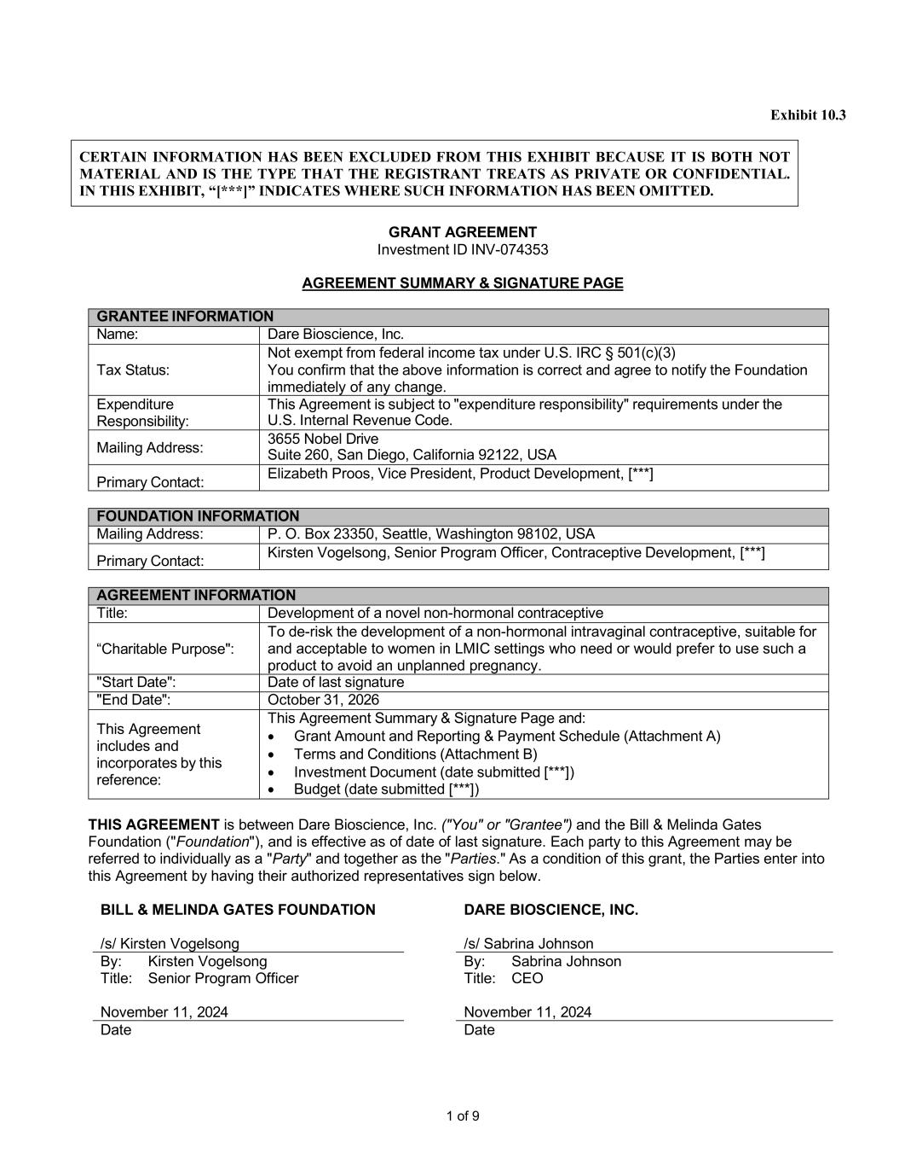
Investment ID INV-026060 4 of 4 Version: August 2022
1 of 9 Exhibit 10.3 CERTAIN INFORMATION HAS BEEN EXCLUDED FROM THIS EXHIBIT BECAUSE IT IS BOTH NOT MATERIAL AND IS THE TYPE THAT THE REGISTRANT TREATS AS PRIVATE OR CONFIDENTIAL. IN THIS EXHIBIT, “[***]” INDICATES WHERE SUCH INFORMATION HAS BEEN OMITTED. GRANT AGREEMENT Investment ID INV-074353 AGREEMENT SUMMARY & SIGNATURE PAGE GRANTEE INFORMATION Name: Dare Bioscience, Inc. Tax Status: Not exempt from federal income tax under U.S. IRC § 501(c)(3) You confirm that the above information is correct and agree to notify the Foundation immediately of any change. Expenditure Responsibility: This Agreement is subject to "expenditure responsibility" requirements under the U.S. Internal Revenue Code. Mailing Address: 3655 Nobel Drive Suite 260, San Diego, California 92122, USA Primary Contact: Elizabeth Proos, Vice President, Product Development, [***] FOUNDATION INFORMATION Mailing Address: P. O. Box 23350, Seattle, Washington 98102, USA Primary Contact: Kirsten Vogelsong, Senior Program Officer, Contraceptive Development, [***] AGREEMENT INFORMATION Title: Development of a novel non-hormonal contraceptive “Charitable Purpose": To de-risk the development of a non-hormonal intravaginal contraceptive, suitable for and acceptable to women in LMIC settings who need or would prefer to use such a product to avoid an unplanned pregnancy. "Start Date": Date of last signature "End Date": October 31, 2026 This Agreement includes and incorporates by this reference: This Agreement Summary & Signature Page and: • Grant Amount and Reporting & Payment Schedule (Attachment A) • Terms and Conditions (Attachment B) • Investment Document (date submitted [***]) • Budget (date submitted [***]) THIS AGREEMENT is between Dare Bioscience, Inc. ("You" or "Grantee") and the Bill & Melinda Gates Foundation ("Foundation"), and is effective as of date of last signature. Each party to this Agreement may be referred to individually as a "Party" and together as the "Parties." As a condition of this grant, the Parties enter into this Agreement by having their authorized representatives sign below. BILL & MELINDA GATES FOUNDATION /s/ Kirsten Vogelsong DARE BIOSCIENCE, INC. /s/ Sabrina Johnson By: Kirsten Vogelsong By: Sabrina Johnson Title: Senior Program Officer Title: CEO November 11, 2024 November 11, 2024 Date Date

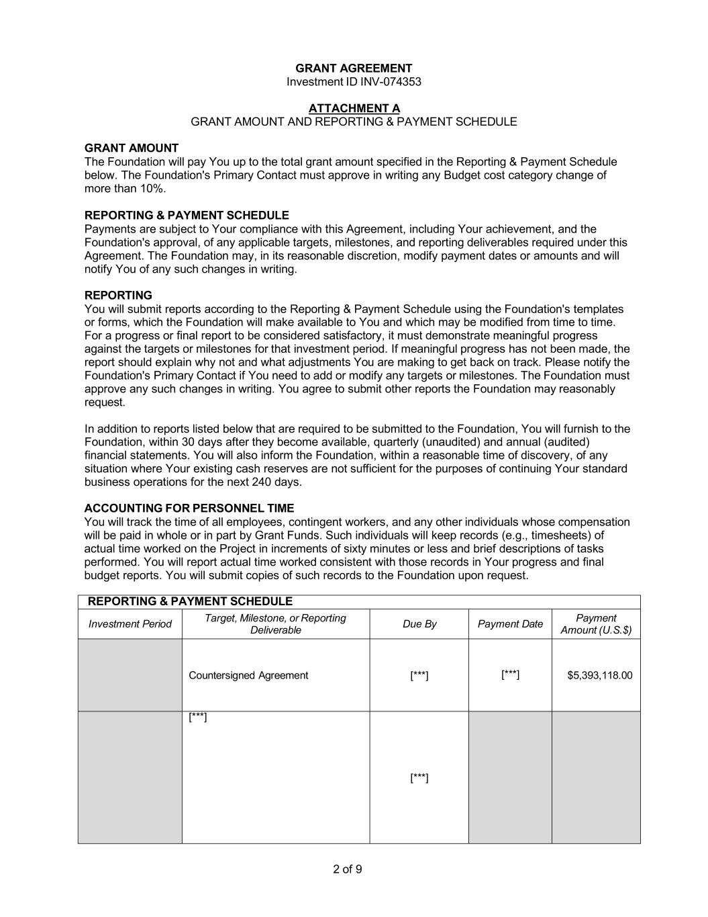
2 of 9 GRANT AGREEMENT Investment ID INV-074353 ATTACHMENT A GRANT AMOUNT AND REPORTING & PAYMENT SCHEDULE GRANT AMOUNT The Foundation will pay You up to the total grant amount specified in the Reporting & Payment Schedule below. The Foundation's Primary Contact must approve in writing any Budget cost category change of more than 10%. REPORTING & PAYMENT SCHEDULE Payments are subject to Your compliance with this Agreement, including Your achievement, and the Foundation's approval, of any applicable targets, milestones, and reporting deliverables required under this Agreement. The Foundation may, in its reasonable discretion, modify payment dates or amounts and will notify You of any such changes in writing. REPORTING You will submit reports according to the Reporting & Payment Schedule using the Foundation's templates or forms, which the Foundation will make available to You and which may be modified from time to time. For a progress or final report to be considered satisfactory, it must demonstrate meaningful progress against the targets or milestones for that investment period. If meaningful progress has not been made, the report should explain why not and what adjustments You are making to get back on track. Please notify the Foundation's Primary Contact if You need to add or modify any targets or milestones. The Foundation must approve any such changes in writing. You agree to submit other reports the Foundation may reasonably request. In addition to reports listed below that are required to be submitted to the Foundation, You will furnish to the Foundation, within 30 days after they become available, quarterly (unaudited) and annual (audited) financial statements. You will also inform the Foundation, within a reasonable time of discovery, of any situation where Your existing cash reserves are not sufficient for the purposes of continuing Your standard business operations for the next 240 days. ACCOUNTING FOR PERSONNEL TIME You will track the time of all employees, contingent workers, and any other individuals whose compensation will be paid in whole or in part by Grant Funds. Such individuals will keep records (e.g., timesheets) of actual time worked on the Project in increments of sixty minutes or less and brief descriptions of tasks performed. You will report actual time worked consistent with those records in Your progress and final budget reports. You will submit copies of such records to the Foundation upon request. REPORTING & PAYMENT SCHEDULE Investment Period Target, Milestone, or Reporting Deliverable Due By Payment Date Payment Amount (U.S.$) Countersigned Agreement [***] [***] $5,393,118.00 [***] [***]

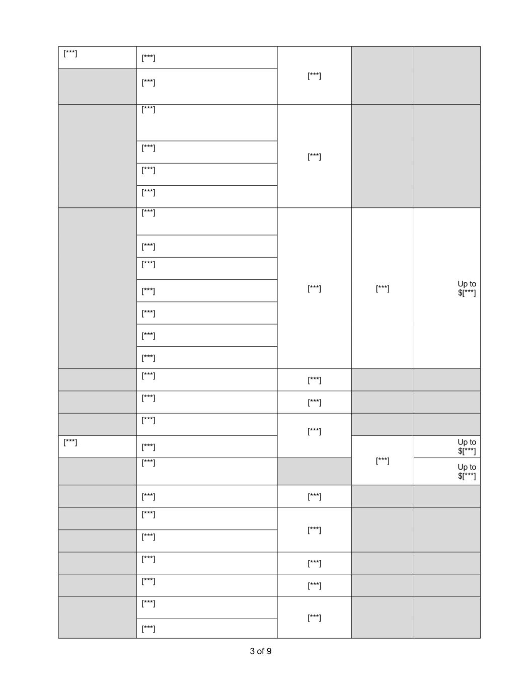
3 of 9 [***] [***] [***] [***] [***] [***] [***] [***] [***] [***] [***] [***] Up to $[***] [***] [***] [***] [***] [***] [***] [***] [***] [***] [***] [***] [***] [***] [***] [***] Up to $[***] [***] Up to $[***] [***] [***] [***] [***] [***] [***] [***] [***] [***] [***] [***] [***]


4 of 9 [***] [***] [***] [***] [***] Total Grant Amount Up to $10,683,142.00

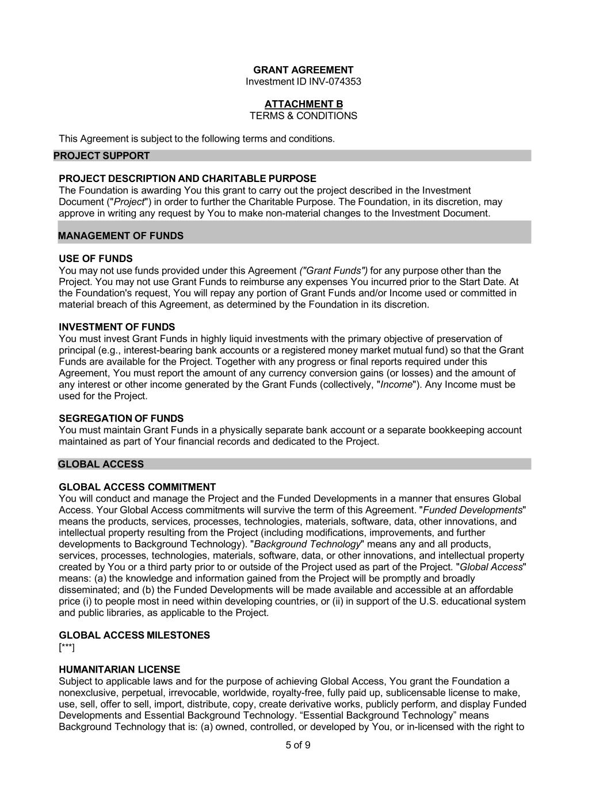
5 of 9 GRANT AGREEMENT Investment ID INV-074353 ATTACHMENT B TERMS & CONDITIONS This Agreement is subject to the following terms and conditions. PROJECT SUPPORT PROJECT DESCRIPTION AND CHARITABLE PURPOSE The Foundation is awarding You this grant to carry out the project described in the Investment Document ("Project") in order to further the Charitable Purpose. The Foundation, in its discretion, may approve in writing any request by You to make non-material changes to the Investment Document. MANAGEMENT OF FUNDS USE OF FUNDS You may not use funds provided under this Agreement ("Grant Funds") for any purpose other than the Project. You may not use Grant Funds to reimburse any expenses You incurred prior to the Start Date. At the Foundation's request, You will repay any portion of Grant Funds and/or Income used or committed in material breach of this Agreement, as determined by the Foundation in its discretion. INVESTMENT OF FUNDS You must invest Grant Funds in highly liquid investments with the primary objective of preservation of principal (e.g., interest-bearing bank accounts or a registered money market mutual fund) so that the Grant Funds are available for the Project. Together with any progress or final reports required under this Agreement, You must report the amount of any currency conversion gains (or losses) and the amount of any interest or other income generated by the Grant Funds (collectively, "Income"). Any Income must be used for the Project. SEGREGATION OF FUNDS You must maintain Grant Funds in a physically separate bank account or a separate bookkeeping account maintained as part of Your financial records and dedicated to the Project. GLOBAL ACCESS GLOBAL ACCESS COMMITMENT You will conduct and manage the Project and the Funded Developments in a manner that ensures Global Access. Your Global Access commitments will survive the term of this Agreement. "Funded Developments" means the products, services, processes, technologies, materials, software, data, other innovations, and intellectual property resulting from the Project (including modifications, improvements, and further developments to Background Technology). "Background Technology" means any and all products, services, processes, technologies, materials, software, data, or other innovations, and intellectual property created by You or a third party prior to or outside of the Project used as part of the Project. "Global Access" means: (a) the knowledge and information gained from the Project will be promptly and broadly disseminated; and (b) the Funded Developments will be made available and accessible at an affordable price (i) to people most in need within developing countries, or (ii) in support of the U.S. educational system and public libraries, as applicable to the Project. GLOBAL ACCESS MILESTONES [***] HUMANITARIAN LICENSE Subject to applicable laws and for the purpose of achieving Global Access, You grant the Foundation a nonexclusive, perpetual, irrevocable, worldwide, royalty-free, fully paid up, sublicensable license to make, use, sell, offer to sell, import, distribute, copy, create derivative works, publicly perform, and display Funded Developments and Essential Background Technology. “Essential Background Technology” means Background Technology that is: (a) owned, controlled, or developed by You, or in-licensed with the right to

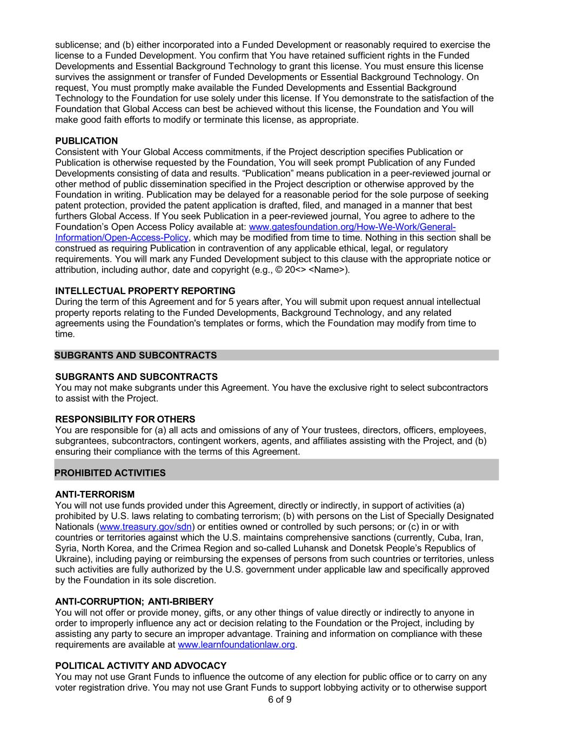
6 of 9 sublicense; and (b) either incorporated into a Funded Development or reasonably required to exercise the license to a Funded Development. You confirm that You have retained sufficient rights in the Funded Developments and Essential Background Technology to grant this license. You must ensure this license survives the assignment or transfer of Funded Developments or Essential Background Technology. On request, You must promptly make available the Funded Developments and Essential Background Technology to the Foundation for use solely under this license. If You demonstrate to the satisfaction of the Foundation that Global Access can best be achieved without this license, the Foundation and You will make good faith efforts to modify or terminate this license, as appropriate. PUBLICATION Consistent with Your Global Access commitments, if the Project description specifies Publication or Publication is otherwise requested by the Foundation, You will seek prompt Publication of any Funded Developments consisting of data and results. “Publication” means publication in a peer-reviewed journal or other method of public dissemination specified in the Project description or otherwise approved by the Foundation in writing. Publication may be delayed for a reasonable period for the sole purpose of seeking patent protection, provided the patent application is drafted, filed, and managed in a manner that best furthers Global Access. If You seek Publication in a peer-reviewed journal, You agree to adhere to the Foundation’s Open Access Policy available at: www.gatesfoundation.org/How-We-Work/General- Information/Open-Access-Policy, which may be modified from time to time. Nothing in this section shall be construed as requiring Publication in contravention of any applicable ethical, legal, or regulatory requirements. You will mark any Funded Development subject to this clause with the appropriate notice or attribution, including author, date and copyright (e.g., © 20<> <Name>). INTELLECTUAL PROPERTY REPORTING During the term of this Agreement and for 5 years after, You will submit upon request annual intellectual property reports relating to the Funded Developments, Background Technology, and any related agreements using the Foundation's templates or forms, which the Foundation may modify from time to time. SUBGRANTS AND SUBCONTRACTS SUBGRANTS AND SUBCONTRACTS You may not make subgrants under this Agreement. You have the exclusive right to select subcontractors to assist with the Project. RESPONSIBILITY FOR OTHERS You are responsible for (a) all acts and omissions of any of Your trustees, directors, officers, employees, subgrantees, subcontractors, contingent workers, agents, and affiliates assisting with the Project, and (b) ensuring their compliance with the terms of this Agreement. PROHIBITED ACTIVITIES ANTI-TERRORISM You will not use funds provided under this Agreement, directly or indirectly, in support of activities (a) prohibited by U.S. laws relating to combating terrorism; (b) with persons on the List of Specially Designated Nationals (www.treasury.gov/sdn) or entities owned or controlled by such persons; or (c) in or with countries or territories against which the U.S. maintains comprehensive sanctions (currently, Cuba, Iran, Syria, North Korea, and the Crimea Region and so-called Luhansk and Donetsk People’s Republics of Ukraine), including paying or reimbursing the expenses of persons from such countries or territories, unless such activities are fully authorized by the U.S. government under applicable law and specifically approved by the Foundation in its sole discretion. ANTI-CORRUPTION; ANTI-BRIBERY You will not offer or provide money, gifts, or any other things of value directly or indirectly to anyone in order to improperly influence any act or decision relating to the Foundation or the Project, including by assisting any party to secure an improper advantage. Training and information on compliance with these requirements are available at www.learnfoundationlaw.org. POLITICAL ACTIVITY AND ADVOCACY You may not use Grant Funds to influence the outcome of any election for public office or to carry on any voter registration drive. You may not use Grant Funds to support lobbying activity or to otherwise support

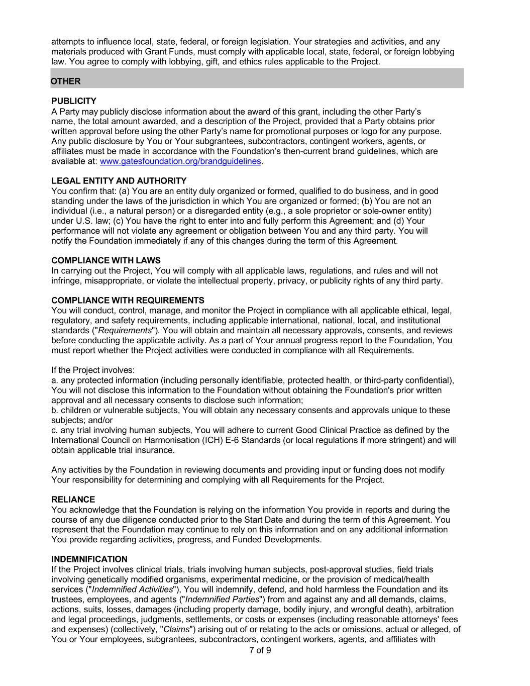
7 of 9 attempts to influence local, state, federal, or foreign legislation. Your strategies and activities, and any materials produced with Grant Funds, must comply with applicable local, state, federal, or foreign lobbying law. You agree to comply with lobbying, gift, and ethics rules applicable to the Project. OTHER PUBLICITY A Party may publicly disclose information about the award of this grant, including the other Party’s name, the total amount awarded, and a description of the Project, provided that a Party obtains prior written approval before using the other Party’s name for promotional purposes or logo for any purpose. Any public disclosure by You or Your subgrantees, subcontractors, contingent workers, agents, or affiliates must be made in accordance with the Foundation’s then-current brand guidelines, which are available at: www.gatesfoundation.org/brandguidelines. LEGAL ENTITY AND AUTHORITY You confirm that: (a) You are an entity duly organized or formed, qualified to do business, and in good standing under the laws of the jurisdiction in which You are organized or formed; (b) You are not an individual (i.e., a natural person) or a disregarded entity (e.g., a sole proprietor or sole-owner entity) under U.S. law; (c) You have the right to enter into and fully perform this Agreement; and (d) Your performance will not violate any agreement or obligation between You and any third party. You will notify the Foundation immediately if any of this changes during the term of this Agreement. COMPLIANCE WITH LAWS In carrying out the Project, You will comply with all applicable laws, regulations, and rules and will not infringe, misappropriate, or violate the intellectual property, privacy, or publicity rights of any third party. COMPLIANCE WITH REQUIREMENTS You will conduct, control, manage, and monitor the Project in compliance with all applicable ethical, legal, regulatory, and safety requirements, including applicable international, national, local, and institutional standards ("Requirements"). You will obtain and maintain all necessary approvals, consents, and reviews before conducting the applicable activity. As a part of Your annual progress report to the Foundation, You must report whether the Project activities were conducted in compliance with all Requirements. If the Project involves: a. any protected information (including personally identifiable, protected health, or third-party confidential), You will not disclose this information to the Foundation without obtaining the Foundation's prior written approval and all necessary consents to disclose such information; b. children or vulnerable subjects, You will obtain any necessary consents and approvals unique to these subjects; and/or c. any trial involving human subjects, You will adhere to current Good Clinical Practice as defined by the International Council on Harmonisation (ICH) E-6 Standards (or local regulations if more stringent) and will obtain applicable trial insurance. Any activities by the Foundation in reviewing documents and providing input or funding does not modify Your responsibility for determining and complying with all Requirements for the Project. RELIANCE You acknowledge that the Foundation is relying on the information You provide in reports and during the course of any due diligence conducted prior to the Start Date and during the term of this Agreement. You represent that the Foundation may continue to rely on this information and on any additional information You provide regarding activities, progress, and Funded Developments. INDEMNIFICATION If the Project involves clinical trials, trials involving human subjects, post-approval studies, field trials involving genetically modified organisms, experimental medicine, or the provision of medical/health services ("Indemnified Activities"), You will indemnify, defend, and hold harmless the Foundation and its trustees, employees, and agents ("Indemnified Parties") from and against any and all demands, claims, actions, suits, losses, damages (including property damage, bodily injury, and wrongful death), arbitration and legal proceedings, judgments, settlements, or costs or expenses (including reasonable attorneys' fees and expenses) (collectively, "Claims") arising out of or relating to the acts or omissions, actual or alleged, of You or Your employees, subgrantees, subcontractors, contingent workers, agents, and affiliates with

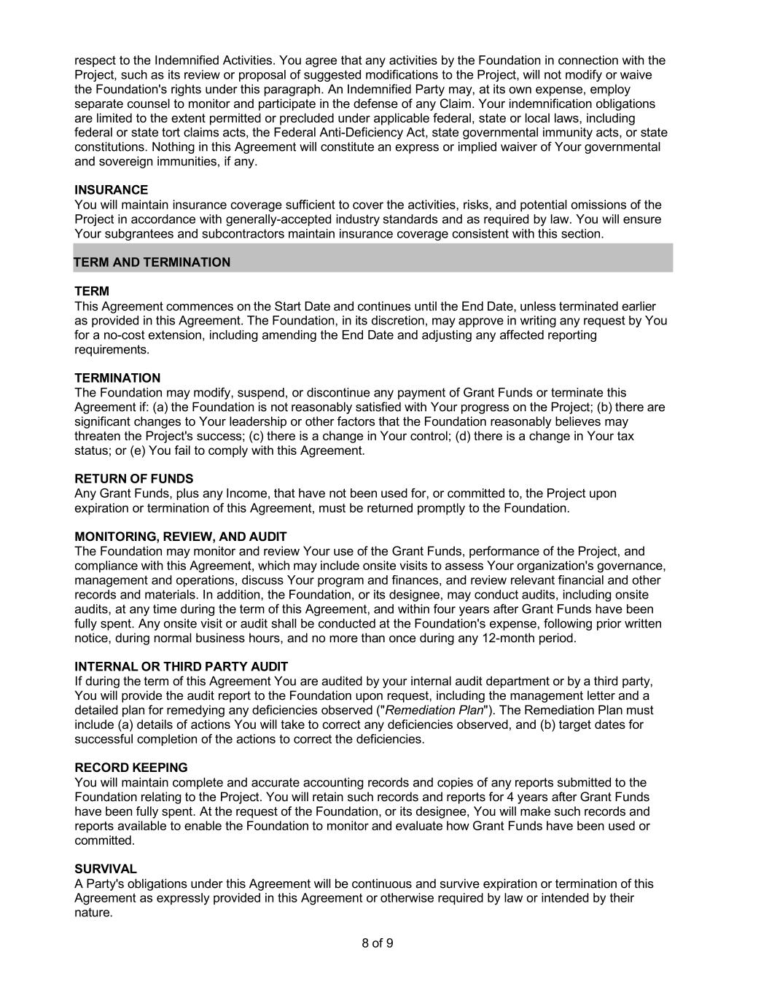
8 of 9 respect to the Indemnified Activities. You agree that any activities by the Foundation in connection with the Project, such as its review or proposal of suggested modifications to the Project, will not modify or waive the Foundation's rights under this paragraph. An Indemnified Party may, at its own expense, employ separate counsel to monitor and participate in the defense of any Claim. Your indemnification obligations are limited to the extent permitted or precluded under applicable federal, state or local laws, including federal or state tort claims acts, the Federal Anti-Deficiency Act, state governmental immunity acts, or state constitutions. Nothing in this Agreement will constitute an express or implied waiver of Your governmental and sovereign immunities, if any. INSURANCE You will maintain insurance coverage sufficient to cover the activities, risks, and potential omissions of the Project in accordance with generally-accepted industry standards and as required by law. You will ensure Your subgrantees and subcontractors maintain insurance coverage consistent with this section. TERM AND TERMINATION TERM This Agreement commences on the Start Date and continues until the End Date, unless terminated earlier as provided in this Agreement. The Foundation, in its discretion, may approve in writing any request by You for a no-cost extension, including amending the End Date and adjusting any affected reporting requirements. TERMINATION The Foundation may modify, suspend, or discontinue any payment of Grant Funds or terminate this Agreement if: (a) the Foundation is not reasonably satisfied with Your progress on the Project; (b) there are significant changes to Your leadership or other factors that the Foundation reasonably believes may threaten the Project's success; (c) there is a change in Your control; (d) there is a change in Your tax status; or (e) You fail to comply with this Agreement. RETURN OF FUNDS Any Grant Funds, plus any Income, that have not been used for, or committed to, the Project upon expiration or termination of this Agreement, must be returned promptly to the Foundation. MONITORING, REVIEW, AND AUDIT The Foundation may monitor and review Your use of the Grant Funds, performance of the Project, and compliance with this Agreement, which may include onsite visits to assess Your organization's governance, management and operations, discuss Your program and finances, and review relevant financial and other records and materials. In addition, the Foundation, or its designee, may conduct audits, including onsite audits, at any time during the term of this Agreement, and within four years after Grant Funds have been fully spent. Any onsite visit or audit shall be conducted at the Foundation's expense, following prior written notice, during normal business hours, and no more than once during any 12-month period. INTERNAL OR THIRD PARTY AUDIT If during the term of this Agreement You are audited by your internal audit department or by a third party, You will provide the audit report to the Foundation upon request, including the management letter and a detailed plan for remedying any deficiencies observed ("Remediation Plan"). The Remediation Plan must include (a) details of actions You will take to correct any deficiencies observed, and (b) target dates for successful completion of the actions to correct the deficiencies. RECORD KEEPING You will maintain complete and accurate accounting records and copies of any reports submitted to the Foundation relating to the Project. You will retain such records and reports for 4 years after Grant Funds have been fully spent. At the request of the Foundation, or its designee, You will make such records and reports available to enable the Foundation to monitor and evaluate how Grant Funds have been used or committed. SURVIVAL A Party's obligations under this Agreement will be continuous and survive expiration or termination of this Agreement as expressly provided in this Agreement or otherwise required by law or intended by their nature.

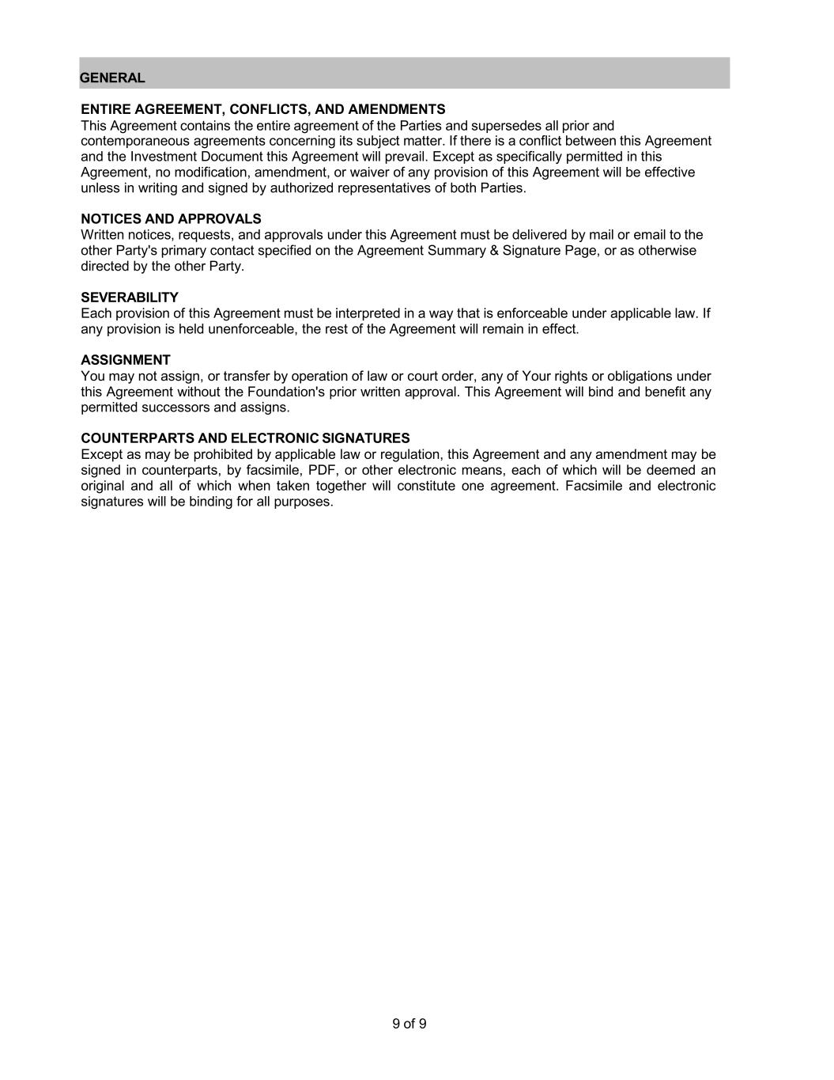
9 of 9 GENERAL ENTIRE AGREEMENT, CONFLICTS, AND AMENDMENTS This Agreement contains the entire agreement of the Parties and supersedes all prior and contemporaneous agreements concerning its subject matter. If there is a conflict between this Agreement and the Investment Document this Agreement will prevail. Except as specifically permitted in this Agreement, no modification, amendment, or waiver of any provision of this Agreement will be effective unless in writing and signed by authorized representatives of both Parties. NOTICES AND APPROVALS Written notices, requests, and approvals under this Agreement must be delivered by mail or email to the other Party's primary contact specified on the Agreement Summary & Signature Page, or as otherwise directed by the other Party. SEVERABILITY Each provision of this Agreement must be interpreted in a way that is enforceable under applicable law. If any provision is held unenforceable, the rest of the Agreement will remain in effect. ASSIGNMENT You may not assign, or transfer by operation of law or court order, any of Your rights or obligations under this Agreement without the Foundation's prior written approval. This Agreement will bind and benefit any permitted successors and assigns. COUNTERPARTS AND ELECTRONIC SIGNATURES Except as may be prohibited by applicable law or regulation, this Agreement and any amendment may be signed in counterparts, by facsimile, PDF, or other electronic means, each of which will be deemed an original and all of which when taken together will constitute one agreement. Facsimile and electronic signatures will be binding for all purposes.

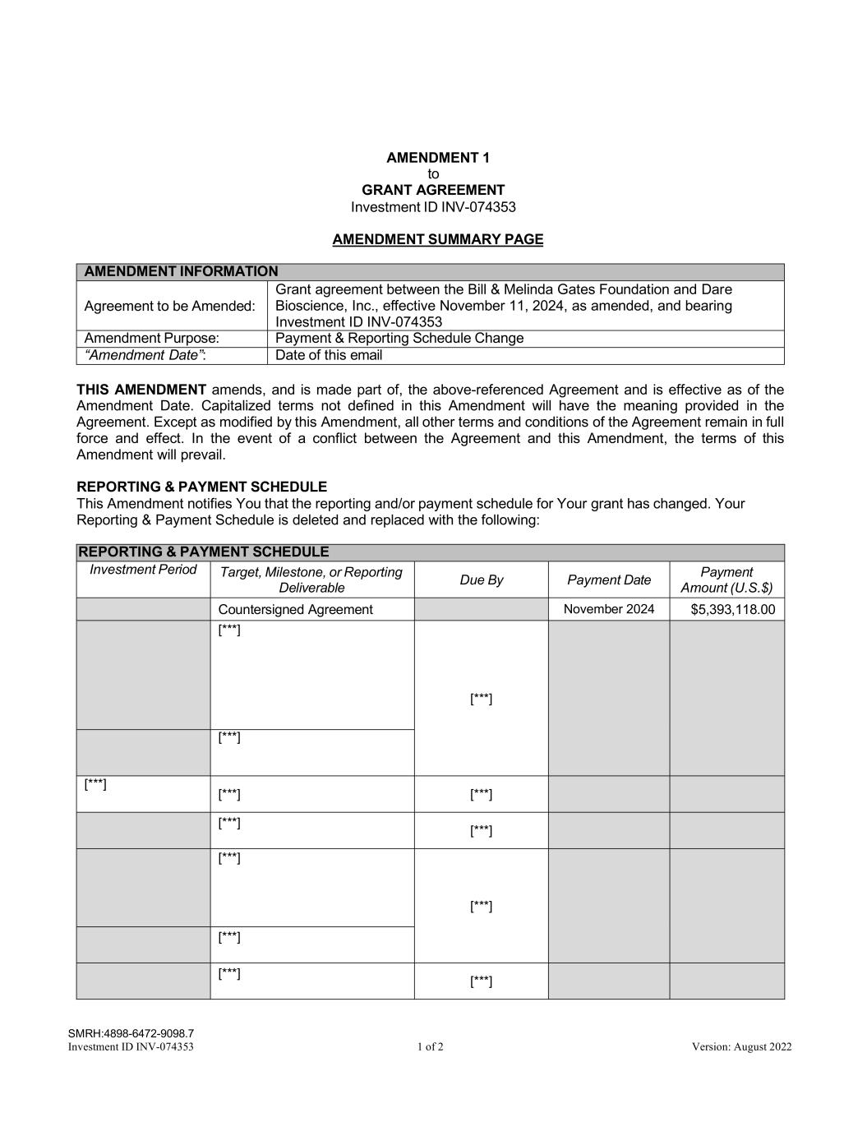
SMRH:4898-6472-9098.7 Investment ID INV-074353 1 of 2 Version: August 2022 AMENDMENT 1 to GRANT AGREEMENT Investment ID INV-074353 AMENDMENT SUMMARY PAGE AMENDMENT INFORMATION Agreement to be Amended: Grant agreement between the Bill & Melinda Gates Foundation and Dare Bioscience, Inc., effective November 11, 2024, as amended, and bearing Investment ID INV-074353 Amendment Purpose: Payment & Reporting Schedule Change “Amendment Date”: Date of this email THIS AMENDMENT amends, and is made part of, the above-referenced Agreement and is effective as of the Amendment Date. Capitalized terms not defined in this Amendment will have the meaning provided in the Agreement. Except as modified by this Amendment, all other terms and conditions of the Agreement remain in full force and effect. In the event of a conflict between the Agreement and this Amendment, the terms of this Amendment will prevail. REPORTING & PAYMENT SCHEDULE This Amendment notifies You that the reporting and/or payment schedule for Your grant has changed. Your Reporting & Payment Schedule is deleted and replaced with the following: REPORTING & PAYMENT SCHEDULE Investment Period Target, Milestone, or Reporting Deliverable Due By Payment Date Payment Amount (U.S.$) Countersigned Agreement November 2024 $5,393,118.00 [***] [***] [***] [***] [***] [***] [***] [***] [***] [***] [***] [***] [***]

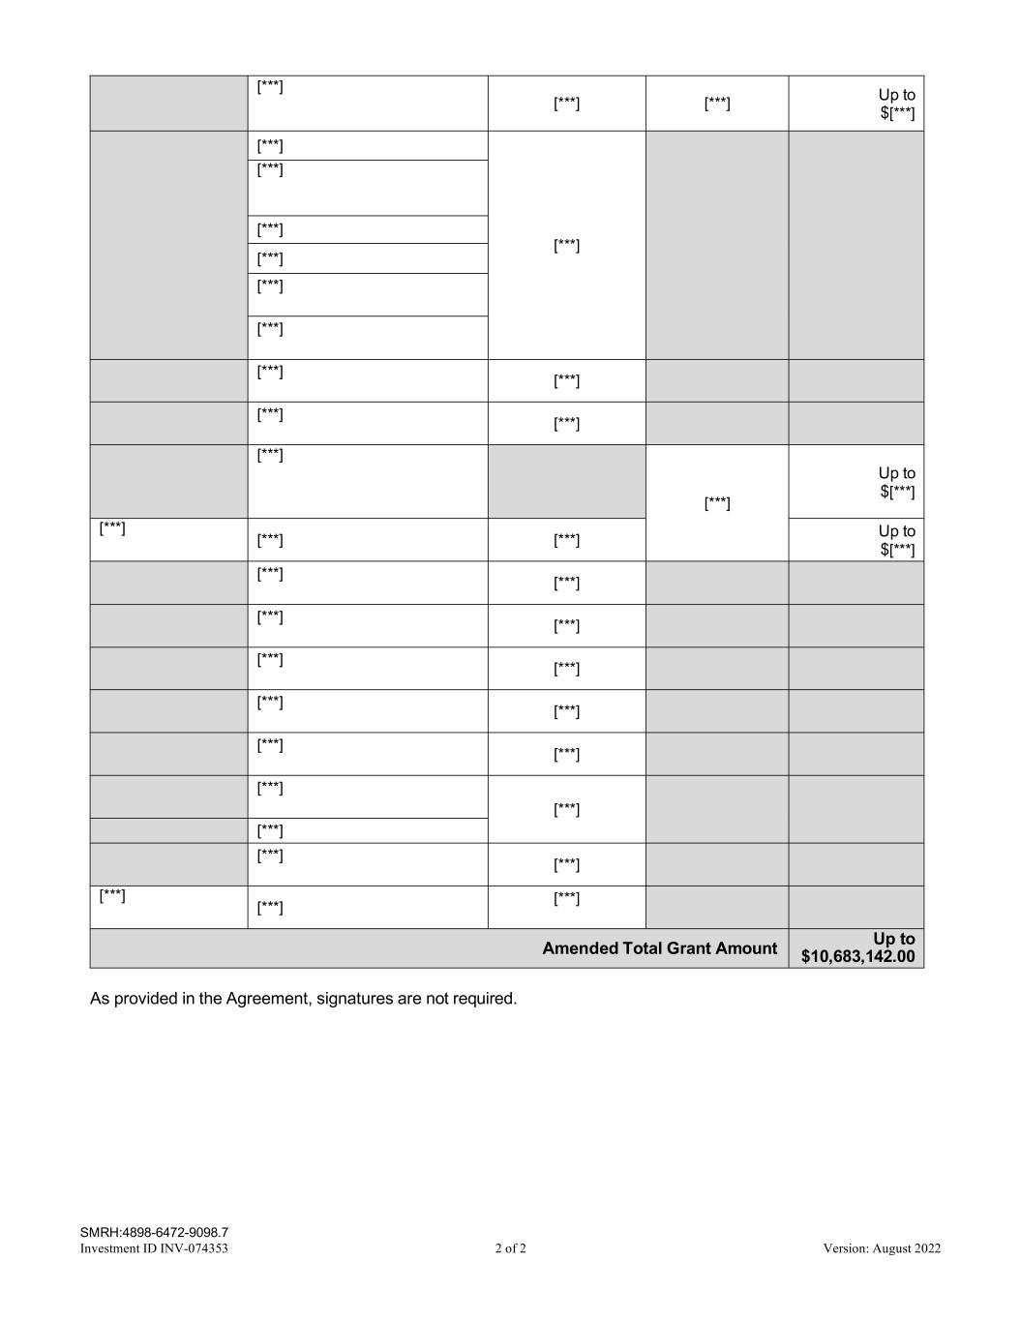
SMRH:4898-6472-9098.7 Investment ID INV-074353 2 of 2 Version: August 2022 [***] [***] [***] Up to $[***] [***] [***] [***] [***] [***] [***] [***] [***] [***] [***] [***] [***] [***] Up to $[***] [***] [***] [***] Up to $[***] [***] [***] [***] [***] [***] [***] [***] [***] [***] [***] [***] [***] [***] [***] [***] [***] [***] [***] Amended Total Grant Amount Up to $10,683,142.00 As provided in the Agreement, signatures are not required.

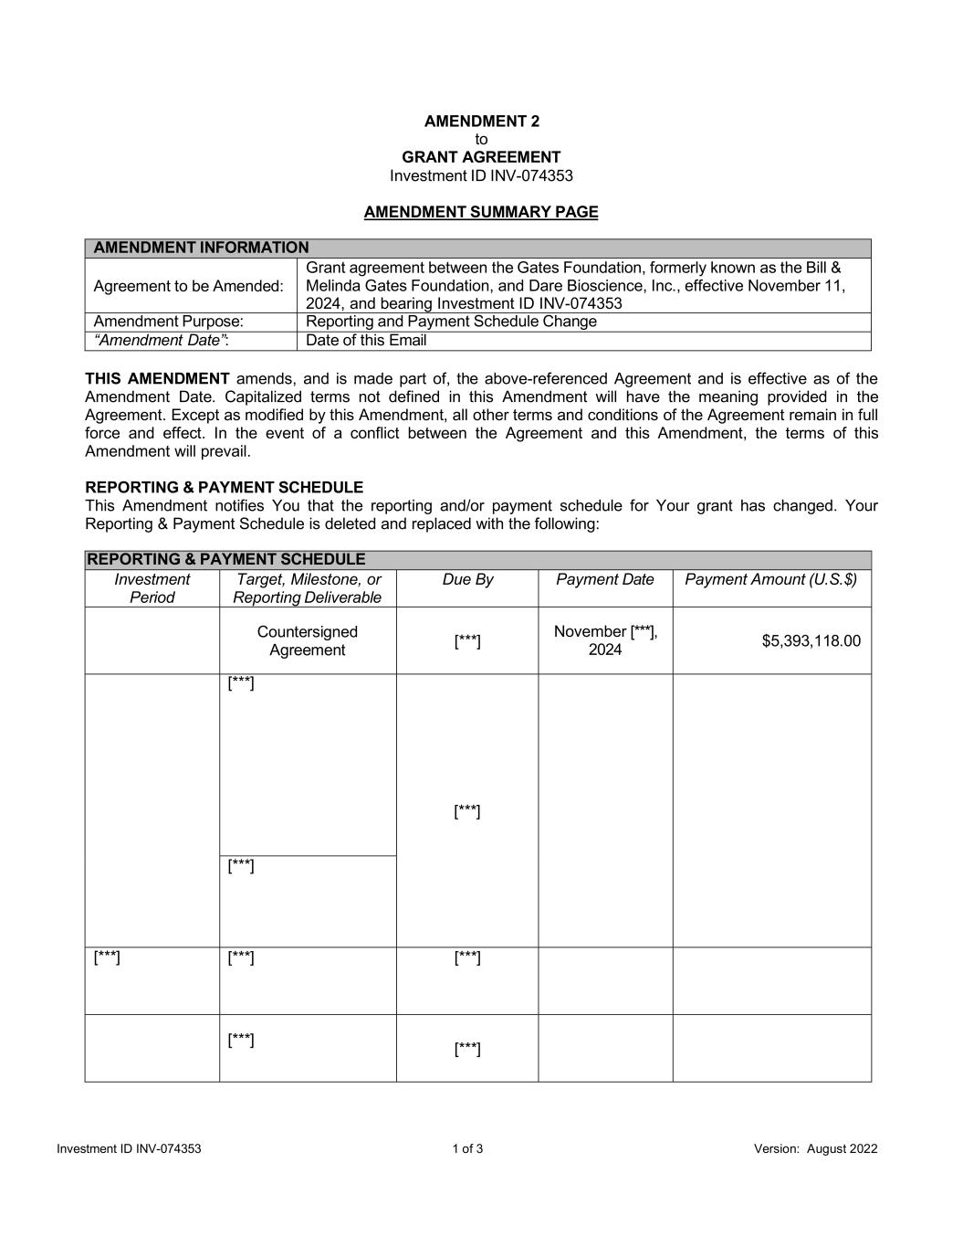
Investment ID INV-074353 1 of 3 Version: August 2022 AMENDMENT 2 to GRANT AGREEMENT Investment ID INV-074353 AMENDMENT SUMMARY PAGE AMENDMENT INFORMATION Agreement to be Amended: Grant agreement between the Gates Foundation, formerly known as the Bill & Melinda Gates Foundation, and Dare Bioscience, Inc., effective November 11, 2024, and bearing Investment ID INV-074353 Amendment Purpose: Reporting and Payment Schedule Change “Amendment Date”: Date of this Email THIS AMENDMENT amends, and is made part of, the above-referenced Agreement and is effective as of the Amendment Date. Capitalized terms not defined in this Amendment will have the meaning provided in the Agreement. Except as modified by this Amendment, all other terms and conditions of the Agreement remain in full force and effect. In the event of a conflict between the Agreement and this Amendment, the terms of this Amendment will prevail. REPORTING & PAYMENT SCHEDULE This Amendment notifies You that the reporting and/or payment schedule for Your grant has changed. Your Reporting & Payment Schedule is deleted and replaced with the following: REPORTING & PAYMENT SCHEDULE Investment Period Target, Milestone, or Reporting Deliverable Due By Payment Date Payment Amount (U.S.$) Countersigned Agreement [***] November [***], 2024 $5,393,118.00 [***] [***] [***] [***] [***] [***] [***] [***]

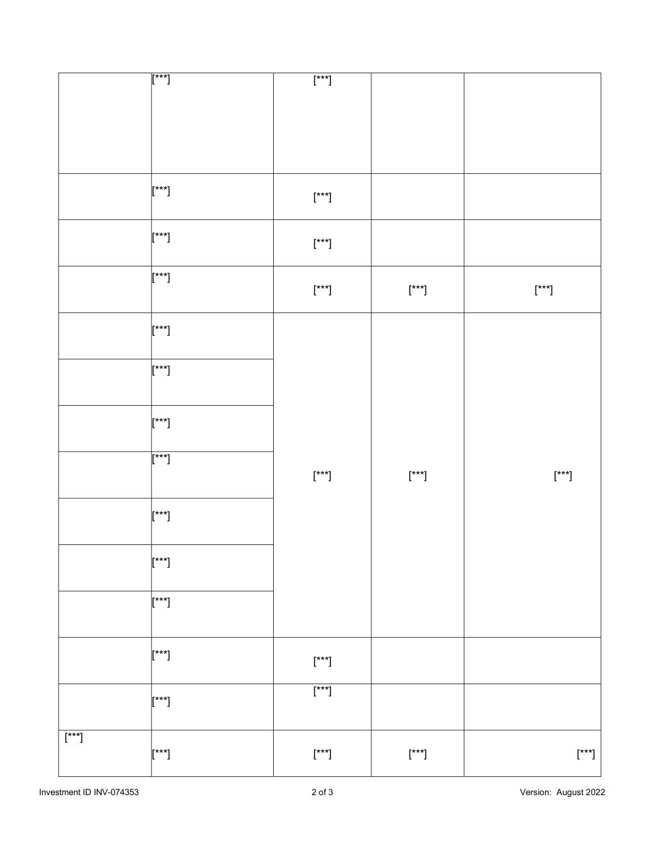
Investment ID INV-074353 2 of 3 Version: August 2022 [***] [***] [***] [***] [***] [***] [***] [***] [***] [***] [***] [***] [***] [***] [***] [***] [***] [***] [***] [***] [***] [***] [***] [***] [***] [***] [***] [***] [***]

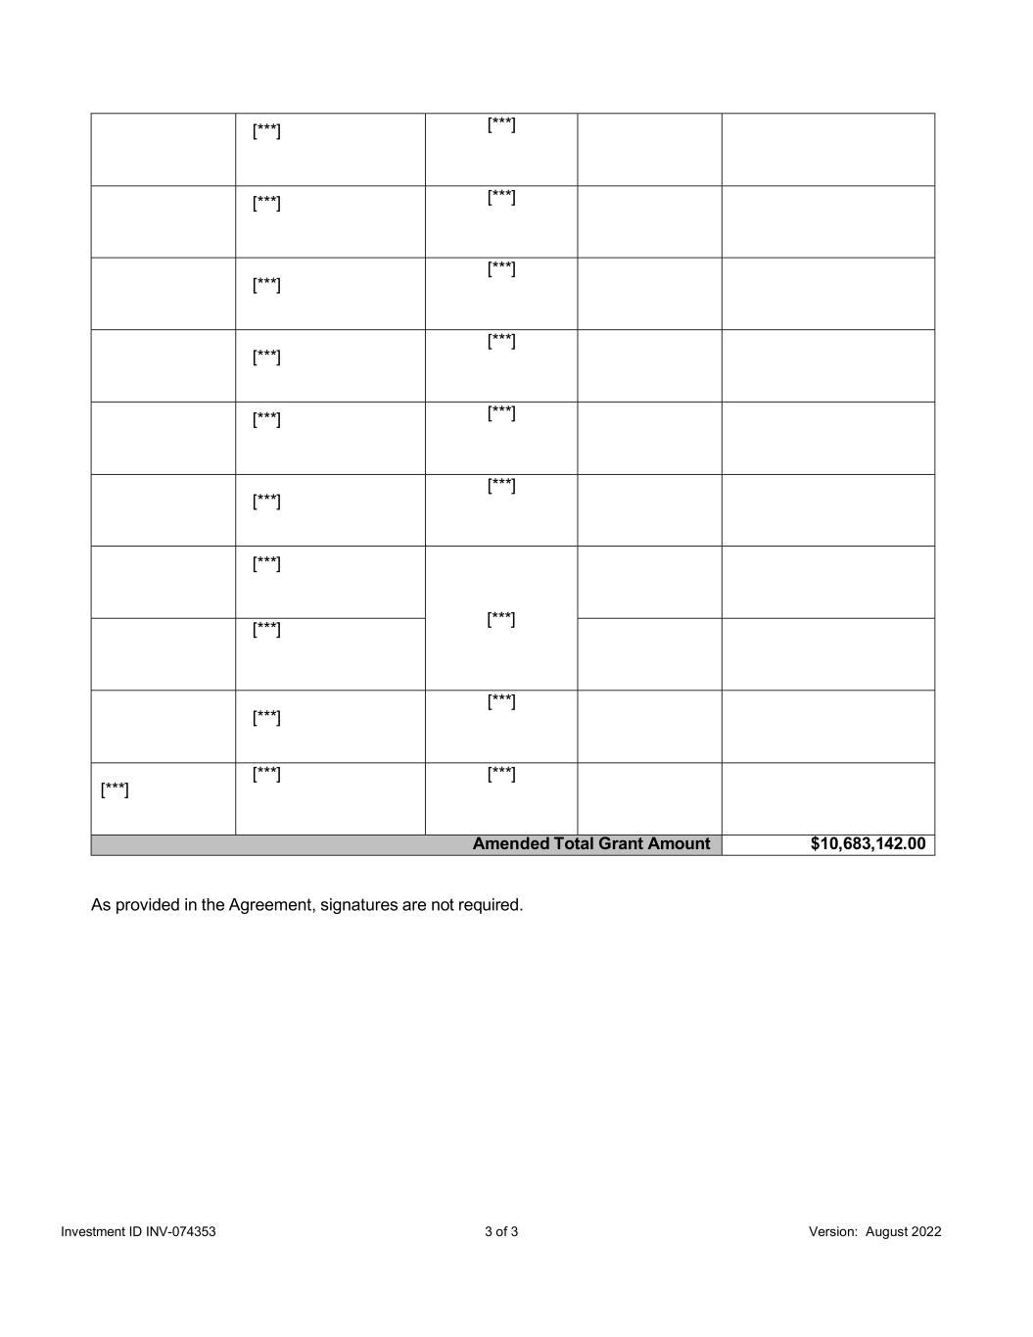
Investment ID INV-074353 3 of 3 Version: August 2022 [***] [***] [***] [***] [***] [***] [***] [***] [***] [***] [***] [***] [***] [***] [***] [***] [***] [***] [***] [***] Amended Total Grant Amount $10,683,142.00 As provided in the Agreement, signatures are not required.

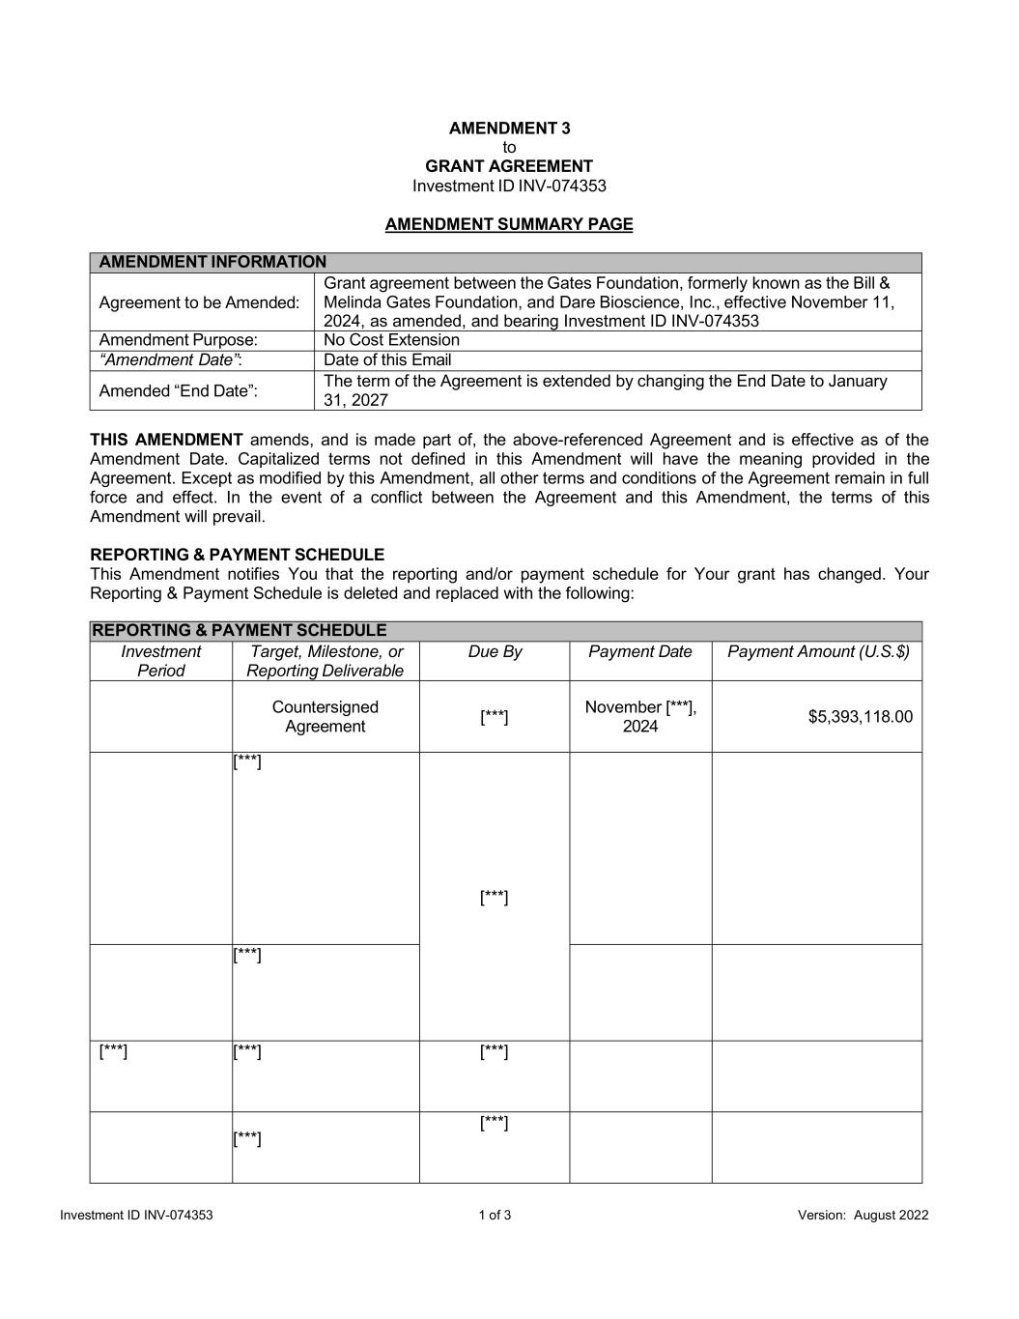
Investment ID INV-074353 1 of 3 Version: August 2022 AMENDMENT 3 to GRANT AGREEMENT Investment ID INV-074353 AMENDMENT SUMMARY PAGE AMENDMENT INFORMATION Agreement to be Amended: Grant agreement between the Gates Foundation, formerly known as the Bill & Melinda Gates Foundation, and Dare Bioscience, Inc., effective November 11, 2024, as amended, and bearing Investment ID INV-074353 Amendment Purpose: No Cost Extension “Amendment Date”: Date of this Email Amended “End Date”: The term of the Agreement is extended by changing the End Date to January 31, 2027 THIS AMENDMENT amends, and is made part of, the above-referenced Agreement and is effective as of the Amendment Date. Capitalized terms not defined in this Amendment will have the meaning provided in the Agreement. Except as modified by this Amendment, all other terms and conditions of the Agreement remain in full force and effect. In the event of a conflict between the Agreement and this Amendment, the terms of this Amendment will prevail. REPORTING & PAYMENT SCHEDULE This Amendment notifies You that the reporting and/or payment schedule for Your grant has changed. Your Reporting & Payment Schedule is deleted and replaced with the following: REPORTING & PAYMENT SCHEDULE Investment Period Target, Milestone, or Reporting Deliverable Due By Payment Date Payment Amount (U.S.$) Countersigned Agreement [***] November [***], 2024 $5,393,118.00 [***] [***] [***] [***] [***] [***] [***] [***]

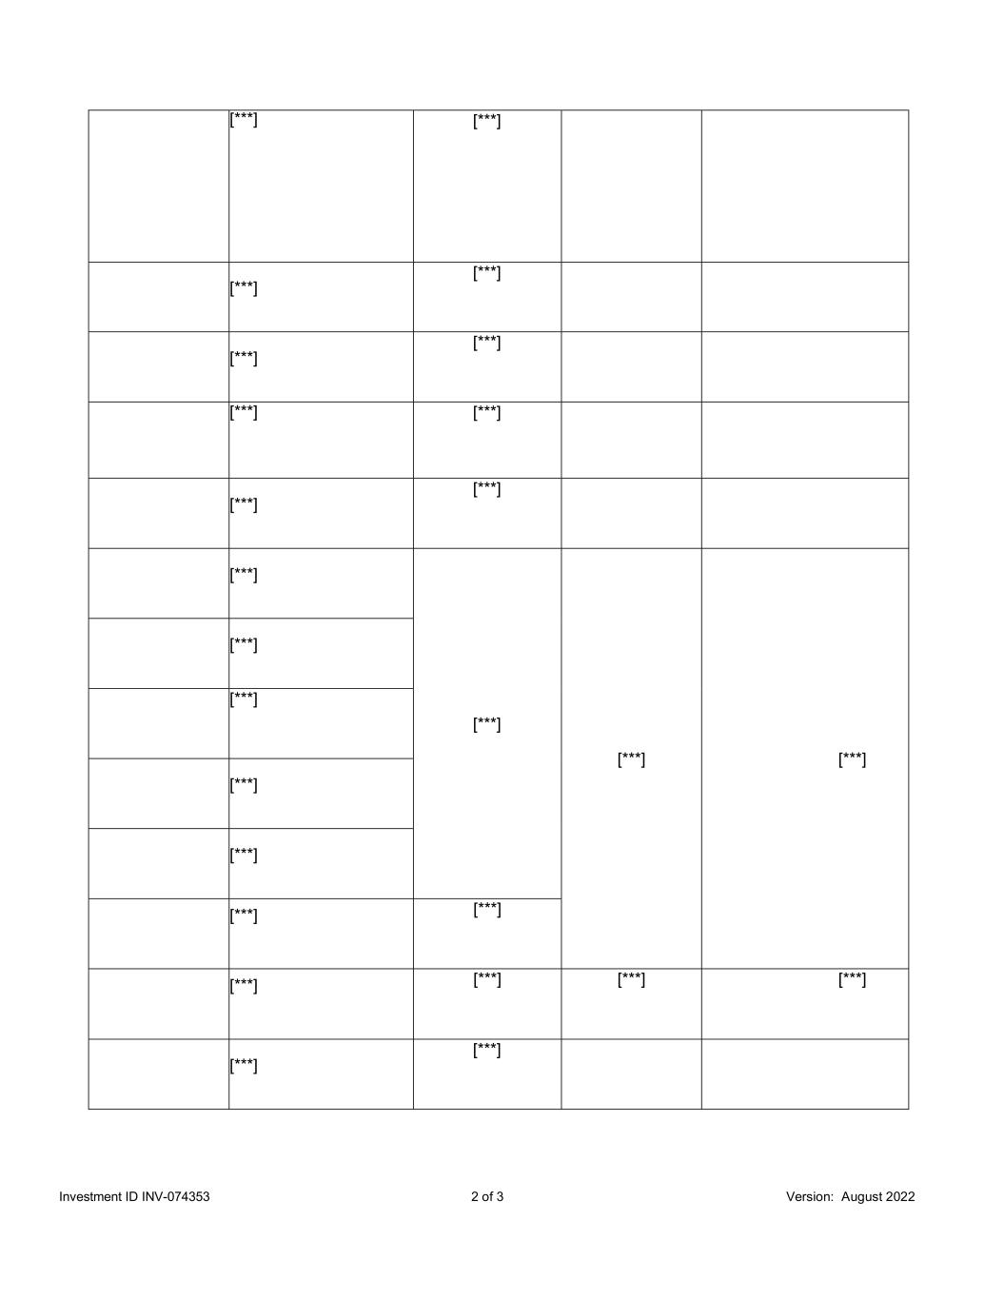
Investment ID INV-074353 2 of 3 Version: August 2022 [***] [***] [***] [***] [***] [***] [***] [***] [***] [***] [***] [***] [***] [***] [***] [***] [***] [***] [***] [***] [***] [***] [***] [***] [***] [***]

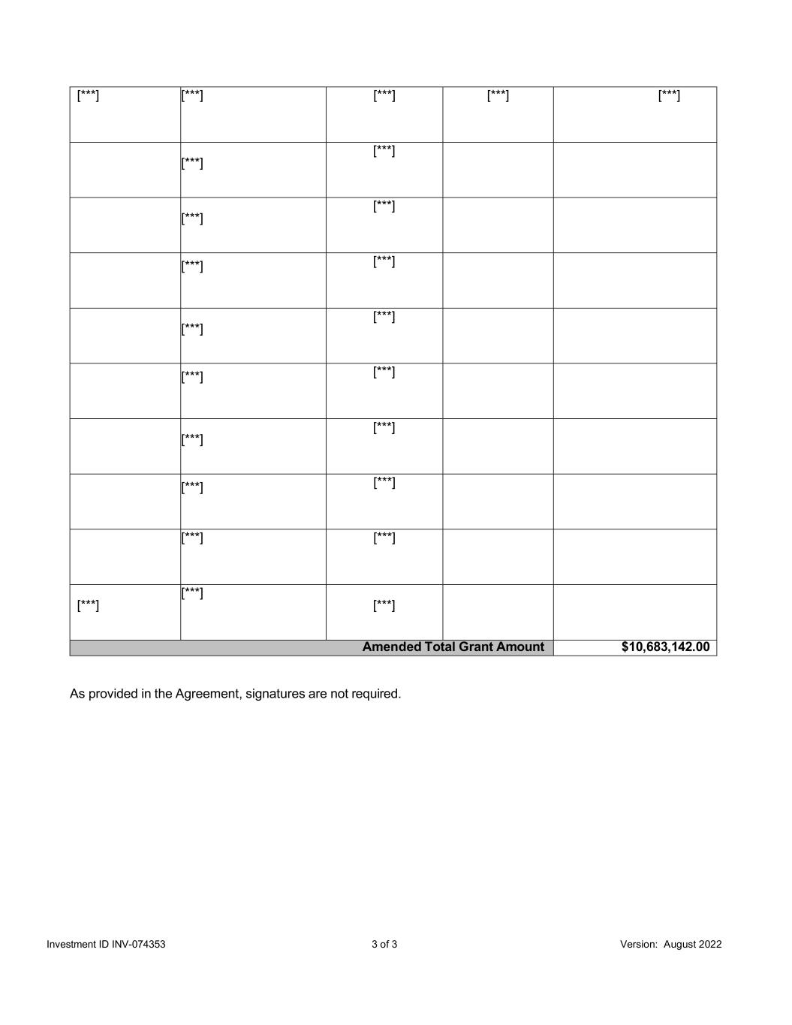
Investment ID INV-074353 3 of 3 Version: August 2022 [***] [***] [***] [***] [***] [***] [***] [***] [***] [***] [***] [***] [***] [***] [***] [***] [***] [***] [***] [***] [***] [***] [***] [***] Amended Total Grant Amount $10,683,142.00 As provided in the Agreement, signatures are not required.

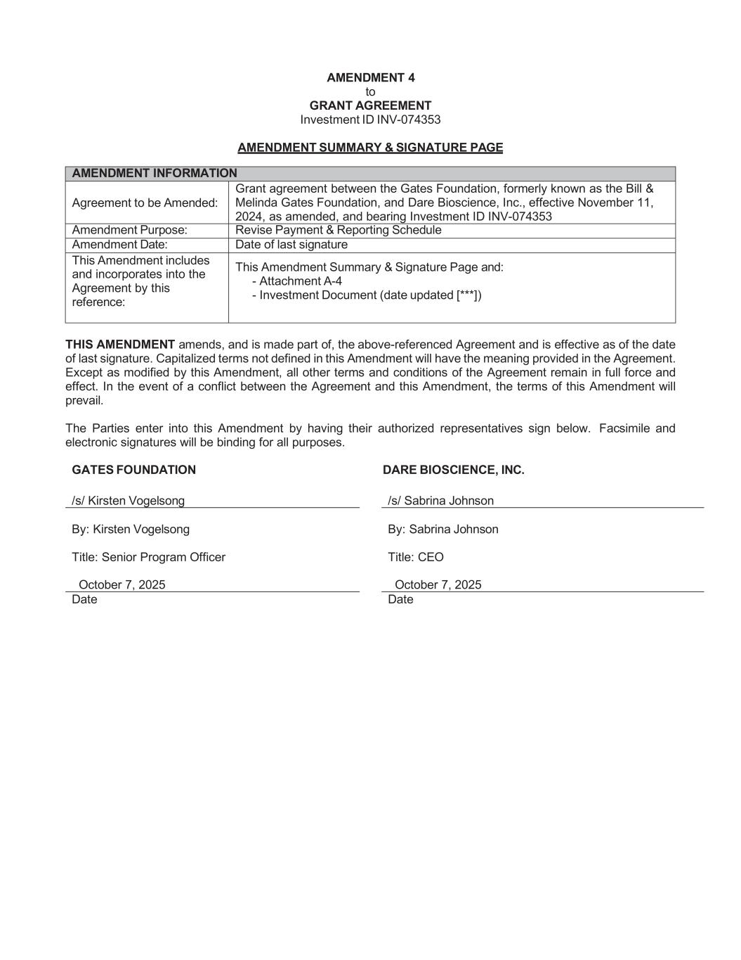
AMENDMENT 4 to GRANT AGREEMENT Investment ID INV-074353 AMENDMENT SUMMARY & SIGNATURE PAGE AMENDMENT INFORMATION Agreement to be Amended: Grant agreement between the Gates Foundation, formerly known as the Bill & Melinda Gates Foundation, and Dare Bioscience, Inc., effective November 11, 2024, as amended, and bearing Investment ID INV-074353 Amendment Purpose: Revise Payment & Reporting Schedule Amendment Date: Date of last signature This Amendment includes and incorporates into the Agreement by this reference: This Amendment Summary & Signature Page and: - Attachment A-4 - Investment Document (date updated [***]) THIS AMENDMENT amends, and is made part of, the above-referenced Agreement and is effective as of the date of last signature. Capitalized terms not defined in this Amendment will have the meaning provided in the Agreement. Except as modified by this Amendment, all other terms and conditions of the Agreement remain in full force and effect. In the event of a conflict between the Agreement and this Amendment, the terms of this Amendment will prevail. The Parties enter into this Amendment by having their authorized representatives sign below. Facsimile and electronic signatures will be binding for all purposes. GATES FOUNDATION DARE BIOSCIENCE, INC. /s/ Kirsten Vogelsong /s/ Sabrina Johnson By: Kirsten Vogelsong By: Sabrina Johnson Title: Senior Program Officer Title: CEO October 7, 2025 October 7, 2025 Date Date

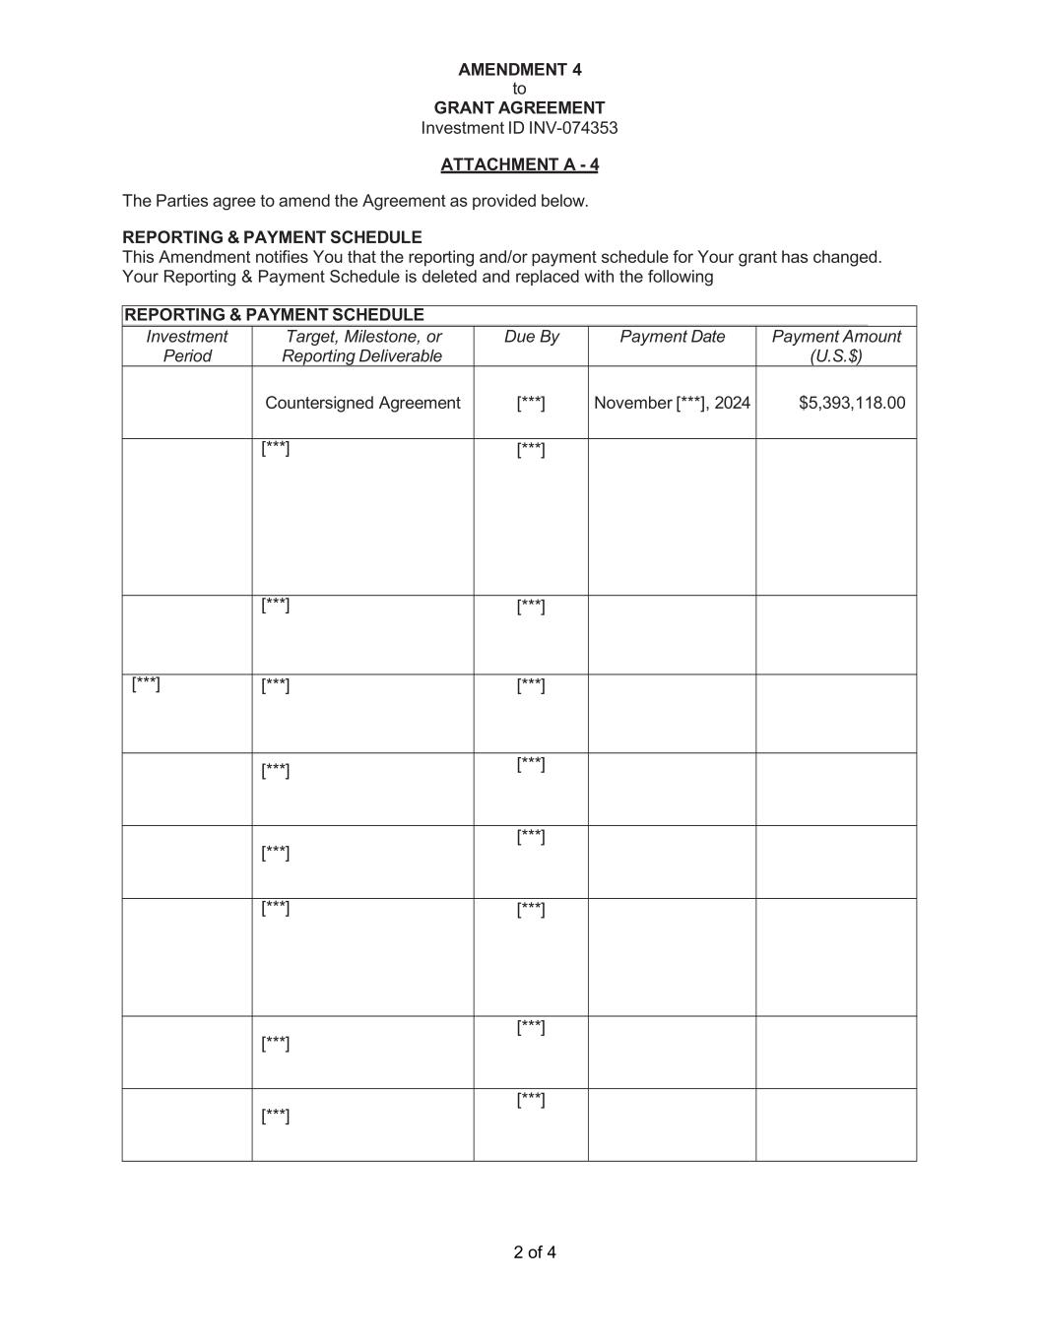
2 of 4 AMENDMENT 4 to GRANT AGREEMENT Investment ID INV-074353 ATTACHMENT A - 4 The Parties agree to amend the Agreement as provided below. REPORTING & PAYMENT SCHEDULE This Amendment notifies You that the reporting and/or payment schedule for Your grant has changed. Your Reporting & Payment Schedule is deleted and replaced with the following REPORTING & PAYMENT SCHEDULE Investment Period Target, Milestone, or Reporting Deliverable Due By Payment Date Payment Amount (U.S.$) Countersigned Agreement [***] November [***], 2024 $5,393,118.00 [***] [***] [***] [***] [***] [***] [***] [***] [***] [***] [***] [***] [***] [***] [***] [***] [***]

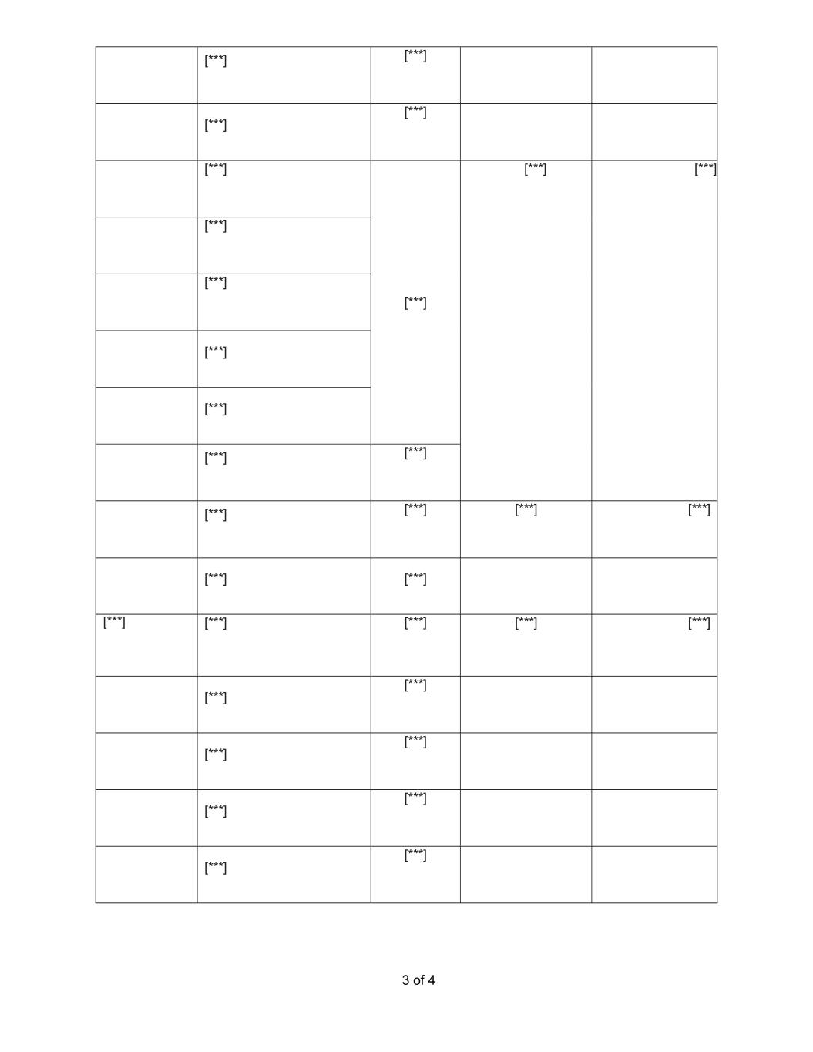
3 of 4 [***] [***] [***] [***] [***] [***] [***] [***] [***] [***] [***] [***] [***] [***] [***] [***] [***] [***] [***] [***] [***] [***] [***] [***] [***] [***] [***] [***] [***] [***] [***] [***] [***]

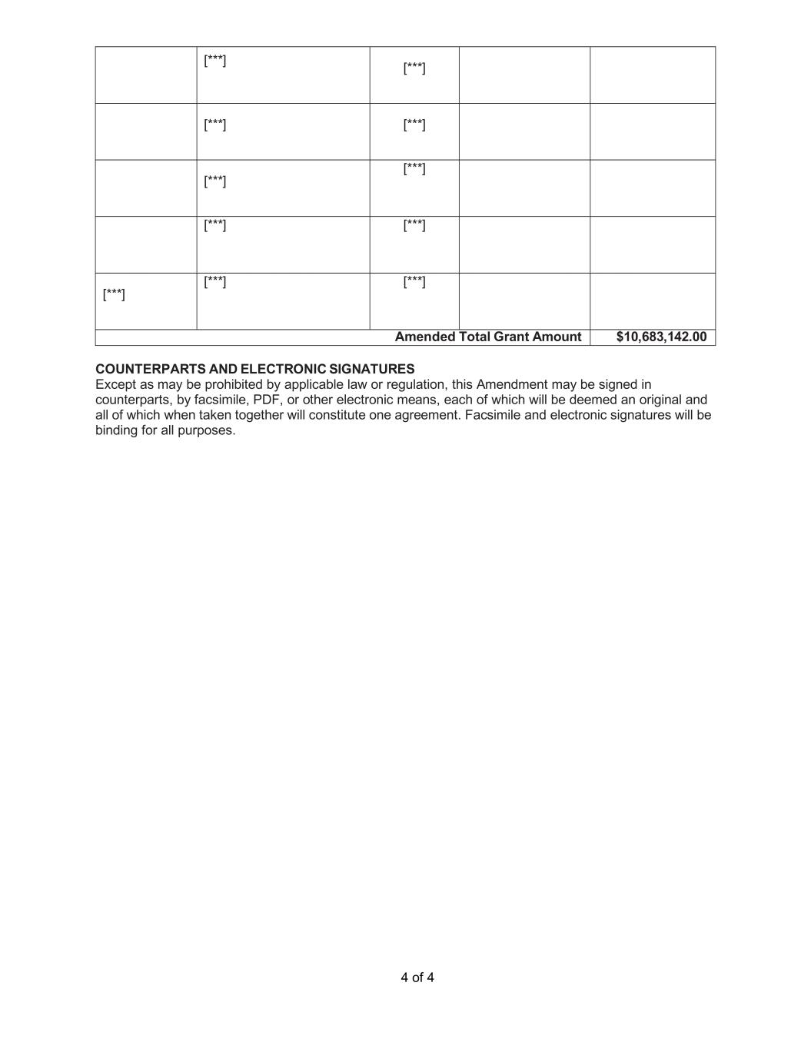
4 of 4 [***] [***] [***] [***] [***] [***] [***] [***] [***] [***] [***] Amended Total Grant Amount $10,683,142.00 COUNTERPARTS AND ELECTRONIC SIGNATURES Except as may be prohibited by applicable law or regulation, this Amendment may be signed in counterparts, by facsimile, PDF, or other electronic means, each of which will be deemed an original and all of which when taken together will constitute one agreement. Facsimile and electronic signatures will be binding for all purposes.

Exhibit 31.1
CERTIFICATIONS
I, Sabrina Martucci Johnson, certify that:

 |  |  | 1. |  |  | I have reviewed this Quarterly Report on Form 10-Q of Daré Bioscience, Inc.;
 |  |  | 2. |  |  | Based on my knowledge, this report does not contain any untrue statement of a material fact or omit to state a material fact necessary to make the statements made, in light of the circumstances under which such statements were made, not misleading with respect to the period covered by this report;
 |  |  | 3. |  |  | Based on my knowledge, the financial statements, and other financial information included in this report, fairly present in all material respects the financial condition, results of operations and cash flows of the registrant as of, and for, the periods presented in this report;
 |  |  | 4. |  |  | I am responsible for establishing and maintaining disclosure controls and procedures (as defined in Exchange Act Rules 13a-15(e) and 15d-15(e)) and internal control over financial reporting (as defined in Exchange Act Rules 13a-15(f) and 15d-15(f)) for the registrant and have:
 |  |  | a. |  |  | Designed such disclosure controls and procedures, or caused such disclosure controls and procedures to be designed under our supervision, to ensure that material information relating to the registrant, including its consolidated subsidiaries, is made known to us by others within those entities, particularly during the period in which this report is being prepared;
 |  |  | b. |  |  | Designed such internal control over financial reporting, or caused such internal control over financial reporting to be designed under our supervision, to provide reasonable assurance regarding the reliability of financial reporting and the preparation of financial statements for external purposes in accordance with generally accepted accounting principles;
 |  |  | c. |  |  | Evaluated the effectiveness of the registrant’s disclosure controls and procedures and presented in this report my conclusions about the effectiveness of the disclosure controls and procedures, as of the end of the period covered by this report based on such evaluation; and
 |  |  | d. |  |  | Disclosed in this report any change in the registrant’s internal control over financial reporting that occurred during the registrant’s most recent fiscal quarter (the registrant’s fourth fiscal quarter in the case of an annual report) that has materially affected, or is reasonably likely to materially affect, the registrant’s internal control over financial reporting; and
 |  |  | 5. |  |  | I have disclosed, based on my most recent evaluation of internal control over financial reporting, to the registrant’s auditors and the audit committee of the registrant’s board of directors (or persons performing the equivalent functions):
 |  |  | a. |  |  | All significant deficiencies and material weaknesses in the design or operation of internal control over financial reporting which are reasonably likely to adversely affect the registrant’s ability to record, process, summarize and report financial information; and
 |  |  | b. |  |  | Any fraud, whether or not material, that involves management or other employees who have a significant role in the registrant’s internal control over financial reporting.
Date: November 13, 2025
/s/ Sabrina Martucci Johnson
Sabrina Martucci Johnson
President and Chief Executive Officer
(Principal executive officer and principal financial officer)

Exhibit 32.1
CERTIFICATION PURSUANT TO 18 U.S.C. SECTION 1350,
AS ADOPTED PURSUANT TO
SECTION 906 OF THE SARBANES-OXLEY ACT OF 2002
In connection with the Quarterly Report on Form 10-Q of Daré Bioscience, Inc. (the “Company”) for the fiscal quarter ended September 30, 2025, as filed with the Securities and Exchange Commission on the date hereof (the “Report”), the undersigned, Sabrina Martucci Johnson, President and Chief Executive Officer of the Company, hereby certifies, pursuant to 18 U.S.C. Section 1350, that, to her knowledge on the date hereof:
(1) The Report fully complies with the requirements of Section 13(a) or 15(d) of the Securities Exchange Act of 1934; and
(2) The information contained in the Report fairly presents, in all material respects, the financial condition and results of operations of the Company.
Date: November 13, 2025

/s/ Sabrina Martucci Johnson
Sabrina Martucci Johnson
President and Chief Executive Officer
(principal executive officer and principal financial officer)

