UNITED STATES

SECURITIES AND EXCHANGE COMMISSION

WASHINGTON, DC 20549

FORM 10-Q

(Mark One)

- QUARTERLY REPORT PURSUANT TO SECTION 13 OR 15(d) OF THE SECURITIES EXCHANGE ACT OF 1934

- TRANSITION REPORT PURSUANT TO SECTION 13 OR 15(d) OF THE SECURITIES EXCHANGE ACT OF 1934

For the transition period from to

Commission File Number: 001-36395


DARÉ BIOSCIENCE, INC.

(Exact Name of Registrant as Specified in its Charter)
Delaware |  | 20-4139823
(State or Other Jurisdiction |  | (IRS Employer
of Incorporation) |  | Identification No.)
3655 Nobel Drive, Suite 260 | (858) 926-7655 | 92122
San Diego, CA | (Registrant’s telephone number, including area code) | (Zip Code)
(Address of Principal Executive Offices)
 | (Former name, former address and former fiscal year, if changed since last report)
Securities registered pursuant to Section 12(b) of the Act:
Title of each class | Trading Symbol(s) | Name of each exchange on which registered
Common Stock | DARE | Nasdaq Capital Market

Indicate by check mark whether the registrant (1) has filed all reports required to be filed by Section 13 or 15(d) of the Securities Exchange Act of 1934 during the preceding 12 months (or for such shorter period that the registrant was required to file such reports), and (2) has been subject to such filing requirements for the past 90 days. Yes x No o

Indicate by check mark whether the registrant has submitted electronically every Interactive Data File required to be submitted pursuant to Rule 405 of Regulation S-T (§232.405 of this chapter) during the preceding 12 months (or for such shorter period that the registrant was required to submit such files). Yes x No o

Indicate by check mark whether the registrant is a large accelerated filer, an accelerated filer, a non-accelerated filer or a smaller reporting company, or emerging growth company. See the definitions of “large accelerated filer,” “accelerated filer,” “smaller reporting company,” and “emerging growth company” in Rule 12b-2 of the Exchange Act.

Large Accelerated Filer | o | Accelerated filer | o
Non-accelerated filer | x | Smaller reporting company | x
Emerging growth company | o

If an emerging growth company, indicate by check mark if the registrant has elected not to use the extended transition period for complying with any new or revised financial accounting standards pursuant to Section 13(a) of the Exchange Act. o
Indicate by check mark whether the registrant is a shell company (as defined in Rule 12b-2 of the Act). Yes ☐ No x

As of May 13, 2024, 101,092,900 shares of the Registrant’s Common Stock, par value $0.0001, were issued and outstanding.

1

CAUTIONARY NOTE REGARDING FORWARD-LOOKING STATEMENTS

This Quarterly Report on Form 10-Q, in particular “Item 2. Management's Discussion and Analysis of Financial Condition and Results of Operations,” of Part I. Financial Information, and the information incorporated by reference herein contains forward-looking statements that involve substantial risks and uncertainties. All statements, other than statements of historical facts, contained in this report, including statements regarding our strategy, future operations, future financial position, projected revenue, funding and expenses, prospects, plans and objectives of management, are forward-looking statements. Forward-looking statements, in some cases, can be identified by terms such as “believe,” “may,” “will,” “estimate,” “continue,” “anticipate,” “design,” “intend,” “expect,” “could,” “plan,” “potential,” “predict,” “seek,” "pursue," “should,” “would,” “contemplate,” "project,” “target,” “tend to,” or the negative version of these words and similar expressions.

Forward-looking statements involve known and unknown risks, uncertainties and other factors that may cause our actual results, performance or achievements to be materially different from any future results, performance or achievements expressed or implied by the forward-looking statements, including those factors described in Part II, Item 1A, "Risk Factors", in this report, and elsewhere in this report. Given these uncertainties, you should not place undue reliance on any forward-looking statement. The following factors are among those that may cause such differences:

- Inability to raise additional capital, under favorable terms or at all, to fund our operating needs and continue as a going concern;

- The number and scope of product development programs we pursue;

- Clinical trial outcomes and results of preclinical development;

- Failure to complete development of our product candidates or submit and obtain United States Food and Drug Administration, or FDA, or foreign regulatory authority approval for our product candidates on projected timelines or budgets, or at all;

- Challenges and delays in obtaining timely supplies of our product candidates, including their components as well as the finished product, in the quantities needed in accordance with current good manufacturing practices, our specifications and other applicable requirements;

- The performance of third parties on which we rely to conduct nonclinical studies and clinical trials of our product candidates;

- Our failure, or a failure of a strategic collaborator, to successfully commercialize our product candidates, if approved, or our failure to otherwise monetize our portfolio programs and assets;

- Termination by a collaborator of our respective out-license agreements for commercialization of XACIATO™ (clindamycin phosphate) vaginal gel 2%, or XACIATO, and Ovaprene®, or, in the case of Ovaprene, a decision by the collaborator not to make the license grant fully effective following its review of the results of the ongoing pivotal clinical trial of Ovaprene;

- The timing and amount of future royalty, milestone or other payments to us, if any, under our out-license agreement for Ovaprene, and of upside-sharing milestone payments from XOMA under our traditional and synthetic royalty purchase agreements, if any;

- The performance of third parties on which we rely to commercialize, or assist us in commercializing, XACIATO and any future product;

- Difficulties with maintaining existing collaborations relating to the development and/or commercialization of our product candidates, or establishing new ones on a timely basis or on acceptable terms, or at all;

- The terms and conditions of any future strategic collaborations relating to our product candidates;

- The degree of market acceptance that XACIATO and any future product achieves;

- Coverage and reimbursement levels for XACIATO and any future product by government health care programs, private health insurance companies and other third-party payors;

- Our loss of, or inability to attract, key personnel;

- A change in the FDA's prior determination that the Center for Devices and Radiological Health would lead the review of a premarket approval application for potential marketing approval of Ovaprene;

- A change in regulatory requirements for our product candidates, including the development pathway pursuant to Section 505(b)(2) of the Federal Food, Drug, and Cosmetic Act, or the FDA's 505(b)(2) pathway;

- Unfavorable differences between preliminary, interim or topline clinical study data reported by us and final study results;

- Communication from the FDA or another regulatory authority, including a complete response letter, that such agency does not accept or agree with our assumptions, estimates, calculations, conclusions or analyses of clinical or nonclinical study data regarding a product candidate, or that such agency interprets or weighs the importance of study data differently than we have in a manner that negatively impacts the candidate's prospects for regulatory approval in a timely manner, or at all;

- Failure to select product candidates that capitalize on the most scientifically, clinically or commercially promising or profitable indications or therapeutic areas within women's health including due to our limited financial resources;

- Loss or impairment of our in-licensed rights to develop and commercialize XACIATO and our product candidates;

- The timing and amount of our payment and other obligations under our in-license and acquisition agreements for XACIATO and our product candidates;

- Developments by our competitors that make XACIATO, or any potential product we develop, less competitive or obsolete;

- Unfavorable or unanticipated macroeconomic factors, geopolitical events or conflicts, public health emergencies, or natural disasters;

- Weak interest in women's health relative to other healthcare sectors from the investment community or from pharmaceutical companies and other potential development and commercialization collaborators;

- Cyber-attacks, security breaches or similar events compromising our technology systems and data, our financial resources and other assets, or the technology systems and data of third parties on which we rely;

- Difficulty in introducing branded products in a market made up of generic products;

- Inability to adequately protect or enforce our, or our licensor’s, intellectual property rights;

- Lack of patent protection for the active ingredients in XACIATO and certain of our product candidates that expose them to competition from other formulations using the same active ingredients;

- Higher risk of failure associated with product candidates in preclinical stages of development that may lead investors to assign them little to no value and make these assets difficult to fund;

- Dependence on grant funding to advance the development of several of our product candidates;

- Disputes or other developments concerning our intellectual property rights;

- Actual and anticipated fluctuations in our quarterly or annual operating results or results that differ from investors' expectations for such results;

- Price and volume fluctuations in the stock market, and in our stock in particular, which could cause investors to experience losses and subject us to securities class-action litigation;

- Failure to maintain the listing of our common stock on the Nasdaq Capital Market or another nationally recognized exchange;

- Development of safety, efficacy or quality concerns related to our product or product candidates (or third-party products or product candidates that share similar characteristics or drug substances), whether or not scientifically justified, leading to delays in or discontinuation of product development, product recalls or withdrawals, diminished sales, and/or other significant negative consequences;

- Product liability claims or governmental investigations;
- Changes in government laws and regulations in the United States and other jurisdictions, including laws and regulations governing the research, development, approval, clearance, manufacturing, supply, distribution, pricing and/or marketing of our products, product candidates and related intellectual property, health care information and data privacy and security laws, transparency laws and fraud and abuse laws, and the enforcement thereof affecting our business; and

- Increased costs as a result of operating as a public company, and substantial time devoted by our management to compliance initiatives and corporate governance practices.

In addition, statements that “we believe” and similar statements reflect our beliefs and opinions on the relevant subject. These statements are based upon information available to us as of the date of this report, and while we believe such information forms a reasonable basis for such statements, such information may be limited or incomplete, and our statements should not be read to indicate that we have conducted an exhaustive inquiry into, or review of, all potentially available relevant information. These statements are inherently uncertain and investors are cautioned not to unduly rely upon these statements.

All forward-looking statements in this report are current only as of the date of this report. We do not undertake any obligation to publicly update any forward-looking statement to reflect events or circumstances after the date on which any statement is made or to reflect the occurrence of unanticipated events, except as required by law.

TABLE OF CONTENTS

 |  |  |  |  |  |  |  |  |  |  |  |  |  | Page
 | PART I. FINANCIAL INFORMATION
 | Item 1. | Condensed Consolidated Financial Statements (Unaudited) |  |  |  |  |  |  |  |  |  |  |  | 1
 | Item 2. | Management's Discussion and Analysis of Financial Condition and Results of Operations |  |  |  |  |  |  |  |  |  |  |  | 25
 | Item 3. | Quantitative and Qualitative Disclosures About Market Risk |  |  |  |  |  |  |  |  |  |  |  | 38
 | Item 4. | Controls and Procedures |  |  |  |  |  |  |  |  |  |  |  | 38
 | PART II. OTHER INFORMATION
 | Item 1. | Legal Proceedings |  |  |  |  |  |  |  |  |  |  |  | 39
 | Item 1A. | Risk Factors |  |  |  |  |  |  |  |  |  |  |  | 39
 | Item 2. | Unregistered Sales of Equity Securities and Use of Proceeds |  |  |  |  |  |  |  |  |  |  |  | 39
 | Item 3. | Defaults Upon Senior Securities |  |  |  |  |  |  |  |  |  |  |  | 39
 | Item 4. | Mine Safety Disclosures |  |  |  |  |  |  |  |  |  |  |  | 39
 | Item 5. | Other Information |  |  |  |  |  |  |  |  |  |  |  | 39
 | Item 6. | Exhibits |  |  |  |  |  |  |  |  |  |  |  | 40
 |  | SIGNATURES |  |  |  |  |  |  |  |  |  |  |  | 41

PART I. FINANCIAL INFORMATION

Item 1. Condensed Consolidated Financial Statements (Unaudited)

Daré Bioscience, Inc. and Subsidiaries

Condensed Consolidated Balance Sheets

 |  | March 31, |  |  | December 31,
 |  | 2024 |  |  | 2023
 |  | (unaudited)
Assets
Current assets
Cash and cash equivalents | $ | 3,630,603 |  | $ | 10,476,056
Other receivables |  | 1,385,672 |  |  | 949,211
Prepaid expenses |  | 4,814,082 |  |  | 6,118,272
Other current assets |  | 152,204 |  |  | —
Total current assets |  | 9,982,561 |  |  | 17,543,539
Property and equipment, net |  | 52,493 |  |  | 655,975
Deposits |  | 762,432 |  |  | 1,163,477
Operating lease right-of-use assets |  | 1,560,706 |  |  | 1,319,630
Other non-current assets |  | 654,530 |  |  | 599,594
Total assets | $ | 13,012,722 |  | $ | 21,282,215
Liabilities and stockholders’ equity (deficit)
Current liabilities
Accounts payable | $ | 4,040,509 |  | $ | 3,385,551
Accrued expenses |  | 1,370,465 |  |  | 2,889,005
Royalties payable |  | 7,674 |  |  | —
Deferred grant funding |  | 11,835,871 |  |  | 13,737,154
Current portion of lease liabilities |  | 470,390 |  |  | 468,726
Total current liabilities |  | 17,724,909 |  |  | 20,480,436
Deferred revenue, non-current |  | 1,000,000 |  |  | 1,000,000
Liability related to the sale of future royalties, net |  | 4,115,631 |  |  | 3,913,676
Lease liabilities long-term |  | 1,171,592 |  |  | 935,743
Total liabilities |  | 24,012,132 |  |  | 26,329,855
Commitments and contingencies (Note 8)
Stockholders' equity (deficit)
Preferred stock, $0.01 par value, 5,000,000 shares authorized; None issued and outstanding |  | — |  |  | —
Common stock, $0.0001 par value; 240,000,000 shares authorized; 100,581,900 and 99,973,932 shares issued and outstanding |  | 10,058 |  |  | 9,997
at March 31, 2024 and December 31, 2023, respectively |  | 10,058 |  |  | 9,997
Accumulated other comprehensive loss |  | (400,123) |  |  | (360,896)
Additional paid-in capital |  | 167,382,042 |  |  | 166,539,290
Accumulated deficit |  | (177,991,387) |  |  | (171,236,031)
Total stockholders' equity (deficit) |  | (10,999,410) |  |  | (5,047,640)
Total liabilities and stockholders' equity (deficit) | $ | 13,012,722 |  | $ | 21,282,215

See accompanying notes.

1

Daré Bioscience, Inc. and Subsidiaries

Condensed Consolidated Statements of Operations and Comprehensive Loss

(Unaudited)

 |  | Three months ended March 31,
 |  | 2024 |  |  | 2023
Revenue
Royalty revenue | $ | 9,302 |  | $ | —
Total revenue |  | 9,302 |  |  | —
Operating expenses
General and administrative |  | 2,670,581 |  |  | 3,337,426
Research and development |  | 3,328,520 |  |  | 5,020,223
Royalty expense |  | 7,674 |  |  | —
License fee expense |  | 25,000 |  |  | 25,000
Total operating expenses |  | 6,031,775 |  |  | 8,382,649
Loss from operations |  | (6,022,473) |  |  | (8,382,649)
Other income (expense) |  | (732,883) |  |  | 340,148
Net loss | $ | (6,755,356) |  | $ | (8,042,501)
Foreign currency translation adjustments |  | (39,227) |  |  | (22,005)
Comprehensive loss | $ | (6,794,583) |  | $ | (8,064,506)
Loss per common share - basic and diluted | $ | (0.07) |  | $ | (0.09)
Weighted average number of shares outstanding:
Basic and diluted |  | 100,514,272 |  |  | 85,517,540

See accompanying notes.

2

Daré Bioscience, Inc. and Subsidiaries

Condensed Consolidated Statements of Stockholders’ Equity

(Unaudited)

Three Months Ended March 31, 2024

 |  |  |  |  |  |  | Additional |  |  | Accumulated |  |  |  |  |  | Total
 |  |  |  |  |  |  |  |  |  | other |  |  |  |  |  | Total
 | Common stock |  |  |  |  |  | paid-in |  |  | comprehensive |  |  | Accumulated |  |  | stockholders'
 | Shares |  |  | Amount |  |  | capital |  |  | loss |  |  | deficit |  |  | equity
Balance at December 31, 2023 | 99,973,932 |  | $ | 9,997 |  | $ | 166,539,290 |  | $ | (360,896) |  | $ | (171,236,031) |  | $ | (5,047,640)
Stock-based compensation | — |  |  | — |  |  | 627,700 |  |  | — |  |  | — |  |  | 627,700
Issuance of common stock | 607,968 |  |  | 61 |  |  | 215,052 |  |  | — |  |  | — |  |  | 215,113
Net loss | — |  |  | — |  |  | — |  |  | — |  |  | (6,755,356) |  |  | (6,755,356)
Foreign currency translation adjustments | — |  |  | — |  |  | — |  |  | (39,227) |  |  | — |  |  | (39,227)
Balance at March 31, 2024 | 100,581,900 |  | $ | 10,058 |  | $ | 167,382,042 |  | $ | (400,123) |  | $ | (177,991,387) |  | $ | (10,999,410)

Three Months Ended March 31, 2023

 |  |  |  |  |  |  | Additional |  |  | Accumulated |  |  |  |  |  | Total
 |  |  |  |  |  |  |  |  |  | other |  |  |  |  |  | Total
 | Common stock |  |  |  |  |  | paid-in |  |  | comprehensive |  |  | Accumulated |  |  | stockholders'
 | Shares |  |  | Amount |  |  | capital |  |  | loss |  |  | deficit |  |  | equity
Balance at December 31, 2022 | 84,825,481 |  | $ | 8,482 |  | $ | 152,529,579 |  | $ | (351,311) |  | $ | (141,074,640) |  | $ | 11,112,110
Stock-based compensation | — |  |  | — |  |  | 624,621 |  |  | — |  |  | — |  |  | 624,621
Issuance of common stock from the exercise of warrants | 1,353,515 |  |  | 136 |  |  | 1,299,239 |  |  | — |  |  | — |  |  | 1,299,375
Net loss | — |  |  | — |  |  | — |  |  | — |  |  | (8,042,501) |  |  | (8,042,501)
Foreign currency translation adjustments | — |  |  | — |  |  | — |  |  | (22,005) |  |  | — |  |  | (22,005)
Balance at March 31, 2023 | 86,178,996 |  | $ | 8,618 |  | $ | 154,453,439 |  | $ | (373,316) |  | $ | (149,117,141) |  | $ | 4,971,600

See accompanying notes.

3

Daré Bioscience, Inc. and Subsidiaries

Condensed Consolidated Statements of Cash Flows

(Unaudited)

 |  | Three months ended March 31,
 |  | 2024 |  |  | 2023
Cash flows from operating activities
Net loss | $ | (6,755,356) |  | $ | (8,042,501)
Adjustments to reconcile net loss to net cash used in operating activities:
Depreciation |  | 10,778 |  |  | 9,508
Right of use asset - operating lease |  | 117,239 |  |  | 89,940
Stock-based compensation |  | 627,700 |  |  | 624,621
Disposal of property and equipment |  | 600,000 |  |  | —
Non-cash interest expense on liability related to sale of future royalties |  | 85,432 |  |  | —
Changes in operating assets and liabilities:
Accounts receivable |  | (67,644) |  |  | —
Other receivables |  | (368,817) |  |  | (695,548)
Prepaid expenses |  | 1,304,190 |  |  | (416,464)
Deposits |  | 401,045 |  |  | —
Other current assets |  | (152,204) |  |  | (201,385)
Other non-current assets |  | (54,936) |  |  | (166,545)
Operating lease liability |  | (120,802) |  |  | (95,846)
Accounts payable |  | 654,958 |  |  | 667,661
Accrued expenses |  | (1,318,149) |  |  | (5,413,814)
Royalties payable |  | 7,674 |  |  | —
Interest payable |  | 117,213 |  |  | —
Deferred grant funding |  | (1,901,283) |  |  | (2,477,198)
Net cash used in operating activities |  | (6,812,962) |  |  | (16,117,571)
Cash flows from investing activities
Purchases of property and equipment |  | (7,296) |  |  | —
Net cash used in investing activities |  | (7,296) |  |  | —
Cash flows from financing activities
Net proceeds from issuance of common stock |  | 215,113 |  |  | —
Proceeds from the exercise of common stock warrants |  | — |  |  | 1,299,375
Repayment of liability on sale of future royalties |  | (690) |  |  | —
Payments on note payable |  | (200,391) |  |  | —
Net cash provided by financing activities |  | 14,032 |  |  | 1,299,375
Effect of exchange rate changes on cash and cash equivalents |  | (39,227) |  |  | (22,005)
Net change in cash and cash equivalents |  | (6,845,453) |  |  | (14,840,201)
Cash and cash equivalents, beginning of period |  | 10,811,056 |  |  | 34,669,605
Cash and cash equivalents, end of period | $ | 3,965,603 |  | $ | 19,829,404
Reconciliation of cash, cash equivalents and restricted cash to amounts reported in the consolidated balance sheets:
Cash and cash equivalents | $ | 3,630,603 |  |  | 19,744,404
Restricted cash included in other non-current assets |  | 335,000 |  |  | 85,000
Total cash, cash equivalents and restricted cash | $ | 3,965,603 |  | $ | 19,829,404
Supplemental disclosure of non-cash investing and financing activities:
Operating right-of-use assets obtained in exchange for new operating lease liabilities, net | $ | 358,315 |  | $ | —

See accompanying notes.

4

Daré Bioscience, Inc. and Subsidiaries

Notes to Condensed Consolidated Financial Statements (Unaudited)

- ORGANIZATION AND DESCRIPTION OF BUSINESS

Daré Bioscience, Inc. is a biopharmaceutical company committed to advancing innovative products for women’s health. Daré Bioscience, Inc. and its wholly-owned subsidiaries operate one segment. In this report, the “Company” refers collectively to Daré Bioscience, Inc. and its wholly-owned subsidiaries, unless otherwise stated or the context otherwise requires.

The Company began assembling its diverse portfolio in 2017 through acquisitions, exclusive in-licenses and other collaborations. The Company's programs target unmet needs in women's health in the areas of contraception, vaginal health, reproductive health, menopause, sexual health, and fertility, and aim to expand treatment options, enhance outcomes and improve ease of use for women.

The Company’s primary operations have consisted of, and are expected to continue to consist primarily of, research and development activities to advance its product candidates through clinical development and regulatory approval.

The Company's portfolio includes drug and drug/device product candidates and potential product candidates in various stages of development.

The first U.S. Food and Drug Administration (FDA)-approved product to emerge from the Company's portfolio of women's health product candidates is XACIATO™ (clindamycin phosphate) vaginal gel 2%, or XACIATO. In March 2022, the Company entered into an exclusive global license agreement with an affiliate of Organon & Co., Organon International GmbH, or Organon, to commercialize XACIATO, which became fully effective in June 2022. Under the license agreement, Organon (and/or its affiliates, agents or sublicensees) is solely responsible for the marketing, distribution and sale of XACIATO in the United States (and outside the U.S. if approved in non-U.S. jurisdictions in the future). Organon commenced U.S. marketing of XACIATO in the fourth quarter of 2023 and, in January 2024, Organon announced that XACIATO was available nationwide.

- BASIS OF PRESENTATION AND SUMMARY OF SIGNIFICANT ACCOUNTING POLICIES

Basis of Presentation

The accompanying condensed consolidated financial statements have been prepared in accordance with generally accepted accounting principles in the United States, or U.S. GAAP, as defined by the Financial Accounting Standards Board, or FASB, for interim financial information and with the instructions to Form 10-Q and Article 8 of Regulation S-X. Accordingly, they do not include all of the information and footnotes required by GAAP for complete financial statements. In management’s opinion, the accompanying condensed consolidated financial statements reflect all adjustments, consisting of normal recurring adjustments, considered necessary for a fair presentation of the results of the interim periods presented.

Interim financial results are not necessarily indicative of results anticipated for any other interim period or for the full year. The accompanying condensed consolidated financial statements should be read in conjunction with the audited financial statements and notes thereto included in the Company's Annual Report on Form 10-K for the year ended December 31, 2023, or the 2023 10-K.

5

Cash and Cash Equivalents

The Company considers cash and all highly liquid investments with an original maturity of three months or less to be cash and cash equivalents. The Company has an aggregate of approximately $0.3 million in restricted cash as of March 31, 2024, related to (i) letters of credit established under real property leases for the Company's wholly-owned subsidiary, Dare MB Inc., that serve as security for potential future default of lease payments, and (ii) collateralized cash for the Company's credit cards. The restricted cash is unavailable for withdrawal or for general obligations and is included in other non-current assets on the Company's consolidated balance sheet.

Going Concern

The Company prepared its condensed consolidated financial statements on a going concern basis, which assumes that the Company will realize its assets and satisfy its liabilities in the normal course of business. The Company has a history of losses from operations, expects negative cash flows from its operations to continue for the foreseeable future, and expects that its net losses will continue for at least the next several years as it develops and seeks to bring to market its existing product candidates and to potentially acquire, license and develop additional product candidates. These circumstances raise substantial doubt about the Company's ability to continue as a going concern. The accompanying condensed consolidated financial statements do not include any adjustments to reflect the possible future effects on the recoverability and reclassification of assets or the amounts and classifications of liabilities that may result from the outcome of the uncertainty of the Company's ability to continue as a going concern.

As of March 31, 2024, the Company had an accumulated deficit of approximately $178.0 million, cash and cash equivalents of approximately $3.6 million, deferred grant funding liabilities under the Company's grant agreements related to DARE-LARC1, DARE-LBT and its bacteria-based live biotherapeutic product of approximately $11.8 million, and a working capital deficit of approximately $ 7.7 million. The Company's cash and cash equivalents at March 31, 2024 represented grant funds received under such agreements that may be applied solely toward direct costs for the development of DARE-LARC1, DARE-LBT and its bacteria-based live biotherapeutic product, other than approximately 10% of such funds, which may be applied toward general overhead and administration expenses that support the entire operations of the Company. For the three months ended March 31, 2024, the Company incurred a net loss of approximately $6.8 million and had negative cash flow from operations of approximately $6.8 million.

Based on the Company's current operating plan estimates, the Company does not have sufficient cash to satisfy its working capital needs and other liquidity requirements over at least the next 12 months from the date of issuance of the accompanying condensed consolidated financial statements. The Company will need to raise substantial additional capital to continue to fund its operations and to successfully execute its current strategy.

There can be no assurance that capital will be available when needed or that, if available, it will be obtained on terms favorable to the Company and its stockholders. If the Company cannot raise capital when needed, on favorable terms or at all, the Company will not be able to continue development of its product candidates, will need to reevaluate its planned operations and may need to delay, scale back or eliminate some or all of its development programs, reduce expenses, file for bankruptcy, reorganize, merge with another entity, or cease operations. If the Company becomes unable to continue as a going concern, the Company may have to liquidate its assets, and might realize significantly less than the values at which they are carried on its condensed consolidated financial statements, and stockholders may lose all or part of their investment in the Company's common stock. The Company's condensed consolidated financial statements do not include any adjustments that might result from the outcome of these uncertainties.

The Company’s significant accounting policies are described in Note 2 to the consolidated financial statements included in the 2023 10-K. Since the date on which the 2023 10-K was filed with the U.S. Securities and Exchange Commission, or the SEC, there have been no material changes to the Company’s significant accounting policies.

Fair Value of Financial Instruments

GAAP defines fair value as the price that would be received for an asset or the exit price that would be paid to transfer a liability in the principal or most advantageous market in an orderly transaction between market participants on the measurement date, and also establishes a fair value hierarchy which requires an entity to maximize the use of observable inputs, where available. The three-level hierarchy of valuation techniques established to measure fair value is defined as follows:

6

- Level 1: inputs are unadjusted quoted prices in active markets for identical assets or liabilities.

- Level 2: inputs other than Level 1 that are observable, either directly or indirectly, such as quoted prices in active markets for similar assets and liabilities, quoted prices for identical or similar assets or liabilities in markets that are not active, or other inputs that are observable or can be corroborated by observable market data for substantially the full term of assets or liabilities.

- Level 3: unobservable inputs that are supported by little or no market activity and that are significant to the fair value of the assets or liabilities.

The following tables present the classification within the fair value hierarchy of financial assets and liabilities that are remeasured on a recurring basis as of March 31, 2024 and December 31, 2023. There were no financial assets or liabilities that were remeasured using a quoted price in active markets for identical assets (Level 2) or using unobservable inputs (Level 3) as of March 31, 2024 or December 31, 2023.

Fair Value Measurements

Level 1 Level 2 Level 3 Total

Balance at March 31, 2024

Current assets:

Cash equivalents ⁽¹⁾ $ 1,434,234 $ — $ — $ 1,434,234

Balance at December 31, 2023

Current assets:

Cash equivalents ⁽¹⁾ $ 9,982,079 $ — $ — $ 9,982,079

- Represents cash held in money market funds.

Revenue Recognition

Under Accounting Standards Codification Topic 606, or ASC 606, the Company recognizes revenue when it transfers promised goods or services to customers in an amount that reflects the consideration to which it expects to be entitled in exchange for those goods or services. To determine revenue recognition for contracts with customers, the Company performs the following five steps: (i) identify the contract(s) with a customer; (ii) identify the performance obligations in the contract; (iii) determine the transaction price;
- allocate the transaction price to the performance obligations in the contract; and (v) recognize revenue when (or as) the Company satisfies its performance obligations. At contract inception, the Company assesses the goods or services agreed upon within each contract, assesses whether each good or service is distinct, and determines those that are performance obligations. The Company then recognizes as revenue the amount of the transaction price allocated to the respective performance obligation when (or as) the performance obligation is satisfied.

In a contract with multiple performance obligations, the Company develops estimates and assumptions that require judgment to determine the underlying stand-alone selling price for each performance obligation, which determines how the transaction price is allocated among the performance obligations. The estimation of the stand-alone selling price(s) may include estimates regarding forecasted revenues or costs, development timelines, discount rates, and probabilities of technical and regulatory success. The Company evaluates each performance obligation to determine if it can be satisfied at a point in time or over time. Any change made to estimated progress towards completion of a performance obligation and, therefore, revenue recognized will be recorded as a change in estimate. In addition, variable consideration must be evaluated to determine if it is constrained and, therefore, excluded from the transaction price.

Collaboration Revenues. The Company enters into collaboration and licensing agreements under which it out-licenses certain rights to its products or product candidates to third parties. The terms of these arrangements typically include payment of one or more of the following to the Company: non -refundable, up-front license fees; development, regulatory and/or commercial milestone payments; and royalties on net sales of licensed products. As of March 31, 2024, the Company has not recognized any collaboration revenues.

7

License Fee Revenue. If the license to the Company’s intellectual property is determined to be distinct from the other performance obligations identified in a contract, the Company recognizes revenues from non-refundable, upfront fees allocated to the license when the license is transferred to the customer and the customer is able to use and benefit from the license. For licenses bundled with other promises, the Company utilizes judgment to assess the nature of the combined performance obligation to determine whether the combined performance obligation is satisfied over time or at a point in time and, if over time, the appropriate method of measuring progress for purposes of recognizing revenue from non-refundable, upfront fees. The Company evaluates the measure of progress each reporting period and, if necessary, adjusts the measure of performance and related revenue recognition. To date, the Company has recognized $12.8 million in license fee revenue, $10.0 million of which represents the upfront payment under its license agreement for XACIATO and $1.0 million of which represents the payment required by the first amendment to such license agreement entered into in July 2023.

Royalties. For arrangements that include sales-based royalties, including milestone payments based on the level of sales, and for which the license is deemed to be the predominant item to which the royalties relate, the Company recognizes revenue at the later of (i) when the related sales occur, or (ii) when the performance obligation to which some or all of the royalty has been allocated has been satisfied (or partially satisfied). As of March 31, 2024, the Company has recognized approximately $17,000 in royalty revenue.

Product Supply. Arrangements that include a promise for future supply of product for commercial supply at the licensee’s discretion are generally considered as options. The Company assesses if these options provide a material right to the licensee and if so, they are accounted for as separate performance obligations. The Company evaluates whether it is the principal or agent in the arrangement. The evaluation is based on the degree the Company controls the specified product at any time before transfer to the customer. Revenues are recognized on a gross basis if the Company is in the capacity of principal and on a net basis if the Company is in the capacity of an agent. The Company recognized approximately $ 205,000 in revenue, recorded in other income, along with $201,000 in other expense attributed to the cost of revenue associated with its product supply arrangement for XACIATO, in the Company's 2023 consolidated statement of operations and comprehensive loss. That arrangement was terminated effective December 14, 2023 and the Company will not recognize product supply revenue associated with that agreement in the future.

Milestones. At the inception of each arrangement in which the Company is a licensor and that includes developmental, regulatory or commercial milestones, the Company evaluates whether achieving the milestones is considered probable and estimates the amount to be included in the transaction price using the most likely amount method. If it is probable that a significant revenue reversal would not occur, the associated milestone value is included in the transaction price. Milestone payments not within the Company's control, such as where achievement of the specified milestone depends on activities of a third party or regulatory approval, are not considered probable of being achieved until the specified milestone occurs. Through March 31, 2024, the Company has recognized $1.8 million of milestone payment revenues, which was recognized in the fourth quarter of 2023.

Bayer License. In January 2020, the Company entered into a license agreement with Bayer HealthCare LLC, or Bayer, regarding the further development and commercialization of Ovaprene in the U.S. Upon execution of the agreement, the Company received a $1.0 million upfront non-refundable license fee payment from Bayer. Bayer, in its sole discretion, has the right to make the license effective by paying the Company an additional $20.0 million. The Company concluded that there was one significant performance obligation related to the $1.0 million upfront payment: a distinct license to commercialize Ovaprene effective upon the receipt of the $20.0 million fee. The $1.0 million upfront payment will be recorded as license revenue at the earlier of (1) the point in time the Company receives the $20.0 million fee, the license is transferred to Bayer and Bayer is able to use and benefit from the license and (2) the termination of the agreement. As of March 31, 2024, neither of the foregoing had occurred. The $1.0 million payment is recorded as deferred license revenue in the Company's consolidated balance sheets at March 31, 2024 and December 31, 2023.

The Company will also be entitled to receive (a) milestone payments totaling up to $310.0 million related to the commercial sales of Ovaprene, if all such milestones are achieved, (b) tiered royalties starting in the low double digits based on annual net sales of Ovaprene during a calendar year, subject to customary royalty reductions and offsets, and (c) a percentage of sublicense revenue.

Potential future payments for variable consideration, such as commercial milestones, will be recognized when it is probable that, if recorded, a significant reversal will not take place. Potential future royalty payments will be recorded as revenue when the associated sales occur. (See Note 3, Strategic Agreements.)

8

- STRATEGIC AGREEMENTS

Strategic Agreements for Product Commercialization

Organon Exclusive License Agreement

In March 2022, the Company entered into an exclusive license agreement with Organon which became effective in June 2022, whereby Organon licensed exclusive worldwide rights to develop, manufacture and commercialize XACIATO and other future intravaginal or urological products for human use formulated with clindamycin that rely on intellectual property controlled by the Company. In July 2022, the Company received a $10.0 million non-refundable and non-creditable payment from Organon, which was recorded as license fee revenue. In July 2023, the Company received a $1.0 million payment from Organon in connection with the amendment to the license agreement the parties entered into, which was also recorded as license fee revenue. In the fourth quarter of 2023, in connection with the first commercial sale in the U.S. of XACIATO in accordance with the license agreement, as amended, the Company received the $1.8 million milestone payment from Organon.

Under the terms of the license agreement, as amended, the Company is entitled to receive tiered double-digit royalties based on net sales and up to $180.0 million in tiered commercial sales milestones and regulatory milestones. Royalty payments will be subject to customary reductions and offsets.

At the inception of the license agreement, the Company concluded that the transaction price was $10.0 million and should not include the variable consideration related to unachieved development, regulatory, commercial milestones and future sales-based royalty payments. This consideration was determined to be constrained as it is probable that the inclusion of such variable consideration could result in a significant reversal in cumulative revenue. The Company re-evaluates the transaction price at each reporting period as uncertain events are resolved and other changes in circumstances occur. The transaction price was updated to $12.8 million as of March 31, 2024.

The Company will recognize any consideration related to sales-based payments, including milestones and royalties which relate predominantly to the license granted, at the later of (i) when or as the related sales occur, or (ii) when the performance obligation to which some or all of the royalty has been allocated has been satisfied (or partially satisfied).

The Company was responsible for regulatory interactions and for providing product supply on an interim basis until Organon assumed such responsibilities, which occurred in December 2023. Prior to that time, Organon purchased all of its product requirements of XACIATO from the Company at a transfer price equal to the Company's manufacturing costs plus a single-digit percentage markup.

Unless terminated earlier, the agreement will expire on a product-by-product and country-by-country basis upon expiration of the applicable royalty period for each licensed product. In addition to customary termination rights for both parties, following the first anniversary of the effective date of the agreement, Organon may terminate the agreement in its entirety or on a country-by-country basis at any time in Organon's sole discretion on 120 days' advance written notice.

9

Bayer HealthCare License Agreement

In January 2020, the Company entered into a license agreement with Bayer, regarding the further development and commercialization of Ovaprene in the U.S. The Company received a $1.0 million upfront non-refundable license fee payment from Bayer and Bayer agreed to support the Company in development and regulatory activities by providing the equivalent of two experts to advise the Company in clinical, regulatory, preclinical, commercial, CMC and product supply matters. The Company is responsible for the pivotal trial for Ovaprene and for its development and regulatory activities and has product supply obligations. Bayer, in its sole discretion, has the right to make the license effective by paying the Company an additional $20.0 million, referred to as the $20.0 million fee. After payment of the $20.0 million fee, Bayer will be responsible for the commercialization of Ovaprene for human contraception in the U.S. Such license would be exclusive as to the commercialization of Ovaprene for human contraception in the U.S. and co-exclusive with the Company with regard to development.

The Company concluded there was one significant performance obligation related to the $1.0 million upfront payment: a distinct license to commercialize Ovaprene effective upon the receipt of the $20.0 million fee. The $1.0 million upfront payment will be recorded as license revenue at the earlier of (i) the point in time the Company receives the $20.0 million fee, the license is transferred to Bayer and Bayer is able to use and benefit from the license and (ii) the termination of the agreement. As of March 31, 2024, neither of the foregoing had occurred. The $1.0 million payment is recorded as long-term deferred license revenue in the Company's consolidated balance sheets at March 31, 2024 and December 31, 2023.

If Bayer elects to make the license effective, the Company will be entitled to receive (a) a milestone payment in the low double-digit millions upon the first commercial sale of Ovaprene in the U.S. and escalating milestone payments based on annual net sales of Ovaprene during a calendar year, totaling up to $310.0 million if all such milestones, including the first commercial sale, are achieved, (b) tiered royalties starting in the low double digits based on annual net sales of Ovaprene during a calendar year, subject to customary royalty reductions and offsets, and (c) a percentage of sublicense revenue.

The initial term of the agreement, which is subject to automatic renewal terms, continues until the later of the expiration of any valid claim covering the manufacture, use, sale or import of Ovaprene in the U.S. or 15 years from the first commercial sale of Ovaprene in the U.S. In addition to customary termination rights for both parties, Bayer may terminate the agreement at any time on 90 days' notice and the agreement will automatically terminate if the Company does not receive the $20.0 million fee if and when due.

Strategic Agreements for Pipeline Development

Douglas License Agreement / The University of Manchester Stand-by Direct License Arrangement

In August 2023, the Company entered into a license agreement with Douglas Pharmaceuticals Limited, or Douglas, under which the Company acquired the exclusive rights to develop and commercialize a lopinavir and ritonavir combination soft gel vaginal insert for the treatment of cervical intraepithelial neoplasia (CIN) and other HPV-related pathologies, and an agreement with The University of Manchester, pursuant to which The University of Manchester consented to Douglas' sublicense to the Company of certain rights it previously granted to Douglas and agreed to grant the Company a direct license to such rights if its license agreement with Douglas is terminated. Under the Company's agreement with Douglas, it received an exclusive, royalty-bearing license to research, develop and commercialize the licensed intellectual property in the United States for the treatment or prevention of all indications for women in female reproductive health. The Company is entitled to sublicense the rights granted to it under the agreement.

Under the terms of the Douglas agreement, the Company agreed to make potential future payments of up to $5.25 million in the aggregate upon achievement of certain development and regulatory milestones, and of up to $64.0 million in the aggregate upon achievement of certain commercial sales milestones for each product covered by the licenses granted under the agreement. The development and regulatory milestones may be paid in shares of the Company’s common stock, in the Company's sole discretion subject to specified limitations. Additionally, Douglas is eligible to receive tiered royalties in low single-digit to low double-digit percentages based on annual net sales of products and processes covered by the licenses granted under the agreement. As of March 31, 2024, no payments had been made under the Douglas agreement.

10

Hennepin License Agreement

In August 2022, the Company entered into a license agreement with Hennepin Life Sciences LLC, or Hennepin, under which the Company acquired the exclusive global rights to develop and commercialize treatments delivering the novel antimicrobial glycerol monolaurate (GML) intravaginally for a variety of health conditions including bacterial, fungal, and viral infections. As a result of this license, the Company commenced its DARE-GML program. Under the agreement, the Company received an exclusive, worldwide, royalty-bearing license to research, develop and commercialize the licensed technology. The Company is entitled to sublicense the rights granted to it under the agreement.

Under the terms of the license agreement, the Company agreed to make potential future payments of up to $6.25 million in the aggregate upon achievement of certain development and regulatory milestones, and up to $45.0 million in the aggregate upon achievement of certain commercial sales milestones for each product covered by the licenses

granted under the agreement, which may be paid, in the Company’s sole discretion, in cash or shares of the Company’s common stock. Additionally, Hennepin is eligible to receive tiered royalties in low single-digit to low double-digit percentages based on worldwide net sales of products and processes covered by the licenses granted under the agreement. As of March 31, 2024, no payments have been made under this agreement.

MBI Acquisition

In November 2019, the Company acquired Dare MB Inc., or MBI, to secure the rights to develop a long-acting reversible contraception method, that a woman can turn on or off herself, according to her own needs. This candidate is now known as DARE-LARC1.

Under the terms of the merger agreement, the Company agreed to pay former MBI stockholders: (a) up to $46.5 million contingent upon the achievement of specified funding, product development and regulatory milestones; (b) up to $55.0 million contingent upon the achievement of specified amounts of aggregate net sales of products incorporating the intellectual property the Company acquired in the merger; and (c) tiered royalty payments ranging from low single-digit to low double-digit percentages based on annual net sales of such products sold by the Company (but not by sublicensee) and a percentage of sublicense revenue related to such products.

In June 2021, a total of $1.25 million of the contingent consideration became payable upon the achievement of certain of the funding and product development milestone events. In accordance with the terms of the merger agreement, the Company’s board of directors elected to pay a portion of these milestone payments in shares of the Company’s common stock, and in September 2021, the Company issued approximately 700,000 shares of its common stock to former stockholders of MBI and paid $75,000 in cash to the stockholders’ representative in satisfaction of the $1.25 million in milestone payments associated with milestones achieved in June 2021.

TriLogic and MilanaPharm License Agreement / Hammock Assignment Agreement

In December 2018, the Company entered into an Assignment Agreement with Hammock Pharmaceuticals, Inc., or the Assignment Agreement, and a First Amendment to License Agreement with TriLogic Pharma, LLC and MilanaPharm LLC, or the License Amendment. Both agreements relate to the Exclusive License Agreement among Hammock, TriLogic and MilanaPharm dated as of January 9, 2017, or the MilanaPharm License Agreement. Under the Assignment Agreement and the MilanaPharm License Agreement, as amended by the License Amendment, the Company acquired an exclusive, worldwide license under certain intellectual property to, among other things, develop and commercialize products for the diagnosis, treatment and prevention of human diseases or conditions in or through any intravaginal or urological applications. The licensed intellectual property relates to the hydrogel drug delivery platform of TriLogic and MilanaPharm known as TRI-726. In XACIATO, this proprietary technology is formulated with clindamycin for the treatment of bacterial vaginosis. In December 2019, the Company entered into amendments to each of the Assignment Agreement and License Amendment. In September 2021, the Company entered into a second amendment to the License Agreement. In March 2022, the Company entered into a Consent, Waiver and Stand-By License Agreement with TriLogic, MilanaPharm and Organon, which further amended the License Agreement.

11

Under the terms of the License Agreement, the Company paid clinical and regulatory development milestones of $300,000 in the aggregate to MilanaPharm, the final payment of which was made in 2021, and $500,000 in connection with the first commercial sale in the United States of XACIATO in the fourth quarter of 2023. Additionally, the Company may pay up to $250,000 upon the first commercial sale in the United States of successive licensed products for each vaginal or urological use. In addition, upon achievement of $50.0 million in cumulative worldwide net sales of licensed products the Company must pay MilanaPharm $1.0 million. MilanaPharm is also eligible to receive (a) a low double-digit percentage of all income received by the Company or its affiliates in connection with any sublicense granted to a third party for use outside of the United States, subject to certain exclusions, and (b) high single-digit to low double-digit royalties based on annual worldwide net sales of licensed products and processes.

Hammock assigned and transferred to the Company all of its right, title and interest in and to the MilanaPharm license agreement and agreed to cooperate to transfer to the Company all of the data, materials and the licensed technology in its possession pursuant to a technology transfer plan. Hammock is eligible to receive up to $1.1 million in the aggregate upon achievement of certain clinical and regulatory development milestones, $850,000 of which has been paid as of March 31, 2024.

Pear Tree Acquisition

In May 2018, the Company acquired Pear Tree Pharmaceuticals, Inc., or Pear Tree, to secure exclusive, sublicensable, worldwide rights under certain patents and know-how to develop and commercialize a proprietary formulation of tamoxifen for vaginal administration. This acquisition led to the Company's DARE-VVA1 program.

Under the terms of the merger agreement, the Company agreed to pay the former stockholders of Pear Tree: (a) up to $ 15.5 million in the aggregate upon achievement of certain clinical development and regulatory milestones by licensed products, and (b) up to $47.0 million in the aggregate upon achievement of certain commercial milestones by licensed products. Additionally, the former stockholders of Pear Tree are eligible to receive tiered royalties based on single-digit to low double-digit percentages of annual net sales of licensed products by the Company or its affiliates, subject to customary reductions and offsets, and a portion of royalties the Company receives from sublicensees. Both the milestone and royalty payments may be made, in the Company's sole discretion, in cash or in shares of its common stock in accordance with the terms of the merger agreement. Under the merger agreement, in addition to customary royalty reductions and offsets, royalty payments and payments based on income received from sublicensees of licensed products made by the Company to Pear Tree's licensors are creditable against all royalty and sublicense revenue share payments payable to the former stockholders of Pear Tree.

The Company agreed to pay licensors of Pear Tree (a) up to approximately $ 3.2 million in the aggregate upon achievement of certain clinical development, regulatory and commercial milestones by each licensed product, and (b) semi-annual royalties based on a single-digit percentage of net sales of licensed products by the Company or its affiliates, subject to customary reductions and offsets, or a portion of any royalties the Company or its affiliates receives from sublicensees, and a low double-digit percentage of all sublicensing fees or other lump sum payments or compensation the Company receives from sublicensees, subject to customary exclusions. The milestone payments to the licensors of Pear Tree may be made, in the Company's sole discretion, in cash or in shares of its common stock in accordance with the terms of the license agreements. Portions of certain milestone payments made to Pear Tree's licensors may be creditable against royalty payments due to Pear Tree's licensors.

Catalent JNP License Agreement

In April 2018, the Company entered into an exclusive license agreement with Catalent JNP, Inc., or Catalent, under which Catalent granted the Company (a) an exclusive, royalty-bearing worldwide license under certain patent rights, either owned by or exclusively licensed to Catalent, to make, have made, use, have used, sell, have sold, import and have imported products and processes, and (b) a non-exclusive, royalty-bearing worldwide license to use certain technological information owned by Catalent to make, have made, use, have used, sell, have sold, import and have imported products and processes. As a result of this license agreement, the Company commenced its DARE-HRT1, DARE-FRT1 and DARE-PTB1 programs. The Company is entitled to sublicense the rights granted to it under this agreement.

12

Under the terms of the license agreement, the Company paid a $250,000 non-creditable upfront license fee to Catalent in connection with the execution of the agreement and will pay a $100,000 annual license maintenance fee on each anniversary of the date of the agreement. The annual maintenance fee will be creditable against royalties and other payments due to Catalent in the same calendar year but may not be carried forward to any other year. Catalent is eligible to receive up to (a) $13.5 million in the aggregate in payments based on the achievement of specified development and regulatory milestones, $1.0 million of which has been paid as of March 31, 2024; and (b) up to $30.3 million in the aggregate in payments based on the achievement of specified commercial sales milestones for each product or process covered by the licenses granted under the agreement. Additionally, Catalent is eligible to receive mid single-digit to low double-digit royalties based on worldwide net sales of products and processes covered by the licenses granted under the agreement. In lieu of such royalty payments, the Company will pay Catalent a low double-digit percentage of all sublicense income the Company receives for the sublicense of rights under the agreement to a third party.

Adare Development and Option Agreement

In March 2018, the Company entered into an exclusive development and option agreement with Adare Pharmaceuticals USA, Inc., or Adare, for the development and potential exclusive worldwide license of injectable formulations of etonogestrel for contraceptive protection over 6-month and 12-month periods (which the Company refers to as DARE-204 and DARE-214, respectively). The agreement, as amended, provides the Company with an option to negotiate an exclusive, worldwide, royalty-bearing license, with rights to sublicense, for the programs if the Company funds the conduct of specified development work. The Company has no obligation to exercise its option.

SST License and Collaboration Agreement

In February 2018, the Company entered into a license and collaboration agreement with Strategic Science & Technologies-D LLC and Strategic Science & Technologies, LLC, referred to collectively as SST, under which the Company received an exclusive, royalty-bearing, sublicensable license to develop and commercialize, in all countries and geographic territories of the world, for all indications for women related to female sexual dysfunction and/or female reproductive health, including treatment of female sexual arousal disorder and/or female sexual interest/arousal disorder, or the Field of Use, SST’s topical formulation of Sildenafil Cream, 3.6% as it existed as of the effective date of the agreement, or any other topically applied pharmaceutical product containing sildenafil or a salt thereof as a pharmaceutically active ingredient, alone or with other active ingredients, but specifically excluding any product containing ibuprofen or any salt derivative of ibuprofen, or the Licensed Products.

SST will be eligible to receive payments of up to $18.0 million in the aggregate upon achievement of certain clinical and regulatory milestones in the U.S. and worldwide, and up to $100.0 million in the aggregate upon achievement of certain commercial sales milestones. If the Company enters into strategic development or distribution partnerships related to the Licensed Products, additional milestone payments would be due to SST. Additionally, SST is eligible to receive tiered royalties based on percentages of annual net sales of licensed products in the single-digit to mid double-digits subject to customary royalty reductions and offsets, and a percentage of sublicense revenue.

ADVA-Tec License Agreement

In March 2017, the Company entered into a license agreement with ADVA-Tec, Inc., or ADVA-Tec, under which the Company was granted the exclusive right to develop and commercialize Ovaprene for human contraceptive use worldwide.

Under the terms of the license agreement, the Company will pay ADVA-Tec (a) up to $14.6 million in the aggregate based on the achievement of specified development and regulatory milestones, $1.2 million of which has been paid; and (b) up to $20.0 million in the aggregate based on the achievement of certain worldwide net sales milestones.

Additionally, ADVA-Tec is eligible to receive royalties based on aggregate annual net sales of Ovaprene in specified regions at a royalty rate that will vary between 1% and 10% and will increase based on various net sales thresholds, subject to customary reductions and offsets.

13

If the Company sublicenses its rights under the agreement, in lieu of royalty payments to ADVA-Tec, ADVA-Tec is eligible to receive a double -digit percentage of sublicense revenue received by the Company during the royalty term; provided, however, that for sublicense revenue the Company receives prior to the first commercial sale of a licensed product that represents an upfront payment or license fee due on or around the effective date of the sublicense, ADVA-Tec is eligible to receive a single-digit percentage of that sublicense revenue.

- STOCKHOLDERS’ EQUITY

September 2023 Registered Direct Offering

In August 2023, the Company entered into a securities purchase agreement with an institutional investor and an investor affiliated with Douglas for the purchase and sale of 10,000,000 shares of the Company's common stock and warrants to purchase an aggregate of 10,000,000 shares of the Company's common stock in a registered direct offering priced at-the-market under Nasdaq rules. The offering closed on September 1, 2023. Each warrant is exercisable for one share of the Company's common stock. The terms of the warrants are further described below in this Note 4. The offering price was $0.70 per share of common stock and accompanying warrant. The aggregate gross proceeds to the Company from the offering were $7.0 million, and net proceeds were approximately $7.0 million. The offering was made pursuant to the Company's registration statement on Form S-3 (File No. 333-254862), filed with the SEC on March 30, 2021, and declared effective by the SEC on April 7, 2021, and a prospectus supplement thereunder.

March 2023 ATM Sales Agreement

In March 2023, the Company entered into a sales agreement with Stifel, Nicolaus & Company, Incorporated, or Stifel, and Cantor Fitzgerald & Co., or Cantor, to sell shares of its common stock from time to time through an "at-the-market," or ATM, equity offering program under which Stifel and Cantor act as the Company's agent. The Company agreed to pay a commission equal to 3% of the gross proceeds of any common stock sold under the agreement or such lower amount as the Company and Stifel and Cantor agree, plus certain legal expenses. Shares of the Company's common stock sold under the agreement will be issued pursuant to the Company's shelf registration statement on Form S-3 (File No. 333-254862), the base prospectus included therein, originally filed with the SEC on March 30, 2021 and declared effective by the SEC on April 7, 2021, the prospectus supplement dated March 28, 2024 relating to the offering of up to $19.0 million of shares of the Company's common stock under the sales agreement, and any subsequent prospectus supplement related to the offering of shares of the Company's common stock under the sales agreement. During the three months ended March 31, 2024, the Company sold 607,968 shares of common stock under this agreement for gross proceeds of approximately $0.2 million.

14

Common Stock Warrants

December 2023 Warrants

In connection with the royalty interest financing agreement the Company entered into in December 2023, the Company issued a warrant to purchase up to an aggregate of 5,000,000 shares of the Company's common stock. The warrant has a term of five years from the date of issuance and an exercise price of $0.3467 per share, subject to customary adjustment for stock splits and similar transactions. A holder (together with its affiliates) may not exercise any portion of the warrant to the extent that the holder would own more than 4.99% (or, at the election of the holder 9.99%) of the Company's outstanding common stock immediately after exercise. The warrant includes certain rights in favor of the holder upon a “fundamental transaction” as described in the warrant, including the right of the holder to receive from the Company or the successor entity an amount of cash equal to the Black-Scholes value (as described in the warrants) of the unexercised portion of the warrant on the date of the consummation of such fundamental transaction.

The warrant was allocated a value of $0.8 million using a Black-Scholes option pricing model based on the relative fair value method. The Black-Scholes model used the following assumptions: expected volatility: 85.91%; risk-free interest rate: 4.05%; expected dividend yield: 0%; and expected term: 5 years. The warrant was deemed to be classified as equity and recorded within additional paid in capital on the 2023 consolidated balance sheet. As of March 31, 2024, no portion of the warrant has been exercised.

September 2023 Warrants

In connection with the registered direct offering completed in September 2023, the Company issued warrants to purchase up to an aggregate of 10,000,000 shares of the Company's common stock. The warrants became exercisable on March 1, 2024, expire March 1, 2029 and have an exercise price of $0.77 per share, subject to customary adjustment for stock splits and similar transactions. A holder (together with its affiliates) may not exercise any portion of a warrant to the extent that the holder would own more than 4.99% (or, at the election of the holder 9.99%) of the Company's outstanding common stock immediately after exercise. The warrants include certain rights in favor of the holders upon a “fundamental transaction” as described in the warrants, including the right of the holders to receive from the Company or the successor entity an amount of cash equal to the Black-Scholes value (as described in the warrants) of the unexercised portion of the warrants on the date of the consummation of such fundamental transaction.

The warrants were allocated a value of $2.9 million using a Black-Scholes option pricing model based on the relative fair value method as they were issued with common stock. The Black-Scholes model used the following assumptions: expected volatility: 87.77%; risk-free interest rate: 4.29%; expected dividend yield: 0%; and expected term: 5.5 years. The warrants were deemed to be classified as equity and recorded within additional paid in capital on the 2023 consolidated balance sheet. As of March 31, 2024, none of the warrants have been exercised.

February 2018 Warrants

In connection with an underwritten public offering in February 2018, the Company issued to the investors in that offering, warrants exercisable through February 2023 with an initial exercise price of $3.00 per share. The Company estimated the fair value of the warrants as of February 15, 2018 to be approximately $3.0 million which was recorded in equity as of the grant date. The warrants included a price-based anti-dilution provision, which resulted in automatic reductions to the exercise price of the warrants in April 2019 and July 2020 to $0.98 per share and to $0.96 per share, respectively. In January 2023, February 2018 warrants to purchase 1,353,515 shares of common stock were exercised for gross proceeds of approximately $1.3 million and the remaining unexercised February 2018 warrants expired on February 15, 2023.

Summary of Warrant Activity

A summary of warrant activity during the three months ended March 31, 2024 is presented below:

15

 |  |  |  | Common Stock
 | Number of |  |  | Weighted |  | Weighted
 | Shares |  |  |  |  | Average
 | Underlying |  |  | Average |  | Remaining Life |  |  | Intrinsic Value
 | Warrants |  | Exercise Price |  |  | in Years |  |  | Intrinsic Value
Outstanding December 31, 2023, | 15,006,500 |  | $ | 0.63 |  | 5.11 |  | $ | —
Granted | — |  |  | —
Exercised | — |  |  | —
Forfeited or expired | — |  |  | —
Outstanding and exercisable March 31, | 15,006,500 |  | $ | 0.63 |  | 4.92 |  | $ | —
2024, | 15,006,500 |  | $ | 0.63 |  | 4.92 |  | $ | —

- STOCK-BASED COMPENSATION

2014 Employee Stock Purchase Plan

The Company’s 2014 Employee Stock Purchase Plan, or the ESPP, became effective in April 2014, but no offering period has been initiated thereunder since January 2017.

There was no stock-based compensation related to the ESPP for the three months ended March 31, 2024 or March 31, 2023.

Amended and Restated 2014 Stock Incentive Plan

The Amended and Restated 2014 Stock Incentive Plan, or the Amended 2014 Plan, provided for the grant of stock-based awards to employees, directors, consultants and advisors. There were 2,046,885 shares of common stock authorized for issuance under the Amended 2014 Plan when it was approved by the Company's stockholders in July 2018. The number of authorized shares increased annually on the first day of each fiscal year by the least of (i) 2,000,000, (ii) 4% of the number of outstanding shares of common stock on such date, or (iii) an amount determined by the Company’s board of directors. On January 1, 2022, the number of available shares increased by 2,000,000 to 2,201,855. As a result of the approval of the 2022 Plan (as defined below) by the Company's stockholders on June 23, 2022, no further awards have been or will be granted under the Amended 2014 Plan. Outstanding awards previously granted under the Amended 2014 Plan continue to remain outstanding in accordance with their terms.

2022 Stock Incentive Plan

In April 2022, the Company's board of directors approved the Daré Bioscience, Inc. 2022 Stock Incentive Plan, or the 2022 Plan, which was subsequently approved by the Company's stockholders on June 23, 2022, and became effective as of that date. The 2022 Plan provides for the grant of stock-based incentive awards to employees, directors, consultants, and advisors.

The number of shares of common stock authorized for issuance under the 2022 Plan is (a) 10,117,305; plus (b) up to 6,144,682 shares subject to awards granted under the Amended 2014 Plan or the 2007 Stock Incentive Plan that expire, terminate or are otherwise forfeited on or after June 23, 2022.

16

Summary of Stock Option Activity

The table below summarizes stock option activity under the Company's stock incentive plans and related information for the three months ended March 31, 2024. The exercise price of all options granted during the three months ended March 31, 2024 was equal to the market value of the Company’s common stock on the date of grant. As of March 31, 2024, unamortized stock-based compensation expense of approximately $4.5 million will be amortized over a weighted average period of 2.26 years. The number of shares of common stock available for future awards granted under the 2022 Plan as of March 31, 2024 was 4,312,422 .

 | Number of |  | Weighted Average
 | Shares |  |  | Exercise Price
Outstanding at December 31, 2023 | 9,463,556 | $ |  | 1.46
Granted | 2,414,536 |  |  | 0.46
Exercised | —
Cancelled/forfeited | (1,379) |  |  | 105.90
Expired | —
Outstanding at March 31, 2024 | 11,876,713 | $ |  | 1.24
Exercisable at March 31, 2024 | 6,039,532 | $ |  | 1.49

Compensation Expense

Total stock-based compensation expense related to stock options granted to employees and directors recognized in the condensed consolidated statements of operations is as follows:

Three Months Ended
March 31,

 |  | 2024 |  |  | 2023
Research and development | $ | 206,602 |  | $ | 200,301
General and administrative | $ | 421,098 |  | $ | 424,320
Total | $ | 627,700 |  | $ | 624,621

- LEASED PROPERTIES

The Company's lease for its corporate headquarters (3,169 square feet of office space) commenced on July 1, 2018. In February 2022, the Company entered into an amendment to extend the term of the lease through August 31, 2024. On March 8, 2024, the Company entered into another amendment to extend the term of the lease for three years such that the term now expires on October 31, 2027, and resulted in additional operating lease liabilities and ROU assets of approximately $0.4 million in March 2024.

MBI, a wholly owned subsidiary the Company acquired in November 2019, leased general office space in Lexington, Massachusetts. The lease for that space commenced on July 1, 2013. In February 2022, the Company entered into an amendment to extend the term of the lease for three years to December 31, 2025, subject to the landlord's right to terminate the lease on December 31, 2023, which right was exercised by the landlord in September 2022. MBI entered into a new lease for general office space and laboratory space in June 2023 that commenced on November 1, 2023 for three years, expiring on December 31, 2026, and resulted in an increase in operating lease liabilities and ROU assets of approximately $1.3 million in November 2023.

Under the terms of each lease, the lessee pays base annual rent (subject to an annual fixed percentage increase), plus property taxes, and other normal and necessary expenses, such as utilities, repairs, and maintenance. The Company evaluates renewal options at lease inception and on an ongoing basis and includes renewal options that it is reasonably certain to exercise in its expected lease terms when classifying leases and measuring lease liabilities. The leases do not require material variable lease payments, residual value guarantees or restrictive covenants.

17

The leases do not provide an implicit rate, and therefore the Company uses its incremental borrowing rate as the discount rate when measuring operating lease liabilities. The incremental borrowing rate represents an estimate of the interest rate the Company would incur at lease commencement to borrow an amount equal to the lease payments on a collateralized basis over the term of the lease within a particular currency environment. The Company uses an incremental borrowing rate consisting of the current prime rate plus 200 basis points for operating leases. The depreciable lives of operating leases and leasehold improvements are limited by the expected lease term.

At March 31, 2024, the Company reported operating lease ROU assets of approximately $1.6 million in operating lease ROU assets in the condensed consolidated balance

sheets.

Total operating lease costs were approximately $200,000 and $139,000 for the three months ended March 31, 2024 and March 31, 2023, respectively. Operating lease costs consist of monthly lease payments expense, common area maintenance and other repair and maintenance costs and are included in general and administrative expenses in the condensed consolidated statements of operations.

Cash paid for amounts included in the measurement of operating lease liabilities was approximately $159,000 and $105,000 for the three months ended March 31, 2024 and March 31, 2023, respectively, and these amounts are included in operating activities in the condensed consolidated statements of cash flows. At March 31, 2024, operating leases had a weighted average remaining lease term of 3.17 years and a weighted average interest rate of 10.50%.

As of March 31, 2024, future minimum lease payments under the Company's operating leases are as follows:

Remainder of 2024 | $ | 456,000
2025 |  | 660,000
2026 |  | 680,000
2027 |  | 130,000
Total future minimum lease payments |  | 1,926,000
Less: accreted interest |  | 284,000
Total operating lease liabilities | $ | 1,642,000

- SALE OF FUTURE ROYALTIES

On December 21, 2023, the Company entered into a royalty interest financing agreement, or the Royalty Interest Agreement, with United in Endeavour, LLC, or UiE, under which UiE acquired a portion of the Company's royalty interest in XACIATO. The Company received $5.0 million from UiE when the parties entered into the Royalty Interest Agreement (the "Initial Investment"), and between January 1, 2024 and December 31, 2026, the Company may, in its sole discretion, elect to receive three additional payments (each a "Supplemental Investment") from UiE of up to an aggregate of $7.0 million, for a total of up to $12.0 million.

18

Under the Royalty Interest Agreement, the Company agreed to make the following payments to UiE, until such time when UiE has received aggregate payments equaling a 12% internal rate of return (the “IRR”) on the Initial Investment and each Supplemental Investment, if any (the "Hard Cap"): (i) from December 21, 2023 through December 31, 2025, 50% of the amount of royalty payments remaining after all amounts that are due and payable and actually paid by the Company to any licensor or sublicensee on the royalty payments generated and received by the Company on net sales of XACIATO by Organon have been deducted (the “Net Royalty Payments”), (ii) from January 1, 2026 through December 31, 2029, 75% of the Net Royalty Payments, and (iii) from December 21, 2023 through December 31, 2029, 10% of the amount of milestone payments remaining after all amounts that are due and payable and actually paid by the Company to any licensor or sublicensee on the milestone payments generated and received by the Company on net sales of XACIATO by Organon have been deducted. After December 31, 2029, the Company will be required to make certain additional payments to UiE to the extent UiE has not received payments equaling the Hard Cap by December 31, 2029, December 31, 2033, and December 31, 2034, respectively. In addition, if UiE has not received payments equaling the Hard Cap by December 31, 2035 and the Company has other sources of assets or income besides XACIATO sufficient to complete such payments, the Company has agreed to pay UiE quarterly payments evenly divided over a two-year term, such that UiE will have obtained the IRR, taking into account all other payments received by UiE from the Company under the Royalty Interest Agreement. UiE’s right to receive payments will terminate when UiE has received the Hard Cap.

The Company evaluated the terms of the Royalty Interest Agreement and concluded that the features of the Royalty Interest Agreement were similar to those of a debt instrument. As a result, the Company applied the debt recognition guidance under ASC 470, Debt, and recorded the Initial Investment as a liability related to the sale of future royalties (“Royalty Obligation”) on the Company's 2023 consolidated balance sheet, which will be amortized under the effective interest method over the estimated term of the Royalty Interest Agreement. If the Company elects to receive additional Supplemental Investments, such additional Supplemental Investments will also be recorded as a liability related to the sale of future royalties when they are received and amortized under the interest method over the estimated remaining term of the Royalty Interest Agreement. In addition, in accordance with ASC 470, Debt, the Company will account for any royalties received in the future as non-cash royalty revenue in the consolidated statements of operations as a reduction to the debt balance.

As royalties and milestone payments are received by the Company from Organon and the Company subsequently pays the amounts due to UiE in respect thereof in accordance with the Royalty Interest Agreement, the Royalty Obligation will be effectively repaid during the term of the Royalty Interest Agreement. In order to determine the amortization of the Royalty Obligation, the Company is required to estimate the total amount of future payments to UiE during the term of the Royalty Interest Agreement.

At execution of the Royalty Interest Agreement, the Company’s estimate of this total interest expense resulted in an effective annual interest rate of approximately 22.48%. This estimate contains significant assumptions that impact both the amount recorded at execution and the interest expense that will be recognized over the royalty period. The Company will periodically assess the estimated amounts due and payable to UiE and to the extent the amount or timing of such payments is materially different than the original estimates, an adjustment will be recorded prospectively to increase or decrease interest expense. There are a number of factors that could materially affect XACIATO's commercial success, and therefore the amount and timing of the Company's payments to UiE, and correspondingly, the amount of interest expense recorded by the Company, most of which are not within the Company’s control. Such factors include, but are not limited to, the capabilities of Organon and its commitment of sufficient resources to market, distribute and sell the product; timely and adequate commercial supply of the finished product and its components; perceived superiority of its cure rates compared to other available treatments; patient satisfaction and willingness to use it again and refer it to others; price pressure given the high level of generic treatments and changes in health care laws and regulations; adequate coverage, pricing and reimbursement from third-party payors; and approval of new entrants, including alternative, non-antibiotic treatment options. These factors could result in increases or decreases to both royalty revenues and interest expense.

Warrants

In connection with entering into the Royalty Interest Agreement, the Company issued to UiE a warrant (the “Initial Royalty Warrant”) to purchase up to 5,000,000 shares of the Company’s common stock. In addition, for every $1,000,000 of Supplemental Investment, the Company will issue a warrant to purchase 1,000,000 shares of common stock, for an aggregate of warrants to purchase up to 7,000,000 shares of common stock (collectively the “Additional Royalty Warrants,” and together with the Initial Royalty Warrant, the “Royalty Interest Agreement Warrants”).

19

The Royalty Interest Agreement Warrants are exercisable, in full or in part, at any time on or prior to the fifth anniversary of their issuance date at an exercise price of $0.3467 per share, subject to customary anti-dilution adjustments. The Royalty Interest Agreement Warrants may be exercised for cash, or if at the time of exercise there is no effective registration statement registering for resale the shares underlying the Royalty Interest Agreement Warrants, then in lieu of paying the exercise price in cash, the holders may elect to exercise on a cashless basis.

The Royalty Interest Agreement Warrants were deemed to be equity classified warrants and recorded under additional paid in capital. The fair value of the Initial Royalty Warrant was determined to be $0.8 million (Note 4) and was recorded as a debt discount against the Initial Investment.

The following table shows the activity of the Royalty Obligation since the transaction inception through the period indicated:

 |  | March 31, 2024
Upfront payment from the sale of future royalties | $ | 5,000,000
Debt issuance cost |  | (276,101)
Relative fair value of Initial Royalty Warrant |  | (834,512)
Royalty payments |  | (690)
Non-cash interest expense and interest payable associated with the sale of future royalties |  | 226,934
Liability related to the sale of future royalties | $ | 4,115,631

- COMMITMENTS AND CONTINGENCIES Insurance Financing
In July 2023, the Company obtained financing for director and officer and other insurance premiums. The agreement for such financing assigns to the lender a first priority lien on and a security interest in the financed insurance policies and any additional premium required in the financed insurance policies including (a) all returned or unearned premiums, (b) all additional cash contributions or collateral amounts assessed by the insurance companies in relation to the financed insurance policies and financed by the lender,
- any credits generated by the financed insurance policies, (d) dividend payments, and (e) loss payments which reduce unearned premiums. If any circumstances exist in which premiums related to any financed insurance policy could become fully earned in the event of loss, the lender will be named a loss-payee with respect to such policy.

The total premiums, taxes and fees financed was approximately $0.6 million with an annual interest rate of approximately 8.0%. In consideration of the premium payment by the lender to the insurance companies or the agent or broker, the Company promised to pay the lender the amount financed plus interest and other charges permitted under the agreement. The Company will make monthly installment payments on the financed amount through April 20, 2024. The financed amount, or note payable, is recognized as an insurance financing cost included in other current assets and accrued expenses in the Company's consolidated balance sheets. As of March 31, 2024, the Company's remaining obligation under the agreement was approximately $67,000.

CRADA with NICHD for the Pivotal Phase 3 Study of Ovaprene

In July 2021, the Company entered into a Cooperative Research and Development Agreement, or the CRADA, with the U.S. Department of Health and Human Services, as represented by the Eunice Kennedy Shriver National Institute of Child Health and Human Development, or NICHD, for the conduct of a multi-center, non-comparative, pivotal Phase 3 clinical study of Ovaprene, or the Ovaprene Phase 3. The Ovaprene Phase 3 will be conducted within NICHD’s Contraceptive Clinical Trial Network with NICHD's contract research organization providing clinical coordination and data collection and management services for the Ovaprene Phase 3. The Company and NICHD will each provide medical oversight and final data review and analysis for the Ovaprene Phase 3 and will work together to prepare the final report of the results of the Ovaprene Phase 3. The Company is responsible for providing clinical supplies of Ovaprene, coordinating interactions with the FDA, preparing and submitting supportive regulatory documentation, and providing a total of $5.5 million in payments to NICHD to be applied toward the costs of conducting the Ovaprene Phase 3. NICHD is responsible for the other costs related to the conduct of the Ovaprene Phase 3. The Company has made aggregate payments of $5.0 million to NICHD, all of which was paid before January 1, 2023. The Company's remaining obligation under the CRADA at March 31, 2024 was $0.5 million.

20

- GRANT AWARDS

NICHD Non-Dilutive Grant Funding

The Company has received notices of awards and non-dilutive grant funding from NICHD to support the development of several of its product candidates. NICHD issues notices of awards to the Company for a specified amount, and the Company must incur and track expenses eligible for reimbursement under the award and submit a detailed accounting of such expenses to receive payment. If the Company receives payments under the award, the amounts of such payments are recognized in the statements of operations as a reduction to research and development activities as the related costs are incurred to meet those obligations over the period.

DARE-PTB1

In August 2020, the Company received a notice of award of a grant from NICHD to support the development of DARE-PTB1. The award of approximately $300,000 was to be used for what is referred to as the "Phase I" segment of the project outlined in the Company's grant application. The Phase I segment ended in July 2023. The Company received aggregate reimbursements under the award of approximately $216,000 during the grant period which ended in July 2023. No further funds are available under this award for the Phase I segment.

In December 2023, the Company received a notice of award of approximately $2.0 million for the "Phase II" segment of the project. The Company recorded credits to research and development expense for costs related to the NICHD award of approximately $112,000 during the three months ended March 31, 2024. At March 31, 2024, the Company recorded a receivable of approximately $45,000 for expenses incurred through such date that it believes are eligible for reimbursement under the grant.

DARE-LARC1

In September 2021, the Company received a notice of award of a grant from NICHD to support the development of DARE-LARC1. The award in the amount of approximately $300,000 was to be used to explore device insertion and removal in nonclinical studies.

The Company recorded credits to research and development expense of approximately $32,000 for costs related to the NICHD award during the three months ended March 31, 2023. The Company received aggregate reimbursements under the NICHD award of approximately $278,000 during the grant period, which ended in June 2023. No further funds are available under this award.

DARE-204 and DARE-214

In May 2022, the Company received a notice of award of a grant from NICHD of approximately $249,000 to support end-user research to better understand women's preferences for a long-acting injectable contraceptive method. The findings from the research will inform the Company's target product profile and guide its development priorities for DARE-204 and DARE-214.

The Company recorded credits to research and development expense of approximately $49,000 for costs related to the NICHD award during the three months ended

March 31, 2023. The Company received aggregate reimbursements under the NICHD award of approximately $249,000 during the grant period, which ended in September 2023.

No further funds are available under this award.

DARE-PTB2

In July 2023, the Company received a notice of award of a grant from NICHD of approximately $385,000 to support preclinical development of a potential new therapeutic for the prevention of idiopathic preterm birth. The grant funds will support activities related to the conduct and completion of proof-of-concept target validation studies in collaboration with the University of South Florida, which are to occur over a 12-month period.

The Company recorded credits to research and development expense of approximately $126,000 for costs related to the NICHD award for the three months ended March 31, 2024. The Company recorded a receivable of approximately $118,000 and $100,000 at March 31, 2024 and December 31, 2023, respectively, for expenses incurred through such date that it believes are eligible for reimbursement under the grant.

21

Other Non-Dilutive Grant Funding

As described below, the Company has received funding under grant agreements it entered into with the Bill & Melinda Gates Foundation, or the Foundation, in June 2021, November 2022, and January 2024. The Company is required to apply the funds it receives under the agreements solely toward direct costs for the applicable funded projects, other than approximately 5%-15% of such funds, which it may apply toward general overhead and administrative expenses that support the entire operations of the Company. The Company receives funding in advance and tracks and reports eligible expenses incurred to the Foundation. Funds received that have not been spent are recorded as cash and cash equivalents and as a deferred grant funding liability in the Company’s consolidated balance sheets. The deferred grant funding liability also includes grant funds spent but not yet expensed in accordance with GAAP. The grant agreements include the Foundation's standard discretionary termination provisions. Any grant funds that have not been used or committed to the funded project must be returned promptly to the Foundation upon expiration or termination of the agreement.

2021 DARE-LARC1 Grant Agreement

In June 2021, the Company entered into an agreement with the Foundation under which the Company was awarded up to $49.0 million to support the development of DARE-LARC1. The agreement supports technology development and preclinical activities over the period of June 30, 2021 to November 1, 2026, to advance DARE-LARC1 in nonclinical proof of principle studies and other IND-enabling work to allow for the submission of an IND application with the FDA, approval of which will be required to commence testing in humans.

As of March 31, 2024, the Company has received a cumulative total of approximately $28.4 million in non-dilutive funding under the agreement: approximately $11.5 million in 2021, approximately $12.4 million in 2022, and $4.5 million in 2023. Additional payments are contingent upon the DARE-LARC1 program’s achievement of specified development and reporting milestones. The Company recorded credits to research and development expense of approximately $2.3 million and $2.5 million for costs related to this award for the three months ended March 31, 2024 and 2023, respectively. As of March 31, 2024, the Company has recorded approximately $11.2 million of deferred grant funding liability related to this award in the Company's condensed consolidated balance sheets.

2022 DARE-LBT Grant Agreement

In November 2022, the Company entered into an agreement with the Foundation under which the Company was awarded $585,000 to support the development of DARE-LBT over the period of November 11, 2022 to February 29, 2024.

The Company received the full amount of the award in November 2022. The Company recorded credits to research and development expense of approximately $235,000 and $21,000 for costs related to this award for the three months ended March 31, 2024 and 2023, respectively. As of March 31, 2024, the Company has recorded approximately $11,000 of deferred grant funding liability related to this award in the Company's condensed consolidated balance sheets.

2024 Biotherapeutic Product Grant Agreement

In January 2024, the Company entered into an agreement with the Foundation under which the Company was awarded $750,000 to fund activities related to bacteria-based live biotherapeutic product development. The Company received the full amount of the award in January 2024.

The Company recorded credits to research and development expense of approximately $133,000 for costs related to this award for the three months ended March 31, 2024. As of March 31, 2024, the Company has recorded approximately $0.6 million of deferred grant funding liability in the Company's condensed consolidated balance sheets.

22

- NET LOSS PER SHARE

The Company computes basic net loss per share, or EPS, using the weighted average number of common shares outstanding during the period, without consideration for common stock equivalents. Diluted EPS is based upon the weighted average number of common shares and potentially dilutive securities (common share equivalents) outstanding during the period. Dilutive securities include the dilutive effect of in-the-money options and warrants, which is calculated based on the average share price for each period using the treasury stock method. Under the treasury stock method, the exercise price of an option or warrant, the amount of compensation cost, if any, for future service that the Company has not yet recognized, and the amount of estimated tax benefits that would be recorded in paid-in capital, if any, when the option or warrant is exercised are assumed to be used to repurchase shares in the current period. Dilutive securities are excluded from the diluted EPS calculation if their effect is anti-dilutive.

The following potentially dilutive outstanding securities were excluded from diluted EPS for the period indicated because of their anti-dilutive effect:

Potentially dilutive securities |  | Three Months Ended
 |  | March 31,
 |  | 2024 |  |  | 2023
Stock options |  | 11,876,713 |  |  | 9,110,219
Warrants |  | 15,006,500 |  |  | 6,500
Total |  | 26,883,213 |  |  | 9,116,719

- SUBSEQUENT EVENTS Strategic Royalty Financing
On April 29, 2024, the Company entered into a traditional royalty purchase agreement and a synthetic royalty purchase agreement (together, the “Royalty Purchase Agreements”) with XOMA (US) LLC (“XOMA”) pursuant to which XOMA paid $22.0 million to the Company. In addition, if XOMA receives total payments under the Royalty Purchase Agreements (as described below) equal to an amount that exceeds $88.0 million, XOMA will pay $11.0 million to the Company for each successive $22.0 million XOMA receives under the Royalty Purchase Agreements (such $11.0 million payments to the Company, the “Contingent Purchase Price Payments”).

Under the Royalty Purchase Agreements, the Company sold, assigned, transferred and conveyed its right, title and interest in and to the following to XOMA:

- 100% of the royalties and potential milestone payments the Company would otherwise have the right to receive from and after April 1, 2024 under the Company's exclusive license agreement with Organon, based on net sales of XACIATO, net of (i) all royalty and milestone payments due and payable and actually paid by or on behalf of the Company under its exclusive license agreement with third-party licensors TriLogic and MilanaPharm, and (ii) all payments due and payable and actually paid by or on behalf of the Company under the Royalty Interest Agreement between the Company and UiE (such net amount, the “Purchased Receivables”);

- 25% of the potential future $20.0 million payment that the Company would otherwise have the right to receive under the Company's license agreement with Bayer, if Bayer, in its sole discretion, elects to make the license granted thereunder effective following completion of the pivotal clinical trial of Ovaprene; and

- a synthetic royalty of 4.0% of the Company's, its affiliates’ and its sublicensees’ future net sales of the Company's investigational product Ovaprene, and 2.0% of the Company's, its affiliates’ and its sublicensees’ future net sales of the Company's investigational product Sildenafil Cream, 3.6%; provided, however, that, if XOMA receives total payments under the Royalty Purchase Agreements, net of any Contingent Purchase Price Payments made to the Company, equal to an amount that exceeds $110.0 million, the foregoing percentages will be reduced to 2.5% and 1.25%, respectively (such amounts described in the foregoing clauses (b) and (c), collectively, the “Revenue Participation Right”).

23

Pursuant to the traditional royalty purchase agreement, XOMA, at its sole cost and discretion, may repay in full and retire all of the Company's payment obligations to UiE under the Royalty Interest Agreement. If XOMA does so, no further amounts in respect of the Royalty Interest Agreement will be deducted from the net royalties and net milestone payments that XOMA is entitled to receive under the traditional royalty purchase agreement. As of April 29, 2024, the Company cannot elect to receive any additional funding from UiE under the Royalty Interest Agreement without XOMA’s prior written consent.

Receipt of Payment Under 2021 DARE-LARC1 Grant Agreement

In April 2024, the Company received $1.0 million from the Foundation under the agreement the Company entered into with the Foundation in June 2021 to support the development of DARE-LARC1 (see Note 9).

24

Item 2. Management's Discussion and Analysis of Financial Condition and Results of Operations

The following discussion and analysis of financial condition and results of operations should be read in conjunction with our unaudited condensed consolidated financial statements and notes thereto included in this Quarterly Report on Form 10-Q and our audited financial statements and notes thereto for the year ended December 31, 2023 included in our Annual Report on Form 10-K for the year ended December 31, 2023, or our 2023 10-K, filed with the Securities and Exchange Commission, or SEC, on March 30, 2023. Past operating results are not necessarily indicative of results that may occur in future periods.

The following discussion includes forward-looking statements. See “CAUTIONARY NOTE REGARDING FORWARD-LOOKING STATEMENTS,” above. Forward-looking statements are not guarantees of future performance and our actual results may differ materially from those currently anticipated and from historical results depending upon a variety of factors, including, but not limited to, those discussed in Part I, Item 1A. Risk Factors of our 2023 10-K, and in our subsequent filings with the SEC, including any discussed in Part II, Item 1A of this report under the heading “Risk Factors,” which are incorporated herein by reference.

In this report, “we,” “us,” “our,” “Daré” or the “Company” refer collectively to Daré Bioscience, Inc. and its wholly owned subsidiaries, unless otherwise stated or the context otherwise requires. All information presented in this report is based on our fiscal year. Unless otherwise stated, references to particular years, quarters, months or periods refer to our fiscal years ending December 31 and the associated quarters, months and periods of those fiscal years.

Daré Bioscience® is a registered trademark of Daré Bioscience, Inc. and XACIATO™ is a trademark of Daré Bioscience, Inc. with registration pending. Ovaprene® is a registered trademark licensed to Daré Bioscience, Inc. All other trademarks, service marks or trade names appearing in this report are the property of their respective owners. Use or display by us of other parties’ trademarks, service marks or trade names is not intended to and does not imply a relationship with, or endorsements or sponsorship of, us by the trademark, service mark or trade name owners.

Business Overview

We are a biopharmaceutical company committed to advancing innovative products for women’s health. We are driven by a mission to identify, develop and bring to market a diverse portfolio of differentiated therapies that prioritize women's health and well-being, expand treatment options, and improve outcomes, primarily in the areas of contraception, vaginal health, reproductive health, menopause, sexual health and fertility. Our business strategy is to in-license or otherwise acquire the rights to differentiated product candidates in our areas of focus, some of which have existing clinical proof-of-concept data, to take those candidates through mid to late-stage clinical development or regulatory approval, and to establish and leverage strategic collaborations to achieve commercialization. We and our wholly-owned subsidiaries operate in one business segment.

The first FDA-approved product to emerge from our portfolio of women's health product candidates is XACIATO™ (clindamycin phosphate) vaginal gel 2%, or XACIATO (pronounced zah-she-AH-toe). We achieved FDA approval of XACIATO three years after acquiring rights to the program. XACIATO was approved by the FDA in December 2021 as a single-dose prescription medication for the treatment of bacterial vaginosis in females 12 years of age and older. In March 2022, we entered into an agreement with an affiliate of Organon & Co., Organon International GmbH, or Organon, which became fully effective in June 2022, whereby Organon licensed exclusive worldwide rights to develop, manufacture and commercialize XACIATO. In accordance with the license agreement, as amended, we are no longer working on the development, manufacture or commercialization of XACIATO. Organon commenced U.S. marketing of XACIATO in the fourth quarter of 2023 and, in January 2024, Organon announced that XACIATO was available nationwide.

Our product pipeline includes diverse programs that target unmet needs in women's health in the areas of contraception, vaginal health, reproductive health, menopause, sexual health and fertility, and aim to expand treatment options, enhance outcomes and improve ease of use for women. We are primarily focused on progressing the development of our existing portfolio of product candidates. However, we also explore opportunities to expand our portfolio by leveraging assets to which we hold rights or obtaining rights to new assets, with continued focus solely on women's health.

Our current portfolio includes five product candidates in advanced clinical development (Phase 2-ready to Phase 3):

25

- Ovaprene®, a hormone-free, monthly intravaginal contraceptive;

- Sildenafil Cream, 3.6%, a proprietary cream formulation of sildenafil for topical administration to the female genitalia on demand for the treatment of female sexual arousal disorder (FSAD);

- DARE-HRT1, an intravaginal ring designed to deliver both bio-identical estradiol and progesterone together, continuously over a 28-day period, for the treatment of moderate-to-severe vasomotor symptoms, as part of menopausal hormone therapy;

- DARE-VVA1, a proprietary formulation of tamoxifen for intravaginal administration being developed as a hormone-free alternative to estrogen-based therapies for the treatment of moderate-to-severe dyspareunia, or pain during sexual intercourse, a symptom of vulvar and vaginal atrophy associated with menopause; and

- DARE-HPV/CIN, a proprietary, fixed-dose formulation of lopinavir and ritonavir in a soft gel vaginal insert for the treatment of cervical intraepithelial neoplasia (CIN) and other human papillomavirus (HPV)-related pathologies.

Our portfolio also includes five product candidates in Phase 1 clinical development or that we believe are Phase 1-ready:

- DARE-PDM1, a proprietary hydrogel formulation of diclofenac, a nonsteroidal anti-inflammatory drug, for vaginal administration as a treatment for primary dysmenorrhea;

- DARE-204 and DARE-214, injectable formulations of etonogestrel designed to provide contraception over 6-month and 12-month periods, respectively;

- DARE-FRT1, an intravaginal ring designed to deliver bio-identical progesterone continuously for up to 14 days for luteal phase support as part of an in vitro fertilization treatment plan; and

- DARE-PTB1, an intravaginal ring designed to deliver bio-identical progesterone continuously for up to 14 days for the prevention of preterm birth.

In addition, our portfolio includes five preclinical stage programs:

- DARE-LARC1, a contraceptive implant delivering levonorgestrel with a woman-centered design that has the potential to be a long-acting, yet convenient and user-controlled contraceptive option;

- DARE-LBT, a novel hydrogel formulation for vaginal delivery of live biotherapeutics to support vaginal health;

- DARE-GML, an intravaginally-delivered potential multi-target antimicrobial agent formulated with glycerol monolaurate (GML), which has shown broad antimicrobial activity, killing bacteria and viruses;

- DARE-RH1, a novel approach to non-hormonal contraception for both men and women by targeting the CatSper ion channel; and

- DARE-PTB2, a novel approach for the prevention and treatment of idiopathic preterm birth through inhibition of a stress response protein.

The product candidates and potential product candidates in our portfolio will require review and approval from the FDA, or a comparable foreign regulatory authority, prior to being marketed or sold. See below and ITEM 1. "BUSINESS," in Part I of our 2023 10-K for additional information regarding our product candidates.

Our primary operations have consisted of research and development activities to advance our portfolio of product candidates through late-stage clinical development and/or regulatory approval. We expect our research and development expenses will continue to represent the majority of our operating expenses for at least the next twelve months. Until we secure additional capital to fund our operating needs, we will focus our resources primarily on advancement of Ovaprene and Sildenafil Cream. In addition, we expect to incur significant research and development expenses for the DARE-LARC1 program, but we also expect such expenses will be supported by non-dilutive funding provided under a grant agreement we entered into in June 2021 through at least 2026.

26

As discussed below, we will need to raise substantial additional capital to continue to fund our operations and execute our current business strategy. We are also subject to a number of other risks common to biopharmaceutical companies, including, but not limited to, dependence on key employees, reliance on third-party collaborators, service providers and suppliers, being able to develop commercially viable products in a timely and cost-effective manner, dependence on intellectual property we own or in-license and the need to protect that intellectual property and maintain those license agreements, uncertainty of market acceptance of products, uncertainty of third-party payor coverage, pricing and reimbursement for products, rapid technology change, intense competition, compliance with government regulations, product liability claims, and exposure to cybersecurity threats and incidents.

The process of developing and obtaining regulatory approvals for prescription drug and drug/device products in the United States and in foreign jurisdictions is inherently uncertain and requires the expenditure of substantial financial resources without any guarantee of success. To the extent we receive regulatory approvals to market and sell our product candidates, the commercialization of any product and compliance with subsequently applicable laws and regulations requires the expenditure of further substantial financial resources without any guarantee of commercial success. The amount of post-approval financial resources required for commercialization and the potential revenue we may receive from sales of any product will vary significantly depending on many factors, including whether, and the extent to which, we establish our own sales and marketing capabilities and/or enter into and maintain commercial collaborations with third parties with established commercialization infrastructure.

Ovaprene® Program Update

In December 2023, we announced commencement of the multi-center, single arm, non-comparative, pivotal Phase 3 clinical study of Ovaprene to evaluate its effectiveness as a contraceptive along with its safety and acceptability (ClinicalTrials.gov ID: NCT06127199). The study aims to enroll sufficient participants across approximately 20 study sites in the U.S. to have approximately 250 participants complete approximately 12 months (13 menstrual cycles) of use. Based on typical dropout rates for contraceptive efficacy studies, we will seek to enroll more than double the number of subjects we target to complete 13 menstrual cycles of use. Before commencing the study, we worked with our collaborators at the National Institutes of Health, or NIH, and at Bayer to review and implement study design considerations provided by the FDA with its Investigational Device Exemption, or IDE, approval letter, which we believe will further position the Phase 3 study to collect safety and effectiveness data to enable the preparation of, and to support the submission of, a PMA application for Ovaprene. The primary objective of the study is to assess the typical use pregnancy rate over 13 menstrual cycles, or the estimated Pearl Index for Ovaprene. Secondary objectives are to assess Ovaprene's 13-cycle use cumulative pregnancy rate, safety, acceptability, product fit/ease of use, and assessments of vaginal health. If successful, we expect the study to support a premarket approval application to the FDA, as well as regulatory filings in Europe and other countries worldwide, to allow for marketing approvals of Ovaprene.

The Phase 3 study is being conducted under our Cooperative Research and Development Agreement, or CRADA, with the U.S. Department of Health and Human Services, as represented by the Eunice Kennedy Shriver National Institute of Child Health and Human Development, or NICHD, part of the NIH, and within NICHD’s Contraceptive Clinical Trial Network. We and NICHD will each provide medical oversight and final data review and analysis for the study and will work together to prepare the final report of the results of the study. We are responsible for providing clinical supplies of Ovaprene, coordinating interactions with the FDA, preparing and submitting supportive regulatory documentation, and providing a total of $5.5 million to NICHD to be applied toward the costs of conducting the Phase 3 study, $ 5.0 million of which has been paid. NICHD is responsible for the other costs related to the conduct of the Phase 3 study and for managing the payment of expenses to the contract research organization for the study, the clinical sites, and other parties involved with the study. We expect to make the remaining $0.5 million payment to NICHD in the third quarter of 2024. Depending on the duration of the enrollment period and number of subjects enrolled in the Phase 3 study, there may be future costs associated with the study that are not reflected in the current budget under the CRADA. We and NICHD are in discussions regarding the CRADA, which may include discussing a mechanism to potentially provide for additional future payments by us in support of the Phase 3 study.

27

Sildenafil Cream, 3.6% Program Update

In 2023 we completed our exploratory Phase 2b RESPOND clinical study of Sildenafil Cream, 3.6%, or Sildenafil Cream, in premenopausal women with FSAD and, in January 2024, we announced the successful completion of an end-of-Phase 2 meeting with the FDA. We and the FDA aligned on key elements of the Phase 3 program to support a new drug application, or NDA, filing, including confirming that FSAD is acceptable as an indication, the clinical trials can be conducted in a premenopausal FSAD-only population, and 12-weeks of blinded treatment to assess efficacy may be acceptable, provided that the trials are adequately powered for efficacy assessment. This is a shorter period of blinded treatment than the 24 weeks recommended in the FDA's 2016 draft guidance for industry on developing drugs for the treatment of low sexual interest, desire and/or arousal in women. Within the second quarter of 2024, we expect additional feedback from the FDA on our proposed primary and secondary patient reported outcome endpoints for the Phase 3 pivotal trials of Sildenafil Cream, as well as additional information on data that may be needed in an NDA submission to appropriately qualify any ingredient (other than sildenafil) for the vaginal route of administration. We have also requested clarification on the safety database (size and duration exposure) that the FDA will require for an NDA submission. Two successful Phase 3 clinical studies of Sildenafil Cream will be required to support an NDA for Sildenafil Cream for the treatment of FSAD. We anticipate that each of our Phase 3 studies of Sildenafil Cream will cost approximately $15.0 million.

Other Development Program Updates

We continue to work on the development of our other clinical and preclinical-stage programs, including conducting activities necessary to enable submission of an investigational new drug, or IND, application to the FDA for a pivotal Phase 3 clinical study of DARE-HRT1, activities in preparation for a Phase 2 randomized, double-blinded, placebo-controlled, dose-finding clinical study of DARE-VVA1 based on our FDA-cleared IND relating to DARE-VVA1 and the anticipated study, and limited activities to support an IND submission to the FDA to enable Phase 2 clinical development of DARE-HPV/CIN in the United States. We do not plan to commence the Phase 3 study of DARE-HRT1 or a Phase 2 study of DARE-VVA1 or DARE-HPV/CIN until after we secure additional capital. See ITEM 1. "BUSINESS," in Part I of our 2023 10-K for additional information regarding our clinical and preclinical-stage programs.

Royalty Monetization

Traditional and Synthetic Royalty Purchase Agreements with XOMA

On April 29, 2024, we entered into a traditional royalty purchase agreement and a synthetic royalty purchase agreement with XOMA (US) LLC, or XOMA (which, together, we refer to as the Royalty Purchase Agreements), and XOMA paid $22.0 million to us. In addition, if XOMA receives total payments under the Royalty Purchase Agreements (as described below) equal to an amount that exceeds $88.0 million (which we refer to as the Revenue Sharing Threshold), XOMA will pay $11.0 million to us for each successive $22.0 million XOMA receives under the Royalty Purchase Agreements (such $11.0 million payments to us we refer to as the Contingent Purchase Price Payments).

Under the Agreements, we sold, assigned, transferred and conveyed our right, title and interest in and to the following to XOMA:

- 100% of the royalties and potential milestone payments we would otherwise have the right to receive from and after April 1, 2024 under our exclusive license agreement with Organon, based on net sales of XACIATO, net of (i) all royalty and milestone payments due and payable and actually paid by or on behalf of us under our exclusive license agreement with third-party licensors TriLogic Pharma, LLC and MilanaPharm LLC, and (ii) all payments due and payable and actually paid by or on behalf of us under our royalty interest financing agreement with United in Endeavour, LLC, or UiE, (such net amount we refer to as the Purchased Receivables);

- 25% of the potential future $20.0 million payment that we would otherwise have the right to receive under our license agreement with Bayer HealthCare LLC, or Bayer, relating to Ovaprene, if Bayer, in its sole discretion, elects to make the license granted thereunder effective following completion of the pivotal clinical trial of Ovaprene; and

28

- a synthetic royalty of 4.0% of our, our affiliates’ and our sublicensees’ future net sales of Ovaprene, and 2.0% of our, our affiliates’ and our sublicensees’ future net sales of Sildenafil Cream; provided, however, that, if XOMA receives total payments under the Royalty Purchase Agreements, net of any Contingent Purchase Price Payments made to us, equal to an amount that exceeds $110.0 million, the foregoing percentages will be reduced to 2.5% and 1.25%, respectively (such amounts described in the foregoing clauses (b) and (c) we collectively refer to as the Revenue Participation Right).

Pursuant to the traditional royalty purchase agreement, XOMA, at its sole cost and discretion, may repay in full and retire all of our payment obligations to UiE under our royalty interest financing agreement with UiE. If XOMA does so, no further amounts in respect of that agreement will be deducted from the net royalties and net milestone payments that XOMA is entitled to receive under the traditional royalty purchase agreement. As of April 29, 2024, we cannot elect to receive any additional funding from UiE under our royalty interest financing agreement with UiE without XOMA’s prior written consent.

In connection with the synthetic royalty purchase agreement, we granted to XOMA a security interest in certain product assets related to Ovaprene and Sildenafil Cream.

The Royalty Purchase Agreements contain certain representations and warranties regarding our rights and obligations with respect to our license agreement with Organon, our license agreement with Bayer and our in-license agreements relating to XACIATO, Ovaprene and Sildenafil Cream, as well as customary representations and warranties for a transaction of this nature. The Royalty Purchase Agreements also contain customary covenants for a transaction of this nature, including covenants that limit or restrict our ability to incur indebtedness or liens related to the Purchased Receivables, the Revenue Participation Right, and certain product assets related to Ovaprene and Sildenafil Cream (except pursuant to a suitable intercreditor agreement). The Royalty Purchase Agreements do not restrict our ability to out-license any of our products or product candidates.

Royalty Interest Financing Agreement with UiE

In December 2023, we entered into a royalty interest financing agreement with UiE pursuant to which we sold an interest in the royalty and milestone payments we receive from Organon in respect of net sales of XACIATO. On the effective date of the agreement, we received a payment of $5.0 million from UiE. Until December 31, 2026, in accordance with the terms of the royalty interest financing agreement, we are entitled to elect to receive three additional payments from UiE of up to an aggregate of $7.0 million. See ITEM 1.

"BUSINESS- Royalty Interest Financing Agreement," in Part I of our 2023 10-K and Note 7, Sale of Future Royalties, to our condensed consolidated financial statements contained in this report for additional information. As discussed above, as of April 29, 2024, under the terms of our traditional royalty purchase agreement with XOMA, we cannot elect to receive any additional funding from UiE under the royalty interest financing agreement without XOMA’s prior written consent.

29

Recent Events

Strategic Royalty Financing

As discussed above, in April 2024, we entered into the Royalty Purchase Agreements with XOMA and XOMA paid $22.0 million to us. In addition, we are entitled to Contingent Purchase Price Payments if the Revenue Sharing Threshold is achieved. See “Royalty Monetization—Traditional and Synthetic Royalty Purchase Agreements with XOMA,” above.

Receipt of Grant Funding Installment to Support DARE-LARC1

In April 2024, we received a payment of $1.0 million as the latest installment under a grant to advance the development of our investigational contraceptive DARE-LARC1 in nonclinical proof-of-principle studies and other IND-enabling work to allow for the submission of an IND application with the FDA, approval of which will be required to commence testing in humans. Under the terms of the grant agreement, we may receive a total of up to approximately $49.0 million to support nonclinical development of DARE-LARC1. As of the date of this report, we had received a cumulative total of approximately $29.4 million of such total potential amount under the grant agreement. Additional payments are conditioned on the program meeting specified development and reporting milestones. See Note 9, Grant Awards- Other Non-Dilutive Grant Funding- 2021 DARE-LARC1 Grant Agreement, to our condensed consolidated financial statements contained in this report for additional information regarding the grant agreement.

Noncompliance with Nasdaq’s Minimum Bid Price Requirement

In January 2024, we received a letter from the Listing Qualifications Department, or the Nasdaq Staff, of The Nasdaq Stock Market LLC, or Nasdaq, notifying us that because we had not timely regained compliance with the minimum $1.00 per share requirement for continued listing on The Nasdaq Capital Market as set forth in Nasdaq Listing Rule 5550(a)(2), or the Minimum Bid Price Requirement, our common stock was subject to delisting from The Nasdaq Capital Market unless we timely requested a hearing before the Nasdaq Hearings Panel, or the Panel, to appeal the Nasdaq Staff’s delisting determination. We submitted a timely request for a hearing before the Panel, which stayed the suspension and delisting of our common stock pending the decision of the Panel and the expiration of any extension period granted by the Panel.

In February 2024, the Panel notified us that, based on its review of the written record, which included our commitment to effect a reverse stock split if necessary to regain compliance with the Minimum Bid Price Requirement, it determined to grant us a temporary exception until July 15, 2024, or the Exception Period, to regain compliance with the Minimum Bid Price Requirement. The Panel granted the temporary exception subject to us obtaining board of directors and stockholder approval for and effecting the reverse stock split on or before specified dates that would enable us to demonstrate compliance with the Minimum Bid Price Requirement by evidencing a closing bid price of $1.00 or more per share for a minimum of ten consecutive trading sessions on or before July 15, 2024. The Panel advised us that, during the Exception Period, we must provide Nasdaq with prompt notification of any significant events that may affect our compliance with Nasdaq listing requirements, including any event that may call into question our ability to meet the terms of the temporary exception. The Panel also advised us that should we fail to meet any of the terms of the temporary exception, our common stock will immediately be delisted. In April 2024, we filed with the SEC our definitive proxy statement relating to our 2024 annual meeting of stockholders, to be held on June 5, 2024, which includes, as Proposal 4, a reverse stock split proposal to be voted upon by our stockholders at the 2024 annual meeting.

Receipt of Grant to Support Biotherapeutic Product Development

In January 2024, we entered into a grant agreement with the Bill & Melinda Gates Foundation, or the Foundation, pursuant to which we received $750,000 in grant funding to gather and analyze data on the global bacterial biologic supply chain to help the Foundation identify potential contract manufacturing organization partners for manufacturing clinical and commercial supplies of bacteria-based biotherapeutic products. See Note 9, Grant Awards- Other Non-Dilutive Grant Funding- 2024 Biotherapeutic Product Grant Agreement, to our condensed consolidated financial statements contained in this report for additional information.

30

Financial Overview

Revenue

To date we have generated approximately $ 12.8 million in revenue, all from payments received under our license agreement with Organon to commercialize XACIATO. In the future, we may generate revenue from license fees, milestone payments, and research and development payments in connection with strategic collaborations, as well as product sales of future products, if any. Our ability to generate such revenue will depend on the extent to which clinical development of our product candidates is successful and we or a strategic collaborator receive regulatory approvals to market such product candidates, as well as the eventual commercial success of the approved products. If we fail to complete the development of our product candidates in a timely manner, or to receive regulatory approval for such product candidates, our ability to generate future revenue and our results of operations would be materially adversely affected.

Research and Development Expenses

The majority of our operating expenses during a fiscal year are research and development expenses, a significant portion of which, excluding those funded by non-dilutive grants, are associated with the clinical development for our product candidates that have reached the human clinical study development phase. Research and development expenses include research and development costs for our product candidates and transaction costs related to our acquisitions. We recognize all research and development expenses as they are incurred. Research and development expenses consist primarily of:

- expenses incurred under agreements with clinical trial sites and consultants that conduct research and development and regulatory affairs activities on our behalf;

- laboratory and vendor expenses related to the execution of nonclinical studies and clinical trials;

- contract manufacturing expenses, primarily for the production of clinical supplies;

- transaction costs related to acquisitions of companies, technologies and related intellectual property, and other assets;

- milestone payments due to third parties under acquisition and in-licensing arrangements we incur, or the incurrence of which we deem probable; and

- internal costs associated with activities performed by our research and development organization and generally benefit multiple programs.

Investment in the development of and seeking regulatory approval for our clinical-stage and Phase 1-ready product candidates and the development of any other potential product candidates we may advance into and through clinical trials in the pursuit of regulatory approvals, will increase our research and development expenses. Activities associated with the foregoing will require a significant increase in investment in regulatory support, clinical supplies, inventory build-up related costs, and the payment of success-based milestones to licensors. In addition, we continue to evaluate opportunities to acquire or in-license other product candidates and technologies, which may result in higher research and development expenses due to, among other factors, license fee and/or milestone payments.

Until the first commercial sale of XACIATO, we recognized contract manufacturing expenses associated with producing commercial supplies of XACIATO and costs of regulatory affairs activities related to XACIATO as research and development expenses. Following the first commercial sale of XACIATO, and during the interim period when we were the NDA holder of XACIATO and provided commercial supplies of XACIATO to Organon, those expenses were recognized as general and administrative expenses.

We recognize the Australian Research and Development Tax Incentive Program, or the Tax Incentive, as a reduction of research and development expenses. The amounts are determined based on our eligible research and development expenditures and are non-refundable, provided that in order to qualify for the Tax Incentive the filing entity must have revenue of less than AUD $20.0 million during the tax year for which a reimbursement claim is made and cannot be controlled by an income tax exempt entity. The Tax Incentive is recognized when there is reasonable assurance that the Tax Incentive will be received, the relevant expenditure has been incurred, and the amount can be reliably measured or reliably estimated.

31

We receive funding through grants that support activities related to the development of certain of our product candidates. As we incur eligible expenses under those grants, we recognize grant funding in the statements of operations as a reduction to research and development expenses (contra-research and development expense). For more information, see Note 2, Basis of Presentation and Summary of Significant Accounting Policies – Grant Funding, to our consolidated financial statements contained in our 2023 10-K and Note 9, Grant Awards, to our condensed consolidated financial statements contained in this report. For the three months ended March 31, 2024 and 2023, we recognized contra-research and development expense of approximately $2.9 million and $2.6 million, respectively.

Conducting clinical trials necessary to obtain regulatory approval is costly and time consuming. We may not obtain regulatory approval for any product candidate on a timely or cost-effective basis, or at all. The probability of success of our product candidates may be affected by numerous factors, including clinical results and data, competition, intellectual property rights, manufacturing capability and commercial viability. As a result, we cannot accurately determine the duration and completion costs of development projects or when and to what extent we will generate revenue from the commercialization of any of our product candidates.

License Fee Expenses

License fee expenses consist of up-front license fees and annual license fees due under our in-licensing arrangements.

General and Administrative Expenses

General and administrative expenses consist of personnel costs, facility expenses, expenses for outside professional services, including legal, audit and accounting services, commercial-readiness expenses, and royalty and milestone expenses. Personnel costs consist of salaries, benefits and stock-based compensation. Facility expenses consist of rent and other related costs. Commercial-readiness expenses consist of consultant and advisor costs. Royalty and milestone expenses consist of payments we owe under our in-license agreements.

Critical Accounting Policies and Estimates

Management’s discussion and analysis of financial condition and results of operations is based on our interim condensed consolidated financial statements, that we prepared in accordance with accounting principles generally accepted in the United States, or GAAP. Preparing these financial statements requires management to make estimates and judgments that affect the reported amounts of assets, liabilities and expenses, and related disclosures. On an ongoing basis, we evaluate these estimates and judgments. We base our estimates on historical experience and on various assumptions we believe to be reasonable under the circumstances. These estimates and assumptions form the basis for making judgments about the carrying values of assets and liabilities and the recording of expenses that are not readily apparent from other sources. Actual results may differ materially from these estimates. For a description of critical accounting policies that affect our significant judgments and estimates used in the preparation of our accompanying condensed consolidated financial statements, refer to Item 7 in Management’s Discussion and Analysis of Financial Condition and Results of Operations in our 2023 10-K.

32

Results of Operations

Comparison of Three Months Ended March 31, 2024 and 2023 (Unaudited)

The following table summarizes our condensed consolidated results of operations for the periods indicated, together with the changes in those items in terms of dollars and percentage:

 |  | Three Months Ended March 31, |  |  |  |  |  | Change
 |  | 2024 |  |  | 2023 |  |  | $ |  |  | %
Revenues:
Royalty revenue | $ | 9,302 |  | $ | — |  | $ | 9,302 |  |  | — %
Total revenue |  | 9,302 |  |  | — |  |  | 9,302 |  |  | — %
Operating expenses:
General and administrative |  | 2,670,581 |  |  | 3,337,426 |  |  | (666,845) |  |  | (20)%
Research and development |  | 3,328,520 |  |  | 5,020,223 |  |  | (1,691,703) |  |  | (34)%
Royalty expense |  | 7,674 |  |  | — |  |  | 7,674 |  |  | — %
License fee expenses |  | 25,000 |  |  | 25,000 |  |  | — |  |  | — %
Total operating expenses |  | 6,031,775 |  |  | 8,382,649 |  |  | (2,350,874) |  |  | (28)%
Loss from operations |  | (6,022,473) |  |  | (8,382,649) |  |  | 2,360,176 |  |  | (28)%
Other income |  | (732,883) |  |  | 340,148 |  |  | (1,073,031) |  |  | (315)%
Net loss | $ | (6,755,356) |  | $ | (8,042,501) |  | $ | 1,287,145 |  |  | (16)%
Other comprehensive loss:
Foreign currency translation adjustments |  | (39,227) |  |  | (22,005) |  |  | (17,222) |  |  | 78 %
Comprehensive loss | $ | (6,794,583) |  | $ | (8,064,506) |  | $ | 1,269,923 |  |  | (16)%

Revenues

Revenues for the three months ended March 31, 2024 related to our license agreement with Organon to commercialize XACIATO. We did not recognize any revenue for the three months ended March 31, 2023.

General and administrative expenses

The decrease of approximately $0.7 million in general and administrative expenses for the three months ended March 31, 2024 as compared to the three months ended March 31, 2023 was primarily attributable to decreases in (i) commercial-readiness expenses of approximately $0.3 million, (ii) general corporate overhead of approximately $0.3 million, (iii) and personnel costs of approximately $0.1 million. These decreases were partially offset by increased professional services expense of approximately $0.1 million.

Research and development expenses

The decrease of approximately $1.7 million in research and development expenses for the three months ended March 31, 2024 as compared to the three months ended March 31, 2023 was primarily attributable to decreases in (i) costs related to development activities for Sildenafil Cream as a result of the completion of the Phase 2b RESPOND clinical study completed in June 2023 of approximately $1.9 million, (ii) costs related to development activities for our pre-clinical stage programs of approximately $0.8 million, (iii) costs related to development activities for our Phase 1 and Phase 1-ready programs of approximately $0.6 million, (iv) costs related to development activities for our Phase 2-ready programs of approximately $0.1 million, and (v) personnel costs of approximately $0.1 million. These decreases were partially offset by increases in costs related to our ongoing pivotal Phase 3 clinical trial of Ovaprene and manufacturing and regulatory affairs activities of approximately $1.8 million.

33

Royalty expenses

Royalty expenses for the three months ended March 31, 2024 related to our license agreement with MilanaPharm and our royalty interest financing agreement with UiE.

License fee expenses

For each of the three months ended March 31, 2024 and March 31, 2023, we accrued $25,000 of the $100,000 annual license maintenance fee payable under our license agreement related to DARE-HRT1.

For further discussion of these license fees, see Note 3 to our condensed consolidated financial statements contained in this report.

Other income

The decrease of $1.1 million in other income for the three months ended March 31, 2024 as compared to the three months ended March 31, 2023 was primarily due to a loss on the disposal of a fixed asset of $0.6 million and a decrease in interest earned on cash balances in the current period.

Liquidity and Capital Resources

Plan of Operations and Future Funding Requirements

We prepared the accompanying condensed consolidated financial statements on a going concern basis, which assumes that we will realize our assets and satisfy our liabilities in the normal course of business. We have a history of losses from operations and expect to incur significant losses from operations and negative cash flows from operations for the foreseeable future as we continue to develop and seek to bring to market our product candidates. At March 31, 2024, our accumulated deficit was approximately $178.0 million, our cash and cash equivalents were approximately $3.6 million, and our working capital deficit was approximately $7.7 million. We incurred a loss from operations of approximately $6.8 million and had negative cash flow from operations of approximately $6.8 million during the three months ended March 31, 2024. These circumstances raise substantial doubt about our ability to continue as a going concern. The accompanying condensed consolidated financial statements do not include any adjustments to reflect the possible future effects on the recoverability and reclassification of assets or the amounts and classifications of liabilities that may result from the outcome of the uncertainty of our ability to remain a going concern.

Our cash and cash equivalents at March 31, 2024 represented funds received under our grant agreements related to DARE-LARC1 and bacteria-based live biotherapeutic product development, and such funds may be applied solely toward direct costs of such matters, other than approximately 10% of such funds, which may be applied toward general overhead and administration expenses that support our entire operations. For additional information about these grant agreements, see "—Deferred Grant Funding" and "—Grant Agreements," below.

The majority of our operating expenses during a fiscal year are research and development expenses, a significant portion of which, excluding those funded by non-dilutive grants, are associated with the clinical development for our product candidates that have reached the human clinical study development phase. In large part, we can control the pace of advancement of our development programs and therefore, we can control the timing of when we incur most of our research and development expenses. We expect our primary uses of capital to be staff-related expenses, the cost of clinical trials and regulatory activities related to our product candidates, costs associated with contract manufacturing services and third-party clinical research and development services, payments to third-party licensors upon the occurrence of commercial milestones for XACIATO and development milestones for our product candidates pursuant to terms of the agreements under which we acquired or in-licensed rights to those programs, legal expenses, other regulatory expenses and general overhead costs. Our future funding requirements could also include significant costs related to commercialization of our product candidates, if approved, depending on the type, nature and terms of commercial collaborations we establish, and in particular, if we determine to engage in commercialization activities directly as opposed to through a third-party collaborator. We anticipate our general and administrative expenses for 2024 will be consistent with our general and administrative expenses for 2023.

34

We closely monitor our cash resources and we have implemented cost-savings measures, primarily by controlling our spend on research and development activities related to clinical-stage programs other than Ovaprene and Sildenafil Cream. Our research and development expenses for 2024, until we secure additional capital to fund our operating needs, will continue to be primarily associated with manufacturing activities in connection with our ongoing pivotal Phase 3 clinical study of Ovaprene and activities, including regulatory affairs activities, related to advancing Sildenafil Cream toward a Phase 3 clinical study. However, we plan to continue to advance preclinical development of DARE-LARC1, the costs of which are being supported by grant funding. Based on anticipated costs for two Phase 3 studies of Sildenafil Cream, we will need to raise significant additional capital to advance Sildenafil Cream through Phase 3 development. We currently anticipate our research and development expenses for 2024 will be considerably less than our research and development expenses for 2023.

Based on our current operating plan estimates, and taking into account the $22.0 million we received in April 2024 under the Royalty Purchase Agreements and the $1.0 million we received in April 2024 under the grant agreement related to DARE-LARC1, we do not have sufficient cash to satisfy our working capital needs and other liquidity requirements over at least the next 12 months from the date of issuance of the accompanying condensed consolidated financial statements. Historically, the cash used to fund our operations has come from a variety of sources and predominantly from sales of shares of our common stock. We have also received a significant amount of cash through non-dilutive grants, strategic collaborations and royalty financing transactions.

We will continue to evaluate and may pursue a variety of capital raising options on an on-going basis, including sales of equity (including sales of our common stock in ATM offerings), debt financings, government or other grant funding, collaborations, structured financings, and strategic alliances or other similar types of arrangements. Many aspects of our ability to obtain additional capital are not entirely within our control and there can be no assurance that capital will be available when needed or that, if available, it will be obtained on terms favorable to us and our stockholders. Our ability to raise capital through sales of our common stock will depend on a variety of factors including, among others, market conditions, the trading price and volume of our common stock, our clinical and commercial developments, and investor sentiment. In addition, macroeconomic factors and volatility in the financial market, which may be exacerbated in the short term by concerns over inflation, interest rates, economic recession, adverse developments affecting financial institutions or the financial services industry, impacts of the wars in Ukraine and the Middle East, strained relations between the U.S. and several other countries, and social and political discord and unrest in the U.S., among other things, may make equity or debt financings more difficult, more costly or more dilutive to our stockholders, and may increase competition for, or limit the availability of, funding from other potential third-party sources of capital, such as strategic collaborators and sources of grant funding. In addition, equity or debt financings may have a dilutive effect on the holdings of our existing stockholders, and debt financings may subject us to restrictive covenants, operational restrictions and security interests in our assets. If we raise capital through collaborations, structured financings, strategic alliances or other similar types of arrangements, we may be required to relinquish some or all of our rights to potential revenue or to intellectual property rights for our product candidates on terms that are not favorable to us.

If we cannot raise capital when needed, on favorable terms or at all, we will not be able to continue development of our product candidates, will need to reevaluate our planned operations and may need to delay, scale back or eliminate some or all of our development programs, reduce expenses, file for bankruptcy, reorganize, merge with another entity, or cease operations. If we become unable to continue as a going concern, we may have to liquidate our assets, and might realize significantly less than the values at which they are carried on our financial statements, and stockholders may lose all or part of their investment in our common stock. See the risk factor in Part I, Item 1A of our 2023 10-K titled, We will need to raise substantial additional capital to continue our operations and execute our business strategy, and we may not be able to raise adequate capital on a timely basis, on favorable terms, or at all.

35

Deferred Grant Funding

We have received substantial funding under grant agreements related to DARE-LARC1 and DARE-LBT. Under these agreements, and under the agreement we received from the Foundation in January 2024 to fund activities related to bacteria-based live biotherapeutic product development, we generally receive grant funds before we incur the eligible expenses. Funds received that have not been spent are recorded both as cash and cash equivalents and as a deferred grant funding liability in our consolidated balance sheets. Our deferred grant funding liability also includes grant funds spent but not yet expensed in accordance with GAAP. As of March 31, 2024, our deferred grant funding liability was approximately $11.8 million, which primarily consisted of unspent funds for the DARE-LARC1 program. For more information about these grant agreements, see "—Grant Agreements" below, Note 2, Basis of Presentation and Summary of Significant Accounting Policies—Grant Funding to our consolidated financial statements in our 2023 10-K, and Note 9, Grant Awards-Other Non-Dilutive Grant Funding to our condensed consolidated financial statements contained in this report.

Cash Flows

The following table shows a summary of our cash flows for the periods indicated:

Net cash used in operating activities

Net cash used in investing activities

Net cash provided by financing activities

Effect of exchange rate changes on cash and cash equivalents

Net decrease in cash and cash equivalents

Net cash used in operating activities

Three months ended March 31,

2024 2023

- (6,812,962) $ (16,117,571)

(7,296)—

14,0321,299,375

(39,227) (22,005)

$ (6,845,453) $ (14,840,201)

Cash used in operating activities for the three months ended March 31, 2024 included the net loss of $6.8 million, decreased by non-cash stock-based compensation expense of approximately $0.6 million. Components providing operating cash were a decrease in prepaid expenses of approximately $1.3 million, an increase in accounts payable of approximately $0.7 million, a decrease in deposits of approximately $0.4 million, and an increase in interest payable of approximately $0.1 million. Components reducing operating cash were a decrease in deferred grant funding of approximately $1.9 million, a decrease in accrued expenses of approximately $1.3 million, an increase in other receivables of approximately $0.4 million, an increase in other current assets of approximately $150,000, an increase in accounts receivable of approximately $68,000 and an increase in other non-current assets of approximately $55,000.

Cash used in operating activities for the three months ended March 31, 2023 included the net loss of $8.0 million, decreased by non-cash stock-based compensation expense of approximately $0.6 million. A component providing operating cash was an increase in accounts payable of approximately $ 0.7 million. Components reducing operating cash were a decrease in accrued expenses of approximately $5.4 million, a decrease in deferred grant funding of approximately $2.5 million, an increase in prepaid expenses of approximately $0.4 million, an increase in other receivables of approximately $0.7 million, and a one-time cybersecurity fraud loss of $0.2 million, net of insurance reimbursement, which was recognized in general and administrative expenses.

Net cash used in investing activities

Net cash used in investing activities for the three months ended March 31, 2024 was approximately $7,300. No cash was used in investing activities for the three months ended March 31, 2023.

36

Net cash provided by financing activities

Cash provided by financing activities for the three months ended March 31, 2024 consisted primarily of proceeds from the sales of our common stock under our ATM sales agreement of approximately $0.2 million offset by payments on the insurance financing note payable of approximately $0.2 million. Cash provided by financing activities for the three months ended March 31, 2023 consisted of approximately $1.3 million from sales of our common stock upon the exercise of warrants.

License and Royalty Agreements

We agreed to make royalty and milestone payments under the license and development agreements related to XACIATO, Ovaprene, and Sildenafil Cream and under other agreements related to our other clinical and preclinical candidates. During 2024, based on our current expectations regarding the development of our product candidates and sales of XACIATO, we expect to pay approximately $ 2.8 million in royalty and milestone payments under the license and development agreements. For further discussion of these potential payments, see Note 3 to our condensed consolidated financial statements contained in this report.

Grant Agreements

We have received substantial funding under grant agreements with the Foundation related to DARE-LARC1, DARE-LBT and activities related to bacteria-based live biotherapeutic product development. Grant funds under these agreements generally are received before we incur the eligible expenses. Unspent grant funds are recorded as deferred grant funding liability in our consolidated balance sheets and our deferred grant funding liability as of March 31, 2024 primarily consisted of unspent grant funds for the DARE-LARC1 program. For more information, see Note 2, Basis of Presentation and Summary of Significant Accounting Policies—Grant Funding to our consolidated financial statements in our 2023 10-K, and Note 9, Grant Awards-Other Non-Dilutive Grant Funding to our condensed consolidated financial statements contained in this report.

Other Contractual Obligations

We enter into contracts in the normal course of business with various third parties for research studies, clinical trials, testing and other services. These contracts generally provide for termination upon notice, and we do not believe that our non-cancelable obligations under these agreements are material.

Off-Balance Sheet Arrangements

We did not have during the periods presented, and we do not currently have, any off-balance sheet arrangements, as defined under applicable SEC rules.

37

Item 3. Quantitative and Qualitative Disclosures About Market Risk

Under SEC rules and regulations, as a smaller reporting company we are not required to provide the information required by this item.

Item 4. Controls and Procedures

Evaluation of Disclosure Controls and Procedures

We maintain disclosure controls and procedures (as defined in Rule 13a-15(e) of the Exchange Act) designed to provide reasonable assurance that information required to be disclosed in our Exchange Act reports is recorded, processed, summarized and reported within the time periods specified in the SEC’s rules and forms, and that such information is accumulated and communicated to our management, including our principal executive and financial officer, as appropriate, to allow timely decisions regarding required disclosure. In designing and evaluating the disclosure controls and procedures, management recognized that any controls and procedures, no matter how well designed and operated, can only provide reasonable assurance of achieving the desired control objectives, and in reaching a reasonable level of assurance, management necessarily was required to apply its judgment in evaluating the cost-benefit relationship of possible controls and procedures.

Based on an evaluation performed under the supervision and with the participation of our management, including our principal executive and financial officer, of the effectiveness of our disclosure controls and procedures, our principal executive and financial officer concluded that our disclosure controls and procedures (as defined in Rule 13a-15(e) of the Exchange Act) were effective as of March 31, 2024 at the reasonable assurance level.

Changes in Internal Control Over Financial Reporting

There was no change in our internal control over financial reporting identified in connection with the evaluation required by Rules 13a-15(d) and 15d-15(d) of the Exchange Act that occurred during the fiscal quarter to which this report relates that has materially affected, or is reasonably likely to materially affect, our internal control over financial reporting.

38

PART II. OTHER INFORMATION

Item 1. Legal Proceedings

From time to time, we may become involved in various claims and legal proceedings. Regardless of outcome, litigation and other legal proceedings can have an adverse impact on us because of defense and settlement costs, diversion of management resources and other factors. As of the date of filing this report, there is no material pending legal proceeding to which we are a party or to which any of our property is subject, and management is not aware of any contemplated proceeding by any governmental authority against us.

Item 1A. Risk Factors

An investment in shares of our common stock involves a high degree of risk. You should carefully consider the risks and uncertainties described in our 2023 10-K, in addition to other information in this report, before investing in our common stock. The occurrence of any of these risks could have a material adverse effect on our business, financial condition, results of operations and growth prospects. In these circumstances, the market price of our common stock could decline, and you may lose all or part of your investment. Except as discussed below, there have been no material changes from the risk factors disclosed in Part I, Item 1A. Risk Factors in our 2023 10-K.

The Revenue Sharing Threshold may never be achieved and, as a result, we may not realize any future income based on sales of XACIATO.

We have sold our right, title and interest in 100% of the royalties and potential milestone payments we would otherwise have the right to receive under our license agreement with Organon based on net sales of XACIATO, net of payments to upstream third-party licensors and UiE. Whether we receive any future income based on net sales of XACIATO will depend on whether the Revenue Sharing Threshold is reached, which may not occur. Whether the Revenue Sharing Threshold is reached will depend, in part, on Organon’s future commercial success with XACIATO, which is outside of our control, and the successful development and commercialization of Ovaprene and/or Sildenafil Cream, which are subject to significant risks and uncertainties, some of which are outside of our control, as discussed in Part I, Item 1A. Risk Factors of our 2023 10-K.

Item 2. Unregistered Sales of Equity Securities and Use of Proceeds

- None.

- None.

- None.

Item 3. Defaults Upon Senior Securities

None.

Item 4. Mine Safety Disclosures

Not applicable.

Item 5. Other Information

- None.

- None.

- During the period from January 1, 2024 to March 31, 2024, none of our directors or officers (as defined in Rule 16a-1(f) under the Exchange Act) adopted or terminated any Rule 10b5-1 trading arrangement (as defined in Item 408(a)(1)(i) of Regulation S-K) or any non-Rule 10b5-1 trading arrangement (as defined in Item 408(c) of Regulation S-K).

39

Item 6. Exhibits
 |  |  |  |  |  |  |  |  |  |  |  |  |  |  | Incorporated by Reference
Exhibit
Number |  |  | Description of Exhibit |  |  |  |  |  |  |  |  |  | Form |  | File No. |  | Filing Date |  | Exhibit No. |  | Filed Herewith
3.1 |  |  | Third Amended and Restated By-laws |  |  |  |  |  |  |  |  |  |  |  |  |  |  |  |  |  | X
10.1* |  |  | Consulting Agreement by and between Daré Bioscience, Inc. and |  |  |  |  |  |  |  |  |  |  |  |  |  |  |  |  |  | X
 |  |  | Lisa Walters-Hoffert, dated as of January 26, 2024
31.1
31.1 |  |  | Certification of Principal Executive Officer and Principal Financial |  |  |  |  |  |  |  |  |  |  |  |  |  |  |  |  |  | X
 |  |  | Officer pursuant to Rule 13a-14(a)/15d-14(a) of the Securities
 |  |  | Exchange Act of 1934, as amended
32.1 |  |  | Certification of Principal Executive Officer and Principal Financial |  |  |  |  |  |  |  |  |  |  |  |  |  |  |  |  |  | #
 |  |  | Officer pursuant to 18 U.S.C. §1350, as adopted pursuant to
 |  |  | Section 906 of the Sarbanes-Oxley Act of 2002
101.INS |  |  | XBRL Instance Document |  |  |  |  |  |  |  |  |  |  |  |  |  |  |  |  |  | X
101.SCH |  |  | XBRL Taxonomy Extension Schema Document |  |  |  |  |  |  |  |  |  |  |  |  |  |  |  |  |  | X
101.CAL |  |  | XBRL Taxonomy Extension Calculation Linkbase Document |  |  |  |  |  |  |  |  |  |  |  |  |  |  |  |  |  | X
101.DEF |  |  | XBRL Taxonomy Extension Definition Linkbase Document |  |  |  |  |  |  |  |  |  |  |  |  |  |  |  |  |  | X
101.LAB |  |  | XBRL Taxonomy Extension Label Linkbase Document |  |  |  |  |  |  |  |  |  |  |  |  |  |  |  |  |  | X
101.PRE |  |  | XBRL Taxonomy Extension Presentation Linkbase Document |  |  |  |  |  |  |  |  |  |  |  |  |  |  |  |  |  | X
104 |  |  | Cover Page Interactive Data File (formatted as Inline XBRL and |  |  |  |  |  |  |  |  |  |  |  |  |  |  |  |  |  | X
 |  |  | contained in Exhibit 101)

- Management contract or compensatory plan or arrangement

- Furnished herewith. This certification is being furnished solely to accompany this report pursuant to U.S.C. § 1350, and is not being filed for purposes of Section 18 of the Securities Exchange Act of 1934, as amended, and is not to be incorporated herein by reference into any filing of the registrant whether made before or after the date hereof, regardless of any general incorporation language in such filing.

40

Signatures

Pursuant to the requirements of the Securities Exchange Act of 1934, the registrant has duly caused this report to be signed on its behalf by the undersigned thereunto duly authorized.

 |  |  | Daré Bioscience, Inc.
Date: May 14, 2024 | By: |  | /s/ Sabrina Martucci Johnson
 |  |  | Sabrina Martucci Johnson
 |  |  | President and Chief Executive Officer
 |  |  | (Principal Executive Officer and Principal Financial Officer)
Date: May 14, 2024 | By: |  | /s/ MarDee Haring-Layton
 |  |  | MarDee Haring-Layton
 |  |  | Chief Accounting Officer
 |  |  | (Principal Accounting Officer)
 |  | 41

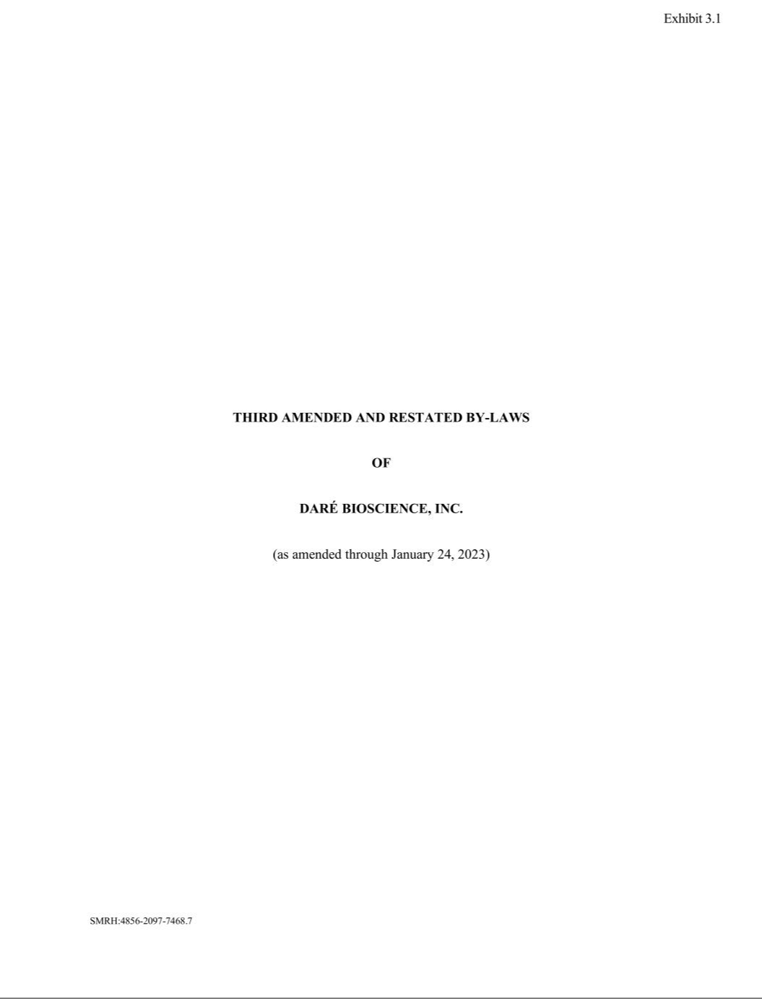

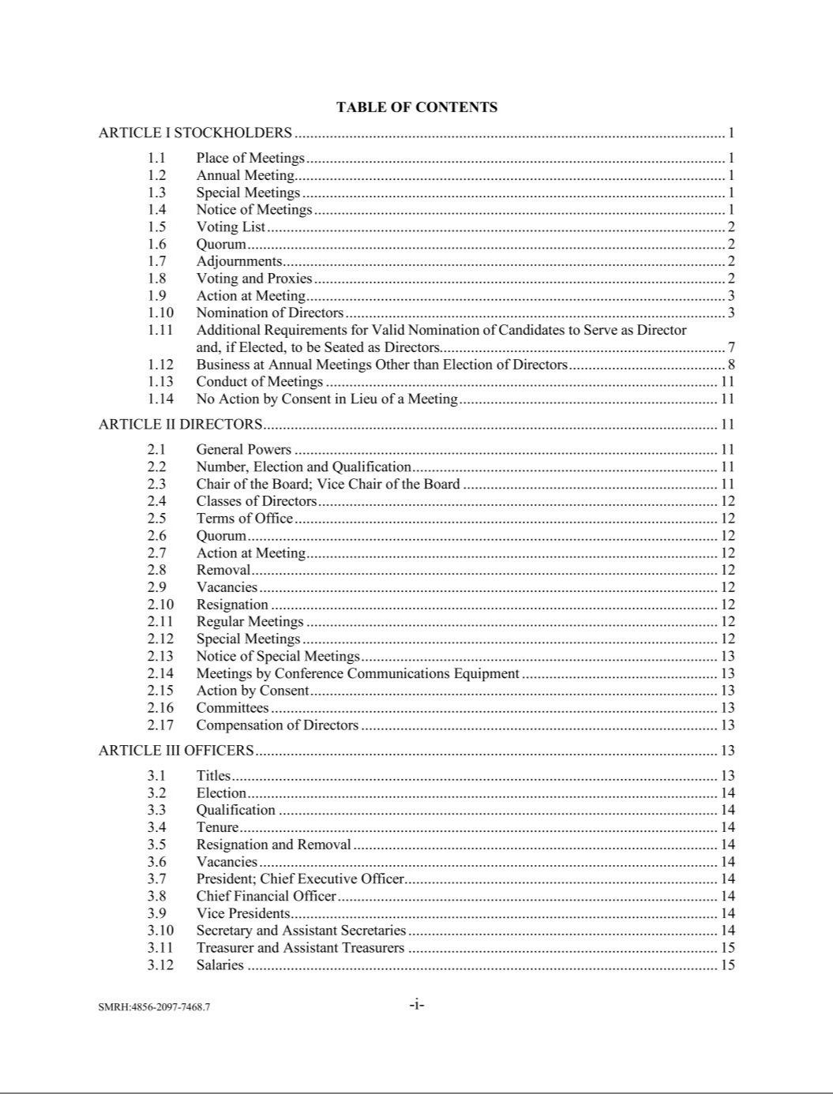

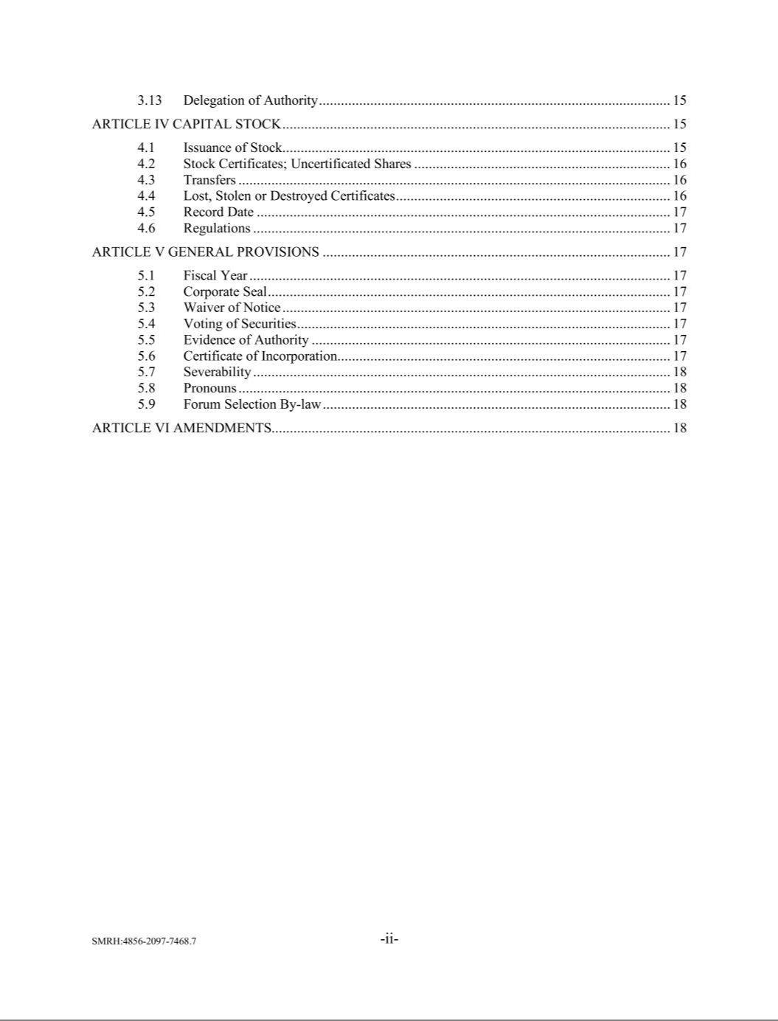

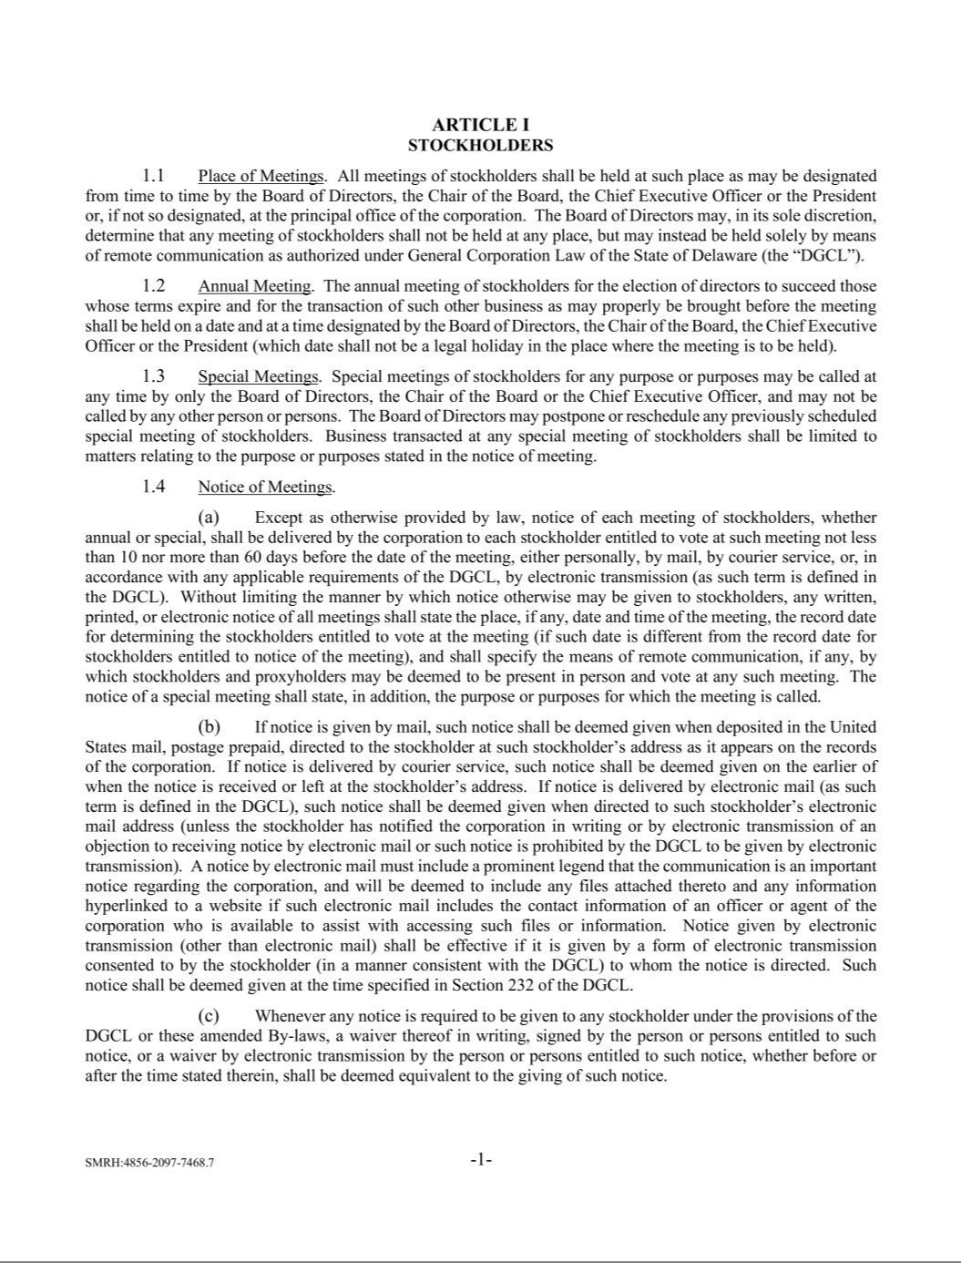

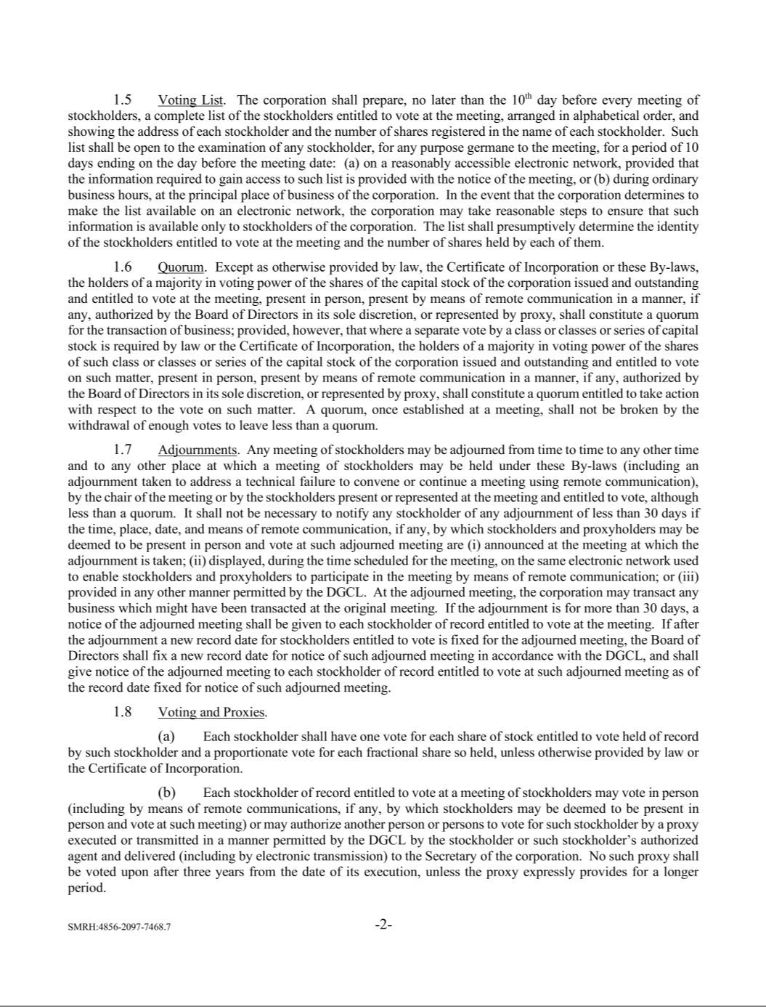

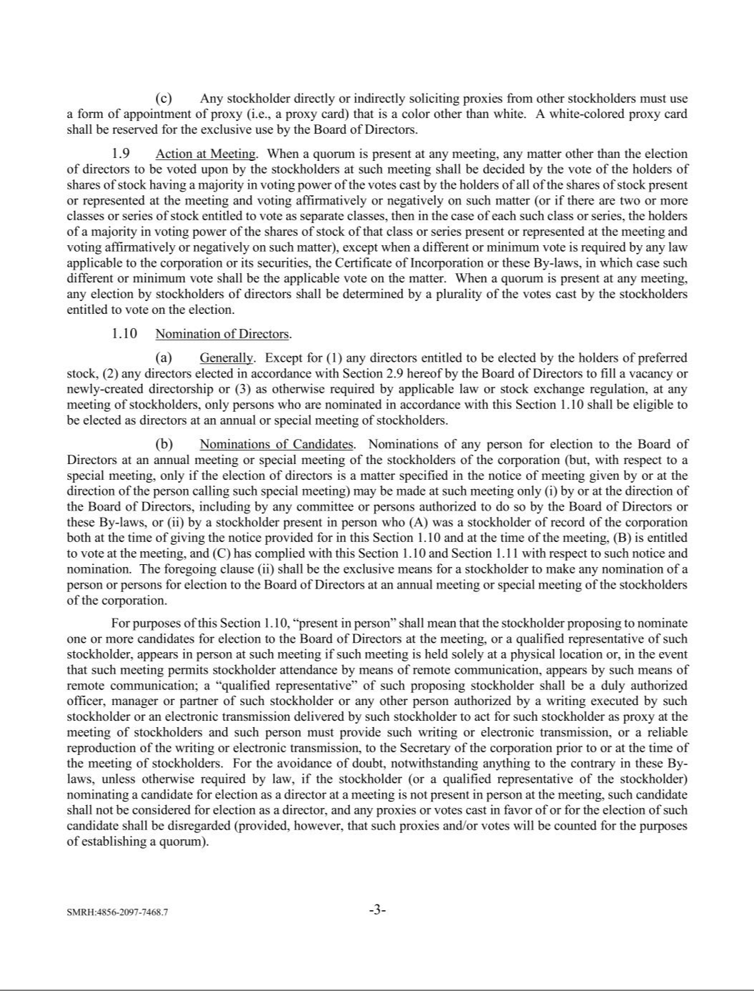

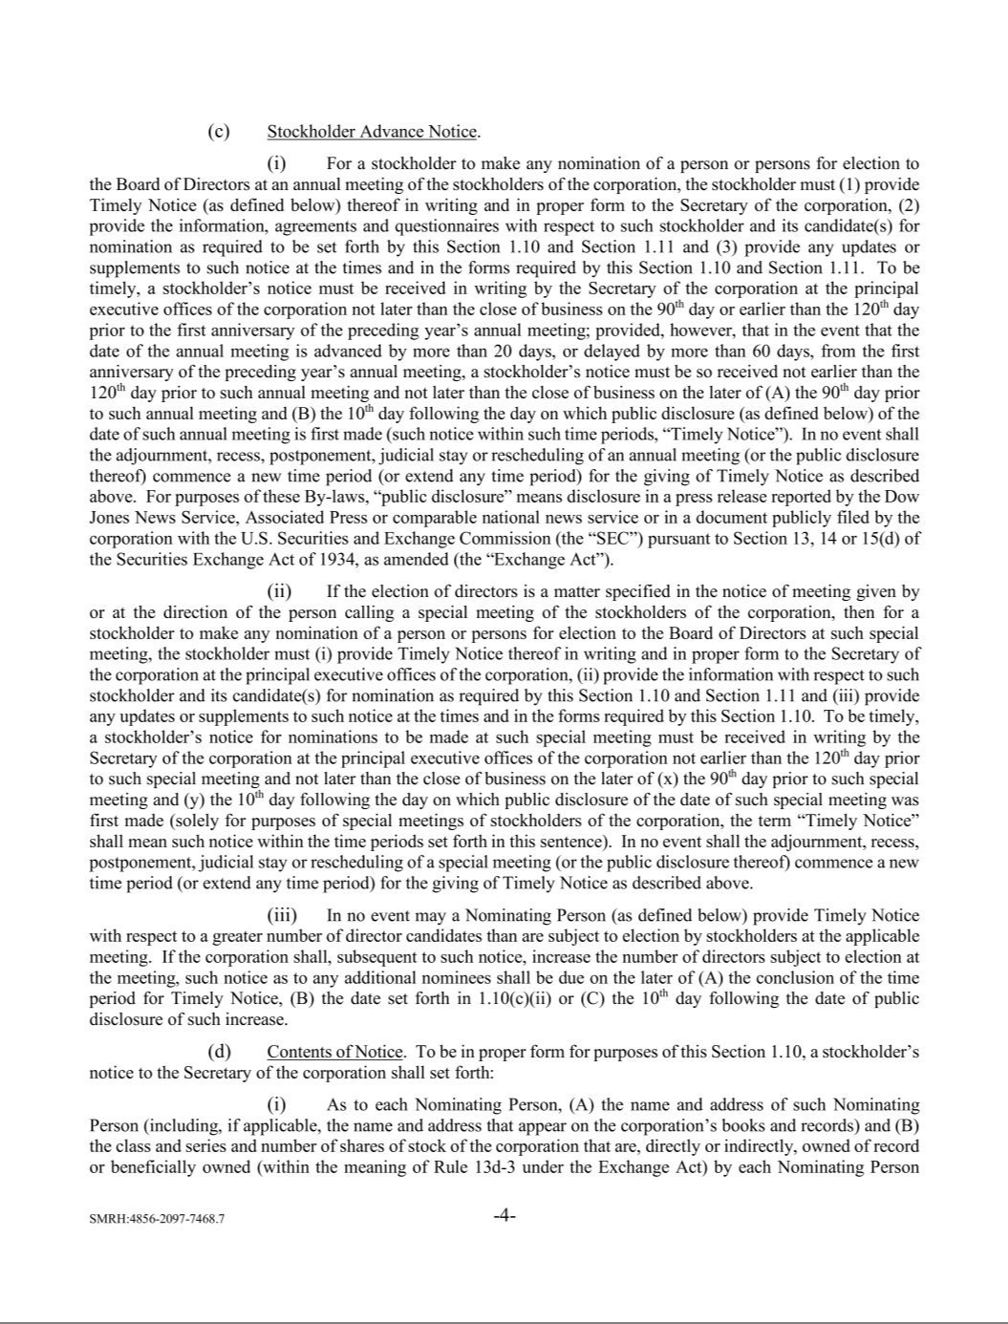

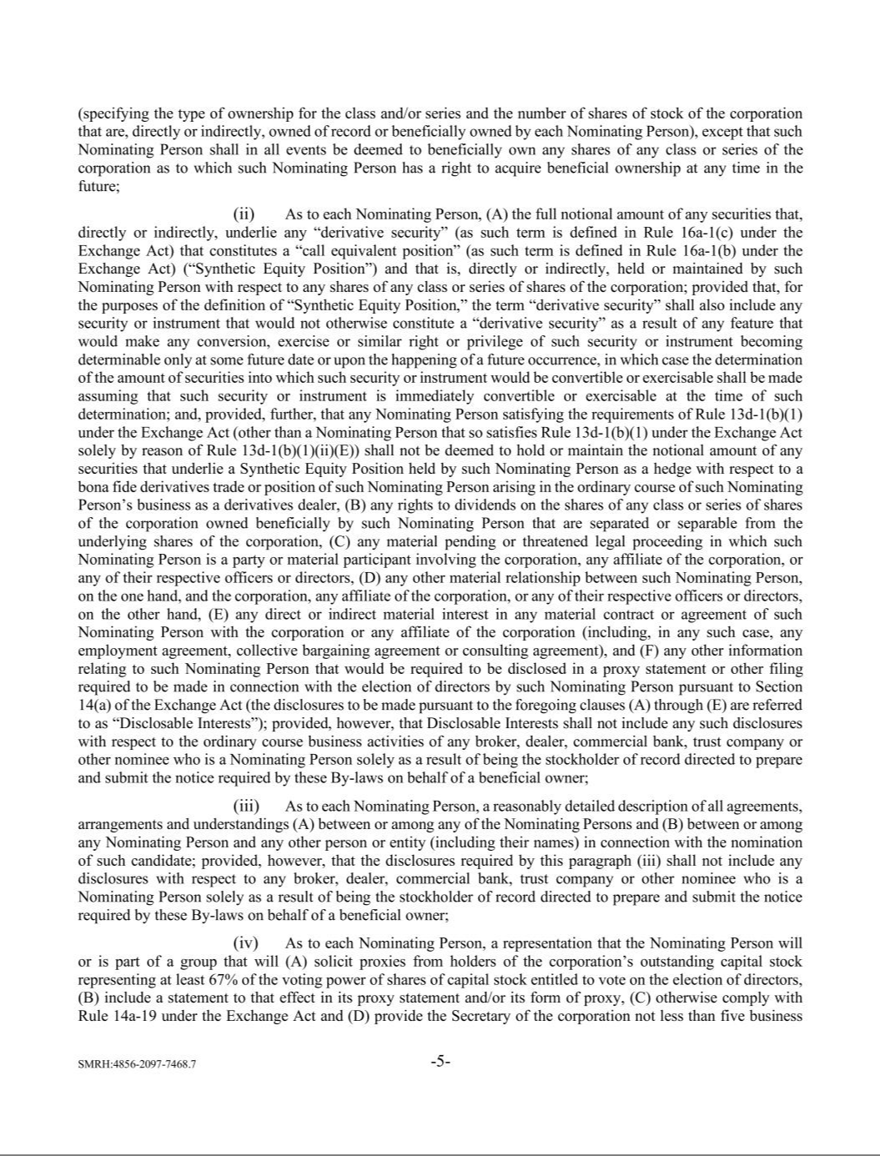

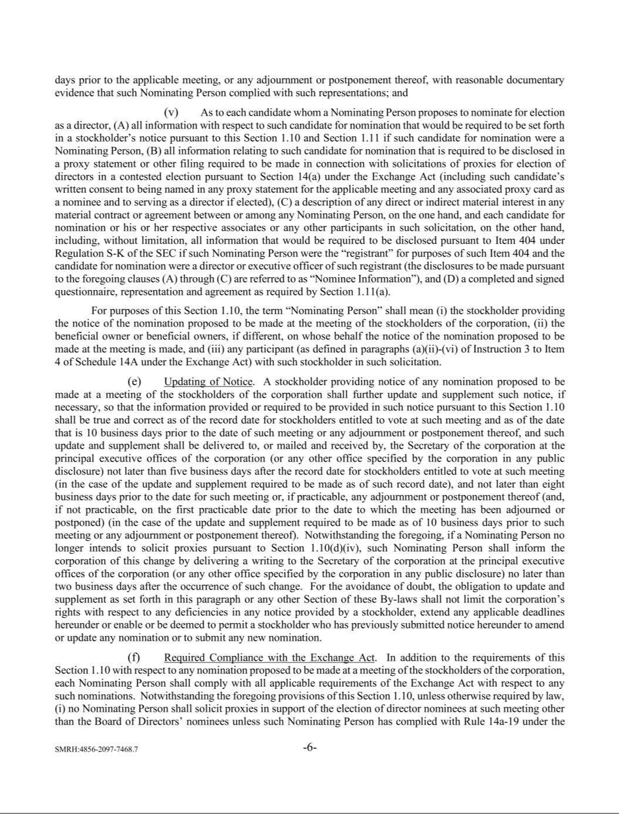

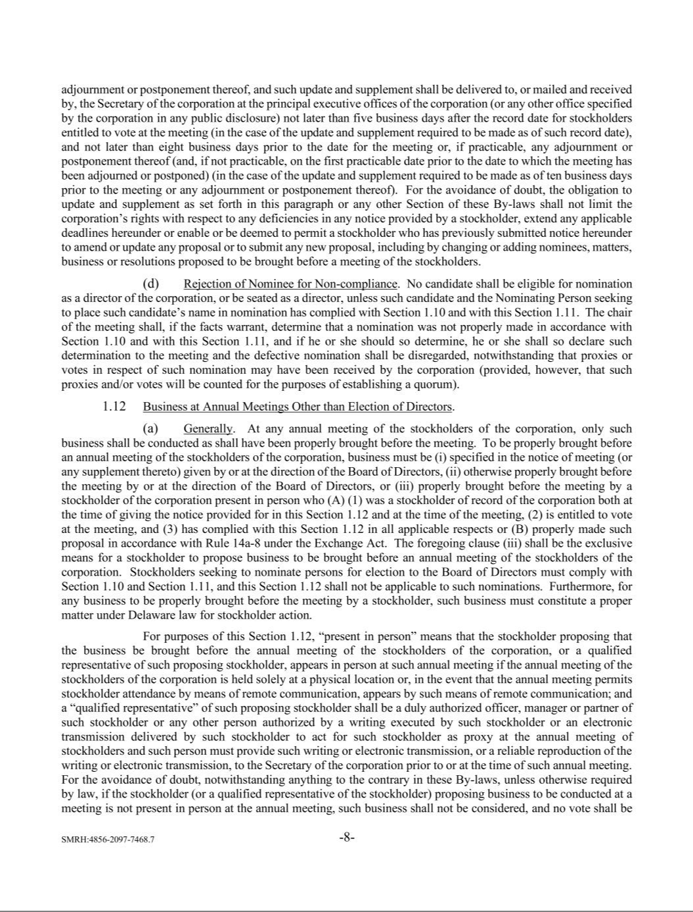

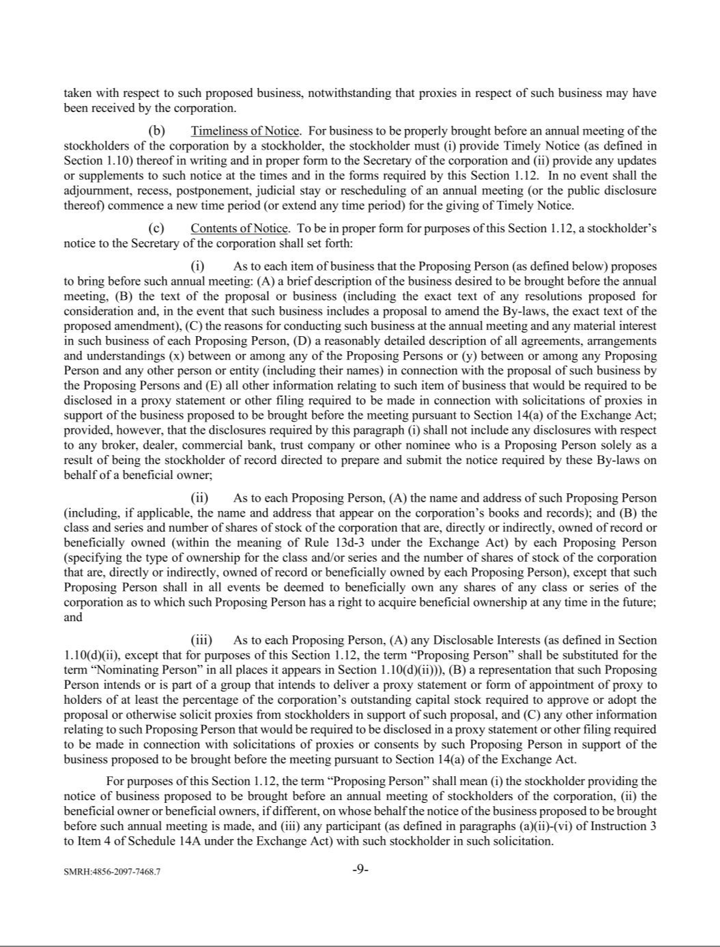

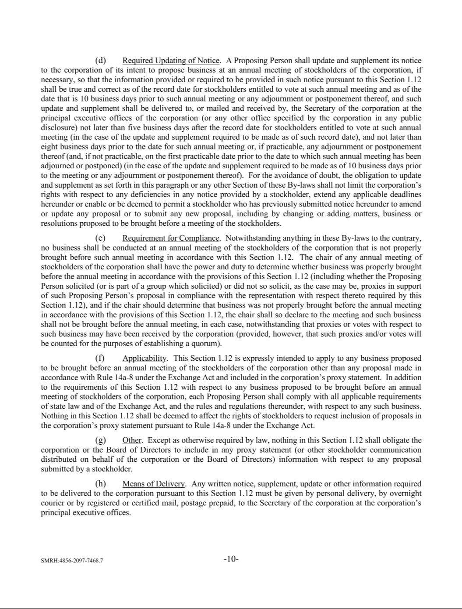

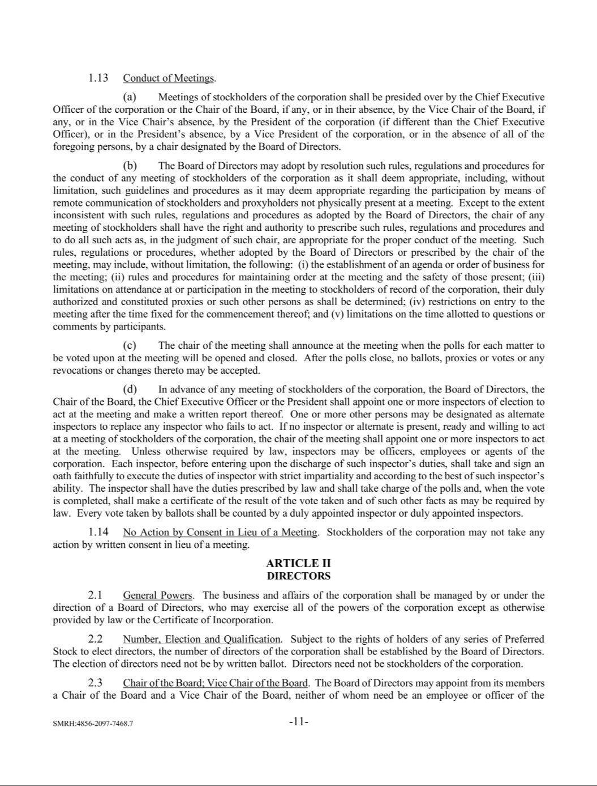

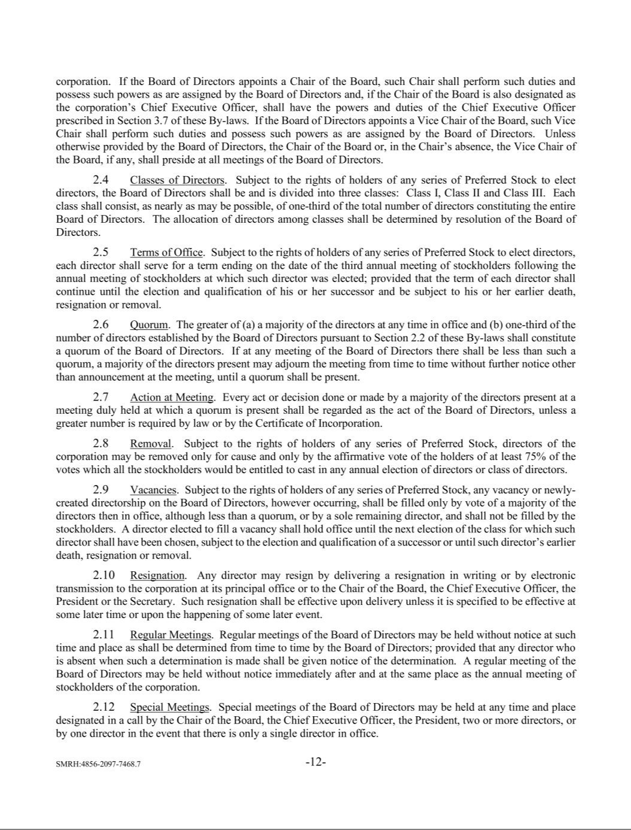

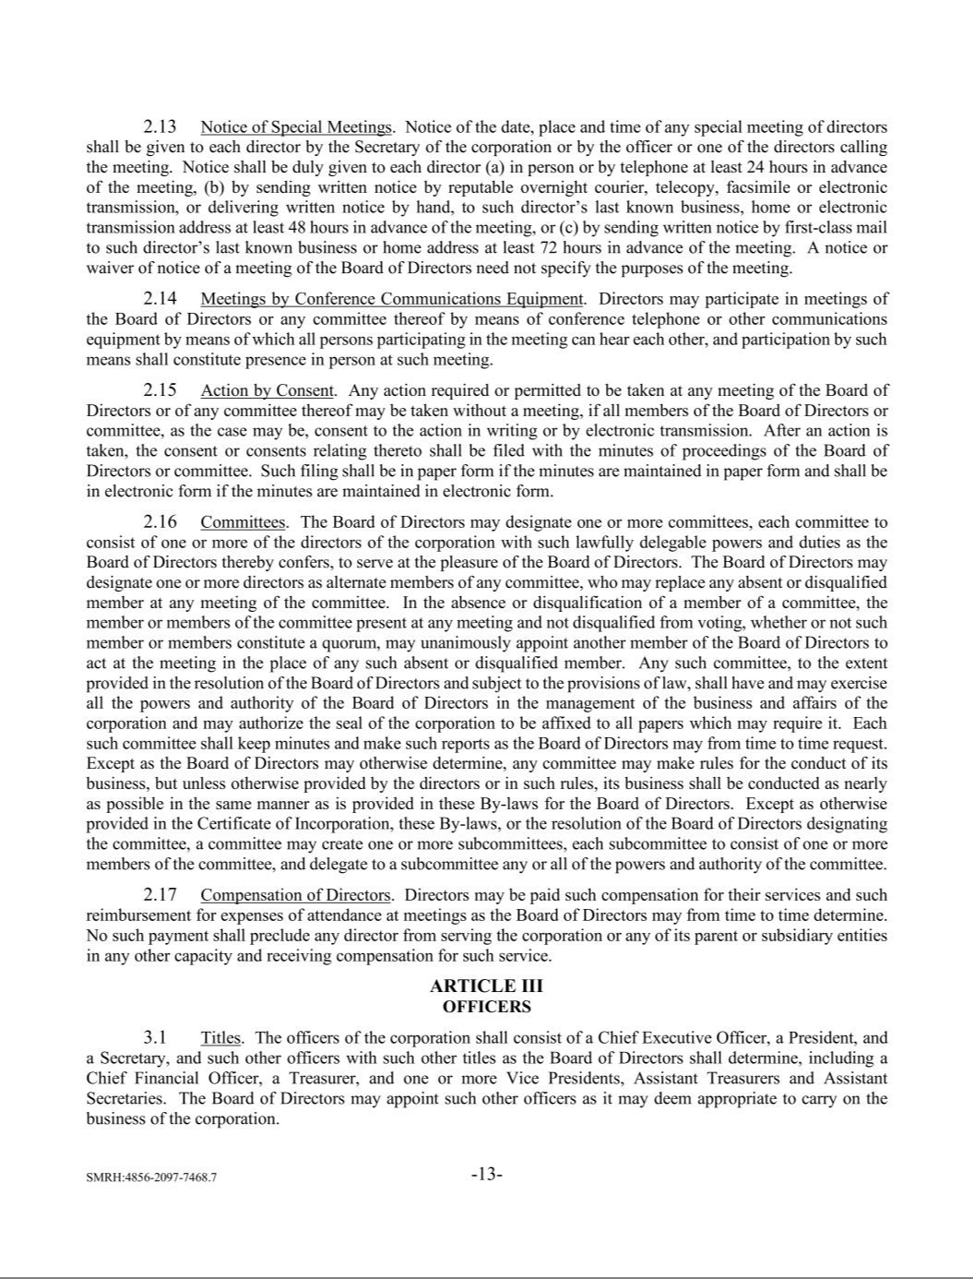

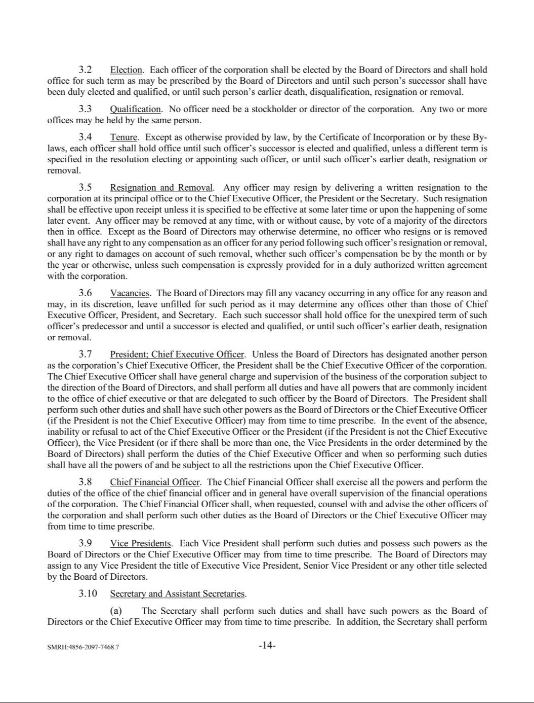

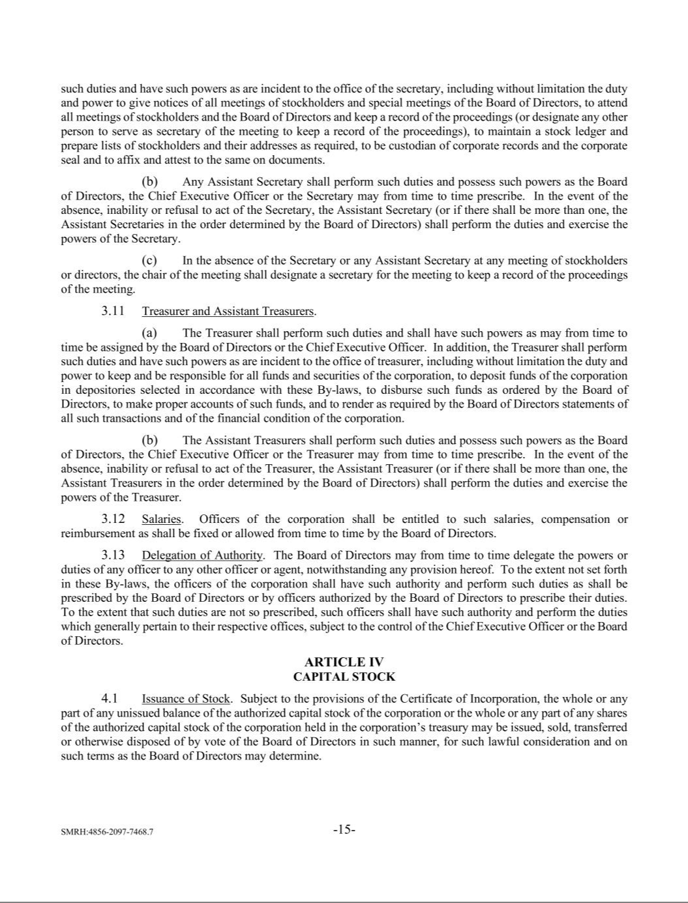

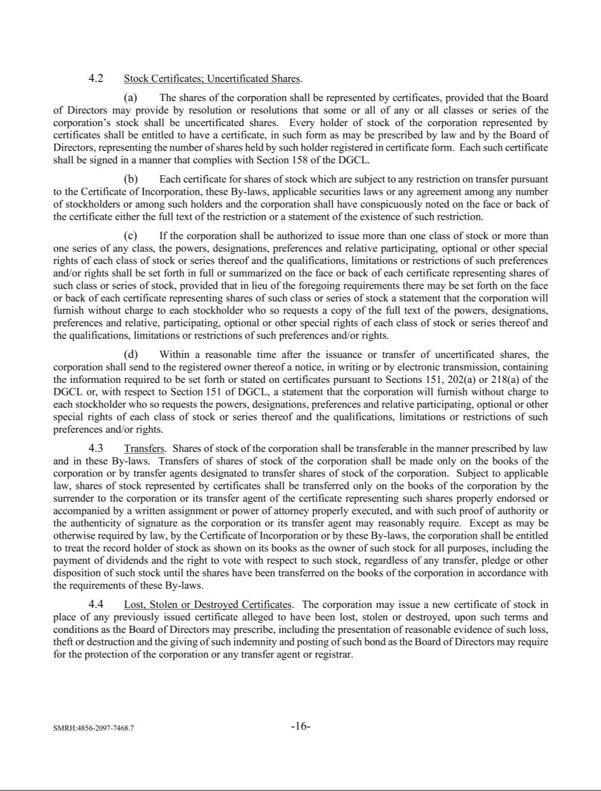

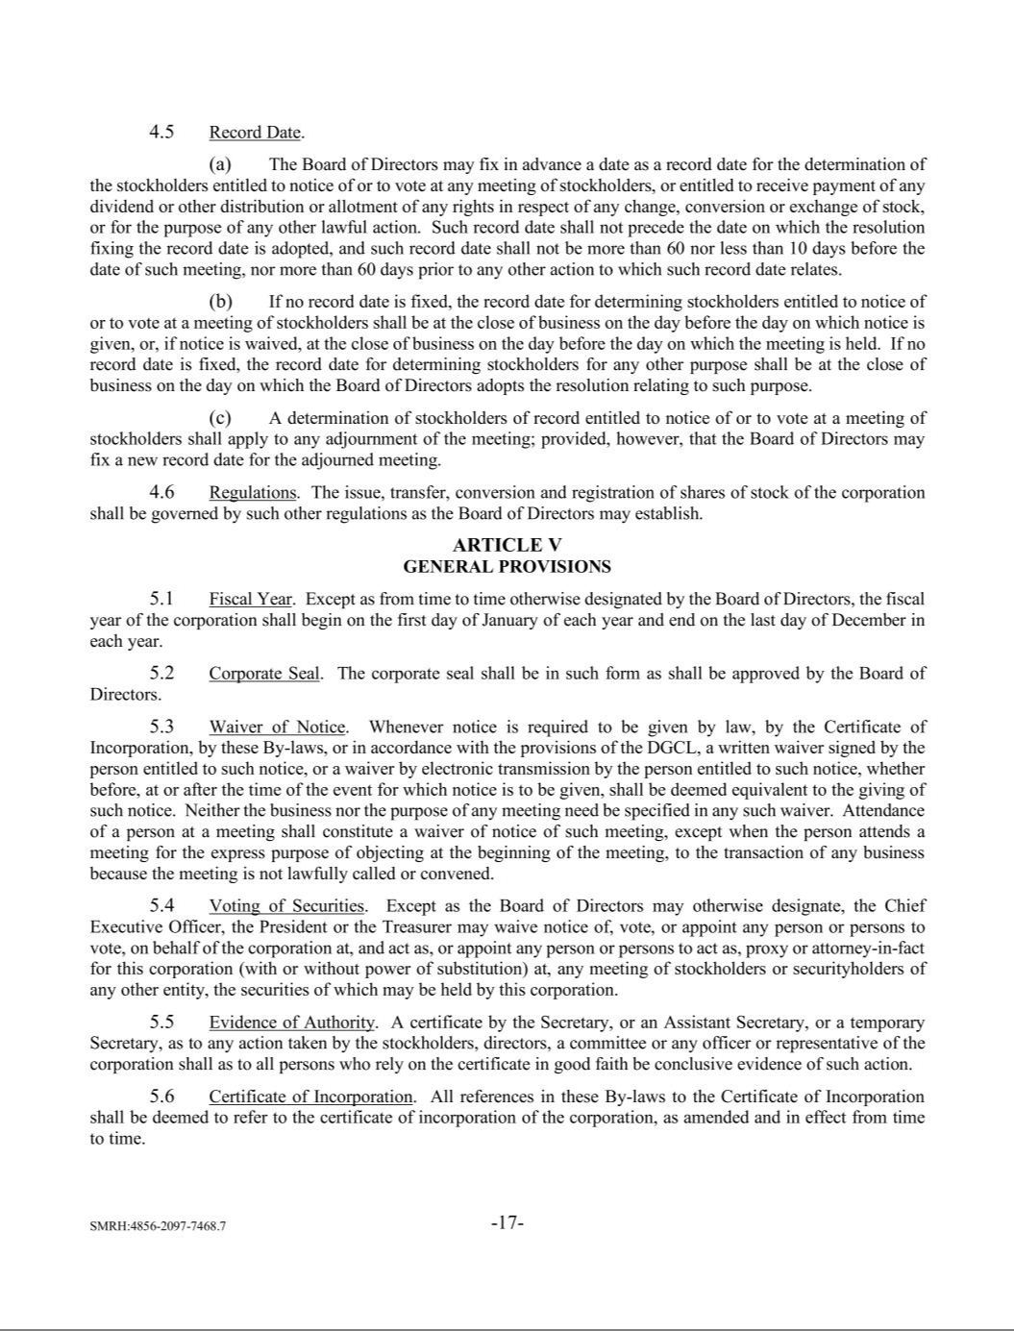

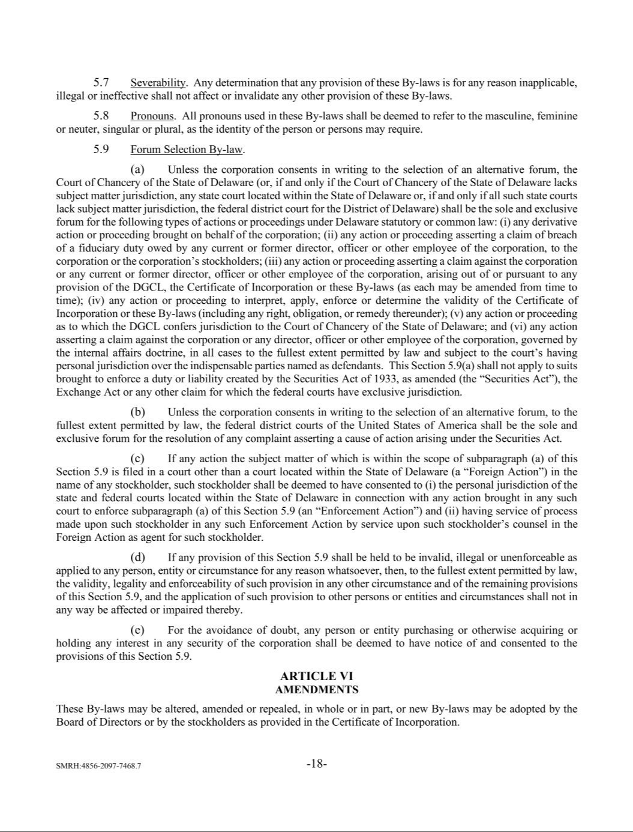

Exhibit 10.1

CONSULTING SERVICES AGREEMENT

This Consulting Services Agreement (“Agreement”) is entered into and effective as of January 26, 2024 (“Effective Date”) by and between Daré Bioscience, Inc. (“Company”), and Lisa Walters-Hoffert (“Consultant”).

WHEREAS, prior to the Effective Date, Consultant was employed by the Company pursuant to an Employment Agreement dated August 15, 2017, between the Company and Consultant (as amended, the “Employment Agreement”); and

WHEREAS, the Company desires that Consultant provide transition services to, and Consultant desires to provide transition services to, the Company as a consultant to the Company, commencing on the Effective Date.

NOW, THEREFORE, in consideration of such service and the mutual covenants and promises herein contained, and for other good and valuable consideration, the receipt and sufficiency of which are hereby acknowledged, the Company and Consultant, intending to be legally bound, hereby incorporate the Recitals set forth above and agree as follows:

- Term/Termination.

  - Employment Termination. Consultant acknowledges and agrees that Consultant’s employment by the Company will terminate on the Effective Date. On the Effective Date, Consultant shall receive payment of (i) any accrued and unpaid base salary and reimbursement of expenses in accordance with Company policy, in each case accrued through the date of termination, and (ii) the bonus to which Consultant is entitled under the Company’s performance bonus plan in respect of fiscal year 2023 (notwithstanding that Consultant will not be employed by the Company on the date such bonus would otherwise be paid under the Company’s performance bonus plan). Consultant acknowledges and agrees that Consultant is not entitled to any severance payments or benefits in connection with the termination of her employment pursuant to the Employment Agreement or otherwise.

  - Service Period. Subject to (i) Consultant’s timely execution of the release of claims attached hereto as Exhibit A (the “Release”) on or within twenty-one (21) days after the Effective Date and (ii) Consultant not subsequently revoking the Release in accordance with applicable law, the Company hereby agrees to utilize the services of Consultant, and Consultant hereby agrees to serve the Company, upon the terms and conditions contained in this Agreement, commencing on the Effective Date and continuing for nine (9) months thereafter (such period, the “Service Period”).

  - Resignation as an Officer and Director. As of the Effective Date, Consultant shall be deemed to have resigned as (i) an officer of the Company and any of its affiliates, (ii) a member of the board of directors of the Company and any of its affiliates, and (iii) a fiduciary of any Company or affiliate benefit plans. On or immediately following the Effective Date, Consultant shall confirm the foregoing by submitting to the Company in writing a confirmation of Consultant’s resignation(s).

- Services of Consultant.

Consultant shall report to the Chief Executive Officer of the Company (the “CEO”), shall perform the services as may be requested from time to time by the CEO (the “Services”) and shall have such duties, authorities and responsibilities as are directed by the CEO.

- Compensation.

  - Fee. In consideration of all Services rendered by Consultant under this Agreement, the Company shall pay Consultant a base fee (the “Base Fee”) at a monthly rate of $31,667.00 during the Service Period. The Base Fee shall be paid by the Company in equal monthly installments.

  - Supplemental Payment. For a period of nine (9) months following the Effective Date, the Company shall provide a taxable payment to Consultant in an amount equal to the health insurance premiums paid by Consultant, up to $500.00 per month.

  - Options. Consultant holds stock options granted to Consultant pursuant to the Company’s Amended and Restated 2014 Stock Incentive Plan and the Company’s 2022 Stock Incentive Plan as detailed on Exhibit B hereto (the “Options”). The Options will remain outstanding, eligible to vest and will be exercisable, in each case, in accordance with the terms of stock incentive plans pursuant to which the Options were granted and the stock option agreements evidencing the Options.

  - Reimbursement of Expenses. The Company shall promptly reimburse Consultant for reasonable expenses actually incurred by Consultant directly in connection with the business and affairs of the Company and the performance of Consultant’s duties hereunder, subject to appropriate substantiation and itemization of such expenses and fees in accordance with the guidelines and limitations established by the Company from time to time. All such reimbursements shall be made as soon as reasonably practicable following receipt of the required documentation from Consultant and in

A-1

all events on or before the last day of Consultant’s taxable year following the taxable year in which the expense occurred.

- Confidentiality.

Section 8 (Confidentiality and Restrictive Covenants) and Section 9 (Intellectual Property) of the Employment Agreement (collectively, the “Covenants”) shall continue in full force and effect and are incorporated by reference herein.

- Ownership and License.

  - Company Except with respect to Background Technology (as defined in Section 5.b), all ideas, know-how, processes, information, drawings, documents, designs, models, inventions, copyrightable material and other tangible and intangible materials authored, prepared, created, made, developed, delivered, conceived or reduced to practice, in whole or in part, by Consultant in the course of providing the Services including, without limitation, computer programs, data and documentation (collectively, “Results”), are and will be the sole and exclusive property of Company, and Consultant hereby irrevocably, expressly and automatically assigns, in perpetuity, all right, title and interest in and to such Results to Company, including, without limitation, all copyrights, patent rights, trade secrets, trademarks, moral rights and all other applicable proprietary and intellectual property rights throughout the world (collectively, “Intellectual Property Rights”). If Consultant has any rights to the Results that cannot (as a matter of law) be assigned to Company in accordance with the foregoing, Consultant unconditionally and irrevocably: (i) waives the enforcement of such rights; and (ii) grants to Company an exclusive, irrevocable, perpetual, worldwide, royalty-free license (a) to reproduce, create derivative works of, distribute, publicly perform, publicly display, digitally perform, and otherwise use and exploit such Results, (b) to use, make, have made, sell, offer to sell, import, and otherwise exploit any product or service based on, embodying, incorporating, or derived from the Results, and (c) to exercise any and all other present or future rights not yet known in the Results, in each case with the right to sublicense such rights through multiple levels of sublicensees.

  - Background Technology. The parties acknowledge that certain intellectual property developed, acquired, or otherwise obtained by Consultant prior to, or independently of, this Agreement and certain intellectual property licensed or obtained by Consultant from third parties (collectively, “Background Technology”) may be used by Consultant in the performance of the Services. Consultant will specifically identify and describe to Company for inclusion in a work statement executed by the CEO and Consultant (“Work Statement”), all Background Technology that Consultant may use in the performance of Services under such Work Statement and the failure to so specify shall preclude Consultant from later claiming the existence of any such Background Technology. Consultant unconditionally grants to Company a

2

non-exclusive, perpetual, irrevocable, worldwide, fully-paid right and license, with the right to sublicense through multiple levels of sublicensees, under all of Consultant’s Intellectual Property Rights in any Background Technology incorporated into or necessary for Company to fully utilize and capitalize the Services and Results, (a) to reproduce, create derivative works of, distribute, publicly perform, publicly display, digitally perform, and otherwise use and exploit the Results, (b) to use, make, have made, sell, offer to sell, import, and otherwise exploit any product or service based on, embodying, incorporating, or derived from the Background Technology, and (c) to exercise any and all other present or future rights not yet known in the Background Technology, in each case with the right to sublicense such rights through multiple levels of sublicensees. Consultant represents, warrants and covenants that it has an unqualified right to license to Company and its designees all Background Technology as provided in this Section.

- Additional Agreements. Consultant will ensure that each of its personnel who will have access to any Proprietary Information or perform any Services has entered into a binding, effective, written agreement, enforceable under applicable law, with Consultant that: (a) is expressly for the benefit of Company; (b) irrevocably conveys to Consultant all right, title, and interest, including intellectual property rights, in and to all portions of the Results developed by such employee, to at least the same extent as such rights are conveyed to Company in this Section 5; and (c) requires such personnel to maintain the confidentiality of, refrain from using, and otherwise protect Propriety Information to at least the same extent as Section 4.

- Data. As used herein “Data” means (a) all data and information (i) submitted to Consultant by Company or Company’s customer, (ii) obtained, developed, or produced by Consultant in connection with this Agreement, or (iii) to which Consultant has access in connection with the provision of Services and (b) all derivatives of any of the foregoing.

  - All Data (and any and all Intellectual Property Rights therein) to which Consultant may have access hereunder is and shall remain the sole property of Company. All Data will be considered Results and assigned to Company as provided in Section 5.

  - Upon Company’s request from time to time or at any time, at the end of a Work Statement or this Agreement or, with respect to any particular Data, on such earlier date that the same shall be no longer required by Consultant in order to render the Services hereunder, Consultant shall promptly provide an electronic copy of all Data to Company, in the format reasonably requested by Company. If Company requests at any time, Consultant shall destroy all copies of the Data in Consultant’s possession or control. Consultant shall not withhold any Data as a means of

resolving any dispute. Consultant shall not use Data for any purpose other than that of rendering the Services under this Agreement, nor sell, assign, lease, dispose of or otherwise exploit Data. Consultant will not provide access to any Data pertaining to a particular Customer to any other Customer. Consultant shall not possess or assert any lien or other right against or to Data.

  - Consultant shall establish and maintain environmental, safety and facility procedures, data security procedures and other safeguards against the destruction, loss, or alteration of Data in the possession of Consultant which are (i) in conformance with any requirements set forth in the applicable Work Statement, and (ii) in any event no less rigorous than those maintained by Consultant for its own information of a similar nature. As part of the Services, Consultant shall develop and maintain procedures for the reconstruction of lost Data, and Consultant shall use its best efforts to correct, at Company’s request, any material destruction, loss or alteration of any Data caused by Consultant or any Consultant personnel.

- Cooperation. Consultant shall perform, during and after the term of this Agreement, all acts deemed necessary or desirable by Company to permit and assist it, in evidencing, perfecting, obtaining, maintaining, defending and enforcing Intellectual Property Rights and/or Consultant’s assignments herein. Such acts may include, but are not limited to, execution of documents and assistance or cooperation in legal proceedings. Consultant hereby irrevocably designates and appoints Company and its duly authorized officers and agents, as Consultant’s agents and attorneys with full power of substitution, to act for and in behalf and instead of Consultant, to execute and file any documents and to do all other lawfully permitted acts to further the above purposes with the same legal force and effect as if executed by Consultant.

  - Moral Rights. Any assignment of copyright hereunder (and any ownership of a copyright as a work made for hire) includes all rights of paternity, integrity, disclosure and withdrawal and any other rights that may be known as or referred to as “moral rights” (collectively, “Moral Rights”). To the extent such Moral Rights cannot be assigned under applicable law and to the extent the following is allowed by the laws in the various countries where Moral Rights exist, Consultant hereby ratifies and consents to any action of Company that would violate such Moral Rights in the absence of such ratification/consent. Consultant will confirm any such ratifications and consents from time to time as requested by Company.

- Interference With Company Business; No Conflict. For the term of this Agreement and for a period of three (3) years thereafter, Consultant shall not, for itself or any third party, directly or indirectly divert or attempt to divert from Company (or any affiliate of it that might be formed) any

3

business of any kind in which Company is engaged including, without limitation, the solicitation of or interference with any of its customers, clients or vendors. During the term of this Agreement and for one (1) year thereafter, Consultant will not encourage or solicit any employee or consultant of Company (or any of its affiliates) to terminate its or his or her employment or consulting relationship with Company for any reason. Consultant will not accept work, enter into a contract, or accept an obligation, that conflicts with Consultant’s obligations hereunder or the scope of the Services rendered for the Company, under this Agreement. Consultant warrants that, as of the Effective Date, there is no other contract or duty on the part of Consultant that conflicts with or is inconsistent with this Agreement.

  - License. If any Intellectual Property Rights or inventions assigned hereunder or any Results are based on, or incorporate, or are improvements or derivatives of, or cannot be reasonably made, used, modified, maintained, supported, reproduced and distributed or otherwise fully exploited without using or violating technology or Intellectual Property Rights owned or licensed by Consultant and not assigned hereunder, Consultant hereby grants Company a perpetual, irrevocable, worldwide, fully paid-up, royalty-free, nonexclusive, sublicensable right and license to exploit and exercise all such technology and Intellectual Property Rights in support of Company’s exercise or exploitation of any Results or assigned Intellectual Property Rights or inventions (including any modifications, improvements and derivatives works thereof).

- Independent Contractor. Consultant shall act in the capacity of an independent contractor with respect to the Company, and not as an employee or authorized agent of the Company. Consultant shall have no authority to enter into contracts or binding commitments in the name or on behalf of the Company. Consultant will not use the Company’s logo or marks without prior written approval, and then such use shall be only for the benefit of the Company and at the direction of the Company. Consultant shall not be, nor represent itself as being, an agent of the Company, and shall not be, nor represent itself as being, authorized to bind the Company. Consultant agrees, acknowledges and understands that neither it nor its employees or agents shall have the status of an employee of the Company and, except as expressly provided herein, shall not participate in any employee benefit plans or group insurance plans or programs (including, but not limited to salary, bonus or incentive plans, stock option or purchase plans, or plans pertaining to retirement, deferred savings, disability, medical or dental), even if it is considered eligible to participate pursuant to the terms such plans. In addition, Consultant understands and agrees that consistent with its independent contractor status, neither it nor its employees or agents will apply for any government-sponsored benefits intended only for employees, including, but not limited to, unemployment benefits. Consultant’s exclusion from benefit

programs maintained by the Company is a material component of the terms of compensation negotiated by the parties, and is not premised on Consultant’s status as a non-employee with respect to the Company. To the extent Consultant or its employees or agents may become eligible for any benefit programs maintained by the Company (regardless of timing or reason for eligibility), Consultant hereby waives its right to participate in the programs. Consultant’s waiver is not conditioned on any representation or assumption concerning Consultant’s legal status as a contractor or employee. The Company shall issue Form 1099 records for its payments to Consultant made pursuant to this Agreement. Because Consultant is an independent contractor, it is solely responsible for all taxes, withholdings, and other similar statutory obligations including, without limitation, Workers’ Compensation Insurance, Unemployment Insurance, or State Disability Insurance. Consultant shall defend, indemnify and hold Company harmless from any and all claims made by any entity on account of an alleged failure by Consultant to satisfy any such tax or withholding obligations. Consultant warrants that it has sought and obtained independent advice regarding the tax consequences of the payments made pursuant to this Agreement.

- Representations and Warranties. Consultant represents and warrants that, as of the Effective Date and at all times during the term of this Agreement: (i) Consultant’s performance of the Services and all terms of this Agreement will not breach any agreement that Consultant has with another party including, without limitation, any agreement to keep in confidence proprietary information acquired by Consultant in confidence or trust prior to the execution of this Agreement; (ii) Consultant is not and will not be bound by any agreement, nor has assumed or will assume any obligation, which would in any way be inconsistent with the Services to be performed by Consultant under this Agreement; (iii) in performing the Services, Consultant will not use any confidential or proprietary information of another party, or infringe the Intellectual Property Rights of another party, nor will Consultant disclose to Company, or bring onto Company’s premises, or induce Company to use any confidential or proprietary information of any person or entity other than Company or Consultant; (iv) Consultant will abide by all applicable laws and the Company’s safety rules in the course of performing the Consulting Services; and (v) Consultant will not use or retain any other individual(s) or employee(s) in performing services for the Company except with prior written approval has been obtained from the Company.

- Indemnity. Consultant will defend, indemnify and hold Company and its affiliates (and their respective employees, directors and representatives) harmless against any and all losses, liabilities, damages, claims, demands and suits and related costs and expenses (including, without limitation, reasonable attorneys’ fees and court costs) arising or resulting,

4

directly or indirectly, from (i) Consultant’s provision of Services or Results; (ii) any act or omission of Consultant (or its employees or independent contractors) or Consultant’s (or its employees’ or independent contractors’) breach of any representation, warranty or covenant of this Agreement, or (iii) infringement of any third-party intellectual property rights by the Results, Company’s use of the Results or Consultant’s performance of the Services, and (iv) any failure (alleged or actual) by Consultant to satisfy any of the tax or withholding obligations for Consultant or any employee or individual retained by Consultant to perform services for the Company.

- Limit of Liability. TO THE MAXIMUM EXTENT PERMITTED UNDER APPLICABLE LAW: (I) IN NO EVENT WILL COMPANY BE LIABLE TO CONSULTANT FOR ANY INDIRECT, SPECIAL, EXEMPLARY, INCIDENTAL, OR CONSEQUENTIAL DAMAGES (INCLUDING LOSS OF PROFITS) ARISING FROM OR RELATING TO THIS AGREEMENT, EVEN IF COMPANY KNEW OR SHOULD HAVE KNOWN OF THE POSSIBILITY OF, OR COULD REASONABLY HAVE PREVENTED, SUCH DAMAGES; AND (II) COMPANY’S TOTAL LIABILITY ARISING FROM OR RELATING TO THIS AGREEMENT, WHETHER SUCH DAMAGES ARE BASED ON TORT, CONTRACT, OR ANY OTHER LEGAL THEORY, WILL NOT EXCEED THE AMOUNT OF FEES PAID BY COMPANY TO CONSULTANT UNDER THIS AGREEMENT.

- Governing Law. This Agreement will be governed by the laws of the United States of America and the State of California, without reference to its conflict of laws principles or any other principles that would result in the application of a different body of law.

- Injunctive Relief. Nothing in this Agreement will limit either party’s right to seek immediate injunctive or other equitable relief whenever the facts or circumstances would permit a party to seek such relief in a court of competent jurisdiction. Consultant acknowledges that its breach of Company’s Intellectual Property Rights may cause irreparable damage and hereby agrees that Company shall be entitled to injunctive relief in the event thereof, without the necessity of posting bond, as well as such further relief as may be granted by a court of competent jurisdiction.

- Assignment. This Agreement (together with all attached exhibits) shall be binding upon Consultant, and inure to the benefit of the parties hereto and their respective heirs, successors, assigns, and personal representatives; provided, however, that Consultant shall not assign any of its rights or delegate any of its duties hereunder without Company’s prior written consent and any attempted assignment or delegation will be void.

- Notices. All notices, requests, demands or other communications which are required or may be given pursuant to the terms of this Agreement shall be in writing and shall be deemed to have been duly given: (i) on the date of delivery if delivered by hand or by confirmed facsimile; (ii) upon the fifth day after such notice is deposited in the United States mail, if mailed by registered or certified mail, postage prepaid, return receipt requested, or (iii) upon the date of the courier’s verification of delivery at the specified address if sent by a nationally-recognized overnight express courier. Written notices shall be provided to the applicable party at the address first written above, or such address as may be otherwise provided in writing by a party hereunder.

- Cumulative Remedies, Waiver and Severability. Consultant recognizes that nothing in this Agreement is intended to limit any remedy of Company under the Uniform Trade Secrets Act and that Consultant could face possible criminal and civil actions, resulting in substantial monetary liability if Consultant misappropriates Company’s trade secrets. All rights and remedies, whether conferred hereunder, or by any other instrument or law, unless otherwise expressly stated, will be cumulative and may be exercised singularly or concurrently. The failure of either party to enforce any of the provisions hereof will not be construed to be a waiver of the right of such party thereafter to enforce such provisions. If one or more provisions in this Agreement are ruled entirely or partly invalid or unenforceable by any court or governmental authority of competent jurisdiction, then: (i) the validity and enforceability of all provisions not ruled to be invalid or unenforceable shall remain unaffected; (ii) the effect of such ruling shall be limited to the body making the ruling; (iii) the provision(s) held wholly or partly invalid or unenforceable shall be deemed amended, and the parties shall reform the provision(s) to the minimum extent necessary to render them valid and enforceable in conformity with the parties’ intent as manifested herein; and (iv) if the ruling, or the controlling principle of law or equity leading to the ruling, is subsequently overruled, modified, or amended, then the provision(s) in question, as originally set forth in this Agreement, shall be deemed valid and enforceable to the maximum extent permitted by the new controlling principle of law or equity. WITHOUT LIMITING THE FOREGOING, IT IS UNDERSTOOD AND AGREED THAT EACH AND EVERY PROVISION OF THIS AGREEMENT, INCLUDING WITHOUT LIMITATION LIMITATIONS OF LIABILITY OR EXCLUSION OF DAMAGES IS INTENDED BY THE PARTIES TO BE ENFORCEABLE TO THE MAXIMUM ALLOWED BY APPLICABLE LAW SEVERABLE AND INDEPENDENT OF ANY OTHER SUCH PROVISION AND TO BE ENFORCED AS SUCH. IT IS EXPRESSLY UNDERSTOOD AND AGREED THAT IN THE EVENT ANY REMEDY HEREUNDER IS DETERMINED TO HAVE FAILED OF ITS ESSENTIAL PURPOSE, ALL LIMITATIONS OF LIABILITY AND EXCLUSIONS OF DAMAGES SET FORTH HEREIN

5

SHALL REMAIN IN EFFECT TO THE MAXIMUM ALLOWED BY APPLICABLE LAW.

- Survival. The provisions of this Agreement that may be reasonably interpreted as surviving its termination, including the applicable provisions of Section 1(b), Sections 3(b) and 3(c), Section 4, Section 5, Section 7, Section 8, and Sections 10 through 16, (inclusive), shall continue in effect after termination of this Agreement.

- Integration; Order of Precedence. This Agreement and the Exhibits attached hereto (collectively, the “Contract Documents”) constitute the entire agreement between the parties, and supersede all other prior or contemporaneous communications between the parties (whether written or oral) relating to the subject matter of the Contract Documents, including, without limitation, the Employment Agreement, other than the Covenants. The Contract Documents may be modified or amended solely in a writing signed by both parties.

CONSULTANT HAS READ THIS AGREEMENT CAREFULLY AND UNDERSTANDS AND ACCEPTS THE OBLIGATIONS WHICH IT IMPOSES UPON CONSULTANT WITHOUT RESERVATION. NO PROMISES OR REPRESENTATIONS HAVE BEEN MADE TO CONSULTANT TO INDUCE CONSULTANT TO SIGN THIS AGREEMENT. CONSULTANT SIGNS THIS AGREEMENT VOLUNTARILY AND FREELY.

IN WITNESS WHEREOF, the parties hereto have executed this Agreement as of the first day above written.

Daré Bioscience, Inc.

By: /s/ Sabrina Martucci Johnson

Sabrina Martucci Johnson, CEO

CONSULTANT

By: /s/ Lisa Walters-Hoffert

Lisa Walters-Hoffert

Exhibit 31.1

CERTIFICATIONS

I, Sabrina Martucci Johnson, certify that:

- I have reviewed this Quarterly Report on Form 10-Q of Daré Bioscience, Inc.;

- Based on my knowledge, this report does not contain any untrue statement of a material fact or omit to state a material fact necessary to make the statements made, in light of the circumstances under which such statements were made, not misleading with respect to the period covered by this report;

- Based on my knowledge, the financial statements, and other financial information included in this report, fairly present in all material respects the financial condition, results of operations and cash flows of the registrant as of, and for, the periods presented in this report;

- I am responsible for establishing and maintaining disclosure controls and procedures (as defined in Exchange Act Rules 13a-15(e) and 15d-15(e)) and internal control over financial reporting (as defined in Exchange Act Rules 13a-15(f) and 15d-15(f)) for the registrant and have:

  - Designed such disclosure controls and procedures, or caused such disclosure controls and procedures to be designed under our supervision, to ensure that material information relating to the registrant, including its consolidated subsidiaries, is made known to us by others within those entities, particularly during the period in which this report is being prepared;

  - Designed such internal control over financial reporting, or caused such internal control over financial reporting to be designed under our supervision, to provide reasonable assurance regarding the reliability of financial reporting and the preparation of financial statements for external purposes in accordance with generally accepted accounting principles;

  - Evaluated the effectiveness of the registrant’s disclosure controls and procedures and presented in this report my conclusions about the effectiveness of the disclosure controls and procedures, as of the end of the period covered by this report based on such evaluation; and

  - Disclosed in this report any change in the registrant’s internal control over financial reporting that occurred during the registrant’s most recent fiscal quarter (the registrant’s fourth fiscal quarter in the case of an annual report) that has materially affected, or is reasonably likely to materially affect, the registrant’s internal control over financial reporting; and

- I have disclosed, based on my most recent evaluation of internal control over financial reporting, to the registrant’s auditors and the audit committee of the registrant’s board of directors (or persons performing the equivalent functions):

  - All significant deficiencies and material weaknesses in the design or operation of internal control over financial reporting which are reasonably likely to adversely affect the registrant’s ability to record, process, summarize and report financial information; and

  - Any fraud, whether or not material, that involves management or other employees who have a significant role in the registrant’s internal control over financial reporting.

Date: May 14, 2024

/s/ Sabrina Martucci Johnson

Sabrina Martucci Johnson

President and Chief Executive Officer

(Principal executive officer and principal financial officer)

Exhibit 32.1

CERTIFICATION PURSUANT TO 18 U.S.C. SECTION 1350,

AS ADOPTED PURSUANT TO

SECTION 906 OF THE SARBANES-OXLEY ACT OF 2002

In connection with the Quarterly Report on Form 10-Q of Daré Bioscience, Inc. (the “Company”) for the fiscal quarter ended March 31, 2024, as filed with the Securities and Exchange Commission on the date hereof (the “Report”), the undersigned, Sabrina Martucci Johnson, President and Chief Executive Officer of the Company, hereby certifies, pursuant to 18 U.S.C. Section 1350, that, to her knowledge on the date hereof:

- The Report fully complies with the requirements of Section 13(a) or 15(d) of the Securities Exchange Act of 1934; and

- The information contained in the Report fairly presents, in all material respects, the financial condition and results of operations of the Company. Date: May 14, 2024

/s/ Sabrina Martucci Johnson

Sabrina Martucci Johnson

President and Chief Executive Officer

(principal executive officer and principal financial officer)

